Comparative Assessment of Rule-Based Design on the Pressures and Resulting Scantlings of High Speed Powercrafts
Jean-Baptiste R. G. SOUPPEZ ^{a,}, Ermina BEGOVIC ^{b}, Pradeep SENSHARMA ^{c}, Fuhua WANG ^{d} and Anders ROSÉN ^{e}
ª Mechanical, Biomedical & Design Department, School of Engineering and Technology, College of Engineering and Physical Sciences, Aston University, UK.
^{b} Department of Industrial Engineering, University of Naples Federico II, Italy.
^{c} Naval Sea Systems Command, US.
^{d} Marine Design and Research Institute of China, China.
^{e} KTH Royal Institute of Technology, Stockholm, Sweden.
Abstract. The rules and regulations inherent to the design pressures and scantlings of high-speed powercrafts are numerous, and regularly reviewed. Recently, the new ISO 12215-5:2019 made notable changes to the way high-speed crafts are analysed, including extending the acceleration experienced up to 8 g in certain circumstances. Nevertheless, despite the multiple iterations and variety of regulatory bodies, the seminal work undertaken on planing crafts throughout the 1960s and 1970s remains the foundation of any rule-based design requirement. Consequently, this paper investigates an array of recently published rules though a comparative design case study, the current state-of-the-art across a number of regulations, and the ultimate impact on scantlings. The study reveals that, despite divergence in intermediate calculations and assumptions, similar requirements are ultimately achieved. Eventually, discussion on the comparison undertaken and future trends in high-speed marine vehicles is provided, tackling the relevance of classical planing theory in light of contemporary innovations.
Keywords. High-Speed Craft; Hydrodynamic Pressure; Rules & Regulations.

Introduction
The recent publication of the ISO 12215-5:2019 [1], governing the design pressures, stresses and scantlings for monohulls brought a number of regulatory changes that are characteristic of the contemporary evolution of high-speed vessels. From the developments in composite structures allowing for lighter vessels [2] to the growing use of hydrofoils, first in sailing yachts [3] and now cascading into high-speed crafts, higher speeds are increasingly more common. Furthermore, progress in shock mitigating seats have altered the operating behaviour: as the crew does not experience as high accelerations, the speed may not be reduced in waves, leading to greater accelerations and hydromechanic loads on the structure. Consequently, higher accelerations are featured in the ISO standard [4], which now extends to commercial crafts [5]. A number of other regulatory bodies have also recently published revised rules inherent to structural requirements, to reflect the fast changing design of high-speed marine vehicles.
Nevertheless, the quantification of design pressures remains almost exclusively based on seminal work undertaken on prismatic geometries in the 1960s and 1970s, including the research of Heller & Jasper [6], Savitsky [7], Savitsky & Brown [8] and Allen & Jones [9]. While it could be argued that these do not reflect several decades of advances in hydrodynamics and modifications in hull shape design, structural layout and materials, they remain the foundation of multiple rules and regulations for the structure of small and large crafts. Yet, each regulatory body adopts a singular approach to the assessment of pressures, and ultimately the resulting scantlings, as well as the actual definition of a high-speed craft based on either displacement or length [10].
These observations have motivated experimental campaigns to evaluate the relationship between regulatory and actual pressures, with notable towing tank experiments [11, 12] and full-scale instrumentation being undertaken [13]. Furthermore, improvements in numerical simulations have also enabled the investigation of slamming pressures for the purpose of regulatory validation [14]. In recent years, the suitability of seminal academic work in contrast with the latest research findings has therefore been questioned [15, 16, 17], with some alternatives being proposed [18].
Therefore, this paper endeavours to tackle the discrepancies and commonalities in pressure assessments and scantlings for an array of high-speed rules, in order to quantify the level of uncertainty that might arise. This will provide a better insight into the more recent versions of these various rules, as such a study was last undertaken in 2003 [19], and the last few years have seen many updated regulations. Therefore, the new underpinning key equations will be introduced to identify the similitudes and differences that may affect the intermediate calculations and final scantlings requirements. Furthermore, the relevance of traditional planing theory will be evaluated against the emerging and future trends in the design of high-speed marine vehicles.

Comparative Assessment

2.1 Test Case
The present study will be based upon a suitable ocean going 24 m high-speed geometry previously studied at model-scale in the literature [20], and depicted in Figure 1, with the full-scale data introduced in Table 1.

Figure 1: Geometry of the 24m planing craft considered [20].

Table 1: Main hydrostatics.
Length overall | L_{OA} | 24 m
Length on waterline | L_{WL} | 22.55 m
Beam overall | B_{OA} | 5.36 m
Beam on waterline | B_{WL} | 5.36 m
Beam at chine | B_{C} | 5.36 m
Canoe body draft | Tc | 1.21 m
Displacement | Δ | 68 t
Deadrise angle | β | 17 °
Top Speed | V_{MAX} | 50 kts
Category | Ocean going vessel

A typical 5083 welded aluminium alloy was chosen as build material for the plating of the vessel. In order to compare the pressures, accelerations and ultimately the required scantlings across an array of regulations, a specific panel, located in the slamming area and representative of an expected structural arrangement on the given vessel calculated empirically [21] has been selected, as detailed in Table 2.

Table 2: Selected panel specifications.
Panel length | 1000 mm
Panel breadth | 400 mm
Longitudinal curvature | 0 mm
Transverse curvature | 0 mm
Distance from aft perpendicular | 19.22 m (85% Lwl)
Freeboard height | 2.01 m
Chine height above waterline | 0.80 m
Local deadrise | 35 °
Construction material | EN AW-5083 H32

The test case will be subjected to a number of recently reviewed rules, with all calculations undertaken as specified by the regulations, originating from some of the largest regulatory bodies, namely: Det Norske Veritas (DNV) [22], China Classification Society (CCS) [23], Det Norske Veritas Germanischer Lloyds (DNVGL) [24], American Bureau of Shipping (ABS) [25], Bureau Veritas (BV) [26], International Organisation for Standardization (ISO) [1], Lloyds Register (LR) [27] and Registro Italiano Navale (RINa) [28].

2.2 High-Speed Definition
The significant changes in the waterline length of high-speed crafts prompted Savitsky to adopt a beam-based Froude number, termed speed coefficient [7]. Volumetric Froude numbers are also frequently employed when characterizing planing crafts, and the foundation of the IMO high-speed definition [29].
Looking at the various definition of high-speed adopted by the studied regulatory bodies, presented in Table 3, a displacement based criteria appears most common, relying on either volume ($∇$ in m³) or mass ($Δ$ in t), and expressing the speed in m.s⁻¹ or knots (note: 3.7 m.s⁻¹ = 7.19 knots). Therefore, these all appear consistent with the IMO high-speed definition [29], related to volumetric Froude number. When looking at regulations coming from a small craft background (as opposed to large ships), the criteria is based on the waterline length, and thus the simpler Froude number, the relevance of which can be harder to ascertain for planing craft. This is evidenced in perhaps the largest divide identified here, namely ABS considering planing from a Froude number of 0.75, as opposed to the much higher 1.6 value adopted by ISO. This can also be understood as the effect of length, given that ABS can extend to 130 m, while ISO is limited to 24 m.

Table 3: Comparison of the definition of high-speed across regulatory bodies
International Maritime Organisation | $V \left[m.s^{-1}\right]≥3.7{ ∇}^{0.1667}$
China Classification Society | $V \left[m.s^{-1}\right]≥3.7{ ∇}^{0.1667}$
Det Norske Veritas Germanischer Lloyds | $V \left[m.s^{-1}\right]≥3.7{ ∇}^{1/6}$
Registro Italiano Navale | $V \left[kts\right]≥7.2{ ∇}^{0.1667}$
Lloyds Register | $V \left[kts\right]≥7.19{ Δ}^{1/6}$
Det Norske Veritas | $V \left[kts\right]≥7.16{ Δ}^{0.1667}$
Bureau Veritas | $V \left[kts\right]≥7.16{ ∇}^{1/6}$
American Bureau of Shipping | $V \left[kts\right]≥2.36 \sqrt{L_{WL}}$
International Organisation for Standardization | $V \left[kts\right]≥5 \sqrt{L_{WL}}$

2.3 Det Norske Veritas (2015)
The DNV rules for the classification of high-speed, light crafts and naval surface crafts [22] are applicable to vessels constructed in steel, aluminium and fibre reinforced composites, with a distinction made between High-Speed Light Craft (HSLC) and Light Craft (LC), the former being concerned in the present study. Additional craft types covered by the rule include passenger vessel, car ferry, cargo, patrol and naval vessels.
Service and environmental restrictions apply as a function of the intended operation of the craft, divided in 7 categories, from R0 to R6, covering long international voyages where the vessel is to be self-sufficient and beyond rescue assistance on the one hand (R0), all the way to inland and sheltered navigation where the sea is calm and distance from refuge is very short (R6).
The scantlings will be impacted by restrictions on speed reduction for a given wave height, as well as a maximum allowable vertical acceleration. In this instance, an unrestricted service with a significant wave height of 1.5 m was adopted, and maintained consistent across the various calculations. More specific structural design parameters, such as deflection, vibration and corrosion, are left to the designer’s consideration.

2.4 China Classification Society (2017)
The high-speed craft rules for sea-going vessel published by CCS [23] were originally dated 2015, but were later amended in 2017, the latter version being employed in this instance, with its scope covering:
- Passenger craft (including ro-ro passenger craft): voyage ≤ 4 h.
- Cargo craft: gross tonnage ≥ 500, voyage ≤ 8 h.
- Cargo craft: gross tonnage ≤ 500, voyage ≤ 8 h.

The regulatory body characterizes each vessel with a combination of three factors, each with a range of subcategories:
- Hull type: monohull HSC, catamaran HSC, wave piercing, surface effect ship, air cushion vehicle, or hydrofoiling craft.
- Craft category: passenger A, passenger B, ro/po passenger A, ro/ro passenger B, or cargo.
- Service restriction: open sea service restriction (OSSR), greater coastal service restriction (GCSR), coastal service restriction (CSR), sheltered water service restriction (SWSR), calm water service restriction (CWSR).

To determine the design loads, the average 1/100th highest vertical acceleration at the centre of gravity is to be taken, with the maximum significant wave height assumed directly related to the service restriction (OSSR: 7 m; GCSR: 6 m; CSR: 4 m; SWSR: 2 m; CWSR: 1 m).

2.5 Det Norske Veritas Germanischer Lloyds (2018)
Resulting from the merger of two class rules, the DNVGL regulations for high-speed light crafts [24] incorporates many elements previously found in the DNV rules tackled in Section 2.3, such as the service restrictions, and various crafts and constructions methods covered by its scope.
High-speed and light crafts built in steel and aluminium are subject to a scantlings reduction compared to the rules for ships published by this regulatory body, considering the different design philosophy when it comes to stiffener spacing, longitudinal framing, longitudinal strength and local buckling, as well as sea state and weather for service restriction.

2.6 American Bureau of Shipping (2018)
The ABS high-speed craft (HSC) rules, or high-speed naval craft (HSNC) rules [25] are applicable for steel, aluminium and composite construction, for monohulls (up to 130 m), multihulls (up to 100 m), surface effect ships (up to 90 m) and hydrofoiling crafts (up to 60 m).
Further restrictions are given for coastal and riverine crafts. The recommended significant wave height for riverine crafts is 0.5 m, compared to 4.0 m for HSNC.

2.7 Bureau Veritas (2018)
The BV rules [30] specifically dedicated to high-speed craft appear identical to that of both the IMO [29] and recently published RINa rules [31]. The latest developments regarding high-speed from BV are focussed on crew boats [26], featuring four areas of operation, ranging from open sea service (sea area 4, H_{S} ≥ 4 m) to smooth sea (sea area 1, H_{S} ≤ 0.5 m), solely described as a function of the significant wave height H_{S}, which is not expected to be exceeded by more than an average of 10% per year.
While the regulation is mostly intended for low speed craft, it can be extended into high-speed territory on an individual basis up to a maximum speed $V$ (kts) expressed as a function of the waterline length $L_{WL}$ (m):

$$\begin{aligned}V≤10\sqrt{L_{WL}}\#\left(1\right)\end{aligned}$$

In this case, this extends the applicable speed to 49 knots for the test case under study, thereby providing comparable scantlings as other regulations considered. Moreover, as common practice across regulatory bodies, the minimum required scantlings assume that the materials used are protected in such a way that the strength lost by corrosion is negligible.

2.8 International Organisation for Standardization (2019)
The ISO 12215-5:2019 [1] is one of the ten parts of the standard for the hull construction and scantlings for small crafts, more specifically focussed on the design pressures, design stresses and scantling determination for monohulls. As such, it is a core component of small craft structural regulations, historically for vessels up to 24 m hull length, but now also extending beyond to 24 m load line length [32], in an effort to bridge the regulatory gap arising from the different definitions of the 24 m threshold [4]. Crafts are categorized based solely on limiting environmental restrictions, without criteria for distance from safe heaven, with a total of four design categories defined by the Recreation Craft Directive (RCD II) [33]. These range from ocean (category A, wind exceeding Beaufort 8 and significant wave height exceeding 4 m) down to inland (wind up to Beaufort 4 and significant wave height up to 0.3 m).
The regulation aims at providing essential minimum requirement, i.e. lower bound practice, and as such, does not account for any corrosion margin for instance. The first 40% of the length on waterline is considered to be the slamming region, and a simplified approach to scantlings assessments is adopted. Indeed, for isotropic materials, a built-in beam under a uniformly distributed load is assumed. This leads to a thickness requirement in the case of panels, and both a section modulus and area of the web for stiffeners, together with a maximum slenderness recommendation in lieu of a buckling analysis.

2.9 Lloyds Register (2019)
The special service craft rules [27] published by LR govern the scantlings, in steel, aluminium alloy and composite, of the following types of vessels: high-speed crafts, light displacement crafts, multihulls, yachts of overall length 24 m or greater, and vessels with draught to depth ratio lesser than or equal to 0.55.
Furthermore, it is worth noting that additional craft types may be considered upon request, including: amphibious air cushion vehicles, rigid inflatables, hydrofoiling or foil assisted crafts, and vessels with a Rule length less than 24 m and draught to depth ratio greater than 0.55.
All crafts are to be aware of the weather forecast for the proposed and current areas of operation and area of refuge. The following inland (zones 1, 2, 3), coastal (G1, G2) and seagoing (G3, G4, G5, G6, the latter being unrestricted) service area notations describe the restrictions for which a craft may be approved.
In the case of the aluminium test panel of this study, the scantlings determined under LR rely on the assumption that the materials used are selected, manufactured and protected in such a way that there is negligible loss in strength due to corrosion. Where aluminium alloy is not protected against corrosion, by painting or other approved means, the scantlings may require further design consideration.

2.10 Registro Italiano Navale (2020)
A wide scope is covered by the RINa rules for an array of high-speed crafts, including pleasure crafts [28], yachts designed for charter, [34], military vessels [31] and fast patrol boats [35]. The rules for pleasure yachts (Part B), effective since 1 January 2020, apply to hulls of length not less than 16 m and up to the length as defined in the relevant sections according to the hull material and hull type intended for unrestricted service, which are to be classed by RINa. On the other hand, the rules for the classification of yachts designed for commercial use (Part B), also effective since 1 January 2020, apply to overall length of 24 m and up to 90 m. Four categories of navigations, defined as a function of environmental conditions for wind and waves, are defined, namely unrestricted, offshore, inshore and special navigation.

Results
The comparative regulatory assessment of the representative slamming panel selected was undertaken using the range of regulatory bodies outlined in Section 2. Quantitatively, there is a very larger scatter in the accelerations and design pressures calculated, with respectively a 30.2% and 24.8% variation from the mean that is reflected in the design values depicted respectively in Figure 2 and Figure 3.

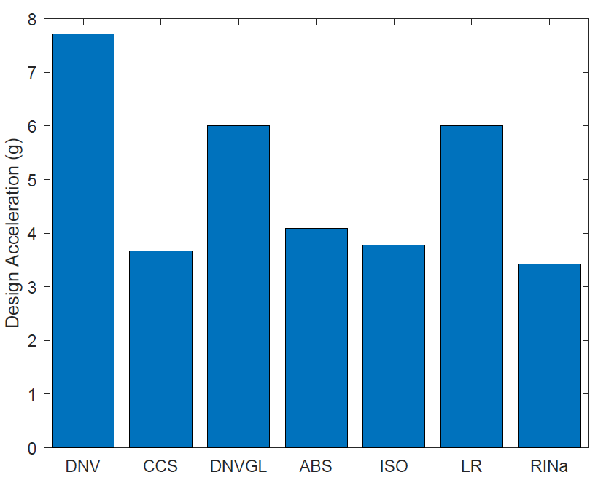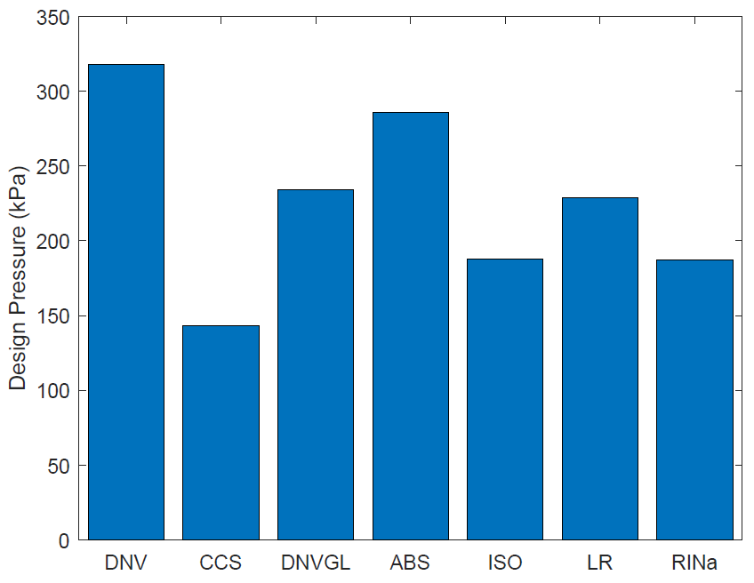
Figure 2: Design accelerations at 50 knots. Figure 3: Design pressures at 50 knots.

In this particular case study, both the DNVGL and LR calculations for the acceleration were capped at 6 g, in accordance with the inherent regulations. The same limit is not enforced by DNV, hence the much higher acceleration, that cascades down into higher pressures and ultimately a greater thickness requirement.
Of further interest is the longitudinal pressure distributions, presented in Figure 4. While all rules agree to a significant reduction of the pressure in the aft end of the vessel, it should be noted that this pressure reduction might vary, typically with the acceleration experienced by the craft. Indeed, at higher speeds and therefore accelerations, particularly on small crafts, there is a high probability of slamming towards the stern of the vessel. For instance, the ISO 12215-5 considers a constant longitudinal pressure distribution throughout the length of the vessels for accelerations of 6 g and above.
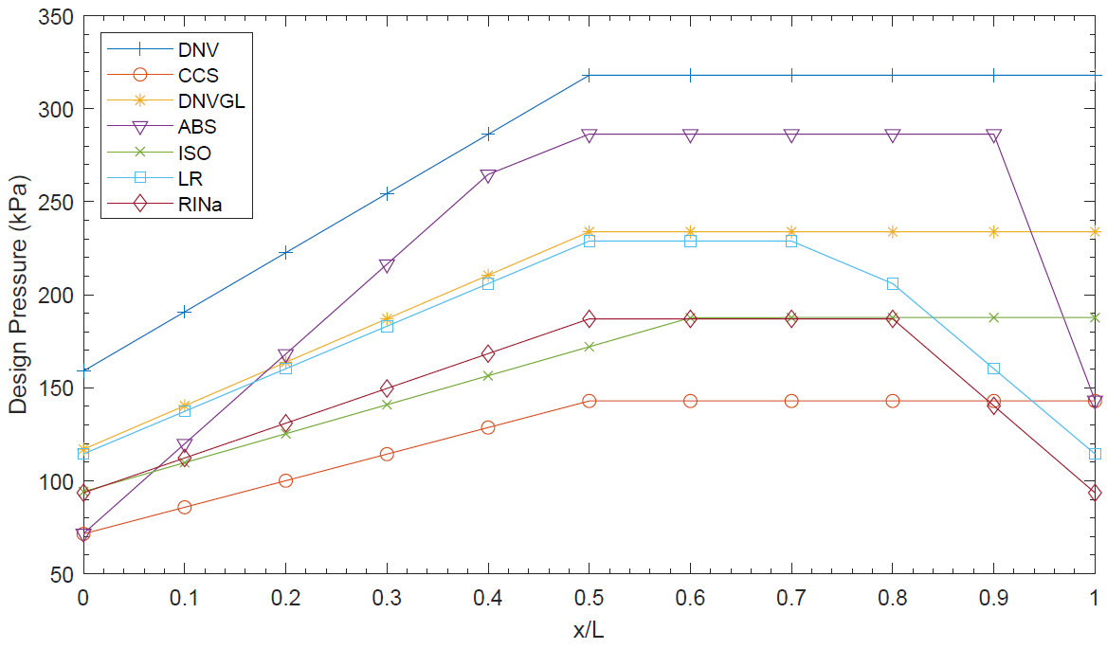
Figure 4: Longitudinal pressure distributions.
Interestingly, most regulatory differences occur at the bow. ABS adopts a pressure reduction forward of x/L = 0.9, thereby strictly applying the theory presented by Allen & Jones [9]. Conversely, most other regulation will extend the maximum pressure all the way to the forward perpendicular, there are exceptions amongst the regulatory bodies considered in this study, such as BV and RINA. Indeed, the reduction in pressure at the bow begins from x/L = 0.8. Lastly, LR has elected to initiate the forward pressure reduction from x/L = 0.75. At the aft perpendicular, regulatory bodies agree to a pressure reduction that can reach as low as half of the maximum pressure, with the exception of ABS that allows a decrease down to a quarter.
Despite the variations in accelerations and pressures, the deviation from the mean drops to 8.9% when looking at the final minimum required thickness, as presented in Figure 5.

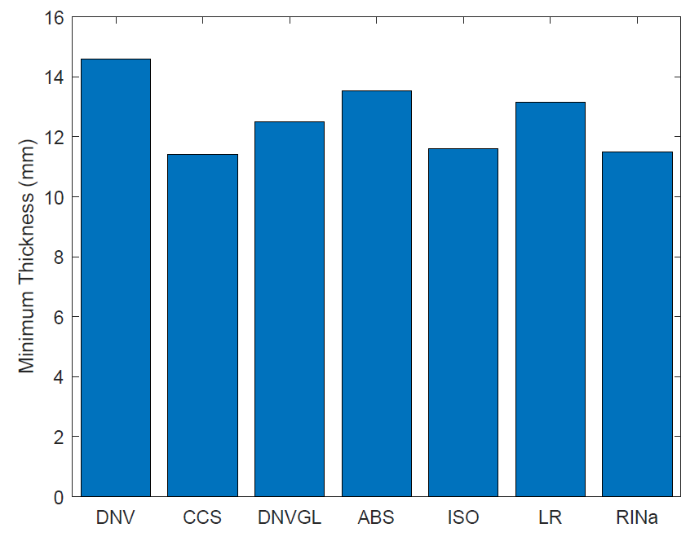
Figure 5: Minimum required thickness at 50 knots.
Considering the practical aspects such as standard sheet thicknesses and allowance for corrosion margin, the actual plating thicknesses would end up being very similar across the regulatory bodies. This is particularly reassuring in light of the strong differences noticed in the pressures, and would indicate that, despite varying approaches, consistent outputs for the scantlings can be expected.
Remarkably, while being based on the same classical planing craft theory, and ultimately achieving relatively similar scantlings, the intermediate calculation process reveals significant scatter. The large variations in accelerations and pressures, arising from the often unspecified assumptions, simplifications and factors of safety employed by regulatory bodies raise the question of the suitability of the design pressures.

Discussion

4.1 Regulatory Design
The proposed comparison for the test panel under study employed the assumption that, for some of the class rules where a significant wave height for maximum speed operation is a user input, a value of 1.5m shall be employed. Consequently, some of the pressures could vary. Nevertheless, this raises a very important aspect of the structural design of high-speed crafts, namely the duality of governing operational case. Indeed, two different modes of operations can affect the final scantlings. On the one hand, the vessel may be assumed to operate at full speed in the maximum wave height allowable for the vertical acceleration to remain sensible (typically up to 6 g for leisure crafts, higher for commercial vessels). On the other hand, the vessel may be operating in the maximum sea state consider for its category of operation, but as a much reduced speed.
Ultimately, the approach taken is to limit the maximum design acceleration. Historically, the crew experiencing similar levels of acceleration as the vessel would instinctively initiate a reduction in speed. However, the developments in shock mitigating seats now means the crew experiences reduced vertical accelerations, thereby pushing the vessel into a more extreme mode of operation. In recent years, this has justified extension to the acceleration limit of certain rules [2].
In today’s commercial market, where several class rules can classify a given vessel, not imposing over-structured scantlings can appear as an attractive selling point. This is particularly crucial when considering a heavier vessel would need more power and burn more fuel to achieve a target speed, thus increasing both build and operation costs.
Fortunately, despite the theoretical differences and largely varying intermediate calculations presented in Table 4, a relatively consistent scantling outputs were achieved. This could be expected, considering the degree of collaboration between class rules as part of the International Association of Classification Societies to ensure suitable requirements across regulatory bodies.

4.2 Design Evolution and Future Adaptations
While the original underpinning studies focussed on prismatic hull forms, a simplification still relevant in the case of numerical validation for instance [36], modern high-speed craft designs are much more refined. The vessels are likely to exhibit curvature, which prompted hydrodynamic experiments into the associated slamming loads [37], single curvature correction adopted by regulatory bodies, and the recent development of a new double curvature correction for small crafts under the latest ISO 12215-5 [38]. Moreover, specific design features, such as spray rails, are omnipresent and thus have been investigated experimentally [39], while the growing presence of hydrofoils on marine vehicles also calls for a more versatile approach to slamming loads [40].
Table 4: Comparison of the regulatory calculation process to ascertain the acceleration, design pressure and required thickness. | Design stress | $$σ_{d}=120 MPa$$ | $$σ_{d}=110 MPa$$ | $$σ_{d}=120 MPa$$ | $$σ_{d}=125 MPa$$ | $$σ_{d}=112.5 MPa$$ | $$σ_{d}=125 MPa$$ | $$σ_{d}=125 MPa$$
 | Required thickness | $$t_{min}=\frac{t_{0}+kL}{\sqrt{f}}\frac{s}{s_{R}}$$  $$t=\frac{22.4k_{r}k_{a}s\sqrt{P_{sl}}}{\sqrt{σ_{sl}}}$$ | $$t_{min}=\frac{K_{0}K_{1}\sqrt[3]{L}}{\sqrt{σ_{s}}}+1.5$$  $$t=KC_{1}C_{2}s\sqrt{\frac{P}{σ_{sw}}}$$ | $$t_{min}=\frac{t_{0}+kL}{\sqrt{f}}\frac{s}{s_{R}}$$  $$t=\frac{22.4k_{r}k_{a}s\sqrt{P_{sl}}}{\sqrt{σ_{sl}}}$$ | $$t=\frac{s\sqrt{pk}}{\sqrt{1000σ_{a}}}$$ | $$t=b×k_{C}\sqrt{\frac{P×k_{2b}}{1000×σ_{d}}}$$ | $$t_{p}=\frac{22.4s\sqrt{p}}{\sqrt{f_{}σ_{a}}}$$ | $$t=22.4 μ s \sqrt{\frac{P}{σ_{am}}}$$  No less than: $1.35 L^{1/3}≥2.5$
 | Bottom Planing Design Pressure | Greater of:  $$P_{sl}=1.3k_{l}{\left(\frac{Δ}{nA}\right)}^{0.3}T_{O}^{0.7}\frac{50-β_{x}}{50-β_{cg}}a_{cg}$$  $$P_{sl}=\frac{21}{\tan{(}β_{x})}k_{a}k_{b}C_{W}\left(1-\frac{20T_{L}}{L}\right){\left(\frac{0.3}{A}\right)}^{0.3}$$ | $$P_{sl1}=1.16k_{l1}{\left(\frac{Δ}{nA}\right)}^{0.3}\frac{50-β_{x}}{50-β}a_{cg}d_{w}$$ | Greater of  $$P_{sl}=\frac{a_{CG}Δ}{0.14A_{ref}}⋅K_{red}⋅K_{l}⋅K_{β}$$  $$P_{sl}=\frac{21}{\tan{(}β_{x})}k_{a}k_{b}C_{W}\left(1-\frac{20T_{FP}}{L}\right){\left(\frac{0.3}{A}\right)}^{0.3}$$ | $$P_{bxx}=\frac{N_{1}Δ}{L_{w}B_{w}}⋅{(1+n}_{cg})F_{D}F$$ | Greater of:  $$\left(\frac{{0.1m}_{LDC}}{L_{WL}×B_{C}}×(1+k_{DC}^{0.5}×k_{DYN})\right)×k_{AR}×k_{L}$$  $$max\left[\left(0.45×m_{LDC}^{0.33}+{0.9L}_{WL}×k_{DC}\right)×k_{L};10T_{C};7\right]$$ | $$P_{dlb}=\frac{f_{d}Δ}{L_{WL}G_{0}}⋅⋅{(1+a}_{v})$$ | $$P_{Slam}=70 \frac{Δ}{S_{ref}} K_{1} K_{2} K_{3} a_{CG}$$
 | Acceleration | $a_{cg}=\frac{V}{\sqrt{L}}\frac{3.2}{L^{0.76}}f_{g}g_{0 }$ min $1g_{0}$ for R0-R4; min $0.5g_{0}$ R5-R6  Instantaneous values of $a_{cg}$ (when $V/\sqrt{L}≥3$):  $$a_{cg}=\frac{k_{h}g_{0}}{1650}\left(\frac{H_{s}}{B_{WL2}}+0.084\right)(50-β_{cg}){\left(\frac{V}{\sqrt{L}}\right)}^{2}\frac{LB_{WL2}^{2}}{Δ}$$ | $$a_{cg}=\frac{K_{T}}{426}(\frac{V_{H}}{\sqrt{L}})^{1.4}(\frac{H_{1/3}}{B_{WL}}+0.07)(50-β)(\frac{L}{B_{WL}}-2)\frac{B_{WL}^{3}}{Δ}g$$ | $$a_{cgi}=\frac{k_{h}g_{0}}{1650}(\frac{H_{si}}{B_{WL2}}+0.084)(50-β_{cg})(\frac{V_{i}}{\sqrt{L}})^{2}\frac{LB_{WL2}^{2}}{Δ}$$  $a_{cg}≥1g_{0}$ for R0-R4; $a_{cg}≥0.5g_{0}$ for R5-R6  $a_{cg}≥c_{HSLC}⋅C_{RW}⋅\frac{V_{i}}{\sqrt{L}}$; not greater than 6$g_{0}$ | Lesser of:  $$n_{cg}=N_{2}\left(\frac{12 h_{1/3}}{B_{w}}+1\right) (50-β_{cg})×\frac{V^{2}×B_{w}^{2}}{Δ}$$  $$n_{cgmax}=1.39+\frac{k_{n}×V}{\sqrt{L}}$$ | Lesser of:  $$k_{DYN1}=0.32\left(\frac{l_{WL}}{10×B_{C}}+0.084\right)×(50-β_{0.4})×\frac{V^{2}×B_{C}^{2}}{m_{LDC}}$$  $$k_{DYN2}=\frac{0.5×V}{m_{LDC}^{0.17}} not>6 or ≤3$$ | $a_{v}=1.5×$_{B}L_{I}$(H_{I}+0.084)(5-0.1{}_{D}){\left(\frac{V}{\sqrt{L}}\right)}^{2}\frac{1}{1000}$ | $$a_{CG}=\frac{\left(50-α_{CG}\right)\left(\frac{τ}{16}+0.75\right)\left(\frac{H_{s}}{T}+0.084\frac{B}{T}\right)}{3555C_{B}}K_{FR}K_{HS}$$  No less than: $a_{CG}=fos.soc.\frac{V}{\sqrt{L}}$
 | Body | DNV | CCS | DNVGL | ABS | ISO | LR | RINa

Perhaps one of the most significant developments in high-speed crafts is the use of stepped hull. While the concept has been around since the early 20th century, single and now double stepped hulls have become increasingly popular to achieve higher top speeds at a lower power.
As the designs evolve, so do the materials. Anisotropic composites as well as sandwich panels will respond differently to slamming, introducing new failure mechanisms, often in relation to the core, that remain to be better understood [41]. Hence, new material and behaviour call for refined theory and structural analysis.
Slamming also extends beyond traditional planing monohulls into multihulls, with the wetdeck slamming of catamarans being of particular interest [42]. With the forthcoming ISO 12215-7 for multihull scantlings, the design pressures will be assessed as a function of those for monohulls, as described in the ISO 12215-5, and originating from the classical studies of the 1690s and 1970s. Therefore, additional questions could be raised regarding the relevance of such theories, when more recent research is available.
This particular study demonstrated some recent improvements, fox example the implementation on a maximum acceleration of 6 g in the DNVGL rules, which was absent in the DNV one, as a consequence of the merger.
While there is strong supporting evidence to propose a new paradigm when it comes to slamming loads on high-speed marine vehicles, this has not been implemented by any of the recent regulatory revisions. First of all, this may be out of caution, as older theories have long been trialled and tested, and therefore may benefit from a higher confidence level amongst the industry. Indeed, the implementation of a new theory for regulatory purposes would require significant validation investment, a longer time frame for the redaction of new rules, and a higher risk that regulatory bodies may not be willing to take.
Nevertheless, this should not be seen as an obstacle for both academic research and higher-performance design, both of which can highly benefit and contribute to the scientific advances in high-speed marine vehicles theories.

Conclusions
A test case was employed in order to compare and contrast a range of recently reviewed high-speed regulations. A number of discrepancies were highlighted, some rooted in the historical background of the regulatory bodies, although the eventual impact on required scantlings was relatively moderate, and would appear even smaller once additional practical considerations are accounted for. Indeed, despite the varying approaches and assumptions, coherent requirements across regulations were identified.
Of particular interest was the omnipresence of the seminal academic work of the 1960s and 1970s on planing hull underpinning modern regulations despite the array of recent innovations, proposed improvements on historical methods, and novel research findings. While arguments can be made for anchoring rules and regulations in these proven pieces of work, and the vast amount of time and validation that the implementation of newer theories would represent for class societies, too many changes in high-speed marine designs have been made since prismatic surfaces, and so much more depth of knowledge and understanding is now available for the designers to ignore.
Therefore, while published rules are unlikely to radically change, designers should endeavour to make full use of the literature and create the necessary paradigm shift in their own design practice.

References
[1] ISO, ISO 12215-5: 2019 Small Craft - Hull construction and scantlings. Part 5: Design pressures for monohulls, design stresses, scantlings determination, International Organisation for Standardization, 2019.
[2] J.-B. R. G. Souppez, Designing the next generation of small pleasure and commercial powerboats with the latest ISO 12215-5 for hull construction and scantlings, in The 1st SNAME / IBEX Symposium, Tampa, Florida, 2019.
[3] J. Dewavrin and J.-B. R. G. Souppez, Experimental investigation into modern hydrofoils-assisted monohulls: how hydrodynamically efficient are they?, The International Journal of Small Craft Technology, vol. 160, pp. 111-120, 2018.
[4] J.-B. R. G. Souppez, Structural design of high performance composite sailing yachts under the new BS EN ISO 12215-5, Journal of Sailing Technology, vol. 3, no. 1, pp. 1-18, 2018.
[5] J.-B. R. G. Souppez, Structural Analysis of composite search and rescue vessels under the new BS EN ISO 12215-5, in Surv 9 - Surveillance, Search and Rescue Craft, London, 2018.
[6] S. R. Heller and N. H. Jasper, On the structural design of planing craft, RINA Transactions, 1960.
[7] D. Savitsky, Hydrodynamic design of planing hulls, Marine Technology, 1964.
[8] D. Savitsky and P. W. Brown, Procedures for hydrodynamic evaluation of planing hulls in smooth and rough water, Marine Technology, vol. 13, 1976.
[9] R. G. Allen and J. R. Jones, A simplified method for determining structural design limit pressures on high performance marine vehicles, in AIAA/SNAME Advanced Marine Vehicle Conference, 1978.
[10] W. Froude, Experiments on surface-friction experienced by a plane moving through water, British Association for the Advancement of Science, 1972.
[11] A. Rosen, E. Begovic, M. Razola and K. Garme, High-speed craft dynamics in waves: challenges and opportunities related to the current safety philosophy, in 16th International Ship Stability Workshop, Belgrade, 2017.
[12] J. Camilleri, D. J. Taunton and P. Temarel, Full-scale measurements of slamming loads and response son high-speed planing craft in waves, Journal of Fluids and Structures, vol. 81, pp. 201-229, 2018.
[13] F. Prini, S. Benson, R. W. Birmingham, R. S. Dow, L. J. Ferguson, P. J. Sheppard, H. J. Phillips, M. C. Johnson, J. Mediavilla Varas and S. Hirdaris, Full-Scale seakeeping trials of an all-weather lifeboat, in Surv9 - Surveillance, Search and Rescue Craft, London, 2018.
[14] S. Kin, D. Novak, K. Weems and H.-C. Chen, Slamming impact design loads on large high speed naval craft, in SuperFAST, Saint-Petersburg, 2008.
[15] J. Bowles and J. Soja, Comparative analysis of common methods for predicting vertical acceleration of hard chine planing monohulls including correlation to hydrodynamic model test data, 4th Cheasapeake Powerboat Symposium, 2014.
[16] M. Razola, K. Garme and A. Rosén, On high-speed craft acceleration statistics, Ocean Engineering, vol. 114, pp. 115-133, 2016.
[17] E. Begovic, C. Bertorell, S. Pennino, V. Piscopo and A. Scamardella, Statistical analysis of planing hull motions and accelerations in irregular head seas, Ocean Engineering, vol. 112, pp. 253-264, 2016.
[18] M. Razola, A. Rosén and K. Garme, Allen and Jones Revisited, Ocean Engineering, vol. 89, 2014.
[19] Committee V.4, Structural design of high speed vessels, in The 15th International Ship and Offshore Structures Congress, San Diego, 2003.
[20] E. Begovic and C. Bertorello, Resistance assessment of warped hullform, Ocean Engineering, vol. 56, pp. 28-42, 2012.
[21] D. Gerr, The Elements of Boat Strength, Adlard Coles Nautical, 1999.
[22] DNV, Rules for classification of high speed, light craft and naval surface craft, Det Norske Veritas, 2015.
[23] CCS, Rules for construction and classification of sea-going high speed craft, China Classification Society, 2017.
[24] DNVGL, Rules for classification: high speed and light craft: Part 3, structures, equipment, Det Norske Veritas Germanischer Lloyds, 2018.
[25] ABS, High speed craft, American Bureau of Shipping, 2018.
[26] BV, Rules for the classification of crew boat, Bureau Veritas, 2018.
[27] Lloyds Register, Rules and regulations for the classification of special service craft, Lloyds Register, 2019.
[28] RINa, Rules for the classification of pleasure yachts, Registro Italiano Navale, 2020.
[29] IMO, International Code of Safety for High-Speed Craft, International Maritime Organisation, 1994.
[30] BV, Rules for the classification of high speed craft, Bureau Veritas, 2002.
[31] RINa, Rules for the classification of naval ships, Registro Italiano Navale, 2017.
[32] IMO, International Convention on Load Lines, International Maritime Organisation, London, 2003.
[33] European Parliament, Directive 2013/53/EU: recreational craft and personal watercrafts, Official Journal of the European Union, 2013.
[34] RINa, Rules for the classification of yachts designed for commercial use, Registro Italiano Navale, 2020.
[35] RINa, Rules for the classification of fast patrol vessels, Registro Italiano Navale, 2020.
[36] K. Hajime, A computing method for the flow analysis around a prismatic planing-hull, in The 5th International Conference on High-performance Marine Vehicles, Launceston, 2006.
[37] J. B. Weber, R. Das and M. Battley, Effect of curvature on slamming loads, 35th International Conference on Ocean, Offshore and Arctic Engineering, 2016.
[38] J.-B. R. G. Souppez and J. Ridley, The revisions of the BS EN ISO 12215, in Marine Sector Showcase - Composite UK, Southampton, 2017.
[39] J. Seo, H.-K. Choi, U.-C. Jeong, D. K. Lee, S. H. Rhee, C.-M. Jung and J. Yoo, Model tests on resistance and seakeeping performance of wave-piercing high-speed vessel with spray rails, International Journal of Naval Architecture and Ocean Engineering, vol. 8, pp. 442-455, 2016.
[40] J.-B. R. G. Souppez, J. Dewavrin, F. Gohier and G. Borba Labi, Hydrofoil configurations for sailing superyachts: hydrodynamics, stability and performance, in Design & Construction of Super & Mega Yachts, Genoa, 2019.
[41] M. Battley and T. Alled, Core failure in sandwich structures subjected to water slamming loads, Journal of Sandwich Structures and Materials, vol. 21, 2019.
[42] A. Swidan, G. Thomas, I. Penesis, D. Ranmuthugala, W. Amin, T. Allen and M. Batteley, Wetdeck slamming loads on a developed catamaran hullform – experimental investigation, Ships and Offshore Structures, vol. 12, 2016.

Corresponding author, Mechanical, Biomedical & Design Department, School of Engineering and Technology, College of Engineering and Physical Sciences, Aston University, MB153H, Aston Street, B4 7ET, Birmingham, UK; E-mail: j.souppez@aston.ac.uk

