Numerical Study on Ship Parametric Roll in Head Waves
Huawei ZHOU^{a,}, Fuhua WANGª, Renchuan ZHU^{b}，Kaiyuan SHI^{b}
ª Marine Design & Research Institute of China, Shanghai, China, 200011
^{b} Shanghai Jiao Tong University, Shanghai, China, 200240
Abstract. Ship parametric roll is one of the five stability failure modes and is introduced into the second-generation intact stability criteria by the International Maritime Organization (IMO) recently. In this paper, a 6 degree of freedom (DOF) three-dimensional time-domain model based on the impulse response function (IRF) method is constructed to predict large-amplitude ship motions and investigate the phenomenon of parametric roll in head waves as well as major factors. The Froude-Krylov (F-K) forces and the restoring forces are calculated on the instantaneous wet surface to take into account the nonlinearity, while the radiation and diffraction forces are kept linear and transformed from frequency-domain results calculated with the three-dimensional Havelock form translating-pulsating source Green function method. The proposed weakly nonlinear time-domain model is used to simulate motions of the C11 containership, which predicts the occurrence of the parametric roll successfully and shows a good agreement with the experimental data in amplitude. The inner mechanism of parametric roll is revealed by investigating the time-history and resonance frequencies of restoring forces and coefficients numerically.
Keywords. Parametric roll; impulse response function; time-domain model; numerical study

Introduction
Ship parametric roll is considered to be one of the five stability failure modes and is introduced into the second-generation intact stability criteria by the IMO recently due to its incidence rate and huge hazard, such as the accident of a C11 class post Panamax containership [1].
The main mechanism of parametric roll has been acknowledged by scientists in earlier times [2]. Essentially, it is a parametric resonance phenomenon due to the periodic change of the metacentric height and characterized by large-amplitude ship roll in head waves. Such as containership, Ro-Ro ship and fishing ship usually have a bow with large flare and a flat stern together, which may cause great changes of water plane in waves and lead to periodic stability changes. When the period meets the parametric resonance period, large-amplitude roll motion can be triggered.
Various numerical methods in potential theory framework have been applied to simulate the parametric roll in time-domain, which can be divided into direct time-domain method and the IRF method in accordance with procedures to obtain radiation and diffraction forces. Both concentrate on simulating nonlinear restoring forces and incident wave forces while keep the diffraction and radiation forces linear to obtain the balance between accuracy and time. Silva and Soares [3] constructed a time-domain strip theory model and a 6-DOF procedure with a semi-empirical formula for surge motion to predict the parametric roll of a ship. Chu, Wu and Lu et al. [4] constructed a time-domain hybrid model with free surface Green function in inner domain and Rankine source in outer domain to simulate the parametric roll considering the couplings among heave, roll and pitch modes. Liu and Papanikolaou [5] constructed a 3D time-domain model based on the IRF concept and zero-speed free surface Green function to predict the parametric roll in waves. Kim and Kim [6] compared different numerical methods and concluded that the results from the direct time-domain method and the IRF method agree well.
In the IRF method, lots of theories were employed to solve the frequency-domain problem and obtain hydrodynamic coefficients at full frequency range, such as strip theory [7], zero-speed Green function method combined with speed correction [8], non-zero speed Green function method [9], Rankine source [10], and so on. The non-zero speed Havelock form translating-pulsating source Green function method has been proven to have an acceptable balance between accuracy and computing efficient [9].
In this paper, a 6-DOF time-domain model based on the IRF concept and the non-zero speed Havelock form translating-pulsating source Green function method is constructed to predict the parametric roll. The F-K forces and the restoring forces are calculated on the instantaneous wet surface while the radiation and diffraction forces are kept linear by transforming from frequency-domain results. The model is applied to simulate the parametric roll resonance of C11 containership in head waves and compared with experiment. Based on the good agreement between the simulation and experiment, the inner mechanism and major factors of the ship parametric roll are investigated numerically.

Theory of IRF method for ship motions in time-domain
The right-hand coordinate system $OXYZ$ is fixed on the plane of undisturbed water surface and advancing forward with the ship speed $U_{0}$. The origin is located at the middle and center of the ship, with x-axis pointing to the bow, y-axis pointing to the port, and z-axis pointing upward.
Within the framework of linear hydrodynamics and introducing the concept of IRF for ship motions, radiation potentials in the time-domain can be represented as a series of impulses and the following relations can be established [11],
$A_{kj}=μ_{kj}-\frac{c_{kj}}{ω^{2}}-\frac{1}{ω}\int_{0}^{∞}{K_{kj}(t)sin⁡(ωt)}dt$ (1)
$B_{kj}=b_{kj}+\int_{0}^{∞}{K_{kj}(t)cos⁡(ωt)}dt$ (2)
where $ω$is the encounter frequency of the ship in waves. $A_{kj}$ and $B_{kj}$ are added-mass and damping coefficients in the frequency domain, respectively. $K_{kj}$ is the retardation function. $μ_{kj}$, $b_{kj}$ and $c_{kj}$ are added mass, damping coefficients at infinite frequency and the radiation restoring force coefficients, respectively. $b_{kj}$ and $c_{kj}$ can be considered as a correction for the radiation forces due to the non-zero speed, which are related with the geometry as well as the ship speed.
By the Inverse Fourier transformation of Eqs. (1) and (2), the retardation function $K_{kj}$ can be expressed as
$K_{kj}(t)=\frac{2}{π}\int_{0}^{∞}{(B_{kj}(ω)-b_{kj}})\cos{ω}tdω$ (3)
$K_{kj}(t)=\frac{2}{π}\int_{0}^{∞}{ω(μ_{kj}-A_{kj}(ω)-\frac{c_{kj}}{ω^{2}}})\sin{ω}tdω$ (4)
According to Newton’s second law, the 6-DOF motion equations of ship in waves can be expressed as
$$\sum_{j=1}^{6}{\left\{(M_{kj}+μ_{kj}){\overset{••}{ξ}}_{j}(t)+\int_{0}^{t}{K_{kj}(t-τ){\overset{•}{ξ}}_{j}(τ)}dτ+b_{kj}{\overset{•}{ξ}}_{j}(t)+c_{kj}ξ_{j}(t)\right\}}$$$+F_{k}\left(t\right)=F_{k0}\left(t\right)+\int_{-∞}^{∞}{K_{k7}\left(t-τ\right)ζ\left(τ\right)}dτ, k=1, 2, ⋯, 6$ (5)
where $M$ is the ship mass matrix. $ξ_{j}$ is the oscillatory motion of the j-th mode and the over-dot represents the time derivative.
$F_{k}$ represent the nonlinear restoring forces, evaluated on the instantaneous wetted surface $S$ and defined as
$F_{k}=-\iint_{S}{ρgz⋅n_{k}}dS, k=1, 2, ⋯, 6$ (6)
where $ρ$ and $g$ are water density and gravitational acceleration, respectively. $z$ is the wave height on the instantaneous wetted surface.
$F_{k0}$ is the nonlinear F-K force, calculated on the instantaneous wet surface as
$F_{k0}(t)=ρg\iint_{S}{(Ae^{kz}\cos{(}kx-ω_{e}t)-\frac{1}{2}kA^{2}e^{2kz})}⋅n_{k}dS$ (7)
where $ρ$ is water density. $g$ is gravitational acceleration. $k$ and $A$ are the incident wave number and amplitude, respectively. $n_{k}$ represents the generalized normal vector for the
ship hull surface.
The 6-DOF motion equations (5) can be solved by fourth-order Runge-Kutta method numerically.

Validation
To validate the capability of the proposed weakly nonlinear time-domain model on the prediction of the occurrence of the parametric roll, it is applied to predict motions of the well-known post Panamax C11 containership in regular head waves, which has been investigated by a free running experiment with a 1/65.5 scaled model conducted at the seakeeping basin (length: 69m, breadth: 46m, height: 4m) of China Ship Science Research Center [12].
The main particulars and panels of the C11 containership are shown in Table 1 and Figure 1 respectively.

Table 1. Main particulars of the C11 containership
Main particulars |  | Unit | Full-scale | Model-scale
Waterline length | $$L_{wl}$$ | m | 262 | 4
Waterline breadth | $$B_{wl}$$ | m | 40 | 0.611
Draught at amidships | $$T$$ | m | 11.5 | 0.176
Displacement | $$W$$ | ton | 67508 | 0.2402
 | $$X_{cg}$$ | m | -5.482 | -0.084
Center of gravity | $$Y_{cg}$$ | m | 0 | 0
 | $$Z_{cg}$$ | m | 6.936 | 0.1059
Transverse metacentric height in the calm water | $$GM$$ | m | 1.928 | 0.029
Longitudinal radius of inertia | $$K_{yy}$$ | $$L_{pp}$$ | 0.24 | 0.24
Natural roll period | $$T_{roll}$$ | s | 24.68 | 3.05

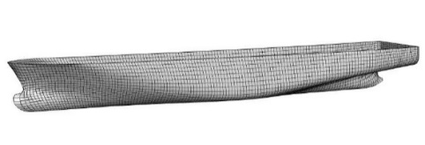
Figure 1. Full surface panels of C11 containership
The present weakly nonlinear time-domain model is validated by two cases, as listed in Table 2, where $Fn$ is the Froude number,$λ, H$ and $β$ denote the wave length, height and incident direction, respectively. The wave and ship speed conditions in the two cases are set identical with that in the experiment of Bu [12].
Table 2. Cases of the C11 containership to validate the model on the parametric roll prediction
Case | $${Fn}_{}$$ | $$λ/L_{wl}$$ | $$H/λ$$ | $$β$$
1 | 0.1 | 1.0 | 0.01 | 180°
2 | 0.05 | 1.0 | 0.03 | 180°
In case 1, the time-history of heave and pitch motions from simulation and experiment are compared in Figure 2. It shows that heave and pitch motions from the proposed model agree well with experimental results in both peak and period. In this case, there is no occurrence of parametric roll in both simulation and experiment.
In case 2, the time-history of roll motion from simulation and experiment are compared in Figure 3. There is a gradual amplification process of roll motion until the parametric roll is triggered in both simulation and experiment. Parametric roll amplitude from simulation is up to 35.4°, which agrees well with experimental result 34.7°.
The above two examples show that the present numerical model can predict the parametric roll of C11 containership successfully.
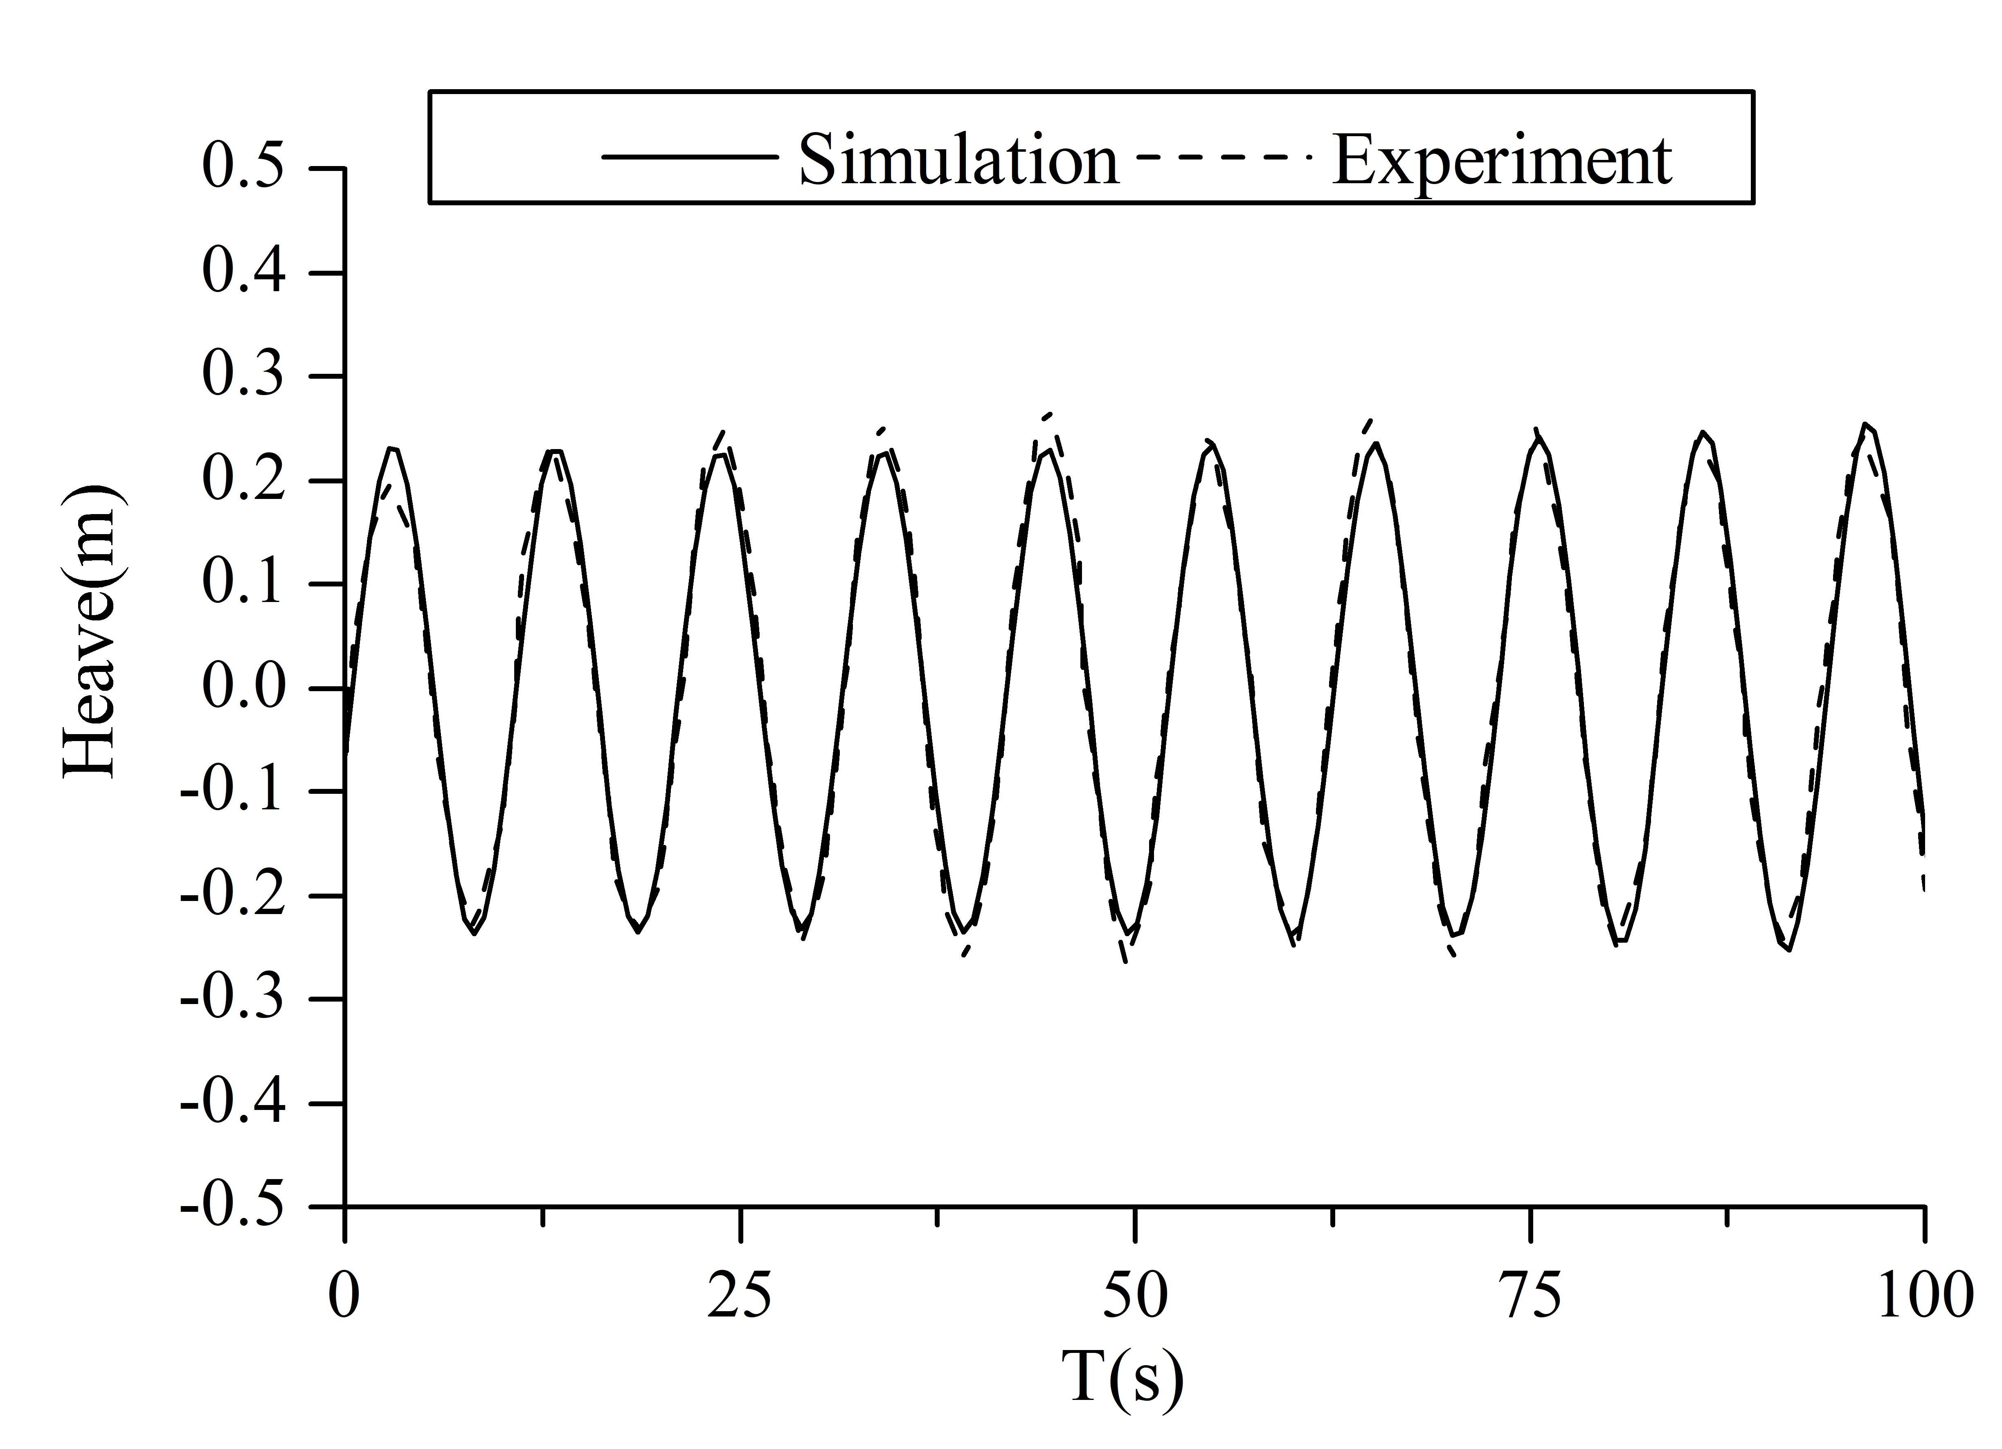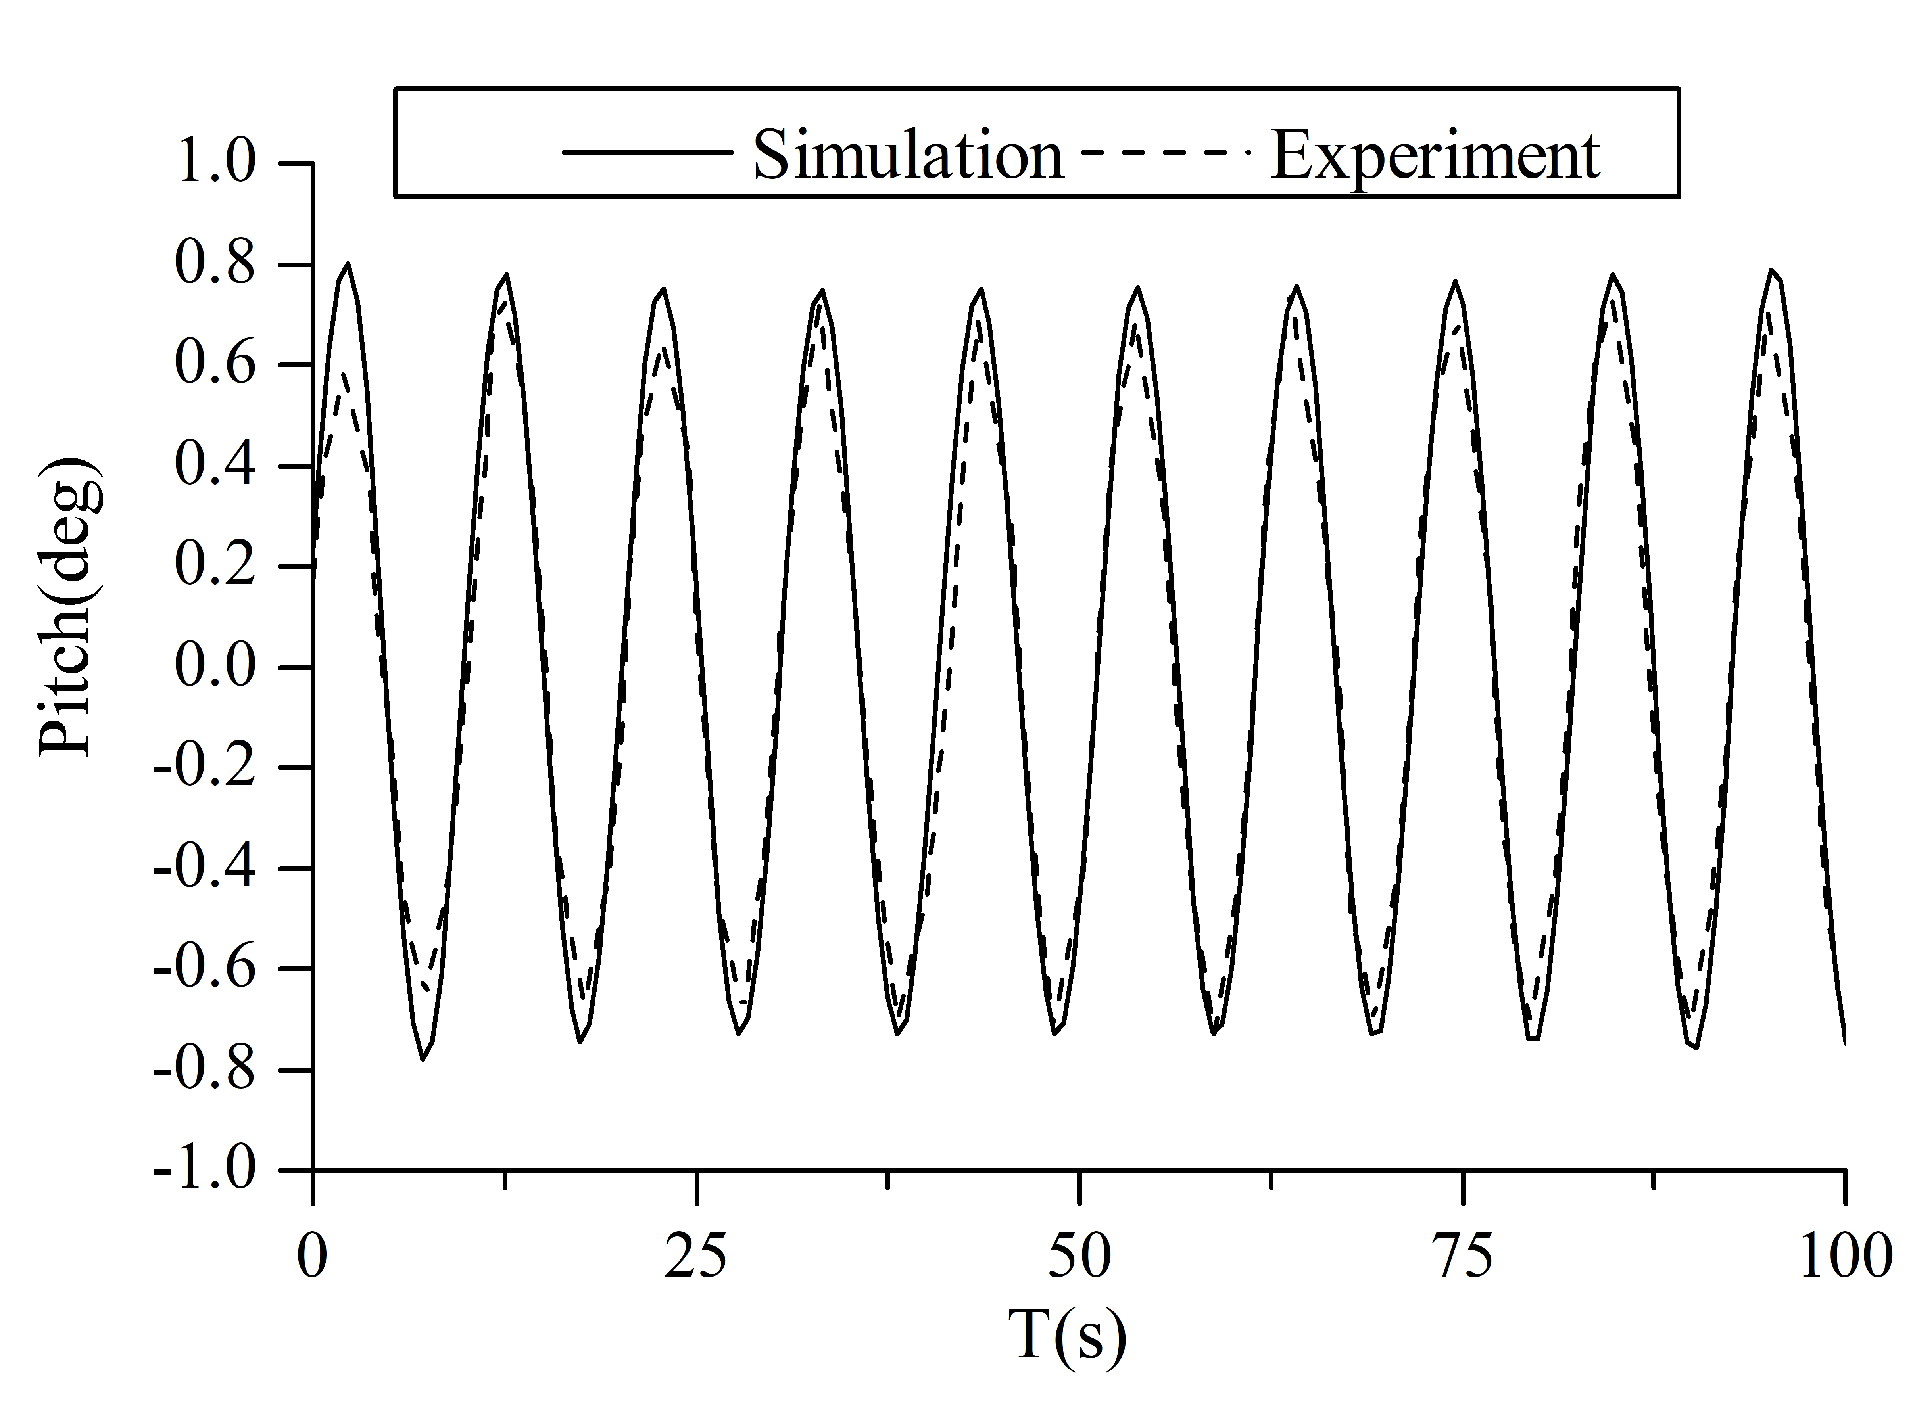
Figure 2. The time-history of heave and pitch comparison between simulation and experiment on case 1, $Fn=0.1, λ/L_{wl}=1.0, H/λ=0.01, β={180}^{°}$
Figure 3. The time-history of roll comparison between simulation and experiment on case 2,
$Fn=0.05, λ/L_{wl}=1.0, H/λ=0.03, β={180}^{°}$

Inner mechanism of the parametric roll
To further investigate the inner mechanism of the parametric roll, the time-history roll restoring force $F_{4}$ and coefficients $C_{44}$ is monitored in the model-scale numerical simulation on case 2, which is illustrated in Figure 4. Spectrum analysis result of $F_{4}$ and $C_{44}$ is illustrated in Figure 5. It shows that model-scale $C_{44}$ oscillates periodically within a range from 50 to 190 N·m/rad, which is far larger than the static restoring force 74.8 N·m/rad and with the principal frequency of 4.41rad/s, double frequency of 8.82rad/s and triple frequency of 13.23rad/s, in which the principal frequency is the wave encounter frequency $ω_{e}$and about twice as much the ship natural frequency $ω_{n}$. Additionally, $F_{4}$ oscillates periodically with the principal frequency of 2.06rad/s, the secondary frequencies of 6.6rad/s and 11.2rad/s, in which the principal frequency is the ship natural frequency $ω_{n}$, and the secondary frequencies are the sum of ${ω_{n}+ω}_{e}$ or ${ω_{n}+2ω}_{e}$. It is numerically proven that when $ω_{e}/ω_{n}≈2,$ periodic changes of incident wave phase cause the periodic oscillation of $C_{44}$ and $F_{4 }$ with amplitudes far larger than static results, which is the major reason to trigger the ship parametric roll.
Figure 4. The model-scale time-history of roll restoring force $F_{4}$ and coefficients $C_{44}$ on case 2,
$Fn=0.05, λ/L_{wl}=1.0, H/λ=0.03, β={180}^{°}$
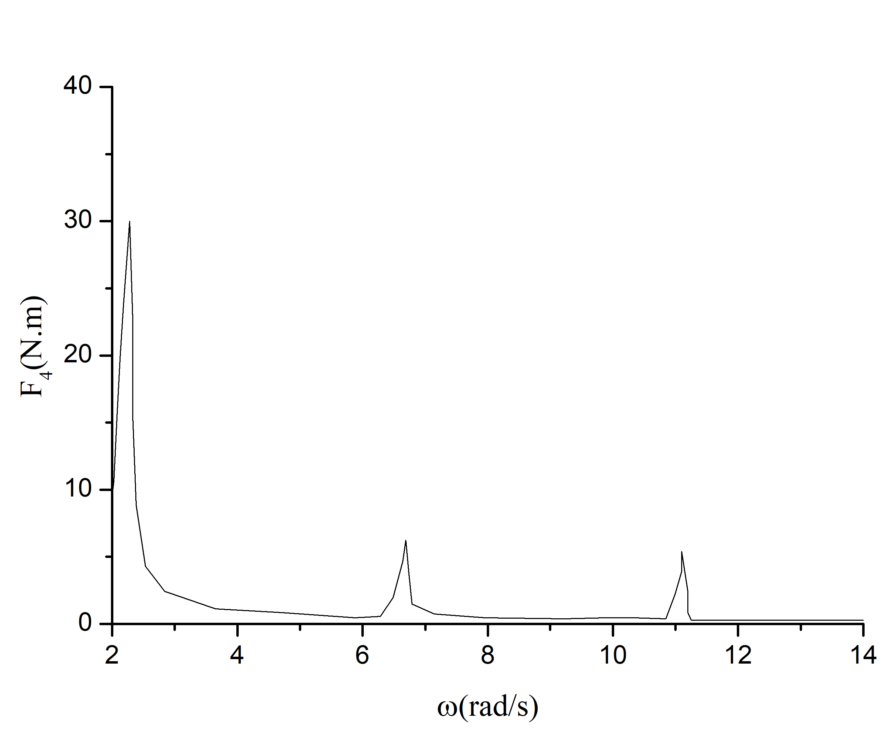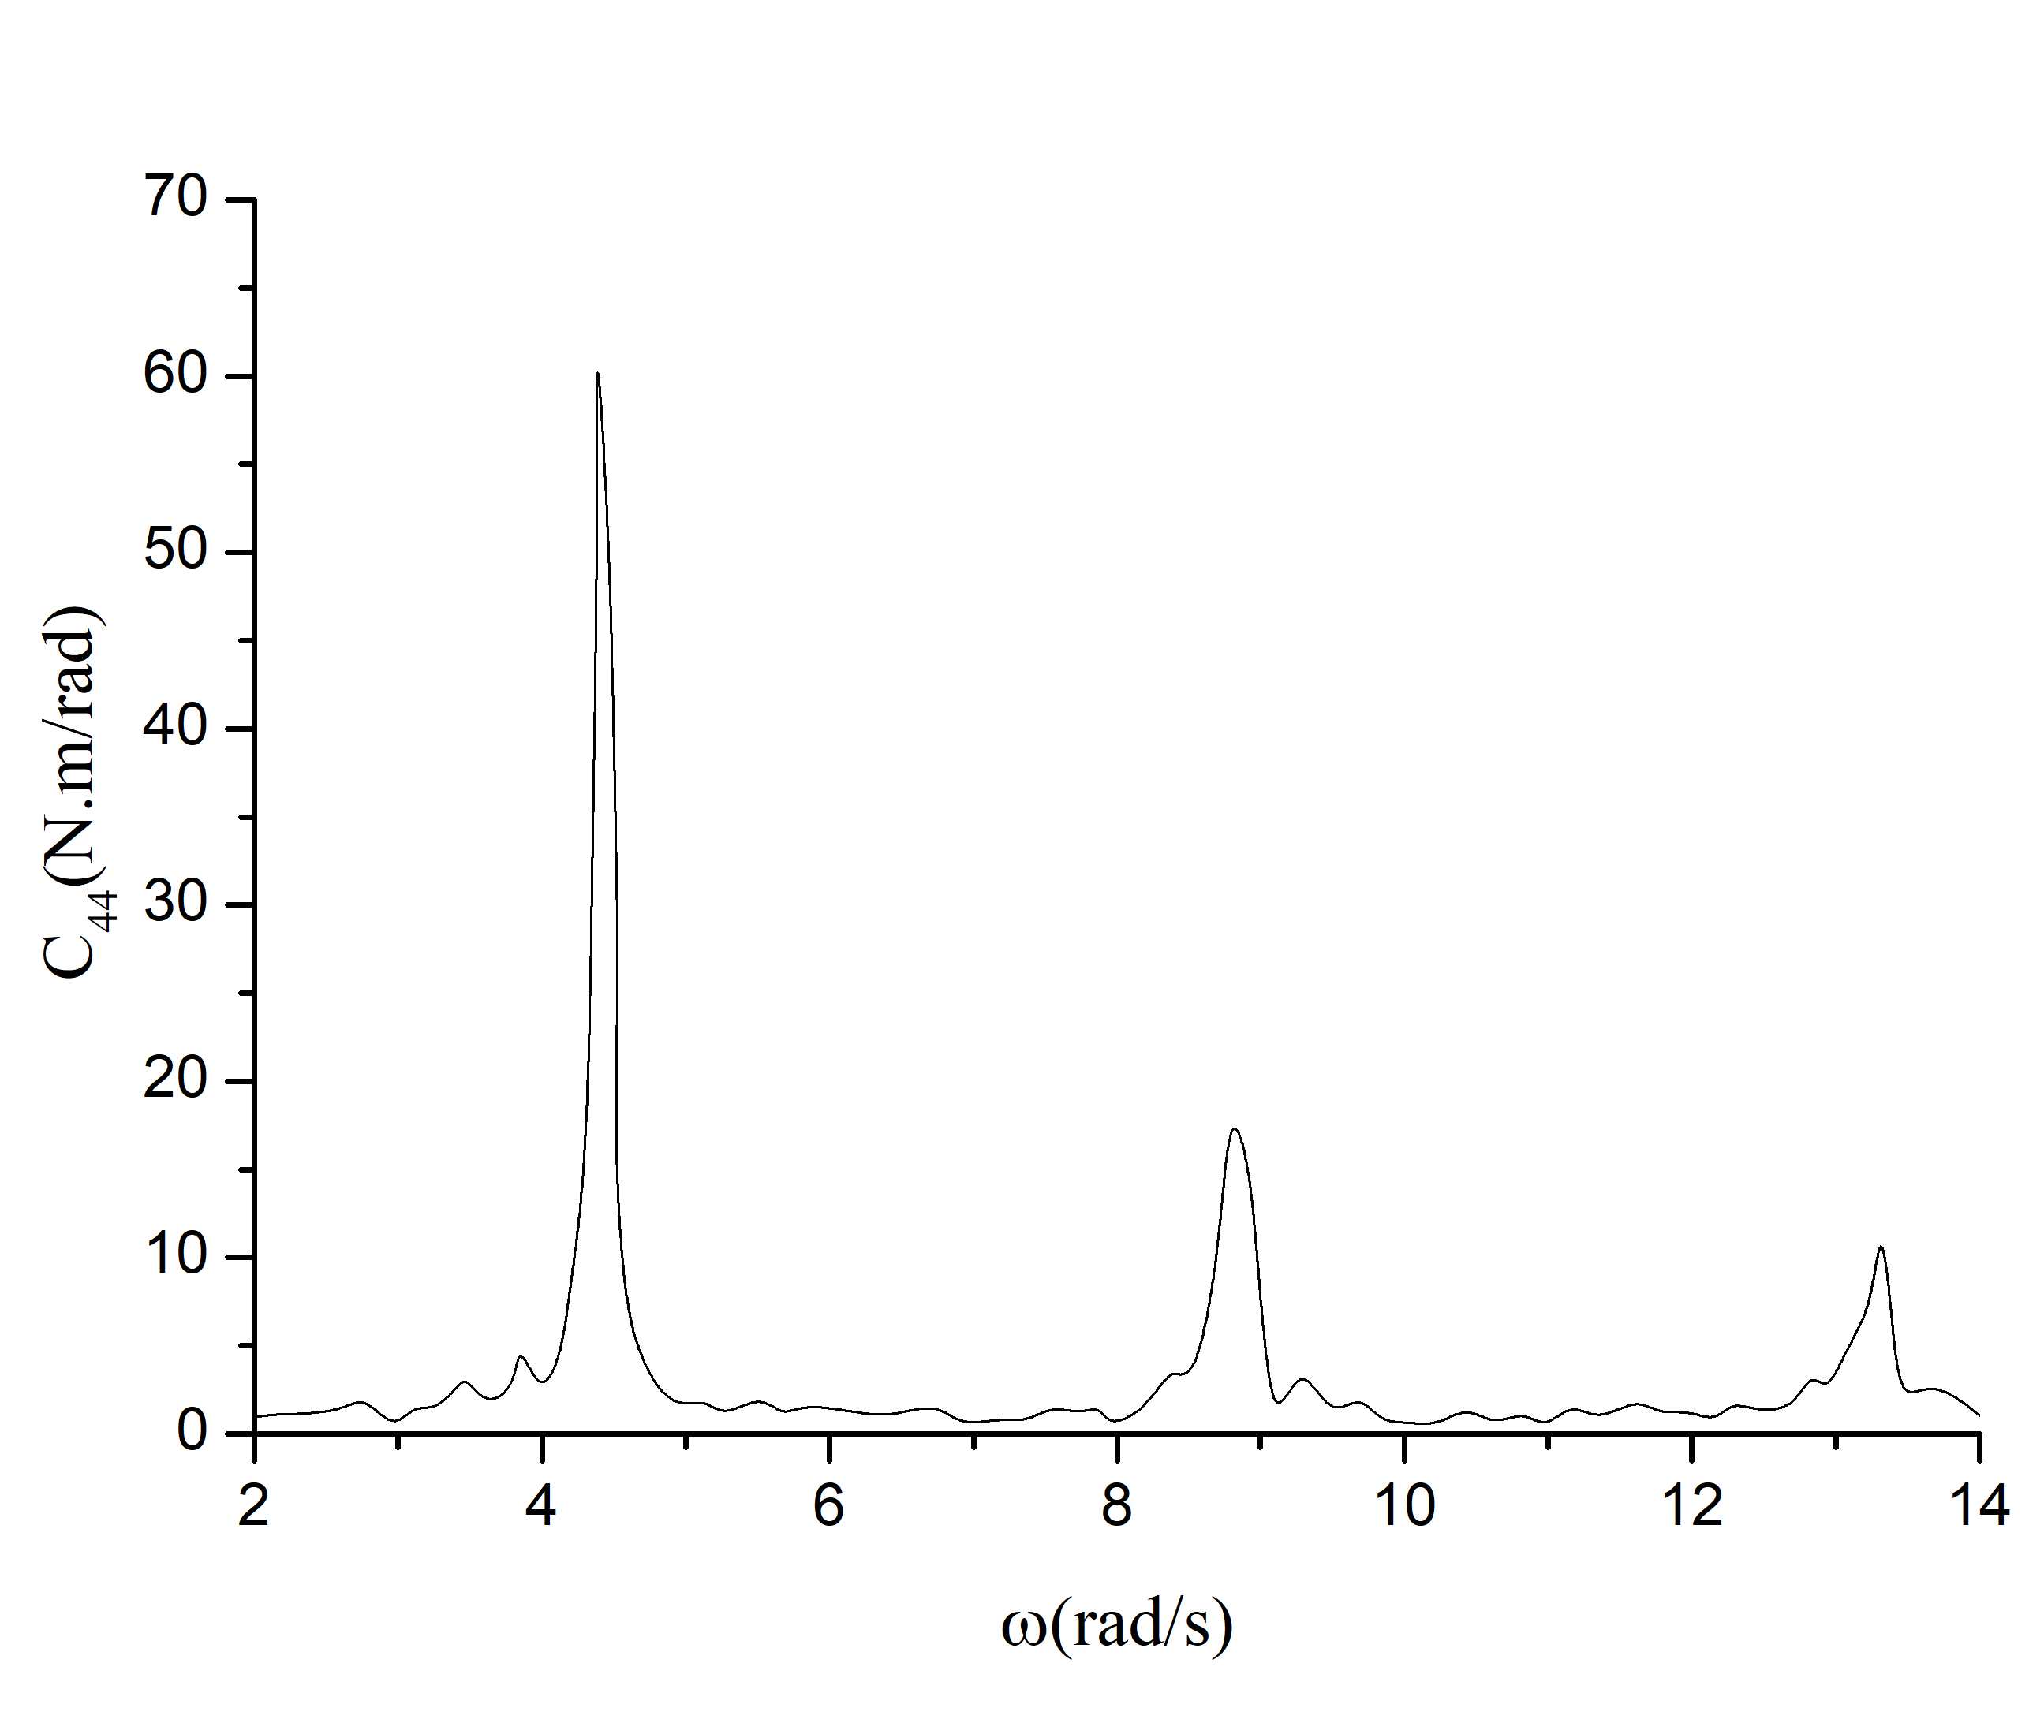
Figure 5. The frequency-domain roll restoring force $F_{4}$ and coefficients $C_{44}$ on case 2,
$Fn=0.05, λ/L_{wl}=1.0, H/λ=0.03, β={180}^{°}$
To investigate the influence of speed and wave height on the occurrence and amplitude of the parametric roll, 6 cases are studied, as listed in Table 3.
Table 3. Cases to investigate influence of ship speed and wave height on the parametric roll
Case | $${Fn}_{}$$ | $$λ/L_{wl}$$ | $$H/λ$$ | $$β$$ | $$ω_{e}/ω_{n}$$
1 | 0.10 | 1.0 | 0.01 | 180° | 2.384
2 | 0.05 | 1.0 | 0.03 | 180° | 2.145
3 | 0.10 | 1.0 | 0.03 | 180° | 2.384
4 | 0.15 | 1.0 | 0.03 | 180° | 2.621
5 | 0.05 | 1.0 | 0.01 | 180° | 2.145
6 | 0.05 | 1.0 | 0.02 | 180° | 2.145

The results of cases 2, 3 and 4 with the same wave height and those of cases 2, 5 and 6 with the same speed are put together to investigate the influence of ship speed $U_{0}$ and wave height on the parametric roll amplitude (Figure 6, Figure 7). 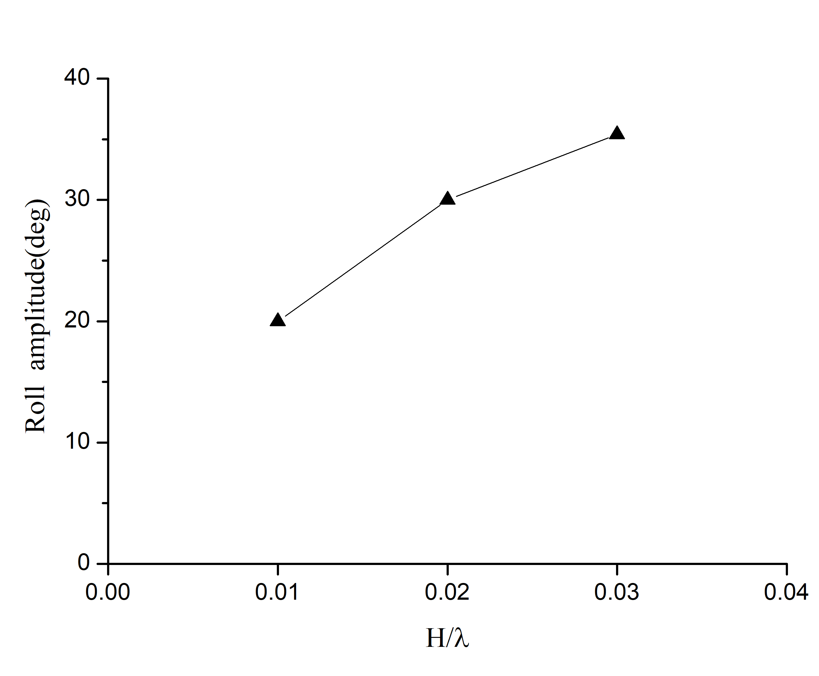
Figure 6. Roll amplitudes on cases 2, 3 and 4 Figure 7. Roll amplitudes on cases 2, 5 and 6,
$Fn=0.05, 0.1, 0.15, H/λ=0.01, 0.02, 0.03,$
$λ/L_{wl}=1.0, H/λ=0.03, β={180}^{°}$ $Fn=0.05, λ/L_{wl}=1.0, β={180}^{°}$
Parametric rolls are triggered in all the cases. In Figure 6, the parametric roll amplitude is largest when $Fn=0.05$ and smallest when $Fn=0.15$. It seems that the closer the value of $ω_{e}/ω_{n}$is to 2, the bigger the parametric roll amplitude. As an effective way the ship speed can be modified to control the wave encounter frequency to avoid the parametric roll in navigation.
In Figure.7, the parametric roll amplitude is the largest when $H/λ=0.03$ and smallest when $H/λ=0.01$. It is suggested that the parametric roll amplitude has a positive relation with the wave height. As cases 1 and 3 are compared, although both with the same wave encounter frequency, the parametric roll is triggered in case 3 with amplitude up to 30.2°, but not in case 1. It means that $ω_{e}/ω_{n}≈2$ is not the only factor to determine the occurrence of parametric roll, and in some cases the wave height is also crucial.

Conclusion
This paper constructs a 6-DOF weakly nonlinear time-domain model based on the IRF concept and the non-zero speed Havelock form translating-pulsating source Green function method to predict large-amplitude ship motions in regular head waves. The F-K forces and the restoring forces are calculated on the instantaneous wet surface in time-domain directly while the radiation and diffraction forces are transformed from frequency-domain to time-domain by the retardation function.
The weakly nonlinear time-domain model is validated by the experimental results of C11 containership without and with parametric roll. It is demonstrated that the proposed model succeeds in prediction of parametric roll and agree well with experimental data in roll amplitude.
Based on this, the inner mechanism of parametric roll is investigated by analysis of the time-history and resonance frequency of restoring forces and coefficients. It is found that resonance frequencies of restoring force coefficients are once, double and triple times of the wave encounter frequency. Principle resonance frequency of restoring forces is the ship natural frequency. It is revealed that when $ω_{e}/ω_{n}≈2,$ periodic changes of incident wave phase cause the periodic oscillation of $C_{44}$ and $F_{4 }$ with amplitudes far larger than static results, which is the major reason to trigger the ship parametric roll.
The influence of ship speed and wave height on parametric roll occurrence and amplitude is further investigated. It is found that the ship speed can be modified to avoid the parametric roll in navigation. The wave height is a plus condition to parametric roll occurrence when $ω_{e}/ω_{n}≈2$ and has a positive relation with the parametric roll amplitude.

References
- France, W.N., Levadou, M., Treakle, T.W.et al. An Investigation of Head-Sea Parametric Roll and Its Influence on Container Lashing System， Marine Technology, 2003: 40(1), 1-19.
- Watanabe, Y. On the Dynamical Properties of the Transverse Instability of a Ship due to Pitching. Journal of the Society of Naval Architects, 1934: Vol. 53, 51- 70 (in Japanese).
- Silva, S. R. E., & Soares, C. G. Prediction of parametric rolling in waves with a time-domain non-linear strip theory model. Ocean Engineering, 2013: 72(4), 453-469.
- Chu, J. L., Cheng-Sheng, W. U., Jiang, L. U., & Min, G. U. Study on a 3D Time-domain Method to Predict Parametric Rolling of a Ship in Regular Head Seas，Journal of Ship Mechanics, 2016: 20(12).
- Liu, S., & Papanikolaou, A. Prediction of parametric rolling of ships in single frequency regular and triple frequency group waves. Ocean Engineering, 2016: 120, 274-280.
- Kim, T., & Kim, Y. Multi-level approach for parametric roll analysis. International Journal of Naval Architecture & Ocean Engineering, 2011: 3(1), 53-64.
- Salvesen, N., Tuck, E.O., Faltinsen, O. M. Ship motions and sea loads. Trans. SNAME, 1970: 78: 250-287.
- Newman J.N. Algorithms for the Free-surface Green Function. Journal of Engineering Mathematics, 1985: Vol. 19, 57-67.
- Hong, L., Zhu, R. C., Miao, G. P., & Fan, J. Study on Havelock form translating-pulsating source Green's function distributing on horizontal line segments and its applications. Ocean Engineering, 2016: 124, 306-323.
- Bruzzone, D., Gironi, C., & Grasso, A. Nonlinear effects on motions and loads using an iterative time-frequency solver， International Journal of Naval Architecture & Ocean Engineering, 2011: 3(1), 20-26.
- Cummins, W. E. The Impulse Response Function and Ship Motions. Schiffstechnik, 1962: 9, 101-109.
- Bu, S.X. A Study on Stability Criteria of Parametric Rolling. Master Thesis, China Ship Science Research Center, 2014.

Huawei ZHOU, Corresponding author, Marine Design & Research Institute of China, No. 168, Zhongshan Nanyi Road, Shanghai, China, 200011; E-mail: hongdoux@163.com.

