Second Generation Intact Stability Criteria fallout on naval ships limiting KG curves
Gennaro ROSANO^{a,}, Ermina BEGOVIĆ ª, Guido BOCCADAMO ª, Barbara RINAURO ª
ª University of Naples Federico II, Department of Industrial Engineering,
Via Claudio 21, 80125, Naples, Italy

Abstract. The International Maritime Organization (IMO) finalized the Second Generation Intact Stability Criteria (SGISC), in February 2020. They are intended to be included in Part A of the 2008 International Code on Intact Stability in the following years. The SGISC consider five modes of dynamic stability failure in waves: parametric roll, pure loss of stability, surf-riding/broaching to, dead ship condition and excessive acceleration. In this paper, two semi-displacement, round bilge and transom stern hull forms, the parent hull of the Systematic Series D and the ONR Tumblehome, i.e. typical naval hull forms, are examined. Although naval ships are not directly impacted by SGISC, they are sensitive to dynamic stability failure phenomena due to their geometry and range of service speeds. The procedures to assess the ship vulnerability to the dead ship condition and excessive acceleration criteria, referring to the latest drafts of the criteria (SDC 7/5, 2019), were implemented in Matlab®,. The limiting KG curves associated with this set of criteria were obtained for each vessel. The minimum allowable KG curve associated with the excessive acceleration criterion was compared with the maximum allowable KG curve associated with dead ship condition, to investigate the existence of a safe operational area.
Keywords. Second Generation Intact Stability Criteria, Dead Ship Condition, Excessive Acceleration, Systematic Series D, ONRT

Nomenclature
Symbol | Unit | Definition
Δ | t | Displacement
A_{L} | m² | Lateral exposed area
B | m | Ship breadth
b_{BK} | m | Bilge keel span
C | - | Long-term stability failure index
C_{B} | - | Block coefficient
C_{m} | - | Midship section coefficient
C_{s,i} | - | Short-term stability failure index
d | m | Draught
g | m/s² | Gravity acceleration
GM | m | Transversal metacentric height
KG | m | Height of the center of gravity above the keel line
l_{BK} | m | Bilge keel length
L | m | Ship length
N | - | Total number of sea states
R_{DS0} | - | Dead ship condition limit value
R_{EA} | - | Excessive acceleration limit value
W_{i} | - | Weighting factor

Abbreviations
DSC | Dead Ship Condition
DSA | Direct Stability Assessment
EA | Excessive Acceleration
IMO | International Maritime Organization
OG | Operational Guidance
OL | Operational Limitations
OM | Operational Measures
SDC | Sub-Committee on Ship Design and Construction
SGISC | Second Generation Intact Stability Criteria

Introduction
The Second Generation Intact Stability Criteria (SGISC) assess five modes of intact stability failure in waves: pure loss of stability, parametric roll, surf riding/broaching to, dead ship condition and excessive acceleration. They were developed by the IMO Correspondence Group on Intact Stability after the revision of the Intact Stability Code, which entered into force in 2008 and finalized at the 7-th session of the IMO Sub-Committee on Ship Design and Construction (SDC) in February 2020; they are intended to be included in Part A of the 2008 IS Code in the following years.
While the first generation of intact stability criteria is mainly based on a statistic approach, the second generation criteria are based on the physics of the phenomena which could lead to the stability failure. They are organized according to three different levels of assessment to avoid unnecessary, complex and time-consuming calculations to verify if a ship is vulnerable to a certain phenomenon in a given loading condition. Level 1 and Level 2 are known as Vulnerability Criteria, while Level 3 is called Direct Stability Assessment (DSA). There are refinements of the physical model and a reduction in severity from first to third level. Indeed, some assumptions are made in order to simplify the procedure of assessment in the Vulnerability Criteria. Level 1 assessment is straightforward as its aim is to distinguish between non-vulnerable and vulnerable ships, which are defined as “unconventional ships”; Level 2 assessment requires additional information about the ship and it can be performed once a numerical code has been written; the DSA requires numerical or experimental simulations of the ship behavior in waves, requiring sophisticate tools and expert designers. The hierarchy between levels was abolished since the 7-th session of Working Group on Intact Stability of the SDC Sub-Committee, hence the assessment could start at any level.
Operational Measures (OM) could be developed if one or more loading conditions fail Level 2 or DSA. They can be distinguished in Operational Limitations (OL), which define limits on ship’s operation in a given loading condition, and Operational Guidance (OG), which are recommendations about combinations of ship speed and wave directions to be avoided in relevant sea states [1].
The assessment is performed in probabilistic terms through the evaluation of long-term probabilities of failure, since the environment is intrinsically non-deterministic.
In the present work, the vulnerability to dead ship condition (DSC) and excessive acceleration (EA) criteria were applied on two naval hull forms: the parent hull model D1 of the Systematic Series D [2] and the notional US Office of Naval Research Tumblehome (ONRT) surface combatant. Both vessels are semi-displacement, round bilge and transom stern hull forms. This kind of ships appears sensitive to the stability failure modes assessed by this new generation of intact stability criteria, due to their geometries and range of speeds, although the SGISC do not apply to naval vessels. Five displacements were considered for each ship, with the aim to derive the limiting KG curves associated with Level 2 of DSC and EA criteria, where KG is the height of the center of gravity above the baseline. It is worth noting that all stability criteria define a maximum KG value; the only exception is the excessive acceleration criterion which defines a minimum KG value below which the safety of crew and passengers against lateral accelerations is not guaranteed. Hence, the simultaneous application of the stability criteria should define a sufficiently large range of operational KG between the minimum and maximum allowable values for each displacement.
The application of the SGISC to naval vessels has been reported in several works in recent years. Eight naval ships were tested against Level 1 and 2 of parametric roll and surf-riding/broaching to in Tomaszek & Bassler, 2015 [3]. A helicopter carrier, a destroyer derived from model DTMB 5415 and an offshore patrol vessel were widely studied by Grinnaert, 2017 [4], Grinnaert et al., 2016 [5], Petacco et al. 2017 [6], Petacco 2019 [7]: the allowable KG curves associated to Level 1 and 2 of parametric roll, pure loss of stability, dead ship condition and excessive acceleration were obtained and compared with those associated with the Naval Ship Code. They showed that a safe range of operational KG between the minimum and maximum value could not exist for all operational draughts or, if it exists, it could be not sufficiently large to be considered acceptable.
As regard the vessels taken into account in the present work, Begović et al., 2018 [8], examined the vulnerability to surf-riding/broaching of all models of the Systematic Series D identifying the critical ship speeds; surf-riding/broaching to and pure loss of stability criteria were applied to the parent hull of the Series D in Rinauro & Begović, 2019 [9] showing that the ship was not vulnerable to Level 2 of surf-riding/broaching up to 19.35 knots and to Level 2 of pure loss of stability up to 15.6 knots; Begović et al., 2019 [10], examined the vulnerability to surf-riding/broaching to, pure loss of stability and parametric roll of the models D1 and D5 of the Series D, the ONRT model and a frigate ship, analyzing the ship vulnerability as a function of the speed for each criterion. These last vessels were considered by Boccadamo & Rosano (2019), [11], in order to find the allowable KG curves associated with Level 1 and 2 of the excessive acceleration criterion, showing that there were not ranges of allowable KG when the hulls have not bilge keels. Rinauro & Rosano, 2020, [12], compared the minimum and maximum allowable KG curves associated with Level 1 and 2 of the excessive acceleration and dead ship condition respectively, for model D1 and D5 of the Series D. In their work, it was shown that the curves associated with Level 1 conflicted at some draughts, while those associated with Level 2 defined a range of allowable KG at each draught, for both vessels. It was seen that there were some inconsistencies between Level 1 and 2 of DSC.

Presentation of criteria
A brief presentation of the phenomena examined will be given in the following sub-sections, jointly with the corresponding vulnerability criteria. Further information can be found in the most recent draft of the criteria [1] and in the explanatory notes [13], [14].

Dead Ship Condition
In dead ship condition, it is assumed that the ship loses her power, and turns into beam seas. In this condition, the ship heels to a stable heel angle, due to the action of a steady wind; she rolls around this angle under the action of beam waves. A sudden and long gust occurs when the ship is at the maximum windward angle of roll; this leads to an increasing of the maximum leeward angle to which the survivability of the ship is related.
The first level of assessment is the well-known Weather Criterion, currently into force in Part A of the 2008 IS Code.
The second level of assessment requires the computation of short-term indexes $C_{s,i}$that represent the probability of capsizing in the considered sea state [15]. Each sea state is defined by a significant wave height and an average zero up-crossing period as reported in the North Atlantic wave scatter diagram. A weighting factor W_{i} is defined as the ratio between the number of observations for the given sea state and the total number of observations. The evaluation of the short-term indexes requires the estimation of the roll motion spectrum relative to the stable heel angle. A simplified one degree of freedom model is adopted to describe the roll motion of the ship; the model has non-linearities in the damping and restoring terms.
The short-term indexes allow the computation of a long-term probability index$C$ which represents the vulnerability of the vessel to the dead ship condition failure mode, in the given loading condition. It is calculated as the weighted sum of the short-term failure indexes $C_{s,i}$:
$C= \sum_{i=1}^{N}{W_{i}C_{s,i}}$ (1)
The ship is not vulnerable to dead ship condition in the loading condition examined if the long-term index is lower than the limit value $R_{DS0}=0.06$.

Excessive Acceleration
The excessive acceleration criterion was introduced after accidents occurred on board of Chicago Express, in 2008, and CCNI Guayas, in 2009, where lateral accelerations greater than 1.0·g were experienced at the bridge deck, due to synchronous resonance. As a result, crew members lost their lives or suffered serious injuries in both casualties. The main causes of the accidents were the low roll period due to high values of the metacentric height GM and the low roll damping due to the low advancing speeds.
The first level of assessment requires the computation of the lateral acceleration acting at the calculation point which has to be compared with the limit value. Several simplifying assumptions make Level 1 results straightforward and very conservative.
The second level of assessment adopts a simplified one degree of freedom model, which is non-linear in the damping term. The ship is assumed to be in beam waves at zero speed. A short-term probability index $C_{s,i}$ has to be evaluated for all reported sea states in the North-Atlantic scatter diagram; the index represents the probability of exceeding the lateral acceleration of 9.81 m/s² at the calculation point, in the given sea state.
The long-term index is the weighted sum of the short-term failure indexes $C_{s,i}$:
$C= \sum_{i=1}^{N}{W_{i}C_{s,i}}$ (2)
The ship is not vulnerable to the excessive acceleration failure mode in the examined loading condition if the long-term index is lower than the limit value $R_{EA}=3.9·{10}^{-4}$.

Sample ships
The parent hull model D1 of the Systematic Series D and the ONRT model were analyzed in this work.
The Systematic Series D was developed by Kracht and Jacobsen [2] in the 90’s. It consists of seven models, from D1 to D7, divided in two groups; models D1 and D5 are the corresponding parent hulls. Model D1 was based on a twin-screw round bilge hull form; model D5 was obtained from model D1 modifying its sectional area curve. The other models were obtained through a systematic variation of the beam to draft ratio, the longitudinal prismatic coefficient and the volumetric coefficient. The body plan of model D1 is reported in Figure 1.
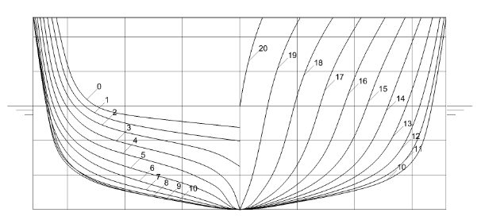
Figure 1. D1 model body plan

In the present work, five draughts were considered, from 3.2 m to 3.6 m, with a step of 0.1 m, to analyze the vulnerability of the model to DSC and EA criteria; the highest one corresponded to the design draught. A volume of displacement was associated to each draught; the lowest one was about 80% of the highest one. The vessel was assumed in a zero trim condition; a superstructure was hypothesized based on that of the Braunschweig class (K-130) corvettes of the German Navy; lateral accelerations were calculated at the command bridge; a hypothesis on the bilge keels length and span was made. The vessel main dimensions are reported in Table 1.
The ONRT model is a notional surface combatant developed for research’s purpose and publicly accessible. The model represents typical high-speed ship, having a wave piercing hull design and transom stern. It is characterized by 10° tumblehome sides. The body plan of the ONRT model is reported in Figure 2.

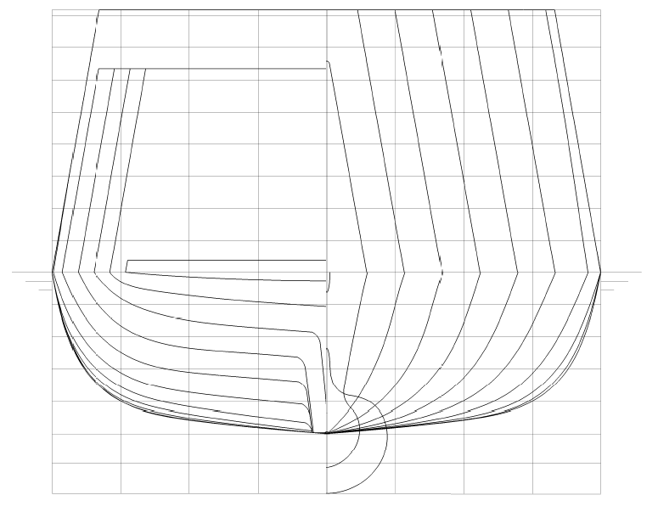

Figure 2. ONRT model body plan

Five draughts were considered, from 4.7 m to the design draught 5.494 m, to investigate if the model is vulnerable to DSC and EA criteria; the volume of displacement associated to the lowest draught was about 75% of that associated to the highest one. The vessel was assumed in a zero trim condition; lateral accelerations were computed at a point located in the midplane, at 102 meters from the stern and 22 from the keel line; a hypothesis on the bilge keels length and span was made. The main dimensions are reported in Table 1.

Table 1. D1 and ONRT models: main parameters at the design draught
Particular | Unit | D1 | ONRT
L | m | 90.0 | 154.0
B | m | 13.5 | 18.78
d | m | 3.6 | 5.494
Δ | t | 2215.0 | 8596.0
C_{B} | - | 0.50 | 0.535
C_{m} | - | 0.80 | 0.837
l_{BK}/L | - | 0.40 | 0.33
b_{BK}/B | - | 0.032 | 0.067
A_{L} | m² | 820.67 | 1778.6

Results
Numerical codes were written in Matlab® to assess if the ship met the dead ship condition and excessive acceleration vulnerability criteria in a given loading condition. The codes were validated according to the examples reported in the explanatory notes [13], [14]. The righting arm curves used in the DSC assessment were obtained in Maxsurf Stability®.
The limiting KG curves complying with Level 2 of DSC and EA criteria are shown in Figure 3 and 4, for D1 and ONRT models respectively. DSC imposes a maximum value of KG for a given volume of displacement. At the opposite, the EA criterion imposes a minimum value of KG in order to avoid too low roll periods. Hence, the simultaneous verification of both criteria should define a sufficiently large range of allowable KG between the minimum and maximum values.

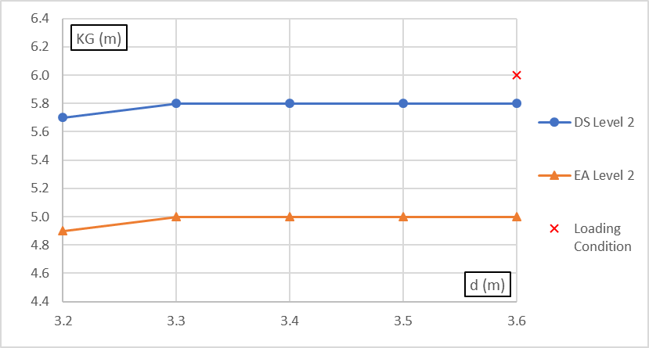

Figure 3. D1 model limiting KG curves

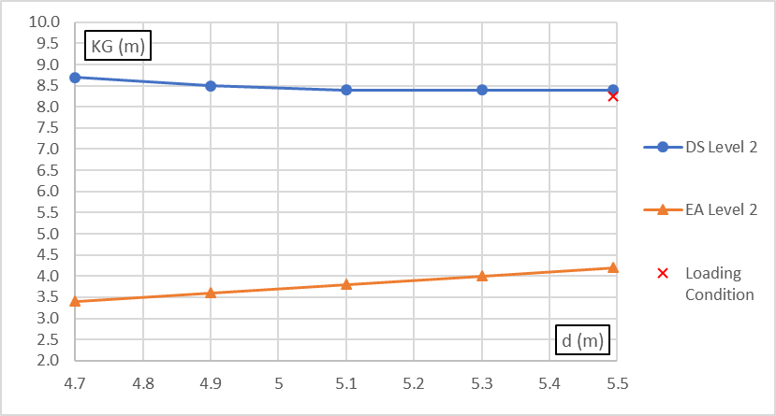

Figure 4. ONRT model limiting KG curves

The limiting KG curves were obtained through a systematic variation of the height of the center of gravity by step of 0.1m. As shown in Figure 3 and 4, there are no conflicts between the minimum (orange line) and maximum (blue line) allowable KG curves associated with Level 2 of DS and EA respectively. Hence, a range of allowable KG exists at each draft.
It is known from a previous work [9], that the KG value is equal to 6 m at the design draught 3.6 m for D1 model; it was obtained from Italian Navy ships statistics. This value is greater than the maximum allowable KG complying with Level 2 of DSC showing that the loading condition is “unsafe” with respect to the DSC failure mode.
As regards the ONRT model, in [10] it is reported the KG value equals to 8.24 m at the design draught of 5.494 m; the loading condition is inside the safe range of allowable KG defined by DSC and EA criteria, although it is very near to the upper limit defined by DSC.
It should be noted that the results obtained could be affected by the estimation of the roll damping performed using Ikeda’s simplified method, which is the one recommended in DS and EA procedures, in absence of experimental data or other suitable methods. Indeed, both D1 and ONRT have midship section coefficients C_{m} outside the range of applicability of the method; in addition, the ONRT ship has the ratio between the bilge keel span and the ship breadth greater than the limit value of the method.

Conclusions
In the present work, the second level of assessment of dead ship condition and excessive acceleration criteria was studied. The limiting KG curves associated with level 2 of both criteria were obtained for two semi-displacement, round bilge and transom stern hull forms: the parent hull D1 of the Systematic Series D and the notional ONR Tumblehome ship. Both vessels are typical naval hull forms. Five displacement volumes were considered for each ship.
The results showed that a sufficiently large range of allowable KG existed at each draught for both vessels, also due to the fact that both vessels were fitted with bilge keels. It was also shown that the KG value representative of the loading condition at the design draught: for D1 model did not met the DSC, since it was greater than the limit value associated to DSC; for ONRT ship satisfied both DSC and EA criteria, since it was between the upper and lower limits defined by DSC and EA criteria respectively.
Particular attention should be kept in the estimation of the roll damping when one or more parameters are outside the range of applicability of Ikeda’s method.

References
- IMO SDC 7/5. Finalization of Second Generation Intact Stability Criteria. Report of the Correspondence Group (Part 1). Submitted by Japan, London, UK, 2019.
- Kracht AM, Jacobsen A. D-Series Systematic Experiments with Models of Fast Twin-Screw Displacement Ships, Sname Trans. 1992, 100, 199–222.
- Tomaszek, H.; Bassler, C.C. Dynamic Stability Assessment of Naval Ships in Early-Stage Design. In Proceedings of the 12th International Conference on the Stability of Ships and Ocean Vehicles, Glasgow, UK, 14–19 June 2015.
- Grinnaert F. Analysis and implementation of second generation criteria in a stability computer code. Mechanics of the fluids [physics.class-ph]. Université de Bretagne occidentale - Brest, 2017. English. NNT : 2017BRES0003. tel-01578973.
- Grinnaert, F.; Gualeni, P.; Billard, J.; Laurens, J.; Petacco, N. Application of 2nd Generation Intact Stability Criteria on Naval Ships. In Proceedings of the 15th International Ship Stability Workshop, Stockholm, Sweden, 13–15 June 2016.
- Petacco, N.; Gualeni, P.; Billard, J.; Grinnaert, F. An integration of present navy ships intact stability criteria in the perspective of ship performance assessment in a seaway. In Proceedings of the 16th International Ship Stability Workshop, Belgrade, Serbia, 5–7 June 2017.
- Petacco, N.; Gualeni, P.; Billard, J.; Grinnaert, F. An integration of present navy ships intact stability criteria in the perspective of ship performance assessment in a seaway. In Proceedings of the 16th International Ship Stability Workshop, Belgrade, Serbia, 5–7 June 2017.
- Begovic, E.; Bertorello, C.; Boccadamo, G.; Rinauro, B. Application of surf-riding and broaching criteria for the systematic series D models. Ocean Eng. 2018, 170, 246–265.
- Rinauro, B.; Begovic, E. Vulnerability assessment of surf-riding-broaching and pure loss of stability for Systematic Series D1 model. Ships Offshore Struct. 2019, doi:10.1080/17445302.2019.1596545.
- Begovic, E.; Rinauro, B.; Cakici, F. Application of the 2nd Generation Intact Stability Criteria for fast semi-displacement ships. In Proceedings of the 18th International Congress of the International Maritime Association of the Mediterranean (IMAM 2019), Varna, Bulgaria, 9–11 September 2019.
- Boccadamo G., Rosano G., Excessive Acceleration Criterion: Application to Naval Ships, J. Mar. Sci. Eng. 2019, 7, 431, https://doi.org/10.3390/jmse7120431
- Rinauro B, Rosano G. Vulnerability assessment to Dead Ship Condition and Excessive Acceleration criteria for semi-displacement hulls, International Conference on Post Graduate Research, Gdansk, 2020.
- IMO SDC 4/5/1/Add.3. Finalization of Second Generation Intact Stability Criteria. Report of the Correspondence Group (Part 4). Submitted by Japan, London, UK, 2016.
- IMO SDC 4/5/1/Add.4. Finalization of Second Generation Intact Stability Criteria. Report of the Correspondence Group (Part 5). Submitted by Japan, London, UK, 2016.
- IMO SLF 48/4/6. Review of the Intact Stability Code. A modular methodology for the estimation of the ship roll safety under the action of stochastic wind and waves. Submitted by Italy, London, UK, 2005

Corresponding Author, gennaro.rosano@unina.it.

