Innovative approach for use of hydrofoils on ultralight seaplane
Antonio Maglione ^{a,}, Ubaldo Cella ^{b,c}, Marco E. Biancolini ^{c}, Leonardo Lecce ^{d}
ª Ingegneria Dei Systemi S.p.A.– Aerospace and Unmanned Systems Division
^{b} Design Methods Aerospace
^{c} University of Rome “Tor Vergata”
^{d} Novotech – Aerospace Advanced Technology S.R.L.
Abstract. Retractable hydrofoils may enhance performances of seaplane during take-off and landing runs by lowering the speed when the hull is leaving or touching water surface. Hydrofoils are designed to complement airlift with additional hydrodynamic lift elevating the hull above the water at a speed lower than take-off speed; this minimizes slamming phenomenon on the hull, improving seakeeping capability of the seaplane, since water impacts are minimized compared to conventional configuration and, as a consequence, forces and accelerations on airframe, crew and passengers are reduced. This is of foremost importance on ultralight seaplanes, where wave forces acting on the relatively small aircraft mass provide high accelerations and significant roll, pitch and yaw forces that are higher on light aircraft compared to heavy seaplanes. As matter of facts, clear advantage of this configuration is the increase of sea state when a light seaplane can safely fly, providing additional useful days along the year. Important benefit is the improvement of seaplane performances during take-off and landing, reducing duration of the most critical flight phases, increasing overall safety and reducing pilot workload. Further benefits are envisioned, with optimization of wing, empennage and fuselage to minimize aero-drag and, as snow-ball effect, mission fuel consumption and energy power requirements. Life-cycle cost receives benefits too, since less water spray is ingested by engine and less water droplets impinge on fast revolving propeller, thus reducing expensive power plant maintenance cost over the entire service life.
Keywords. Hydrofoil design, seaplane, slamming, seakeeping, multiphase analysis, aircraft design, snow-ball effect

Introduction
Seaplanes have a fundamental part in the history of aviation and their diffusion from the origin of aeronautic history was quite important since there was no need of large landing infrastructures for them to operate. Seaplanes had significant military role up to WWII and large governments funding for development were massively provided [1][2] to support seaplane technology development. International contests such as Schneider’s Trophy [3] for fast seaplanes had the primary aim to develop technologies used for navy fighter aircraft.
Even large military supersonic air-bomber seaplanes were conceived and developed in the 50’s, but none of them entered in full service [4]. Post-WWII, a sharp decline affected seaplane diffusion since balistic transcontinental missile development and large numbers of airports built around the world shadowed the need for military and civil seaplanes.
Still, there are quite a few seaplanes active today, many of them are civil aircraft targeted to fire-fighting, like ex-Canadair Viking CL415 that is able to drop several tons of water scooped on lakes or by the sea coast mixed with fire retardant agents, and few military aircraft dedicated to specific missions like offshore Search and Rescue, Medical Evacuation and troops transportation on small islands, such as ShinMaywa US2 from Japan and AVIC AG600 from People Republic of China. (Figure 1).
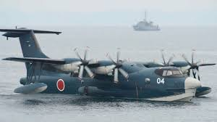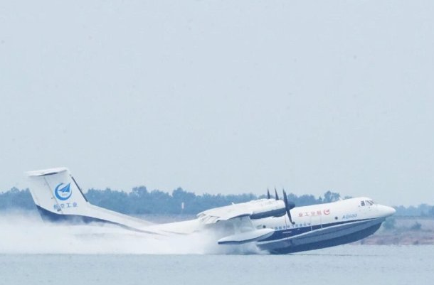
Figure 1. ShinMaywa US-2; AVIC AG600
Seaplanes are not intrinsically more dangerous than conventional airplanes, but clearly operate in a more dangerous environment. Landing and take-off runs are the most difficult flight phases for a seaplane; on calm water those may be considered as relatively easy tasks, since useful lengths of free water are available in lakes or by the sea coast and the pilots are free to select course orientation to avoid cross-wind and obstacles. Difficulties arise when sea state is higher, with waves impacting the hull generating heavy slamming on aircraft structure and significant accelerations on crew and equipment. Further, take-off drag increases in growing sea state and breaking waves, worsening take-off performances.
The history of using hydrofoil on seaplanes is very long as reported by Eugene Handler (Bureau of Naval Weapons) [5]. An historical review by Vagianos and Thurston of the attempt to adopt hydrofoils in seaplane, as well as an in depth description of their design complexities, is referenced in [6]. The work reports that during the very early days of aeronautics before WWI, there was an intensive development of seaplanes with hydrofoils to improve take-off distances and payload capability and already by 1911 seaplanes developed in France, Italy, Great Britain, and the United States had succeeded in conducting sustained flight off water with a variety of hydrofoil concepts.
After the war research was pushed by Schneider’s Trophy international contest but unfortunately none of those attempts appear to be ended in a successful configuration; as an example, Giovanni Pegna designed for Società Anonima Piaggio & C [7] the very innovative P.7 (see Figure 2) to compete in the 1929 Schneider’s Trophy. The streamlined seaplane didn’t have a conventional planing hull and only split flat small mono-foil were intended to sustain the aircraft during take-off and landing runs.
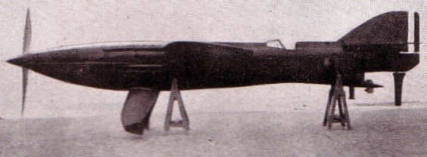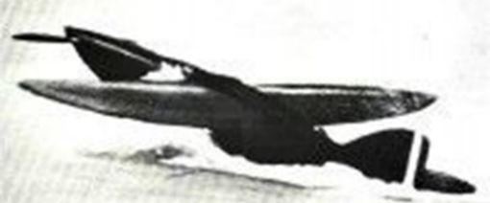
Figure 2. P.7 - Società Anonima Piaggio & C, 1929.
The configuration was very innovative but was jeopardised by mechanical technology limits of the time, no flight was achieved and the project was abandoned.
In recent years, interest in small seaplanes is growing pushed by the demand for personal airplanes that unplugs the same old baseline requirement that historically drove seaplanes diffusion, i.e. to operate an aircraft without a landing infrastructure.
As an example of small seaplanes are referenced ICON A5 and LISA AKOYA. Those aircraft integrate small planing sponsons or inverted hydrofoils to reduce aerodynamic drag; no evidence appears in the design of the seaplane to adequately perform in a significant sea state, since the majority of customers operate from relatively calm stretches of water in lakes and inner channels of North America. 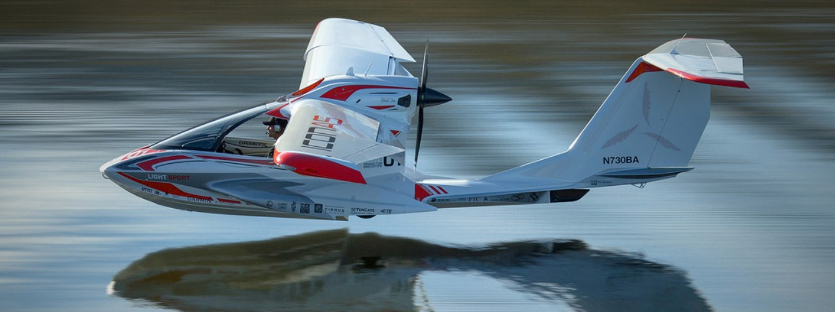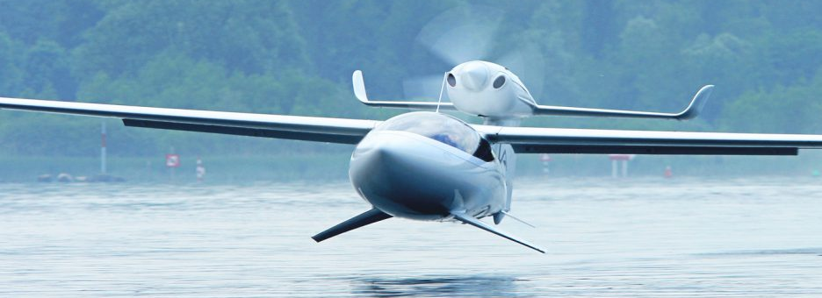

Figure 3 ICON A5; LISA AKOYA
The adversity of sea state on a seaplane can be basically described as inversely proportional to the mass of the aircraft itself, since the forces increase by the sea state while the body accelerations are inversely dependent to the aircraft mass, i.e. higher on light seaplanes compared to heavy seaplanes.
This paper describe a sensitivity study aimed at evaluating the use of hydrofoils on a Ultralight Seaplane, with the objective to enhance performances at higher sea state, in order to increase operability in open water and number of allowed days along the year in which the seaplane can be operated.

Seaplane description
The SEAGULL is an innovative “green” two seat ultralight seaplane having a hybrid propulsion unit with a ROTAX 912 four cylinder piston engine (75,3 kW at 5800 RPM) and an electrical engine (Emrax 228 100 kW peak, 55 kW continuous) in series with a back-up batteries system. Its aerodynamic architecture is characterized by a high wing braced configuration with the side braces made by two electro-mechanical actuator capable to perform the complete folding of both wings in mooring or transport configuration, automatically without manual intervention (EU Patent N. 102017000131163).
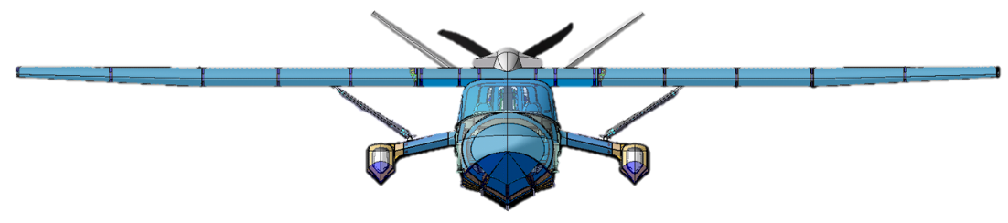
Figure 4 SEAGULL
This feature can envision a possible further innovation in which the semi-wings are rotated vertically, with movable surfaces (i.e. ailerons and flaps) cambering wing profile, to generate wind lift to smoothly propel the seaplane; this may allow, as an example, to get in and out of protected marine environment without the need of mechanical propulsion either aerial or marine. Seagoing performances are granted by conventional sponsons integrated in the main hull to get adequate stability in rough seas and in cross wind conditions.
SEAGULL design has been a synergic effort of aeronautical and marine expertise that evolved in several development steps (see Figure 5) [8] and validated by experimental testing both in towing tank and in wind tunnel (see figures 6 and 7). Design target has been a spectrum of usage up to Sea State 2; laboratory and ground testing are in progress and first flight is planned in 2021.
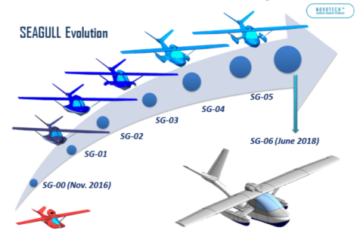
Figure 5. SEAGULL Configuration Evolution.

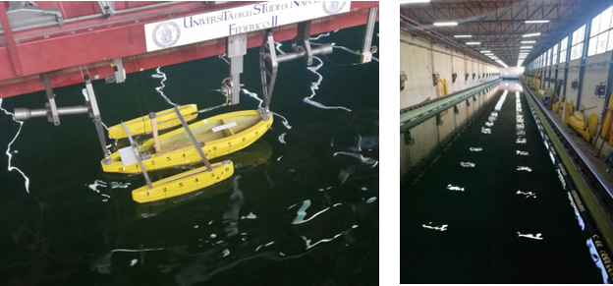
Figure 6. Towing Tank Tests.
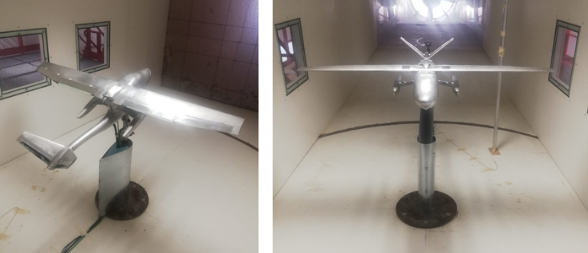
Figure 7. Wind Tunnel Tests
SEAGULL main configuration and preliminary performances data are reported in Table 1.
Table 1. SEAGULL Preliminary data and performances.
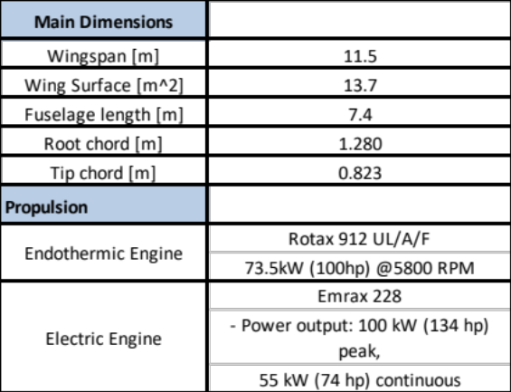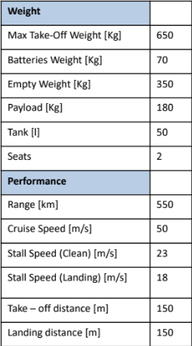

Concept sizing
The aim of this effort was to get a preliminary sensitivity study on using hydrofoils on an ultralight seaplane to increase sea-state capability; to start this process it was defined the main baseline objective: to step up from Sea State 2 up to Sea State 3.
As matter of facts, increase wave height from 0.2-0.5m to 0.5-1.25 may appear not as an exceptional leap but in relative terms this may represent, based as an example on statistical data of the Mediterranean [9], the possibility to approximately double operational days over the year (see Figure 8).

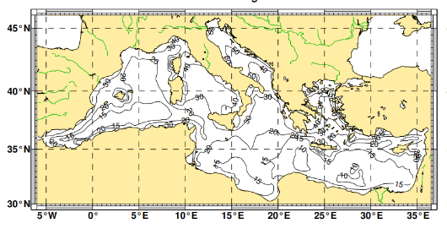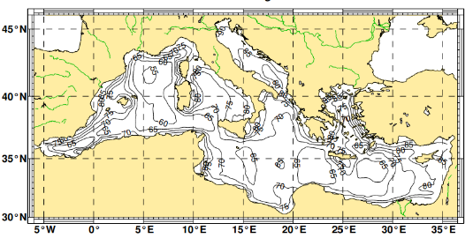
Figure 8. Annual Spatial distribution of P(Hs<0,5m) and P(Hs<1,25m) in the Mediterranean.

To achieve this objective, the hydrofoils have been conceived to provide lift to sustain the hull above the water at a distance equal or greater than a height of 1.0 m.
For the sensitivity analysis it was selected a very simple hydrofoil based on two straight segments in the so-called L-Shape configuration, oriented inboard in the perspective to investigate a solution in which the hydrofoils are retractable inside the structure of the floaters. The hydrofoils shape is inspired by a previous work concerning the design of hydrofoils for a high-performance sailing catamaran [10].
The hydrofoils draft in static conditions was set to one meter. The angle between the outer segment and the water plane was set to 35 degree to have a draft range in foiling condition, between minimum and take-off speed, of half meter. The total reference surface, projected on the waterplane, is 0.2 square meter per foil. This value was selected assuming the foil to sustain the maximum take-off mass at a speed of 15 knots with a vertical component of the lift coefficient of 0.4. It is then expected the aerofoils to operate at a local lift coefficient that do not exceed 0.8. The free surface level in this condition is at the junction region of the two foil’s segments at a level that ensure the fuselage hull to be fully foiling above the water (see Figure 9). The taper ratio of the outer element is 0.7. This first attempt uses the well-known NACA 63(1)-412 profile mounted with an incidence of 6.5 degree with no twist.
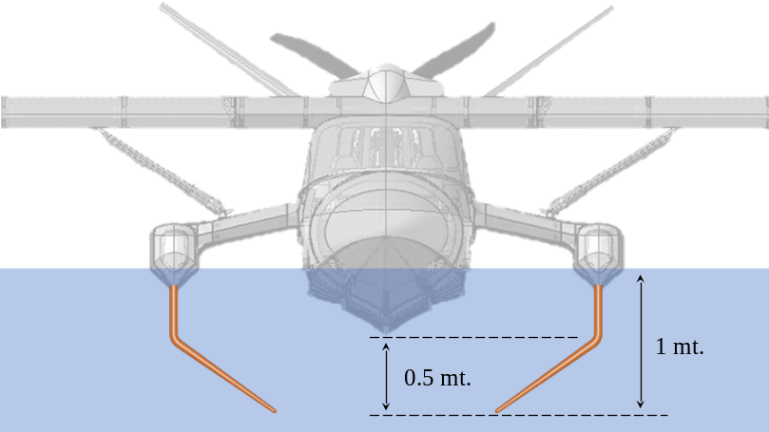
Figure 9. Layout of hydrofoils configuration.

Numerical verification
Conventional analytical methods usually adopted in aeronautics in the design phases show significant limits in seaplane design [11], and this is moreover true in case of foiling configurations in presence of free surfaces. Similarly, simplified CFD approaches as lifting line theory or panel based solutions provide only rough indications of the generated forces. Therefore, it was decided to use a high-fidelity CFD approach using a multiphase fully turbulent RANS analyses modelling the free surface by a VOF (Volume of Fluid) technique. The computational grid was generated modelling half domain extended four meters upstream the foil and six meters downstream, four meters wide with a depth of three meters. The mesh is a structured multi-block with a size of about five million of hexahedral cells (Figure 10). The first layer of cells on the wall was dimensioned to obtain a dimensionless wall distance y⁺ [12] between 30 and 100 in order to model the boundary layer by wall functions. The adopted turbulence model was the k-ω SST of Menter [13].

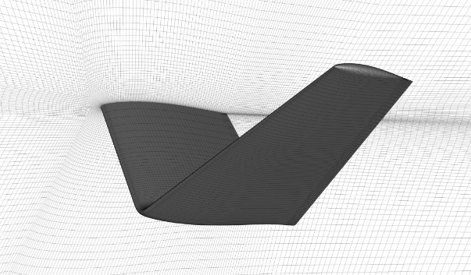
Figure 10. Computational mesh.
The performances of the hydrofoils were verified extracting lift and drag at several velocities up to the take-off speed. The Figure 11 reports the lift generated along all the speed range. The dashed curve is the difference between the maximum take-off mass (MTOM) and the aerodynamic lift generated by the aircraft. This value is the target for the hydrofoils to sustain the aircraft in foiling conditions. The minimum foiling speed is confirmed to occur between 15 and 18 knots. At lower speed, the aircraft operates with the contribution of the hull. The grey area in the graph marks the transition between these two conditions.
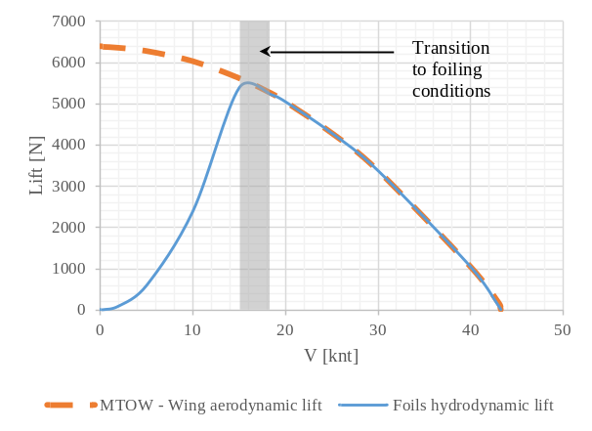
Figure 11. Hydrofoil lift during take-off run.
The drag of the isolated hydrofoils was compared with the hydrodynamic drag experimentally measured, on the current aircraft configuration, in the towing tank of the University of Naples. The comparison of the two curves is reported in Figure 12. In foiling conditions (speeds higher than 15 knots) the drag of hydrofoils represents the total hydrodynamic drag of the aircraft. Its value is lower in most of the range speed than the drag of the aircraft in a configuration without hydrofoils and a significant contribution in the reduction of the take-off length is then forecasted. At lower speed the hull hydrodynamic drag (at a displacement that accounts for the hydrofoils lift contribution) has to be added to the drag generated by the hydrofoils leading to a deterioration of the total drag of the actual aircraft.

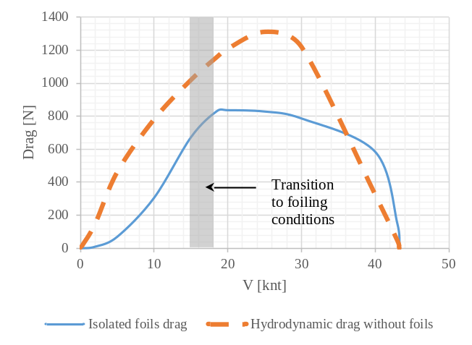
Figure 12. Comparison between the conventional hull and the isolated hydrofoils drag
As a preliminary estimation, the analysis shows that hydrofoils shave hull lift-off speed from 44 knots to approximately 20 knots, reducing water dynamic pressure on the hull to less than 20% of the reference conventional configuration.
The advantage in terms of take-off length derived by the adoption of the hydrofoils should be globally evaluated accounting for other drag contributions due to immersed surfaces needed for stability reasons. As matter of facts, in the range of foiling speeds the aerodynamic authority of horizontal and vertical empennage to control aircraft attitude is not yet adequate and an immersed empennage is therefore mandatory.
Figure 13 shows a pictorial view made superimposing hydrofoils CFD computation at 20 knots, with free surface plotted detecting the isosurface at a value of volume of fluid fraction equal to 0.5, with a coherent rendering of SEAGULL CAD model.
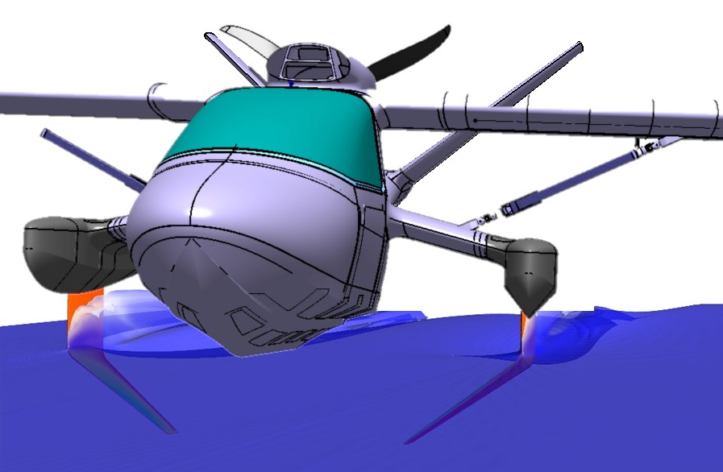
Figure 13. Pictorial view superimposing hydrofoils CFD output at 20 knots with coherent rendering of SEAGULL CAD.

Identification of potential additional advantages
This research effort on application of foiling on ultra-light seaplanes as devices dedicated to improve the seakeeping capability have revealed that the advantages on hydrodynamic drag may not generate only reduction of take-off time, smoothing of landing runs and increasing of operational days over the year.
In a snow-ball effect the above advantages trigger an optimization of the overall aircraft design, eventually impacting on power-plant size, wing and empennage dimensions, optimization of fuselage hull and floaters/sponsons; the optimization brings additional aerodynamic drag reduction with positive effect on energy consumptions during flight, plus operative empty weight reduction with associated increase of payload capability for a given maximum take-off mass.
Further advantage may appear on reliability and maintenance costs over the entire life cycle: as matter of facts, reduced running time in the water and an increased distance above water surface during large portion of take-off and landing phases minimize engine water spray ingestion and droplets impingement on fast revolving propeller blades, ending up in less aggression from water with potential benefits in terms of life cycle cost of power plant, the most expensive segment of aircraft maintenance cost.
Significant additional benefit is envisioned considering seaplane impacting a breaking wave: smaller exposed volumes and cross sections exposed under foiling to breaking wave minimize impact forces and, as a consequence, behaviour of the ultralight seaplane with lower accelerations and roll, pitch and yaw forces, translating in reduction of crew workload and increased passengers comfort.
Analysis and estimation of the above advantages may be part of a future research program on this theme.

Conclusions
This paper focuses on the preliminary verification of the impact of the adoption of hydrofoils, as devices dedicated to improve the seakeeping capability, would have on the aircraft performance.
Even if the sensitivity study has been based on a very simple hydrofoil concept, it shows that foiling ultra-light seaplanes have a number of potential advantages compared to conventional planing hull seaplanes: reduced take-off time and smoothed landing runs, increased operational days over the year, reduced water spray due to increased distance above water surface during large portions of take-off and landing.
Deeper analysis appears necessary to fully validate the foiling concept with particular attention to aircraft controllability during transition phases, i.e. from conventional hull dynamic lift to foiling lift to complete aerodynamic lift during take-off runs and, vice versa, on the most critical landing runs.
Further advantages are envisioned related to overall optimization of seaplane design for energy consumption during flight, payload capability, maintenance costs and behaviour under breaking waves. Those topics may be part of future research program on this theme.
References
- Massy, H.S., “The seaplane and its development”, Royal United Services Institution. Journal, 57:429, pp. 1452-1467, 1913.
- Coombes, L.P. and Perring, W.G.A., “The Farnborough Seaplane Tank: The New Equipment for Seaplane Research and Development Fully Described”, Aircraft Engineering and Aerospace Technology, Vol. 6 No. 3, pp. 63-66, 1934.
- Pegram R., “Schneider Trophy Seaplanes and Flying Boats: Victors, Vanquished and Visions”, Fonthill Media, 2012.
- Wornom E. Dewey “Transonic Aerodynamic characteristics of a model of a proposed six-engine Hull-Type Seaplane designed for supersonic flight”, NASA Langley Research Center, 1960.
- Handler E., "The Bureau of Naval Weapons Hydrofoil Seaplane", Naval Engineers Journal, Volume75, Issue2, pp. 449-452, May 1963.
- Vagianos N. J. and Thurston D. B., "Hydrofoil Seaplane Design", Thurston Aircraft Corporation, Report No. 6912S, May 1970.
- Gavazzi P., “Volare Avanti: Storia degli aerei Piaggio”, Proedi Editore, Milano, 2000.
- Barile, M. Amendola G., Ingenito V., Migliaccio M., Lecce L., “Development of a morphing wing concept for the Seagull A/C – The next generation marin-air vehicle”; Italian Association of Aeronautics and Astronautics XXV International Congress, 2019.
- “Wind and Wave Atlas of the Mediterranean Sea” Western European Union, 2004.
- Biancolini M. E., Cella U., Clarich A. and Franchini F., “Multi-objective Optimization of A-Class Catamaran Foils Adopting a Geometric Parameterization Based on RBF Mesh Morphing”, in Evolutionary and Deterministic Methods for Design Optimization and Control With Applications to Industrial and Societal Problems, Vol 49, Springer, 2018.
- Masri J., Laurent D., Benoit H., “ A review of the Analytical Methods used for Seaplanes Performance Prediction”; 6th Aircraft Structural design Conference; Bristol, 2018
- Hermann Schlichting, “Boundary Layer Theory”, McGraw-Hill, 1979.
- Menter F. R., “Two-Equation Eddy-Viscosity Turbulence Models for Engineering Applications”. AIAA Journal. 32(8). pp. 1598–1605. August 1994.

Corresponding Author.
The term foiling refers to the condition in which the full displacement is sustained by the foils with no contribution from the hull.

