Innovative use of hybrid propulsion system in fast passenger ferries over 300 passengers and 20 knots
Ing. Valerio RUGGIEROª and Ing. Ph.D. Ferdinando MORACE^{b}
ª Dipartimento di Ingegneria, University of Messina,
^{b} Liberty Lines, Trapani
Abstract. The passenger transportation among Islands or coastal locations is usually realized by High speed ferries. These vessels use traditionally powerful high speed diesel engines, but this transportation has the characteristic of being subject to season, weather condition, period of the years, causing often an underutilization of the power installed onboard, by the fact that the displacement varies significantly and also the amount of runs scheduled per day.
In consideration also of the need to reduce the impact of waves generated by the hull, especially considering the historical or naturalistic scenarios where these vessels operate, the authors investigated the possibility to adopt an hybrid propulsion on an high speed hull, using tank test at a wider range of speed, to optimize usage.
This use of hybrid propulsion is innovative, because usually the hybrid propulsion is used for slow, traditional vessels, according to the limited request of power for propulsion.
In the study proposed there is a “dual use” , that can be obtained navigating in “peak touristic season” using traditional propulsion, with diesel engines, at 22-24 knot, and in “low season” performing the entire trip or part of it, using only batteries or hybrid. With the use of this system the authors studied a solution capable to carry over 300 passengers, verifying also that the weight of the batteries, actually traditional Li-Po batteries, doesn’t impact too much on the total displacement, but also investigating the aspect of the firefighting system on hybrid vessel, aspect that it s innovative, due to the tendency of Li-Po batteries at overheating and exploding in case of fire.

Keywords. Hybrid propulsion, ferries, catamaran, resistance.
Symbology
[Symbol] [Definition] [(Unit)]
C_{F} Friction coefficient [-]
C_{RS} Residual resistance coefficient on ship [-]
C_{FS} Friction coefficient on the full scale ship [-]
C_{TS} Total resistance coefficient on the full scale ship [-]
Fr Froude Number [-]
L_{WL} Length in the waterline [m]
V Linear velocity [m/s]
V_{S} Velocity of the ship [m/s]
B Breadth, moulded [m]
B_{WL} Breadth in the waterline [m]
L Length in general [m]
L_{OA} Length over all [m]
L_{WL} Length in waterline [m]
L_{PP} Length between perpendiculars [m]
S Wetted surface m² ]
T Draught, moulded of ship [m ]
C_{TL} Telfer coefficient [- ]
D Height (main deck height from base line) [m]
LCG Longitudinal position of center of gravity [m]
VCG Vertical position of center of gravity [m]
GMT Metacentric Height [m]
LCB Longitudinal position of center of buoyancy [m]
VCB Vertical position of center of buoyancy [m]

Introduction
The passenger transportation in coastal waters has to deal with a significant change in terms of numbers of passengers transported and operational speed trough the various periods of the years.
The routes are connecting usually a main port like Naples or Trapani, or Trieste and several locations of touristic interest, often also located in protected areas [1,2].
As result of these situations the ratio of usage of a ferry can drop from the 100% in summer/touristic season to 20-30% in winter season , when the ferry is operating only as public transport for the local population of the various ports connected.
Obviously, the speed also can be reduced during the low season, because there is no need to perform the transportation of an high flow of passengers during the day. Furthermore usually the distance between one port to the other, like for example from Naples to Capri or from Capri to Ischia or from Trapani to Favignana or from Favignana to Levanzo are of 10 nm or less, meaning that an operative speed of 15-16 knots can still guarantee a reasonable trip of 35-40 min instead that the 20 minutes required at 25-30 knot. This because is important to remember that also a fast ferry cannot , usually, develop his full speed in the first part and last part of the trip, due to the need to avoid noise, pollution, waves in the Port areas or in proximity of the coast. In addition, assuming to study a scenario in “low season” that usually correspond the winter , the weather or sea state and then the consequent behaviour of the ship in terms of seakeeping and passenger’s comfort can suggest a speed reduction.
As consequence of the above description the Authors want investigate the possibility to study an innovation in the project of fast ferries to realize a propulsion system capable to deal efficiently with this double scenario: high speed/full load during “peak season” requiring high installed power, medium speed/low load during “low season”.

Technical examination of the problem
The behaviour of high speed hulls is well known, with the usually technical solutions adopted to reduce the P_{E} when operating at high Fr numbers: planning or semi planning, hulls, or catamarans to achieve a good L/B ratio with sufficient stability and wide platform for passengers, high speed diesel engines, light displacement.
In last years, also considering the attention to the environment and clean production of energy, became more and more interesting the possibility to adopt hybrid propulsion systems [3-6], using electrical energy, stored in batteries, for the propulsion. This became possible thanks to the development of more efficient batteries the Li-Po or NIB (Sodium ion), instead of the traditional Lead acid, with the capacity to store higher quantity of energy.
The use of electricity to operate the propellers, that in this case will be replaced by waterjets, offers the advantage to consider 2 possible solutions: producing the energy ashore, and the store in batteries or produce the energy on board by electric generators and the send to the waterjets, using a battery pack to store energy and be able to manage peaks of request, maintaining the GG.EE. always operating at best efficiency point in terms of specific consumption.
This second solution, the production of energy on board, has been improuved in last years with the cohoperation of manifacturers of diesel engines and electrical engines, because some solutions have been realized with a very compact electrical engine, located between the diesel engine and the shaft line.

Table 1. Main data
L.o.a: | 40.10 | m
B: | 10.10 | m
Displ.Full load: | 150 | t
T: | 1.70 | m
Speed: | 30 | knots
Passengers: | 350

Table 2. Semi hull data-Hydrostatics DWL of demihull
Displacement | 73,45 | t
Volume (displaced) | 71,581 | m^3
Draft Amidships | 1,51 | m
Immersed depth | 1,515 | m
WL Length | 39,269 | m
Beam max extents on WL | 2,71 | m
Wetted Area | 137,806 | m^2
Max sect. area | 2,774 | m^2
Waterpl. Area | 67,507 | m^2
Prismatic coeff. (Cp) | 0,63
Block coeff. (Cb) | 0,42
Max Sect. area coeff. (Cm) | 0,793
Waterpl. area coeff. (Cwp) | 0,634
LCB length | 13,881 | from zero pt. (+ve fwd) m
LCF length | 13,868 | from zero pt. (+ve fwd) m
LCB % | 35,349 | from zero pt. (+ve fwd) % Lwl
LCF % | 35,314 | from zero pt. (+ve fwd) % Lwl
KB | 0,951 | m
KG fluid | 0 | m
BMt | 0,43 | m
BML | 80,698 | m
GMt corrected | 1,381 | m
GML | 81,649 | m
KMt | 1,381 | m
KML | 81,649 | m
Immersion (TPc) | 0,692 | tonne/cm
MTc | 1,474 | tonne/cm
RM at 1deg = GMt.Disp.sin(1) | 1,674 | tonne/cm
Length:Beam ratio | 14,49
Beam:Draft ratio | 1,789
Length:Vol^0.333 ratio | 9,632
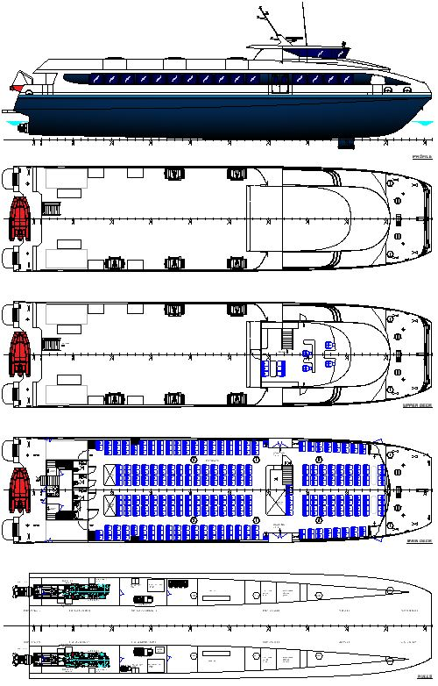
Figure 1. General Arrangement

This solution was already used and adopted during II World war by Italian submarines, but the recent development in electronic, with the possibility to control and optimize the use of the electric motor, makes this solution more interesting.
In consideration of the above, the authors examined the propulsion system of a Ferry catamaran for passenger transportation, and studied the possibility , using the tank test data and CFD simulation for Resistance as valid input, to realize an innovative propulsion system, capable to operate in dual mode: traditional diesel engine at high speed and electrical driven at low medium speed.
The system studied is based on the traditional architecture of a fast ferry, with catamaran type hulls, realized in Aluminium alloy, with the following main data:

The propulsion system
The propulsion system is realized by the installation of one high speed diesel engine in each hull, of 2300 kW of power at 2000 rpm, (Continuous duty rating).
The propulsion is realized with waterjets, positioned close to transom of each hull. The reason of this choice will be explained in further paragraph.
Between each Engine and the waterjet input shaft, is installed an electrical engine of 400 kW of power, asynchronous, also capable to be used as a generator.
The engine will be separated by a clutch from engine.
In each compartment in the hull, will be installed a battery pack, Li-Po type, of 300 kWh of capacity.
The propulsion system can operate in 5 different ways:
- DEM (Diesel-Electric mode) the electric motors , on each shafts can be fed by the generator, allowing for speed up to 5 knots, This DEM mode permits the ferry to operate at low speed , in port areas, with fuel savings and reduced noise levels.
- BEM (Battery -Electric mode) the electric motors , on each shafts can be fed by the battery pack, without pollution, noise, etc. The range and speed of this BEM will be described in next paragraph, explaining the impact of the battery package on displacement and consequent performance of the ferry.
- HM (Hybrid mode) one of the two main engines shafts generators provides the needed electrical power to run the second electric motor for propulsion and hotel needs. With this solution, as will be explained showing the resistance data, will be possible operate traditionally during the navigation in low season, using only one engine, but with the capability to obtain significant reduction in pollution and consumption.
- TM (Traditional Mode) , the ferry can run at 27 knots, full displacement , performing the necessary duty during the peak season , transporting high volume of passengers, combining the full load (300 pax) with the capability to complete the circuit of stops in few hours and consequently realizing several connections during the day.
- FM (Full speed mode) with both main engines and generators supplying power to the two electric motors and feeding the hotel loads, the ferry could increase his speed at about 2 knots, if required, to compensate a delay or different reason , maintaining the commercial respect of connection time between the stops.

All the above Modes have been developed considering and existing Electrical consumption for Ship services, inclusive of air conditioning, of 60 kW in all conditions.
The type of hull examined has been tested at Vienna Model Basin, and then developed trough CFD (Fig.2) in order to obtain exact values at the speed of interest.

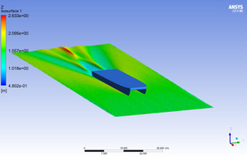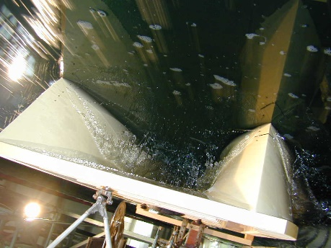
Fig. 2 CFD simulation and Tank test

The results gave the following table (Tab.3) for the considered speed:

Table 3.
Speed (knots) | Pe (Kw) | Fn
5 | 80 | 0,131
15 | 400 | 0,39
27 | 2200 | 0,655

Battery pack sizing
The main problem to solve with hybrid propulsion on a ship like this , as it possible to see from the Fr at the various speed considered (5,15,27 kn), is the need to maintain the Displacement in a light condition, in order to reduce the resistance especially at higher speed.
The main problem typically studied on these vessels is the weight of battery packs, and also the difficulty to operate in full “Diesel electric” mode, combining Diesel Generators with electrical propulsion for the propellers/waterjet, because all those solutions will increase the displacement. Considering the progress in battery weight, the authors studied the present solution.
As results of efforts from manufacturer of Li-Po batteries of last generation, now a package of batteries of 120 kWh has a weight of 900 kg about.
It is important to consider the following graph (Fig. 3), when sizing the batteries, to ensure enough life for the batteries:

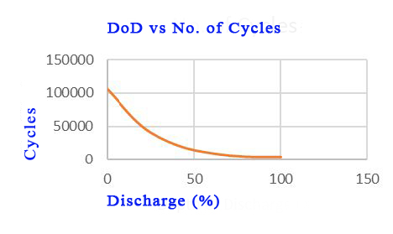
Figure 3. Life cycles of batteries.
The usage/discharge of batteries cannot pass the 15-20% otherwise there will be a serious drop in battery’s life.
In consideration with the above graph and with the resistance curve of hull, the Authors considered to install in each hull a battery package of 360 kWh, usable 300kWh, with a weight of 2700 kg, including the cooling system.
This value , 3 t in each hull , can appear as high , but it is important to note that compared to a total Full load Displacement of 146 t, with 22.5 t of passengers (assuming a value of 75 kg each) is not creating a significant impact on the resistance, even using a planning hull type.
Each electrical engine, installed between the M.E. and gearboxes, also with a Power of 400 kW has a weight and dimensions with without a significant impact on the installation of the engines in the hulls, moreover, the author considered average engines already available on market, capable to operate as engines and/or as generators, and the development from manifacturers is extremely fast, offering always better peerformances.
Resuming the data of above, the total weight increase for the complete ferry, due to the hybrid system, is about 14 t. inclusive of batteries, electrical engines, control units of the systems. (frequency converter etc). Around 10% of Full Load displacement, but with significant advantages.
This system allows to obtain the following performance:
- DEM : the Gensets (2x150 kW) can provide the 80 kW required for propulsion at 5 knots and the hotel services,
- BEM 5 knots: The ferry can operate for 1 h using about the 25% of capacity of each battery pack, a speed of 5 knots is enough to travel in and out from each port, in total
- HM Hybrid Mode: in this situation only one of the Engines (2300 kW each) will operate, providing the 400 kW (P_{E}) needed for propulsion , estimate 800 kW with a propulsive efficiency of 0.5 and feeding the Hotel systems with the 60 kW required , and the Ferry can reach a cruise speed of about 15 knots , enough to cover a voyage of 10 nm in 40 mins.
- TM The ferry can use the power of both the MM.EE: and reach a cruise speed of 27 knots.
- FM The ferry can use the power of both the MM.EE, and in case of supplying the electrical motors on shaft lines with power generated by the gensets is possible to increase the maximum speed to 2 knots, or have extra margin to adjust at sea state.

Propulsion system
The propulsion system will require a complete monitoring system, in order to optimize the performances and minimize the losses of energy, as already studied and adopted on similar high performances ships. Moreover the fore stabilization wings, controlled by the above mentioned monitoring systems, and studied according also to other experiences of authors oh high speed vessels [7,8,9] will guarantee a better trim in case of unusual weight distribution caused by the passengers, indeed on these ferries cannot be neglected the problem of the disposition of passengers and consequent significant change in final LCG position, with impact on trim and consequently on resistance, assuming the planning typology of the hulls.
The use of waterjets for the propulsion has been carefully considered by the Authors, and it is a consequence of the need to adopt a solution capable to match the following parameters:
- Good manoeuvrability at low speed
- Draft reduction
- High efficiency at high speed, reducing the resistance of appendages (no rudders, no shaft lines etc)

Considering the above and the fact that the ferry will have to operate in a wide range of speed (5,18,27 knots) the Authors, also considering the literature available [10,11], decided to install waterjets instead of traditional propellers with shaft line. The waterjets solution can also offer an advantage in the trim and weight distribution, considering the weight of superstructure and wheelhouse mainly located forward.

Battery pack positioning for firefighting
The separation of the battery compartment from the MM.EE., gives an important contribution in the firefighting problem. The dangerous behaviour of Li batteries in presence of overheating is well known, and the most used solution , in case of fire, is to reduce the temperature of the battery pack[12,13]. In a ship this solution can be realized by flooding the compartment where the batteries are located and this can obviously impact on stability. The catamaran architecture, with the separation of each battery pack, makes possible to submerge the battery compartment, compartment with a relatively small volume, as consequence of the limited width of each hull, and still maintain an acceptable level of buoyancy and stability.

Conclusion
The study demonstrates the possibility to combine efficiently a traditional High Speed hull with an hybrid system , taking advantage of the recent developments in battery technology and performances, in order the realize a ship extremely flexible, capable to operate in “clean way” or as a fast ship.
The main limits, actually under investigation are regarding the weight of the battery package, and the complexity, in terms of firefighting and storage of the Li-Po batteries.
In order to solve this problem a possible solution could be the usage of Na [14] batteries, if their capacity in terms of kWh/kg will increase reaching the same of Li-Po.
The main interesting development of the case study examined, remains the possibility to realize a ship capable to operate within a large range of situations, at a reasonable cost, offering to the Owner company the possibility of having profit in low and high season.
The possibility to realize the above described project is strictly related to the latest developments of the electronics in order to optimize the management of the propulsion system to address the “energy flow” in order to optimize the efficiency and the environmental protection.

References
- V.Ruggiero, 2019, “Impact of hybrid propulsion on the project of small passenger ferries for Italian scenario”, 3rd International Conference on Nautical and Maritime Culture, Naples 14-15 November 2019, Book: Nautical and Maritime Culture from the Past to the Future. ISBN 978-1-64368-038-5
- Bucci V., Marino A., Businaro A. 2015, “The new hybrid small passenger vessel for the Venice lagoon Vittorio Bucci, Alberto Marinò, Andrea Businaro in NAV 2015, Proceedings of 18th Conference on Ships and Shipping research – 24/26 giugno 2015, Lecco, pagg 1107 - 1115, ISBN 978 88 940 55719
- Bordianu, A., Samoilescu, 2019. "Electric and Hybrid Propulsion in the Naval Industry", 11th symposium ATEE 2019.
- Litwin, W., Lesnjewski, W., Piatek, D., Niklos,K., 2019. "Experimental research on the energy efficiency of a parallel hybrid drive for an inland ship", Energies, 12(9), pp.1675
- Balsamo, F., Capasso, C., Venevi, O., 2018. "Performance evaluation of an all-electric waterbus supplied by hybrid energy", Proceedings of SPEEDAM 2018.
- Vicenzutti, A., La Monaca, U., Bosich, D., Bucci, V., Marinò, A., Sulligoi, G., Pelaschiar, R. “Early-stage design of shipboard integrated power systems: CSI-based multiple solutions comparison” (2017) 2017 IEEE Electric Ship Technologies Symposium, ESTS 2017, art. no. 8069325, pp. 478-485. DOI: 10.1109/ESTS.2017.8069325
- Giallanza, A., Cannizzaro, L., Porretto, M., Marannano, G.”Design of the stabilization control system of a High-Speed craft”(2017) Lecture Notes in Mechanical Engineering, pp. 575-584. DOI: 10.1007/978-3-319-45781-9_58
- Ruggiero V, Ricca S., Cucinotta F, Russo V., 2007 Optimization of stabilization wing for an high speed craft multihull in Proceedings ICMRT (International Conference on Marine Resarch and Transportation) 07 - Ischia. pp 11-18 ISBN 8890117435
- Giallanza, A., Marannano, G., Morace, F., Ruggiero, V.”Numerical and experimental analysis of a high innovative hydrofoil” (2020) International Journal on Interactive Design and Manufacturing, 14 (1), pp. 43-57. DOI: 10.1007/s12008-019-00616-0
- Benvenuto G., Campora U., Figari M., Ruggiero V., “A dynamic model for the performance prediction of a waterjet propulsion system” ,1998, DEVELOPMENTS IN MARINE TECHNOLOGY,Volume: 11 Pages: 727-733,Proceedings Conference: 7th International Symposium on Practical Design of Ships and Mobile Units, THE HAGUE, NETHERLANDS, WOS:000077676000085
- Altosole, M., Benvenuto, G., Figari, M., Campora, U. “Dimensionless numerical approaches for the performance prediction of marine waterjet propulsion units” (2012) International Journal of Rotating Machinery, 2012, art. no. 321306,DOI: 10.1155/2012/321306
- Russo P., Di Bari C., Mazzaro M., De Rosa A, Morriello I, 2018 “Effective Fire Extinguishing Systems for Lithium-ion Battery” , CHEMICAL ENGINEERINGTRANSACTIONS, VOL. 67, 2018; ISSN 2283-9216
- Tesla Model S “Emergency Response guide” , Tesla , 3500 Deer Creek Road,Palo Alto, CA 94304
- Sun, Yang-Kook; Myung, Seung-Taek; Hwang, Jang-Yeon (2017-06-19). "Sodium-ion batteries: present and future". Chemical Society Reviews. 46 (12): 3529–3614. doi:10.1039/C6CS00776G. ISSN 1460-4744. PMID 28349134.

