Investigation of Environmental Effects of High Speed Boats

Ahmet Dursun ALKAN a,[1], Onur USTA a, Alpay ACAR a, Elis ATASAYAN a

a Turkish Naval Academy, National Defence University, Tuzla, Istanbul

**Abstract:** Luxury high-speed boats are increasingly being used for entertainment purposes. However, not only humans, but also animals are negatively affected by high-speed boats, and time is running out fast for people to do something about it. This study presents a review of current negative effects of high-speed boats to the environment.

In this study, the flow around a benchmark planing Fridsma boat is simulated by CFD and resistance values for different non-dimensional Froude number (Fn) conditions are validated from the experimental results obtained from the literature. Using the same CFD methodology, a catamaran model in which the towing tank test results are available, is simulated for different Fn conditions and resistance values are predicted. In the CFD analysis, unsteady flow around the Fridsma hull model and catamaran model is simulated using overset meshing technique and turbulence is modeled by Reynolds Averaged Navier Stokes (RANS) with SST (Menter) k-omega turbulence model. Resistance values are compared with the experimental data and required propulsion powers are estimated for different Fn conditions. Then, total resistance of the catamaran for full-scale vessel is calculated using an extrapolation method and required propulsion power predictions are conducted. Noise prediction, corresponding to the required propulsion power are presented. In particular, the change of noise level and harmful gases released into the environment, when the speed of the vessel increases are examined and discussed. Consequently, it is believed that this study would lay an important foundation for the widespread investigation for the negative effects of the high-speed boats in the future.

**Keywords:** High-speed boat, Fridsma hull, high-speed catamaran, ship resistance, noise, gas emissions.

# Introduction

Over the last years, the volume of commercial shipping has experienced an increasing trend due to increasing ship size, service speed and number of ships operating [1]. This trend led to a significant increase in various emissions from ships. Various anthropogenic effects have been targeted with increased environmental awareness to ensure sustainable shipping. While the primary focus of international organizations is on greenhouse gas emissions of maritime transport, the underwater noise propagation by ships, especially high speed boats, has been targeted due to its potential impact on marine fauna [2].

The noise radiating from high-speed boats arises from various sources. At low ship speeds, machinery noise is dominant until propeller cavitation occurs, which then dominates the overall radiated noise spectrum.

According to the World Health Organization (WHO), noise, which is a negative phenomenon that disturbs both the passengers and the crew, is also one of the most dangerous forms of pollution for aquatic ecosystems [3].

Literature review has been evaluated by many studies, investigating the noise and harmful gasses released by high speed boats. Fakan and McCormick [4] investigated the negative effects of motorboat noise on Amphiprion melanopus and Acanthochromis polyacanthus fish living in coral reefs. In this study, it was determined that the noise propagating from motorboats have negative psychological effects on fish. Smott et al. [5] investigated the effect of noise of the boats on fish living on the May River in South Carolina. It has been determined that the noise frequencies measured from four different regions of the river overlap with the communication frequencies of the fish living in this river. It has been mentioned that this condition will negatively affect their development and life strategies. Wang et al. [6] conducted noise measurements at twenty five different locations on Yangtze River, in China. In this study, it was pointed out that noise pollution should be prevented for endangered Yangtze finless porpoises living in the river. Sarà et al. [7] collected acoustical and behavioral data of bluefin tuna (Thunnus Thynnus) affected by three different types of vessel noise (ferry, small boat and hydrofoil) near Western Sicily. This study showed that the tunas took one-way coordinated swimming in a schooling without vessel noise. Antithetically, the tuna changed the direction of swimming and increased their vertical movement towards the surface or sea bottom. The tuna shoal demonstrated an unconcentrated structure and uncoordinated swimming behaviour with vessel noise. The result of their study showed that behavioural deviations occurred in the tuna shoal due to noise pollution from small boats with outboard motors. Sims et al. [8] investigated how the noise affect the animals. They focused on whether Indo-Pacific humpback dolphins sounds are affected by high-speed vessels at close distances. The sounds of vessel, ambient, and Indo-Pacific humpback dolphin were taken from hydrophone for 14 months in the waters surrounding Lantau Island in Hong Kong with the help of a long-term sound monitoring program. The humpback dolphins demonstrated behavioural changes due to high levels of traffic and dived longer related to approaching vessels at high speeds. In addition to tending to mask communication, the dolphins may not have had enough time to get away from the high speed vessels and may feel physically impaired. In addition, dolphins can suffer from chronic damage and communication disorders after long term exposure. Hazel et al. [9] conducted an experimental study to investigate whether vessel speed influences the behavioural characteristics of green turtles at the north-eastern margin of Moreton Bay, Queensland, Australia. According to the results, they found that the ratio of turtle flee responses decreased as the vessel speed increased. They concluded that it would be beneficial to prevent turtle injuries or deaths by supporting the use of speed restrictions as well as reducing ship traffic against the risk of green turtles’ collision with high speed vessels. John and Davenport [10] remarked that sea turtles and dugongs are open to injury or death due to collisions with boats. Green turtles can encounter propeller or impact damage as a result of swimming slowly and dugongs cannot stand clear of high-speed sailing vessels. According to observations of Roberts et al. [11], the number of harbour porpoises reduced due to vessel traffic in Brixham in the county of Devon, in the south-west of United Kingdom. In the study, restrictions and speed limits for the ships were suggested. Gospić and Picciulin [12] examined the effects of anthropogenic noise in the sea on sensitive marine species. The effects on fish, molluscs, crustaceans and marine mammals were studied within the dimensions of “behavioral and acoustic response”, “physiological effects”, “hearing loss and masking”. They concluded that the noise starts to affect all their lives negatively before they are born and has negative effects throughout their lives.

Bassam et al. [13] emphasized CO2 emissions may heighten up to 250% by 2050 according to the last IMO study without these regulations. Klebanoff et al. [14] compared the greenhouse gas and pollutant emissions (NOx, HC and PM10) of a high-speed hydrogen fuel-cell catamaran ferry and a diesel-fueled monohull ferry (both have the same performance- a top speed of 35 knots and a route of 24 nautical miles long). According to the results of the study, emissions of catamaran ferry operated with 100% renewable electricity can be reduced up to 99.1% in NOx, 99.2% in HC and 98.6% in PM10 in comparison to diesel-fueled monohull ferry. Farrel et al. [15] investigated the prevention of air pollution stemming from ferry vessel in San Francisco. The study is recommending that cost-effective technologies are available that's why regulations should be applied for these vessels. Gusti and Semin [16] investigated the effect of ship speed on ship emission and concluded that if the ship speed reduces, required power and fuel consumption will decrease in the same distance.

Literature research shows that noise and emissions have a negative impact on all living things in nature. If there is a slower cruising speed, the noise and emissions will be reduced and this will have less negative impact on the environment.

In the present study, the flow around a benchmark planing boat called Fridsma hull is simulated for the Froude number range of 0.59 to 1.78 using a commercial CFD program. Besides, a high-speed catamaran model [23], named ATA catamaran is simulated for Froude number range of 0.53 to 0.93 (20 to 35 knots for the full scale ship) using the same CFD methodology. Total resistance values for the Fridsma hull model and catamaran model in different conditions are estimated and extrapolated to full scale data. Then required propulsion power to service the ships in investigated velocity range is determined.

**2. Geometrical Characteristics of Fridsma Hull and ATA Catamaran**

As presented in the study of Fridsma [17] and Akkerman et.al [18], Fridsma hull has a simple hull geometry and extensive experimental data. In this study, the hull geometry is generated with the help of some analytical formulas available in Fridsma (1969). Main parameters of the Fridsma hull are depicted in Table 1.

Main dimensions for a high-speed catamaran, named ATA catamaran which is a 1/13 scale of the full-scale ship is presented in Table 1 below [23]. The resistance tests were carried out on bare hull for the given conditions.

**Table 1.** Main dimensions of the Fridsma hull model and ATA Catamaran model

|  |  |  |  |
| --- | --- | --- | --- |
| **Characteristic** | **Symbol** | **Fridsma hull model**  **Value** | **ATA Catamaran model**  **Value** |
| Length [m] | L | 1.143 | 2.935 |
| Breadth overall [m] | B | 0.286 | 0.892 |
| Breadth btw. axis of symmetry [m]  Breadth of semihull [m]  Draught [m] | BBAS  BS  T | -  -  0.069 | 0.649  0.215  0.114 |
| Longitud. center of gravity [m]  Vertical center of gravity [m] | LCG from aft  VCG from keel | 0.457  0.084 | -  - |
| Wetted area [m2] | S | 0.3905 | 1.746 |
| Deadrise angle [] | [o] | 20 | - |
| Displacement [kg] | Δ | 14.20 | 71 |
| Velocity [m/s]  Froude number [non-dimensional] | *U*  *Fn* | 1.97, 2.98, 3.98, 4.95, 5.96  0.59, 0.89, 1.19, 1.48, 1.78 | 2.854, 3.567, 4.280, 4.994  0.532, 0.665, 0.798, 0.931 |

In the study, the CFD analysis of the Fridsma hull which is scaled by factor 5 is simulated as well. The geometry of the Fridsma hull model is presented in Figure 1.

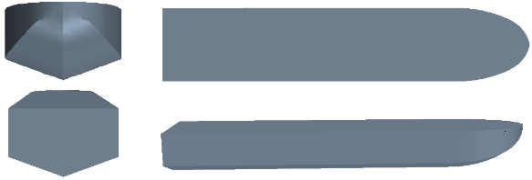

**Figure 1**. Geometry of the Fridsma hull.

The scale factor of the full-scale ATA catamaran is 13. Therefore, the full-scale ship has around 38 m length and 11.60 m breadth with 160-tone displacement. The geometry of the ATA catamaran model is presented in Figure 2.

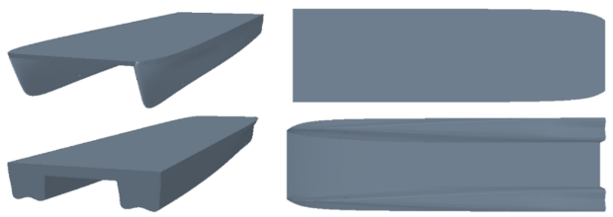

**Figure 2.** Geometry of the ATA catamaran.

**3. CFD Simulations**

A commercial flow solver is used to simulate the resistance tests for the Fridsma planing hull and ATA catamaran.

*3.1 CFD Simulations for Fridsma Planing Hull and ATA Catamaran*

CFD analysis carried out modeling unsteady, turbulent flow around the Fridsma hull and ATA catamaran. Overset meshing technique, which allows to simulate the case using multiple overlapping meshes that automatically get connected by interpolating cell data in the overlapping regions is used in this study. In overset meshing, the computational domain consists of two different regions. One is the region enclosing the entire solution domain, which involve passive cells. This region is called background region. The other region is the smaller region containing the body within the domain involve active cells, called as overset region.

In Fridsma planing hull simulations, computational domain and mesh size are adjusted according to model length which is L=1.143 m. The computational domain is generated according to the guideline published by the ITTC [19] and it extends for 3L in front of the boat, 9L behind the boat, and 4L to the side and 1.5L under the keel of the boat. The air region is 1L above the free surface. The flow around the ship is considered symmetric with respect to centerline of the hull, therefore only half of the computational domain was modeled and computational time is reduced more than half.

Boundary conditions are defined as velocity inlet for inlet where the flow comes, pressure outlet for outlet of the flow and wall for all remaining surfaces of the computational domain. The hull surface was also defined as smooth wall boundary condition.

In ATA Catamaran simulations, computational domain and mesh sizes are adjusted according to model length which is L=2.935 m. The background domain extended 5 ship lengths (L) to backward, 3L to upward, 3L to each side walls and 2L to downward. The air region is kept 0.5L above the free surface. Boundary conditions are defined as the same as Fridsma hull. The boundary conditions of the computational domain for catamaran simulations are represented in Figure 3.

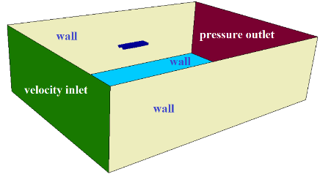

**Figure 3.** Boundary conditions of the computational domain for ATA catamaran.

Boundary layer region is important for pressure and velocity fluctuations; therefore, prism layers are generated to model the boundary layer region better. The grid must be finer around the hull to capture the water-air interface in order to model the flow details better. The grid resolution in overset region is higher than the background region, as presented in Figure 4 and Figure 5.

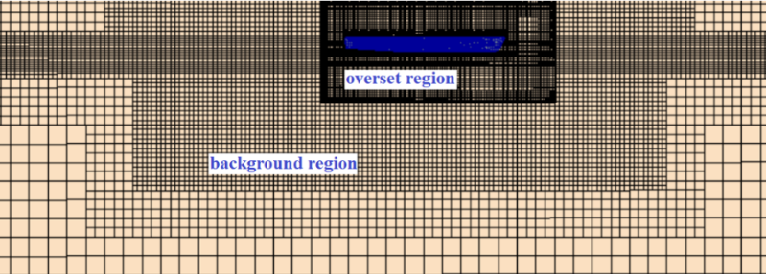

**Figure 4.** Grid resolution in the overset region and the background region.

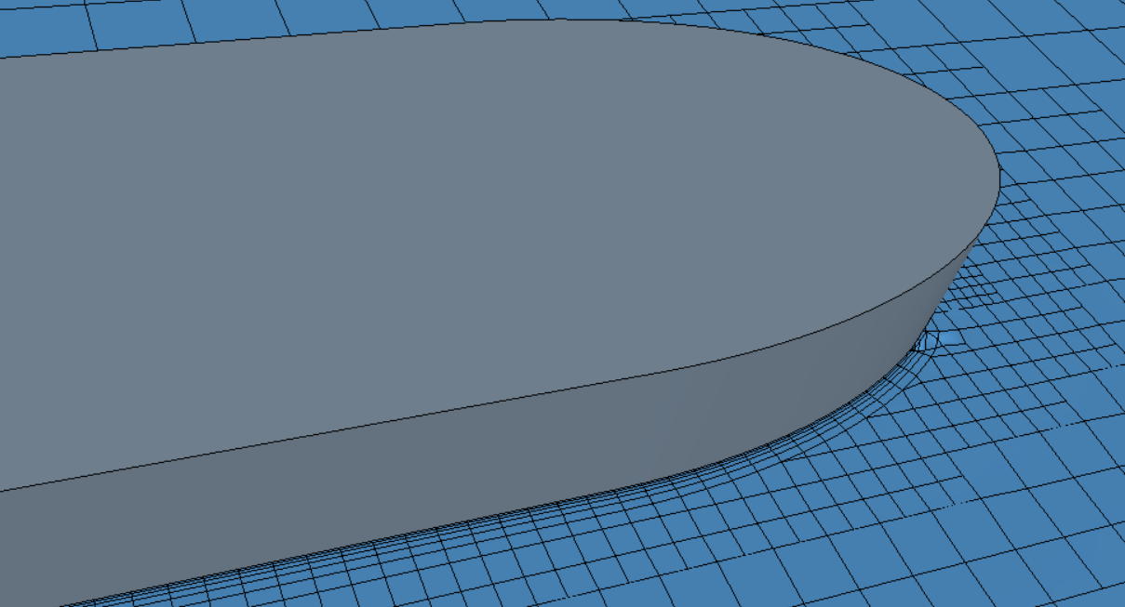 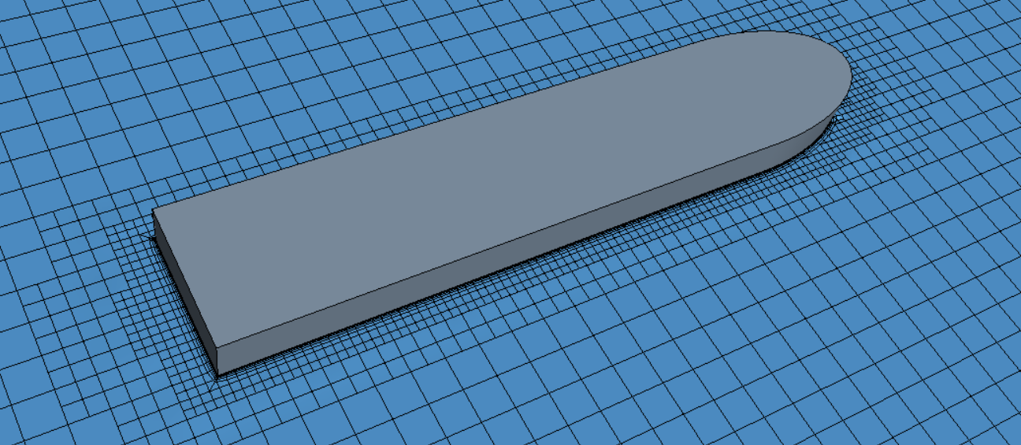

**Figure 5.** Grid resolution around the Fridsma hull model.

The total number of elements for the Fridsma hull is approximately 1.4 M, while total number of elements for the catamaran model is approximately 2.5 M for the simulations. Time step is determined as 0.05 s for all of the simulations.

For the physical modeling, the Volume of Fluid (VOF) approach, which puts in one more equation to the system of equations, was selected to predict the position of the free surface in every time step. The k-ɛ turbulence model was used to solve the turbulence effects on the flow. The Dynamic Fluid Body Interaction (DFBI) module is activated to simulate ship motions by evaluating the forces and moments on the hull. In this study, only heave and pitch motions were allowed to predict pitch and trim ranges by time.

4. Results and Discussions

*4.1 Comparison of the Resistance Predictions on Fridsma Hull*

In this section, numerical results obtained with CFD analysis and Savitsky method are compared with the experimental data in terms of total resistance values for different Froude numbers.

CFD analysis of the Fridsma hull is carried out for both L=1.143 m model and L=5.715 m model which is λ=5. Total resistance values predictions of the Fridsma model corresponding Froude numbers given by Table 1 are compared to EFD, CFD and Savitsky method as presented by Figure 6 below. In order to the presented results to be more similar to a real high-speed craft, the results of the model with scale factor λ=5 are given.

**Figure 6.** Comparison of the total resistance values for corresponding Froude numbers.

Savitsky [20] derived semi-empirical formulas for the motions and the resistance of the prismatic planing hulls. His approach is accepted in good accordance with the

experimental results. The method of Savitsky is used in the study to compare the resistance values obtained numerically and experimentally.

The comparisons for the predicted total resistance values with the experiment (EFD) and numerical (CFD) and Savitsky method results show that the total resistance for the Fn=0.590 are around 1.6-1.7 kN and 1.9-2.1 kN for the Fn=0.890. However, Savitsky approach underestimates the total resistance for these conditions. For the Fn=1.188, Fn=1.478 and Fn=1.780; EFD, CFD and Savitsky predictions are between 2.0 and 2.4 kN, 2.5 and 2.8, 3.1 and 3.6 kN, respectively. Results obtained by CFD are close to experimental data and these results are in better accordance with experiments compared to the results obtained by using Savitsky approach.

*4.2 Comparison of the Resistance Predictions on ATA Catamaran*

Total resistance predictions, obtained by EFD, CFD and Savitsky method for ATA Catamaran for different non-dimensional Fn conditions are presented in Figure 7.

**Figure 7.** Comparison of the total resistance values for corresponding Froude numbers.

The comparisons for the predicted total resistance values with the EFD, CFD and Savitsky method results show that the total resistance for the Fn=0.532 is around 45 N for EFD, CFD and Savitsky predictions. For the Fn=0.665, EFD and CFD results are around 55 N, while the Savitsky approach result is higher, which is around 72 N. EFD and CFD results are between 68-72 N for Fn=0.798 conditions and between 86-91 N for Fn=0.931 conditions. Thus, it can be said that the CFD predictions have similar results with the experiments. However, the Savitsky formula results are around 20-25% higher for the Fn=0.665, Fn=0.798 and Fn=0.931 conditions. The Savitsky approach underestimates the sinkage of the vessel and this might be one of the reasons why the order of difference is higher.

Total resistance and required propulsion power predictions of the ATA Catamaran for full-scale vessel are presented in Table 2 below. The required propulsion power for the ATA Catamaran is calculated by Maxsurf software.

**Table 2.** Total resistance and required propulsion power for the ATA Catamaran (full scale).

|  |  |  |  |
| --- | --- | --- | --- |
| **Fn** | **RT [kN]**  **EFD** | **RT [kN]**  **Savitsky** | **Required Power [kW]** |
| 0.532 | 80 | 75 | 780 |
| 0.665 | 95 | 116 | 1500 |
| 0.798 | 115 | 135 | 2170 |
| 0.931 | 143 | 160 | 2910 |

The required propulsion power for the full-scale catamaran is obtained between 780 and 2910 kW for 0.532 and 0.931 Fn number range, respectively. A main engine selection is made to meet this propulsion power. The noise data that is obtained from technical specification of this main engine is presented in Figure 8 below. The sound pressure level values (SPL) are given in dB unit and the frequency values, which are presented in logarithmic scale, are given in Hz unit.

**Figure 8.** Noise data of the main engine.

The noise data of the main engine is presented to give an idea of ​​the noise emitted into the environment. The noise of the main engine is around 90 dB, which is quite violent and harmful noise for the marine animals and people. In addition, it is obvious that the emission gases discharged to the environment in response to this propulsion power will very adversely affect animals, nature and people.

*4.3 Prediction of Fuel Emissions* *on ATA Catamaran*

Table 3 shows the dependence of the amount of exhaust gas spread by the vessels on fuel emission factors: HC, CO, CO2, PM, NOx and SOx. It can be seen from Table 3 that fuel emission factors also increased due to the increase in fuel consumption of catamarans. Since the major increase has been observed for CO2, calculations of emission factor and related analysis were detailed only for CO2. [21]

**Table 3.** Diesel engines emissions factors.

|  |  |  |  |  |  |  |
| --- | --- | --- | --- | --- | --- | --- |
| Emission type | HC | CO | CO2 | P.M10 | SOx | NOx |
| Emissions factor [g/kg fuel] | 2.4 | 7.4 | 3170 | 1.3 | 20 | 57 |

In this section, the CO2 emission, which is one of the most harmful emissions emitted from ships, has been calculated analytically. As can be seen from the Equation (1) above, CO2 emissions emitted from ships depends on emission factor, specific fuel oil consumption (SFOC) and engine load. The equation shows that if engine load increases, SFOC and CO2 emission will increase proportionally.

${CO}_{2}emissions [g/hr]=Emission factor×\left[EnginePower×\int_{0}^{T}{\left({SFOC}_{t}×Engine{Load}_{t}\right)ⅆt}\right]$ (1)

Equation (1) which is obtained from [22], is used to calculate the amount of the emissions from a ship by an hour (g/hr). Emissions from ships are usually calculated by means of quantifying the fuel consumption by power production first and then multiplying the consumption by emission factors.

In this study, emission factor (emission value of engine) accepted constant (one gram), sailing time is calculated for one hour time-frame and the equation is calculated for 1850 kW engine power with a velocity range of 20 - 35 knots, 75 % and 90 % engine load. The result of the CO2 emission analysis is presented in Figure 9 below.

**Figure 9.** CO2 Emission Analysis.

The graph presented in Figure 9 shows that CO2 emission increases about 5-8 % per 1 knot speed increase. One may observe that if the service speed is increased only one knot, from 34 knot to 35 knot, then the calculated CO2 emission of 35 knot raised about %30 of the CO2 emission of 34 knot.

**5. Conclusions**

A numerical study has been carried out to predict the damages to the environment in response to the increasing speed of high-speed boats. Within this context, total resistance values have been compared with the experimental data and required propulsion powers have been estimated for different non-dimensional Fn conditions for two different kinds of high-speed boats. Then, total resistance of the catamaran for full-scale vessel have been calculated using an extrapolation method and required propulsion power predictions have been conducted. Noise and fuel emissions predictions, corresponding to the required propulsion power have also been performed.

Based on the foregoing analysis, some conclusions drawn from the study are as follows:

* For high-speed boats, if the velocity is increased, the resistance value corresponding to this speed also increases and if the resistance increases, it is necessary to increase the propulsion power.
* If the required propulsion power increases, it is necessary to choose a stronger main engine. A stronger main engine causes more fuel consumption, emissions and noise. As a result, if the velocity of a vessel is increased, the damage to the environment, people and animals increases.

The general conclusion obtained from the study is, a certain speed limit rule should be arranged for high-speed boats and the boats should not exceed this speed. If this issue is not taken into account carefully and necessary measures are not taken; the environment, people and animals will continue to be negatively affected.

**Acknowledgments**

The authors appreciate Özata Shipyard, which provided the experimental data and allowed it to be shared in the paper.

References

[1] J. A. Hildebrand, “Anthropogenic and natural sources of ambient noise in the ocean,” *Mar. Ecol. Prog. Ser.*, vol. 395, pp. 5–20, 2009.

[2] B. Aktas, “A Systematic Experimental Approach to Cavitation Noise Prediction of Marine Propellers,” School of Marine Science and Technology Newcastle University, Ph.D. Thesis, 2016.

[3] W. H. Organization, “Burden of Disease from Environmental Noise,” p. 128, 2011.

[4] E. P. Fakan and M. I. McCormick, “Boat noise affects the early life history of two damselfishes,” *Mar. Pollut. Bull.*, vol. 141, no. May 2018, pp. 493–500, 2019.

[5] S. Smott, A. Monczak, M. E. Miller, and E. W. Montie, “Boat noise in an estuarine soundscape – A potential risk on the acoustic communication and reproduction of soniferous fish in the May River, South Carolina,” *Mar. Pollut. Bull.*, vol. 133, no. November 2017, pp. 246–260, 2018.

[6] Z. T. Wang *et al.*, “Underwater noise pollution in China’s Yangtze River critically endangers Yangtze finless porpoises (Neophocaena asiaeorientalis asiaeorientalis),” *Environ. Pollut.*, vol. 262, p. 114310, 2020.

[7] G. Sarà *et al.*, “Effect of boat noise on the behaviour of bluefin tuna Thunnus thynnus in the Mediterranean Sea,” *Mar. Ecol. Prog. Ser.*, vol. 331, pp. 243–253, Feb. 2007.

[8] P. Q. Sims, S. K. Hung, and B. Würsig, “High-Speed Vessel Noises in West Hong Kong Waters and Their Contributions Relative to Indo-Pacific Humpback Dolphins (Sousa chinensis ),” *J. Mar. Biol.*, vol. 2012, pp. 1–11, 2012.

[9] J. Hazel, I. Lawler, H. Marsh, and S. Robson, “Vessel speed increases collision risk for the green turtle Chelonia mydas,” *Endanger. Species Res.*, vol. 3, no. October, pp. 105–113, 2007.

[10] J. Davenport and J. L. Davenport, “The impact of tourism and personal leisure transport on coastal environments: A review,” *Estuar. Coast. Shelf Sci.*, vol. 67, no. 1–2, pp. 280–292, 2006.

[11] L. Roberts, S. Collier, S. Law, and A. Gaion, “The impact of marine vessels on the presence and behaviour of harbour porpoise (Phocoena phocoena) in the waters off Berry Head, Brixham (South West England),” *Ocean Coast. Manag.*, vol. 179, no. July, p. 104860, 2019.

[12] N. Rako-Gospić and M. Picciulin, “Underwater noise: Sources and effects on marine life,” *World Seas An Environ. Eval. Vol. III Ecol. Issues Environ. Impacts*, pp. 367–389, 2018.

[13] A. M. Bassam, A. B. Phillips, S. R. Turnock, and P. A. Wilson, “An improved energy management strategy for a hybrid fuel cell/battery passenger vessel,” *Int. J. Hydrogen Energy*, vol. 41, no. 47, pp. 22453–22464, 2016.

[14] L. E. Klebanoff *et al.*, “Comparison of the greenhouse gas and criteria pollutant emissions from the SF-BREEZE high-speed fuel-cell ferry with a diesel ferry,” *Transp. Res. Part D Transp. Environ.*, vol. 54, pp. 250–268, 2017.

[15] A. E. Farrell, J. J. Corbett, and J. J. Winebrake, “Controlling air pollution from passenger ferries: Cost-effectiveness of seven technological options,” *J. Air Waste Manag. Assoc.*, vol. 52, no. 12, pp. 1399–1410, 2002.

[16] A. P. Gusti and Semin, “Effect of ship speed on ship emissions,” *Asian J. Sci. Res.*, vol. 11, no. 3, pp. 428–433, 2018.

[17] G. Fridsma, “A systematic study of the rough-water performance of planing boats, Davidson Laboratory Report, 1275.,” 1969.

[18] I. Akkerman, J. Dunaway, J. Kvandal, J. Spinks, and Y. Bazilevs, “Toward free-surface modeling of planing vessels: Simulation of the Fridsma hull using ALE-VMS,” *Comput. Mech.*, vol. 50, no. 6, pp. 719–727, 2012.

[19] “Practical guidelines for ship CFD applications,” *Int. Towing Tank Conf.*, vol. In: Procee, 2011.

[20] D. Savitsky, “Hydrodynamic analysis of planing hulls,” *Mar. Technol.*, vol. 1, pp. 1, 71–95, 1964.

[21] A. Banawan, M. Mosleh, and I. S. Seddiek, “Prediction of the fuel saving and emissions reduction by decreasing speed of a catamaran,” *J. Mar. Eng. Technol.*, vol. 12, no. 3, pp. 40–48, 2013.

[22] J. Faber, D. Nelissen, G. Hon, H. Wang, and M. Tsimplis, “Regulated slow steaming in maritime transport: An assessment of options, costs and benefits.”, Report Delft, 2012.

[23] A. D. Alkan, “From Design Stage to Operational Performance of an Innovative Lightweight Composite Catamaran”, 11th International Symposium on High Speed Vehicles, Vol.1, No.1, Napoli, Italy, pp. 1-15, 2017.

1. Corresponding Author, Turkish Naval Academy, National Defence University, Tuzla, Istanbul, Turkey; E-mail: adalkan@dho.edu.tr, alkanad@yildiz.edu.tr.