Assessment of shipboard sound insulation in the low frequency range through a laboratory experimental methodology based on a modal approach

Mirko BASSETTIa,[1], Federico GAGGEROa, Andrea PRATOb, Alessandro SCHIAVIb, Tatiana PAISc, Paolo SILVESTRIc, Enrico LEMBOd

a Cetena S.p.a, Genova, Italy

b INRiM – National Institute of Metrological Research, Turin, Italy

c Università degli Studi di Genova, Genova, Italy

d Fincantieri Direzione Navi Mercantili ASR

**Abstract.** In recent years a growing need in naval acoustics for the characterization of low frequency materials below 100 Hz and particularly from 50 Hz has been observed. The problem related to airborne and impact acoustic insulation at low frequencies is becoming more and more relevant due to the considerable impact of sound sources at these frequencies, such as audio-video systems in theaters and discos as well as TV systems inside cabins. Current measurement procedures for identifying the sound insulation properties of bulkheads and floors are not sufficient to ensure repeatable and reproducible measurements, as accuracy and precision values are too low to be accepted when applied at frequencies below 100 Hz. In fact, at low frequencies and in ordinary laboratory or room volumes between 40 m3 and 80 m3, the acoustic field is no longer diffuse due to the dominant presence of standing waves or modes, which result in large fluctuations of the sound pressure level in space and frequency. In the present study, an experimental methodology based on the modal approach is proposed and applied for the study of low-frequency sound insulation phenomena below 100 Hz in the naval field. An extensive experimental activity has been conducted at CETENA laboratories in Riva Trigoso, which has allowed to validate the measurement procedure and compare it with classical theories of sound transmission. The development of this approach seems to be able to provide significant support in the design phase for the optimization of shipboard sound insulation performances.

**Keywords.** Low frequency, modal approach, airborne sound insulation, impact sound insulation, naval acoustics

# Introduction

Laboratory measurements of the sound insulation of vertical partitions (in terms of airborne sound insulation) and horizontal partitions (in terms of impact noise attenuation) are historically performed in the frequency range between 100 Hz and 5000 Hz, as described in the ISO 10140 series of standards [1]. In some specific areas, related to building acoustics and particularly naval noise control, a growing interest has been observed in the possibility of extending measurements into the low frequency range, down to 50 Hz. Existing standards (ASTM and ISO) suggest to verify the possibility of extension of measurement capabilities to low frequencies, adopting appropriate procedures and methodologies, without however providing specific technical/practical implementation details. It is therefore necessary to make use of measurement techniques, supported by a consolidated theoretical basis, completely innovative, in order to properly determine the acoustic performance of the partitions, in the low frequency range. The presence of low-frequency tonal components, generated by the operation of thrusters and propagated through the metal structures, as well as the partitions commonly adopted in the naval sector, present mechanical characteristics particularly favorable to the propagation and transmission of noise below 100 Hz [2]. For this reason, it is necessary to extend the methods for the evaluation of the acoustic performance below this frequency. This extension involves, however, a series of technical and procedural issues still debated in the international scientific and regulatory community, and results are currently available in the technical and scientific literature. As a matter of fact, at present, for the low-frequency range, a technical measurement procedure effectively representative of acoustic behavior has not yet been identified, the qualification procedures for laboratories have not been defined, and the proposed rating criteria (ISO 717 series, 2013) in building acoustics are not considered satisfactory [3] and are not used. The choice to keep the voluntary extension of acoustic measurements to low frequencies in the current regulations is mainly due to the lack of significant case studies. The assumptions for measurements up to 50 Hz are currently only supported by theoretical studies and acoustic field modelling (e.g. [4]). Some European research groups have devoted themselves to the experimental study of the proposed extension. Various hypotheses have been formulated and some measurement methodologies investigated, also on the basis of previous studies already carried out since the 1990s of the last century (e.g. [5]). However, a rigorous comparison between laboratories for the definition of repeatability and reproducibility of measurements is still far from being planned and uncertainties, when stated or commented, are significantly high. In addition, the accuracy of results, obtained with different measurement methods, remains a critical issue to be thoroughly investigated. Recently, the INRiM (National Institute of Metrological Research) proposed technical procedures for measuring the sound insulation of horizontal and vertical partitions extended up to 50 Hz, defining a qualification protocol of the measurement environments able to guarantee such extensibility, based on the study of the spatial and temporal distribution of the standing wave field, the so-called modal approach [6-9]. At CETENA acoustics laboratories, such method has been recently implemented to evaluate the sound insulation performances of naval partitions and floors in the low-frequency range. In this work, preliminary results are shown and described.

# Theoretical background of the modal approach

Considering a parallelepipedal space of dimensions *Lx*, *Ly*, *Lz* bounded by flat, homogeneous and perfectly reflecting surfaces, analogous to an acoustic test laboratory, the spatial-temporal distribution of acoustic pressure within such space, for each resonance frequency (or normal mode of vibration), is given by:

 (1)

where the resonant frequency (or mode) *fn* is

 (2)

Depending on the values of the trio of modal indices (*nx*, *ny*, *nz*) it is possible to define three types of modes or resonance frequencies, namely axial, tangential and oblique [10]. From Eq. 1, in the eight vertices of the parallelepiped all modes contribute to the sound pressure; at the center of the room all modes for which at least one of the three modal numbers is odd are zero. Such non-diffuse acoustic field is exacerbated below the Shroeder frequency of enclosed rooms which depends on the room volume *V* and by the reverberation time *T* and is given by *fs*=2000(*T*/*V*)0.5. This value, for the small laboratory and naval cabins which are in order of few cubic meters, is usually around 300-400 Hz. This means that standard acoustic measurements in such small rooms are not accurate for the evaluation on the sound insulation performances. In fact, standard acoustic descriptors, such as sound reduction *R* and impact sound pressure level *L*, assume a diffuse acoustic field, thus are inaccurate when applied to non-diffuse conditions, i.e. typically below 100 Hz and result in low reproducibility values and are not representative of the correct physical phenomena involved (low modal density, non-uniform sound field in space, and frequency domains) [11-12]. Currently, it is not possible to correctly define the incident and transmitted sound power in such a modal acoustic field using the standard approach. However, as described in [13], evidence of transmission of source room modes into the receiving room through the partition occurring in airborne sound insulation measurements allows the introduction of the modal approach based on a description of modal sound transmission loss, i.e., the attenuation of source room modes passing through the partition into the receiving room. This evaluation allows to move from a statistical point of view in terms of averaged spatial-temporal sound pressure levels, typical of the diffuse field condition, to a discrete one, focused, in the frequency domain, on the modes of the source room and, in space, on the positions of maximum modal sound pressure levels (corners of rectangular rooms). This descriptor of sound transmission loss in the non-diffuse field can be represented by the modal sound isolation, *Dmodal*(*fn*), which is defined as the difference between the highest sound pressure levels of the modal components of the source environment (room 1), *fn*, evaluated at the corner positions, *xcorner*, and transmitted into the receiving environment (room 2) (Eq. 4) [6-7]:

** (4)

*Dmodal*(*fn*) is a discrete index in that it refers only to the resonant frequencies of the source room and provides an indication of the sound transmission loss of an acoustic mode passing through the partition from the source room to the receiving room. In addition, the resonant frequencies provide information about the resonant half-bandwidth *f-3dB* related to modal sound absorption [14] and are stable over time. In the case of modal sound overlap of transmitted and proper modes in the receiving room, a numerical method was used to normalize these phenomena and minimize any systematic errors [6].

At the same time, the motion of the ship floor is described by the equation of the damped, forced, inhomogeneous bending wave responsible for the sound radiation in the receiving room [15]. This results in a strongly modal acoustic field in the receiving room governed by the damped wave equation which is similar to Eq. (1). The effect of the sound pressure field generated in the receiving room on the vibrational velocity field of the floor and the transmission of airborne sound from the source room to the receiving room are neglected. In this wat, a new descriptor is introduced, namely the modal impact sound pressure level, *Lmodal*, defined as the highest sound pressure level measured at the corners of the receiving room for each resonant frequency, *fn* [8]. Because of the discrete nature of modal sound isolation, a new method is also proposed to extend it to the entire low-frequency range in the one-third octave bands of 50 Hz, 63 Hz, 80 Hz (44 Hz to 89 Hz, the lower and upper limits, respectively). Considering a laboratory room with different dimensions, it is possible to assume that resonant frequencies can shift in frequency and move along the envelope of the spectra of the source room and the receiving room, i.e., along the curve connecting the resonant peaks of the source room point by point (linear fit) [16]. In this way, both modal descriptors can be extended to the entire 44-89 Hz range and a representation in third-octave bands is thus possible. The envelope method was validated experimentally and statistically by measurements on scaled models [6].

# Qualification of CETENA acoustic laboratories

Prior to the implementation of the proposed measurement method, the qualification of laboratory rooms is necessary in order to evaluate rooms’ modes. At CETENA laboratory (Riva Trigoso), two main chambers are dedicated to the measurement of sound insulation and impact sound insulation according to ISO 10140: the transmitting room for the airborne sound insulation of vertical bulkheads (Chamber 1) and the receiving room used for both airborne and impact sound insulation measurements (Chamber 2). A third room is used as transmitting room for the measurement of impact sound insulation but is useless for the above-mentioned measurements. The three rooms are semi-reverberant chambers with a parallelepiped shape and volumes of approximately 50-60 m3. The rooms are completely decoupled and the perimeter walls are built in reinforced concrete with high acoustic impedance. The whole of the three chambers is shown in Figure 1. The qualification of acoustic rooms for low frequency modal measurements consists in the experimental evaluation of the acoustic modes of each. For this reason, a single layer wall of high-density solid brick was constructed between chambers 1 and 2 so that vibrational modes generated by perimeter contours are negligible. The measurement of the modes is carried out by placing the sound source emitting a sweep signal from 20 Hz to 120 Hz in a corner of the room and the microphones in the 7 corners at a distance of about 5 cm from them, positions in which all the acoustic resonance modes of each parallelepiped room are excited.

Figure 1 (right) shows the average experimental spectra of each room, from which the final modes are evaluated. Chambers 1 and 2 show a strongly modal behavior. Modes are represented by the different peaks of the spectral curve. From these average curves, the resonant frequencies can thus be deduced as summarized in Table 1.

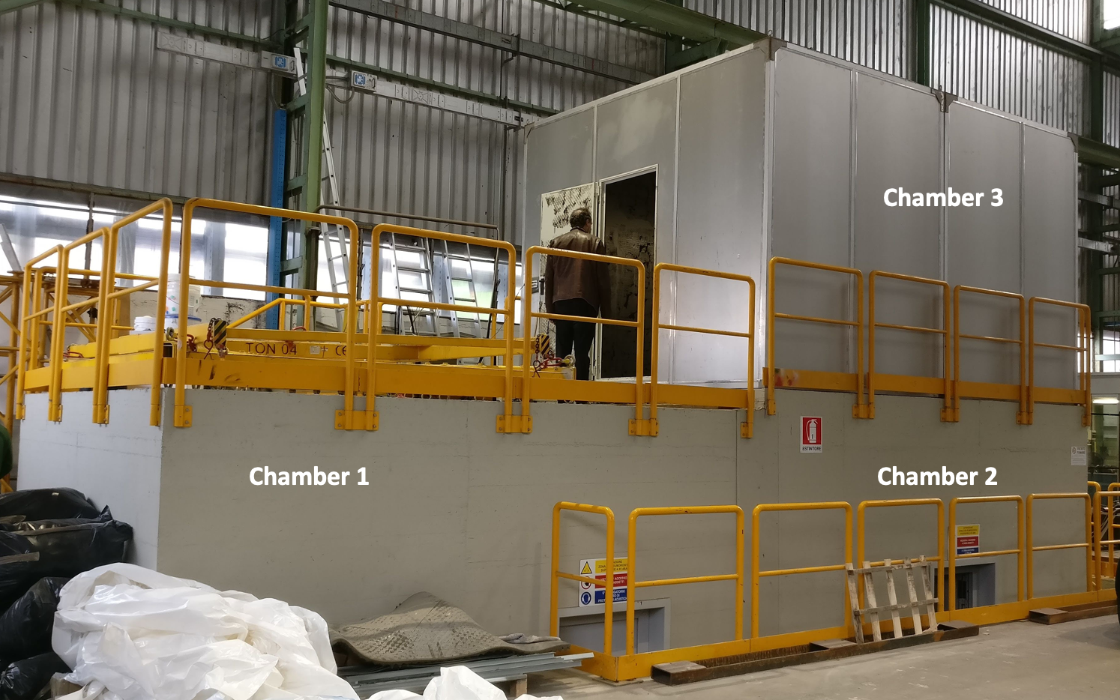 

**Figure 1.** CETENA acoustic test chambers.

**Table 1.** Resonant frequencies or modes or chamber 1 and chamber 2

|  |  |  |  |  |  |
| --- | --- | --- | --- | --- | --- |
| **Modes of room 1 / Hz** | | | **Modes of room 2 / Hz** | | |
| 43.3 | 66.1 | 97.8 | 35 | 68.9 | 97.8 |
| 46.7 | 69 | 99.4 | 45.3 | 69.6 | 102.5 |
| 51 | 81.3 | 102.4 | 51.9 | 78.3 | 104.6 |
| 62.6 | 86 | 106 | 58.4 | 82.6 | 108.2 |
| 64.1 | 93.1 | 110.4 | 62.2 | 86.2 | 112 |

# Airborne sound insulation

Once the highest modal excitation points have been identified, i.e. the corners of the laboratory environment, sound pressure level measurements are performed using a closed box type loudspeaker generating a sweep type signal from 20 Hz to 120 Hz in a corner of the source room, placing microphones in the 7 corners of the source room and in the 8 corners of the receiving room. Spectra analysis is performed using FFT (frequency resolution of 0.1 Hz) in order to identify all modes. Measurements are carried out on a vertical bulkhead coated with Paroc insulation system (Fig. 2, right).

 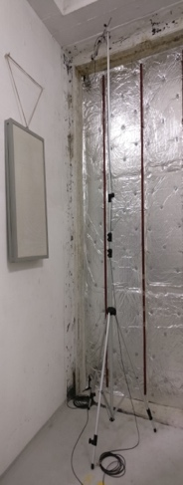

**Figure 2.** Average spectra of the source and receiver rooms (left) at Cetena during low-frequency sound insulation measurements on a naval bulkhead coated with Paroc isolation system (right).

Measurements are repeated three times to assess the repeatability of the test. From the modes previously measured during the qualification, source and receive room modes are identified (Fig. 2, left). Once the sound pressure levels of the receiving room are normalized to eliminate modal sound overlap, the low-frequency modal sound insulation curve for each mode of the transmitting room is obtained (Fig. 3, left) given by Eq (4). The uncertainty bars (±2 dB) take into account the dispersion of the measured sound pressure level values in the corners of the rooms and repeatability measurements.

From the envelope of the modal experimental curves of the source and receiver environments (Fig. 2), low-frequency modal isolation in third octaves was extended, as described previously and shown in Fig. 3 (right). Modal sound insulation values between 35 dB and 45 dB are found, congruent with the type of partition measured.

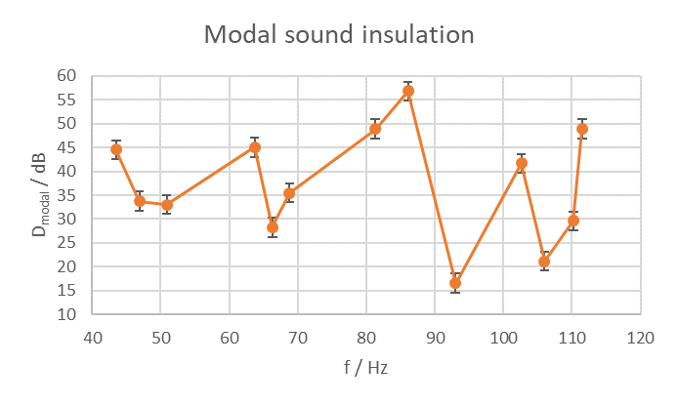 

**Figure 3.** Modal sound insulation measured with the procedure described.

# Impact sound insulation

Similarly, impact sound pressure level measurements are performed using a heavy/soft standardized rubber ball (see ISO 10140-3:2010), in Fig. 4, dropped on the floor at a distance of 1 m at four different floor positions within 0.75 m from the edge, in order to generate impact noise and excite the main modes of the floor and the chamber below. Such a source is preferred over the normalized tapping machine because the latter fails to excite low frequencies with sufficient energy [8]. The sound generated by the normalized soft impact ball is acquired by placing microphones in the 8 corners of the receiving room. Spectra analysis is performed by FFT (frequency resolution of 0.25 Hz) in order to identify all modes. In this case, a ship floor coated with several layers of anti-noise material (in Fig. 4) is tested. Measurements are repeated three times to assess the repeatability of the test. From the spectra obtained from the eight microphone positions and the four source positions (32 spectra), energy averaging is performed in order to obtain the modal sound pressure level generated by the impact source on the ship floor as shown in Fig. 5. Receiving chamber modes can be identified. Conjugating the resonant peaks, the envelope of the experimental modal curve is obtained and the modal impact sound pressure level is extended to third octave bands, as previously described and depicted in Fig. 6. Values between 75 dB and 80 dB are found and are congruent with the measured floor type. The uncertainty bars (±2 dB) take into account the dispersion of the measured sound pressure levels in the corners and repeatability measurements. In Fig. 6, a comparison is also shown between the impact noise levels, in third octaves, from 50 Hz to 80 Hz using the modal approach and the standard method according to ISO 10140-3:2010 from 50 Hz to 5000 Hz. As expected, modal values are higher and not very comparable with the standard ones because the measurands of the two procedures differ both physically and computationally. The former, however, are more accurate for representing the actual noise perception [17].

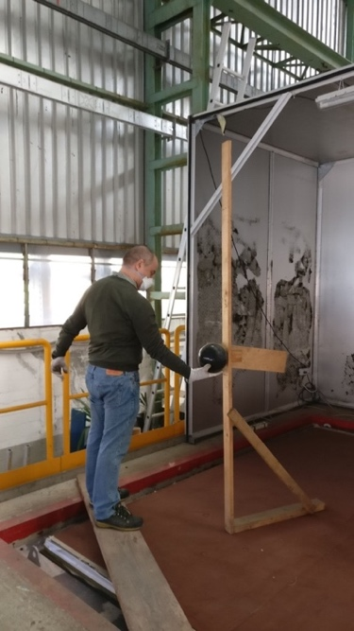 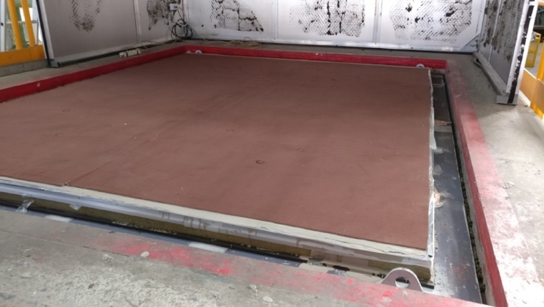

**Figure 4.** The heavy/soft normalized rubber ball dropped from 1 m (left) and the naval floor with laminated coating (right).



**Figure 5.** Average spectrum of the receiving room at Cetena with a floor covering. The solid lines represent the envelope of the spectrum of the receiving room, i.e., the curve connecting the resonant peaks.



**Figure 6.** Modal impact sound insulation in third octaves from 50 Hz to 80 Hz measured using the modal approach, and from 50 Hz to 5000 Hz measured according to ISO 10140-3:2010.

# Conclusions

Standard acoustic descriptors are not accurate for the evaluation of airborne and impact sound insulation performances of naval bulkheads and floors in the low frequency range, below 100 Hz. For this reason, in this paper, a novel measurement method based on a modal approach, developed at INRiM, is implemented at CETENA laboratories. The laboratory is initially qualified in order to find the modes of the rooms with the aim of carrying out airborne and impact sound insulation measurements below 100 Hz. Modal airborne sound insulation, based on the sound transmission of the source room modes into the receiving room through the partition, is evaluated for a ship bulkhead coated with Paroc insulation system. From the difference of the modal sound pressure levels measured in the two rooms, suitably normalized, the modal sound insulation is evaluated in the range between 44-89 Hz. By applying the spectra envelope method, it is possible to extend the measurement to the entire low frequency range and represent it in one third octave bands from 50 Hz to 80 Hz. Values between 35-45 dB are found, congruent with the type of partition measured. A similar approach is applied also for impact sound insulation measurements on a ship floor covered with insulating layers. This procedure allows evaluating the modal sound pressure levels generated by the impact of a normalized heavy/soft rubber ball in the receiving room. Modal sound pressure levels are evaluated in the range 44-89 Hz and extended to the low frequency range from 50 Hz to 80 Hz. Values between 75-90 dB are found, in line with the type of floor measured.

References

1. ISO 10140:2010 Acoustics - Laboratory measurement of sound insulation of building elements. All parts, 2010
2. Silvestri, P., Pais, T., Gaggero, F., Bassetti, M. Dynamic Characterization of Steel Decks with Damping Material by Impact Test (2021) International Journal of Structural Stability and Dynamics, 21 (7), art. no. 2150096, DOI: 10.1142/S0219455421500966
3. Masovic, D.B.; Sumarac Pavlovic, D.S.; Mijic, M.M. On the suitability of ISO 16717-1 reference spectra for rating airborne sound insulation. J. Acoust. Soc. Am. 2013, 134, EL420–EL425
4. Hopkins C, Turner P. Field measurement of airborne sound insulation between rooms with non-diffuse sound fields at low frequencies. Applied Acoustics 2005; 66:1339-1382
5. Simmons C. Measurement of sound pressure levels at low frequencies in rooms. Comparison of available methods and standards with respect to microphone positions. NT Techn Report 385 1997
6. A. Prato, Laboratory measurements of building acoustics at low frequencies: a modal approach, PhD Thesis in Metrology: Measuring Science and Technique, INRIM and Politecnico di Torino, 2015.
7. Prato, A., Schiavi, A., Sound insulation of building elements at low frequency: A modal approach, Energy Procedia, 78, pp. 128-133, 2015.
8. Prato, A., Schiavi, A., Ruatta, A., A modal approach for impact sound insulation measurement at low frequency, Building Acoustics, 23 (2), pp. 110-119, 2016.
9. Prato, A., Schiavi, A., Problems and possible solutions in the evaluation of laboratory airborne sound insulation at low frequencies, 42nd International Congress and Exposition on Noise Control Engineering 2013, INTER-NOISE 2013: Noise Control for Quality of Life, 2, pp. 1645-1654, 2013
10. Kuttruff H. Room acoustics. Abingdon: Taylor & Francis; 2000.
11. A. Meier, A. Schmitz, G. Raabe, Inter-laboratory test of sound insulation measurements on heavy walls: part II - results of main test, Building Acoustics 6 (1999) 171-186
12. Scrosati, C., Scamoni, F., Prato, A., Secchi, S., Fausti, P., Astolfi, A., Barbaresi, L., D'Alessandro, F., Di Bella, A., Schenone, C., Zambon, G., Uncertainty of facade sound insulation by a Round Robin Test. Evaluations of low-frequency procedure and single numbers, Building and Environment, 105, pp. 253-266, 2016. DOI: 10.1016/j.buildenv.2016.06.003
13. Osipov A, Mees P, Vermeir G, Low-frequency airborne sound transmission through single partitions in buildings. Applied Acoustics 1997; 52; p. 273-288
14. Prato, A., Casassa, F., Schiavi, A., Reverberation time measurements in non-diffuse acoustic field by the modal reverberation time, Applied Acoustics, 110, pp. 160-169, 2016.
15. Neves e Sousa, A. and Gibbs, B.M., Low frequency impact sound transmission in dwellings through homogeneous concrete floors and floating floors, Applied Acoustics, 2011, 72(4), 177-189
16. R. J. Pinnington, Using the envelope of the frequency response in the measurement of power absorbed by a finite structure, J Sound Vibrat 109 (1986) 127–39
17. Rossi, L., Prato, A., Lesina, L., Schiavi, A., Effects of low-frequency noise on human cognitive performances in laboratory, Building Acoustics, 25 (1), pp. 17-33, 2018.

1. Mirko Bassetti, CETENA S.p.a, Genova, Italy; E-mail: mirko.bassetti@cetena.it.