AIRBORNE SOUND PROPAGATION INDUCED BY A CRUISE SHIP THROUGH SIMULATION AND CORRELATION WITH REAL MEASUREMENTS
Mirko BASSETTI^{a1}, Maurizio MORELLIª, Attilio BINOTTI^{b} ,Enrico LEMBO^{c} Andrea IULIANO^{c}
ª Cetena S.p.a, Genova, Italy
^{b} OTOSPRO S.p.a, Pavia, Italy
^{c} Fincantieri DMC, ASR Trieste, Italy

Abstract
The publication of the Lloyd’s Register notation [1], in addition to port and civil regulations, may in the future result in shipowners requesting certification of the airborne noise levels emitted by their vessels, necessary to access areas of natural interest or certain ports [2]. This study models the sound propagation induced by a cruise ship using a software tools, starting with a database of measurements and calculations on the sound power generated by the main sources in accordance with ISO 9614-1 [3] and 9614-2 [4]. The results compared with real measurements in the far field showed the need to calibrate the model through a campaign of measurements of on-board sources in terms of sound power and pressure. The experimental measurements of sound pressure and power were used as input for the numerical models that were developed using a commercial software package, estimating in advance the noise levels measured at different distances from the vessel. In a subsequent phase of the study, the estimated data were compared with those calculated through a second experimental measurement campaign performed under the operating conditions indicated by the Lloyd’s Register Class Notation and at progressive distances from the vessel. The simulations allow to estimate the contribution of the individual sources for any desired point and the interventions ad hoc to improve comfort levels in specific positions on board that can be obtained by optimising interventions on the sources to a minimum. The development of this approach has resulted in a predictive tool with a degree of accuracy in the range required by ISO 9613 [5] and therefore capable of assessing the airborne noise emitted, comparing it with the limits imposed by the LR’s regulations or, in general, by port and civil regulations. This approach is also a useful tool for estimating the noise level in external passenger areas and therefore for a project aimed at improving on-board comfort

Introduction
A different approach for the definition of ship noise is followed by Lloyd's Register (LR) Notation [1]. It does not follow the criterion of national regulations that distinguish limits for port areas according to day and night reference periods; instead, it proposes a classification of ships according to vessel class and measured or simulated noise at a predefined distance, as indicated below.
“The publication of the Lloyd's Register (LR) notation [1], in addition to port and civil regulations, may in the future result in shipowners requesting certification of the airborne noise levels emitted by their vessels. This certification may be required for access to particular areas of natural interest or to certain ports [2].”

The Lloyd's Register procedure, i.e. "Procedure for the Determination of Airborne Noise Emissions from Marine Vessels - January 2019 Version 1.0”, was the reference used for the measurement.
The procedure defines both the methodology for calculation by acoustic simulation and the method for direct measurement of sound sources.
- The LR procedure refers to the ISO 9613-2 standard for the prediction calculation;
- For field measurements, as an alternative to the prediction method, the LR procedure requires that measurements are performed at the following distances, see Table 1, according to the acoustic class of the ship.

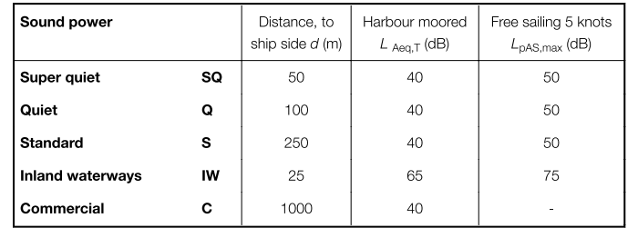
Table 1 - Limits of the procedure for the various additional classes assigned.

The measurement heights in the procedure are:
- 3.5 metres,
- H/2;
- H,
with H = maximum height of the funnels, which varies according to the different types of ship.
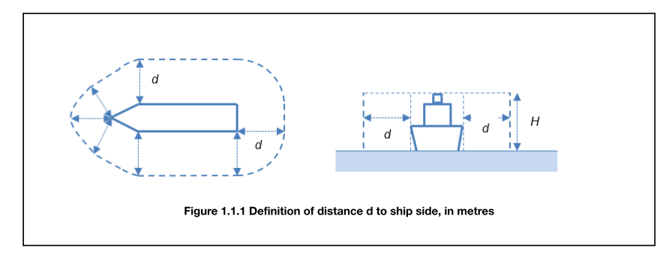
Figure 1 - Example measurement diagram.

The procedure outlined by Lloyd's Register for carrying out field measurements is not easy to apply for the following reasons:
- the need to carry out measurements under harbour conditions in environments with residual noise values below 30 dB(A);
- the need to carry out the measurements under free sailing conditions with a speed of 5 knots in conditions of residual noise lower than 40 dB(A).

The above constraints are determined by the limits of the additional class note, which requires for the first three classes (see Table 5) a ship noise value of L_{Aeq} = 40 dB in harbour condition and L_{pAS,max} = 50 dB in free sailing with a speed of 5 knots.
These values are hardly found in the conditions indicated by the procedure for implementing the measures, particularly in Sea State 2. Even if measurements were planned in the shipyard or in the harbour, the measured noise levels would be even more difficult to detect due to the presence of uncontrollable extraneous noise sources, which increase both residual and environmental noise. For these reasons, measures should be planned in sea areas where there is little traffic from other vessels and in sea state 0 conditions (completely calm sea with no waves).
A further complication is the measurement distance from the ship and the corresponding height measurement: for a Super Quiet class ship, measurements should be taken 50 m from the hull and at heights above 55 m. Given the impossibility of carrying out measurements as described in the previous paragraph, with the aim of empirically assessing the noise emission of a boat, it was decided to use a model of prediction calculation called SoundPlan
This allowed the noise of a C6268-class cruise ship to be assessed at different heights and different distances from the ship's hull according to the Lloyd's procedure. Therefore, the simulations have become a useful tool for verification at points that cannot be verified experimentally.
The simulation of noise levels was carried out in two phases:
- in the initial phase, it was decided to carry out an initial calculation of the ship's noise by characterising the sound sources with the nameplate data provided by the manufacturers of the various systems;
- subsequently, the characterisation of the main sound sources was carried out through two measurement campaigns on-board ship C6268, and the model was updated from theoretical to experimental input data.
The results obtained were compared with the noise levels measured in the vicinity of the ships

Standards and Regulations
The increase in logistic flows and the steady rise in maritime traffic accentuates noise in the maritime and port environment, particularly noise from ships, which is one of the main causes of noise pollution in the areas around the docks.
A brief review of European, National and regional regulation is needed to assess how sensitivity to ship noise has been regulated at the legislative level.
Port noise has been neglected for a long time; recently, some European programmes, including INTERREG [6], have addressed this issue.
In 1994, the European Commission presented a first report on noise levels in different countries (Study related to the preparation of communication on a future EC noise policy)[9]. As a result of the lack of homogeneity in the methods used to determine the noise levels to be compared with the mandatory limits in the various countries, in 1996, the European Commission Green Paper on Future Noise Policy proposed a draft directive that sought to harmonise the methods used to assess the population's exposure to noise and to propose uniform limit values to be adopted.
A reference for environmental noise from ships and boats were the ISO standards (EN ISO 2922:2000[7] and EN ISO 14509:2009[8]), although they do not indicate a real noise emission limit value for noise from ships. These technical standards are still a term of comparison for the noise emission indicators defined by the European Directive 2002/49/EC.
In 2002, the European Parliament issued the above-mentioned Directive 2002/49/EC "relating to the assessment and management of environmental noise", which aims to define a common approach to avoid, prevent and reduce the harmful effects of environmental noise exposure. Although the regulation mainly refers to noise from road, rail and air traffic, Annex IV mentions port noise and stipulates the need to create noise mapping for agglomerations, including ports. This directive remains an important starting point as. To ensure a high level of protection of the environment and human health, it proposes the use of certain indicators and methodologies to make the mapping of environmental noise levels as uniform as possible.
The main indicators are:
- L_{den} = day-evening-night level
- L_{night} = night level

The “day-evening-night” level, L_{den}, in decibels (dB), is defined by the following formula:
in which:
L_{day} is the A-weighted long-period averaged sound level as defined in ISO 1996-2:1987, substituted in 2007 by 1996-2:2007,
L_{evening} is the A-weighted long-period averaged sound level as defined in ISO 1996-2:1987,
L_{night} is the A-weighted long-period averaged sound level as defined in ISO 1996-2:1987.

The day is 12 hours, the evening 4 hours and the night 8 hours. The day starts at 7 a.m. and, consequently, the evening begins at 7 p.m. and the night at 11 p.m.
In the presence of reflected sound, the directive calls for a -3 dB correction if the sound level is measured at the façade.
The directive also provides for the possibility of using additional indicators to monitor or control particular noise situations.
The European directive was transposed into Italian law with Decree No. 194 of 19 August 2005 "Implementation of Directive 2002/49/EC relating to the assessment and management of environmental noise".
Since 1991, for noise pollution assessment, our legislation has used different indicators than L_{den} and L_{night}:
- L_{Aeq}, the A-weighted average sound pressure level: for the daytime period averaged over the 16 hours from 6 a.m. to 10 p.m., for the nighttime period averaged over the 8 hours from 10 p.m. to 6 a.m. and
- L_{va} for airport noise.

The UNI 11252:2007 standard "Acoustics - Procedures for converting daytime and nighttime LAeq values and LVA into L_{den} and L_{night} descriptors" defines the procedures for the conversion of the values of the equivalent continuous level (L_{Aeq)} and of the airport noise assessment index (L_{VA}) into the day-evening-night level (L_{den}) and night noise level (L_{night}) descriptors referred to in Annex I of Directive 2002/49/EC.
Like the directive, Italian Legislative Decree no. 194 of 19 August 2005 does not explicitly mention noise in port areas. Ports are only mentioned in Annex 4.
Article 11 of Italian Law no. 447 of 26 October 1995 "Framework Law on Noise Pollution" leaves the regulation of emissions from the different types of sound sources to individual implementation decrees. Italian Legislative Decree 42, published on 4 April 2017, in Article 14 amends Article 11 of Italian Law 447/95 by reaffirming that one or more decrees will adopt one or more regulations regarding the regulation of noise pollution caused by maritime traffic, vessels and craft of any kind.
The determination of criteria for measuring noise in port areas and the definition of appropriate bands is still to be issued.
Previously, the Italian Prime Ministerial Decree of 14 November 1997, "Limit values for sound sources", defined the daytime and night-time emission limit values expressed in dB(A) for the different classes into which the municipal territory can be divided, see Table 2.
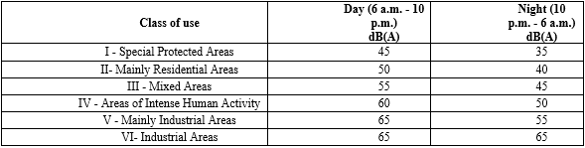

Table 2 - Emission limits Italy - Classification of the municipal territory
Port areas are taken into account in Table 2 Classification of the municipal territory of the Prime Ministerial Decree of 14 November 1997 "Determination of the limit values of sound sources". Here, port areas are considered to be areas falling within Class IV - Areas of intense human activity.
At the regional level, the classification of port areas is heterogeneous:
- In Sardinia, marinas are in class III, while commercial-industrial ports are in class IV, with the possibility of increasing the class according to specific activities;
- In Sicily, they are in class IV, and the class can be expanded so that it is similar to that of Sardinia;
- In Friuli-Venezia Giulia, they are in class VI, but only areas of intense activity are considered;
- In Emilia-Romagna, they are classified as class VI, with no distinction between commercial/industrial ports and tourist ports;
- In Apulia, Campania and Tuscany, class IV is assigned;
- In Marche, a distinction is made between areas of industrial activity and passenger ports, with the former being placed in class VI and the latter in class IV or V, depending on the presence of other activities;
- Liguria stands out among areas of industrial activity and passenger ports, with the former in class VI and the latter in class IV.
The remaining regions with access to the sea (Molise, Abruzzo, Lazio, Veneto, Basilicata, Calabria) have not defined their class or their respective levels.
The issue of port and ship noise is not unique to Italy, so it is helpful to give a brief overview of the regulations in some European countries.
Spain transposes the European Directive with Law 37/2003 and completes it with Royal Decree 1513/2005. Royal Decree No. 1367/2007 defines the limit values for new infrastructure (roads, airports, ports and production areas); see Table 3 reported as integral as per Spanish law in Spanish language.
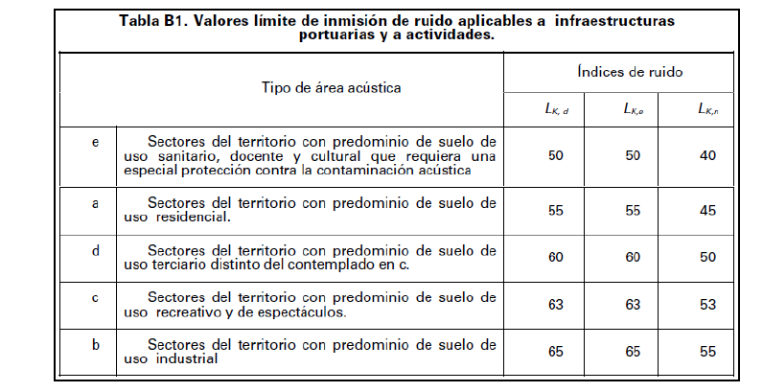
Table 3 - Spanish limits for port infrastructures and activities

In Finland, the government adopted a resolution on noise reduction and measures to reduce noise emissions on 31st May 2006, setting noise abatement targets. The regulation for residential areas sets the population noise exposure limit at an L_{Aeq} value of 55 dB for the daytime (7 a.m. - 10 p.m.) and 45/50 for the nighttime (10 p.m. - 7 a.m.).
In Sweden, the Environmental Protection Agency defines the regulation of outdoor noise. Although the standards refer to industries, they also apply to ports. The limits applicable to industrial activities are given below.

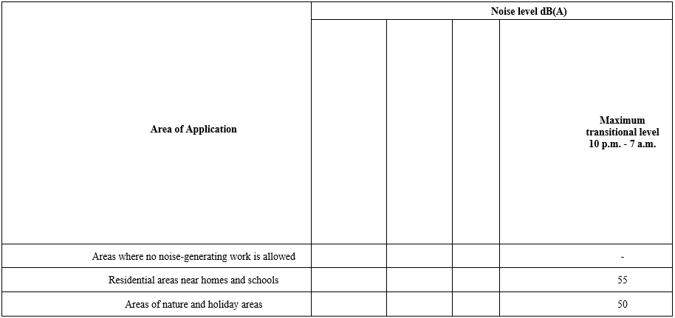

Table 4 - Noise limits for industrial activities depending on the application area in Sweden.

The United Kingdom is a special case concerning noise legislation. Guidance on noise control for outdoor areas where work activities are significantly noisy is given in BS 5228-1:2009 Part 1. The legislation sets out terms and definitions of L_{Aeq} and identifies
various approaches to determine whether a specific type of noise-producing activity is significant or not.

1- Fixed Noise Limits
Noise levels from 7 a.m. to 7 p.m. should not exceed:
- 70 dB(A) in rural, suburban and urban areas away from traffic and industrial activities,
- 75 dB(A) in urban areas close to main roads and in the presence of heavy industry.

2- Noise Change
This approach considers changes in environmental noise and can be divided into two sub-methods.

A - The ABC Method
This method specifies the noise threshold that causes significant negative effects when it exceeds the values given in 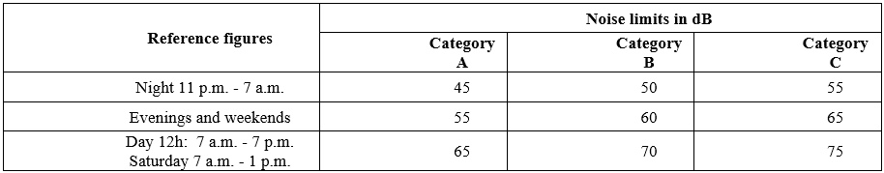

Table 5:

Table 5 - Noise limit values for significant effects on dwellings in the UK.

The different categories are defined as follows:
- category A: threshold values to be used when ambient noise levels (when rounded to the nearest 5 dB) are below these values.
- category B: threshold values to be used when ambient noise levels (when rounded to the nearest 5 dB) are the same as category A values.
- category C: threshold values to be used when ambient noise levels (when rounded to the nearest 5 dB) are higher than category A values.

B - 5 dB(A) Change Method
According to this approach, a disturbance is significant if it exceeds the ambient noise floor by 5 dB(A) or more. However, the noise level must be at its maximum: 65 dB(A), 55 dB(A) and 45 dB(A) during the day, evening and night, respectively.
Given the different regulations and guidelines, it is clear that it is difficult to define a single limit for noise emitted outside port areas and consequently for noise from ships at berth or in transit. The variability of urban port planning means different distances between potential receivers, making it impossible to define a general relationship between source and receiver levels.

- Simulation modelling

The geometric modelling of the ship started with 2D drawings of the ship decks. These, as shown in the following figure, were used to recreate the 3D model within a simulation software, see Figure 2 and Figure 3.

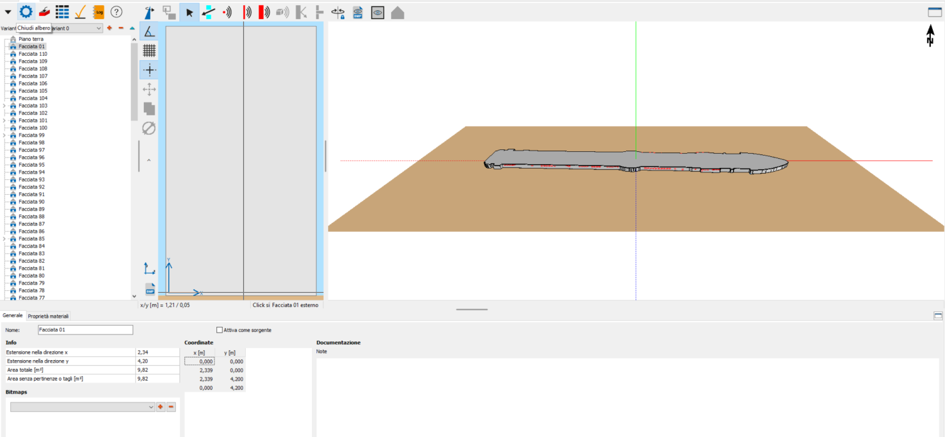
Figure 2 Deck 7 imported into the simulation model

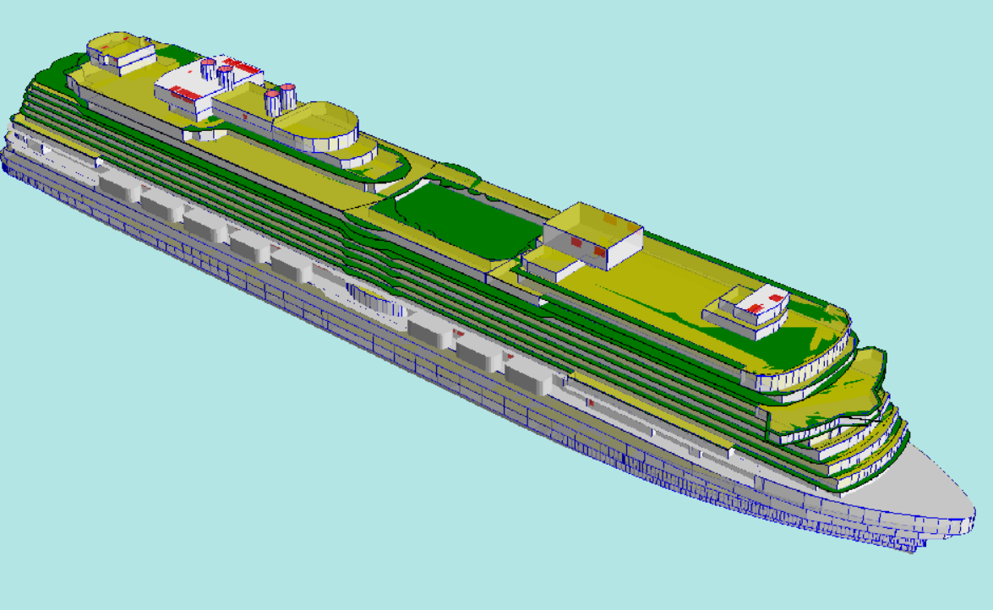
Figure 3 - 3D geometric model views
In this phase of the vessel study, the following was observed:
- the ship was considered as "moored" away from the coast;
- the ship was positioned on a smooth, fully reflective surface, which simulates the sea surface.
The meteorological-climatic values and the attenuation index of the reference surface were introduced into the forecast calculation:
- Temperature: 15 °C;
- Humidity: 90%;
- Wind - Downwind condition according to ISO standards
- Ground factor: 0 For the sea surface (G= 0 Fully reflective surface - G = 1 Fully absorbent surface)
The following conservative assumptions were considered in all the simulations performed:
- Predicted impact at 6 m above the sea surface;
- Presence in all directions of downwind conditions, for all receptors;
- The calculation model complies with ISO 9613 - 2: "Acoustics - Attenuation of sound propagation outdoors, Part 2; General method of calculation" (indicated in Italian Legislative Decree no. 194 of 19/08/2005, implementing European Directive 49/EC/2002) and maintain the conservative assumptions regarding sound emission propagation and absorption.

The calculation model Sound PLAN complies with ISO/TR 17534-3:2015 Acoustics -- Software for the calculation of sound outdoors -- Part 3: Recommendations for quality-assured implementation of ISO 9613-2 in the software according to ISO 17534-1. The model allowed for simulated sound emissions considering a specific wind condition using a special wind rose.
Once the 3D model was completed, the next step was to insert the vessel's sound sources. These have been included as spatial sources, considering their real extension and surface area. To speed up the inclusion of sources, deck elevation snapshots were created and inserted as backgrounds in the walls so that the sources could be drawn in the correct positions to minimize the error in the sound source positioning.

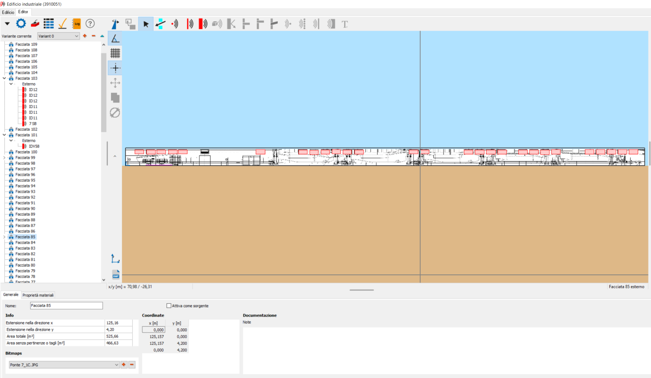
Figure 4 - Sound source input window

- Experimental acoustic input measurements of the simulation models

In June 2020, during the sea trials for the ship’s delivery, two measurement campaigns were carried out to characterise the main sound sources and the ship's noise at 50 m and 100 m from the hull.
The measurements allowed the following sound sources to be characterised:
- 28 of the 66 catalogued as ventilation (IDV symbol), 13 also characterised for power;
- 32 of the 39 catalogued as air conditioning (symbol ID), 13 also characterised for power;
- 2 of the 2 source types catalogued as funnels (pressure only);
- 18 other "additional" mixed sources related to ventilation (radar and other equipment);
- for 60 sources, the sound pressure level was measured at 1 m from the sources; for 26 sources both the sound pressure level and the sound power level were measured;
- for sources where characterisation measurements could not be performed, data measured on sources similar in type, operation and size were used;
- for all measurements performed (pressure and sound power), the operating condition of the source under investigation was indicated (power output, flow rate, etc.);

With the help of a support boat, measurements were taken in the open sea at different distances from the ship, which allowed the collection of data useful for verifying the following:
- the adequacy of the results obtained from the simulation models; and
- the actual emission levels of the ship being studied.
Five measurements were then carried out to verify the models:
- two at 50 metres,
- two at a distance of 100 metres from the ship on the starboard side,
- one 100 metres away on the left-hand side. This last measurement made it possible to verify the symmetry of the ship's emission levels with respect to amidships.

Measurements were taken at an elevation above sea level of approximately 6 metres. The measurement height made it possible to carry out the measurements in a position that was less affected by noise due to the lapping of water against the hull.
For correct model validation, environmental conditions were recorded in terms of air temperature, relative humidity, wind intensity and direction, and atmospheric pressure.
The following additional measurements were carried out during the sea trials:
- In the vicinity of the lifeboats as they constitute an obstacle to propagation for the purposes of radiated noise.

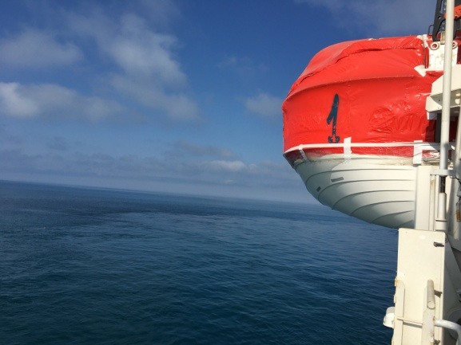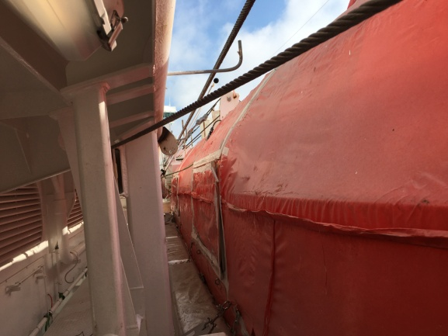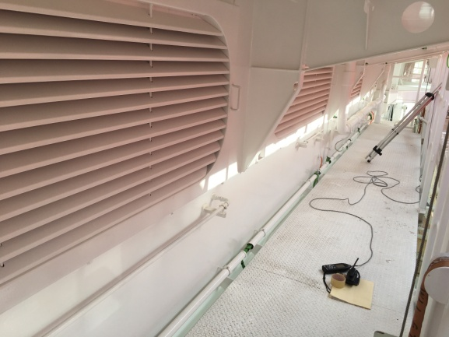
Figure 5 - Photos of the lifeboat section
- Measurements were carried out in the ship's aft section in a passenger area with ample space for sports and recreation. This data made it possible to verify the use of simulation models to simulate comfort levels on-board.

- Simulation model

The simulation models provided the results to be compared with the data measured during the measurement campaigns. Below are some images showing the graphical results of the simulations carried out.
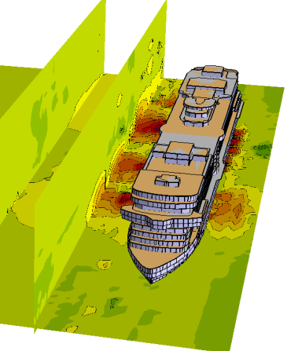

Figure 6 - Images of simulation model results
Based on the characterisation of the sound sources using field measurements, the simulations produced results better aligned with the real situation than the results obtained using theoretical data alone. The data obtained show that, before proceeding to a simple theoretical characterisation of the sound sources present in a ship, in the absence of experimental data, it is necessary to carry out in-depth measurements on similar ships to characterise such complex sound sources better.
The sea trials showed a variable degree of reliability of the models. The comparison between the simulated data and the data measured in situ, at different distances from the ship's hull, established that the prediction calculation performed with the SoundPLAN simulation software identified values closer to the experimental data and more reliable.
ISO 9613 states that a prediction model can be considered reliable when the simulation results are within the values given in Table 6 below, under favourable propagation conditions (downwind, DW1), disregarding the uncertainty with which the source sound power level is determined, as well as problems with reflections or shielding.

Average height of receiver and source [m] | Distance [m] 0 < d < 100 | Distance [m] 100 < d < 1000
0 < h < 5 | ± 3 dB | ± 3 dB
5 < h < 30 | ± 1 dB | ± 3 dB
Table 6 - Levels of accuracy related to the prediction
Table 7 shows the delta between the SoundPLAN simulations and the measurements taken at different distances from the ship.
- The delta between the simulated value and the measured value is in the range of +/-3 dB overall, except for measuring point 3 @ 100 m where the deviation is equal to 3.1 dB;
- The deviation is due to a change in wind direction during the execution of measure 3 (from 20° to 4°);
- This resulted in a value 3 dB(A) higher than the measurement taken at the same distance at point 4.- This latter point has less wind exposure due to its position (covered by the ship) and direction;
- Downwind conditions can lead to a noise increase of up to 6 dB.

Checkpoint | Distance from the ship | Simulated/measured Delta
1 | 50 metres | +1
2 | 50 metres | -0.6
3 | 100 metres | -3.1
4 | 100 metres | 0
Table 7 - Delta LAeq between simulated and measured in SOUNDPLAN

The shielding effect of lifeboats is not negligible, particularly up to 50 m from the ship, where noise increases of more than 3 dB occur. Consequently, the correct measuring point and checkpoint positions are crucial for accurately comparing data. The following map highlights the attenuation caused by the lifeboats.

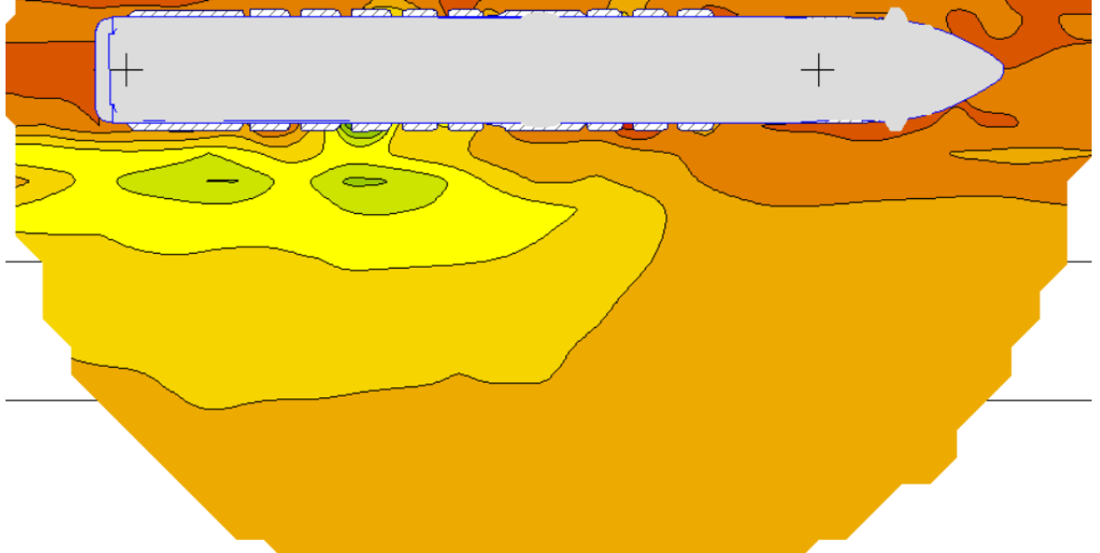
Figure 7 - Attenuation caused by lifeboats

As previously mentioned, during phonometric campaigns, four points on the open decks in a sports/leisure passenger area were also investigated to assess comfort levels in the passenger leisure areas. Overall, the results on the external deck are in line with the measurement results of the measurements. Again, the delta is within the range +/-3 dB.

The following image shows the noise emission map corresponding to the recreational area.
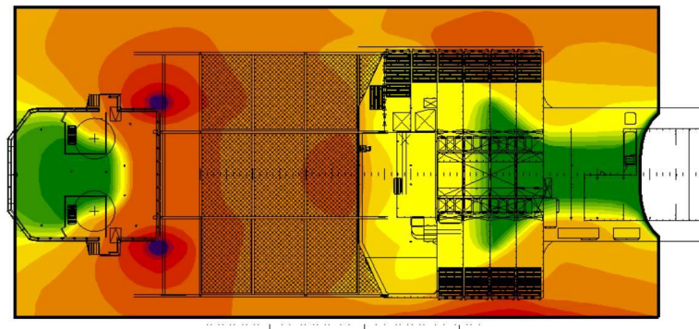
Figure 8 - Map of on-board noise emissions in the sports/leisure area
The simulation model also make it possible to extract, for each verification point inserted in the areas outside the ship, tables with the contributions of the individual sound sources that determine the noise levels at that point. These tables can be extracted for any position located either on the open decks on-board the ship (acoustic comfort) or in the far-field (acoustic impact) and then intervene ad hoc, if necessary, to improve comfort levels at specific positions on board. An improvement in comfort levels can be achieved by optimising and minimising interventions on the sources.

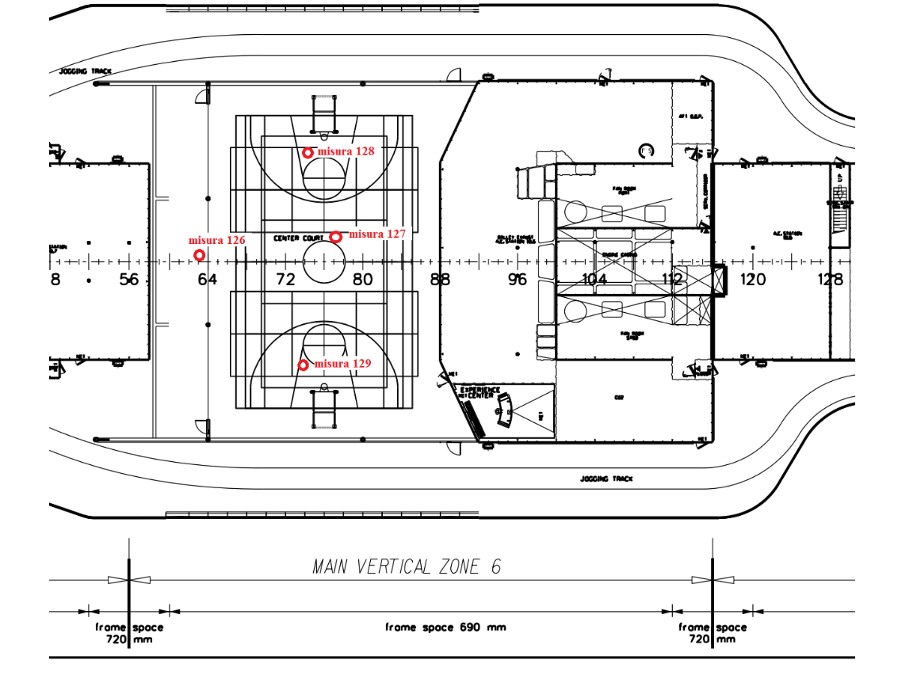

Figure 9 – Points of check between measurements and simulations.

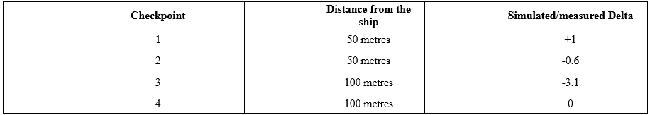
Table 7 - Delta LAeq between simulated and measured in SOUNDPLAN

7 Conclusions

The purpose of the work described here was to use a prediction model to calculate the noise emitted by a cruise ship.

- The project was developed starting with creating a database of acoustic power measurements generated by the primary sources (fans and exhaust gases) in accordance with ISO 9614-1 and 9614-2 or equivalent procedures.
- The values predicted by the calculation model were compared with those measured in two phonometric campaigns, carried out following the operational indications given by Lloyd's Register Notation, to calibrate/update the forecast models.

In terms of accuracy of results:

- the simulation model prepared with the SoundPLAN software approached the results of the far-field measurements at sea and was found to be reliable;
- in the near-field (comfort on-board), the software program was also reliable.
In terms of presenting results:

- SoundPLAN software produced a graphical representation of the results.
- The calculation model with SoundPLAN also produced:
  - a map of noise emissions in the plan at different heights,
  - a map of noise emissions one metre from the facade of the ship decks,
  - the contribution of each source to the noise levels at a given verification point.

The study proved useful in verifying that the use of reliable simulation models is a valid tool for defining the noise emitted by boats. In the future, the results of these simulations can be used for comparison with both the Lloyd's Register Notation limits and those set by national authorities for port areas.
The simulations also proved useful in predicting the sound levels in the vicinity of the external areas of the ships used by passengers. This allows:

- the estimation of on-board comfort,
- identification of the noisiest areas,
- identification of predominant sound sources to be addressed,
- estimation of the benefits and effectiveness of soundproofing measures.

Once the ship's model has been recreated within the calculation software, it can be completed with the morphological and architectural data of the port and urban areas surrounding the quays where the ship will dock. The results obtained will make it possible to verify the acoustic compatibility of each vessel with national limits.

References

[1] Lloyd’s Register (LR) notation, Procedure for the Determination of Airborne Noise Emission from Marine Vessels- Lloyd’s Register (LR), 2019
[2] Luca Fredianelli, Matteo Bolognese, Francesco Fidecaro and Gaetano Licitra, 2021. Classification of Noise Sources for Port Area Noise Mapping, MDPI, 2021.

[3] ISO9614-1, Acoustics — Determination of sound power levels of noise sources using sound intensity — Part 1: Measurement at discrete points, International Standard Organization, 2009.

[4] ISO9614-2, Acoustics — Determination of sound power levels of noise sources using sound intensity — Part 2: Measurement by scanning, International Standard Organization, 1998.

[5] ISO9613-2, Acoustics - Attenuation of sound during propagation outdoors — Part 2: General method of calculation, International Standard Organization, 2006.
[6] Luca Fredianelli, Tomaso Gaggero, Matteo Bolognese, Davide Borelli, Francesco Fidexcaro, Corrado Schenone, Gaetano Licitra -Source characterization guidelines for noise mapping of port areas- Sciencedirec VOLUME 8, ISSUE 3, E09021, MARCH 01, 2022
[7] EN ISO 2922:2000-‘Measurement of airborne sound emitted by vessels on inland waterways and harbour’, International Standard Organization, 2000.
[8] EN ISO 14509-:2009 ‘Small craft – Airborne sound emitted by powered recreational craft – Part 1: Pass-by measurements procedures’, International Standard Organization, 2009.
[9] J. Lambert, M. Vallet. LEN - Study related to the preparation of a communication on a future EC noise policy-European Communities Final report, Report No. 9420, 1994.

