Study of the corrosion behaviour of welded systems for marine industry applications

Alfredo RONDINELLAª , Francesco ANDREATTA^{a,}, Lorenzo DORBOLÒª, Ruben OFFOIACHª, Giovanni CAPURSOª, Gianluca BUFFA^{b} , Davide CAMPANELLA^{b}, Lorenzo FEDRIZZIª

ª University of Udine, Polytechnic department of engineering and architecture,
Via del Cotonificio 108, Udine, 33100, Italy
^{b} University of Palermo, Department of Engineering,
Viale delle Scienze, Palermo, 90128, Italy

Abstract. 5xxx (Al-Mg) and 6xxx (Al-Mg-Si) series alloys are most commonly used in the marine sector as they can guarantee both a good mechanical behavior and good resistance to corrosion in the marine constructions. In fact, sea water contains high amounts of chlorides that can cause, after short exposure times, the failure of entire metal structures. Since in a boat there is the coexistence of different materials, it is inevitable that some of them must be welded together. Welds between dissimilar materials often require the use of non-traditional techniques, such as the process of Friction Stir Welding (FSW) and explosion welding. In this work, the resistance to corrosion of FSW joints (AA5083/AA6082) and trimetallic explosion welded joints (AA5083/AA1050/structural steel) combining galvanic coupling and immersion tests with microstructural characterization of corroded regions. In particular the focus of the work is on the corrosion behavior of thermo-mechanically and nugget zones in FSW joints and on the AA1050/steel interface in the trimetallic joints obtained by explosion welding.
Keywords. Friction stir welding, explosion welding, galvanic coupling, corrosion.

Introduction
Solid-phase welding processes are non-conventional techniques in which the joint is produced without melting the base metal. Since there is no fusion, solid-phase welding can overcome some of the common problems characteristic of traditional techniques such as porosity, hot cracking, distortions and residual stresses [1]. In addition, no filler metals or shielding gases are required and, due to the lower significance of expansion coefficients and thermal conductivity, there is the possibility of joining dissimilar materials together [2].
Friction Stir Welding (FSW) is one of most common solid phase welding processes and requires a cylindrical tool and a pin of suitable shape. These components, rotating at high speed around their own axis and moving along the line of junction, generate through friction the required heat to increase the ductility of the base material until it softens, without reaching the melting point. The materials to be joined, thanks to diffusive processes favored by temperature and plasticization, mix intimately with each other and, once cooled, the solid phase (nugget zone) that joins the two pieces can be seen. In the naval sector, FSW is mostly used to weld aluminum alloys [2]. Therefore, the FSW process is proposed as an alternative to traditional welding used to join together different components (mainly of the superstructure of the boat) made of aluminum alloy [2].
Explosion Welding processes is another solid-state welding technique, used in the naval sector to produce hybrid steel-aluminum alloy joints without incurring in some of the most common downsides of traditional welding. In some ships the hull is made of structural steel while the superstructure is made of one or more aluminum alloys. These two metals cannot be joined by traditional welding techniques and, in the past, were joined by riveting. However, the use of mechanical joints in the marine environment, involves problems of crevice corrosion and galvanic coupling [3].
The introduction of the explosion welding process has enabled the rapid spread of so-called structural transition joints (STJs). These are strips of bimetallic (structural steel-aluminum alloy) or trimetallic (structural steel-pure aluminum-aluminum alloy) material [4]. During the explosion welding process, two panels of metal material to be welded, (structural steel and aluminum alloy series 5xxx) are placed in front of each other at a distance of a few millimeters and with a relative inclination of a few degrees. A thin sheet of commercially pure aluminum (typically AA1050) is often placed between the two panels with the purpose of facilitating the welding of the aluminum alloy and structural steel, avoiding the formation of an interface that is too brittle due to excessive intermetallic formation [5-7]. Given the improved properties of the trimetal STJ joint, it is by far the most widely used in the marine industry. The explosion welding process for the realization of STJ allows to obtain joints with high thickness, even beyond 20 mm [6]. Galvanic corrosion between aluminium alloys and steel is a critical aspect for application in the marine environment [8]. The heterogeneous microstructure of AA5083 and AA6082 might expose the alloys to localized corrosion [9]. Moreover, the existence of thermo-mechanically altered regions in welded joints can negatively affect the corrosion behavior of the aluminum alloys [10, 11]. The corrosion resistance of welds formed utilizing the FSW and explosion welding techniques was investigated in this study by complementary methods in order to correlate microstructural modifications induced by the welding processes.

Materials and Methods

FSW
AA5083-H321 and AA6082-T6 alloys were welded using FSW with the following process parameters:
- tool sink rate of 0.1 mm/s, for a maximum sink rate of 0.2 mm;
- tool dwell time of 1 s;
- tool inclination angle of 2.2°;
- rotation speed of 1600 rpm;
- feed rate of 50 mm/min.

The FSW joint was incorporated in a cold reticulating resin and subjected to metallographic preparation and attacked with Keller solution. Afterwards, the joint was polished to a mirror finish and degreased to restore the surface previously subjected to metallographic attack for optical microscope and SEM observation.
In order to evaluate galvanic coupling, the short circuit current density (i_{sc}) of base materials of the FSW joint (AA5083 and AA6082) was measured by means of a zero-resistance ammeter in 3.5% wt NaCl solution. The FSW joint was immersed the same electrolyte for 7 days. Before and after the test, the joint was observed by SEM to highlight the corrosion morphologies of the various areas of the welds.

Explosion Welding
A TriClad® welded joint, made by NobelClad® (Burbach, Germany), produced by atmospheric explosion welding, was used in this work. The materials used for the production of the joint are:
- Structural steel (steel A516 GR.55);
- Commercially pure aluminum AA1050;
- Aluminum alloy AA5083.
Therefore, the latter were suitably cut, embedded in resin, mirror-polished and degreased. The samples thus obtained were attached to highlight the microstructure of the different areas of the weld. The two aluminums (alloy AA5083 and commercially pure aluminum AA1050) were attacked with Keller solution while Nital was used for the attack of the structural steel. Subsequently of the metallographic attack, light microscopic observations were made.
The trimetallic welded joint underwent the same characterization described above for the FSW joint in order to evaluate galvanic coupling and morphology of attack.

Results and discussion
3.1 FSW

Figure 1 (a) shows the temporal evolution of the short circuit current density (i_{sc}) between AA6082 and AA5083 alloys, during immersion in 3.5 wt% NaCl solution. The monitoring up to 72 hours of immersion, highlights a very modest value of short-circuit currents, which settle around 1*10⁻¹ µA/cm².
Figure 1 (b) shows micrographs of the surfaces of alloys AA6082 and AA5083 before and after the galvanic coupling test. Table I and II show the results of the EDXS analyses performed on the various areas (Sp. on each picture) highlighted in Figure 1 (b).
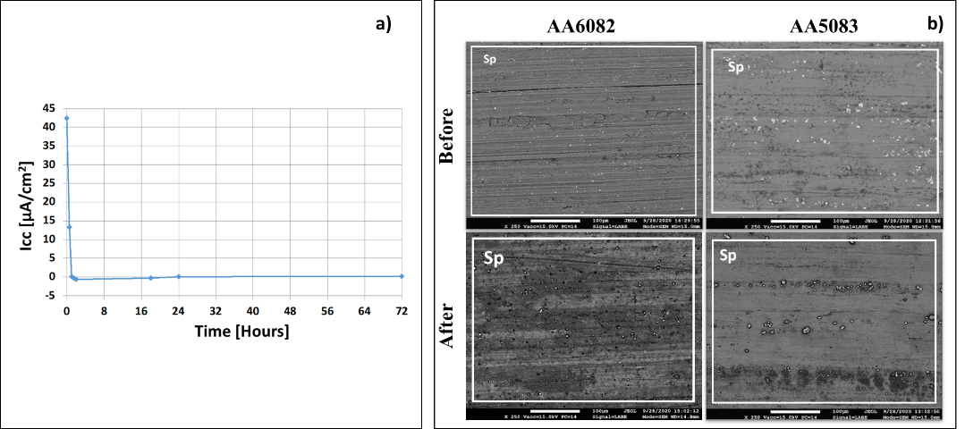

Figure 1. Short circuit current density (i_{sc}) due to galvanic coupling AA5083/AA6082 (A) and SEM morphologies comparison after galvanic coupling for 72 immersion time (B).

Table 1. EDXS chemical analysis of aluminum alloys in highlighted areas of Figure1 before and after immersion tests.
 |  | Al | O | Mg | Si
AA6082 | Before | 95.69 | 2.71 | 0.64 | 0.97
 | After | 50.83 | 47.74 | 0.44 | 0.99
AA5083 | Before | 78.06 | 15.45 | 6.48 | -
 | After | 74.37 | 22.30 | 3.33 | -

The SEM image of the AA6082 alloy (Figure1 (b)) surface before the galvanic coupling test show the typical morphology due the extrusion process which can be still seen after immersion. However, the deformation areas, clear before the test, are no longer recognizable due to a marked and diffuse surface oxidation after the test. The EDXS analyses in Table I and II confirm the high level of oxidation of the AA6082 alloy, with the oxygen signal increasing from about 2.71% to about 47.74%. The Mg content decreases slightly, from 0.64% to 0.44%. The oxidation is less marked for AA5083 alloy with an oxygen concentration of 22.3% after the test. Moreover, AA5083 displays a significant Mg dissolution during the test. It is also noted that the contours of the noble intermetallic phases (bright color) appear to be more defined, probably due to a slight corrosive attack of the matrix (anodic) at the edges of these phases. From the SEM images of the AA5083 alloy surface after the galvanic coupling test (Figure1 (b)), more (dark gray color) and less oxidized (light gray color) areas can be seen in bands, always oriented along the rolling direction.
Figure 2 shows unions of micrographs obtained with a stereoscopic microscope of the section of the welds after metallographic attack and SEM pictures obtained on specific areas of the FSW joint between AA6082 and AA5083 (highlighted with different colors). The metallographic attack with Keller's solution allowed to highlight five different welding zones (Figure2 (a), from left to right):
- unaltered AA5083 alloy (base material);
- thermo-mechanically altered area of AA5083 alloy;
- nugget zone showing the typical onion ring structure with concentric rings;
- thermo-mechanically altered area of AA6082 alloy;
- unaltered AA6082 alloy (base material).
Figure 2 (b) and (d) show SEM micrographs of the area associated with the thermo-mechanically altered areas while Figure 2 (c) shows the mixing area in the FSW weld.
The altered zone of the AA5083 alloy (Figure2 (a) left region, and Figure2 (b)) shows a fine microstructure with no preferential grain orientation in the rolling direction. This indicates that there is no significant grain growth due to the thermal input during FSW process. This means that this area has presumably been affected mostly by mechanical phenomena rather than thermal alterations: therefore, it is likely that this microstructure was caused by tool-induced deformation and the resulting work-hardening phenomena. Fig 2 (b) displays several intermetallic particles that are positioned both within and at the edge of the crystalline grains. According to data reported in literature [9], bright intermetallics contain mainly Fe, Mn and Si and display cathodic behavior relative to the aluminium matrix and Mg and Si-rich dark intermetallics with anodic behavior.
The altered area of the AA 6082 alloy (Figure2 (d)) shows a fine microstructure similar to that observed for AA5083 alloy confirming that thermal alteration in this area is very limited. Intermetallics can be seen also on this area, with composition similar to that of the AA5083.
The mixing area (Figure2 (c)), shows that the microstructure is equiaxial due to dynamic recrystallization and with reduced grain size compared to the altered regions. Al-Fe-Mn-Si and Al-Mg-Si intermetallics tend to be arranged along preferential paths formed due to the rotational motion of the tool during the FSW process.
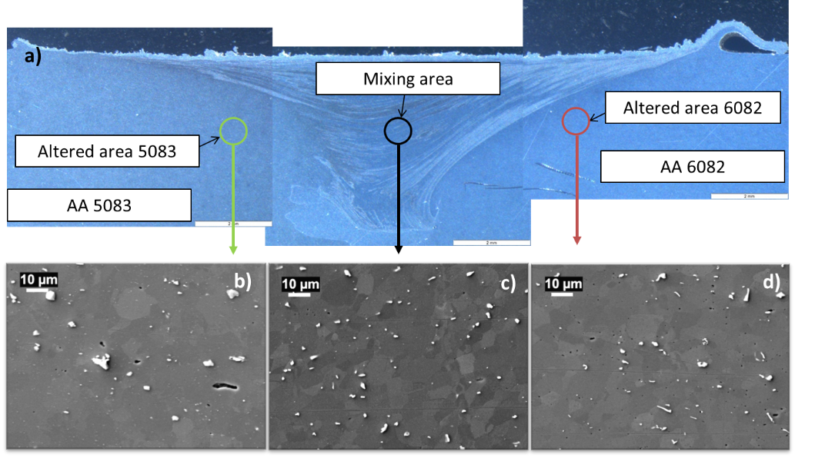
Figure 2. Unions of micrographs of the section of the joint (a). SEM pictures of the thermo-mechanically altered area for the AA 5083 alloy (b), the nugget zone (c) and the thermo-mechanically altered area for the AA 6082 alloy (d).
Figure 3 shows the surface morphologies of the thermo-mechanically areas of both alloys and of the nugget zone after immersion of the welded joint in 3.5% NaCl solution for 7 days. The thermo-mechanically altered area after immersion for the AA5083 alloy can be seen in Figure 3 (a). A slight localized attack is detected at the edge of the noble intermetallics and cracks at the sides of the same can be associated with breaks in the surface oxide film formed during the test.
The thermo-mechanically altered area after immersion for the AA6082 alloy can be seen in Figure 3 (b). The localized attack appears similar to that observed for AA5083 with a slightly more evident attack at the periphery of bright intermetallics with cathodic behavior in the former alloy.
The nugget zone (Figure 3 (c)) shows more severe corrosion attack as compared to the thermo-mechanically altered regions. In particular, the attack at cathodic intermetallics appears more evident than in the thermo-mechanically altered regions. Moreover, some areas are selectively attacked showing marked surface oxidation while other areas are less attacked. The more attacked areas are associated to regions where the AA6082 is more abundant consistently with the morphology observed in the altered regions. The selective attack of AA6082 in the nugget zone is probably indicating that there is a slight galvanic coupling with AA5083 in which the former alloy behaves anodically as compared to the latter.

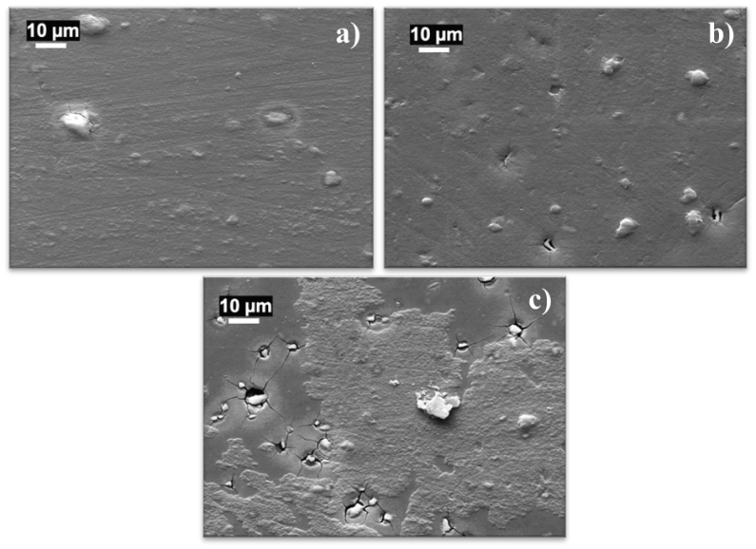
Figure 3. Morphologies after 7 days immersion test of thermo-mechanically altered area of the AA 5083 alloy (a) and AA6082 alloy (b) and of the mixing area (c).

3.2 Explosion Welding
In the sample obtained from the TriClad® joints, shown in Figure 4, it is possible to distinguish 5 areas:
- AA5083 alloy;
- Interface between AA5083 alloy and commercially pure aluminum AA1050;
- Commercially pure aluminum AA1050;
- Interface between commercially pure aluminum AA1050 and structural steel;
- Structural steel A516 GR.55.
The AA5083/AA1050 interface (Figure 4, in red) shows the typical waves formed during the explosion. The formation of a wavy interface in joints obtained by explosive technique is well known.
In this case the interface is not very regular, with waves of plasticized material characterized by a very long pitch (a few millimeters) and the formation of oxides that remain entrapped at the interface between the two alloys. The presence of oxides is most likely due to the fact that the TriClad® joint is made in air favoring oxidation phenomena.
The AA1050/steel interface (Figure 4, in blue) exhibits a large amount of intermetallics rich in Fe and Al. It can be expected that these brittle intermetallics limits the mechanical properties of the joint and its ability to be bent.
In particular, some intermetallics, mainly located near the steel substrate, appear significantly bright suggesting a high Fe content. Intermetallics near the AA1050 alloy appear darker indicating a lower iron content.

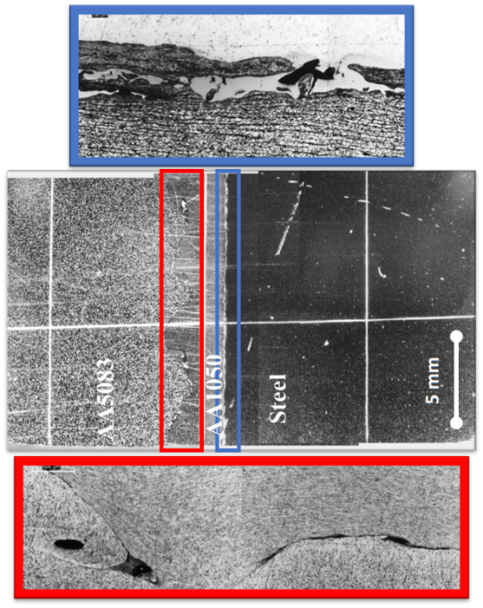

Figure 4. TRICLAD© joint morphology highlighting imperfection at the AA5083/AA1050 (red) and at the AA1050/steel (blue) interfaces.
Figure 5 (a) shows the temporal evolution of the short circuit current density (i_{sc}) between AA1050 and steel, during 1 week of immersion. The monitoring highlights a high short-circuit current density of about 30 µA/cm², which is significantly higher as compared to that observed in Figure 1.
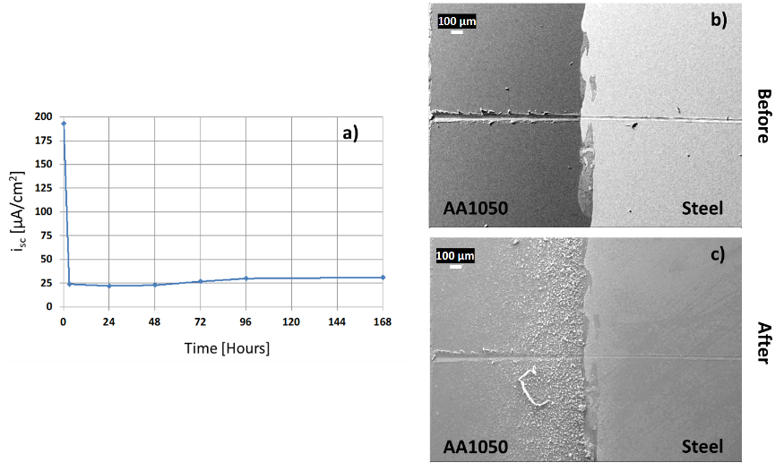

Figure 5. Galvanic coupling for AA1050 and steel in TriClad© joint (A). SEM morphologies before (b) and after (c) immersion tests for the AA1050/steel interface.
The images in Figure 5 (b) and (c) acquired respectively before and after immersion show significant attack mainly localized in the aluminum alloy AA1050 indicating a strong galvanic coupling at the AA1050/steel interface in line with the high i_{sc} observed.

Conclusions
FSW joints (AA5083/AA6082) and trimetallic explosion welded joints (AA5083/AA1050/structural steel) were investigated to correlate their corrosion behavior to microstructural modifications induced by the welding processes:
- Galvanic coupling between AA5083 and AA6082 is weak in FSW joints with AA6082 displaying slightly more anodic behavior than AA5083;
- The nugget zone shows more severe localized attack than the thermo-mechanically altered regions;
- Explosion welded joints are characterized by a strong galvanic coupling between AA1050 and structural steel which is mainly localized at the interface between the two metals.

References
- Mandal, N. R. (2017). Ship construction and welding (Vol. 329). Singapore: Springer.
- Akbari, M., Asadi, P., & Givi, M. K. B. (2014). Advances in Friction Stir Welding and Processing.
- Corigliano, P., Crupi, V., Guglielmino, E., & Sili, A. M. (2018). Full-field analysis of AL/FE explosive welded joints for shipbuilding applications. Marine Structures, 57, 207-218.
- Samardžić, I., Mateša, B., & Kladarić, I. (2011). The influence of heat treatment on properties of three-metal explosion joint: Almg-Al-steel. Metalurgija, 50(3), 159-162.
- Ege, E. S., Inal, O. T., & Zimmerly, C. A. (1998). Response surface study on production of explosively-welded aluminum-titanium laminates. Journal of materials science, 33(22), 5327-5338.
- Costanza, G., Crupi, V., Guglielmino, E., Sili, A., & Tata, M. E. (2016). Metallurgical characterization of an explosion welded aluminum/steel joint. Metall. Ital, 11, 17-22.
- Costanza, G., Tata, M. E., & Cioccari, D. (2018). Explosion welding: process evolution and parameters optimization. In Materials Science Forum (Vol. 941, pp. 1558-1564). Trans Tech Publications Ltd.
- Davis, J. R. (Ed.). (1999). Corrosion of aluminum and aluminum alloys. Asm International.
- Birbilis, N., & Buchheit, R. G. (2005). Electrochemical characteristics of intermetallic phases in aluminum alloys: an experimental survey and discussion. Journal of the Electrochemical Society, 152(4), B140.
- Donatus, U., Thompson, G. E., Zhou, X., Wang, J., Cassell, A., & Beamish, K. (2015). Corrosion susceptibility of dissimilar friction stir welds of AA5083 and AA6082 alloys. Materials Characterization, 107, 85-97.
- Czechowski, M. (2004). Stress corrosion cracking of explosion welded steel‐aluminum joints. Materials and Corrosion, 55(6), 464-467.

Francesco Andreatta, University of Udine, Polytechnic department of engineering and architecture, Via del Cotonificio 108, Udine, 33100, Italy

