Deep Neural Network (DNN) Method to predict the displacement behavior of neutral axis for ships in vertical bending

Alessandro LA FERLITA ^{a,}, Emanuel DI NARDO ^{b,c}, Massimo MACERA, Thomas LINDEMANN ^{d}, Angelo CIARAMELLA ^{b}, Patrick KAEDING ^{d}

ª American Bureau of Shipping, ABS Europe ltd, Hamburg, Germany
^{b} University of Naples Parthenope, Department of Science and Technology, Naples, Italy
^{c} University of Milan, Department of Computer Science, Milan, Italy
^{d} University of Rostock, Chair of Ship Structures, Rostock, Germany

Abstract. The shifting of the neutral axis in the cross section of ship structures is an important result of progressive collapse analyses. The main purpose of the present study is to apply a Deep Neural Network (DNN) method to linear systems and estimate in a relatively short time span the shift of the neutral axis for intact and damaged ships. First, the initial source data related to the intact condition and to several symmetric damaged grounding scenarios of five different vessels (Double Hull Oil Tanker, Single Hull Tanker, 1350TEU Container Vessel, 3500TEU Container Vessel, Bulk Carrier) have been determined with a self-developed code based on the well-established Smith method. With the application of the DNN, the shift of the neutral axis has been predicted for a set of completely new damage scenarios of a ship cross section, demonstrating that the deep neural network approach can estimate the neutral axis performance. The successful prediction obtained within this paper will lead to the DNN’s application for computing the ultimate strength capacity.
Keywords. Deep Neural Network, damaged ship, grounding, neutral axis, data prediction, vertical bending.

Introduction
Structural damages to the hull girder are often caused by extreme loads or accidents, such as grounding or collision, which can pose risks for the structural integrity and can lead to severe consequences for humans and the environment.
The ultimate hull girder capacity and the corresponding neutral axis of a ship can be obtained by simplified methods such as Smith’s Method or by advanced methods such as nonlinear finite element method. Being able to determine in a fast way the residual capacity is an important aspect during emergency salvage operations. The GDI (Grounding Damage Index) approach represents an existing approach to be used in emergency cases, therefore it might be possible to have a preliminary assessment of the residual hull strength capacity by defining the approximate location and amount of damage in the main cross section [1].
Many studies have already focused on structural analyses of ships in damaged conditions and on the assessments of the residual girder strength (La Ferlita et al. [2], Sun et al. [3], Gordo et al. [4], Tabri et al. [5]).
Therefore, ship casualties such as groundings and collisions require fast and reliable analysis methods, in order to predict the possible outcome scenarios.
The Neutral Axis (NA) is a relevant result linked to the ultimate hull girder strength, which is part of the ship’s survivability.
The change in location of the neutral axis is especially important in damaged double bottoms, because the damaged structural elements cannot contribute to the hull girder capacity. Thus, they should be neglected, contributing to a higher displacement of the neutral axis. Furthermore, the relative displacement of the instantaneous neutral axis during the iterative approach can define the most stressed region of the ship cross section. Its influence on the structural response is particularly important for the post-collapse regime as it has been shown by Cerik [6].
The potentials effects of the rotation of the neutral axis on the vertical bending moment have been demonstrated. Villacencio [7] et al, presented a method to determine the displacement behavior of the neutral axis during the loading of a damaged hull exposed to bending moment.
The neural networks have a wide range of applications. They have already been successfully applied in several engineering fields, for instance in fuel ship consumption estimation [8] or for the prediction of the ultimate strength of steel panels [9]. The success and the potentials of the DNN applications are quite relevant, as they could shorten the computation time for the result prediction, after the neural networks have been trained with the sample data.

Description of the application
The aim of this paper is to test the DNN developed for predicting the shift of the neutral axis of different ships cross section exposed to vertical bending moment. This work can be counted as the initial phase for the successive prediction of the residual ultimate strength capacity. Hence, the understanding of the DNN results and of the specific weights of the features, embedded for computing the neutral axis determination, play a paramount role for the further step which consists into the more relevant prediction of the ultimate longitudinal strength for damaged ship cross sections.
In general, the method developed in this paper is carried out by considering the following steps, which can be indicated as:

- Simulation of input & output variables
- Database generation
- DNN training with leave one out validation
- DNN validation with new scenarios

The pure vertical bending moment values, the neutral axis displacement, and the corresponding geometrical parameters of five different vessels (Double Hull Oil Tanker, Single Hull Tanker, 1350TEU Container, 3500TEU Container, Bulk Carrier) have been obtained by simulating several damage scenarios (Table 1).
The values described in Table 1 reveal the percentage of the damage extensions with respect to the intact half breadth and to the intact double bottom (DB) height.
For the Single Hull Tanker, as not being present the double bottom, it has been considered the height of the center girder. Furthermore, the scenarios have been modeled by removing the non-carrying elements within the transverse cross-section of the hull girders.
An inhouse code has been developed according to Det Norske Veritas (DNV) rules (RU-SHIP Pt. 3, Ch.5, Sec.4).
In order, to proof its reliability, the results have been compared with a commercial code MARS 3.0.1, provided by Bureau Veritas (BV). Here, at each iterative step, the vertical position of the instantaneous neutral axis from the baseline is obtained by imposing a zero-axial force condition.
The simulated cases have been chosen by increasing progressively the damage height and damage width symmetrically, with respect to the vessel center line.

Table 1. Scenarios

Scenario | Damage Width Extension | Damage Height Extension (DB)
Intact | 0 | 0
A | 20% | 0%
B | 40% | 40%
C | 60% | 60%
D | 80% | 80%
E | 90% | 90%

The main purpose to choose only symmetrical damages can be reasoned that it has already been demonstrated that the standard Smith’s method can result in overestimation of the ultimate strength, when the damages result asymmetrical and when large heel angles are present [10]. In such cases, the NA does not only translate but it is also rotated [11]. The outcome of the computations obtained with the inhouse code is the sample dataset, which contains the position of the NA at each iteration step. Those results will be compared with DNN prediction values.

Validation of initial source data
The results obtained with the self-developed code based on the iterative incremental approach have been validated against MARS 3.0.1, considering damage and intact scenario. The reliability and the performances of the ULS (Ultimate Limit State) calculations, computed with the inhouse code, have been widely demonstrated by La Ferlita et al. [2] It is worth to observe the instantaneous position of the neutral axis at each incremental step. Figure 1 shows exemplarily the compared intact scenarios, given the hogging (positive curvature) and sagging conditions (negative curvature). Ship structures present the bottom part, which is stiffer than the deck part, therefore two different NA behaviors for the sagging and the hogging case can be distinguished. During sagging, the deck’s elements are subject to compression. In the nonlinear range, specifically where the post-ultimate strength occurs, the buckling spreads downwards the side shell and therefore with increasing curvature, the neutral axis is induced to shift downwards. In many cases, the yielding of the bottom part does not take place, due to the low vertical position of NA, hence the tensile strains in the bottom only increase slightly for increasing curvature values. For the hogging case, the initial neutral axis shifts slowly in the upper region of the mid ship cross section after the elastic phase. This already happens for the first values of small curvatures, where the linear response is dominating.
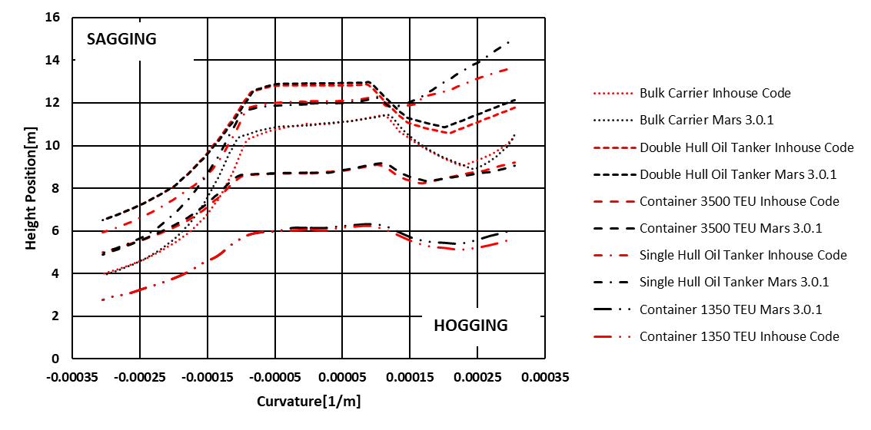
Figure 1. Change of NA position (MARS 3.0.1 vs. Inhouse Code) for different ships (Intact condition) in vertical bending
In this phase, the compression effects on the bottom are less predominant, thus the yielding occurs in the upper part of the cross-section, contributing to a downward displacement of the neutral axis [12]. When the bottom structure buckles, a deviation occurs, and the neutral axis moves upwards. This is mainly caused by the reduction of stiffness at the buckled region in compression, which is larger than the yielded region in tension.

DNN Application
For the estimation of the neutral axis a regression Deep Neural Network is used. Artificial Neural Networks (ANN) have demonstrated to be Universal Function Approximator [13] [14], which indicates their capability, with enough computational units, to estimate any kind of non-linear function. In the current paper, a three layers feed forward network with a high-level number of activation units is used. All layers are defined as fully connected, which indicates the operation expressed by Eq. (1). A combination between the adjustable weights matrix (W) with the input data (x) and the bias (b).

 | $$y=xW^{T}+b$$ | (1)

Furthermore, the first two layers are activated by a non-linear function. This refers to a data’s projection in a non-linear space. There is a greater probability that data became linearly independent for projection in high dimensional space or finding a compact representation for projection in lower dimensional space. This specific process allows to the neural model to define a new function which can represent the data, based on the proposed task. The last layer (output layer) maps the inner network representation from a non-linear space to the output space (neutral axis). This preserves the linear activation, and it allows for regression of any kind of value represented by the estimated feature. For the inner non-linear activation, a variant of Rectified Linear Unit (ReLU) [15], [16] has been chosen to preserve the output response and for avoiding issues related to the network saturation. This choice is one of the most simple and effective procedure in deep learning. The two functions are represented by the equations below:

 | $$\text{ReLU}(x) = max(0, x)$$ | (2)

 | $$\text{Leaky }\text{ReLU}(x) = max(x*α, x)$$ | (3)

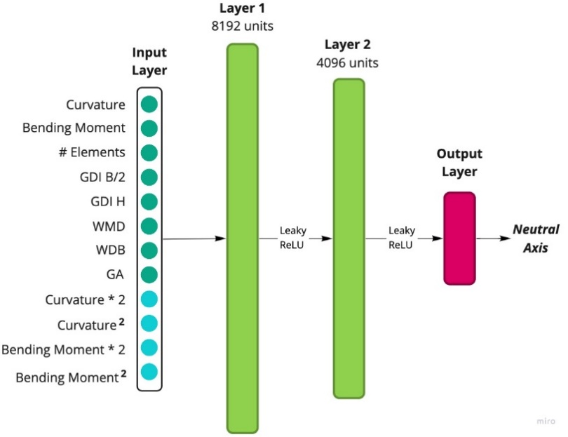
Figure 2. Neural Network architecture
In Eq. (3), $a$ is the negative slope coefficient, which value is comprised between 0 and 1. In the current model 0.3 has been selected. Figure 2 shows the full network architecture. The input variables for each scenario are the following:

- Curvature
- Bending Moment
- Number of Elements $(\# Elements)$
- Width Damage Extension $\left(GDI B/2\right)$
- Height Damage Extension $(GDI H)$
- Inertia Module at the main deck ($WMD$)
- Inertia Module at the bottom ($WDB$)
- Gross Area ($GA$)

Due to the limited number of data and features, the input layer is composed of not only the initial parameters (light green bullets), but a slightly data augmentation is performed to extrapolate more information (light blue bullets). The first layer is composed of 8192 units and the second layer of 4096 units. The number of units is chosen to reduce the bias effect of the data on the network. The network has been written in Tensorflow and trained on GPU (Graphic Processor Unit) using Google Colab. For the algorithm optimizer, “ADAM” [17] has been chosen with a learning rate of 0.001. As a regression objective function, the Mean Squared Error (MSE or L2-loss) and the Mean Absolute Error (MAE or L1-loss) can be considered. The first one has less oscillations during the updates when values are small, while the latter has steady gradients for large values and helps to introduce sparsity in the model. In the current paper, a more powerful and recent loss function is used. It is called Smooth L1 [18]. It has a double behavior, it acts like a MAE function if the difference of the components is small, otherwise it acts like the MSE function. This technique expands the generalization ability of the model.

Leave one-out validation
For the validation of the network, a leave one-out approach is used. Iteratively, a scenario (composed by 200 samples) is entirely excluded from the data set.
a) Scenario Intact – Double Hull Oil Tanker
Figure 3. Leave one out validation results
b) Scenario C – Bulk Carrier

d) Scenario C – Container 1350 TEU
c) Scenario D – Double Hull Oil Tanker

Exemplarily, in Figure 3 are represented four different cases, describing several damage scenarios (Intact, C & D). During the pure elastic phase, the predicted values and the test sample (obtained with the inhouse code) behave similarly, except for the case “a” of
This procedure has been repeated for all cases and for all vessels considered, to check the generalization capabilities of the neural network.
Figure 3, where a slight upward behavior occurs compared to the test samples. The loss values for the Scenario D (case “c”) and Scenario Intact (case “a”) of the Double Hull Oil Tanker yield 0.0027 and 0.0010.

In general, the DNN can be considered as a regression task where the scope is to minimize the distance between the predicted value and the true value. Therefore, the closer to zero loss values are, the better the results obtained. For the Bulk Carrier, the diagram is presented in case “b” of Figure 3 and for the Container 1350 TEU, the diagram is presented in case “d” of Figure 4. the values of loss are respectively 0.0006 and 0.0011, indicating a good prediction.

Results: Wild Data Prediction
After the training has been performed with the leave one out validation, the neural network approach has been tested with several unknown scenarios (wild data) which main features are presented in Table 2.
Table 2. Scenarios for wild data

Scenario | Damage Width Extension | Damage Height Extension (DB)
F | 12% | 35%
G | 37% | 100%
H | 17% | 40%

For the scope, three different damages sizes have been chosen and implemented in two different vessel type: Bulk Carrier and the Double Hull Oil Tanker. Only for Scenario G, the complete damage height of the double bottom has been neglected.
b) Scenario G – Double Hull Oil Tanker
a) Scenario F – Bulk Carrier
Figure 4. Wild data prediction

c) Scenario H – Double Hull Oil Tanker

It is of paramount importance to evidence that the neural network cannot identify the characteristics of a specific vessel type (due to the limited data set), therefore the cases proposed can be considered as completely new for the algorithm.
With regard to leave one out validation results, some differences can be highlighted.
Given the hogging condition, for the scenarios F and G of Figure 4, a relative discrepancy can be found during the yielding phase.
Furthermore, given the sagging case for the case “b” of Figure 4, in the range of curvature values between -0.0002 (1/m) to 0.0003 (1/m), a more rapid downward behavior occurs for the predicted data.
Finally, the loss function of the Bulk Carrier (case a of Figure 4) yields 0.0021, while for the scenarios G and H (case “b” and “c” of Figure 4) are respectively 0.0107 (accuracy prediction decreased) and 0.0010.

Conclusions
A new method, based on the deep neural network (DNN), to estimate the displacement of the neutral axis for intact and damaged ships subjected to pure vertical bending moment is described.
The initial source data has been generated by numerical residual strength calculations (based on the Smith Method), where the neutral axis at each iteration is established by imposing the force equilibrium over the whole midship section.
The results obtained by predicting new scenarios unknown to the DNN, despite the limited number of samples available in the data set, show good agreement with the actual corresponding values. Although, the determination of the neutral axis, respectively of the ultimate capacity strength could evoke the application of simple model 2D tools, the approach presented ensures to successfully determine the behavior of the instantaneous neutral axis rapidly, with reduced numerical and modelling effort. In fact, by considering limited information about the damage scenarios, the computations can be performed in milliseconds. This represents a clear advantage, especially during the execution of salvage operations of grounded ships (where tight time restrictions have to be considered) providing in this way time-efficient measures. The good agreement prediction, revealed in this paper for the neutral axis displacement behavior, will consolidate the development of the ultimate hull girder strength computation by applying the DNN with an increased number of samples and with a reduced number of features. Furthermore, as the Smith’s method might overestimate the magnitude of the residual strength, the initial source database could be improved and extended, considering more precise calculation results (e.g., FEM, Idealized Structural Unit Method).

References

[1] | Paik, J.K., D.K. Kim, D.H. Park, H.B. Kim and M.S. Kim. A new method for assessing the safety of ships damaged by grounding, International Journal of Maritime Engineering, no. 154, pp. 1-20, 2012.
[2] | La Ferlita A, Rathje H, Lindemann T, Kaeding P. and Bronsart R. An Advanced Salvage Method for Damaged Ship Structures. SNAME Maritime Convention, Providence, Rhode Island, USA, October 2021, no. SNAME-SMC-2021-046, 2021.
[3] | Sun Bin. Hu Zhiqiang, Wang Jinab, Yu Zhaolong. An analytical method to assess the damage and predict the residual strength of a ship in a shoal grounding accident scenario. Journal of Ocean Engineering and Science, vol. 1, pp. 167-179, April 2016.
[4] | Gordo J.M., Guedes Soares C. Approximate method to evaluate the hull girder collapse strength. in Mar Struct. 9, 1996, pp. 449-470.
[5] | Kristjan Tabri, Hendrik Naar & Mihkel Kõrgesaar. Ultimate strength of ship hull girder with grounding damage. Ships and Offshore Structures, vol. 15, no. Sup1, pp. 161-175, 2020.
[6] | Cerik B.C., Choung J. Progressive Collapse Analysis of Intact and Damaged Ships under Unsymmetrical Bending. Journal of Marine Science and Engineering., vol. 8, no. 12, 2020.
[7] | R. Villavicencio, Z. Liu, J. Amdahl and G. Guedes Soares. Influence of the neutral axis displacement on the residual strength of a damaged tanker double-bottom structure. Ships and Offshore Structures, vol. 8, no. 6, pp. 663-674, 2012.
[8] | Moreira, Lúcia and Vettor, Roberto and Guedes Soares. Neural Network Approach for Predicting Ship Speed and Fuel Consumption. Journal of Marine Science and Engineering, vol. 9, 2021.
[9] | Mesbahi, Yongchang Pu and Ehsan. Application of artificial neural networks to evaluation of ultimate strength of steel panels. Engineering Structures, vol. 28, no. 8, pp. 1190-1196, 2006.
[10] | Carlos Guedes Soares, Y. Garbatov. ISSC committee III.1: ULTIMATE STRENGHT; Residual Strenght of Damaged Hull Structures 3.1.3. Ships and Offshore Structures XIX, vol. I, 2015, p. 286.
[11] | Pollalis, C.; Samuelided, M. S. Ultimate strength of damaged hulls. Collision and grounding of ships and offshore structures, pp. 297-304, 2013.
[12] | Tetsuya Yao, Masahiko Fujikubo. Buckling and Ultimate Strength of Ship and Ship-like Floating Structures. Kidlington, Oxford, United Kingdom : Butterworth-Heinemann is an imprint of Elsevier, 2016, pp. 336-337.
[13] | Cybenko, George. Approximation by superpositions of a sigmoidal function. Mathematics of control, signals and systems, vol. 2, no. 4, pp. 303-314, 1989.
[14] | Hornik, Kurt and Stinchcombe, Maxwell and White, Halbert. Multilayer feedforward networks are universal approximators. Neural networks, vol. 2, no. 5, pp. 359-366, 1989.
[15] | Krizhevsky, Alex and Hinton, Geoff. Convolutional deep belief networks on cifar-10. Unpublished manuscript, vol. 40, no. 7, pp. 1-9, 2010.
[16] | Andrew L Hannun, Awni Y and Ng, Andrew Y; others. Rectifier nonlinearities improve neural network acoustic models. Proc. icml, vol. 30, no. 1, p. 3, 2013.
[17] | Kingma, Diederik P and Ba, Jimmy. Adam: A method for stochastic optimization. arXiv preprint arXiv:1412.6980, 2014.
[18] | R. Girshick. Fast r-cnn. Proceedings of the IEEE international conference on computer vision, pp. 1440-1448, 2015.

Corresponding author: Alessandro La Ferlita, Book Department, IOS Press, Nieuwe Hemweg 6B, 1013 BG Amsterdam, The Netherlands; E-mail: bookproduction@iospress.nl.

