Innovative and sustainable materials for naval applications through national cooperative research: the experience of the THALASSA project
MEng Simone Panfiglio ^{a,}, Prof. Guido di Bella ^{b}, Prof. Edoardo Proverbio ^{b}, Prof. Lugi Calabrese ^{b}, Prof. Annamaria Visco ^{b}, Prof. Gianluca Cicala ^{c}, Prof. Fabrizio Sarasini ^{d}, Prof. Gianluca Buffa ^{e}
ª NAVTEC – Technological Cluster for blue technology innovation Via Comunale S. Lucia, 40, 98123 Messina, Italy
^{b} University of Messina
^{c} University of Catania
^{d} University of Rome, La Sapienza
^{e} University of Palermo
Abstract. THALASSA is a large research project, developed in the field of the naval structures. It aimed at studying innovative solutions of significant impact in increasing environmental sustainability through a weight reduction, a careful production planning and a circular approach to the entire life cycle of the parts, from design to the disposal/recycle/reuse. The project is led by NAVTEC Technological District and it is composed of a large team counting more than 300 researchers of several centres among which the CNR institutes, the Universities of Messina, Palermo, Catania, Roma “La Sapienza”, and Udine. Innovative solutions for industrial processes of greatest interest for some major national shipbuilding operators such as Azimut Benetti and Fincantieri or for shipowner such as Caronte&Tourits have been investigated, and players such as ATRIA have been assisted in the formulation of innovative coatings. The presence of NAVTEC District has allowed to concentrate the field of action on themes of strong industrial interest and at the same time to widen the research action on a number of different topics with a view on the entire product life cycle. The district allowed to network skills, laboratories and resources that individually would not have led to carry out activities on such a high number of variables, in terms of materials and joint types. Several issues have been addressed, by identifying solutions thanks to skills of the industrial players, such as: joining technologies (i.e. etching / texturing laser, clinching, self piercing riveting, co-curing, bonding, friction stir welding); eco and bio-sustainable composite reinforced by natural (i.e. vegetable or mineral) and hybrid fibres; degree of recoverability of traditional or bio-resins; corrosion of conventional metal structures and processes for increasing the useful life; and innovative coatings that are combined with the functional protection needs of the structures..
Keywords. Materials, Composites, Weight reduction, Recycling, LCA, Joining, Corrosion, Coatings, Managing complexity

Introduction
THALASSA is a project developed by NAVTEC consortium in conjunction with its associates and a number of external partners in the field of materials and joining for the naval sector. It is funded by the Italian ministry of university and research as part of the National Program of Research 2015-2020 under the National Operative Plan and the European Social Fund. Submitted in 2017 as result of a comprehensive work performed by the consortium network aimed at gathering a number of ideas and research activities in the field of material and joining enhancement dedicated to several market application for the naval sector, has been developed through a 36 months plan. A wide and varied project partnership includes the Universities of Messina, Catania and Palermo, various CNR institutes, the University of Rome La Sapienza and Udine as a scientific component. Fincantieri, Azimut Benetti, Caronte & Tourist for the part dedicated to the development of materials, and Colorificio Atria for coatings, are the direct industrial partners.
Materials and joining in the naval sector are deemed as one of the most important topic in terms of engineering enhancement. Although the field of interest is considered as one of the last industrial field to catch up with new technology methods, the variety of application in the naval sector is wide, as it embraces materials from timber to carbon fiber, passing trough a extensive use of steel and other metal compounds.
Maritime transport emits around 1,076 million tonnes of CO₂ annually and is responsible for about 2.8% of global greenhouse gas (GHG) emissions; within this field a business as usual approach towards carbon footprint reduction don’t match the objective set with the Paris Agreement. A systemic approach towards shipping design and operability needs to be put in place and all the aspect of the sector must be evaluated in terms of environmental impact.
With this focus in mind the THALASSA project aims at reducing the environmental impact in the naval construction, through a reduction in weight and in the environmental impact of the production process and the recycling capabilities at the end of ship’s life.
The present work is aimed at listing the main achievements of the project and investigate the main issues encountered during the activities.

The THALASSA project – a network approach
THALASSA is the result of a long lasting networking process, which has been led by the NAVTEC consortium as part of its core business. NAVTEC is a no profit research consortium aimed at fostering the exchange of information and need for innovation according to the triple helix paradigm in the field of blue economy with a specific target and focus, but not limited to, the naval transport sector.
Since its foundation NAVTEC periodically organize a number of activities, primarily consisting in thematic conferences among the associates, aimed at developing a common knowledge database of ideas and research topics as well as market and company needs. As part of these activities a specific roundtable dedicated to innovative materials as more than 50 proposals were focused on topics such as the production processes of hulls and superstructures, paints for hull and upper-structure, and a number of research ideas in the field of boat maintenance and repair.
A number of meetings were held in order to match the proposal coming from research activities to industrial needs and interests. As result of this preparation work a first structure of a research project was proposed, and a number of other information was gathered, including timeframe to perform the activities, associated budget and new infrastructures to be purchased or made available from other sources.
Great attention and effort was put in trying to have an industrial partner for each topic in order to increase the probability of an industrial return and steering of research activities by the private sector.
NAVTEC also actively sourced for funding opportunities to subsidize the project proposal.

Project structure and main objectives
The project is organized in 5 operative work packages, and for each one a more detailed list of activities is listed. It was decided to establish the work packages per topic as this approach was the most immediate in terms of workflow organization, but each WP shared with the others some key elements:
- Attention to weight and performances level for the specific field of interest
- Attention to recycling and to environmental aspects of the whole manufacturing cycle
- LCA analysis of relevant part of the research
A researcher for each WP was appointed as WP representative as shown in Figure 1. A single scientific manager was also appointed to check the overall progress of the project. The roles were chosen among the Universities in relation to the wealth of knowledge of the most experienced professors inside the partnership.
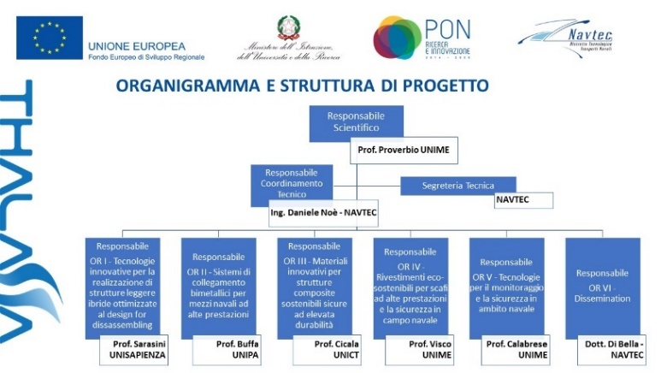
Figure 1 - Overall program structure and WP leader list
As follows the main topics and the activities of each WP are listed.
WP1 entitled “innovative technologies for the implementation of hybrid lightweight structures optimized for design for disassembling” is devoted to test a number of different joining methods, with particular regards to the ones connecting different material types, metal-composite, metal-metal, etc.
“Bimetal connection systems for high performance vessels” is the scope of the WP2, which takes alternative welding processes such as Friction Stir Welding into consideration as the most promising technique to perform a joint between different types of metal edges. A comprehensive evaluation of the process is planned both numerically and experimentally.
The work package 3 is directed at exploiting the sustainability of structures using composite materials. The tasks of this WP are aimed at the development of novel thermosets with high renewable content. The main properties of the developed systems is an high biocarbon content (>35%) and the full recyclability into a reusable thermoplastic resin.
The 4th work package involves the development of innovative coatings with the dual objective of reducing aerodynamic drag and thus fuel consumption by reducing the environmental impact.
The 5th and last topic addressed the definition of technologies and Systems for the Structures Security and Reduction of Marine Hazard. The tasks were developed with the objective of introducing inside the ship as an object a health and usage monitoring system, capable of highlight specific conditions stressful for the structure.

Project achievements
Although the project is still ongoing and some activities are still performing testing and analyses which will be useful to assess some improvement in the field of interest, it is useful to list all the project accomplishments. Due to the nature of the structure of the project those will be presented per work package.
The partners involved in WP1 conducted an extensive investigation on single and double strap joint, on a set of different configurations, ranging from aluminium-composite-aluminium to glass-fibre bonding to carbon fibre-iron and aluminium-steel connections, depending on the interest of the industrial partner involved.
Regarding the double strap connection a comparison among different types of edges preparation [1] was performed assessing the anodizing in TSA as the most effective pre-treatment and the laser etching/texturing as irrelevant to improve the mechanical features of the joint, with particular reference to its resistance in prolonged marine environment (salt spray simulated environment). In addition a number of assessment were performed with several set of composite as bonding strap, with particular attention to the recyclability of the fibre and the resin. Those tests were using the materials assessed for recyclability inside the activities of the work package 3.
Also an in depth study of the single strap connection has been carried out to reduce the safety factor required by the certification body for the design of glass fibre connection by Azimut Benetti. The analysis took into consideration the peculiar features of the joint performed in the production phase, in particular a large thickness of the adhesive layer as compared to the overlapping edges. A detailed FEM analysis was performed as well as testing with specimens fitted with fibre optics sensors to assess the overall structural behaviour.
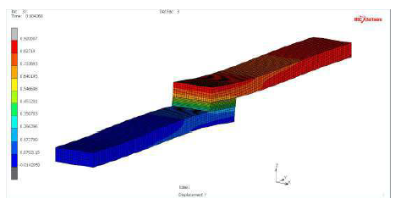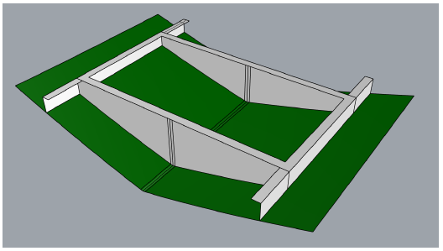
Figure 2 - FEM model of Azimut Benetti single strap joint and case study
As part of the assessment of a real case application a model has been developed to replicate the results at specimen level to a fuel tank application (Figure 2). This type of joint represents a widely used theme of growing interest, due to the need to reduce the heights of the compartmentalization of the double bottoms and the consequent impossibility of manually curing the joint. The bonding therefore represents the only component that guarantees structural continuity, resulting therefore heavily stressed, and in addition it is subjected to the contamination of diesel oil and/or fresh water. A quantitative assessment of the advantages gained by the company with this new approach is still to be defined, a more qualitative valuation is pointing at reduced material use, an increase awareness in numeric tools and a confidence in using those as justification in the certification process.
In addition a number of joint types involved in the production process of cruise ships designed by Fincantieri have been evaluated in terms of in-service issues. In particular bimetallic joints were examined due to the tendency to highlight unwanted cracks inside the joint. The analysis was particularly interesting as the issues and features of this joint were compared with the friction stir welding, subject of the WP2.
A complete mechanical characterization of a hybrid glass fibre – aluminium step joint when using orbital riveting [2] and self piercing has been developed as well as a correlation analysis between the FEM and the real testing, allowing the creation and the fine tuning of a useful set of tools for the shipyards. This joint method has been also reviewed in terms of overall environmental impact and CO₂ emission through an LCA study. A number of cases were run, with different plate thicknesses and two end of life scenarios (Recycled content approach and Substitution Method). The results of this study are of great importance as they evaluate in a quantitative way the environmental contribute to weight reduction. As shown in Figure 3 a maximum 40% CO₂ emission reduction level can be achieved with a 1,5 mm reduction in average thickness of material used for the primary structure.

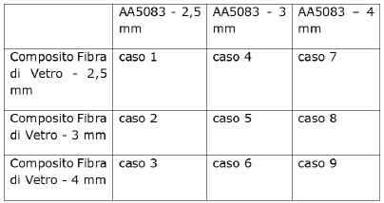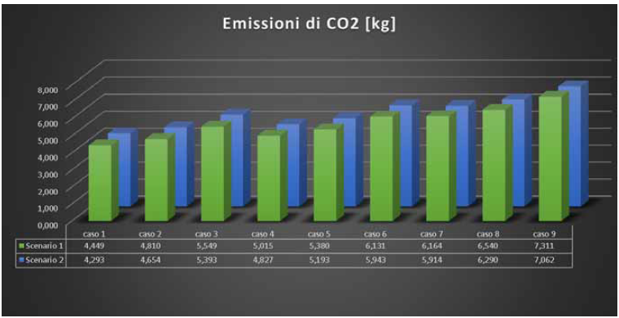
Figure 3 - LCA cases and CO2 assessment
The WP2 conducted a complete engineering process of the friction stir welding technique for naval application, an assessment of the laser welding technique for bimetallic joints flanked by an LCA study for the aforementioned technologies.
The bimetallic joints were meant to give a reliable alternative to triclad ® and triplate ® systems (explosive welding) in terms of flexibility of use, cost and control over a number of joint parameters. As informed by Fincantieri, the commercial explosive welding joints were subject to a number of in service issues, without a definitive fixing due to the inherent nature of the bimetallic connection element.
A complete sensitivity review of critical parameters and variables of the FSW technique has been performed, defining the pin form factor the welding angle, speed and pressure, as well as the need of additive powder and other distinctive elements to maximize the mechanical behaviour of the joint and reduce all the issues coming from the union of dissimilar elements such as corrosion and residual stresses.
A real case scenario has been examined in order to define the different approach in design to replace MIG welding with FSW in middle size shipyard as for instance in Figure 4. In most of the cases in review, especially when in presence of complex geometry the FSW allow for a simpler production method, specifically tolerating an application on the most convenient side, whereas the traditional welding often force the operator to weld in uncomfortable and scarcely accessible positions.

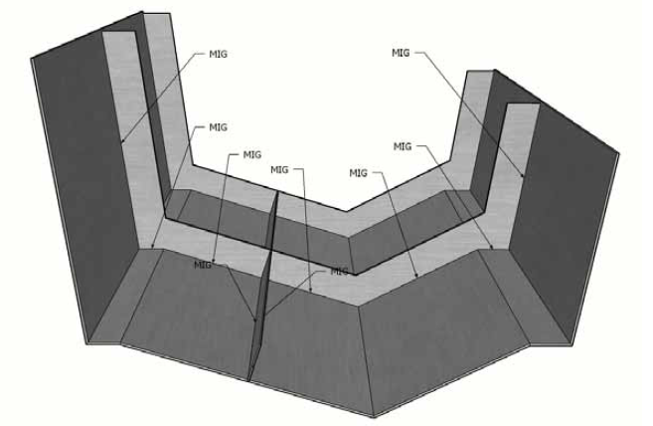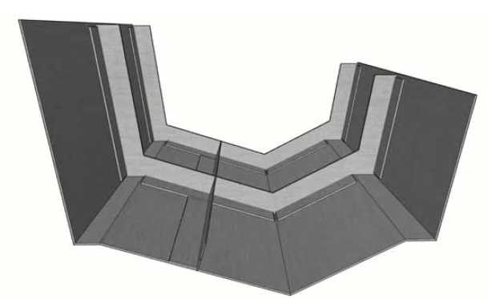
Figure 4 - FSW application case study - MIG configuration (left) and FSW layout (right)
The laser welding process has also been addressed for the naval applications, and a tuning of the parameters and the features of the technique has been performed, with particular reference to the issues coming from the thickness of the joint edges.
Inside the activities of the WP3 a in depth analysis of sustainable and recyclable composite materials for naval applications was performed. Azimut Benetti, CTMI and Fincantieri provided a list of a list of features of the composite materials used in production in order to compare both the matrices and the reinforcement fibers suitable to be replaced or at least introduced as recyclable element. Basalt and linen fibers were considered, where a number of resins were investigated among which the best results were obtained with Polar Bear type.
Basalt and linen were successfully introduced in a standard carbon fiber-epoxy resin configuration keeping the level of mechanical and physical features of the finite material acceptable for the proposed use as structural material.
The thermosetting resin were recycled using a facilitating agent and acidic acid. The resulting material is a thermoplastic resin (avg 60% of yield) which has been tested for strength as such and with different type of reinforcing fibers, all coming from recycle, among which lignin, kenaf and short recycled carbon fibers. [3] The first two attempts resulted in materials unsuitable as structural material, with some difficulties in the moulding process. The last one proved to be a composite material with good mechanical properties. [4]
Azimut Benetti as result of this tests started a study aimed at replacing some elements of the superstructure with an environmental friendly substitute identified in the aforementioned activities. [5]
The activities inside the WP4 were also aimed at replacing pollutant elements inside the paints normally used in the naval sector with more environmental friendly components while keeping the level of performance.
A number of different configuration for anti-fouling and anti-vegetative applications were examined in details, with reference to the effectiveness, the ease of mixing inside the paint matrix, and other useful features for the specific applications. Nano carbon tubes, bio based nanocellulose and nanoketine, tymol and eugenol are some of the elements in use to enhance the environmental tolerance of the fillers. [6]
The results of the lab testing will be useful to define new set of products for naval applications to be further developed by the paint factory partner of the project.

Managing complexity – issues and resolution approach
The project, due to end in November 2022, has or is planning to achieve all the goals and objectives initially foreseen inside the technical specification, although a number of issues arose in due course, first of all the insurgence of the COVID-19 pandemic, which posed a number of logistic and technical issues primarily but not limited to lab availability. In the following paragraphs the main and most relevant issues will be briefly listed and described.

COVID effect – how the pandemic changed the cooperation
The main problem encountered by the project researchers was the pandemic outbreak, which started in Italy 8 months after the project start date. The project was in a crucial phase when the Italian government set a two months lockdown.
The project, which from the beginning envisaged a collaboration of organizations and companies scattered throughout the national territory, already was using online meeting tools as a primary element of collaboration, but, given the experimental nature of the activities, it also included face-to-face cooperation as a primary way of work.
The transition to a fully online management of information and meetings was immediate. The insurmountable issues were determined by the accessibility of the laboratories and the block of transport facilities which led to delays in the work program that reached up to 5 months of interruption. No corrective action could be put in place to overcome or reduce the overall impact on the foreseen plan. In conclusion, the onset of the pandemic has created a general delay in the work program estimated in 6 to 9 months.

Public and private sector – a matter of different approaches and priorities
The onset of the pandemic has not only led to direct effects but has highlighted and accentuated some peculiar characteristics and differences in the way companies conduct research projects compared to research centers and universities.
The companies participating in the project, which initially set a dedicated team for the activities, were forced to reset the company priorities, concentrating their efforts on the primary production activities.
The aforementioned condition caused a delay in the exchange of information and caused a general mismatch in the activities which unbalanced the burden on universities and research bodies, often relegating companies to a passive role of information provider.

A huge number of achievement without an all-encompassing prototype
As detailed inside Chapter 3 a huge number of achievement and improvement in the area of interest were accomplished by the project team. In almost every area of research there was a successful outcome and some of the results will be used in next products from the shipyards involved. As the project unfolded the need or at least the opportunity to design a prototype to test all the different solution emerged. The lack of a distinctive object which could have represented all the project achievement was a missed opportunity in terms of dissemination of results as well as of involvement of a wider number of companies and interest.
The lack of a unique test bed is partially due to the bottom up process used for the definition of the technical specification which developed the structure of the work packages per topic rather than per application.

Conclusions
The THALASSA project is an example of how a cluster based network of companies and research bodies can effectively develop a vast research project by effectively exploiting the strength of the network for the exchange of information, the improvement of production processes, the use of innovative materials and the enhancement of the circularity of products in the field of investigation. within the THALASSA project many results were used across the board by the partners, and served to probe the use of innovative materials in different fields, introducing unconventional joints in minor shipbuilding, the concept of recyclability in yacht shipbuilding and analyzing critically production problems of large national shipbuilding companies. The risk of dispersion of the results was minimized through the definition of activity managers who coordinated the exchange of information inside and outside their field of investigation, even if the use of a single technology demonstrator for all technological advancements would have allowed a greater media impact.

References
- Khaskhoussi, A.; Calabrese, L.; Patané, S.; Proverbio, E. Effect of Chemical Surface Texturing on the Superhydrophobic Behavior of Micro–Nano-Roughened AA6082 Surfaces. Materials 2021, 14, 7161.
- Di Bella, G.; Calabrese, L.; Borsellino, C.; Alderucci, T. Effect of Sheets’ Thickness and Rivet Geometry on Mechanical Properties of Orbital Riveted Aluminium Joints: Experimental and Numerical Analysis. J. Manuf. Mater. Process. 2021, 5, 102.
- Angela Daniela La Rosa, Sebastiano Greco, Claudio Tosto, Gianluca Cicala, LCA and LCC of a chemical recycling process of waste CF-thermoset composites for the production of novel CF-thermoplastic composites. Open loop and closed loop scenarios, Journal of Cleaner Production, Volume 304, 2021.
- Ferrari, F.; Esposito Corcione, C.; Striani, R.; Saitta, L.; Cicala, G.; Greco, A. Fully Recyclable Bio-Based Epoxy Formulations Using Epoxidized Precursors from Waste Flour: Thermal and Mechanical Characterization. Polymers 2021, 13, 2768.
- L. Saitta, C. Tosto, S. Dattilo, C. Puglisi, G. Cicala. Bio-epoxy matrices for composites: from recycling to possible re-uses. Polymers and Sustainability, Lampedusa 1-3 September, 2021.
- Pistone, A.; Scolaro, C.; Visco, A. Mechanical Properties of Protective Coatings against Marine Fouling: A Review. Polymers 2021, 13, 173.

NAVTEC c/o CNR ITAE Testing Center – Via Comunale S. Lucia, 40, 98123 Messina, Italy; E-mail: navtecsicilia@itae.cnr.it.
Fourth IMO Greenhouse Gas Study 2020- Executive summary
Etzkowitz, Henry; Leydesdorff, Loet (1995-01-01). "The Triple Helix -- University-Industry-Government Relations: A Laboratory for Knowledge Based Economic Development". Rochester, NY. SSRN 2480085.

