Experimental investigation on a lightweight ship balcony overhang with bimetallic welded joints
Giulia PALOMBA^{a,}, Pasqualino CORIGLIANOª, Vincenzo CRUPIª, Gabriella EPASTOª and Eugenio GUGLIELMINO ª
ª Department of Engineering, University of Messina, Messina, Italy
Abstract. Integration of lightweight and sustainable solutions in marine structures design is essential to achieve weight reduction goals and improve structural response. A key step to assess the reliability of innovative structural solutions is represented by large-scale experimental investigation. The current paper deals with the analysis of a lightweight ship balcony overhang, which includes an aluminium honeycomb sandwich structure and bimetallic welded joints. The design of the ship balcony overhang was previously performed, as an illustrative example, with the aim of suggesting the replacement of common marine structures with more green and lightweight alternatives. In order to validate the design procedure and to assess the feasibility of the suggested solution, an experimental investigation on a large-scale structure was performed. The ship balcony overhang was tested under bending with a configuration representative of severe loading conditions for ships balconies. The experimental analysis allowed the evaluation of the structure’s strength, stiffness and failure modes, which are useful data to improve the design methodology of such structures and to calibrate numerical models. Comparison with similar structures reported in literature were performed in order to assess the benefits and drawbacks of the suggested lightweight structure.
Keywords. Large-scale testing; bimetallic joints, lightweight marine structures, failure modes

Introduction
Introduction of sustainable solutions and technological improvements in shipbuilding industry are key topics to increase the competitiveness of the field and support its continuous innovation. Among the promising paths toward “green” targets, both weight reduction [1] and a more extensive use of sustainable materials [2] could be suggested as feasible yet effective solutions. In this scenario, a broader use of sandwich structures, based on sustainable materials, is an attractive option for shipbuilding industry [3]–[5], since their basic principle is to combine low weight with high bending stiffness and strength. In addition, sandwich structures could be designed according to the according to the principles of biomimetic science [6]. A consistent and wide use of sustainable sandwich structures requires reliable design and technological solutions to integrate and join them to the main structure. Connection techniques in marine structures are a challenging topic also when considering the introduction of lightweight materials, such as aluminum, which require suitable methods to be joined with other parts made of different metals (e.g. steel). One of the most advanced technique to join dissimilar metals is explosion welding [7]. Extensive experimental investigations focused on different loading conditions [7]–[11] testify the interest toward this particular application. Among other advantages, the excellent performance of explosion welded joints enabled a broader applications of lightweight alloys, which are useful to obtain structures lightening. Shipbuilding industry is in constant search for effective solutions to minimize the mass, especially in the superstructures, and to guarantee high levels of resistance to corrosion [8]: aluminum is an ideal candidate for such purpose, therefore Al/Steel explosive welded joint type is the predominant one for marine industry.
The above premises inspired the main topics of the current work: suggesting a possible application of a lightweight sustainable structure for the shipbuilding industry, connected to the main structural parts with an Al/steel explosion welded joint. A ship balcony overhang, including an aluminum honeycomb sandwich (AHS) panel and bimetallic welded joints, was identified as a commercially interesting component for the plausible integration of the sandwich structure concept into marine structure designs. The AHS was selected according to a comparative design methodology developed in a previous work [12], as an alternative to a similar structure designed and tested by Kharghani and Soares [13]–[15], which consisted in a steel support frame with a balcony floor made of a sandwich panel of balsa core and GFRP (glass-fibre reinforced plastics) skins.
Since both AHS and bimetallic joints are unusual solutions, reliable information from experimental analysis are crucial to support future effective and consistent design of similar structures. Data from small-scale experimental investigations can contribute to structural design, however, when it comes to complex and unusual structures, especially if destined to applications where safety is a primary matter, large-scale experimental analysis are essential for the design of ship hull and structures [16]. As a result, the current paper aims at performing large-scale experimental analysis on a prototype of the designed balcony overhang, in order to validate the design procedure, assess the feasibility of the suggested solution and highlight potential criticalities. The ship balcony overhang was tested under bending load applied at the free extremity of the balcony. Bimetallic parts were introduced as transition joints between the aluminium flooring and the steel ship’s side. The results obtained from full-scale experimental testing disclosed the mechanical response of such complex structure and allowed acquiring information that would be useful to support future design of marine structures involving both lightweight sandwich structures and bimetallic parts.

Preliminary design
In order to clarify the design methodology and the driving reasons behind the experimental analysis, a brief summary of the developed method will be yielded below.
The AHS-based balcony overhang was suggested as a lightweight sustainable alternative to a similar structure designed and tested in Refs. [13]–[15]. The design procedure was at first focused only on replacement the balcony GFRP sandwich panel with a lighter and more sustainable solution. The sandwich width, b and the length, L of were kept the same as in the original structure, i.e. 750 and 1050 mm, respectively. The design methodology included the following steps:
- The bending stiffness (D) of the reference structure was chosen as an equivalence parameter to select an alternative sandwich structure, since such feature is often a critical design criterion in such cases. Considering the sandwich panel geometry, the plate theory was applied and the reference bending stiffness was evaluated according to the well-known theoretical formulation for sandwich panel cylindrical bending [17], resulting equal to 3.15∙10⁷ N mm. Such value is the target that the replacing structure must satisfy.
- Materials charts reporting the bending stiffness of several different alternatives (e.g. AHS, GFRP-PVC, aluminium foam sandwich, etc.), against other useful properties (e.g. core thickness, overall panel density, areal density) were drawn, with the aim of obtaining an intuitive tool to compare several alternatives. AHS was identified as the most convenient solution to achieve weight and volume savings. Considering the perspective of marine applications, proper aluminium alloys were selected for the subsequent steps, and in particular an AA 3003 for the honeycomb core and an AA 5754 for the skins.
- The main design variables, such as the core and skin thicknesses, can be selected by combining the bending stiffness target with other relevant objectives for the final application, such as mass minimisation for the current case study. A reduction of the original mass of approximately 50% was considered a feasible goal, and therefore a mass of around 7-8 kg was set as a further design requirement for the replacing AHS. The integration of both stiffness and mass constraints allowed the identification of the corresponding core and skin thicknesses.
In addition to the sandwich panel identification, a connection frame, including bimetallic joints, was suggested. The presence of Al/steel transition joints allows the integration of some aluminium parts in the supporting balcony frame, producing a further mass saving. The details of the balcony structures are reported in the next section.

Experimental prototype and setup
According to the preliminary design procedure described in the previous section, an equivalent aluminium honeycomb sandwich panel - here named ‘AHS#1’ - was identified. The sandwich features obtained from the design procedure, and reported in Ref. [12], were adapted to those of commercially available AHS, and are summarised in Table 1. Along with the AHS resulting from the equivalence procedure, another sandwich panel, named ‘AHS#2’, having a lower density core, was included in the experimental analysis, with the aim of further investigating the potentialities of AHS in terms of weight reduction as well as the effect of cell size on the overall response of a complex structure. AHS#2 features and the properties of the reference GFRP-balsa-steel structure are also reported in Table 1.

Table 1. Main features of AHS used for experimental investigation.
Structure | Core density ρ_{c} [kg/m³] | Cell size  d [mm] | Core thickness c [mm] | Skin thickness t [mm] | Panel mass m [kg]
AHS #1 | 83 | 6 | 32 | 1.5 | 8.7
AHS #2 | 54 | 9 | 32 | 1.5 | 7.9
Original GFRP-balsa | 155 | / | 30 | 2.5 | 15

The balcony frame, whose main characteristics are summarised in Figure 1, consists of two aluminium plates 3 mm thick to serve as supports for the sandwich plate. Six M13 bolts were used to connect the sandwich panel to the main frame. The bolted connection between the sandwich panel and the supporting plates allowed a simple substitution of the panel to be tested. Two aluminium brackets were welded to the bottom plate in order to improve the structural stability, similarly to the reference structure. The connection of the aluminium plates to the main steel wall is provided by means of an Al/steel explosion welded transition joint, manufactured by TriClad. The welded joint, depicted in Figure 2, consists of ASTM A516 Gr55 structural steel, clad by explosion welding with AA5086 aluminum alloy and provided with an intermediate layer of AA1050 commercial pure aluminum.
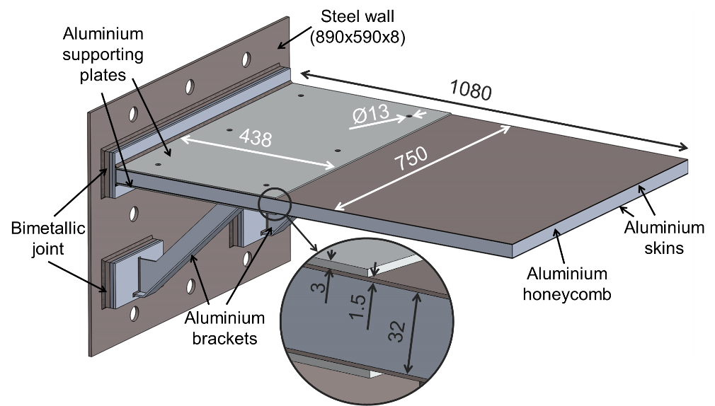
Figure 1. Main features of the developed balcony overhang.

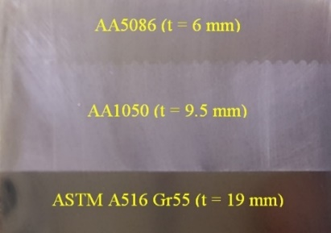
Figure 2. Al/steel transition joint included in the investigated structure

The mass of the balcony frame was estimated equal to 63 kg, against the 135 kg of the reference structure, which was entirely made of steel.
The developed structure was analysed at the CERISI laboratories of the University of Messina, which is provided with an ITALSIGMA testing portal frame for full-scale investigations. The balcony overhang was bolted to a fixed reaction block with six M36 bolts. Two LVDTs were employed to measure the deflection of the structure at the points A and B located along the structure’s longitudinal symmetry axis and whose positions are specified in Figure 3.
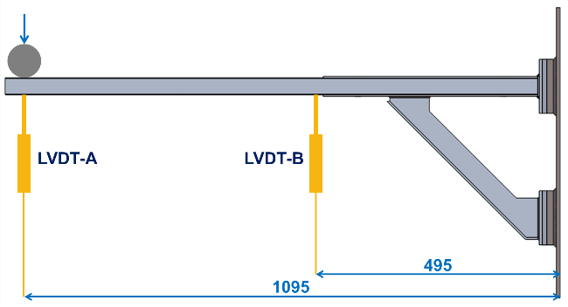
Figure 3. Positions of the LVDT sensors.

A servo-hydraulic actuator with a 100 kN load cell was employed. The load was applied at a constant rate of 10 mm/min at the free extremity of the balcony by means of a steel cylinder 950 mm long and with the diameter equal to 60 mm. The complete experimental setup is depicted in Figure 4.
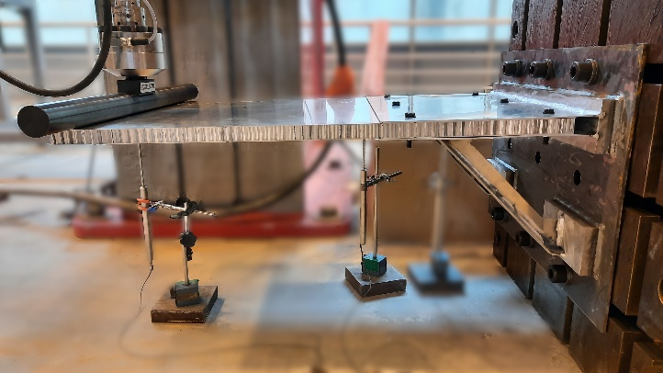
Figure 4. Experimental setup for full-scale testing of the AHS-based balcony overhang.

Experimental results
The load-displacement curves obtained from experimental testing for both AHS#1 and AHS#2 are displayed in Figure 5.
Figure 6 shows the balconies at the maximum displacement.
After removing the applied load, which enabled the elastic recover of the structure, the test was repeated, according to the procedure schematised in Figure 7. The results of the first and second loading run for both structures are reported in Figure 8, which shows a typical strain hardening response.
As expected, the smaller honeycomb cell size of AHS#1 resulted in a stiffer response than AHS#2, which is confirmed by the measurements of both LVDT. LVDT-A and the actuator displacement sensor yielded almost the same measurement for both panels, proving that no cells crushing occurs on the load line. Both tested overhangs showed a
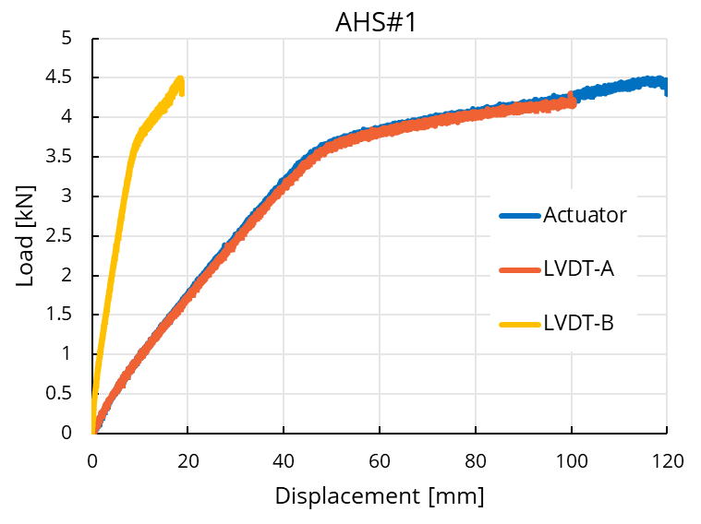
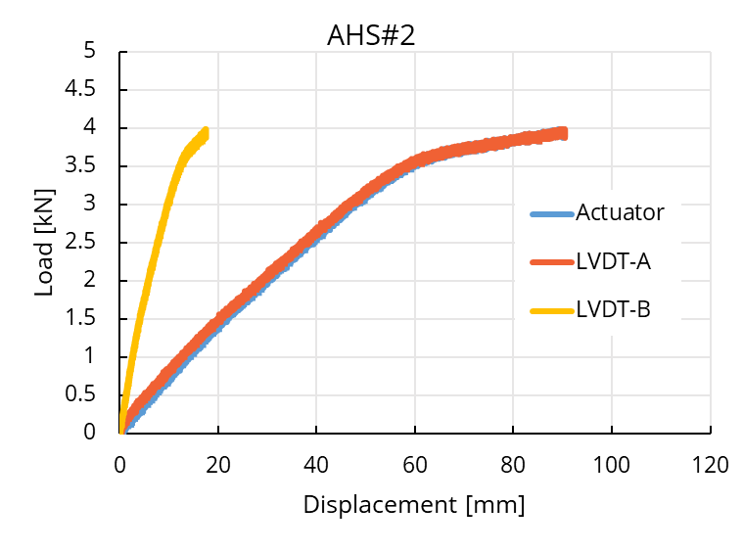
Figure 5. Load-displacement curves for both AHS tested panels.

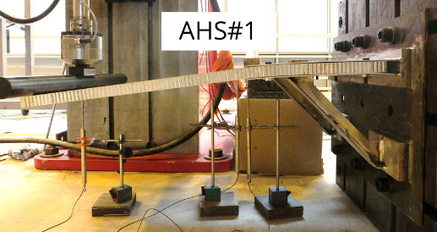 | 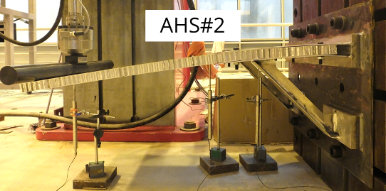
Figure 6. Balcony overhangs at the maximum displacement obtained during the first run of the tests.

plastic deformation mode, which enabled the panel to bend under the applied load without any significant sign of failure in the core or in the skins. The integrity of the bimetallic joints was not affected during the tests: this confirms the reliability of such solution and the possibility to integrate them in complex structures to enhance the use of lightweight alloys.
Despite the difference in AHS panels stiffness, the load registered during both tests were relevant and confirm the potentialities of integrating similar lightweight solutions in prefabricated balcony modules and in other structural components in shipbuilding.

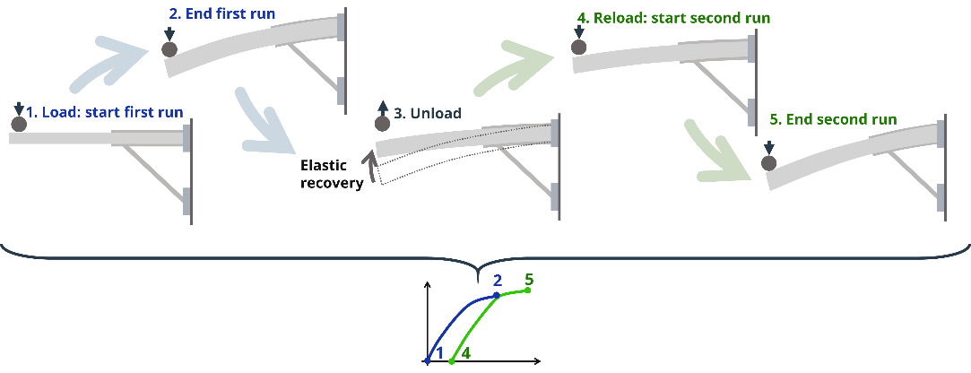
Figure 7. Load-unload sequence applied for the tested structures.

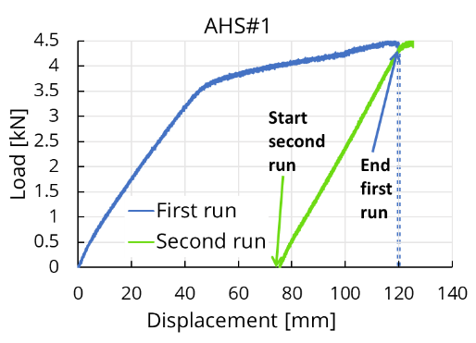 | 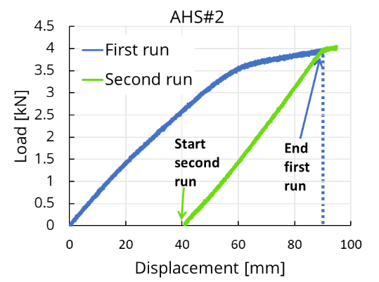
Figure 8. Load-displacement curves for first and second testing run.

The full-scale experimental investigation allowed the identification of the whole structure response, which is a crucial point in the design and building of complex structures where the interaction of different components is not easily predictable.

Conclusions
A full-scale experimental investigation was performed on a ship balcony overhang, including an aluminium honeycomb sandwich and bimetallic joints, with the aim of evaluating the potentialities and functionality of alternative and lightweight solutions in shipbuilding. The same supporting frame was employed to test two different AHS. The bimetallic joints provided reliable connections between the aluminium and steel parts and did not show any sign of failure. The AHS panels experienced plastic bending deformation, keeping the integrity of both core and skins. The panel with the smaller cell size yielded a stiffer response, which is more desirable for overhang ship parts, without significantly increasing the mass (0.8 kg of difference). However, both alternatives were capable to withstand demanding loading conditions, suggesting that similar solutions have the potentialities to be employed in shipbuilding. The introduction of bimetallic joints enabled the use of aluminium supporting plates and brackets, which have the potential to further reduce the weight of similar structures, in comparison to traditional solutions entirely based on steel. The information obtained from full-scale experimental tests are of primary importance since they can be used as input and as a comparative source for complex design process and numerical analysis.

Acknowledgements
The experiments reported in this scientific activity were conducted with the support of Research Project “THALASSA”, funded by the PON (National Operative Programme) 2014-2020.

References
[1] T. Tuswan, K. Abdullah, A. Zubaydi, and A. Budipriyanto, “Finite-element analysis for structural strength assessment of marine sandwich material on ship side-shell structure,” Mater. Today Proc., vol. 13, pp. 109–114, 2019.
[2] M. Önal, G. Neşer, and K. T. Gürsel, “Environmental impacts of steel ship hulls building and recycling by life cycle assessment ( LCA ),” Ships Offshore Struct., vol. 0, no. 0, pp. 1–6, 2020.
[3] G. Palomba, G. Epasto, and V. Crupi, “Lightweight sandwich structures for marine applications: a review,” Mech. Adv. Mater. Struct., vol. 0, no. 0, pp. 1–26, 2021.
[4] J. Kortenoeven, B. Boon, and A. de Bruijn, “Application of Sandwich Panels in Design and Building of Dredging Ships,” J. Sh. Prod., vol. 3, no. 24, pp. 125–134, 2008.
[5] P. Kujala and A. Klanac, “Steel sandwich panels in marine applications,” Brodogradnja, vol. 56, no. 4, pp. 305–314, 2005.
[6] G. Palomba, T. Hone, D. Taylor, and V. Crupi, “Bio-inspired protective structures for marine applications,” Bioinspir. Biomim., vol. 15, no. 5, p. 056016, Aug. 2020.
[7] D. Boroński, A. Skibicki, P. Maćkowiak, and D. Płaczek, “Modeling and analysis of thin-walled Al/steel explosion welded transition joints for shipbuilding applications,” Mar. Struct., vol. 74, p. 102843, Nov. 2020.
[8] Y. Kaya, “Microstructural, mechanical and corrosion investigations of ship steel-aluminum bimetal composites produced by explosive welding,” Metals (Basel)., vol. 8, no. 7, 2018.
[9] P. Corigliano and V. Crupi, “Fatigue analysis of TI6AL4V/INCONEL 625 dissimilar welded joints,” Ocean Eng., vol. 221, no. November 2020, p. 108582, 2021.
[10] P. Corigliano, V. Crupi, and E. Guglielmino, “Non linear finite element simulation of explosive welded joints of dissimilar metals for shipbuilding applications,” Ocean Eng., vol. 160, no. April, pp. 346–353, 2018.
[11] M. Böhm and M. Kowalski, “Fatigue life estimation of explosive cladded transition joints with the use of the spectral method for the case of a random sea state,” Mar. Struct., vol. 71, no. February, 2020.
[12] G. Palomba, G. Epasto, L. Sutherland, and V. Crupi, “Aluminium honeycomb sandwich as a design alternative for lightweight marine structures,” Ships Offshore Struct., vol. 0, no. 0, pp. 1–12, 2021.
[13] N. Kharghani and C. Guedes Soares, “Experimental and numerical study of hybrid steel-FRP balcony overhang of ships under shear and bending,” Mar. Struct., vol. 60, pp. 15–33, Jul. 2018.
[14] N. Kharghani and C. Guedes Soares, “Experimental study of the residual strength of damaged hybrid steel-FRP balcony overhangs of ships,” Prog. Marit. Technol. Eng. - Proc. 4th Int. Conf. Marit. Technol. Eng. MARTECH 2018, no. 2014, pp. 403–412, 2018.
[15] N. Kharghani and C. Guedes Soares, “Mechanical properties evaluation of the components of a failed hybrid steel-FRP balcony overhang in ships,” Mar. Struct., vol. 68, p. 102647, Nov. 2019.
[16] Y. Garbatov, S. Saad-Eldeen, and C. Guedes Soares, “Hull girder ultimate strength assessment based on experimental results and the dimensional theory,” Eng. Struct., vol. 100, pp. 742–750, 2015.
[17] H. G. Allen, Analysis and Design of Structural Sandwich Panels. London: Pergamon Press, 1969.

Corresponding Author: gpalomba@unime.it.

