On the structural response of bio-based adhesives for wooden hulls
Serena BERTAGNA^{a,}, Pasqualino CORIGLIANO^{b}, Vincenzo CRUPI^{b} and
Alberto MARINÒ ª
ª Department of Engineering and Architecture, University of Trieste, Italy
^{b} Department of Engineering, University of Messina, Italy
Abstract. In the last years, the idea of implementing greener and sustainable solutions merged with the basic principles of life cycle assessment concept has turned to be of paramount importance for the boatbuilding industry. In this framework, construction technologies based on wood such as strip-planking represent possible solutions, as they allow the use of a natural-grown material for attaining refined and solid structures. However, since these techniques imply wood bonding through conventional epoxy adhesives, the global eco-friendliness of the final product is lowered. As a consequence, the adoption of innovative bio-based adhesives is a promising solution to investigate. It is known that, generally, bonded joints in wooden hulls are weak spots of the structure, so the performances of the used adhesives should be duly assessed in order to guarantee an effective bonding. In the present research activity, the assessment of the performances of bonded joints manufactured with bio-adhesives is carried out through a FEM-based methodology, starting from the data present in both technical datasheets and literature for the materials used. In such a way, the most promising products can be preliminarily identified in order to deeply investigate their mechanical characteristics through experimental tests, so limiting expensive and time-consuming activities. The proposed methodology was validated through the comparison between the results coming from the FE analysis and the ones stemming from experimental tests. Moreover, the proposed methodology could be profitably used to analyse more complex geometries, such as real and large structures of wooden hulls.
Keywords. Green boatbuilding, wooden boats, wood adhesives, mechanical experimental tests, finite element simulations.

Introduction
The global interest for greener and more sustainable solutions in industrial processes has been increasing in recent years [1]. With specific reference to the boatbuilding industry, this sector represents an important source of environmental pollution due to the substantial production involved and has been undergoing a deep revolution following the green boatbuilding trend. Furthermore, such sector may play a strategic role as innovation carrier within marine constructions, in light of boatbuilders constant research for advancements and novelties for the production of small-size vessels. In particular, in order to pursue green achievements involving materials [2, 3], it is clear that fibre-reinforced polymers (FRPs) commonly used for boat constructions are no longer suitable. This is due to both the high amount of energy required for their production and the difficulties when approaching end-of-life management phases of FRP vessels [4]. As a result, researching innovative and eco-sustainable materials able to provide a lower environmental impact is a necessity. On the other hand, the utmost importance of ensuring robustness and durability, combined with a good weight/resistance ratio, is another crucial factor when choosing the most proper material for boat production.
In this framework, the introduction of bio-based materials specifically formulated for their use within boatbuilding technologies represents a promising solution to investigate. In particular, bio-based polymers (i.e., polymers with a high content of natural origin, derived from natural and renewable resources such as corn, sugarcane, and natural oils [5, 6]) can be employed as both stratification and adhesive resins coupled with other natural materials [7, 8]. Focusing on wood as a boatbuilding material, its great properties including remarkable long-term performance characteristics and aesthetically pleasantness [9] are the reasons why it is still considered as a favourite material for a few specialised shipyards. From the environmental point of view, wood has a low level of embodied energy if compared to many other materials (e.g., steel, aluminium, or plastic) and has a negative net carbon footprint [10, 11]; in addition, a proper management that implies forestry and harvesting practices aimed at ensuring the long-term health and diversity of forests can indefinitely guarantee a flow of wood products [12].
Being the first material ever used in boatbuilding, various technologies based on wood have been developed during centuries; among all, strip-planking technology represents one of the most interesting since it implies a relatively easy and efficient construction method that ensures a strong wooden structure with a remarkable strength-to-weight ratio and high fatigue resistance and resilience, as explained in [13, 14]. Strip-planking constructions imply the stratification of several wood strips having different thickness, kept together by means of adhesives that must be thoroughly chosen to ensure efficient bonding behaviour [15, 16]. Indeed, it must be considered that glued joints in wooden boats may represent weak structural spots; their resistance is therefore of paramount importance and must be a crucial parameter to choose adequate glues [17].
The willing of deepening the knowledge regarding bio-based resins to be used as adhesives and their performances when coupled with wood species commonly used in strip-planked constructions is at the basis of the present research. Indeed, such products are now commercially available, but their use in boatbuilding has been quite limited so far, causing a significant lack as regards information and data coming from relevant applications. Herein, starting from the results of mechanical experimental tests on wooden joints performed and presented by the authors in [8] and in accordance with the relevant literature [18–20], a FEM-based methodology aimed at reproducing the testing procedures by exploiting the data present in both technical datasheets and literature for the selected materials was developed. In particular, the attention was given to the linear-elastic behaviour of the tested joints. With specific reference to two bio-based epoxy resins A and B (having a natural origin content equal to 34.8% and 45.4%, respectively) produced by the Cardolite® Company and two wood essences (Douglas fir and Mahogany Sapele), FE simulations were performed on models representing scarf-jointed strips typically used within strip-planking. The proposed FEM-based methodology was validated by comparing the results coming from the experimental tests to the ones obtained through the FE analyses, performed with the commercial software ANSYS® Workbench 2020 R2. Through its exploitation, a preliminary selection of the most promising materials to be employed for experimental tests could be performed on the basis of their characteristics provided in literature and by suppliers in the technical datasheets, with the final aim of limiting expensive and time-consuming activities. Furthermore, the proposed methodology could be applied to analyse also wooden boats particulars such as structural details, in order to assess their strength and validate the use of bio-based adhesives for specific parts. Indeed, as FE simulations are used during composite vessels design to investigate and understand the best direction to lay reinforcement fibres and to locate and model hull internal reinforcements (Figure 1) [21, 22], they could support also design phases of wooden hulls.
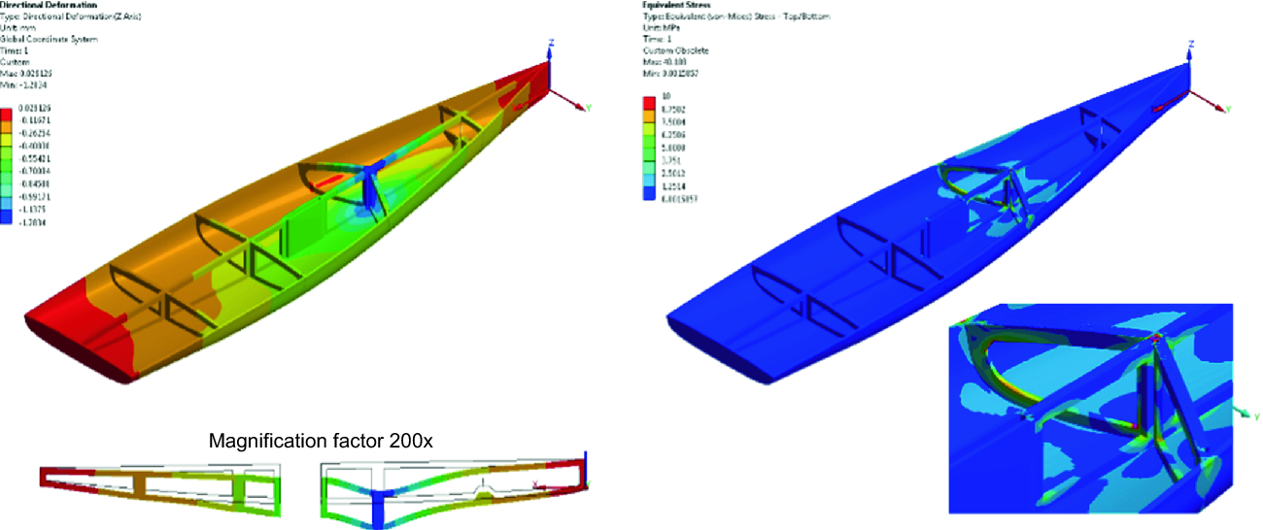
Figure 1. FE analysis on hull internal reinforcements [22].

Finite Element model

Materials properties
The correct materials characterisation in terms of mechanical properties is of paramount importance to ensure reliability of the results coming from the finite element simulations.
As drawn from the literature analysed [18], the selected woods (Douglas fir and Mahogany Sapele) should be modelled as being linear-elastic and orthotropic, hence having unique and independent mechanical properties in the directions of three mutually perpendicular axes: longitudinal, radial, and tangential. These axes are shown in Figure 2 as defined in accordance with the global coordinate system of the FEA software employed. By exploiting the relations between mechanical quantities present in [10] and reported in Table 1, the modulus of elasticity in the longitudinal direction provided in literature for Douglas fir [10] and in the technical datasheet for Mahogany Sapele served as the basis to derive the following properties, whose numerical values are shown in Table 2, along with the Poisson’s ratios provided again in [10]:
- Elastic moduli in radial and tangential directions;
- Shear moduli.
As regards the selected bio-based adhesives, they were characterised as isotropic materials by considering the data given in the technical datasheets as shown in Table 3.
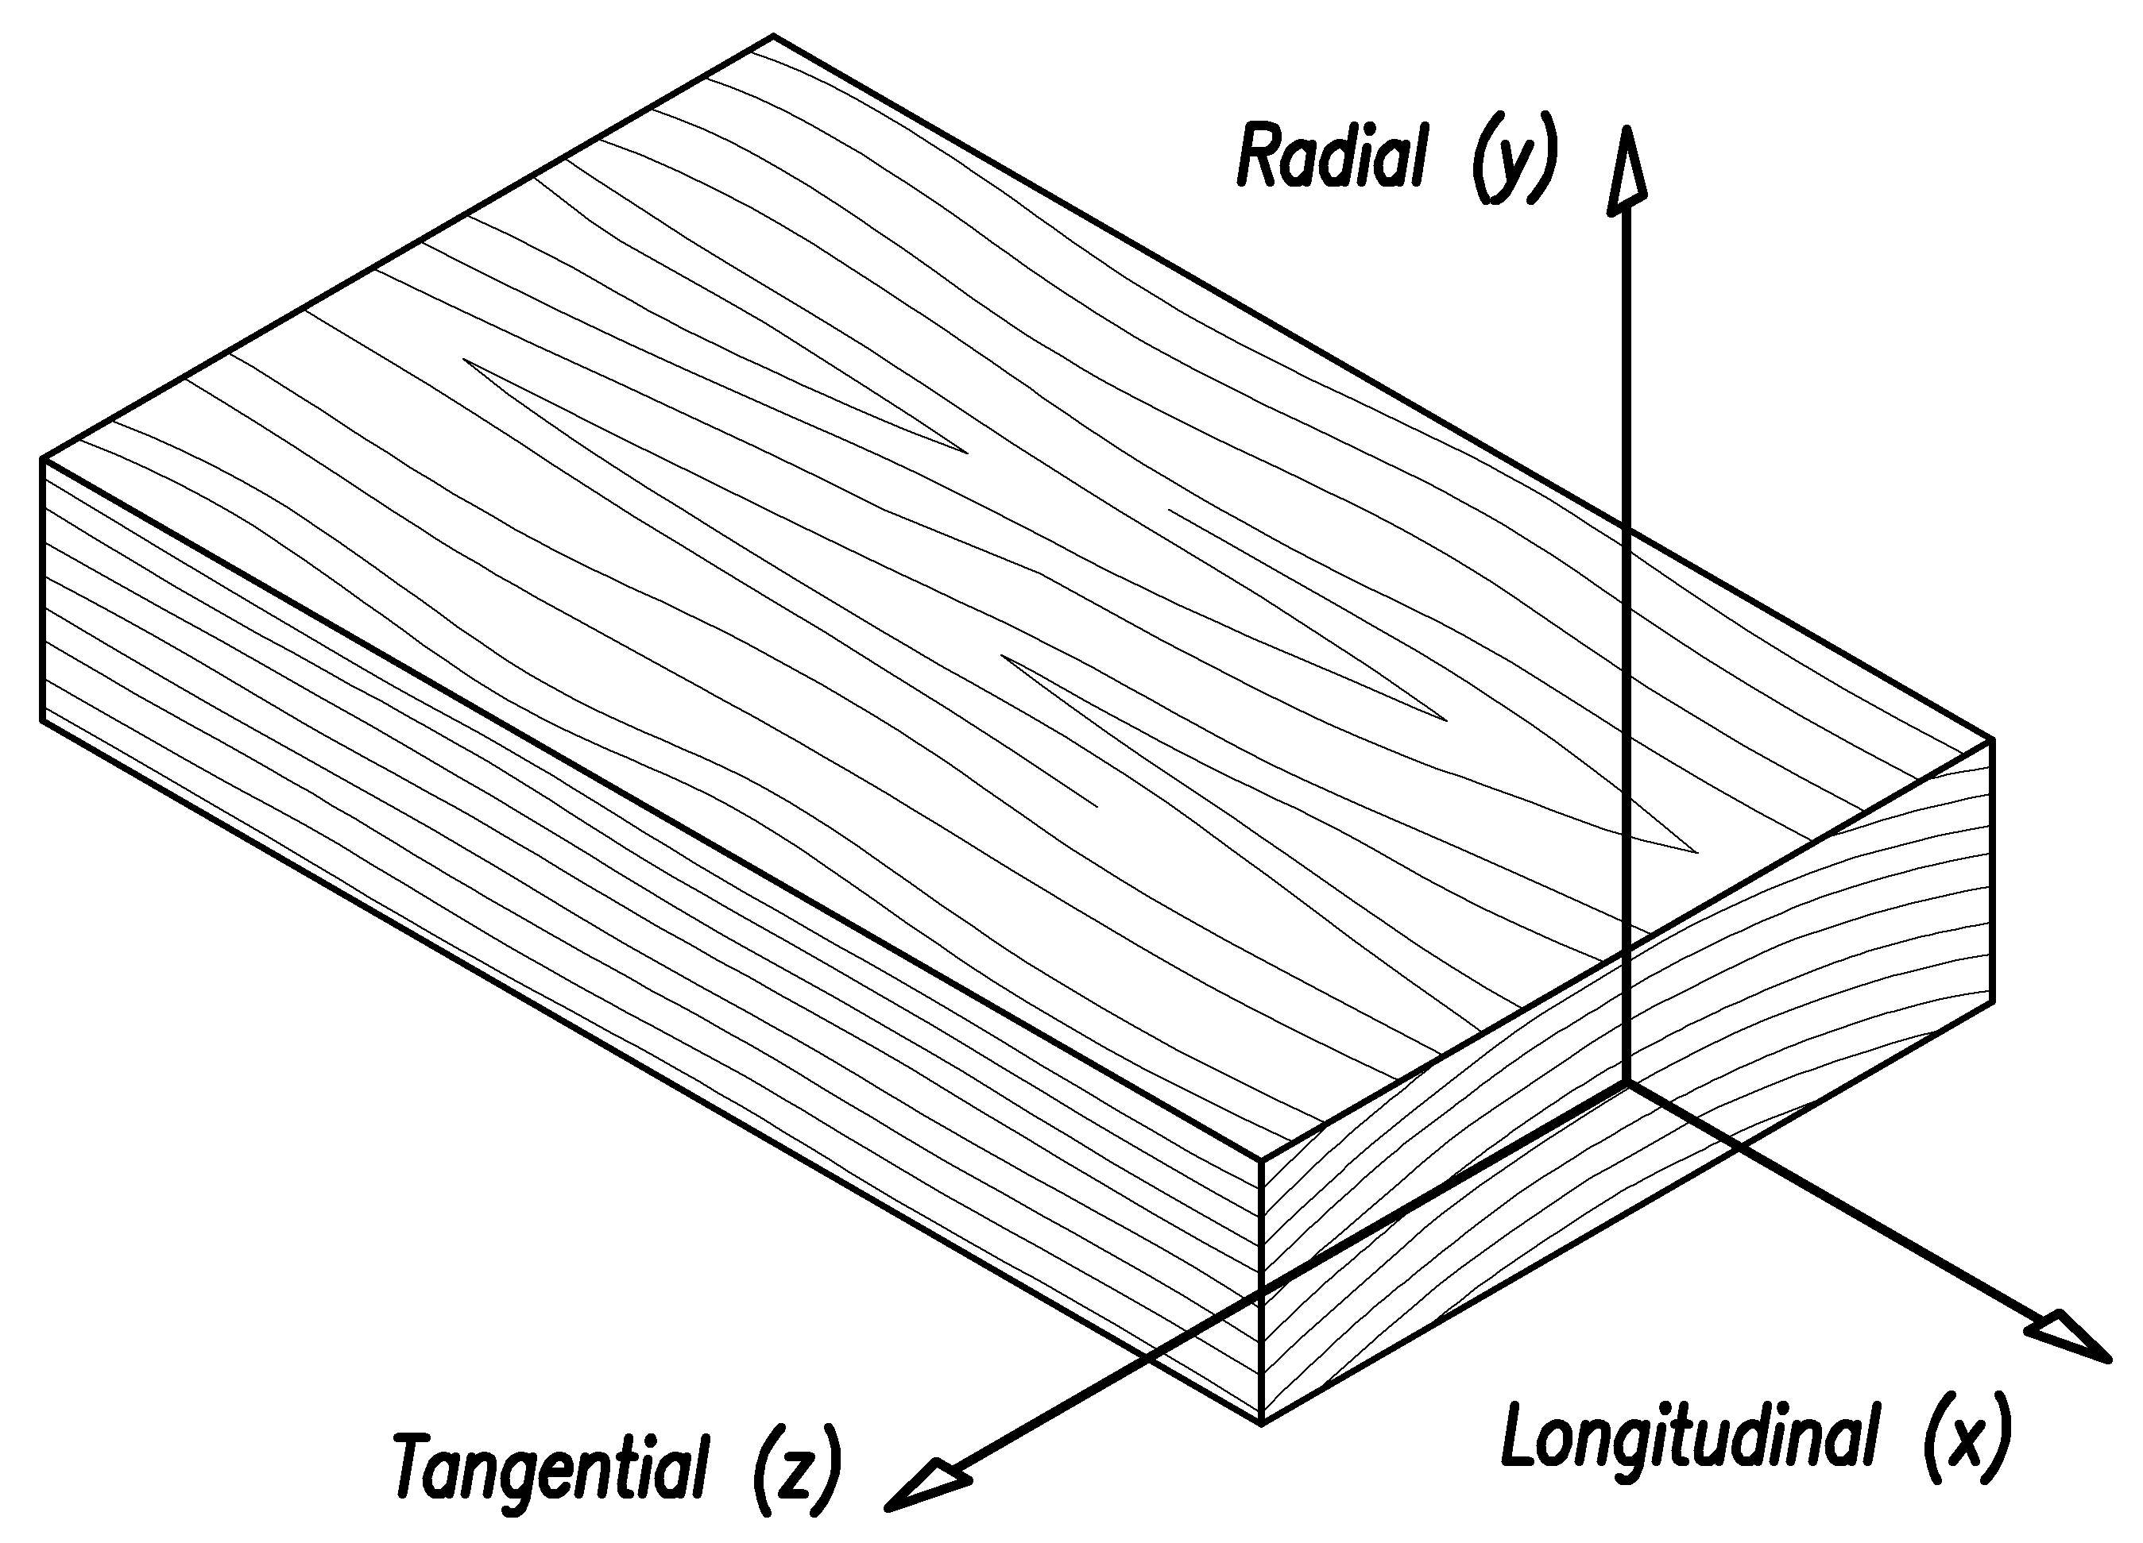
Figure 2. Three principal axes of wood with respect to grain direction and growth rings as defined in accordance with the global coordinate system of the FEA software.
Table 1. Elastic ratios for Douglas fir and Mahogany Sapele [10].
Elastic ratios | Douglas fir | Mahogany Sapele
E_{z}/ E_{x} | 0.050 | 0.050
E_{y}/ E_{x} | 0.068 | 0.111
G_{xy}/ E_{x} | 0.064 | 0.088
G_{xz}/ E_{x} | 0.078 | 0.059
G_{yz}/ E_{x} | 0.007 | 0.021
Table 2. Orthotropic properties for Douglas fir and Mahogany Sapele essences.
Orthotropic properties | Douglas fir | Mahogany Sapele
E_{x} [MPa] | 12150±1318 [10] | 13960±2403 [23]
E_{y} [MPa] | 826 | 1550
E_{z} [MPa] | 608 | 698
G_{xy} [MPa] | 778 | 1229
G_{yz} [MPa] | 85 | 293
G_{xz} [MPa] | 948 | 824
ν_{xy} [-] | 0.292 | 0.297
ν_{yz} [-] | 0.390 | 0.604
ν_{xz} [-] | 0.449 | 0.641
Table 3. Isotropic properties for bio-adhesives A and B [24, 25].
Isotropic properties | Bio-adhesive A | Bio-adhesive B
E [MPa] | 2886 | 2599
G [MPa] | 1069 | 963
ν [-] | 0.35 | 0.35
Natural-origin content [%] | 34.8 | 45.4

Mesh and boundary conditions
In order to properly investigate the behaviour of the investigated bio-adhesives and bonded joints, the FE model must represent both the adhesive layer and the wooden parts.
In the present research, the authors chose to build a 3D solid-body model (Figure 3), in order to adequately consider the wood orthotropic behaviour. Due to the symmetry of the model, a Symmetry Plane in correspondence of the XY plane was set up, in order to reduce computational efforts and times. The different parts of the model were connected together through the Shared topology feature, which allowed creating a set of nodes on the surfaces common to both bodies that is shared by elements on each body; hence, a conformal mesh is generated where bodies meet and these are jointed together.
Building a 3D solid-body model implies the use of 3D solid elements, commonly known as bricks. These are 3D 20-node second-order structural solid elements, in which each node has three translational degrees of freedom. Bricks are originally hexahedral and can degenerate into triangle-based prisms, quadrilateral-based pyramids, or tetrahedrons. For the FE scarf-joint model, the mesh was refined in correspondence with the adhesive layer and the surrounding adherends, in order to ensure a proper resolution and accuracy when simulating the behaviour of the joint itself. The mesh, shown in Figures 4 and 5 and whose properties are reported in Table 4, turned out to be composed of the following three distinct parts:
- Adhesive layer – structured grid composed of hexahedral elements having size equal to 0.1 mm, in order to define the adhesive body itself through two layers of elements;
- Surrounding adherends – unstructured grid composed of hexahedral and tetrahedral elements having size equal to 0.1 mm;
- Parts far from the joint – structured grid composed of hexahedral elements having size equal to 5 mm.
The definition of constraints and applied loads aimed at adequately mimicking the mechanical test carried out in laboratory, that is the tensile strength on scarf-jointed specimens [8]. As regards constraints, a fixed support was placed on the left face of the model, in order to simulate the tightening of the testing machine grip on the specimen. As for the load, a tensile force equal to 10 kN was applied as a linear load to the right face of the specimen. The load and constraint configuration is shown in Figure 6.
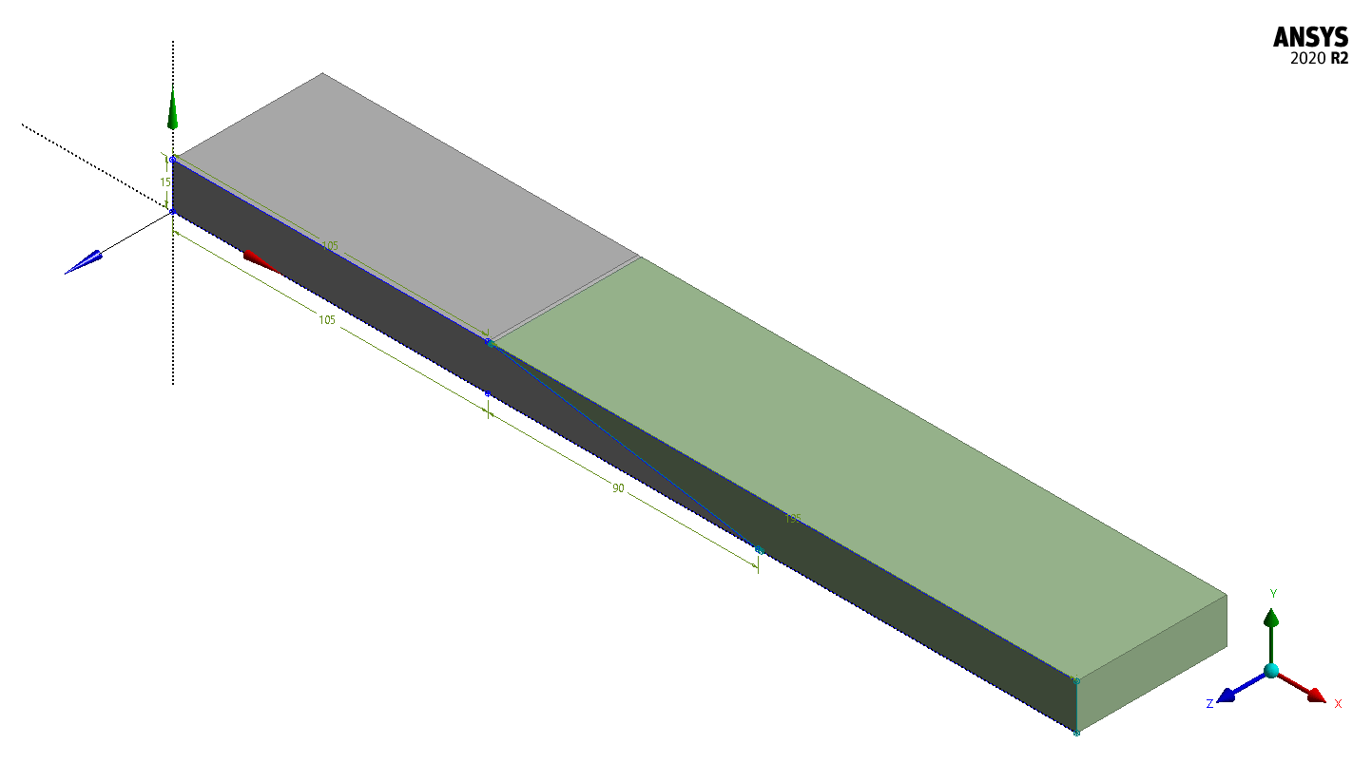
Figure 3. FE scarf-joint model.
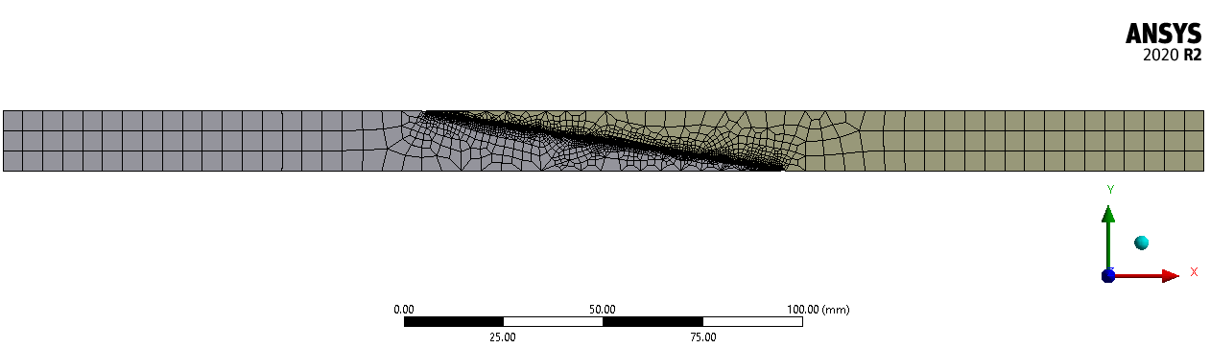
Figure 4. Mesh developed for the FE model.
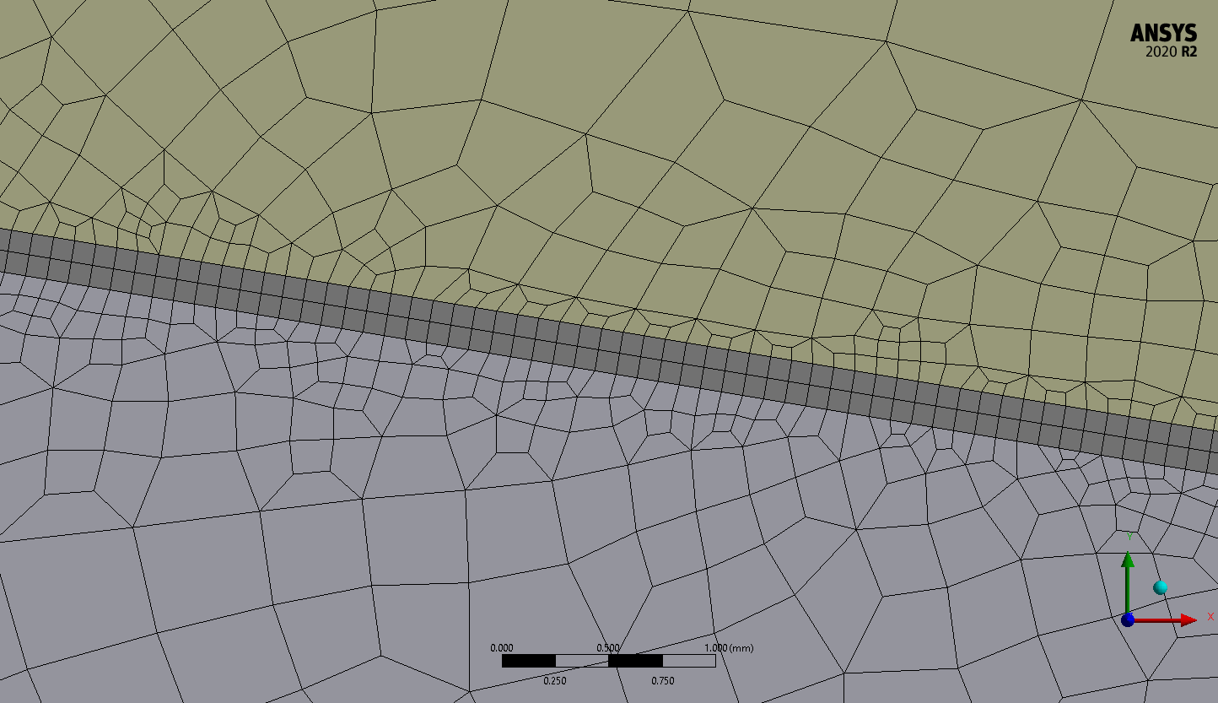
Figure 5. Close-up of the adhesive-layer mesh.
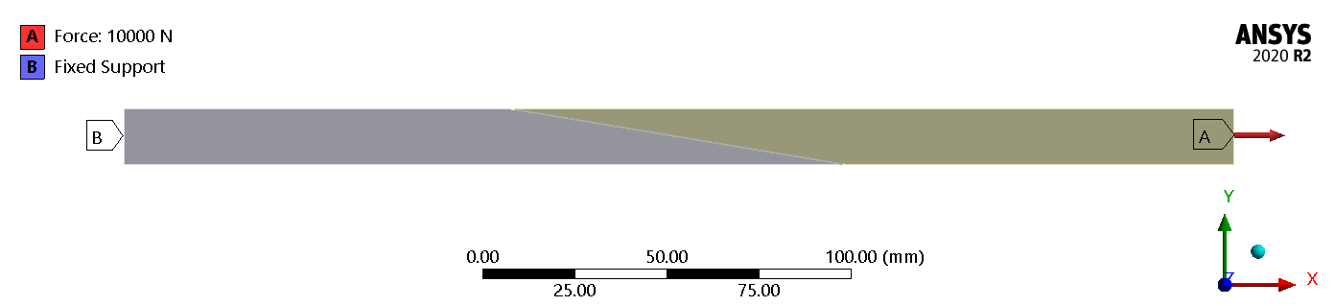
Figure 6. Loads and constraints defined on the FE scarf-joint model.
Table 4. Mesh properties for the FE scarf-joint model.
Property | Value | Explanation
Number of elements | 826163 | -
Number of nodes | 3323946 | -
Element quality (average value) | 0.578 | Metric based on the ratio of the volume to the edge length for a given element  (optimal values within 0.5 ÷ 1.0)
Aspect ratio (average value) | 3.852 | Ratio of longest to the shortest side in an element  (optimal values within 1 ÷ 5)
Skewness (average value) | 0.275 | Metric based on the difference between the shape of the cell and the shape of an equilateral cell of equivalent volume  (optimal values < 0.4)

Results and Discussion

FE results on wooden scarf joints
The modulus of elasticity in tension ${\text{E}}_{\text{t,0}}$ was calculated from FE analyses in order to compare it to the one obtained experimentally as follows:
$${\text{E}}_{\text{t,0}}\text{=}\frac{{\text{l}}_{\text{1}}\left({\text{F}}_{\text{2}}\text{-}{\text{F}}_{\text{1}}\right)}{{\text{A}}_{\text{0}}\left({\text{w}}_{\text{2}}\text{-}{\text{w}}_{\text{1}}\right)}$$ | (1)
in which: ${\text{l}}_{\text{1}}$ is the reference length (equal to 180 mm); $\text{(}{\text{F}}_{\text{2}}\text{ –}{\text{F}}_{\text{1}}\text{)}$ is the load increase on the straight part of the force-displacement curve; ${\text{A}}_{\text{0}}$ is the area of the cross section of the specimen (equal to 750 mm²); $\text{(}{\text{w}}_{\text{2}}\text{ – }{\text{w}}_{\text{1}}\text{)}$ is the displacement increase corresponding to the range $\text{(}{\text{F}}_{\text{2}}\text{ –}{\text{F}}_{\text{1}}\text{)}$.
Each type of investigated specimen was indexed through a code in which the main information as regards testing procedure and materials for the selected wood essences and bio-adhesives are collected, as follows: TJFA and TJFB for Douglas fir and TJMA and TJMB for Mahogany Sapele. Table 5 shows the values of modulus of elasticity in tension E_{t,0} evaluated from FE analyses for each type of investigated specimen.

Table 5. Modulus of elasticity in tension ${\text{E}}_{\text{t,0}}$ evaluated from FE analyses.
Specimen | TJFA | TJFB | TJMA | TJMB
${\text{E}}_{\text{t,0}}$ [MPa] | 6155 | 6154 | 8306 | 8303

The calculated modulus of elasticity in tension ${\text{E}}_{\text{t,0}}$ was compared to the mean values of the experimentally obtained modulus of elasticity in tension for each type of investigated specimen in order to validate the FE model.
However, an additional consideration regarding the mesh structure and dimension should be drawn. The implementation of a 3D solid-body model caused the subsequent FE grid to have a significant number of elements and nodes. The exploited computing device was able to solve the problem in a relatively moderate time, but the use of meshing tools external to the FEA software employed would contribute to reduce mesh dimensions and consequently computational efforts and times.

Mechanical experimental tests on wooden scarf joints
As regards the application of bio-based adhesives in wooden boatbuilding technologies, the authors carried out an extensive campaign of mechanical experimental tests presented in [8]. With specific reference to scarf-jointed strips commonly adopted in strip-planking, tensile tests in accordance with the UNI EN 408:2004 Standard “Structural timber and glued laminated timber – Determination of some physical and mechanical properties” [26] were performed on wooden specimens (Figure 7). The tests aimed at evaluating the modulus of elasticity in tension ${\text{E}}_{\text{t,0}}$.
The results coming from each set of mechanical tests, performed on nine specimens, were elaborated through a statistical analysis and the results for the modulus of elasticity in tension ${\text{E}}_{\text{t,0}}$ in terms of mean value $\overline{\text{x}}$, RMS value and characteristic value ${\text{x}}_{\text{k}}$ (5-percentile) were calculated, as shown in Table 6. Such quantities will serve as terms of comparison with the results coming from the FE simulations on scarf-joint models.
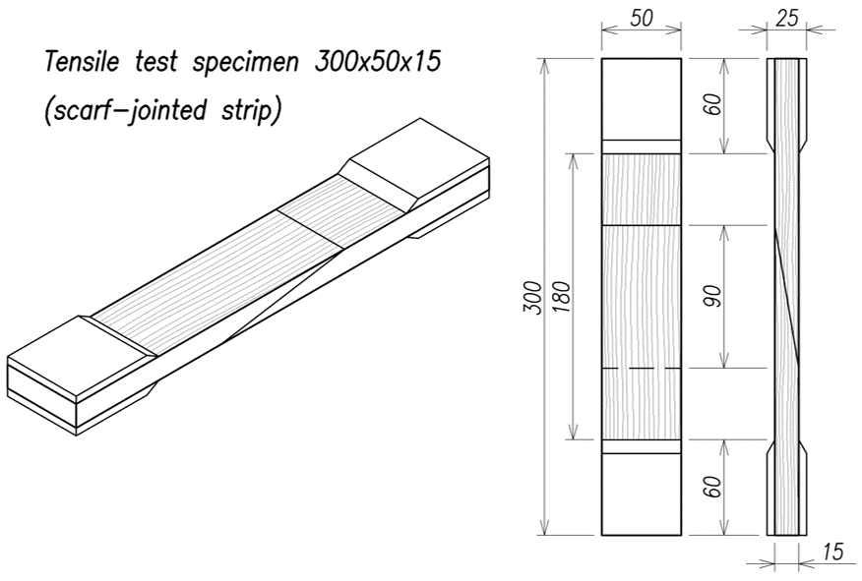
Figure 7. Scarf-jointed specimen geometry and dimensions [8].
Table 6. Results coming from the mechanical experimental tests for the modulus of elasticity in tension ${\text{E}}_{\text{t,0}}$ in terms of mean value $\overline{\text{x}}$, RMS value and characteristic value ${\text{x}}_{\text{k}}$ (5-percentile) [8].
Specimen | ${\text{E}}_{\text{t,0}}$ [MPa]
 | $$\overline{\text{x}}$$ | RMS | x_{k}
TJFA | 6556 | 419 | 5866
TJFB | 6279 | 490 | 5473
TJMA | 8926 | 506 | 8093
TJMB | 8853 | 281 | 8391

Validation of FE results by means of experimental tests
For both the selected wood essences and bio-adhesives, the results coming from the FE simulations were compared with the ones coming from the mechanical tests in the linear-elastic field. Table 7 shows the values of modulus of elasticity in tension ${\text{E}}_{\text{t,0}}$ evaluated from FE simulations and experimental results and a good agreement is achieved.
As shown in Figure 8, the FE results are nearly coincident with the experimental data in the linear-elastic field and it can be asserted that the FE simulations satisfactorily reproduced the behaviour observed during the experimental tests.

Table 7. Modulus of elasticity in tension ${\text{E}}_{\text{t,0}}$ evaluated from FE simulations and experimental results and percentage error.
Specimen | FE simulations | Experimental results | ${\text{E}}_{\text{t,0}}$Error [%]
 | ${\text{E}}_{\text{t,0}}$ [MPa] | ${\text{E}}_{\text{t,0}}$ [MPa]
TJFA | 6155 | 6556±419 | +6.1
TJFB | 6154 | 6279±490 | +2.0
TJMA | 8306 | 8926±506 | +6.9
TJMB | 8303 | 8853±281 | +6.2
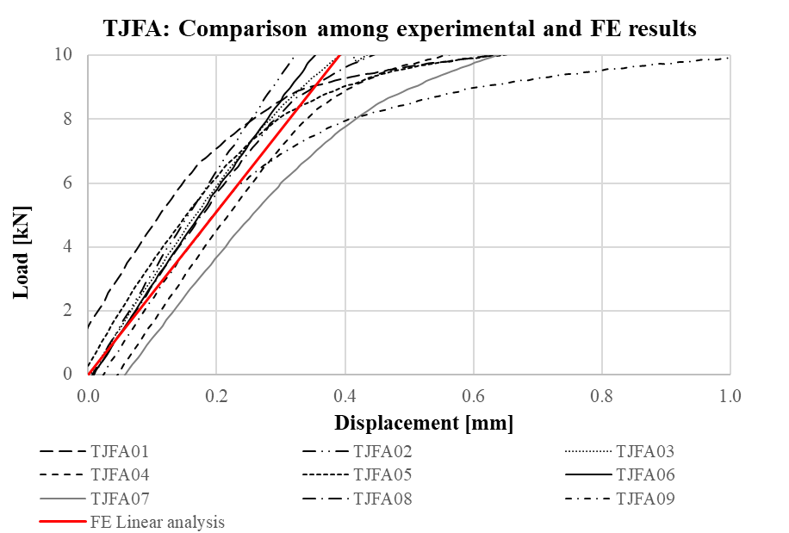 |  | 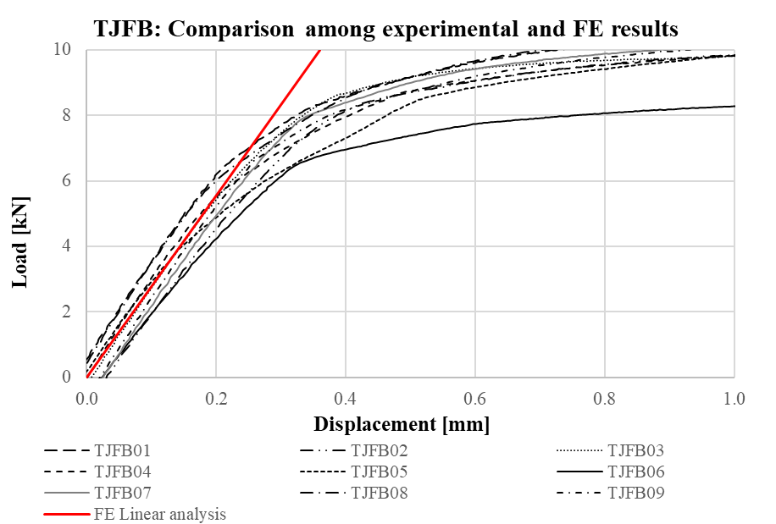
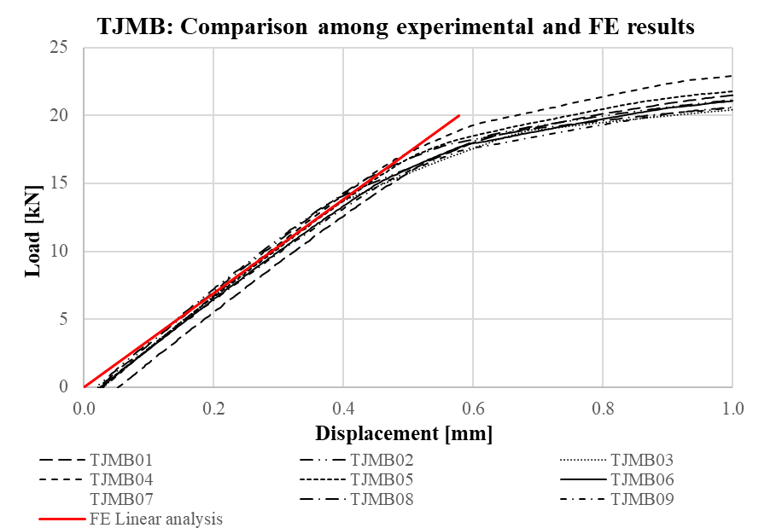
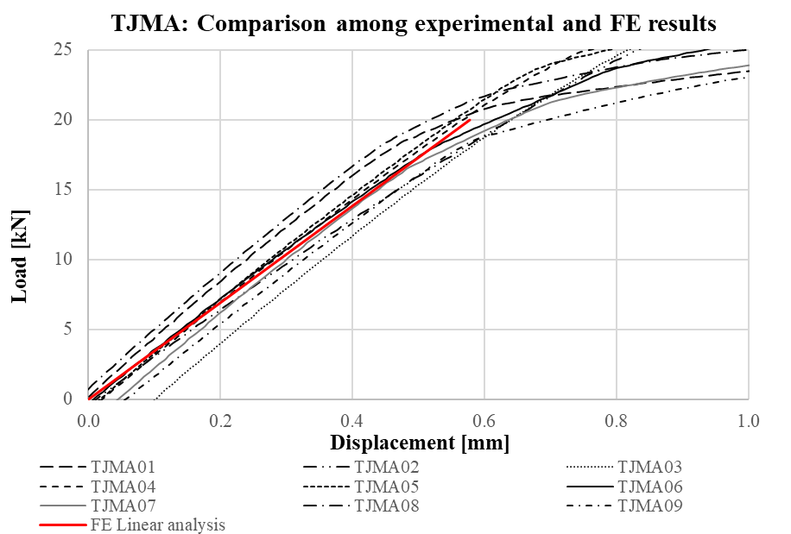
Figure 8. Comparison among experimental and FE results.

Conclusions
As well as all the other industrial sectors, boatbuilding industry has been facing the necessity to undertake sustainable developments and perform processes with a lower environmental impact. Nowadays, international Regulations and Standards are imposing stricter requirements for both navigation and design and construction phases. For the latter, raw materials production and end-of-life alternatives are fundamental factors to be taken into account.
With specific reference to wooden boat constructions, the possibility of enhancing sustainability through the introduction of natural-origin resins to be used as adhesives was the core motivation of the present research. In order to deepen the knowledge regarding such materials, the authors specifically developed a FEM-based methodology aimed at performing a preliminary assessment of mechanical characteristics of bio-based adhesives in wooden bonded joints, starting from the data present in literature and technical datasheets for both adhesives and woods. The FE simulations allowed the validation of the proposed methodology within the linear-elastic field by means of a comparison between FE and experimental results. The proposed methodology proved to be an accurate tool to investigate the structural response of bio-based adhesives for wooden hulls and could be extended to other commercially available bio-based products and wood essences. In such a way, mechanical tests on specimens may be limited to the most promising materials for the required performances, limiting expensive and time-consuming activities. As a deduction coming from the FE simulations, particular attention shall be given to the data provided in the materials’ technical datasheets. Indeed, the reported quantities in terms of modulus of elasticity may be overestimated or not assessed through proper experimental tests on specimens. Consequently, FE investigations shall not imply just the application of the provided quantities, but also a discussion on their reliability and several attempts with different values that take into account dispersion entity. Further developments of the study will be focused on the optimisation of the FE model and mesh, in order to lighten computational efforts as much as possible, and on the extension of FE simulations to wooden boat structural details.

References
- World Commission on Environment and Development (WCED). Our Common Future [Internet]. Oxford and New York: Oxford University Press; 1987. Available from:
https://sustainabledevelopment.un.org/content/documents/5987our-common-future.pdf
- Guo T, Zang H, Dai H. Analysis of green ships design and manufacturing technology. Appl Mech Mater. 2012;109:489–93.
- Xu H, Wang H, Xu H, Kou X, Li C, Yan H, et al. Discuss on green shipbuilding technology: Design and material. Adv Mater Res. 2012;490–495:3296–300.
- Pickering SJ. Recycling technologies for thermoset composite materials-current status. Compos Part A Appl Sci Manuf. 2006;37(8):1206–15.
- Wool R, Sun XS. Bio-Based Polymers and Composites. Inc. E, editor. Elsevier Academic Press; 2005.
- Koncar V. Composites and hybrid structures. Smart Text Situ Monit Compos. 2019 Jan 1;153–215.
- Bertagna S, Marinò A, Corigliano P, Crupi V. Green design of strip-planked Iroko wood for boatbuilding. In: Developments in the Analysis and Design of Marine Structures: Proceedings of the 8th International Conference on Marine Structures (MARSTRUCT 2021). Trondheim; 2021.
- Corigliano P, Crupi V, Bertagna S, Marinò A. Bio-based adhesives for wooden boatbuilding. J Mar Sci Eng. 2021;9(1):1–18.
- Asif M. Sustainability of timber, wood and bamboo in construction. In: Sustainability of Construction Materials. Elsevier Ltd.; 2009. p. 31–54.
- Forest Products Laboratory. Wood Handbook - Wood as an Engineering Material. 2010.
- Bose S, Vijith V. Wooden Boat Building For Sustainable Development. Int J Innov Res Dev. 2012;1(10):345–60.
- Bellassen V, Luyssaert S. Managing forests in uncertain times. Nature. 2014;506:153–5.
- Nicolson I. Cold-Molded and Strip-Planked Wood Boatbuilding. Sheridan House, Incorporated; 1991.
- Nasso C, la Monaca U, Marinò A, Bertagna S, Bucci V. The strip planking: An eco-friendly solution for the end-of-life of ships. In: Technology and Science for the Ships of the Future - Proceedings of NAV 2018: 19th International Conference on Ship and Maritime Research. 2018. p. 444–51.
- Bucci V, Corigliano P, Crupi V, Epasto G, Guglielmino E, Marinò A. Experimental investigation on Iroko wood used in shipbuilding. Proc Inst Mech Eng Part C J Mech Eng Sci. 2017;231(1).
- Corigliano P, Crupi V, Epasto G, Guglielmino E, Maugeri N, Marinò A. Experimental and theoretical analyses of Iroko wood laminates. Compos Part B Eng. 2017;112.
- Corigliano P, Ragni M, Castagnetti D, Crupi V, Guglielmino E. Measuring the static shear strength of anaerobic adhesives in finite thickness under high pressure. J Adhes [Internet]. 2021;97(8):783–800.
- Arciszewska-Kędzior A, Kunecký J, Hasníková H. Mechanical response of a lap scarf joint with inclined faces and wooden dowels under combined loading. J Herit Conserv. 2016;46:80–8.
- Noone SJ. Scarf joint angle optimisation. 2011.
- Kimiaeifar A, Toft H, Lund E, Thomsen OT, Sørensen JD. Reliability analysis of adhesive bonded scarf joints. Eng Struct. 2012;35:281–7.
- Ye Y, Chen C, Liu X. Structural strength analysis of FRP yacht by FEM. Appl Mech Mater. 2013;275–277:105–10.
- Mancuso A, Saporito A, Tumino D. Topology Optimization Design of Internal Reinforcements in a Sailing Dinghy [Internet]. Vol. 2, Lecture Notes in Mechanical Engineering. Springer International Publishing; 2021. 73–79 p. Available from: http://dx.doi.org/10.1007/978-3-030-70566-4_13
- Cirad. Mahogany Sapele Technical Datasheet. 2016.
- Cardolite Corporation. Bio-adhesive A Technical Datasheet: FormuLITE 2501LCA + UltraLITE 2009HSF. 2017.
- Cardolite Corporation. Bio-adhesive B Technical Datasheet: FormuLITE 2501A + 2002B. 2017.
- Ente Italiano di Normazione. DIN EN 408 - Structural timber and glued laminated timber: Determination of some physical and mechanical properties. 2004;(August):35.

Serena Bertagna, University of Trieste, Department of Engineering and Architecture, Via Alfonso Valerio 6, 34127 Trieste, Italy; E-mail: sbertagna@units.it.

