Environmentally friendly composites and surface treatments for metal-to-composite hybrid joints for marine application
Fabrizio SARASINI^{a,}, Jacopo TIRILLÒª, Vincenzo FIORE^{b}, Antonino VALENZA^{b}, Lorena SAITTA^{c}, Claudio TOSTO^{c}, Gianluca CICALA^{c}, Francesca FELLINE^{d}, Antonio GERARDI^{d}, Carlo IGHINA^{e} and Simone PANFIGLIO ^{f}
ª Dept. of Chemical Engineering Materials Environment, Sapienza-Università di Roma, Roma, Italy
^{b} Dept. of Engineering, University of Palermo, Palermo, Italy
^{c}DICAR, University of Catania, Catania, Italy
^{d}Materials and Structures Dept., CETMA, Brindisi, Italy
^{e}AZIMUT|BENETTI Group, Varazze, Italy
^{f}Consorzio di ricerca NAVTEC, Messina, Italy
Abstract. In this study, the use of natural fibres (flax and basalt) in combination with a recyclable epoxy matrix based on cleavable amines is suggested for improving the sustainability of marine industry. In addition, a new and eco-friendly anodizing process based on tartaric sulfuric acid solution (TSA) and a pore widening step in a NaOH aqueous solution was carried out on aluminium alloy (AA5083) to evaluate its effect on the adhesion strength and damage tolerance after low velocity impact of co-cured adhesive joints with a basalt fibre reinforced and recyclable laminate. The durability in marine environment was simulated by exposing samples to salt-fog spray conditions over a period of 90 days. Results highlighted the potential of the proposed natural fibre composites, even though the interfacial adhesion with the recyclable matrix needs to be improved, while the anodizing treatment significantly increased the damage tolerance of the joints irrespective of ageing, impact energy and temperature compared to the reference joints.
Keywords. Adhesive joint, natural fibres, polymer matrix composites, surface treatment, anodizing, bio-composites

Introduction
Since early 1960s the marine industry has experienced an increasing use of composites from small boats to submarines [1]. Traditional marine composites are woven glass/carbon reinforced thermosetting polyester/vinyl ester resins produced by hand lay-up, but the development of low-styrene emission resins, the vacuum resin infusion process and stitched fabrics have all contributed to improve composite quality. However, over recent years there have been some significant changes in both the materials and their applications. For example, increasing concern about environmental impact has favoured a move towards bio-sourced and recyclable matrices and fibres [2]. This is mainly triggered by the fact that traditional composite materials still do not have an environmentally acceptable waste stream solution, in order to deal with the ever-increasing volumes coming from end-of-use boats [3]. In this regard, a new generation of eco-friendly composites seems to be emerging, i.e., materials that can have fibres and resins effectively separated and circulated back into boat building, rather than going to landfill or incineration when the boat is no longer in use.
Chemical recycling is a valuable alternative approach to thermal (pyrolysis) and mechanical (grinding) recycling processes in order to avoid fibres’ and matrix properties degradation, which cannot be effectively reused in useful forms. At the same time, there is the need to limit the use of harmful chemicals to the environment and to the natural fibres. An interesting solution is granted by the use of cleavable amines developed by Connora Technology, which allow to synthesize thermosets which can be recycled, leading to thermoplastics and clean fibres by employing mild acetic acid aqueous solutions at low temperature (lower than 120 °C) [4]. Another concern, particularly important in the nautical field, is the integration of composite materials and metals to create hybrid structural systems [5]. Joining techniques can be of different types, i.e., mechanical, adhesive or of a combination thereof. Compared to mechanical joining, adhesive joints do not induce damage by drilling operations, are potentially free from galvanic corrosion issues along with cost and weight reductions caused by the absence of third joining elements. But these advantages are counteracted by the weakness represented by the adhesion at the substrate/adhesive scale, thus requiring specific surface treatments to mitigate this issue. Among the different available treatments, anodizing process is able to create a good interlocking with the adhesive layer while protecting the metal substrate from corrosion. Most industrial baths currently used are toxic or even carcinogenic, therefore there is an urgent need to use more eco-friendly baths able to impart also a good protection from corrosive environments [6].
In the framework of the THALASSA project, collaboration among universities, research centres and companies is striving to develop greener alternatives to traditional composites and surface treatments for joining dissimilar materials. The present work is focused on the development and mechanical characterization of composite laminates reinforced with natural basalt and flax fibres while exploiting innovative recyclable and bio-based epoxy formulations suitable to resin infusion based on bio-based epoxy monomers and a cleavable amine. In addition, an alternative anodizing process based on environmentally friendly chromium-free electrolytes has been developed to enhance the bonding strength of adhesive co-cured joints in double-strap configurations for nautical applications. Joint strengths have been evaluated under quasi-static loading, under transverse normal impact load at different temperatures and after an artificial salt fog ageing to assess their durability in marine environments.

Materials and methods

Materials
Concerning the natural fibre composites with recyclable matrix, epoxy monomers SuperSap®300 by Entropy Resins have been mixed with Recyclamine®301 from Connora Technologies and a cure inhibitor INH (by Entropy Resins, as a viscosity and pot life modifier). Two 2x2 twill fabrics with areal weight of 200 g/m² and 150 g/m² were used for basalt and flax reinforcement, respectively. Composite panels were prepared by resin infusion by stacking 20 layers of flax and basalt fabrics.
As regards the metal-to-composite hybrid joints, an aluminium alloy 5083 with a nominal thickness of 3.5 mm was selected as the metal substrate in this study, while the composite substrate is based on a bio-based composite material with a Polar Bear epoxy monomer (R*Concept) mixed with Recyclamine® R101 (100:22) and a plain woven basalt fabric (220 g/m²). Basalt fabric (“BAS”) was treated with an amino-silane coupling agent (i.e., Sigma-Aldrich (3-Aminopropyl)trimethoxysilane) in order to improve the fibre-matrix adhesion in composite substrates [7].
Double strap joints were manufactured through vacuum infusion process. Two metallic surface treatments were compared in order to investigate their effects on the aging behaviour of metal to composite bonded joints: i.e., mechanical abrasion and anodizing. Mechanical abrasion was chosen as the reference treatment (“MA”). Specifically, the aluminium substrates were mechanically treated for 20 minutes through an orbital sander Bosch PSS 250 AE with a sandpaper P80 [8]. For the anodizing process (“TSA”), the metal specimens were first smoothed with sandpapers of increasing grit up to 2000 and then cleaned in an ultrasonic acetone bath. Afterwards, they were immersed in an etching NaOH aqueous solution (10 wt.%), subsequently cleaned with deionized water and, after that, de-smutted in 30 %v/v HNO₃ aqueous solution. Finally, the anodizing treatment was realized in a bath composed by 0.48 M sulfuric acid and 80 g/l of tartaric acid (TSA) and water [7]. The process parameters were a voltage of 14 V at 37 °C for 20 min during a moderate stirring. After these steps, the metallic samples were immersed in a 0.1 M NaOH solution at room temperature for 2 min to widen the pores of the oxide layer.

Methods
Composite materials based on SuperSap were subjected to tensile tests and short beam shear tests according to ASTM D3039 and ASTM D2344, respectively. Their thermal stability was assessed by thermogravimetric analysis (TGA) from room temperature up to 800 °C in nitrogen atmosphere with a heating rate of 10 °C/min.
Joints were subjected to low velocity impact tests where the impactor tip (diameter equal to 12.7 mm) with a total mass of 3.055 kg hit the samples in the centre of the overlapped area. Tests were conducted at room temperature and at +60 °C. Post-impact tensile tests, according to ASTM D3528, were carried out to assess the damage tolerance of the joints. The same experimental campaign was performed on virgin and aged specimens. The aging behaviour of the co-cured joints was evaluated by exposing them to salt-fog spray condition (5 wt.% NaCl, 35 °C ± 1 °C) in a climate chamber according to ASTM B 117 for 90 days.
Fracture morphology of composite samples and failed joints was investigated by scanning electron microscopy (SEM). Prior to SEM analysis, specimens were sputter coated with gold.

Results and discussion

Natural fibre composites
The thermal stability of composites was investigated by TGA and the resulting curves in terms of weight loss and its first derivative are shown in figure 1.
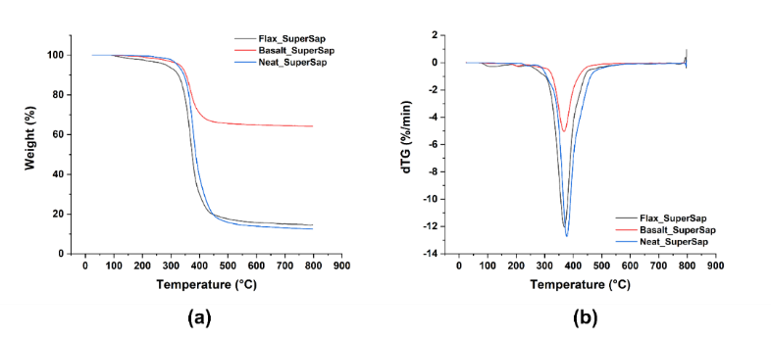
Figure 1. (a) TG and (b) dTG curves for neat bio-based resin and related composite formulations.

The bio-based epoxy resin featured a single-step degradation similar to basalt-based laminates, while flax-based laminates displayed a more complex degradation behaviour with a first degradation step at around 100 °C which is due to the absorbed moisture and the presence of a shoulder before the maximum degradation peak, which is ascribed to the hemicellulose and cellulose constituents [9]. The presence of constituents characterized by a lower thermal stability compared to basalt fibres led to an early onset of degradation for the composite. Interestingly, no significant differences in the temperature of maximum degradation rate were noted, irrespective of fibre type.
Mechanical properties of composites were evaluated in tensile loading, and the Young’s modulus and tensile strength obtained from typical stress vs. strain curves are reported in figure 2a-c. Both composites exhibited a catastrophic failure after reaching the ultimate strength value irrespective of fiber type and, as expected, basalt-based composites showed the highest tensile strength and modulus due to their inherent better mechanical properties compared to flax fibres. The tensile curve of flax-based laminates displayed a marked non-linear behaviour at small strains when compared with basalt [10], whose presence has been related to different mechanisms, including cellulose microfibrils reorientation and shear strain-induced crystallization of the amorphous paracrystalline components [11]. It is expected to mitigate the differences in mechanical properties by hybridizing flax and basalt fibres, as successfully confirmed in other studies with conventional epoxy matrices [12]. The interlaminar shear strength, being a matrix-dominated property, is generally considered as a sensitive parameter for evaluating fabrication quality, especially the consolidation, of the composites, as well as the interfacial compatibility at the fibre/matrix scale. Figure 2d clearly shows the better ILSS values of basalt fibre laminates compared to flax ones. This property can be considered as the result of complex interactions among different parameters, such as the fibre/matrix adhesion quality, the mechanical properties of the single constituents, the fibre volume fraction and the stacking sequence. In any case, it can provide insights into the quality of the manufacturing process of the composites.
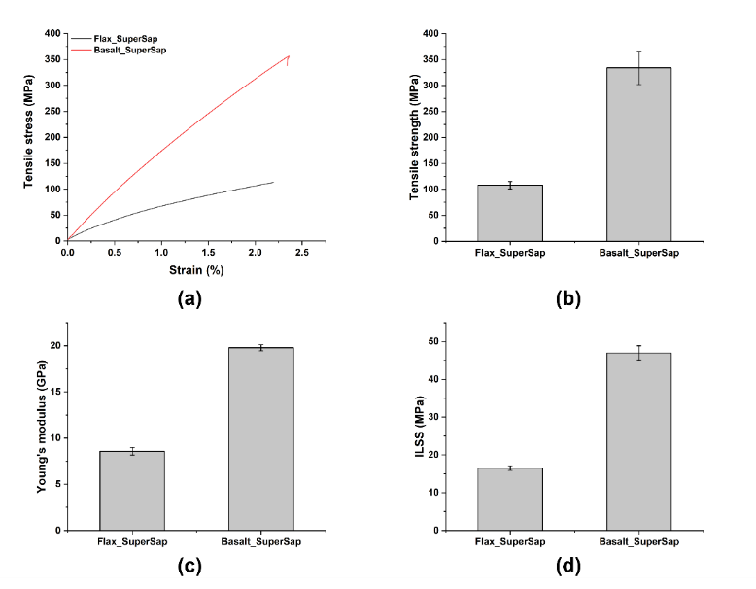
Figure 2. (a) Representative tensile stress vs. strain curves and (b,c) main tensile mechanical properties along with (d) interlaminar shear strength for bio-based composites.

The different values exhibited by the laminates suggest differences not only in the quality of the composites’ consolidation but also in the fibre/matrix compatibility. The composites investigated in the present work are reinforced with woven fabrics, thus showing non-planar interlaminar regions. Therefore, different damage modes can occur before the interlaminar final failure. When comparing the curves obtained during the short beam tests, basalt-based laminates exhibited a curve that rises gradually and then drops suddenly showing a distinct failure load developed in the sample, which is generally linked to an interlaminar shear failure. On the contrary, composites reinforced with flax fibres displayed curves characterized by a catastrophic failure after reaching the maximum load, linked to a typical bending-driven failure on the tensile side of the specimens. It is reasonable to expect the occurrence of different damage modes triggered by a poor fibre/matrix interfacial adhesion before interlaminar failure. This is confirmed by SEM analysis of the fracture surfaces. Flax reinforced laminates displayed a non-optimal fibre/matrix interfacial adhesion with this innovative and recyclable bio-based matrix, as confirmed by the presence of pull-out and debonding phenomena. The interfacial defects appear to trigger the nucleation and propagation of cracks in the brittle epoxy matrix. Better interfacial adhesion was observed in basalt-based laminates, where resin residues sticking on the fibres’ surfaces can be noted along with multiple fibre failures occurring on the same fracture plane, thus supporting the higher mechanical properties featured by basalt laminates. The results highlight the need to improve the fibre/matrix interfacial adhesion for a full exploitation of basalt and flax reinforcements, but the results of the present study compare quite favourably with those available in literature for composites based on conventional epoxy systems [12]. Meredith et al. [13] investigated different woven flax fabrics reinforced epoxy composites and reported tensile strengths ranging from 63 to 77.6 MPa, Young's moduli from 9.3 to 11.2 GPa and interlaminar shear strengths from 10.7 to 23.3 MPa, while Pisupati et al. [14] for composites based on flax fibres and a benzoxazine resin reported values of ILSS lower than 20 MPa. Concerning basalt-based laminates, the measured tensile properties and ILSS values are comparable if not higher than those obtained by Lopresto et al. [15] (∼40 MPa), and Scalici et al. [16](∼20 MPa).

Metal-to-composite hybrid joints
Low velocity impact tests were performed at two different impact energy levels, namely 2.5 J and 5 J, by varying the height of release of the impactor. In table 1are summarized the numerical results extracted from the typical impact curves.

Table 1. Impact parameters obtained from low velocity impact tests at room temperature on virgin joints.
Sample ID | Peak force  (N) | Max Displacement  (mm) | Absorbed energy (J) | Damage  degree
MA-BAS_2.5J | 2052.63±79.72 | 2.10±0.04 | 1.99±0.03 | 0.80±0.01
MA-BAS_5J | 1947.50±106.07 | 3.84±0.15 | 4.77±0.09 | 0.95±0.01
TSA-BAS_2.5J | 3034.62±167.36 | 2.00±0.06 | 2.20±0.11 | 0.88±0.04
TSA-BAS_5J | 2861.15±107.04 | 3.77±0.08 | 4.65±0.02 | 0.92±0.01

The presence of an extended plateau means that extensive damage phenomena occurred in the hybrid joint, as confirmed by a high value of the damage degree, which is defined as the ratio between absorbed energy and impact energy. Samples displayed, irrespective of joint type, a failure characterized by local indentation, matrix cracks and reduced delamination phenomena on the impacted surface of the composite with decohesion at the metal/composite interface. At higher impact energy, i.e., 5 J, a significant plastic deformation of the metal substrate was detected due to the bending stresses induced by the contact with the impactor. The anodizing treatment of the metal substrate along with the surface treatment of basalt fibres led to higher peak forces and lower damage. These results are confirmed by the post-impact tensile tests, which highlighted a reduced damage tolerance of the reference joints compared to the optimized ones. Values of joint shear strength reported in figure 3 for all joints and test conditions, show the better behaviour of TSA joints compared to the baseline not only in terms of absolute values, but also as a function of impact energy. All joints, after the tensile test, featured a failure located at the metal/composite interface, regardless of impact energy and joint type. Despite similarities in the failure of joints at the macroscopic scale, it is still possible to point out different failure modes at the micro scale. In particular, the morphology of the fracture surface of the baseline joint (MA-BAS) displays almost no resin residues (adhesive failure) while the anodized joints (TSA-BAS) showed a partial cohesive failure, as confirmed by the presence of matrix and fibre residues on the substrate. A different morphology was detected for optimized joints, where resin and fibre residues were found on the surface of the metal substrate along with an improved basalt/matrix interfacial adhesion. The same joints have been also impacted at +60 °C, whose numerical results are included in table 2.
Exposure to a relatively high temperature did not markedly affect impact resistance of both joint types, highlighting a behaviour similar to the room temperature one, though a significant decrease in the peak force was detected.
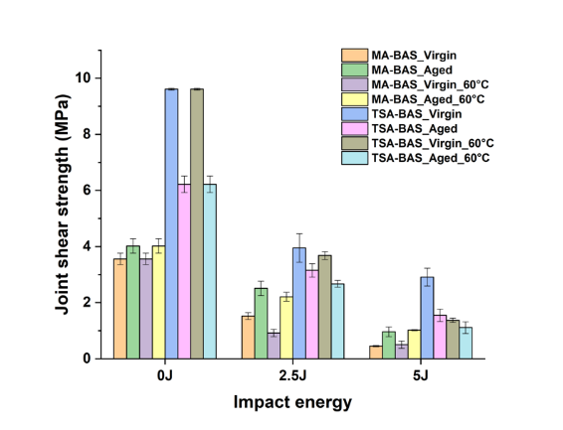
Figure 3. Joint shear strength of joints as a function of ageing, impact energy and impact temperature.

Table 2. Impact parameters obtained from low velocity impact tests at +60 °C on virgin joints.
Sample ID | Peak force  (N) | Max Displacement  (mm) | Absorbed energy (J) | Damage  degree
MA-BAS_2.5J | 1478.50±97.24 | 2.60±0.33 | 2.21±0.08 | 0.87±0.03
MA-BAS_5J | 1392.50±107.74 | 4.70±0.21 | 4.69±0.05 | 0.92±0.01
TSA-BAS_2.5J | 2449.97±61.70 | 1.97±0.04 | 2.51±0.01 | 0.85±0.01
TSA-BAS_5J | 2507.20±75.82 | 3.96±0.14 | 4.69±0.01 | 0.92±0.01

As regards the effect of salt fog exposure, an opposite trend was detected depending on the joint type. In all joints the ageing did not modify the impact curves but induced a decrease in the peak force without significantly affecting the absorbed energy. Aged reference joints experienced an increase in damage tolerance likely due to a post-curing of the matrix which counteracted the poor adhesion already noted for virgin joints. On the contrary, optimized joints exhibited a decrease in joint shear strength after ageing, ascribed to a degradation of the strong interfacial adhesion noted in virgin joints. Despite this opposite effect, optimized joints featured a higher damage tolerance than reference laminates irrespective of impact temperature and energy level.

Conclusions
This work explored the possibility to improve the sustainability of marine industry by suggesting the use of bio-based and recyclable composites based on natural fibres and environmentally friendly anodizing process for improved metal-to-composite hybrid joints. The composite materials investigated in the present study include a high content derived from renewable and carbon dioxide neutral resources and the matrix is cured with cleavable amines able to be recycled leading to thermoplastics and clean fibres by employing mild acetic acid aqueous solutions. Results from the tensile and interlaminar shear tests pointed out the need to improve the fibre (flax and basalt)/matrix interfacial adhesion, but the mechanical properties are in line with those of composites based on traditional and fully fossil-based epoxy matrices. It was also shown that the anodizing process based on environmentally friendly chromium-free electrolytes (i.e., TSA) is a useful method to obtain metal to composite adhesive joints with higher mechanical strength compared to reference joints, even considering the resistance to impact events up to +60 °C. This innovative treatment proved to be beneficial also after an accelerated salt fog exposure. In conclusion, results showed that the application of recyclable and environmentally friendly materials in the marine sector is of particular interest and due to their intrinsic characteristics, can lead to the solution of many problems and to improved performance.

References
[1] Rubino F, Nisticò A, Tucci F, Carlone P. Marine Application of Fiber Reinforced Composites: A Review. J Mar Sci Eng 2020;8:26. doi:10.3390/JMSE8010026.
[2] Bourmaud A, Beaugrand J, Shah DU, Placet V, Baley C. Towards the design of high-performance plant fibre composites. Prog Mater Sci 2018;97:347–408. doi:10.1016/J.PMATSCI.2018.05.005.
[3] Rybicka J, Tiwari A, Leeke GA. Technology readiness level assessment of composites recycling technologies. J Clean Prod 2016;112:1001–12. doi:10.1016/J.JCLEPRO.2015.08.104.
[4] Cicala G, Pergolizzi E, Piscopo F, Carbone D, Recca G. Hybrid composites manufactured by resin infusion with a fully recyclable bioepoxy resin. Compos Part B Eng 2018;132:69–76. doi:10.1016/j.compositesb.2017.08.015.
[5] Valenza A, Fiore V, Fratini L. Mechanical behaviour and failure modes of metal to composite adhesive joints for nautical applications. Int J Adv Manuf Technol 2010 535 2010;53:593–600. doi:10.1007/S00170-010-2866-1.
[6] Abrahami ST, Hauffman T, De Kok JMM, Mol JMC, Terryn H. Effect of Anodic Aluminum Oxide Chemistry on Adhesive Bonding of Epoxy. J Phys Chem C 2016;120:19670–7. doi:10.1021/ACS.JPCC.6B04957/ASSET/IMAGES/ACS.JPCC.6B04957.SOCIAL.JPEG_V03.
[7] Fiore V, Di Franco F, Miranda R, Santamaria M, Badagliacco D, Valenza A. Effects of anodizing surface treatment on the mechanical strength of aluminum alloy 5083 to fibre reinforced composites adhesive joints. Int J Adhes Adhes 2021;108:102868. doi:10.1016/J.IJADHADH.2021.102868.
[8] Di Franco F, Fiore V, Miranda R, Badagliacco D, Santamaria M, Valenza A. Influence of anodizing surface treatment on the aging behavior in salt-fog environment of aluminum alloy 5083 to fiber reinforced composites adhesive joints. Https://DoiOrg/101080/0021846420212011240 2021. doi:10.1080/00218464.2021.2011240.
[9] Yao F, Wu Q, Lei Y, Guo W, Xu Y. Thermal decomposition kinetics of natural fibers: Activation energy with dynamic thermogravimetric analysis. Polym Degrad Stab 2008;93:90–8. doi:10.1016/J.POLYMDEGRADSTAB.2007.10.012.
[10] Mahboob Z, El Sawi I, Zdero R, Fawaz Z, Bougherara H. Tensile and compressive damaged response in Flax fibre reinforced epoxy composites. Compos Part A Appl Sci Manuf 2017;92:118–33. doi:10.1016/J.COMPOSITESA.2016.11.007.
[11] Placet V, Cissé O, Lamine Boubakar M. Nonlinear tensile behaviour of elementary hemp fibres. Part I: Investigation of the possible origins using repeated progressive loading with in situ microscopic observations. Compos Part A Appl Sci Manuf 2014;56:319–27. doi:10.1016/J.COMPOSITESA.2012.11.019.
[12] Raponi E, Boria S, Giammaria V, Fischer B, Pörnbacher J, Sarasini F, et al. Effect of basalt intraply hybridization on the damage tolerance of flax laminates: Experimental analysis and analytical modeling under low-velocity impact. Compos Struct 2022;287:115270. doi:10.1016/J.COMPSTRUCT.2022.115270.
[13] Meredith J, Coles SR, Powe R, Collings E, Cozien-Cazuc S, Weager B, et al. On the static and dynamic properties of flax and Cordenka epoxy composites. Compos Sci Technol 2013;80:31–8. doi:10.1016/j.compscitech.2013.03.003.
[14] Pisupati A, Bonnaud L, Deléglise-Lagardère M, Park CH. Influence of Environmental Conditions on the Mechanical Properties of Flax Fiber Reinforced Thermoset Composites. Appl Compos Mater 2021;28:633–49. doi:10.1007/S10443-021-09885-Z/FIGURES/11.
[15] Fragassa C, Pavlovic A, Santulli C. Mechanical and impact characterisation of flax and basalt fibre vinylester composites and their hybrids. Compos Part B Eng 2018;137:247–59. doi:10.1016/J.COMPOSITESB.2017.01.004.
[16] Scalici T, Pitarresi G, Badagliacco D, Fiore V, Valenza A. Mechanical properties of basalt fiber reinforced composites manufactured with different vacuum assisted impregnation techniques. Compos Part B Eng 2016;104:35–43.

Corresponding Author, Fabrizio Sarasini, Sapienza-Università di Roma, Department of Chemical Engineering Materials Environment, Via Eudossiana 18, 00184 Roma, Italy; E-mail: fabrizio.sarasini@uniroma1.it.

