Surface unmanned multipurpose research marine vehicle: SUNMARE project

Maicol Laurenzaa,[1], Gianluca Pepea, Federica Mezzania, Alec Malito b, Massimo De Laurob, Salvatore Maurob, Antonio Cullaa and Antonio Carcaterraa

a University of Rome, Sapienza, Dept. of Mechanical and Aerospace Engineering, Rome, Italy

b Institute of Marine Engineering, CNR-INM, Rome, Italy

**Abstract.** This paper presents the preliminary activities undertaken for the research project SUNMARE (Surface UNmanned multipurpose research MARine vEhicle), which aims at the development of an innovative autonomous platform for marine, oceanographic, lacustrine, and submerged/semi-submerged cultural heritage monitoring/measurements. SUNMARE is a modular ship comprising of a mother unmanned ship and a smaller autonomous vehicle. Through an innovative fully autonomous launch and recovery system (LARS), the Unmanned surface vehicle (USV) can detach and reconnect to the mother ship. The architecture of the LARS and the on-purposely designed control algorithms are here presented together with statistical recovery success analysis concerning the autonomous dynamic connection of the vehicles, so to assess the reliability of the system.

**Keywords.** Unmanned surface vehicle (USV), Launch and recovery system, Optimal control

# Introduction and SUNMARE project

Recent improvements in sensor technology, combined with increasing interest in oceanographic measurements, are increasingly pushing the development of autonomous marine vehicles. Public and private research institutions are making considerable efforts in financing intelligent marine vehicles able to autonomously perform a wide range of operations and to collect a large quantity of as much as possible heterogeneous data [1-3]. SUNMARE-Surface UNmanned multipurpose research MARine vEhicle projects, funded by Regione Lazio (see Acknowledgments), stands in this scenario.

The aim of SUNMARE project is the development of a multipurpose autonomous research vessel and it presents an entire series of innovative features. From structural point of view, the hull is meant to be transportable, modular, and customizable. Moreover, it adapts to different missions, is resilient so to stand different and adverse sea conditions, and is eco-sustainable, made up of recyclable materials and equipped with a green propulsion system. Nevertheless, the core of the project and the aspect ensuring the reliability of the overall system is the control architecture, consisting of a complex network of algorithms with a dual sphere of application: on one hand, overall autonomous guidance must be performed [4], and it includes decision making processes, obstacle avoidance [5], safe guidance in surrounded environment conditions, such as harbour manoeuvres [6]. On the other hand, control algorithms are adapted for specific oceanographic measurement purposes. In this specific context stands the case here reported of an autonomous mother ship that releases through a launch and recovery system a second smaller autonomous vehicle for survey operations. Such a sophisticated control logic not only provides advantages in terms of safe manoeuvrability, course stability and attitude at low speeds, but also with respect to the achieved level of autonomy, bringing SUNMARE project up to level four according to the MASS (Maritime Autonomous Surface Ship) classification [7].

As intuitive, one of the most critical situations is the recovery of the smaller vessel. Conventional LARS rely on ramps/slipways, crane, intermediate device, and catapults [8] and not by chance human intervention is necessary in most cases [9] to prevent and manage the so-called corner cases. The ambition of SUNMARE is to realise a fully automated LARS, able to retrieve AUV as well as USV. To ensure the recovery, not only the mother ship presents a catamaran-like hull to better host the smaller vessel, as shown in Figure 1, but also the mechanism is structurally designed to pursue high reliability even in adverse sea conditions, a breakthrough in marine technology.

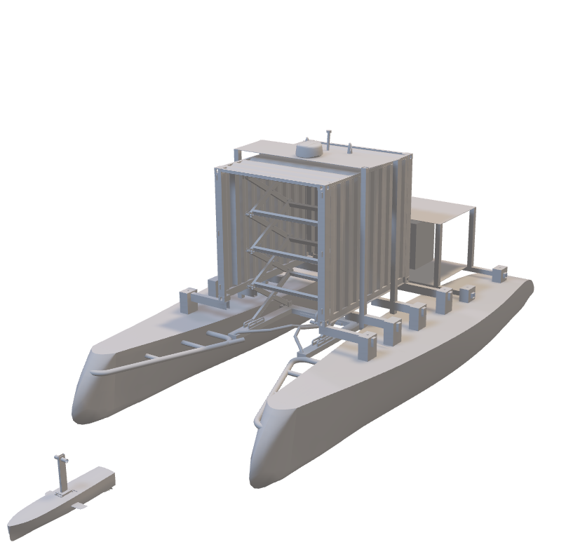

Autonomous vehicle

LARS

Container

Catamaran

mother ship

**Figure 1.** Preliminary design of SUNMARE system

The objective of this work is the assessment of the reliability of the LARS system through statistical analysis and simulations. For this reason, this work initially presents the design of the fully automated LARS; then the strategy and the control algorithms are presented and eventually the results of the simulations are used to demonstrate the robustness of the overall system.

# Launch and recovery system design

LARS has the only purpose of a safe hooking of the USV. The design responds to the intrinsic requirements of the mission and accordingly, it consists of three main parts (Figure 2):

* *Scissor mechanism*: entrusted with the correct positioning of the fork to perform the launch and recovery of the drone.
* *Fork*: whose purpose is the hooking of the USV through the fin.
* *Fin*: component grabbed by the fork. It houses all the communication tools and sensors.

The *Scissor mechanism* is the part actively absorbing the vertical displacements of the USV. The shape, composed of $n$ groups of scissor arms according to the shape of the mother ship and of the vehicle to recover, is justified by several reasons:

* the parallel kinematics of its geometry is extremely robust
* when closed, it has a compact structure guaranteeing enough space for the recovered vessel within the container
* the gear ratio allows amplification of the speed of the mechanism in adjusting its configuration, consequently able to quickly recover the USV.

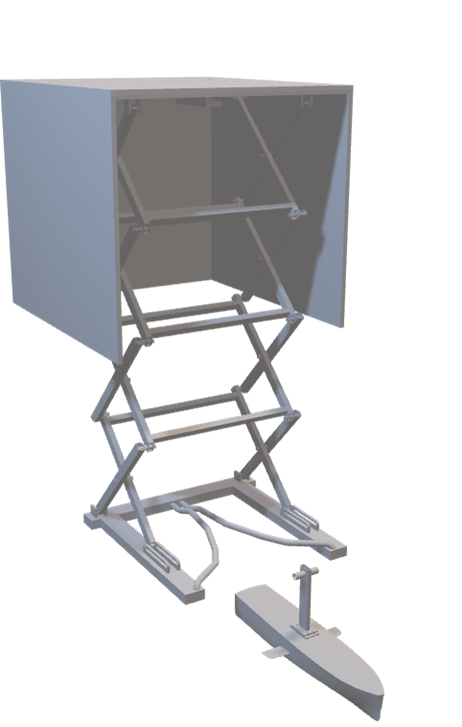

actuator

fork

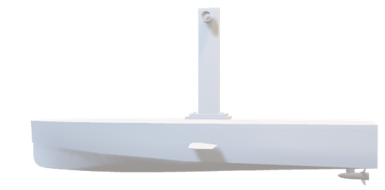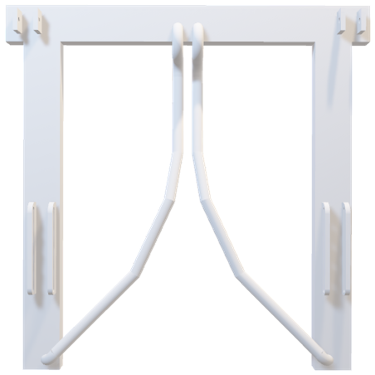

**Figure 2.** a) 3D view of the LARS; b) scissor mechanism and target identification of the recovery phase; c) structure of the fork and its functionality.

The fork is the element that, during the recovery phase, has the purpose of hooking the drone, passively absorbing roll, and transversal trajectory motions. The shape of the fork, shown in Figure 2, is designed to contain and lead the approaching of the USV, even in case of drifts form the desired alignment because of disturbances that cannot be managed by the control and the sensing systems. The fork can be divided into three sectors. *Sector 1* is the largest portion of the fork since, in this area, the first "encounter" with the fin takes place. The fork can accommodate the drone between the rods inviting it to continue towards *Sector 2* and *3*. The inclination of the rod is designed for the fin to enter the fork even in case of impacts. Despite the fork narrows, it is still possible for the drone to escape from the hook. When in *Sector 2*, the drone has no chance to escape, and the probability of successful recovery is 100%. Eventually, simply by assuring the slipping condition between the rods and the fin with an appropriate inclination of *Sector 3*, a stable equilibrium position is achieved.

# Launch and recovery strategy

The launch phase starts when the mother ship extends the LARS system until the USV touches the water and flows away from the catamaran. As intuitive, this manoeuvre is less critical with respect to the more challenging recovery one since it demands collaboration between the two independent vehicles. Prior the recovery, both vehicles must be in appropriate relative state, implying effective communication and vehicle positioning need to be guaranteed. The recovery process starts when the USV communicates, via wireless communication, the end of its mission to the mother ship and is not completed until the USV is retrieved and secured on board of the mother ship. This operation is mainly divided in three phases: vehicles alignment along a common direction; mutual approach between the two vehicles and retrieval of the USV with the fork.

The alignment trajectory, common to both vehicles, is defined according to the direction of the wind and the current to the advantage of energy savings and better manoeuvrability (Figure 3).

WIND

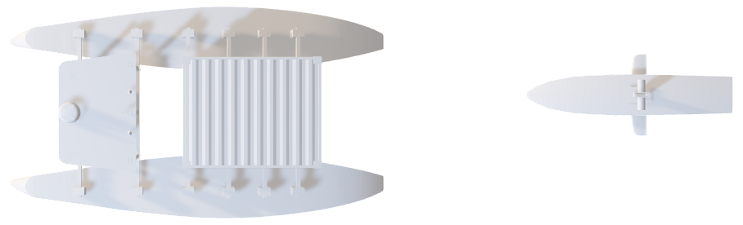

LARS activation

Alignment trajectory

Optimal trajectory

$$L_{MS}$$

$${5 L}_{MS}$$

Mother ship



$$e$$

$$y$$

$$x$$

$$ψ$$

$$ψ_{t}$$

$$u$$

$$v$$

$$P_{USV}$$

Repulsive bivariate distribution

$$P_{MS}$$

**Figure 3.** Recovery manoeuvre: alignment phase, LOSguidance law and obstacle avoidance

The mother ship aligns to the trajectory with a cruise speed lower than the USV, and then, a target point $P_{t}$ is defined along the trajectory at a distance of 5 times the length of the mother ship $L_{MS}$. When the USV approaches the mother ship, an optimal trajectory is generated, allowing to reach the target point with a desired speed and minimal energy cost. Then, a Model Predictive Control (MPC) strategy [10] is used to follow the optimal trajectory. Once the USV is near $P_{t}$, a non-linear feedback control intervenes. The USV switches from following the optimal trajectory to following the alignment trajectory. At this point, the USV reduces its speed so that a relative velocity of 0.5 knots is reached between the USV itself and the mother ship. Eventually, when the USV is within the catamaran, the LARS engages, and the recovery occurs, additionally supported by high accuracy localization sensors. The success of the recovery phase is based on the correct estimation of the state of the system and the consequent selection of the most suitable control logic algorithm according to the relative position between the USV and the mother ship. In the following section the main control algorithms are described.

## Control algorithms

The first step is the generation to the optimal trajectory that must be followed by the USV to reach the same trajectory of the mother ship, aligning with it. The goal of the optimal trajectory generation is the minimization of objective function subject to constraints and model dynamics. The algorithm looks for the so-called open-loop solutions, in which the control $u$ is dependent on the time $u(t)$. The objective function consists of two terms: $J_{b}$ regards the boundary conditions, the integral term $J_{t}$ the entire trajectory, both functions of the state $x$, the control $u$, and time.

|  |  |
| --- | --- |
| $$\min{ J_{b}\left(t_{0},t_{F},x\left(t_{0}\right),x\left(t_{F}\right)\right)+\int_{t_{0}}^{t_{F}}{J_{t}\left(τ,x\left(τ\right),u\left(τ\right)\right) dτ}}$$ | (1) |

The solution is achieved by reducing the problem in equation (1) to simple parametric optimization problem [11]. Once the initial guess is defined, the optimal trajectory is found by accounting also for the dynamics of the two vehicles. Soft constraints are considered for actuation, anti-collision and constraints. The optimal solution can be found in few seconds with a PC I7 10th generation.

To guarantee the USV follows the optimal trajectory just found, MPC is applied. It is an optimal control strategy that computes control inputs by minimizing a given objective function $J$ over a finite prediction horizon :

|  |  |
| --- | --- |
|  | (2) |

with $Q=Q^{T}>0$, $R=R^{T}>0$ tuning parameters. The predictive optimal control problem is solved at each sample time over the entire range $[t;t+T_{h}]$, updating the control solution which represents future control function $u(t)$ over a control horizon $T_{c}$ typically chosen as $T_{c}≤T_{h}$. With the MPC it is possible to treat linear dynamic systems and linear constraints with quadratic objective functions. In this case, the dynamic model is a simple 2-dimensional linear model [12] shown in Figure 3. The control action is determined only by one thruster, with its magnitude and orientation.

Since MPC is based on a linear model, it is not suitable when a certain level of reactiveness is required. Thus, in any circumstance in which a quick and a precise response is needed, such as when the USV is sensibly close to the mother ship, a feedback control algorithm, such as FLOP-Feedback Local Optimality Control [13], is a more appropriate choice. Indeed, it intervenes when the USV approaches the target point $P_{t}$ and is capable of minimizing a generic non-quadratic objective function $J$ in the state $x$ and quadratic in the control $u$ with affine dynamic constraints $\dot{x}=ϕ\left(x\right)+Bu$.

|  |  |
| --- | --- |
| $J=\int_{0}^{T}{\frac{1}{2} u^{T}Ru+g\left(x\right)dt}$ s.t. $\dot{x}=ϕ\left(x\right)+Bu$ | (3) |

The function $g(x)$ plays a key role in the process of tuning the control logic and can be used to include specific potential functions. For example, to ensure the USV does not collide with the mother ship, it is possible to use a confined repulsive potential function centred on the coordinates of the obstacle, i.e., the mother ship. Defining the state of the USV as $x=\left[u,v,r,x_{USV},y_{USV}, ψ\right]$, where $u,v$ are longitudinal and lateral velocities, $r$ is the angular velocity along the z axis, and $x_{USV},y_{USV}, ψ$ are the position and orientation of the USV, the function $g\left(x\right)$ is expressed as:

|  |  |
| --- | --- |
| $$g\left(x\right)=w_{v}{\left(v_{t}-u\right)}^{2}+g_{o}\left(x_{MS},y_{MS}\right)+ w_{e}e^{2}\left(x\right)+w_{ψ}{\left(ψ_{t}\left(x\right)-ψ\right)}^{2}$$ | (4) |

where $w_{e}, w_{ψ}, w_{v}$ are tuning parameters. The first term in equation (4) leads the USV to keep a target longitudinal velocity $v_{t}$; the second is a repulsive bivariate distribution function, centred at the position of the mother ship to avoid collisions between the two vehicles. The last two terms are both related to the guidance law, called *Line-of-Sight* [14], to drive the USV to the target $P_{t}$. It consists of making the vehicle converge to the desired point by adjusting the heading direction of the vehicle. Defining the alignment trajectory as the line which joins the mother ship point $P_{MS}=\left(x_{MS},y_{MS}\right)$ and the target point $P_{t}=\left(x_{t},y_{t}\right)$, see Figure 3, it is easy to determine the target orientation $ψ_{t}$ and cross-tracking error $e$ as:

|  |  |
| --- | --- |
| $\left\{\begin{aligned}ψ_{t}=\operatorname{atan}\left(\frac{x_{t}-x_{USV}}{y_{t}-y_{USV}}\right) \\ e=\left(y_{USV}-y_{t}\right)\cos\left(\operatorname{atan}\left(\frac{y_{t}-y_{MS} }{x_{t}-x_{MS} }\right)\right)-\left(x_{USV}-x_{t}\right)\sin\left(\operatorname{atan}\left(\frac{y_{t}-y_{MS} }{x_{t}-x_{MS} }\right)\right)\end{aligned}\right.$ | (5) |

Converging to the desired path means that the cross-tracking error must tend to zero, and the heading must converge to the heading target. By an appropriate regulation of the function $g(x)$ and of the tuning matrix $R$, together with the planar nonlinear dynamic model of the USV vessel, the explicit control law which guarantees local minimization can be obtained via the variational solution [13, 15]. In this configuration, a high accuracy and precision system with positioning antennas, based on UWB technology [16], is used to track the fin. UWB is a radio communication technology that uses frequencies form 3.6 GHz up to 10 GHz; it provides fast communication in a range of almost 500m, but one of the main applications of this technology is in positioning systems. Indeed, it is possible to measure the relative distances between two antennas through the Time-of-Flight of the signal. This kind of equipment can reach up to centimetre level precision [17]. The positioning measure allows to determine the relative height of the fin with respect to the fork (Figure 2). Concerning the retrieval and extraction of the USV, the scissor mechanism is controlled by a classical PID algorithm, whose target is the vertical distance between the fork and the midpoint of the fin $e_{fin}$ (see Figure 2). This choice is driven by the need of accounting for external disturbances, since the midpoint allows a certain safety range while the USV changes its altitude.

# Numerical results and conclusions

This section discusses the results of the numerical simulation performed to analyse the reliability of the control algorithm through the successful alignment of the vehicles first and the probability of successful recovery of the USV soon after. The simulated situation considers the mother ship following a straight trajectory, whose direction is defined by $ψ_{MS}=180°$, at constant speed of 0.5 knots. At the initial instant, the USV is located at a distance larger than 40 m from the mother ship with direction $ψ_{USV}=0$. Figure 4 shows the results of the alignment phase on the left-hand side. It is possible to distinguish the trajectory of the mother ship in red, the optimal trajectory followed by the USV generated by the MPC control logic first and FLOP when closer in dashed black and the trajectory estimated by the Kalman filter based on sensors data.



$$a)$$

$$b)$$

$$c)$$

$$d)$$

Mother ship trajectory

USV target trajectory

USV trajectory

Estimated USV trajectory

**Legend for Figures a), b), and c)**

**Figure 4.** Trajectories performed by the USV and mother ship during the alignment phase: **a**) along x axis, **b**) y axis and **c**) yaw angle $ψ$; **d**) Success probability of the recovery phase of the USV.

On the right-hand side of Figure 4, the probability of recovery success is shown. A statistical investigation of the recovery manoeuvre, in multibody environment, has been carried out for different sea and wind conditions, together with the scissor mechanism. The probability is calculated by setting different maximum speeds of the scissor’s actuator. The success of the manoeuvre depends on several factors such as the characteristics of propulsive actuation of vehicles, the rudders, the seaworthiness and the control logic set. Once all the dynamic characteristics have been established, it is possible to study the probability of hooking as a function of environmental disturbances. In the carried out prototypical simulation a guaranteed ability to success has been found until a wind speed of 5 m/s, which corresponds to a sea level 3 of Beaufort scale. After this threshold, the rate of success lowers down to zero for sea level 5.

These results confirm the reliability and the robustness of the LARS thanks to the on-purposely designed control architecture and the mechatronic arm design.

Acknowledgments

SUNMARE project is funded by Regione Lazio within the public call “Gruppi di ricerca 2020” – POR FESR Lazio 2014-2020.

References

[1] J. G. Bellingham, "New oceanographic uses of autonomous underwater vehicles," *Marine Technology Society. Marine Technology Society Journal,* vol. 31, no. 3, p. 34, 1997.

[2] M. Bibuli, O. Parodi, L. Lapierre, G. Bruzzone, and M. Caccia, "Vehicle-following guidance for unmanned marine vehicles," *IFAC Proceedings Volumes,* vol. 42, no. 18, pp. 103-108, 2009.

[3] P. F. Rynne and K. D. von Ellenrieder, "Unmanned autonomous sailing: Current status and future role in sustained ocean observations," *Marine Technology Society Journal,* vol. 43, no. 1, pp. 21-30, 2009.

[4] E. Paifelman, G. Pepe, and A. Carcaterra, "An optimal indirect control of underwater vehicle," *International Journal of Control,* Article vol. 94, no. 2, pp. 312-326, 2021, doi: 10.1080/00207179.2019.1590737.

[5] M. Laurenza, G. Pepe, D. Antonelli, and A. Carcaterra, "Car collision avoidance with velocity obstacle approach: Evaluation of the reliability and performace of the collision avoidance maneuver," in *5th International Forum on Research and Technologies for Society and Industry: Innovation to Shape the Future, RTSI 2019 - Proceedings*, 2019, pp. 465-470, doi: 10.1109/RTSI.2019.8895525. [Online]. Available: https://www.scopus.com/inward/record.uri?eid=2-s2.0-85075634772&doi=10.1109/RTSI.2019.8895525&partnerID=40&md5=4ec5929c8f72e43dd57245de1e7efdb1

[6] L. Nesi, G. Pepe, M. Bibuli, E. Zereik, A. Carcaterra, and M. Caccia, "A new tow maneuver of a damaged boat through a swarm of autonomous sea drones," in *IFAC-PapersOnLine*, 2019, vol. 52, 21 ed., pp. 360-366, doi: 10.1016/j.ifacol.2019.12.333. [Online]. Available: https://www.scopus.com/inward/record.uri?eid=2-s2.0-85079686272&doi=10.1016/j.ifacol.2019.12.333&partnerID=40&md5=2cf23d5f18cac2d88f745c6e6b86185a

[7] I. M. Organization, "Outcome of the regulatory scoping exercise for the use of Maritime Autonomous Surface Ships (MASS)," 2021.

[8] L. W. Hanyok and T. C. Smith, "Launch and Recovery System Literature Review," 2010.

[9] L. Henriksen, A. Bjerrum, and A. Ishoy, "Sea trials of MARTIN-a European survey AUV," 1995, vol. 3: IEEE, pp. 1439-1445.

[10] J. Richalet, A. Rault, J. L. Testud, and J. Papon, "Model predictive heuristic control: Applications to industrial processes," *Automatica,* vol. 14, no. 5, pp. 413-428, 1978/09/01/ 1978, doi: https://doi.org/10.1016/0005-1098(78)90001-8.

[11] A. Rao, "A Survey of Numerical Methods for Optimal Control," *Advances in the Astronautical Sciences,* vol. 135, 01/01 2010.

[12] S.-R. Oh and J. Sun, "Path following of underactuated marine surface vessels using line-of-sight based model predictive control," *Ocean Engineering,* vol. 37, no. 2, pp. 289-295, 2010/02/01/ 2010, doi: https://doi.org/10.1016/j.oceaneng.2009.10.004.

[13] G. Pepe, D. Antonelli, L. Nesi, and A. Carcaterra, "Flop: Feedback local optimality control of the inverse pendulum oscillations," in *Proceedings of ISMA 2018 - International Conference on Noise and Vibration Engineering and USD 2018 - International Conference on Uncertainty in Structural Dynamics*, 2018, pp. 93-106. [Online]. Available: https://www.scopus.com/inward/record.uri?eid=2-s2.0-85060389675&partnerID=40&md5=d29242dd2913e82530da27cdf6ac222a

[14] T. Fossen, M. Breivik, and R. Skjetne, *Line-of-Sight Path Following of Underactuated Marine Craft*. 2003.

[15] G. Pepe and A. Carcaterra, "Semi-active damping by variational control algorithms," in *Proceedings of the International Conference on Structural Dynamic , EURODYN*, 2014, vol. 2014-January, pp. 1721-1727. [Online]. Available: https://www.scopus.com/inward/record.uri?eid=2-s2.0-84994438016&partnerID=40&md5=a1eee56015fd2beb9803f75b2215160c

[16] Z. Sahinoglu, S. Gezici, and I. Guvenc, "Ultra-wideband positioning systems," *Cambridge, New York,* 2008.

[17] S. Gezici *et al.*, "Localization via ultra-wideband radios: a look at positioning aspects for future sensor networks," *IEEE signal processing magazine,* vol. 22, no. 4, pp. 70-84, 2005.

1. Maicol Laurenza, University of Rome Sapienza, Dept. of Mechanical and Aerospace Engineering, Rome, Italy; E-mail: maicol.laurenza@uniroma1.it.