Dynamic Instability of Ships in Stern-Quartering Seas within the SGISC framework
Christian LENA^{a,} and Matteo BONCI ª
ª Maritime Research Institute of the Netherlands (MARIN)
Abstract. The International Maritime Organization has formally approved as recommended guidelines the methods and procedures of the Second Generation Intact Stability Criteria (SGISC). These criteria introduce the concept of dynamic stability assessment of ships, defining the failure modes that might occur to a ship that navigates in harsh sea conditions. This paper focuses on the failure mode surf-riding/broaching-to in stern-quartering seas, with the objective of analyzing the characteristics and the potential of SGISC risk assessment in the ship design. The risk-evaluation criteria of surf-riding and broaching were followed through Level 1 and Direct assessment of SGISC. Two different hull designs were considered, a Fast Displacement Ship and a high-speed V-bottom, hard chine hull. Time domain simulations were performed using a time domain potential flow boundary element method. A detailed definition of broaching was used to detect the event occurrence in irregular waves, and the results were compared with failure mode definition of SGISC concerning the roll and lateral acceleration safe limits exceedance. The SGISC were also employed in the attempt to evaluate the different failure mode risk assessment due to different stern appendages configurations of the two hull designs with respect to broaching and surf-riding.
Keywords. Dynamic stability, SGISC, broaching-to, surf-riding.

Introduction
The concept of ship dynamic stability has been in recent years introduced in the Intact Stability regulatory framework of the International Maritime Organization (IMO). In 2020, the Second Generation Intact Stability Criteria (SGISC) were formally approved as recommended guidelines for the safety assessment of ships sailing in severe sea conditions [1]. The SGISC define the main failure modes that might occur to a ship that navigates in heavy waves, namely large acceleration, parametric roll, loss of stability, dead ship condition and surf-riding/broaching-to. The IMO SGISC are intended to complete the 2008 Intact Stability Code, that is based on the static stability of the vessel. Before the IMO SGISC, dynamic effects due to environmental conditions had been taken into account only by means of simplified wind inclining moment.
In this paper a complete SGISC stability assessment was carried out for the failure mode of surf-riding/broaching-to in stern-quartering seas. The objective is to investigate the capability of the SGISC in dealing with the problem of surf-riding/broaching-to in realistic design situations. Two different hull designs with different appendages configurations were considered in the assessment: a fast displacement ship and a high-speed V-bottom, hard chine hull. These vessels have two very different hull shapes but they are susceptible, in different ways and in different sea conditions, to the problem of surf-riding/broaching-to in following seas. The outcomes of the SGISC were also compared with an approach based on the broaching events detection [2-3], that is commonly used for the assessment of the broaching behavior of ships. Comparing the SGISC with the state-of-art of broaching risk assessment can be of help in the understanding of the future potential of the SGISC and to outline possible improvements for the stability assessment.
This investigation was entirely carried out numerically. The SGISC require high complexity techniques that are difficult or rather expensive to apply in model testing. The utilization and testing of proper mathematical tools appears to be of paramount importance for the future application of the SGISC.

Numerical approach
This investigation is carried out using the time domain potential flow boundary element (panel) method PANSHIP. The mathematical model is an extension of the method presented in several past studies [1]; this model has been widely used and already validated for problem in following and stern-quartering waves. The SGISC guidelines request the user to verify the capability of the simulation tool in capturing the dynamic instability of a vessel sailing in harsh seas. PANSHIP proved in past validation studies [8-12] to satisfy the requirements of IMO. This verification is not further discussed in this paper.
PANSHIP makes use of a Green Function to keep into account the surface effects (radiation and diffraction). The calculation of the Green Function requires large computational time: for this reason, the Green Function is calculated linearly for each speed on a fixed geometry that corresponds to the submerged hull of the vessel in calm water, regardless of the variation due to the waves. Instead, the hydrostatic and first order wave excitation components of the total loads are computed on the actual submerged geometry in waves. The hydrodynamic forces acting on the stern appendages (such as active rudders or passive fins) are computed by a semi-empirical model [12]. Both speeds due to the ship motions and the wave orbitals are considered in the fin force computation. In this way, both stabilization and wave excitation force are taken into account in the simulations.
PANSHIP requires the discretisation of the hull by means of quadrilateral panels. After the preparation of a proper input file with all details of the vessel weight distribution, appendages and simulation requirements, runs in calm water at the desired speed are simulated to determine the vessel dynamic equilibrium. This defines the underwater and the above-water parts of the hull, according to which the different force components are calculated. Afterwards, the simulations in waves can start. For applications similar to the one adopted in this work, a simulation time in the range of 3-4 hours can be expected when making use of high performance computer clusters.

Vessels characteristics and design variations
Two vessels were simulated in this ARD project:

- A twin shaft fast displacement ship (FDS) of 100 m.
- A twin shaft, hard chine, V-shaped high speed craft (HSC) of 32 m.
Both designs are characterized by twin shaft arrangements and spade type rudders. The FDS is equipped with bilge keels while both vessels have no active roll stabilization system. The two were modeled in PANSHIP by means of quadrilateral panels. For this work, both hulls were discretized with about 4200 panels. Figure 1 show the main characteristics and hull forms of the two vessels. Table 1 reports the autopilot coefficients used in the simulations.
Symbol | FDS | HSC | 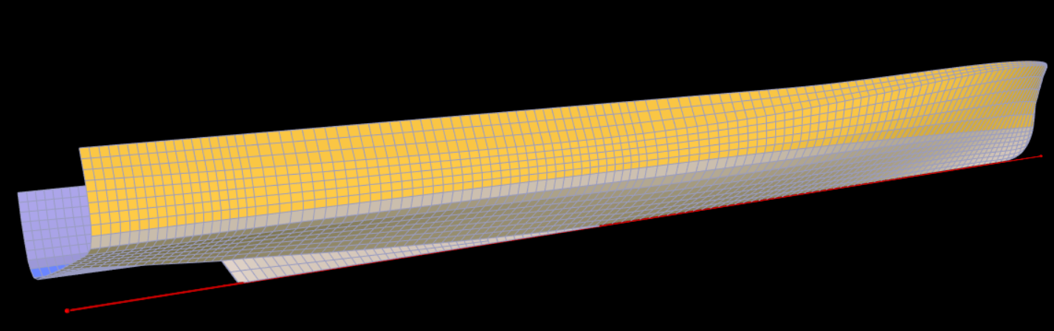
L_{PP} [m] | 100.00 | 32.50
B_{WL} [m] | 12.50 | 6.63
T_{F} [m] | 3.12 | 1.20
T_{A} [m] | 3.12 | 1.72
Δ [t] | 1601 | 129
LCB [m] | 44.80 | 13.50
LCF [m] | 41.39 | 13.14 | 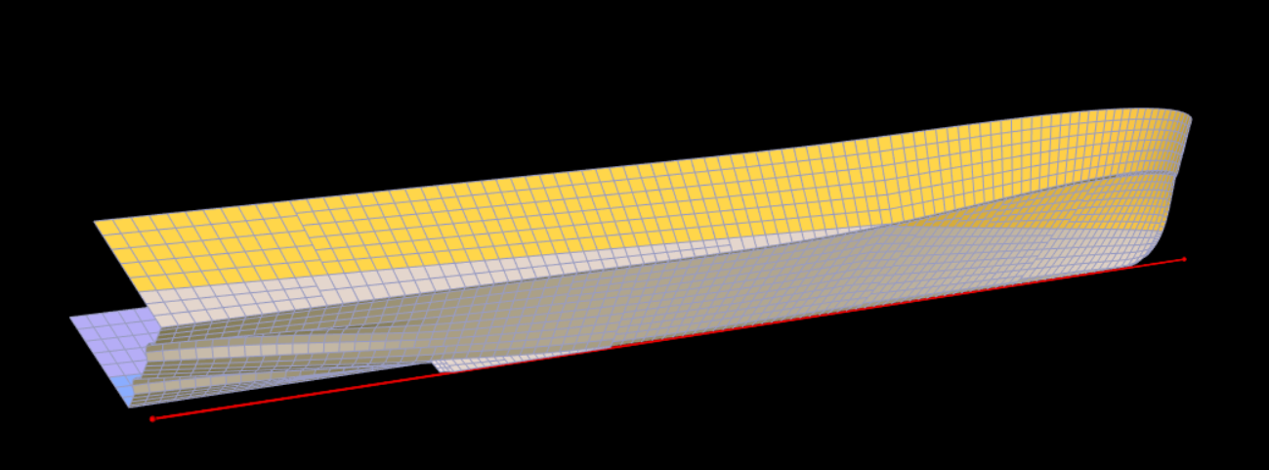
LCG [m] | 44.80 | 13.50
KG [m] | 6.05 | 2.50
GM_{T} [m] | 2.85 | 2.86
k_{X} [m] | 5.00 | 2.72
k_{Y} [m] | 25.00 | 8.13
k_{Z} [m] | 25.00 | 8.13
Figure 1. On the left, the main characteristics of FDS and HSC; on the right, the panel distributions of the FDS (above) and HSC (below).
Table 1. Autopilot control coefficients.
Element | FDS | HSC | Unit
Maximum rudder angle | 40.00 | 35.00 | deg
Maximum rotational rate | 10.33 | 7.00 | deg/s
Yaw proportional gain | 3.00 | 3.00 | deg/deg
Yaw derivative gain | 11.60 | 9.52 | deg/(deg/s)
The behavior in following seas of the vessels was evaluated considering its original design and two variations of its stern appendages arrangement. The design variations and the nomenclature adopted in this paper are summarized below. Table 2 summarizes the characteristics of the appendages and the modification of the rudders.
Original: The original design of the vessels considered in this investigation.
Large Rudders: Enlargement of the rudder surface of 25% compared to the original design. The enlargement was achieved by keeping the aspect ratio of the original rudder. The control characteristics of the rudders remained the same as in the original design. Rudders were modelled using a semi-empirical formulation as done for the ventral fins.
Ventral Fins: Implementation of fixed ventral fins. Ventral fins were added to the original design considering their surface to be the same as for the rudders. They were installed at the same longitudinal position of the rudders and as much as possible to the side of the hull, remaining in the flat area of the stern just before the beginning of the bilge radius. Ventral fins were modelled using a semi-empirical formulation typically employed for lifting surfaces.
Table 2. Position and total lateral area of the additional ventral fins and the modification of the rudders.
Appendages | Parameter | FDS | HSC
Ventral fins | Position [m, m, m] | (1.803, ±4.48, 1.1) | (0.895, ±3.0, 0.8)
 | Total lateral area [m²] | 5.67 | 1.68
Rudders | Position [m, m, m] | (1.803, ±1.95, 1.1) | (0.895, ±1.45, 0.8)
 | Total lateral area [m²] | 5.67 | 1.68
 | Total lateral area modified [m²] | 7.08 | 2.10

Methods for dynamic stability assessment
The dynamic stability of the vessels was assessed using two methods. The first assessment was carried out following the IMO SGISC Level 1, Level 2 and DA [1]. Only the DA in design situations using probabilistic and deterministic criteria were considered: the full probabilistic assessment of IMO SGISC DA was not carried out because of time constraints. According to SGISC DA, the stability criterion is not satisfied when roll and lateral accelerations exceed the defined thresholds. The roll and lateral acceleration exceedance events should be caused by the failure mode selected, in this case surf-riding/broaching-to. In the second assessment, the broaching behavior of the vessels was analyzed with a different approach developed by Lena & Bonci [2], hereby denominated as “broaching assessment”. This assessment relies on the broaching detection method already introduced by previous research works [3], based on the analysis of yaw motions and steering effort of the ship. The analysis was refined in [2] taking into account yaw and time threshold of the broaching event. The outcome of this approach is a probability of broaching calculated as number of events over the wave encounters.
The “broaching assessment” and SGISC DA focus on different aspects: SGISC DA considers roll and lateral acceleration as the main parameters that determine a failure, instead the broaching detection method focuses only on the yaw dynamics of the vessel. For this reason, the outcomes of SGISC assessment for surf-riding/broaching-to can largely differ from a typical broaching investigation. The results of the two methods are shown in section 6, in relation to the dynamic stability assessment of FDS and HSC with varying stern appendages configuration.

Simulations input
Table 3. Environmental conditions selected for the FDS.
Approach [-] | λ /L [-] | H/ λ [-] | H_{S} [m] | T_{P} [s] | Heading [deg]
Broaching assessment | 1.00 | 0.06 | 6.00 | 8.00 | 45
 |  | 0.07 | 7.00
 |  | 0.08 | 8.00
 | 0.90 | 0.05 | 4.50 | 7.59
 |  | 0.06 | 5.40
 |  | 0.07 | 6.30
 |  | 0.08 | 7.20
DA – Probabilistic | 1.09 | 0.08 | 8.20 | 8.36
 | 1.45 | 0.07 | 10.60 | 9.65
DA - Deterministic | 1.09 | 0.06 | 6.90 | 8.36
 | 1.45 | 0.06 | 9.10 | 9.65
Medium to severe environmental conditions were selected for both the FDS and the HSC, considered to be realistic for both vessels operations. Relatively high speed values of respectively 22 knots for the FDS and 20 knots for the HSC were chosen, corresponding to Froude numbers of 0.36 and 0.58 respectively. Simulations were performed in irregular stern-quartering seas. JONSWAP spectra with a peak factor of 3.3 were selected. A heading of 45 degrees was arbitrarily chosen for all simulations performed. Conditions were selected by choosing arbitrary but suitable values of the ratio λ/L (wave length over vessel length). The peak wave spectrum celerity was selected slightly higher than the vessel speed in the sailing direction, obtaining a situation of low wave encounter frequency. The selected wave steepness (defined as wave height over wave length H/λ) was 0.05. The occurrence of broaching events is, in general, rather rare: in order to obtain a better statistical representation of the broaching behavior, the results are based on exceptionally long exposure times, up to about 1800 wave encounters. The environmental conditions of Table 3 and 4 were selected and simulated in PANSHIP.
Table 4. Environmental conditions selected for the HSC.
Approach [-] | λ /L [-] | H/ λ [-] | H_{S} [m] | T_{P} [s] | Heading [deg]
Broaching assessment | 1.40 | 0.06 | 2.69 | 5.36 | 45
 |  | 0.07 | 3.14
 |  | 0.08 | 3.58
 | 1.50 | 0.06 | 2.88 | 5.54
 |  | 0.07 | 3.36
 |  | 0.08 | 3.84
DA – Probabilistic | 1.64 | 0.05 | 2.80 | 5.80
DA - Deterministic |  | 0.04 | 2.00

Discussion of results

IMO SGISC – Level 1 and 2
Both vessels sails faster than Froude number 0.3 and are shorter than 200 m, therefore they do not satisfy Level 1 and the other assessment levels should be analyzed. The results of the Level 2 SGISC are summarized in Figure 2 for the FDS and HSC. The FDS fails to satisfy the IMO requirements only for speeds higher than 21 knots. Instead, the HSC does not satisfy the Level 2 requirements even at 10 knots that corresponds to Fr = 0.29, that is smaller than the suggested threshold of Level 1 (Fr=0.3). The calculated C probability for HSC is 5 time higher than the FDS. The HSC, being a high-speed vessel, can be very prone to surf-riding in many sea states. The FDS instead is a type of vessel that, in its typical operative conditions with respect to the sea states, lies on the threshold of surf-riding, making it a particularly interesting case of study.
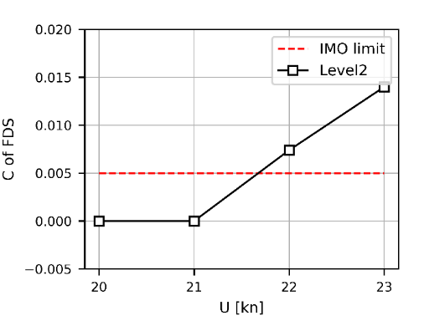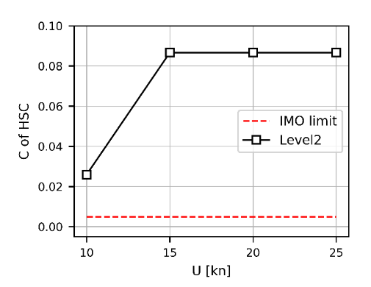
Figure 2. Results of SGISC Level 2 assessment in term of the weighted probability of surf-riding as function of the speed of the vessel.

SGISC DA in design situations using probabilistic criteria
Figure 3 shows the results obtained with the DA in design situations using probabilistic criteria for both the FDS and the HSC. The two vessels were simulated in the original appendages configuration, with enlarged rudders and with the ventral fins (on x-axis). The graphs report the number of cases in which an exceptionally large roll angle (above 40 degrees) or an exceptionally large transversal acceleration (above 1g) take place in the dedicated simulations performed for the two vessels. The transversal acceleration has been evaluated at the center of gravity of the two vessels.
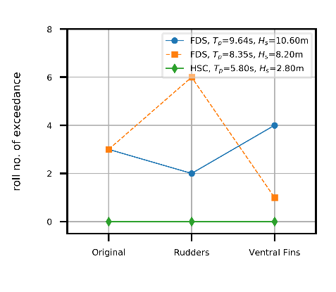 | 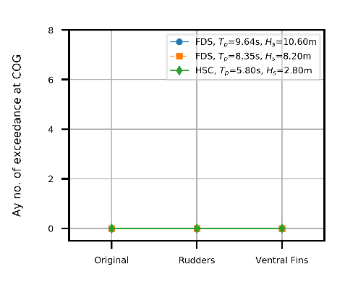
Figure 3. Results of DA in design situations using probabilistic criteria. The number of events characterized by roll exceedance are reported on the left, by transversal acceleration on the right.

The FDS does not satisfy the IMO assessment in design situations using probabilistic criteria with any of the three design configurations proposed, due to roll limit exceedance. It must be noted that, due to the severity of the environmental conditions requested, the FDS capsized in most of the simulations performed.
The HSC satisfies the IMO assessment in design situations using probabilistic criteria with all the three design configurations proposed. No capsize events were observed during the simulations of the HSC resulting in many more wave encounters.

SGISC DA in design situations using deterministic criteria
Figure 4 shows the results obtained with the DA in design situations using deterministic criteria for both the FDS and the HSC. The two vessels were simulated in the original configuration, with enlarged rudders and with the ventral fins. The graphs report the average value of roll angle and lateral acceleration calculated from the maximum values of the five different 3h-exposures.
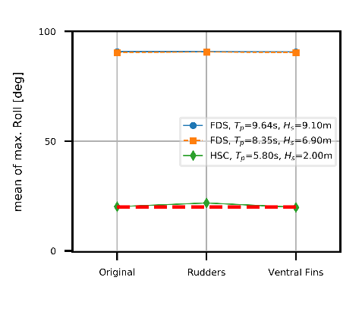 | 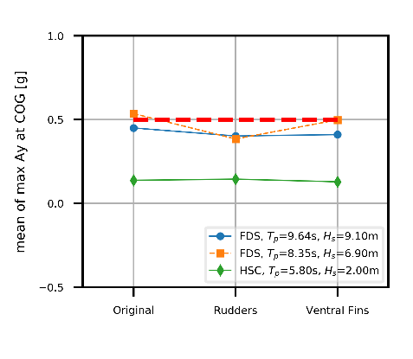
Figure 4. Results of DA in design situations using deterministic criteria. The maximum average values of roll are reported on the left, of transversal acceleration on the right.

The FDS does not satisfy the DA in design situations using deterministic criteria with any of the three design configurations proposed. FDS capsized in all the wave conditions considered. This can be seen from the average of the roll angle maxima of the five different periods of exposures simulated for each condition, that is 90 degrees for all three design. The FDS lies on the edge of the criterion for transversal acceleration.
The HSC satisfies the roll angle criterion with the original and the ventral fins design. The design with enlarged rudders does not satisfy it because of an average roll angle slightly above the limiting criterion. The HSC showed a much better behavior with the conditions of this assessment, being able to survive for the required exposure time. The HSC satisfies the transversal acceleration criterion for all three design variations considered.

Comparison between SGISC Level 2 and DA
In the case of surf-riding/broaching-to failure mode the two levels of analysis look at the dynamic stability problem in two deeply different ways. Level 2 focuses on surf-riding in a quasi-steady fashion, considering evaluating a threshold of speed above which a surf-riding can occur. The DA instead consists in time domain simulations that take into account the complex non-linear dynamics of the ship. The DA criteria, moreover, involve roll and lateral accelerations that are neglected at Level 2.
The FDS vessel is a very interesting example to compare the different SGISC levels of analysis, because in both assessments the FDS lies on the edge of acceptance. The FDS fails to satisfy the Level 2 criteria above 22 knots (see Figure 2). The DA at the same nominal speed also fails to meet the stability criteria. Instead, the FDS meets the Level 2 requirements for the lower speeds of 20 and 21 knots. For these speed, a DA might not be carried out because the ship is considered to be safe and in compliance with SGISC guidelines. However, the FDS sailing at 20 knots fails to satisfy the requirements of both probabilistic and deterministic DA approaches. In other terms, Level2 is not conservative to DA for a speed of 20 knots and, from a rule acceptance point of view, DA at 20 knots can be neglected. The results of the repeated DA at 20 kn are shown in Table 5.
Table 5. Results of the additional Direct Assessment investigation (both design assessments using probabilistic and deterministic criteria) for the FDS sailing at a lower speed of 20 knots. In red, the cases above the limiting thresholds.
FDS  20 knots | H_{S} | T_{P} | Roll exc. | Ay COG exc. | Max. Roll | Max. Ay COG
 | [m] | [s] | [-] | [-] | [deg] | [g]
DA probabilistic | 8.2 | 8.35 | 9 | 0 | - | -
 | 10.6 | 9.64 | 1 | 0 | - | -
DA deterministic | 6.9 | 8.35 | - | - | 91.31 | 0.75
 | 9.1 | 9.6 | - | - | 93.46 | 0.68

Broaching assessment
Both the FDS and the HSC were simulated and the broaching-to behavior assessed using the criteria of Lena & Bonci [2]. The FDS showed a significantly large numbers of catastrophic failures, intended as capsizing of the vessel, that caused a large number of simulations to be stopped before the planned end. This means that the foreseen time of exposure for the FDS was not achieved, in some conditions by a substantial margin. The consequence of this is that the results presented for the FDS are somehow affected by a low number of wave encounters that might add a larger uncertainty to the conclusions that could be drawn. This problem was not observed with the HSC. Most of the HSC simulations were completed successfully and therefore the results can be considered statistically robust. Figure 5 the probability of broaching occurrence for both the FDS and the HSC with the different design variations proposed in this research project.

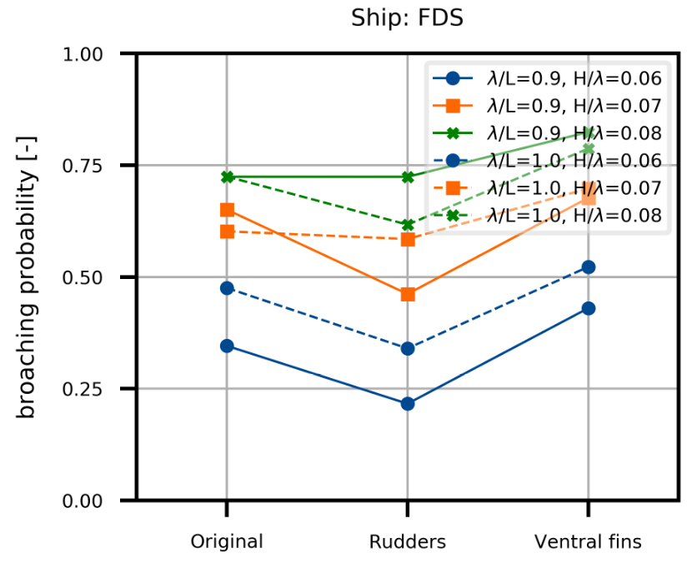 | 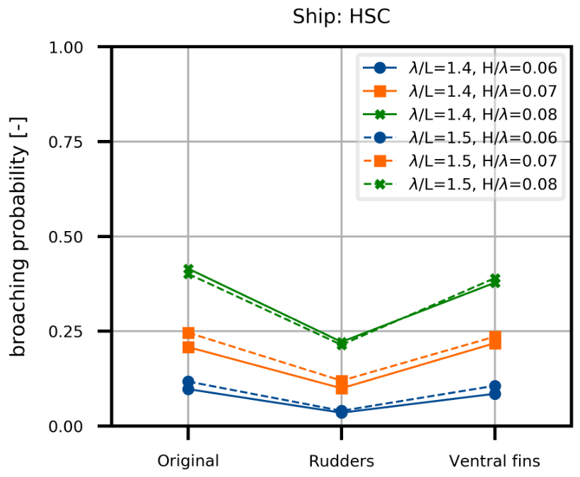
Figure 5. Probability of broaching occurrence for the FDS (left) and for the HSC (right) for different design variations simulated. Yaw angle threshold = 10 deg, time duration threshold = 0 s (see Appendix).

The FDS seems to be much more prone to broaching compared to the HSC, showing significantly higher probability of occurrence in all simulations performed. For the FDS larger rudders limit the probability of broaching. This is not properly evident with two of the most severe conditions simulated, where results with the original design and with the enlarged rudders are very similar. It is however likely that these results are partially affected by a limited time exposure to the waves. For the FDS the use of ventral fins increases the probability of broaching occurrence with all conditions simulated. Ventral fins prove to be effective only within high Froude applications, where the lift that they generate balances and goes beyond the excitation forces that their exposed surface induces. In the FDS case, with a Froude number of 0.36 this does not seem to be the case and the negative consequences of having ventral fins installed are larger than the benefits.
For the HSC, both design variations seem to have a positive influence in reducing the broaching probability of occurrence. The influence of larger rudders is evident for all the conditions selected, whereas the influence of ventral fins is smaller, but still positive.

Conclusions
The two types of IMO SGISC DA selected for this work (probabilistic and deterministic) follow different approaches in defining the final results. They reach similar macro conclusions, especially in defining the FDS as inadequate for broaching and in confirming good performances for the HSC. However, the DA different methods do not always provide equivalent results. This is especially visible for cases that lie on the edge of the acceptance limits. One element of confusion in making a comparison between the two approaches is the significantly different limiting criteria adopted by the two assessments. It is difficult for the user to understand the reasoning behind this difference and, especially, if the different limiting criteria provide a comparable risk evaluation of the parameters evaluated.
From a pure regulatory point of view, the IMO safety assessment procedure (Level 1, Level 2, DA) is reliable for both the FDS as the HSC vessels. However, there were some cases in which the assessment showed some inconsistencies. The general observation on IMO SGISC is that the outcomes depend strongly on the choices made during the assessment (design speed, wave heading, simulation tool…). The IMO is not very detailed in the explanation of the guidelines to be followed. The final recommendation is to pay extreme care in the steps taken to carry out the assessment.
According to the broaching assessment developed by Lena & Bonci, the design variation characterized by enlarged rudders proved to be extremely effective in reducing consistently the probability of broaching occurrence. However, the SGISC DA penalizes this design choice because large rudders, with the same autopilot, cause a larger roll motion. This means that fundamentally different outcomes could be expected between the SGISC DA than an assessment purely based on the broaching dynamics, i.e. focusing on the yaw motions only.

References
- SDC 7/WP.6, 6 February 2020, Finalisation of second generation intact stability criteria, Report of the drafting group on Intact Stability.
- Lena C., Bonci M., Polo J., Investigation on broaching detection parameters and their influence on broaching risk assessment, STAB 2021, 2021.
- Umeda, N., Usada, S., Mizumoto, K., Matsuda, A., Broaching probability for a ship in irregular stern-quartering waves: theoretical prediction and experimental validation, Journal of Marine Science and Technology , Vol. 21, No. 1, p. 23-37, 2016.
- Lin W.M. & Yue D., 1990, Numerical solutions for large-amplitude ship motions in the time domain, Proceedings of the 18th Symposium on Naval Hydrodynamics:41; Ann Arbor.
- Pinkster H.J.M., 1998, Three dimensional time-domain analysis of fin stabilized ships in waves, Graduation Report; Delft University of Technology, Department of Applied Mathematics.
- Van Walree F., 1999, Computational methods for hydrofoil craft in steady and unsteady flow. PhD Thesis; Delft University of Technology, Department of Naval Architecture and Marine Engineering.
- Van Walree F., 2002, ‘Development, Validation and Application of a Time Domain Seakeeping Method for High Speed Craft with a Ride Control System’, Proceedings of the 24th Symposium on Naval Hydrodynamics, Fukuoka, Japan.
- Van Walree F, De Jong P., 2008, Time domain simulations for fast ships in oblique seas. Proceedings of the 6th Osaka Colloquium on Seakeeping and Stability of Ships; Osaka, Japan.
- De Jong P. & Van Walree F., 2009, The development and validation of a time-domain panel method for the seakeeping of high-speed ships, 10th International Conference on Fast Sea Transportation, Athens, Greece.
- De Jong P., 2011, ‘Seakeeping Behaviour of High Speed Ships – An experimental and numerical study’, PhD Thesis, Delft University of Technology.
- De Jong P. & Van Walree F., 2011, Validation of a time domain panel code for high speed craft operating in stern and quartering seas, 11th International Conference on Fast Sea Transportation, Honolulu, USA.
- Bonci M, De Jong P, Van Walree F, Renilson M, Huijsmans R, 2019, The steering and course-keeping qualities of high-speed craft and the inception of dynamic instabilities in the following sea. Ocean Engineering; 194; doi: https://doi.org/10.1016/j.oceaneng.2019.106636.
- Inoue S, Hirano M, Kijima K., 1981, Hydrodynamic derivatives on ship manoeuvring. International Shipbuilding progress, 28(321):112.

E-mail: c.lena@marin.nl; m.bonci@marin.nl

