Safety System for Ships in Harbours
Liliana PINHEIRO^{a,}, Andreia GOMES ª, Conceição FORTES ª and João A. SANTOS ^{b}
ª Ports and Maritime Structures Unit ; Hydraulics and Environment Department, National Laboratory of Civil Engineering. Lisbon, Portugal
^{b} Polytechnic Institute of Lisbon, Portugal
Abstract. SAFEPORT safety system aims at forecasting and alerting, on a regular basis, emergency situations regarding ships operation in port areas caused by extreme weather-oceanographic conditions. It uses forecasts provided offshore of the area under study of sea agitation, wind and tide. The characterization of the response of the free and moored ships at a berth is performed using the numerical package SWAMS. The system issue alerts, through danger levels associated with risk levels of exceedance of recommended values for movements and forces imposed on ship mooring systems. SAFEPORT can be adapted to any port. So far, it has been developed and adapted to three terminals of the port of Sines, where three different ships were simulated. This paper presents the developments made to date of the safety system, which includes tests performed in storm situations. The numerical models run every day, in real-time mode, in a computer cluster and the system provide forecast results for the next 72 hours. The results are disseminated on a web page and a mobile application in a variety of formats. It was concluded that the SAFEPORT safety system issued alerts according to the observed reality during the storm Dora. It has also been shown to be a computer tool for the optimization of ship mooring systems. The system is currently in testing and validation phase therefore, forecasts should be interpreted as indicative.
Keywords. SAFEPORT, SWAMS, Wave propagation, Moored ships, storm Dora, Risk assessment

Introduction
The success of a port depends on three fundamental factors: safety, efficiency, and competitiveness, and all three are interlinked. One of the criteria that ensures the safety and operability of ports is to keep the ships' movements within the established limits, both during entry/exit of the port, during berthing maneuvers and while the ships are moored. Knowing in advance how the ship will respond to incident met-ocean conditions is very useful for planning operations, to take early measures to deal with extreme events, and increase the overall safety record of the port, thus contributing for its economic success. In the case of moored ships subjected to extreme agitation states, the breakage of a mooring element (moorings, bollards and fenders) is an extremely dangerous event. For that reason, there are safety limits imposed on the mooring system efforts and on the horizontal, vertical and rotation movements, and operational limits, beyond which cargo handling becomes restricted or even impossible. For large container ships, limiting the surge movement is essential, as cranes cannot keep up with this movement.
Global shipping has had a clear growth trend and new records every year in the size of ships. In 2021 the port of Sines reached a new record in cargo handled. Given its importance on the Portuguese coast and to ensure its response capacity and provide a continuous and safe service, a safety system for navigation in the port of Sines was developed under the BlueSafePort project. It consists of an Early Warning System (EWS) for risks associated with the safety and operation of ships in maneuvering and moored inside the port, implemented both in a web platform and a mobile application. The SAFEPORT platform is based on the HIDRALERTA system (Fortes et al., 2015 and Pinheiro et al., 2020), and provides 3-day advance forecasts of sea agitation, wind, current and tide conditions, as well as ship motions and mooring forces. The associated risk levels are based on safety and operability criteria. This paper presents the SAFEPORT system in terms of its development and architecture, the flow and processing of data and the operation of the numerical models used to determine the behavior of moored ships at the Port of Sines, subject to waves, tide, current and wind.

The SAFEPORT safety system
The SAFEPORT EWS anticipates the effects of sea agitation on ships, providing systematic and reliable information about ship motions and the forces imposed on the mooring systems. The system uses an integrated numerical tool capable of simulating the response of a moored ship: SWAMS package (Simulation of Wave Action on Moored Ships) (Pinheiro et al., 2013). The system prototype was developed for the Port of Sines and is validated in three terminals, namely the Liquid Bulk Terminal (TGL), the Sines Container Terminal or Terminal XXI (TCS) and the Sines Multipurpose Terminal (TMS) (Figure 1).
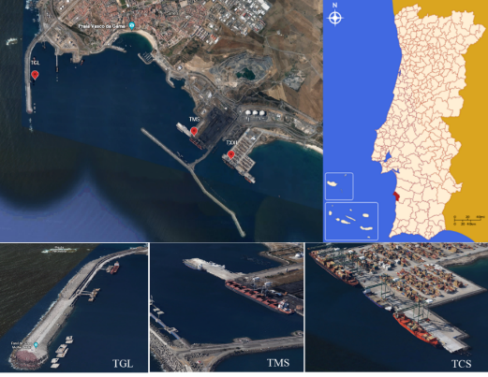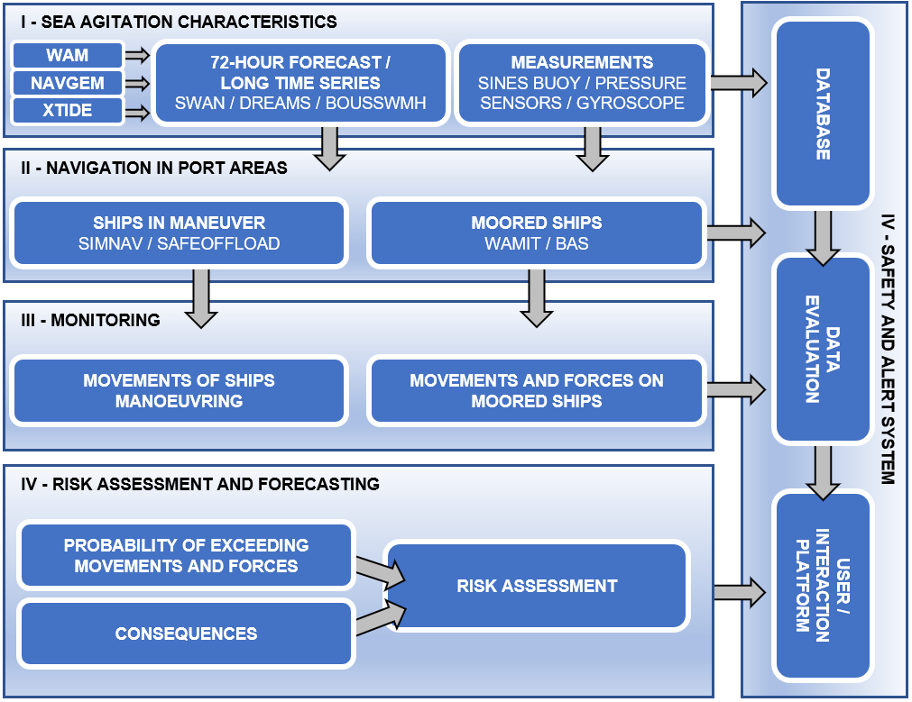
Figure 1. Location of the operational prototype, the Port of Sines, and the target terminals, TGL, TMS and TCS. SAFEPORT safety system architecture
The SAFEPORT EWS is structured as shown in Figure 1, in four modules: I - Sea wave characteristics; II - Navigation in port areas; III - Monitoring; IV - Risk assessment and forecasting. The first module includes most of the numerical models implemented in the system and it also includes in situ data collection, essential in the validation of the numerical models. The results of Module I feed the system's database. Module II contains the remaining numerical models i.e., the navigation models in port areas. This module uses the results of the previous module to evaluate the behavior of ships in ports. Module III deals with the continuous in situ monitoring required to daily validate, in real-time, the results produced by the numerical models. The last module consists of a qualitative analysis of the risk associated to the probability of exceedance of the recommended values for the ship's motions in its 6 degrees of freedom and for the forces in its mooring system (mooring lines and fenders). Based on the risk levels, the system issues alerts, 72 hours in advance, of emergency situations related to a specific moored ship
The coupling of the numerical models was performed through a script routine written in python programming language. Numerical simulations run on the Central Node for Grid Computing of the Portuguese Infra-structure for Distributed Computing, a 64-node high performance computing facility. A web platform and a mobile application were developed. In these it is possible to access and view, in graphic and numerical form, forecasts of sea agitation, tide and wind conditions and the consequences on ships. It is also possible to monitor possible emergency situations in real time and view alerts for navigation and continuous model validations (forecasts vs observations).
The purpose of module I is the characterization of the sea agitation offshore, at the port entrance and in several points within the port basin, in terms characteristics of the wave states. In addition, this module contains the forecast of other phenomena involved in the propagation of sea waves, namely wind fields and tide levels.
Forecast of the sea agitation produced by the WAM (WAMDI Group, 1988) model executed by the ECMWF. WAM is a third-generation ocean wave prediction model that integrates the basic transport equation describing the evolution of a two-dimensional ocean wave spectrum. Its implementation in the safety system enables accurate forecasts, 72 hours in advance (with results every 3 hours), of the significant height (Hs), the peak period (Tp) and the average direction (θm) of the wave states.
The SWAN model (Booij et al., 1999) is a numerical model for the generation, propagation, and dissipation of sea waves, based on the equation for the conservation of wave action. The numerical model SWAN was applied to propagate the wave parameters, i.e., Hs, Tp and θm, estimated by the WAM model (boundary conditions), from offshore to the entrance of the port of Sines. To achieve a better numerical performance, the model calculation domain, as well as the bathymetric meshes, was discretized into three nested rectangular meshes. The physical phenomena accounted on the port of Sines SWAN model were diffraction and dissipation by bottom friction and the simulations were performed in the two-dimensional stationary mode.
Before being incorporated into the system, the WAM and SWAN models were validated, and the SWAN model parameters were calibrated to reproduce as accurately as possible the observed reality. Simulations were performed for 40 years of data between 1988 and 2018 of wave and wind regimes derived from reanalysis of the ERA5 models of the ECMWF, at the nearest point of the Sines1D buoy. The results were compared with the records from the wave buoy. For the comparison of the numerical results and in situ measurements a statistical analysis of the error parameters, is performed. The validation showed that it produces consistent results according to the observed reality.
The wave propagation into the port area is performed with the numerical model DREAMS (Fortes, 2002), a linear finite element model, based on the mild slope equation (Berkhoff, 1972), used to simulate the propagation of monochromatic waves in port basins, considering the combined effects of refraction, diffraction and partial or total reflection of port structures, (Figure 6). The boundary conditions in the model domain were defined from Hs, Tp and θm, parameters obtained by applying the SWAN model. The results were extracted at three points near the three terminals of the port of Sines which will benefit the most from the forecasting system herein presented, more specifically in the bulk liquid (TGL), container (TCS) and multipurpose (TMS) terminals.
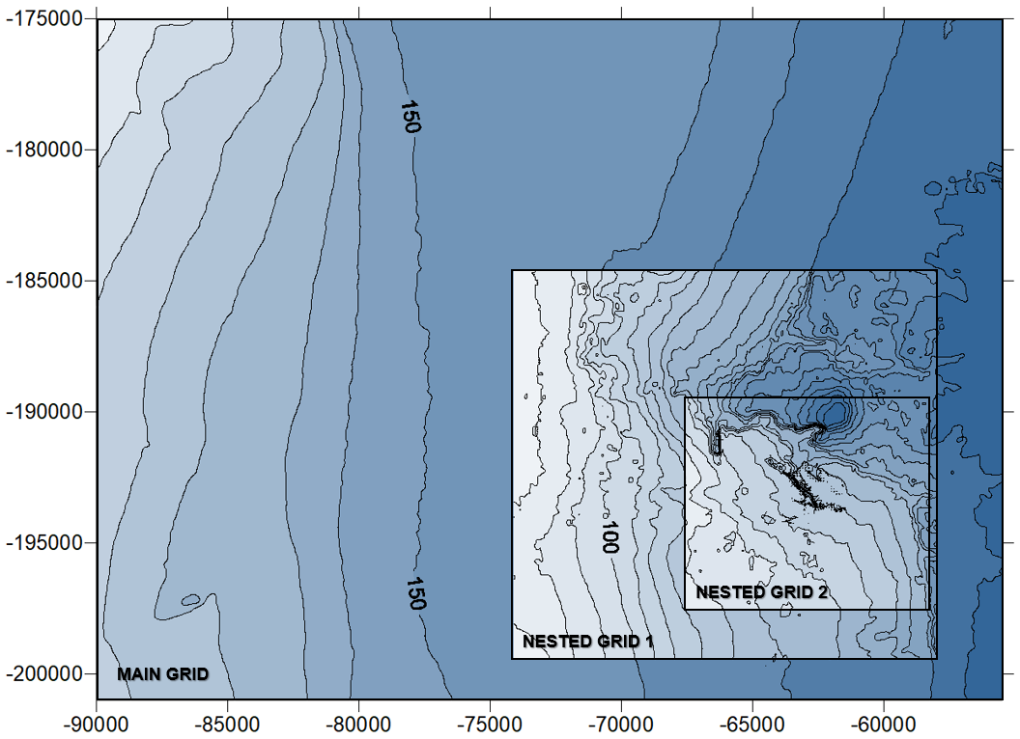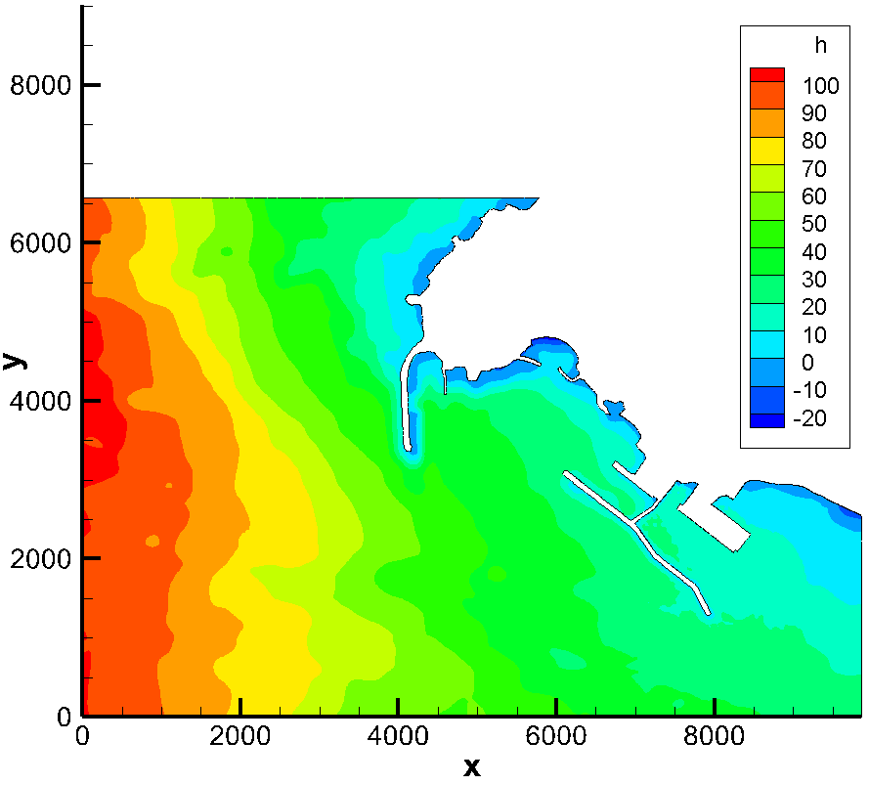
Figure 3. Bathymetric meshes used in the SWAN and DREAMS numerical model.
Module II uses the WAMIT model (Korsemeyer et al., 1988 and Newman & Sclavounos, 1988) and the BAS model (Mynett et al., 1985), capable of characterizing the response of a free and moored ship inside a port subject to the action of sea agitation, wind and current. Given the non-linear behavior of the ship - moorings - fenders system, the numerical models implemented in the system deal with formulations in the time domain, relating instantaneous values of movements and forces. WAMIT is a second-generation radiation/diffraction program based on a three-dimensional panel method which evaluates, in the frequency domain, the radiation and diffraction velocity potentials and the hydrodynamics parameters. BAS simulates the dynamic behavior of moored ships under the influence of environmental conditions. It assembles and solves, in the time domain, the equations of motion of a moored ship. The WAMIT numerical model determines the response of the free-floating ship to incident monochromatic waves. Then, with the hydrodynamic information obtained, it is possible to determine the moored ship response through the BAS numerical model. Three different ships were selected to represent as comprehensively as possible the ships operating in the TGL, TCS and TMS, namely an oil tanker, a container ship, and a general cargo ship, respectively. Nautical Pre-Processor, NPP (Santos, 1994), was employed to discretize the submerged hulls of the ships, into rectangular/triangular flat panels. The submerged hull of the oil tanker was discretized with 1004 panels, the general cargo ship with 1992 panels and the container ship with 3464 panels (Figure 7). This geometric information constitutes the first input data of the ships WAMIT models.
The water depth at TGL was set at 28 meters, at TCS at 17 meters and at TMS at 18 meters. For all models a range of 89 frequencies was considered and in the diffraction case the computations were performed for the possible wave directions approaching each terminal. The outputs of the model consist of the added mass coefficients, the damping coefficients, and the exciting forces. The results of the WAMIT models are put into the convenient format by the HYDRO numerical model (Hurdle, 1987 and Schuurmans, 1991), to be read and used as input data by the BAS model. HYDRO calculates the time dependent retardation functions from the frequency dependent damping functions and a series of approximations to the added mass at infinite frequency and creates a hydrobase suitable for use by BAS.
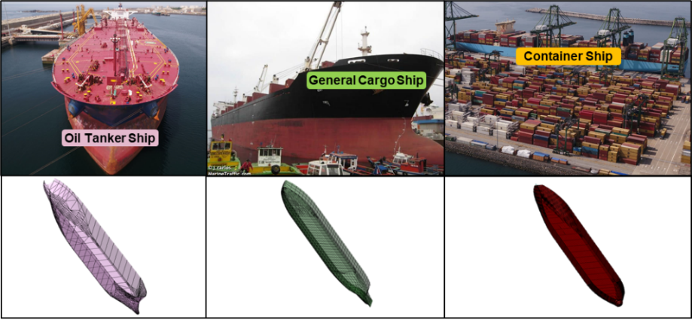
Figure 7. Panel discretization for the 3 ships.
For the oil tanker and the general cargo ship, 8 mooring lines grouped in two and 5 fenders were defined. For the container ship model, a total of 10 mooring lines and 5 fenders were defined (Figure 8).
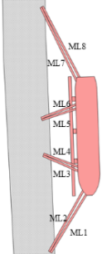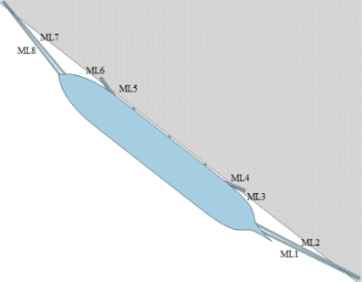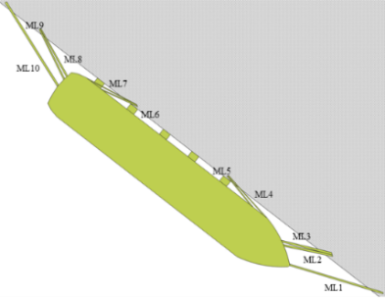
Figure 8. Mooring lines and fenders arrangements of the oil tanker, the general cargo ship and the container ship, respectively.
The constitutive relations for the mooring lines consist of an elongation of 4% for the maximum load of 2100 kN, 1900 kN and 1860 kN for the oil tanker, general cargo ship and container ship, respectively. The constitutive relations for the fenders consist of a maximum force of 8900 kN for a deflection of 1 m. The application of the BAS numerical model to the three ships resulted in time series of the motions and mooring line and fender forces, under wind, current and wave attack.
A risk assessment and forecasting (probability x consequences) was implemented in the SAFEPORT system, associated with the probability of exceeding a pre-established thresholds for the amplitude of ships' motions and for the forces on their mooring system (Pinheiro et al., 2020). Considering the loading and unloading operations, the characteristics of the ships and the need to ensure the safety of persons and infrastructure, consequence levels have been attributed to the threshold values recommended by organizations concerned with maritime and port activities. The consequence levels must be associated with a probability of exceeding the assumed thresholds, to assess the risk associated with a moored ship. The amplitude of ships' motions and the forces on their mooring system are a direct result of wave action. Therefore, the risk analysis was developed assuming a Rayleigh distribution formulated by Longuet-Higgins (1952) which depend on the directional spectrum and the dimensionless wave height. Each time series produced by the ships' BAS models for each variable, namely, six degrees of freedom motion amplitudes, mooring lines forces and fenders forces, undergoes a Fourier transform and a power density spectrum is obtained. From spectral moments of this spectrum the required statistical information can be derived and used in the Rayleigh distribution exceedance probability function. To be used in the qualitative risk analysis herein presented, the exceedance probability (P) of the Rayleigh distribution is ranked as rare (P<0.001%), unlikely (P<0.1%), possible (0.1%<P<10%) and likely (P>10%), which correspond to exceedance probability levels ranging from 0 to 3, respectively. Thus, risk levels can be assigned as shown in Table 3. Based on the risk levels, the system issue alerts, through the definition of danger levels related to the difficulty of loading and unloading operations and the probability of breakage of an element of the mooring system, due to excessive ship motions. The risk levels, relating to the ships’ motions and the forces on their mooring lines, have been color-coded (green, yellow, orange and red) and symbolized to issue the SAFEPORT system alerts.
Table 3. Risk Levels
Exceedance Probablity Levels |  | Consequence Levels
 |  | Insignificant | Mild | Serious | Critical
 |  | 0 | 1 | 2 | 3
Rare (P<0.001%) | 0 | 0 | 0 | 0 | 0
Unlikely (P<0.1%) | 1 | 0 | 1 | 2 | 3
Possible (0.1<P<10%) | 2 | 0 | 2 | 4 | 6
Likely (P>10%) | 3 | 0 | 3 | 6 | 9

Results Dissemination
The dissemination of the results of the SAFEPORT system for the port of Sines is done through a website (Figure 10). and a mobile application (Figure 11) developed under the BlueSafePort project. On these platforms it is possible to access and visualize in graphic and numerical form, forecasts of sea agitation conditions, wind fields, real-time monitoring of possible emergency situations, alerts, the system results database and the continuous validations (forecasts vs observations).
As a result of the system, daily reports are built with the 3-day forecasts and are automatically sent by email to a list of email addresses of the responsible entities.
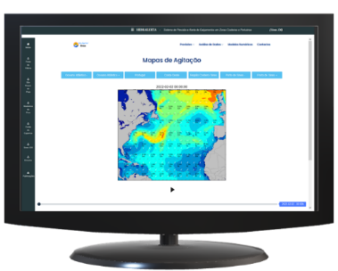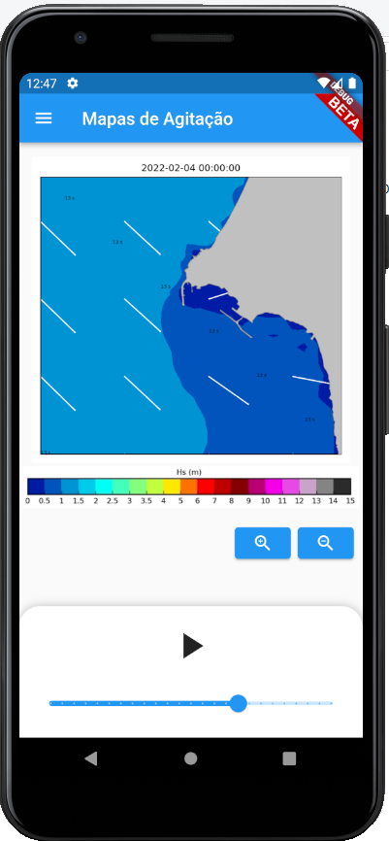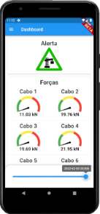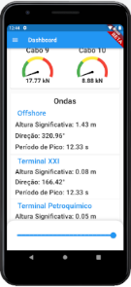
Figure 10. Web page and mobile application.

SYSTEM TEST
For a safety system such as SAFEPORT, it is essential that it works properly in current and storm situations in order to issue alerts of emergency situations only when justified. An application of the SAFEPORT system was performed, for the sea-wave conditions of storm Dora (Gomes et al., 2022). Storm Dora reached its highest intensity during the afternoon of 4th December 2020, and the early morning of 5th December 2020. It was characterized by wind gusts of more than 100 km/h (62 mph) in the areas near the coast and rough sea with records of maximum wave height of 10.3 meters at the Sines1D wave buoy. The WAM model predicted waves predominant θm of north, with Hs ranging between 3m and 8m and Tp between 15s and 18s. In the vicinity of the port of Sines, wave characteristics Hs, Tp and θm, had their Tp between 15 s and 17 s, and Hs between 3 m and 7.55 m (Figure 14). The peak of storm Dora in front of the port of Sines, according to the SWAN model, occurred at 6 p.m. on 4th December 2020. At the TGL Hs = 1.2 m, Tp = 15 s and θm = 210°. The TMS, in turn, is affected by waves with Hs = 0.7 m, Tp = 15 s and θm = 280°. At the TCS, Hs = 0.8 m, Tp = 17 s and θm = 174º.
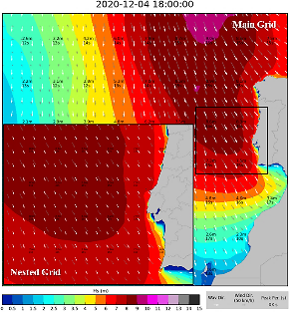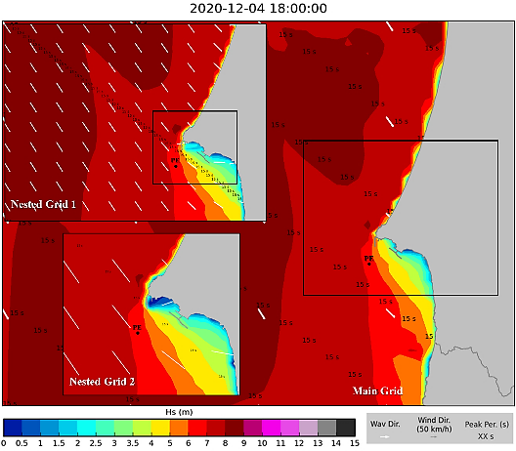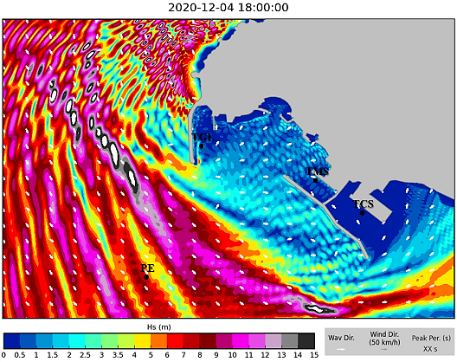
Figure 14. WAM, SWAN and DREAMS model results (Hs, Tp and θm) for 4th December 2020, 6 p.m.

Figure 17 shows the dashboard of alerts disseminated on the SAFEPORT system platforms.
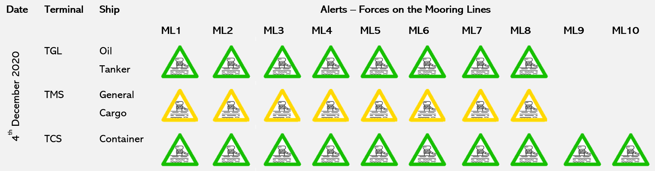
Figure 17. Dashboard of the alerts for the forces on the ships’ mooring lines.

Final considerations
Anticipating potentially hazardous sea and weather states is not sufficient to predict all potentially hazardous situations. The movements of ships depend on a diversity of factors and a complex interaction of phenomena that make certain situations, where the safety of the ship is affected, seem impossible to predict. The SAFEPORT system herein presented can anticipate the effects on ships of sea agitation and potentially dangerous atmospheric conditions, allowing to take informed decisions on mooring procedures and to increase the safety of ships moored within ports. Based on offshore forecasts computed by accurate weather-oceanographic forecasting models, the SAFEPORT system estimates the relevant wave parameters for the assessment of the behavior of ships moored within port basins, using a set of numerical models. The safety system issue alerts associated with danger levels for the ships’ motions and forces on their mooring lines, based on a qualitative analysis of the risk of exceeding recommended values for these variables. The results are disseminated through digital platforms, namely a web page based on the HIDRALERTA web platform, and a mobile application developed under the BlueSafePort project. The prototype of the system is the port of Sines, more specifically the bulk liquid terminal, the multipurpose terminal and the container terminal. Three ships were moored in these terminals, i.e., an oil tanker, a general cargo ship and a container ship. The SAFEPORT system was tested in a storm situation. The alerts issued by the system were in accordance with the reported occurrences.

Acknowledgments
The authors would like to thank the BlueSafePort project (ref: FA_04_2017_016), the National Infrastructure for Distributed Computing (INCD) for granting access to the digital infrastructure to support research and the Sines and Algarve Ports Administration.

References
- Berkhoff, J. (1972). Computation Of Combined Refraction - Diffraction. Coastal Engineering Proceedings, 1(13), 23. https://doi.org/10.9753/icce.v13.23
- Booij, N.R., Holthuijsen, L.H. e Ris, R.C. (1996). The SWAN wave model for shallow water. ICCE´96: 668-676. Orlando.
- Fortes, C.J.E.M. (2002). Transformações não lineares de ondas em portos. Análise pelo método dos elementos finitos. Tese de doutoramento. Lisboa: IST/DEM.
- Korsemeyer, F.T., Lee, C.H., Newman, J.N. e Sclavounos, P.D. (1988). The analysis of wave effects on tension-leg platforms. Proc. 7th International Conference on Offshore Mechanics and Arctic Engineering: 1-14. Texas: Houston.
- Longuet-Higgins M.S. (1952). On the statistical distribution of the heights of sea waves. J. Marine Research. Vol XI, No. 3.
- Mynett, A.E., Keunig, P.J. e Vis, F.C. (1985). The dynamic behaviour of moored vessels inside a harbour configuration. Int. Conf. on Numerical Modelling of Ports and Harbour 23-25: Cranfield: BHRA. The Fluid Engineering Centre, April 1985. England: Birmingham.
- Newman, J. N. and Sclavounos, P. D. (1988). The Computation of Wave Loads on Large Offshore Structures. BOSS ’88 Conference. Trondheim, Norway.
- Persson, A. (2001). User Guide to ECMWF Forecast Products. Meteorological Bulletin M3.2. ECMWF: 115.
- Pinheiro, L. V., CJEM, F., Santos, J. A. & Fernandes, J. L. M. (2013). Numerical software package SWAMS – Simulation of Wave Action on Moored Ships. Proc. PIANC 3rd Mediterranean Days of Coastal and Port Engineering, 22 a 24 de maio, Marseille, França.
- Pinheiro, L., Fortes, C. & Santos, J. (2018). Risk analysis and management of moored ships in ports. the 37th International Conference on Ocean, Offshore and Arctic Engi-neering (OMAE2018). June 17-22, Madrid, Spain.
- Pinheiro, L., Fortes, C., Reis, M. T., Santos, J. & Soares, C. G. (2020). Risk forecast system for moored ships. In proceedings of vICCE (virtual International Conference on Coastal Engineering). 6-9 October.
- Santos, J.A. (1994). MOORNAV – Numerical model for the behaviour of moored ships. Final report, Projecto NATO PO-Waves (3/94-B). Lisbon.
- WAMDI Group (1988). The WAM Model - A third generation ocean wave prediction model. J. Physical Oceanography (18): 1775-1810.

Liliana Pinheiro, Ports and Maritime Structures Unit; Hydraulics and Environment Department, National Laboratory of Civil Engineering, Avenida do Brasil 101, 1700-066 Lisboa, Portugal; E-mail: lpinheiro@lnec.pt.

