A Systematic Ferry Series
Marcello COSTANZO^{a,}, Andrea MANCINI ^{a,}, Luca MAURO ^{a,}
ª CNR – INM, National Research Council of Italy - Institute of Marine Engineering
Abstract. A number of seventeen models of Ferry in scale 1: 28.750 of 10250 ton displacement have been built at the Italian Model Basin, to be tested in the Emilio Castagneto towing tank at INM in Rome. The results of the tests have been collected in this report, delivered and presented in easy and useful form.
Keywords. Systematic series, Big data, resistance tests

Introduction
A number of seventeen models of Ferry in scale 1: 28.750 of 10 250.0 tons displacement have been built at the Italian Model Basin, to be tested in Rome. The results of the tests have been collected in this report, delivered and presented in easy and useful form. The hull C.2054 has been used to build the whole Series, the variations in the forms have been obtained maintaining the same displacement, operating the deformation of the hull in the x, y, z directions using the following parameters:
p = L derived hull / L generating hull
q = B derived hull / B generating hull
r = T derived hull / T generating hull
The derived hulls have all constant volume, while the product p ˑ q ˑ r = 1
The naked hulls have been tested in this conditions:
Δ = 10 250.0 t corresponding to 10 000 m³, project condition, straight trim, CB = 0.515, CM = 0.943, CP = 0.546, CW = 0.715, CVP =0.720, LCB = -1.71% , XCF = - 5.33%.
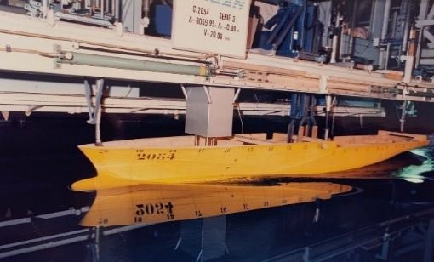
Figure 1. The generating hull model 2054 during the tests
For the symbols used, refer to the ITTC symbology [11]

The Models
The seventeen models have been built in wood, tested in the Emilio Castagneto towing tank at INM in Rome, 220 meters long, 9 meters wide, 3.5 meters deep. They all have been fitted with turbulence stimulators, nails of 2.5 mm diameter and 2 mm overhang, following the ITTC recommendations. The models have the following dimensions, as shown in Table 1.

Table 1. The 17 models of the Systematic Ferry Series
Hull | L | B | T | p | q | r | ie /2 | S / V^{2/3}
 | m | m | m | - | - | - | degree | -
2052 | 3.7411 | 0.8797 | 0.2484 | 1 / 1.3 | √1.3 | √1.3 | 16.78 | 5.918
2053 | 4.2655 | 0.8239 | 0.2325 | 1/√1.3 | ⁴√1.3 | ⁴√1.3 | 13.91 | 6.256
2054 | 4.8634 | 0.7716 | 0.2177 | 1 | 1 | 1 | 11.50 | 6.657
2055 | 6.3224 | 0.6767 | 0.1909 | 1.3 | 1/√1.3 | 1/√1.3 | 7.82 | 7.623
2056 | 4.8634 | 0.5935 | 0.2830 | 1 | 1/1.3 | 1.3 | 8.89 | 6.657
2057 | 4.8634 | 0.8797 | 0.1909 | 1 | √1.3 | 1/√1.3 | 12.5 | 6.924
2058 | 4.8634 | 1.0030 | 0.1675 | 1 | 1.3 | 1/1.3 | 14.81 | 7.356
2159 | 4.8634 | 0.6767 | 0.2484 | 1 | 1/√1.3 | √1.3 | 9.80 | 6.648
2160 | 6.3224 | 0.7716 | 0.1675 | 1.3 | 1 | 1/1.3 | 8.89 | 7.907
2161 | 6.3224 | 0.5935 | 0.2177 | 1.3 | 1/1.3 | 1 | 7.10 | 7.522
2162 | 5.5451 | 0.8797 | 0.1675 | √1.3 | √1.3 | 1/1.3 | 11.50 | 7.634
2163 | 5.5451 | 0.5935 | 0.2484 | √1.3 | 1/1.3 | √1.3 | 7.82 | 7.084
2164 | 5.5451 | 0.7226 | 0.2039 | √1.3 | 1/⁴√1.3 | 1/⁴√1.3 | 9.49 | 7.168
2165 | 3.7411 | 1.0030 | 0.1909 | 1/√1.3 | 1.3 | 1/√1.3 | 16.78 | 6.628
2166 | 3.7411 | 0.6767 | 0.2830 | 1/√1.3 | 1/√1.3 | 1.3 | 11.50 | 6.377
2167 | 3.2812 | 1.0030 | 0.2177 | 1/1.3 | 1.3 | 1 | 18.97 | 6.153
2168 | 3.2812 | 0.7716 | 0.2830 | 1/1.3 | 1 | 1.3 | 14.81 | 5.868
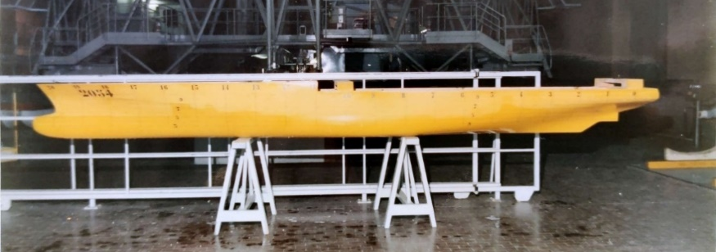
Figure 2. The generating forms of the Serie Models and hull model 2054

The wetted surface
The wetted surface and the entrance angle are free of any variation, while the L/B ratio depends on the block coefficient, the L/V^{1/3} and B/T coefficients, with L/B = [ C_{B} ˑ $L^{3}$/V ˑ T/B ]^{1/2}. The wetted surface has been measured for all the hulls; with these value has been obtained a 2nd degree polynomial surface fitting, where the S/V^{2/3} surface is function of L/V^{1/3} and B/T, independent variables:

S/V^{2/3} = 4.246+0.5085ˑL/V^{1/3}-0.5757ˑB/T-0.009741ˑ(L/V^{1/3})²+ (1)
+0.03287ˑL/V^{1/3}ˑB/T+0.06757ˑ(B/T)²

Table 2. The 17 models of the Systematic Series T90, dimension-less form coefficients:
Hull | L/V^{1/3} | B/V^{1/3} | T/V^{1/3} | L/B | B/T | S/V^{2/3} | S/V^{2/3}
 |  |  |  |  |  | measured | fitted
2052 | 4.994 | 0.8797 | 0.331 | 4.254 | 3.544 | 5.918 | 5.933
2053 | 5.694 | 0.8239 | 0.310 | 5.179 | 3.544 | 6.256 | 6.298
2054 | 6.493 | 0.7716 | 0.291 | 6.307 | 3.544 | 6.657 | 6.702
2055 | 8.440 | 0.6767 | 0.255 | 9.347 | 3.544 | 7.623 | 7.636
2056 | 6.493 | 0.5935 | 0.378 | 8.198 | 2.097 | 6.657 | 6.675
2057 | 6.493 | 0.8797 | 0.255 | 5.531 | 4.607 | 6.924 | 6.903
2058 | 6.493 | 1.0030 | 0.223 | 4.851 | 5.989 | 7.356 | 7.392
2159 | 6.493 | 0.6767 | 0.335 | 7.190 | 2.694 | 6.648 | 6.652
2160 | 8.440 | 0.7716 | 0.223 | 8.198 | 4.607 | 7.907 | 7.905
2161 | 8.439 | 0.5935 | 0.291 | 10.656 | 2.726 | 7.522 | 7.533
2162 | 7.403 | 0.8797 | 0.223 | 6.306 | 5.253 | 7.634 | 7.596
2163 | 7.403 | 0.5935 | 0.331 | 9.347 | 2.391 | 7.084 | 7.069
2164 | 7.403 | 0.7226 | 0.272 | 7.678 | 3.544 | 7.168 | 7.148
2165 | 5.695 | 1.0030 | 0.255 | 4.255 | 5.253 | 6.628 | 6.650
2166 | 5.695 | 0.6767 | 0.378 | 6.308 | 2.390 | 6.377 | 6.284
2167 | 4.994 | 1.0030 | 0.291 | 3.731 | 4.607 | 6.153 | 6.081
2168 | 4.994 | 0.7716 | 0.378 | 4.851 | 2.726 | 5.868 | 5.923

The models are so represented in the L/V^{1/3} and B/T plane:

Figure 3. The 17 models in the L/V^{1/3} B/T plane

How to present the results
The results of the systematic Series will be useful to predict the total resistance of the hulls to be designed, regardless of their actual size.
Classical way is to add the frictional resistance to the residual resistance, using the systematic Serie to predict the residual part of the resistance, while the frictional part is calculated with the well-known frictional coefficient - C_{f} - once we know the length, the wetted surface, the volume and the speed.

Residual Resistance Prediction
The resistance towing tests, performed with the seventeen models, give us the residual resistance coefficient as function of the Froude number, CR=f (FR) .We collected these results in 5th degree polynomial equations, to interpolate the CR for any desired speed. The polynomial equations are here shown in Table 3:

Table 3. The residual resistance coefficient CRˑ10³ as function of Froude number
Hull | L/V^{1/3} | B/T
C.2052 4.99 3.54 CR = 29496FR⁵ - 26789FR⁴ + 9299.1FR³ - 1521.7FR² + 118.77FR - 2.9579
C.2053 5.69 3.54 CR = 28306FR⁵ - 26518FR⁴ + 9494.3FR³ - 1600.2FR² + 127.17FR - 3.2867
C.2054 6.49 3.54 CR = 4218.1FR⁵ - 2769.4FR⁴ + 609.01FR³ - 47.386FR² + 2.7577FR + 0.1188
C.2055 8.44 3.54 CR = 999.83FR⁵ - 650.21FR⁴ + 154.84FR³ - 13.473FR² + 0.8152FR + 0.2165
C.2056 6.49 2.10 CR = 23968FR⁵ - 22193FR⁴ + 7707.1FR³ - 1228.5FR² + 89.97FR - 2.3594
C.2057 6.49 4.61 CR = 8469.2FR⁵ - 6891.6FR⁴ + 2129.4FR³ - 305.5FR² + 21.566FR - 0.1474
C.2058 6.49 5.99 CR = 1912.8FR⁵ - 224.22FR⁴ - 462.91FR³ + 164.61FR² - 13.998FR + 0.3215
C.2159 6.49 2.69 CR = 10975FR⁵ - 9354FR⁴ + 2980.8FR³ - 421.92FR² + 24.422FR + 0.069
C.2160 8.44 4.61 CR = 5081FR⁵ - 4623.8FR⁴ + 1602.7FR³ - 255.87FR² + 19.185FR - 0.2217
C.2161 8.44 2.73 CR = 2609.3FR⁵ - 1770.7FR⁴ + 395.77FR³ - 28.163FR² + 0.6118FR + 0.2363
C.2162 7.40 5.25 CR = 1154.3FR⁵ - 897.75FR⁴ + 380.14FR³ - 88.477FR² + 10.131FR + 0.1741
C.2163 7.40 2.39 CR = 146.1FR⁵ + 920.37FR⁴ - 729.52FR³ + 210.16FR² - 26.256FR + 1.5747
C.2164 7.40 3.54 CR = 9064.6FR⁵ - 7507.4FR⁴ + 2331.4FR³ - 330.58FR² + 21.756FR - 0.2028
C.2165 5.69 5.25 CR = 11373FR⁵ - 8915.1FR⁴ + 2575.8FR³ - 332.2FR² + 21.328FR + 0.0271
C.2166 5.69 2.39 CR = 20960FR⁵ - 19246FR⁴ + 6734.4FR³ - 1104.7FR² + 84.561FR - 2.0084
C.2167 4.99 4.61 CR = 22364FR⁵ - 19507FR⁴ + 6506.5FR³ - 1028.9FR² + 81.343FR - 2.1136
C.2168 4.99 2.73 CR = 29981FR⁵ - 28097FR⁴ + 10208FR³ - 1776.8FR² + 147.72FR - 3.950

The global results of CR=f (FR) for the whole Series of models is obtained with a 3rd degree polynomial surface fitting, where the CR surface, for any FR, is function of L/V^{1/3} and B/T.

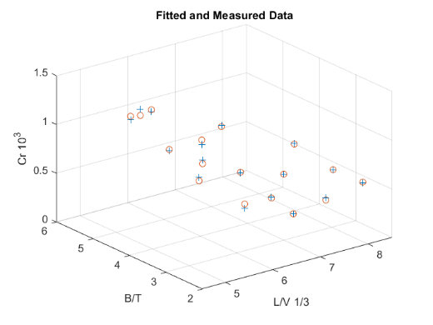
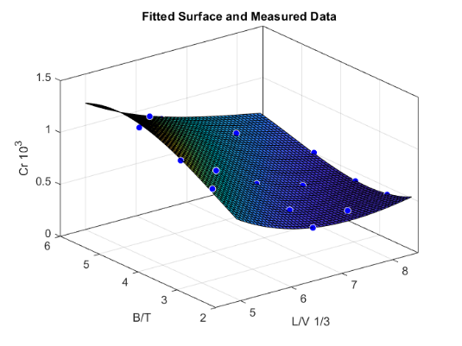
Figure 4. Fitted Surface (left) and Fitted Data (right) together with Measured Data at Froude number 0.250

The fit will assume this form, and the surface can be drawn in iso level curves, at constant Froude number, in the L/V^{1/3} and B/T plane, as shown in figure 5. In the equation (2) the L/V^{1/3} and B/T variables will be called x and y respectively.

sf1(x,y) = p00 + p10ˑx + p01ˑy + p20ˑx^2 + p11ˑxˑy + p02ˑy^2 + (2)
p30ˑx^3 + p21ˑx^2ˑy + p12ˑxˑy^2 + p03ˑy^3

Table 4. The surface coefficients at different Froude number:
FR | 0.150 | 0.175 | 0.200 | 0.225 | 0.250 | 0.275 | 0.300 | 0.325 | 0.350
P00 | 18.52 | 14.24 | 9.28 | 5.359 | 3.877 | 5.853 | 11.65 | 20.37 | 29.75
P10 | -6.498 | -5.013 | -3.229 | -1.864 | -1.539 | -2.657 | -5.291 | -8.813 | -11.87
P01 | -3.006 | -2.042 | -0.9369 | 0.07464 | 0.8564 | 1.31 | 1.498 | 1.601 | 2.00
P20 | 0.7634 | 0.5884 | 0.3739 | 0.2161 | 0.201 | 0.3823 | 0.7658 | 1.249 | 1.619
p11 | 0.6524 | 0.4615 | 0.2305 | 0.02007 | -0.1234 | -0.1761 | -0.1572 | -0.1292 | -0.221
P02 | 0.3089 | 0.2253 | 0.1306 | 0.03857 | -0.04786 | -0.1172 | -0.1658 | -0.1902 | -0.1896
P30 | -0.02725 | -0.02069 | -0.01216 | -0.00603 | -0.006273 | -0.01546 | -0.03386 | -0.05639 | -0.07247
P21 | -0.05172 | -0.03874 | -0.02523 | -0.0141 | -0.007606 | -0.00613 | -0.00807 | -0.00977 | -0.00445
P12 | 0.003709 | 0.003999 | 0.009709 | 0.01761 | 0.02503 | 0.02886 | 0.02841 | 0.02586 | 0.02733
P03 | -0.03186 | -0.02416 | -0.01851 | -0.01434 | -0.01059 | -0.00656 | -0.00237 | 0.000298 | -0.0023

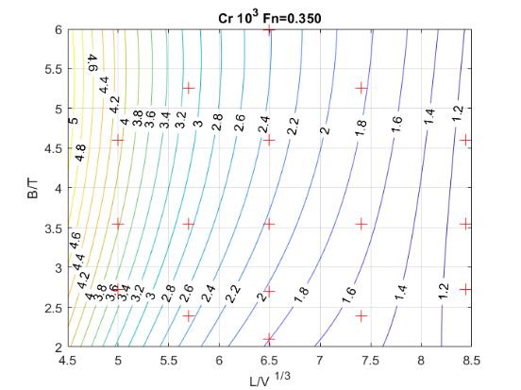
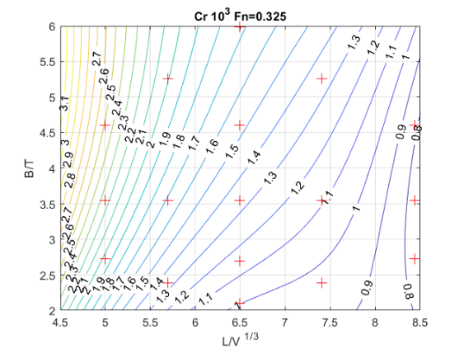

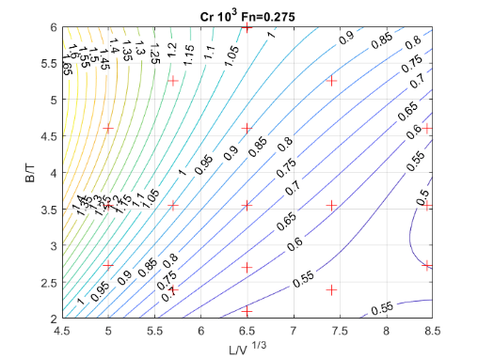
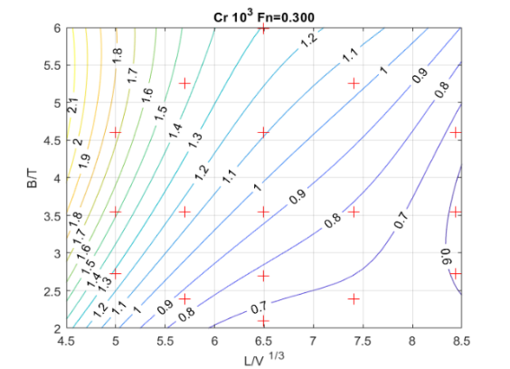

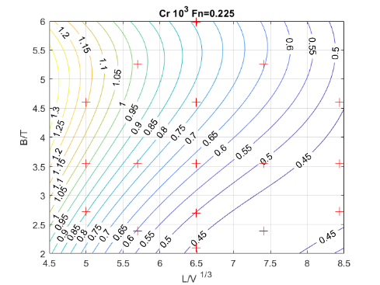
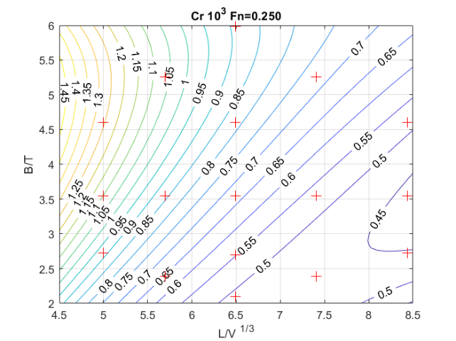

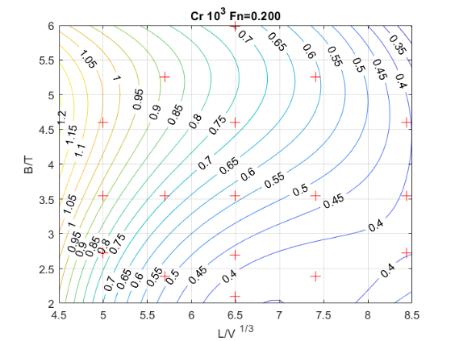
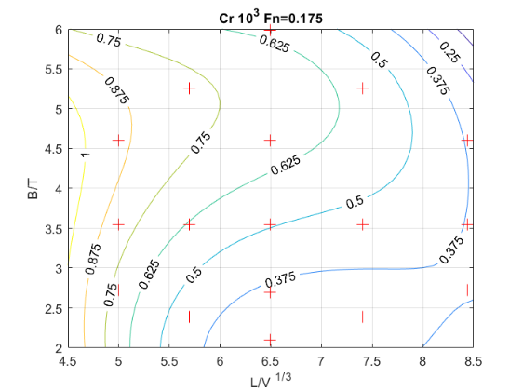

Figure 5. Iso-levels of CR at fixed Froude Number, in the L/V^{1/3} B/T plane
The error evaluation of the residual resistance coefficient is good for all the speeds, as shown in the figure 6.

Figure 6. The measured and the fitted CR data at different Froude Number

The best shape
If the graphs provided so far can help us predict the resistance of the ship to be drawn, nothing can tell us about the best form of the Serie. To obtain this indication, it’s necessary to compare hulls of the same volume moving at the same speed, regardless of their length, that’s to say with the same Froude volumetric number. For a 10000 m³ volume ship, the region of the plane in which the slope becomes flat gives us the best form coefficient, and therefore the best L/V^{1/3} will be greater than 6 and the best B/T will be smaller than 4, as can be seen in Figure 7, where are shown the total resistance results of a 10000 m3 volume ship, at 20 and 22 knots speed.
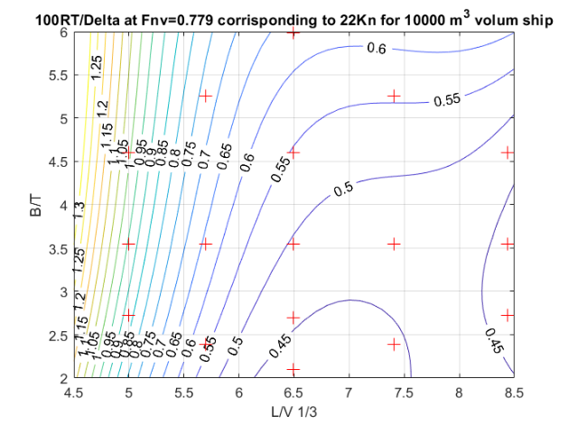
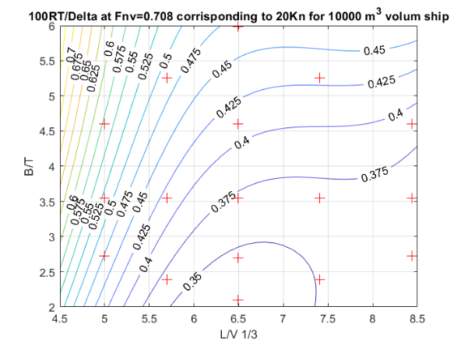
It is not a coincidence that the hull generating the whole Serie, the C.2054 with L/V^{1/3}=6.49 and B/T=3.54 is amongst the best.
Figure 7. The 100ˑRt/Delta ratio at 20 and 22 Knots Ship Speed

How to use the Ferry Series results
As written in the introduction, the seventeen models of the Ferry Series have been built with the scale ratio λ=28.750. All the ships are 10250.0 tons displacement and 10000 m³ volume, CB=0.515, CM=0.943, CP=0.546, CW=0.715, CVP=0.720, LCB=-1.71%, XCF=-5.33%.
The model C.2054 has been used to build the whole Series, the variations in the forms have been obtained, operating the deformation of the hull in the x, y, z directions using the following parameters:

p = L derived hull / L generating hull
q = B derived hull / B generating hull
r = T derived hull / T generating hull

The derived models of the Series have all constant volume, while the product pˑqˑr is pˑqˑr =1, but we can design any size ship derived from the Series, of any displacement, and the product pˑqˑr will be the ratio between the new displacement and the generating hull displacement of 10250 t.
Let's imagine you want to draw a 7500 t displacement ship, with a volume of 7317.1 m³, and a maximum length of 110 meters L ≤110 m, so that the ratio L/V^{1/3} ≤5.65. If the immersion should be not greater than 6 meters T≤6 m, you can obtain a beam of 21.59 meters, remembering that the block coefficient is constant C_{b}=V/(L*B*T)=0.515. Using this value for the block coefficient you can write the relation B=V/(L*C_{b}*T) and, finally, the beam is B=7317.1/(110*0.515*6)=21.59 m . The wetted surface ratio S/V^{2/3} can be now derived from relation (1)

S/V^{2/3} = 4.246+0.5085ˑL/V^{1/3}-0.5757ˑB/T-0.009741ˑ(L/V^{1/3})²+ (1)
+0.03287ˑL/V^{1/3}ˑB/T+0.06757ˑ(B/T)²

We can now write the table 5 with the new ship dimensions.

Table 5. The new ship dimensions:
Hull | L | B | T | p | q | r | pˑqˑr | L/V^{1/3} | B/T | S/V^{2/3}
 | m | m | m | - | - | - | - | - | - | -
Generating Model | 4.8634 | 0.7716 | 0.2177 | 1/λ | 1/λ | 1/λ | 1/λ³ | 6.493 | 3.544 | 6.657
Generating Hull | 139.88 | 22.18 | 6.26 | 1 | 1 | 1 | 1 | 6.493 | 3.544 | 6.657
New Ship | 109.66 | 21.59 | 6.00 | 0.784 | 0.973 | 0.958 | 0.732 | 5.150 | 4.000 | 6.062

With length-displacement ratio L/V^{1/3}=5.15 and the B/T=4.0 we can calculate the residual coefficient resistance at different Froude number from 0.150 to 0.375 using the coefficients in table 4; then with length, speed and viscosity we can calculate the frictional coefficient resistance and, according to ITTC 57 procedure [12] , we can obtain the total resistance as function of the speed.

Table 6. The new ship resistance coefficient as function of the speed:
FR | 0.150 | 0.175 | 0.200 | 0.225 | 0.250 | 0 0.275 | 0.300 | 0.325 | 0.350
Vs (kn) | 9.57 | 11.16 | 12.75 | 14.35 | 15.94 | 17.54 | 19.13 | 20.73 | 22.32
CRˑ10³ | 0.554 | 0.637 | 0.735 | 0.815 | 0.884 | 0.974 | 1.185 | 1.733 | 2.926
Cfˑ10³ | 1.692 | 1.659 | 1.630 | 1.606 | 1.585 | 1.566 | 1.549 | 1.533 | 1.519
Ctˑ10³ | 2.246 | 2.296 | 2.365 | 2.421 | 2.469 | 2.540 | 2.733 | 3.266 | 4.446
Rts (t) | 6.7 | 9.4 | 12.6 | 16.3 | 20.5 | 25.6 | 32.7 | 45.9 | 72.5

We are able now to draw the new ship total resistance curve as function of the speed, our target.

Figure 8. The New Ship Total Resistance Curve

Conclusions
The graphs and the equations provided so far can help the naval architect to predict the resistance of the ship to be drawn, indicating the best form of the Serie too. We hope our job can be interesting for any shipyard and ship designer. The simple use of these results has been our goal.

References
- Todd F. H.”Series 60 Methodical Experiments with Models of Single SCRew Merchant Ships”, Report 1712 of David Taylor Model Basin, Navy Department July 1963
- Hugh Y. H. Yeh “Serie 64 Resistance Experiments on High-Speed Displacement Forms”, Marine Technology 1965 Presented at the 9 December 1964 Meeting of the Chesapeake Section of the SNAME
- R. N. M. Patullo “The B.S.R.A.Trawler Series Part I Beam-Draft and Length_Displacement Ratio Series Resistance and Propulsion Tests” R.I.N.A. Transactions Vol 107 1965
- R. N. M. Patullo “The B.S.R.A.Trawler Series Part II Block Coefficient and Longitudinal Centre of Buoyancy Variation Series, Resistance and Propulsion Tests” R.I.N.A. Transactions Vol 110 1967
- Cedric Ridgely-Nevitt “The Resistance of High Displacement-Length Ratio Trawler Series” S.N:A:M:E: Transactions Vol 75 1967
- Alfred M. Kracht, Alfred Jacobsen “D-Series Systematic Experiments with Models of Fast Twin-Screw Displacement Ships” S:N:A:M:E: Transactions Vol 100 1992
- Franke, R. (1979). A critical comparison of some methods for interpolation of scattered data (No. NPS53-79-003). NAVAL POSTGRADUATE SCHOOL MONTEREY CA.
- Haaland, B., & Qian, P. Z. (2011). Accurate emulators for large-scale computer experiments. The Annals of Statistics, 39(6), 2974-3002.
- R. Rocchi, “Metodo per la previsione statistica di potenza effettiva per navi traghetto” Venezia novembre 1984 NAV84
- M. Costanzo, D. Ranocchia, R. Rocchi, “Prove di Rimorchio sui modelli della serie sistematica T90” Programma Ricerche 1988-90 Rapporto 1990-57
- International Towing Tank Conference - ITTC Symbols and Terminology List Version 2021
https://www.ittc.info/media/9880/structured-list_2021_a.pdf
- ITTC Recommended Procedures: 7.5-02-02-0.1 “Testing and Extrapolation Methods Resistance, Resistance Tests
https://ittc.info/media/1217/75-02-02-01.pdf

Marcello Costanzo, CNR-INM, Institute of Marine Engineering of National Research Council of Italy via di Vallerano 139 00128 Rome Italy; E-mail: marcello.costanzo@cnr.it
Andrea Mancini, CNR-INM, Institute of Marine Engineering of National Research Council of Italy, via di Vallerano 139 00128 Rome Italy; E-mail: andrea.mancini@cnr.it
Luca Mauro, CNR-INM, Institute of Marine Engineering of National Research Council of Italy, via di Vallerano 139 00128 Rome Italy; E-mail: luca.mauro@cnr.it

