Numerical and Physical Modeling of Ship Impacts on Fenders
A. Gomes^{a,}, L. Pinheiroª, J. Simãoª, C. Costaª, C.E.J. Fortesª, and J.A. Santos^{b,c}
ª Ports and Maritime Structures Unit; Hydraulics and Environment Department of the National Civil Engineering Laboratory, Portugal
^{b} Instituto Superior de Engenharia de Lisboa; Instituto Politécnico de Lisboa, Portugal
c Centre for Marine Technology and Ocean Engineering; Universidade de Lisboa, Portugal
Abstract. This paper aims to evaluate the impact of ships on fenders during the berthing process. Physical tests and numerical simulations with MOORNAV tool were performed with versions of the GulfStream ship in still water and under a set of different conditions. A comparative analysis was made between outputs of the two models considering specific conditions. The MOORNAV application resulted in a standard deviation from the physical model of 3% to 6% in relation to the maximum force exerted on each fender.
Keywords. Fenders, GulfStream Ship, Numerical Modelling, Physical Modelling, MOORNAV.

Introduction
The increase in the size, mass and speed of ships reduced transportation costs but, it created new challenging problems associated with operational aspects of large ships. Large ships have larger exposed areas to the action of waves, wind and currents which greatly affect berthing operations. For instance, further developments, solutions and testing are required to improve the berthing process of such ships under various environmental conditions. In addition to developments in ship sizes, the exploration and exploitation of the ports have also brought buildings of new terminals at very exposed locations, which reinforces the need for further advances in berthing technologies.
Numerical models properly developed, validated, and calibrated are a valuable tool in the design and/or improvement of berthing, mooring and fendering. These are very efficient to simulate rapidly ship impact on fenders but, to improve the reliability of their use in practice, it is necessary to calibrate several parameters through physical model measurements. The validation process of the numerical models requires reliable data collected in situ or measured in scale-model tests as these provide relevant information and results about berthing processes.
If the ship’s energy is not absorbed by the fenders, the energy usually damage either the quay or both the quay and the ship, endangering lives and property. Therefore, the main goal of this work is to better understand the relation of the mass of ships with the speed and angle of approach, and their relation to the force distribution on fenders. For that purpose, berthing forces on fenders obtained with a 1:100 scaled physical model and with the application of the MOORNAV module models (Santos, 1994) were performed. The models were made compatible and the differences between them were quantitatively evaluated.

Ship Impact on Fenders
Marine fenders provide a necessary interface between berthing ships and berth structures [4]. Fenders are used to absorb a certain portion of the ship's energy impact (equal to the kinetic energy) without damage to the ship, the waterfront structures and the fenders. Therefore, characterizing the maximum force applied to an individual fender and its distribution among a set of fenders is an essential factor in the design of berthing structures and fenders themselves as well as to improve existing ones.
The fender forces are influenced by a lot of parameters: the configuration of the berthing site, the geometry and the rigidity of the ship’s hull, fenders’ properties, the speed and angle of approach, the forces exerted by tugs, wind, current and waves, the mode of motion and the keel clearance [1].
The quantification of the fender’s forces magnitude can be performed through scaled tests or mathematical formulations in the time domain. A full-scale collision testing of a ship with a quay – fender system is expensive and time-consuming. Thus, practicable and sufficiently accurate numerical models represent a valuable tool to assess the behavior of a berthing ship. Computer simulations provide a good means to evaluate the complex physical processes, to determine the external forces acting on fenders and to design a large number of alternatives in a short period of time [4]. Physical model tests outputs are used as reference to calibrate and validate numerical models and its results.

Gulfstream Ship Case Study

Physical Model Setup
The ship’s physical model is a 1:100 scaled version of GulfStream oil tanker from the Centre for Marine Technology and Ocean Engineering (CENTEC). The ship model overall length is 172.5 cm, the width is 24.8 cm, the maximum height is 14.0 cm and the deadweight is 13.124 kg.

Facility
The physical tests were conducted in an area of 4 m x 4 m of a 22 m x 23 m (width x length) tank of the Ports and Maritime Structures Unit of the Hydraulics and Environment Department of the National Civil Engineering Laboratory (LNEC). The water depth during the tests was 39.5 cm. The berthing system comprises four fenders, equally spaced 40 cm apart.

Tests conditions
The physical tests were conducted in still water. Different conditions for a scaled model ship impact were performed, namely, the ship’s mass ranging from ballast condition to fully loaded, the ship’s approach heading ranging from strictly parallel to the quay to large angles, and the ship’s approach velocity ranging from normal docking speeds to accidental impacts speed.

Measurement equipment and methods
The ship was manually pushed against the fenders and the ships' headings were appreciably adjusted. Ship’s velocity and heading were recorded using an Optitrack® multi-camera motion capture system. A plate with a set of markers was placed on the top of the ship and the full body tracking was performed. The impact forces were registered by four force sensors and a Quantum MX data-acquisition system with CatmanEasy® DAQ Software. Figure 1 shows the measurement equipment used in the physical tests of the GulfStream ship impact on fenders.

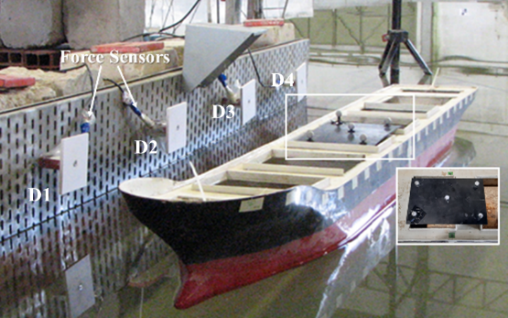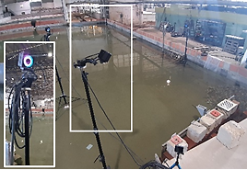
Figure 1. Experimental setup. Left: GulfStream ship scaled model and force sensors. Right:Optitrack cameras setup.
Figure 2 and Figure 3 present results of test series T010: fully loaded ship approaching parallel to the quay. This test series is made of 10 repetitions of the same docking impact.
Figure 3 presents the impact forces on the four fenders, for the first four impacts of the test series. The differences between them arise from the human factor slightly influencing the speed and angle of the ship on impact.

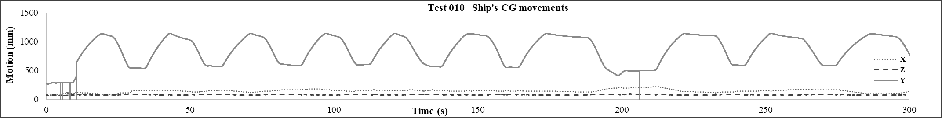
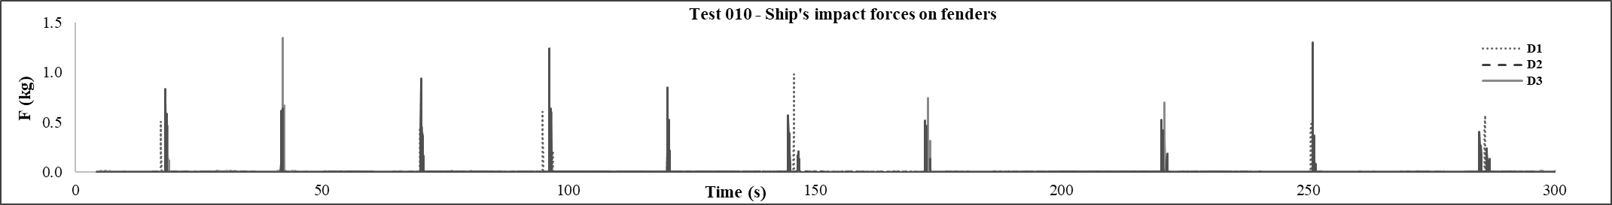
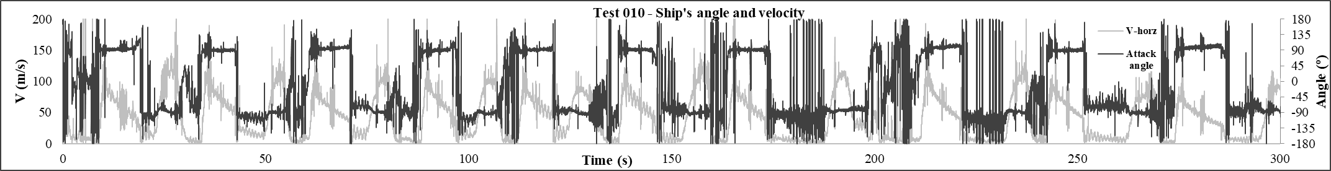
Figure 2. Experimental Measurements. Top: Ship’s center of gravity movements. Center: Ship’s impact forces on fenders. Bottom: Ship’s angle of attack and velocity.
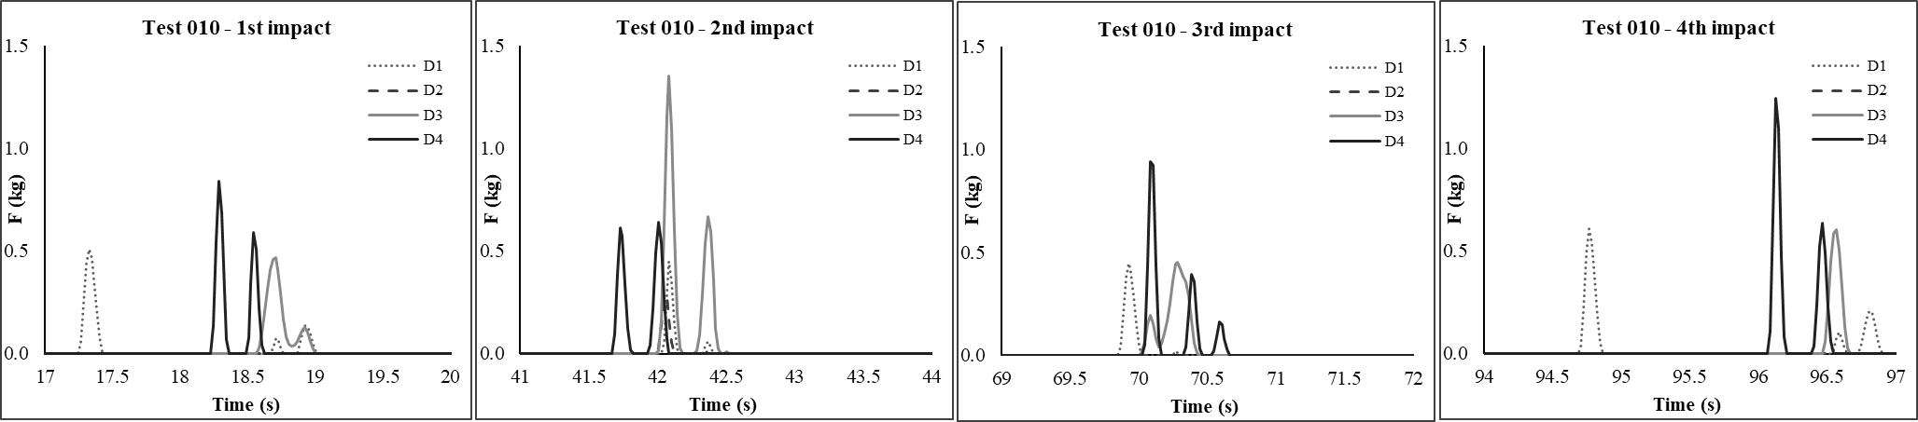
Figure 3. Impact forces on 4 fenders acquired from the physical model for the first four impacts of test series T010.

Numerical Models Setup
The MOORNAV module [5] was selected to perform the numerical simulations. It is an integrated tool that estimates ship movements and the forces exerted on the mooring system through two numerical models, WAMIT and BAS.
The submerged hull of the full-scale version of the GulfStream tanker was discretized in 279 planar rectangular and triangular panels (panels) through a Nautical Pre-Processor [5] and the geometric characteristics of the floating body were extracted. The physical model conditions were reproduced according to Froude's similarity.

WAMIT numerical modelling
WAMIT [2] is a hydrodynamic numerical model, which computes, from the panels of the ship submerged hull, the hydrodynamics of the free-floating body and the corresponding wave diffraction and radiation loads, based on the potential theory.
The fenders support structure is porous so the effects of ship-radiated waves and overpressure can be negligible. This simplification is chosen over the one with an infinite totally reflective vertical wall (only two options in WAMIT model).
The added mass and damping coefficients (Figure 4) related to the resistance to the motion of the GulfStream ship in ballast condition, partially loaded and fully loaded, were computed, as well as the wave load transfer functions in the 6 degrees of freedom. WAMIT results were put into the convenient format to be inputted in BAS numerical model.

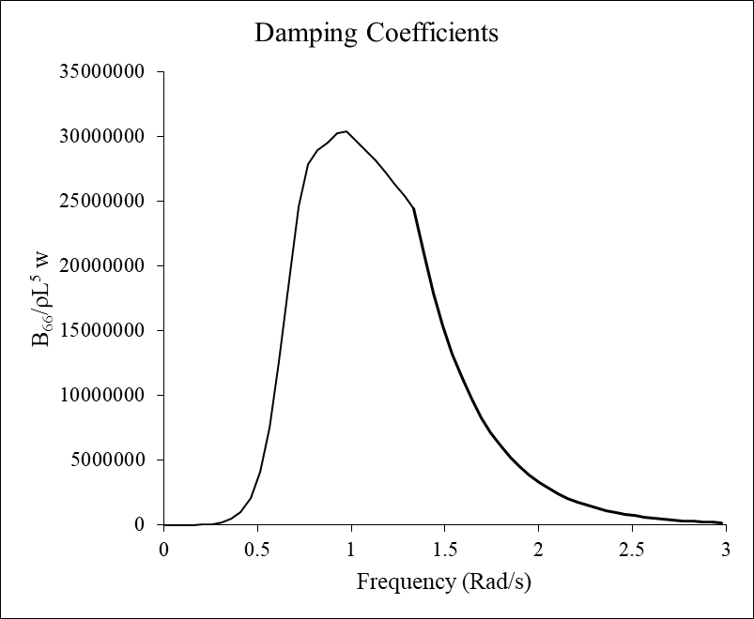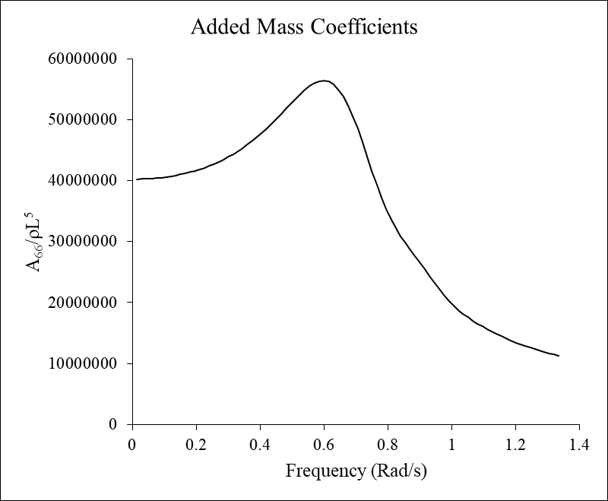
Figure 4. Damping and added mass coefficients associated to the yaw motion of the GulfStream ship due to a rotation along the z-axis.

BAS numerical modelling
The BAS numerical model [3] includes a time domain solver to analyze the dynamic motions of a floating body, taking into account the non-linear stiffness of the fenders and their positions. BAS assembles and solves, in the time domain, the equation of motion of a moored ship – Eq. (1):
$\sum_{j=1}^{6}{[\left(M_{kj}+m_{kj}\right){\ddot{X}}_{j}\left(t\right)+}\int_{-∞}^{t}{K_{kj}\left(t-τ\right){\dot{X}}_{j}\left(τ\right)dτ}+ C_{kj}X_{j}(t)]=F_{k}^{d}\left(t\right)+F_{k}^{w}\left(t\right)+F_{k}^{c}(t){+F}_{k}^{m}\left(t\right)+F_{k}^{f}\left(t\right)$ (1)
where j, k = ship's modes of motion; M_{kj} = ship's inertia matrix; m_{kj} = infinite frequency added-mass matrix; K_{kj} = impulse response matrix; C_{kj} = hydrostatic restitution coefficients matrix; X_{j} (t) = ship’s oscillating motion; F_{k}^{d} = incident wave force; F_{k}^{m} = Forces on the mooring lines; F_{k}^{f} = Forces on the fenders; F_{k}^{w} = wind forces; F_{k}^{c} = current forces; and t = time.
Assuming small amplitude of the ship movements along each of her six degrees of freedom, it is easy to define the part corresponding to the quasi-static variation of submerged hull form. This leads to the hydrostatic restoring matrix C_{kj} whose coefficients are the force along mode k due to a unit change, in still water, of the ship position along mode j.
The same assumption of small amplitude ship movements leads to the linearity of the interaction between the hull and the incident waves. Such linearity allows the decomposition of that problem into two simpler problems, Cummins (1962): the radiation problem in which one determines the forces along each degree of freedom that are needed for an arbitrary hull movement in otherwise calm water, and the diffraction problem in which one determines the force F_{k}^{d} along each degree of freedom k that is exerted by the incident sea waves on the motionless ship hull.
Strictly speaking, this is a set of six equations whose solutions are the time series of the ship movements along each of her six degrees of freedom as well as of the loads in the mooring lines and fenders.
In the equation above mass and hydrostatic restoring matrices depend only on the ship geometry and on the mass distribution therein. The forces due to mooring lines and the fenders can be determined from the constitutive relations of these elements of the mooring system.
Since the BAS model requires the definition of at least one mooring line, it was defined with an extremely high elongation so that the force exerted on it does not influence the motions or the forces exerted on the fenders. Fenders’ position and stiffness was set exactly as the physical model and simulations were performed in still water. The four fenders are characterized by a linear compression with a maximum force of 24500 kN for a deflection of 123.5 mm (consistent with the force sensors characteristics).
To induce the motion of the ship, a force was introduced into the current term F_{k}^{c}, corresponding to the ship’s model velocity in the direction in which the ship was pushed. The solution of equations system (1) using BAS model resulted in the time series of the ship’s motion in six degrees of freedom and the of the fenders’ forces.

Results and Discussion
The physical model tests and the numerical model simulations resulted in time series of the GulfStream ship motions and forces exerted on the four fenders. As a result of this research, a comparative analysis was made between the outputs of the two models. For this purpose, BAS numerical model was applied to simulate the first impact of test series T010 whose results were presented in Figure 3. The distance from the ship to the fenders at the start of the berthing process was set on the numerical model the same as in the physical model.
Figure 6 presents the plot of the GulfStream ship sway and yaw motions and Figure 6 the impact forces on the four fenders, during the first impact.

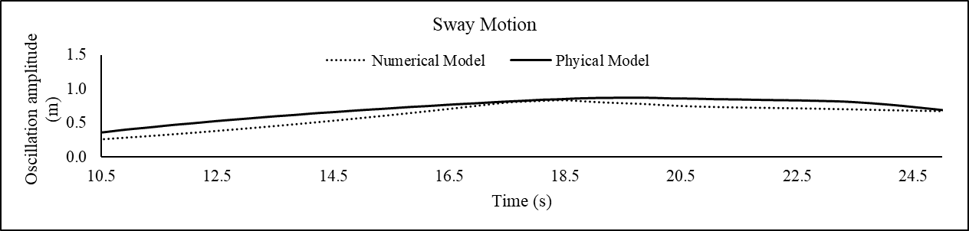

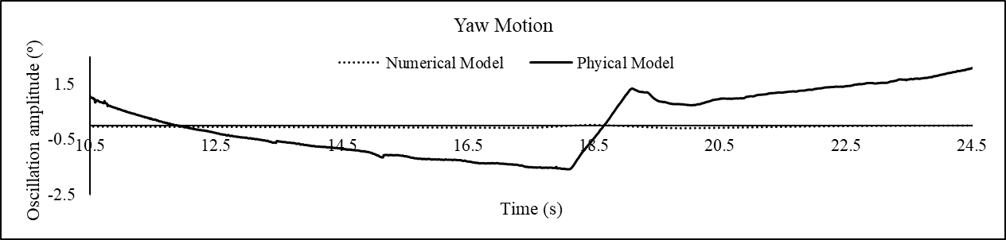
Figure 5. GulfStream ship sway and roll motions obtained through the BAS numerical model.
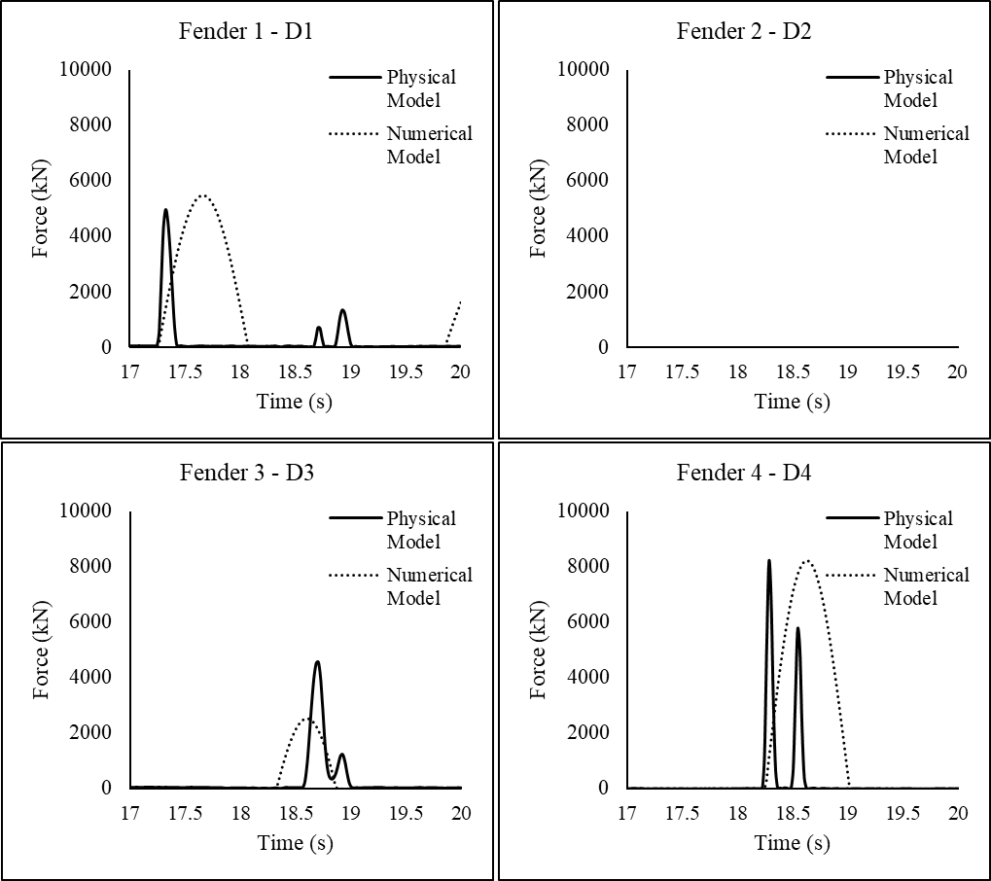
Figure 6. Physical and numerical first impact of the GulfStream ship on fenders.
The first impact on the fenders occurred between 17 s and 20 s in both models. Assuming the measured values in the physical model as benchmark, the numerical model was able to provide accurate estimates of the sway motion amplitude but not so much for the yaw motion amplitude. This can be due to a difference in the angle of attack of the ship, at the time of impact.
In both models, the GulfStream ship hit first D1 and then D4 and D3 respectively. D2 was not impacted at all, in neither model. The first impact of the GulfStream ship on the fenders occur at approximately the same time in both models (t=17,26s). The numerical model accurately estimated the time at which the first impact occurred at D1 and D4, hinting at the fact that the yaw motion velocity (rotation of the ship on the XY plane) is well modeled. As for the impact in D3, the numerical modelling slightly underestimated the time of the impact. This can be due to a slightly deviated positioning of the defense on the physical model.
The time interval between the impact at D1 and the impact at D4 was approximately 1 s, while the impact at D3 occurred 0.34 s after the impact at D4 in the physical model and 0.08 s in the numerical model.
As for the impact magnitude on the fenders, the application of MOORNAV accurately estimated the forces of the GulfStream ship's impact on D4, the most heavily loaded fender. The impact at D1 was slightly overestimated and the impact at D3 was underestimated (almost half of that recorded in the physical model).
In the physical model, the maximum force recorded in D1 was 4970 kN, in D3 was 4567 kN and in D4 was 8208 kN. In the numerical model, the maximum estimated force in D1 was 5483 kN, in D3 was 2532 kN and in D4 was 8216 kN.
The discrepancy between the values measured in the physical model and those obtained by the numerical model simulations can be associated to other factors such as the way the berthing speed of the ship was induced in the physical tests and other physical parameters that were not accounted for in the numerical modelling such as viscosity. A viscosity calibration can be made in the future to improve numerical results.

Conclusions
This research was essentially dedicated to the evaluation of the forces exerted on the fenders by the GulfStream ship. Physical model tests and numerical model simulations were performed. The comparative analysis between the models allowed a better understanding of the variables related to the impact of ships on the fenders, namely the magnitude of the impact forces on the fenders, their sequence and the importance of accounting for all possible physical phenomena in the numerical simulations.
Developments on this berthing impact investigation can be used in the design of fenders and in the improvement of existing inefficient fender systems. Further simulations must be performed to validate the suitability of numerical modeling of ship impacts on fenders. At this stage, aiming the safety of the ship, the fenders and the quay, the use of MOORNAV numerical modeling in the assessment of the impact of ships on the fenders proved to provide accurate results.

Acknowledgments
The authors thank the Centre for Marine Technology and Ocean Engineering for lending the ship model. The financial support from Portuguese national blue fund “Fundo azul”, through project FA_04_2017_016 “BlueSafePort – Safety System for Manoeuvring and Moored Ships in Ports“ is acknowledged.

References
- Fontijn, H.L. (1988). On the Prediction of Fender Forces at Berthing Structures Part I: Calculation Method(s). In: Bratteland, E. (eds) Advances in Berthing and Mooring of Ships and Offshore Structures. NATO ASI Series, vol 146. Springer, Dordrecht. https://doi.org/10.1007/978-94-009-1407-0_4
- Korsemeyer, F.T., Lee, C.H., Newman, J.N. e Sclavounos, P.D. (1988). The analysis of wave effects on tension-leg platforms. Proc. 7th International Conference on Offshore Mechanics and Arctic Engineering: 1-14. Texas: Houston.
- Mynett, A.E., Keunig, P.J. e Vis, F.C. (1985). The dynamic be-haviour of moored vessels inside a harbour configuration. Int. Conf. on Numerical Modelling of Ports and Harbour 23-25: Cranfield: BHRA. The Fluid Engineering Centre, April 1985. England: Birmingham.
- PIANC. (2002). Guidelines for the design of Fender Systems”
- Santos, J.A. (1994). MOORNAV – Numerical model for the behaviour of moored ships. Final report, Projecto NATO PO-Waves (3/94-B). Lisbon.

Corresponding author: ahgomes@lnec.pt

