A Methodology for the Hull Forms Design
of a Passenger Catamaran for
the Venice Lagoon
Luca BRAIDOTTI^{a,}, Serena BERTAGNAª, Mattia ZANINª,
Donato PADOLECCHIAª, Alberto MARINÒª and Vittorio BUCCIª
ª Department of Engineering and Architecture, University of Trieste, Italy
Abstract. The proper definition of the main geometric coefficients and the hull forms of a passenger catamaran must be carried out from the early design stage, due to its strong impact on the resistance, propulsion and the generated wave pattern. This is a primary concern especially in fragile environments, such as the Venice Lagoon, where waves increase erosion phenomena. In this work, a two-phase methodology for the definition of the hull forms of a passenger catamaran, based on both a parametric and CFD analysis, is presented. In the first phase, systematic series data are used to parametrically evaluate possible combinations of main hull dimensions (breadth of the demi hull, deadrise angle), selecting the best one to fit a specific operative scenario (minimisation of required energy). Then, after the validation of mesh parameters with a benchmark hull, the best hull forms are assessed through CFD simulations. To study the interference between the two hulls and select the proper configuration two different distances of the demi hulls are investigated. The methodology has been applied to the preliminary design of a 10 m passenger catamaran for the Venice Lagoon. Routes from the city centre to Marco Polo Airport or Torcello Island have been considered.
Keywords. Catamaran, early design stage, hull forms design, ship resistance, CFD

Introduction
The Venice Lagoon is a very fragile environment that is even more threatened by human action. At a macroscopic level, climate change leads to more frequent exceptional events such as the so-called “high-water”, i.e. exceptional high tides [1]. At a local level, the waterborne transport also impacts the city of Venice and the surrounding lagoon. Firstly, boats and ships, especially if they proceed at high speed, generate significant wave patterns that cause lagoon erosion [2] and compromise the pilings on which the city is built [3]. In addition, the use of endothermic engines, which are often outdated, increases atmospheric pollution. Considering the particulate matter, Venice is one of the most polluted cities in Italy. In 2021, these problems compel UNESCO to consider the addition of Venice to the List of World Heritage in Danger, which was avoided prohibiting large cruise ships' navigation in the “Bacino di San Marco”. Nonetheless, the navigation of small high-speed craft still generates relevant wave height in urban and lagunar environments [4]. For instance, in the Giudecca canal, a significant wave height of about 0.5-0.7 m is usually observed.
Two main strategies have been envisaged to face the environmental problems in the Venice Lagoon. To reduce air pollution, the endothermic engines can be replaced by greener propulsion systems. In this context, hybrid-electric [5] and full-electric [6] boats can be designed and deployed. Besides, the energy efficiency of the small crafts can be enhanced with a proper design of hull forms from the early design stage [7]. The latter affects also the problems related to the generation of waves by high-speed boats [8], thus reducing the erosion phenomena and the flattening of the lagoon. In this context, the application of catamarans and foils can improve the reduction of wave patterns compared to a conventional monohull.
The aim of the present work is the definition and application of a hull forms design methodology for a small passenger catamaran for the Venice Lagoon. The catamaran will be equipped with a full-electric propulsion system [9] dimensioned to fit operations from/to Venice centre to/from the Marco Polo airport or small islands (e.g. Torcello). The rule framework for taxi-boats has been taken as a reference to define maximum dimensions and passenger capacity [10]. Here, a two-step process is applied to define the solution having the highest energy efficiency and a reduced generated wave pattern: first the best hull forms are selected using systematic series, then the design is refined by employing Computational Fluid Dynamic (CFD) analysis.

Methodology
In the present section, a brief review of techniques used for the power predictions for catamarans is firstly provided. Then, the proposed method to enhance energy efficiency for a defined route is presented. The objective is achieved by selecting proper hull forms.

Power Prediction for Catamarans
In the early design stages, it is essential to properly assess the resistance and propulsion performances of a boat or a ship. Considering catamarans, the traditional methods cannot be applied due to the interference among the two hulls that can have a positive or negative impact on the total resistance [11]. To overcome these issues, systematic series of catamarans have been developed and tested in towing tests since the second half of the last century. Among the others, two systematic series are worthy to be mentioned: the Series '64 [12], which can be employed for the early design of round-bilge catamarans, and the Series '89 [13], related to hard-chine catamarans.
The Series '64 and the associated powering prediction method apply to displacing/semi-displacing catamarans (length Froude number 0.2 < Fn_{L} < 1.0) having S/L larger than 0.2, where S is the distance between the centreline of the demi hulls and L is the length at the waterline. The Series '89 applies to faster catamarans (demi hull volumetric Froude number 0.25 < Fn < 1.4) having a fixed distance between the two demi hulls. The hull geometry is mainly defined by the length on breadth ratio L/B_{DH} of the single demi hull and the deadrise angle β ranging within [7.55, 13.55] and [16 deg, 38 deg], respectively.
Besides systematic series, the increase in computational power opened the wide application of CFD for power prediction. CFD codes have been applied also to catamarans. For instance, it has been used to predict the resistance in full-scale of a large medium-speed passenger catamaran [14], the resistance of high-speed catamarans [15,16] or to investigate the effect of different hull forms [17]. To assure CFD results reliability, it is still a best practice to compare them with experimental ones. This procedure allows validating the suitability of the computational set-up (computational domain, mesh generation parameters, boundary conditions, free surface, etc.) that can be kept constant to investigate variants of the hull forms without testing them in a towing tank [18].

Hull Forms Design
To design proper hull forms, a two-step approach is here used to best fit a given operative scenario: first, a parametric analysis is carried out based on systematic series’ power predictions to select the most appropriate parameters of the demi hull for a predefined route(s); then, the hull is modelled in a 3D environment and tested in different configurations through CFD to study the interference between demi hulls and generated wave pattern.
In the first step, the proper systematic series shall be selected for the assumed operative scenario. Round-bilge catamarans shall be preferred for low-medium speed applications (Fn < 0.5) whereas hard-chine hull forms are more suitable when the boat is expected to operate at higher Fn during most of its operative life. In the following, the process is presented for the latter case, using as a reference the hulls from Series '89. With this assumption, two main parameters shall be selected within the series ranges: L/B_{DH} and β. Given an operative scenario, the foreseen route(s) can be split into segments l_{i} having a constant speed V_{i}. Given a constant target hull volume ∇ coming from a preliminary weight estimate, for each speed, the total resistance R_{Ti} and quasi-propulsive efficiency η_{Di} can be evaluated as a function of L/B_{DH} and β using the prediction method for series '89 [13]. Then, the total energy required by the propulsion system for the navigation on the given route(s) will be:
(1)
where P_{Di} = V_{i} R_{Ti} η_{Di} is the delivered power at speed V_{i}, t_{i} = l_{i}/V_{i} is the time required to navigate the i-th segment of the route(s) and N is the total number of segments of the route(s). Thus, L/B_{DH} and β can be parametrically varied within the series ranges to select the couple that minimises E. With such a parametric analysis the combination leading to the higher energy efficiency can be selected.
Then, after the selection of ∇, L/B_{DH} and β, a demi hull shall be modelled in 3D to meet these values starting from the hulls tested to construct the Series '89. Such a final hull can be further tested using CFD. In detail, to overcome the limitations of the Series '89 (which assumes a constant distance between the inner side of demi hulls), multiple configurations of S/L can be tested to further reduce the total resistance and/or the generated wave pattern. All CFD analyses are carried out in compliance with the ITTC recommendations [19]. Nevertheless, before testing the final hull coming from parametric analysis, proper validation of computational arrangement shall be performed. To this end, a benchmark hull shall be chosen among the ones tested in the Series '89 as similar as possible to the final hull. For the benchmark hull, experimental data (resistance, dynamic trim θ and sinkage measured in towing tank) can be compared with the results coming from CFD simulations. Thus, the computational arrangement can be adjusted to reproduce the towing tank results and, then, the same parameters can be used to test all the configurations of the final hull.

Application
In this section, the previously described methodology is applied to the design of a small passenger catamaran for the Venice Lagoon. First, the specifications of the ship and the operative scenario are introduced. Then, the results are provided and discussed.

Test scenario
The ship under design is a small catamaran having the following design constraints: a maximum overall length of 10 m, a maximum overall breadth of 4 m and a displacement of about 5 t. A vertical bow has been chosen for the topside, thus the length at the waterline is fixed to 9.85 m. The boat is equipped with a full-electric propulsion system. Hence, to accommodate the battery packs within the demi hulls, a minimum breadth B_{DH} of 1 m is required, resulting in a maximum L/B_{DH} ratio of 9.85.
The catamaran is supposed to operate in the Venice Lagoon on two main routes: Venice Centre-Marco Polo International Airport and Venice Centre-Torcello. Figure 1 shows the two routes along with the allowed maximum speed according to local speed limits. It is worth noticing that in Venice Lagoon it is common practice to measure the speed in kilometres per hour instead of knots.

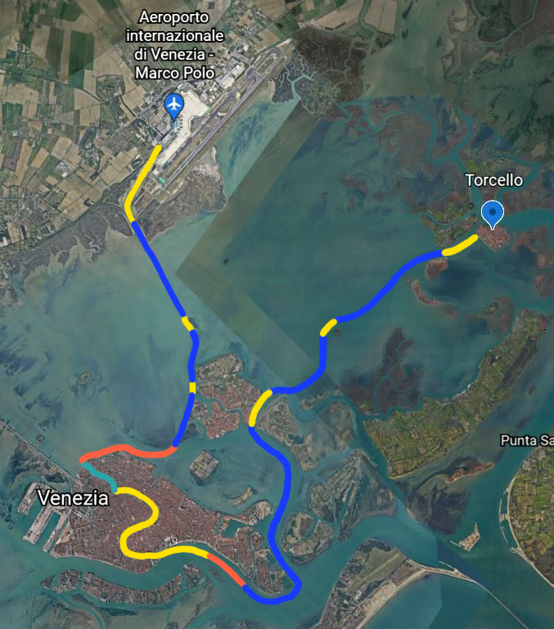
Figure 1. Test routes in the Venice lagoon with speed limits (yellow: 7 km/h, red: 11 km/h, blue: 20 km/h).

Results
Assuming that the catamaran always navigates along the two routes at a speed equal to the speed limit, it is possible to compute E for each combination of L/B_{DH} and β. The results of such a parametric analysis are shown in Figure 2.

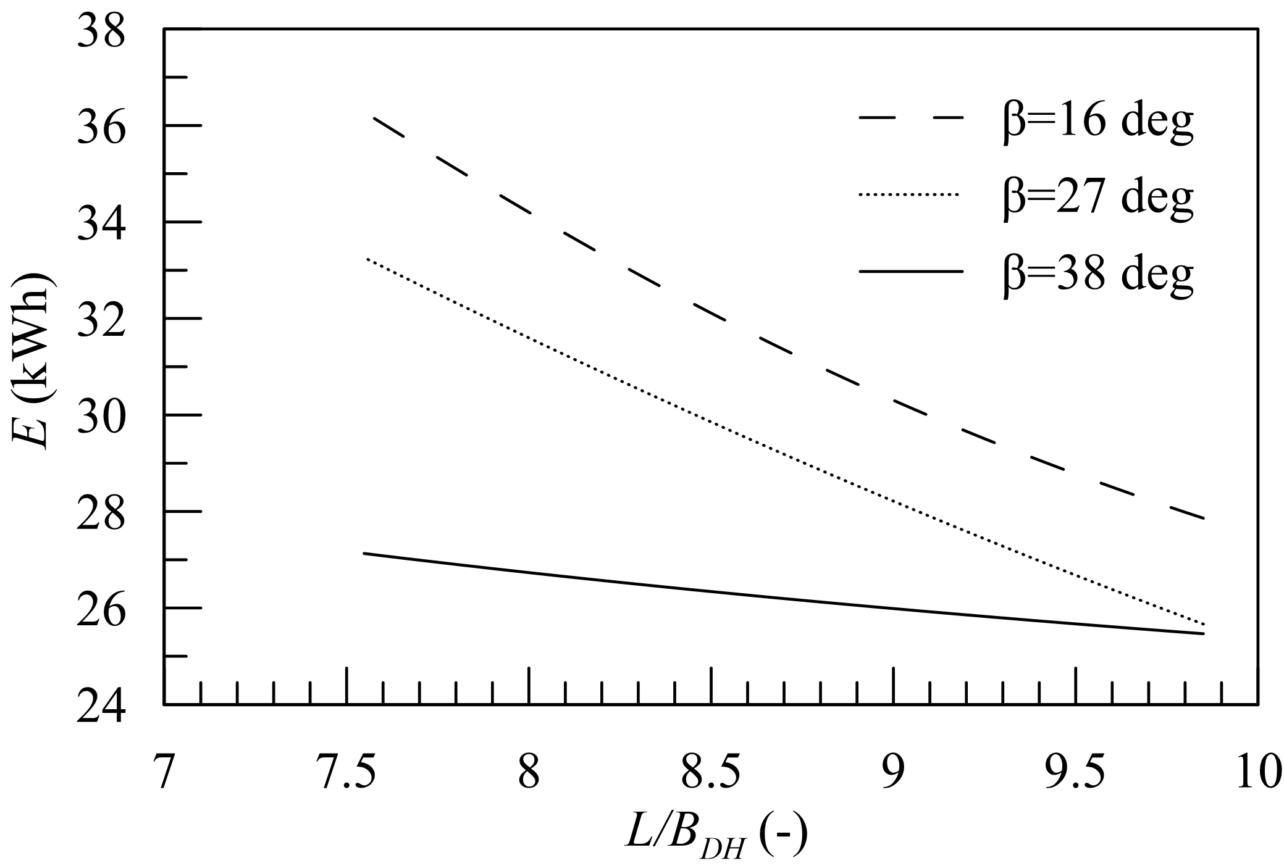
Figure 2. Comparison of the total energy required by the propulsion system in the given operative scenario.
The parametric analyis clearly shows that the most slender demi hull shall be preferred. Therefore, the L/B_{DH} = 9.85 has been selected, being the maximum allowed by the additional geometric constraints. At such an L/B_{DH} ratio, there is no significant difference in required energy for the deadrise angles larger than 27 deg. Nevertheless, β = 38 deg has been selected since the total energy is slightly lower.
In the next phase, the final demi hull has been modelled in 3D according to the β and L/B_{DH} identified by the parametric analysis, resulting in the body plan provided in Figure 3. Table 1 shows the main particulars of the final demi hull along with the ones related to the closest benchmark hull taken from Series '89.
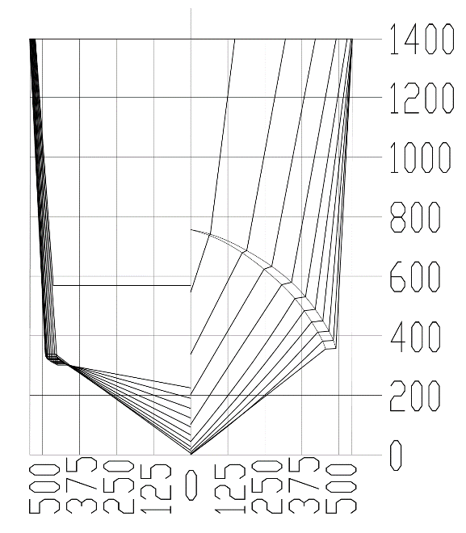
Figure 3. Body plan of the final hull.
Table 1. Main particulars of the benchmark demi hull and the final demi hull
Dimension | Symbol | Unit | Benchmark Demi Hull | Final  Demi Hull
Length overall | L_{OA} | m | 10.93 | 10.21
Length at waterline | L | m | 9.55 | 9.85
Breadth overall of demi hull | B_{OADH} | m | 1.09 | 1.09
Breadth of demi hull at waterline | B_{DH} | m | 1.00 | 1.00
Draught | T | m | 0.55 | 0.55
Deadrise angle | β | deg | 38 | 38
Transom wedge angle | δ | deg | 8 | 8
Hull volume | ∇ | m³ | 2.55 | 2.63
Length on breadth | L/B_{DH} | - | 9.55 | 9.85
Breadth on draught | B_{DH}/T | - | 1.81 | 1.81
Block coefficient | C_{B} | - | 0.484 | 0.483
Prismatic coefficient | C_{P} | - | 0.732 | 0.728
Distance between hulls centrelines on waterline length | S/L | - | 2.60 | 2.69  2.95

In Figure 4, the comparison is presented between the total resistance according to Series '89 and the CFD for the benchmark hull. The results are in quite good agreement, proving the reliability of the assumed computational arrangement.

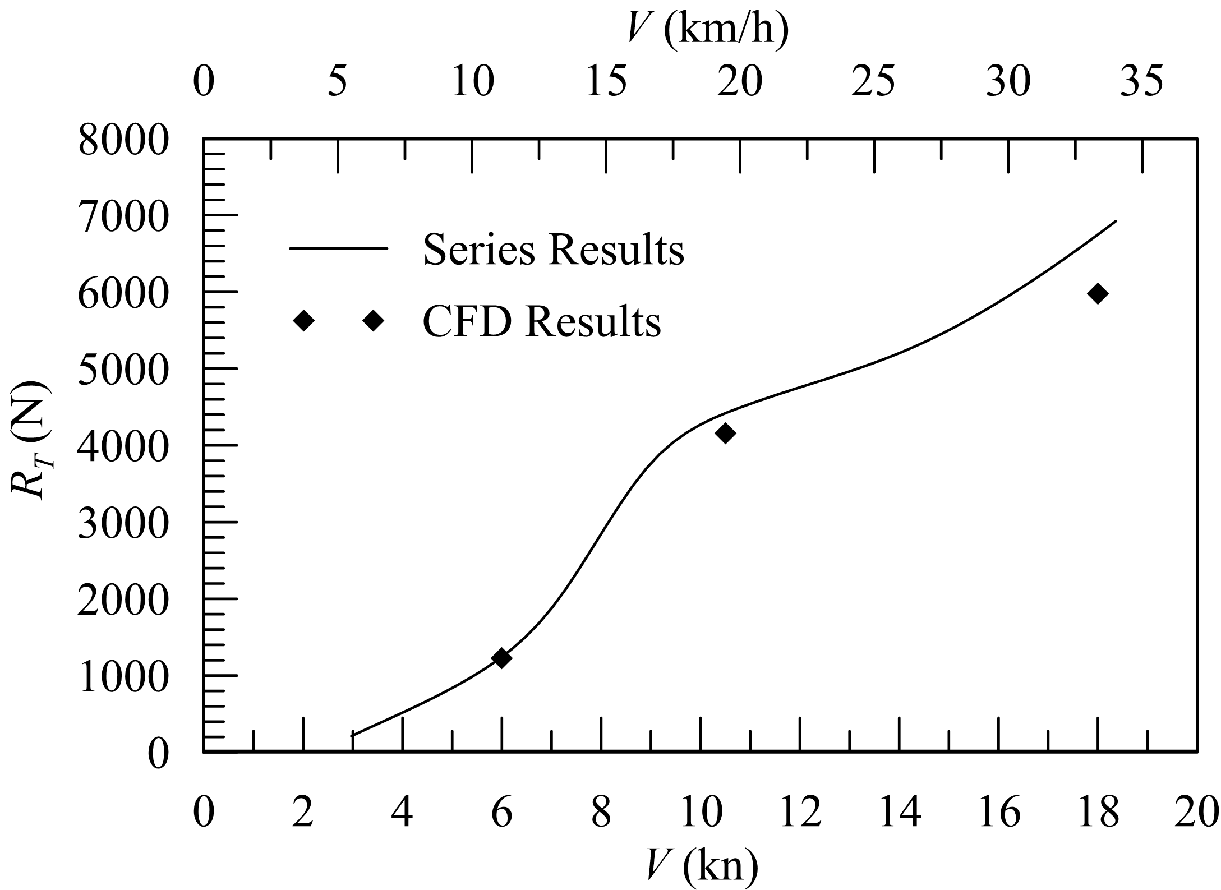
Figure 4. Comparison of results given by Series and CFD simulation on the benchmark hull (S/L =2.60).

Using the same set-up, CFD has been again applied to test two different configurations of the catamaran. Two S/L ratios have been investigated: S/L = 0.269 and S/L = 0.295 corresponding to the maximum overall breadth given in the specification. Considering three different speeds (V = 6 kn, 10.5 kn, 18 kn), the results shown in Table 2 and Figures 5-6 have been obtained for resistance and wave pattern respectively.

Table 2. Results of the resistance prediction for the final hull with different spacing (CFD simulation)
 | S/L = 0.269 |  | S/L = 0.295
V | R_{T} | θ | R_{T} | θ
(kn) | (N) | (deg) | (N) | (deg)
6.0 | 1210 | 0.2 | 1243 | 0.3
10.5 | 3771 | 2.3 | 4030 | 2.1
18.0 | 5010 | 1.8 | 5106 | 1.9
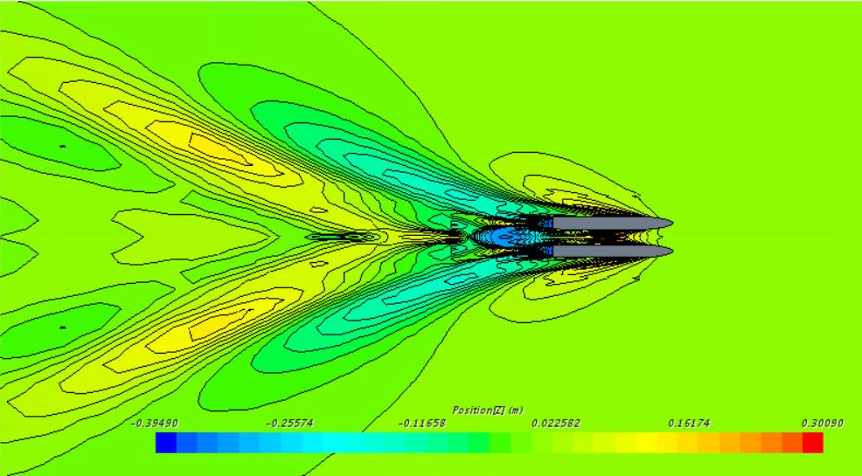
Figure 5. Wave pattern of the final hull with S/L = 0.295 at 18 kn (CFD simulation).
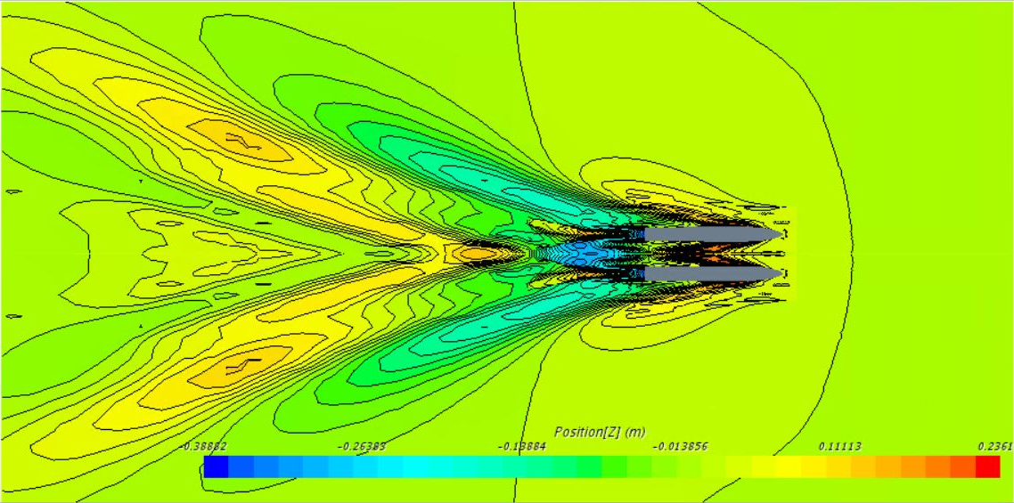
Figure 6. Wave pattern of the final hull with S/L = 0.269 at 18 kn (CFD simulation).

Discussion
Considering the speed limits of the Venice Lagoon, a very large range of Fn is envisaged for the operation of the catamaran. At 20 km/h, Fn = 1.52 which is just above the limit to justify the application of hard chine hull forms. At lower values, round bilge geometries are more efficient. However, the given operative scenario is composed of long segments where the catamaran can navigate at 20 km/h. Furthermore, the maximum speed of the boat will be higher than such a speed limit. Thus, the catamaran operating close to the maximum speed will significantly benefit from hard chine hull forms.
The initial parametric analysis enabled the selection of the catamaran hull forms to minimise the energy required by the propulsion system in the predefined routes. This step required the target hull volume as an input. Thus, a preliminary analysis of the required capacity and weight breakdown is necessary. It is worth noticing that the parametric analysis enables a row estimation of the range of the catamaran before modelling the final hull forms. This can be easily employed to meet the design requirements and rapidly refine the preliminary weight estimate in the early design stage.
Regarding CFD results, the results obtained at low-medium speeds fit very well the experimental results for the benchmark hull, whereas above 10.5 kn the CFD slightly underestimates the total resistance. Considering the final hull, CFD simulations allowed extending the results of the Series '89 by considering different values of S/L. It can be noted that the two tested values provided very close results for R_{T} and θ. Focusing on the wave pattern, the two configurations at 6 kn results in a maximum perturbation lower than 0.1 m. At 18 kn, it increases up to about 0.3 m for S/L = 0.269 and 0.25 for S/L = 0.295. Hence, considering also that the latter configuration maximises the space available onboard, it has been selected. As a result of the next design phases, a 3D parametric model of the catamaran, including structures and outfitting, has been developed as shown in Figure 7. The next design phases confirmed the quality of the assumptions taken in the early stage design about the hull forms which did not require any additional changing.

Figure 7. Render of the final passenger catamaran.

Conclusions
The work showed the feasibility of the combination of power prediction based on systematic series together with CFD analysis to properly design the hull forms of a small-fast catamaran. The usage of series within a parametric analysis enabled the fast test and selection of energy-efficient hull parameters to be used for modelling the demi hull. The application of CFD analysis allowed the design refinement by choosing a proper distancing among the demi hulls to flatten as far as possible the wave pattern at high speed. This aspect is a primary concern in Venice Lagoon, which highly suffers the effects of waves in both urban and surrounding environments.
Considering that CFD simulations are very time-consuming, in future works the parametric analysis might be extended to directly consider different S/L ratios. Hence, the CFD might be used only to verify and refine the selected hull forms instead of exploring different configurations. Finally, to enlarge the applicability of the developed methodology, other systematic series might be considered, e.g. the Series '64 to design slower boats with round bilge hull forms.

Acknowledgements
The authors would like to thank prof. Mitja Morgut, who supported the present work for what concerns CFD simulations and provided the licence for the employed commercial CFD code.

References
- Ferla M, Cordella M, Michielli L, Rusconi A. Long-term variations on sea level and tidal regime in the lagoon of Venice. Estuarine, Coastal and Shelf Science 2007;75(1-2):214-222.
- D'Alpaos A, Carniello L, Rinaldo A. Statistical mechanics of wind wave-induced erosion in shallow tidal basins: Inferences from the Venice Lagoon. Geophysical Research Letters 2013;40(13):3402-3407.
- Ruol P, Martinelli L, Favaretto C. Vulnerability Analysis of the Venetian Littoral and Adopted Mitigation Strategy. Water 2018;10(8):984.
- Madricardo F, Foglini F, Campiani E, Grande V, Catenacci E, Petrizzo A, Kruss A, Toso C, Trincardi F. Assessing the human footprint on the sea-floor of coastal systems: the case of the Venice Lagoon, Italy. Scientific Reports 2019;9, 6615.
- Ruggiero V. New methodology to approach project of small hybrid propulsion passenger ferries for Italian scenario. In: Proceedings of 2020 International Symposium on Power Electronics, Electrical Drives, Automation and Motion (SPEEDAM), 2020 Jun 24-26; Virtual Meeting. Piscataway (NJ): IEEE; p. 425-429.
- Nasso C, la Monaca U, Bertagna S, Braidotti L, Mauro F, Trincas G, Marinò A, Bucci V. Integrated design of an eco-friendly wooden passenger craft for inland navigation. Int. Shipbuild. Prog. 2019;66(1):35-55.
- Bucci V, Sulligoi G, Chalfant J, Chryssostomos C. Evolution in Design Methodology for Complex Electric Ships. J. Ship Prod. Des. 2021;37: 215–227.
- Degan G, Braidotti L, Bosich D, Sulligoi G, Bucci V, Marino A. Feasibility Study of a DC Hybrid-Electric Catamaran for River Navigation. In: Proceedings of 2021 Sixteenth International Conference on Ecological Vehicles and Renewable Energies (EVER); 2021 May 5-7; Monaco, Monaco. Piscataway (NJ): IEEE; p. 1-5.
- Bertagna S, Braidotti L, Padolecchia D, Marinò A, BucciV. Feasibility Study of a Hybrid-electric Taxi Boat for the Venice Lagoon. In: Proceedings of 2022 International Symposium on Power Electronics, Electrical Drives, Automation and Motion (SPEEDAM), 2022 Jun 22-24; Sorrento, Italy. Piscataway (NJ): IEEE; in press.
- Regione Veneto. Norme sulla sicurezza delle navi adibite alla navigazione marittima e addette al trasporto di persone all’interno della Laguna Veneta. 2008.
- Souto-Iglesias A, Fernández-Gutiérrez D, Pérez-Rojas L. Experimental assessment of interference resistance for a Series 60 catamaran in free and fixed trim-sinkage conditions. Ocean Eng. 2012;15:38-47.
- Insel M, Molland AF. An investigation into the resistance components of high speed displacement catamarans. Trans. RINA 1992;134:1–20
- Müller-Graf B, Radojcic D, Simić S. Resistance and Propulsion Characteristics of the VWS Hard Chine Catamaran Hull Series ’ 89. Trans. - Soc. Nav. Archit. Mar. Eng. 2002;110:1–29.
- Haase M, Zurcher K, Davidson G, Binns JR, Thomas G, Bose N. Novel CFD-based full-scale resistance prediction for large medium-speed catamarans. Ocean Eng. 2016;111:198-208
- Fitriadhy A, Azmi SA, Aqilah Mansor N, Adlina Aldin N. Computational fluid dynamics investigation on total resistance coefficient of a high-speed “deep-V” catamaran in shallow water. Int. J. Automot. Mech. Eng. 2017;14(2):4369-4382.
- Shi G, Priftis A, Xing-Kaeding Y, Boulougouris E, Papanikolaou AD, Wang H, Symonds G. Numerical Investigation of the Resistance of a Zero-Emission Full-Scale Fast Catamaran in Shallow Water. Journal of Marine Science and Engineering. 2021;9(6):563.
- Bin Ramsani Z, Tam ICK, Dev A. Effect of Hull Form and its Associated Parameterson the Resistance of a Catamaran. In: Dev Ak, editor. Proceedings of the 6th International Conference on Operation and Technology of Offshore Support Vessels; 2016 Sep 8-9; Singapore. Singapore: Research Publishing; 2016. p. 56-66.
- Kandasamy M, Keat Ooi S, Carrica P, Stern F, Campana EF, Peri D, Osborne P, Cote J, Macdonald N, de Waal N. CFD validation studies for a high-speed foil-assisted semi-planing catamaran. J. Mar. Sci. Technol. 2011;16:157-167.
- ITTC. Recommended Procedures and Guidelines, Practical Guidelines for Ship CFD Applications, rev. 01. 26th International Towing Tank Conference. 2011.

Corresponding Author, Luca Braidotti, Department of Engineering and Architecture, University of Trieste, Via Valerio 10, 34127 Trieste (TS), Italy; E-mail: lbraidotti@units.it.

