The inside story of COVID-19 pandemic on the Diamond Princess as the prime mover of present and future ship design studies
Gennaro ARMAª and Angela Denise PERI^{b}
ª Captain at Princess Cruises. Santa Clarita, California (USA)
^{b} Naval Architect, PhD Student. Department of Architecture and Design (DAD), University of Genoa
Abstract. “..But this coronavirus has forced us into a new framework, within which we move without any ease: everything has new ways, everything appears as never seen, it’s like finding yourself in an uncharted territory..” (G. Arma, 2020)
With these words Gennaro Arma, Captain of the Diamond Princess cruise ship, describes the very first moments following the detection of what would become the first recorded outbreak of Covid-19 outside of China. It occurred during a roundtrip cruise which departed from Yokohama port, in Japan, on 20 January 2020.
Among the 3,700 people on board, more than 700 tested positive for the virus, 14 of whom died during hospitalization. A situation which was faced without the support of emergency protocols that contemplated a modus operandi to follow. The ship constituted a confined control volume which allowed to analyze the main routes of virus propagation that mainly occur through direct contact between individuals, indirect one via contaminated objects and surfaces (also referred to as fomites) and airborne transmission. This has greatly affected the overall design paradigm, especially concerning the safety levels to be assured on board. The paper is going to analyze these focal points, starting from a possible implementation of HVAC system. It comes after an extensive study of the air flow circulation, as well as the application of filtering and purifications solutions, considering ship age and ventilation type, assessing the possibility of isolating those sectors of the plant acting on some areas dedicated to the management of emergency situations. Synoptically, there will be an extensive analysis related to the different surface types present on board and possible design interventions (i.e. smart materials). The Diamond Princess experience represents the prime mover aimed at the world of scientific research at the formulation of design guidelines applicable to the world of cruise ships and, consequently, in the civil architecture field. The outcome results have helped to build a transversal, holistic know-how, thanks to which it will be possible to control the occurrence of future pandemic episodes.
Keywords. Cruise ship design, COVID-19 outbreak, Diamond Princess, HVAC, smart materials, contactless technologies

Introduction
December 31, 2019: the Municipal Health Commission of Wuhan (China) reported a cluster of pneumonia cases of unknown etiology to the World Health Organization [1].
January 9, 2020. The Center for Disease Control and Prevention of China identified a new coronavirus (first named 2019-nCoV) as the etiological cause of these diseases. Authorities have also confirmed inter-human transmission of the virus [2].
February 5, 2020. Japanese authorities announced positive test results for SARS-CoV-2 for 10 people on board the Diamond Princess cruise ship, the consequent cancellation of the cruise, and that the unit was entering quarantine for 14 days based on World Health Organization guidelines. This episode has been recorded as the first pandemic episode outside China [3].
The paper starts with the first-person vivid account of Captain Gennaro Arma, through which it will be possible to understand the high degree of complexity of systemic management of on-board operations, compounded by the need to deal with a microscopic virus free from any possibility of being identified and, even more less, controlled.

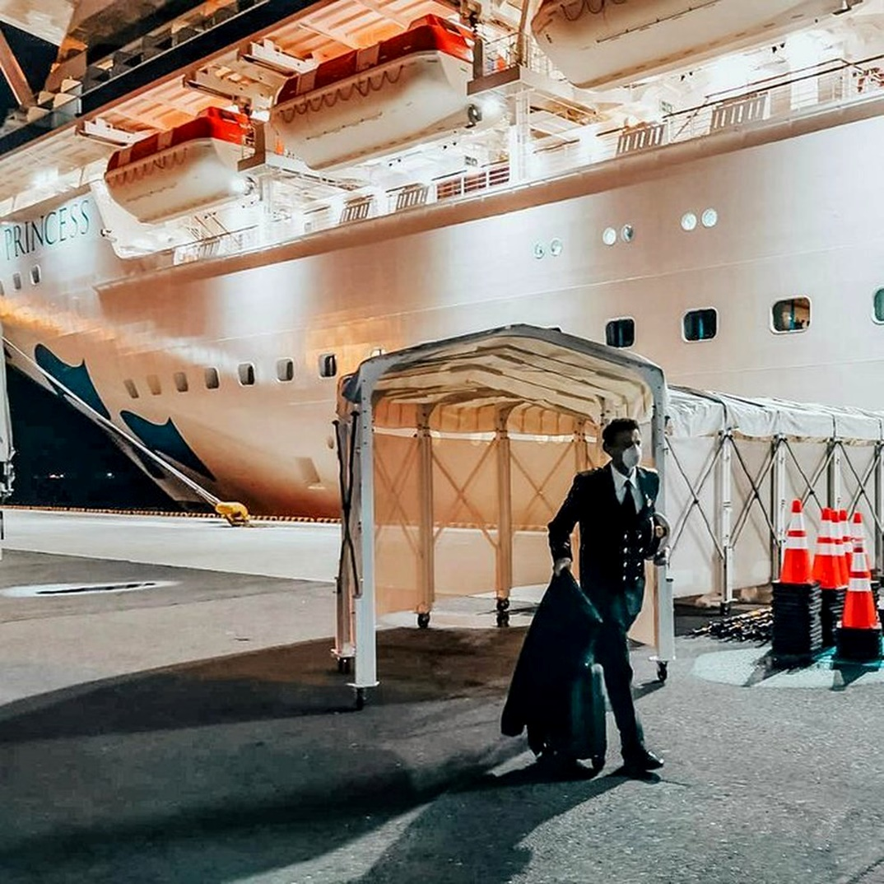
The most important lesson. What Diamond Princess taught about COVID-19

Figure 1. Captain Gennaro Arma is the last person to leave the ship. Ph. Vincenzo Guardascione. Published courtesy of the author.
Our cruise started on January 20th 2020 from Yokohama (Japan). It was a 2-week cruise around the South East China Sea, departing from Japan for Hong Kong, Vietnam, Taiwan and back to Japan.
In early February, towards the end of our cruise, I received information that a man disembarked from the ship in Hong Kong had been hospitalized and tested positive for Coronavirus. At that moment the timing of his contagion was not clear, and we were eventually asked to arrive in Yokohama a little earlier to allow the Japanese authorities to come aboard for an inspection. We docked in Tokyo Bay on the evening of February 3rd, and the ship has been subject to Japanese law ever since. Therefore, we were asked to follow local laws and directions from the authorities. Japanese quarantine officers came aboard to examine the health of all guests and crew. The first phase of the health checks involved the measurement of body temperature of all the crew and guests and the document check in the medical center. Then it was decided to swab our guests and crew who had exhibited symptoms. On the morning of February 5th we were informed that among the samples detected, ten people had tested positive for Coronavirus. At that point the ship was officially quarantined. From that moment everything started to accelerate. I have been instructed by the Japanese Ministry of Health to place all guests on board in solitary confinement under the responsibility of the Japanese quarantine officers. He assigned medical personnel to test every guest and crew member who exhibited fever or symptoms. After all, in that distant February the virus was not only an invisible and unknown enemy.
Since people who had been in close contact with positive patients (such as their cabin mates) were also swabbed, it was found that some people tested positive, even though they were completely asymptomatic. At this point, Japanese quarantine officials decided to change strategy and begin testing people who were more susceptible to the virus, such as guests over 80 or with weaker immune systems due to pre-existing medical conditions.
Given that quarantine procedures required the isolation of each guest in their cabin, everything we had been up to that moment no longer existed. All the passengers were confined in their cabins. As a consequence, restaurants and public spaces would have remained unused.
We all rolled up our sleeves, reinvented, there was a motto that I used in those days and that I shared with the people LEARN_ADAPT_REACT. And that's what we've all done. Being a new subject we learned, adapted and reacted!
Many of the services that we usually provide on board have been adapted to the needs. The crew themselves took up the challenge in an exemplary way, demonstrating flexibility, strength of character and a big heart. All 1045 crew members were simply fabulous. We had to take on different tasks based on the most pressing needs of our guests, the activation of the room service for all our cabins, delivering meals three times a day. The guys who worked in the casino or in the shops found themselves doing surveillance in the corridors or on the decks when the passengers went out for their walk. The dancers' team had been put on the phones to make follow up calls with the guests . I will never stop thanking them for doing all this with a high sense of duty. They faced an emergency that no one had ever faced before, a situation for which there were no manuals or training.
All this was done in compliance with the restrictive measures also imposed to the crew. We all had to maintain interpersonal distance, avoid crowds, wear masks and gloves, continually wash our hands and disinfect common areas. New positive cases were discovered almost every day. From a human point of view this news has never been easy to share, but we have made transparency towards our guests and crew our top priority.
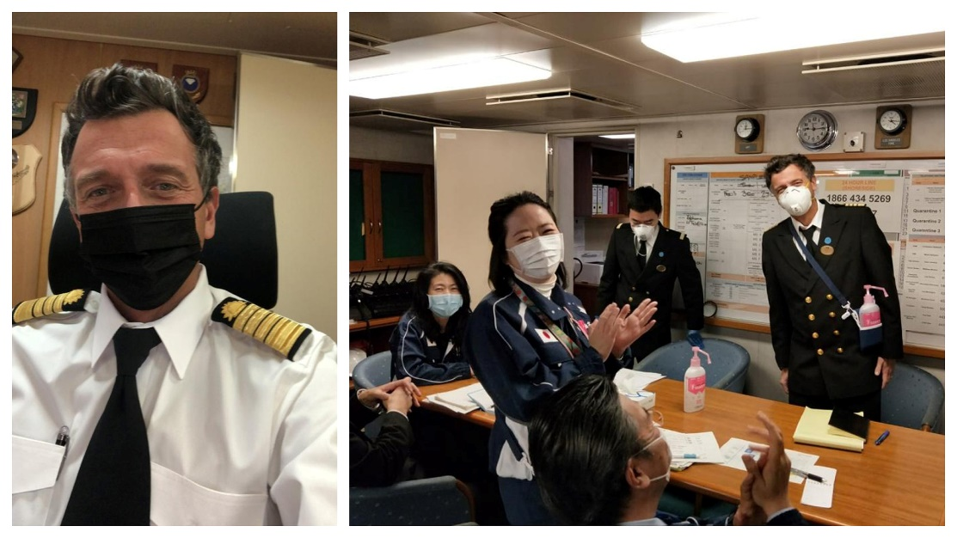
Figure 2. Captain Arma and his staff. Ph. Princess Cruise Company. Copyright Act 17 U.S.C.107.
We have worked in close coordination with local authorities to land positive cases and immediately move them to hospitals. The Japanese government took a huge commitment and I really appreciated their help, as hospital beds became more and more difficult to find. What happened to us is precisely evidence of how an organization can change. But above all of how it is possible to change while running and also quickly. The changes undeniably lead to upheavals in the roles, procedures and in the use of spaces. Innovations generate new solutions and, at the same time, bring to an increase of productivity. In those weeks we created a positive change in the existing state of things by altering the order of things established to make new ones.
During the emergency we practically wrote and put into practice new procedures and processes that undoubtedly marked a turning point also for the post-emergency. I am thinking of the crew canteens and the spacing to be applied to the tables, tracing safety routes for movement inside the ship, the use of the laundry and the air conditioning system. We understood how tracking was important and how difficult is to perform without adequate technology. Let me give an example. To trace a positive person and identify all the others who had been in contact took hours and hours without having mathematical certainty.
It is undeniable that innovations pass through emerging technologies. So, thanks to the smart technological skills, we have created a system that allows you to record the movements of people on board. Constant activity tracking throughout the day allows the monitoring of the position of each subject on board and relative contacts. But not only that, with this technology we have changed the way of doing catering, the on-board program, created new figures and eliminated the others.
Embarkation and disembarkation procedures have been rewritten to ensure safety, avoid crowds and even contact with surfaces. The check-ins will be done online, the doors of the cabins will open automatically. In short, we have made business innovation in all directions on products, services, customers, organization.
In some industrial sectors, the concept of innovation can simply mean a few adjustments to the brand, production or distribution, but in other cases like ours, it can mean completely rethinking the offer, redesigning products and services or even completely changing the model of business in directions that until a few months earlier might have seemed unthinkable.
By innovating, we have come out more modern and flexible to meet the demands of the new market, always keeping the safety of the people on board as our priority. The cruise industry has always shown great resilience and is a sector that has greatly invested a great deal in the fight against COVID-19. The strict and effective protocols that have been implemented, combined with vaccination and staff training have made cruise ships again the most beautiful and safe place to spend the holidays.

What we have learned from Diamond Princess COVID-19 outbreak
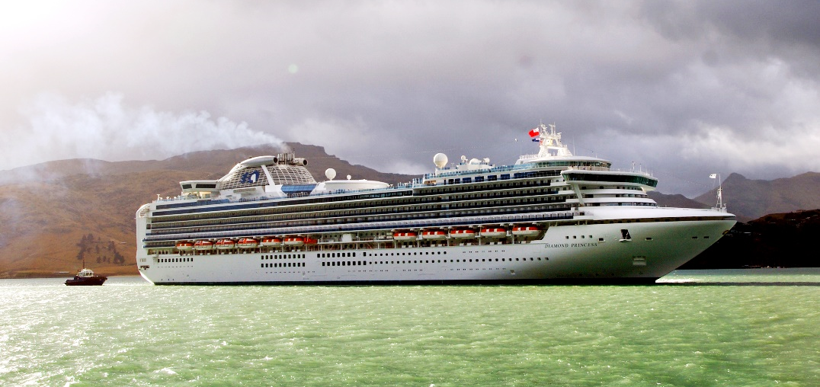
Figure 3. Diamond Princess. Creative Commons License.
Before discussing the design guidelines aimed at the implementation of the entire cruise ship design spiral, within which the dynamics relating to the potential spread of the SARS-CoV-2 virus and other pathologies is not a negligible factor, it is essential to examine the main criticalities that emerged from the direct account of Captain Arma.
The Diamond Princess had 3711 people on board, including 2666 passengers and 1045 crew members, with an average age of 66 and 33.6 years respectively. The fact of including a large number of senior people among the guests (many of them with limited mobility and affected by different comorbidities), interpolated by a sharing of leisure and social activities in public areas, favored a quick escalation of cross-infected cases. Shortly after quarantine was decided, some passengers developed symptoms and tested positive for Covid-19. They were hospitalized ashore while the rest had to remain in their cabins. A total number of 712 people became infected with the virus , among which 567 were passengers and 145 crew members [5].
Cruise ships are isolated communities made up of a heterogeneous set of entertainment venues such as restaurants, theaters, cinemas, ballrooms and wellness areas, designed to give guests moments of leisure and escape from everyday life. Due to its high population density, crowded public lounges and living accommodations, shared sanitary facilities and common water and food supplies, infectious diseases can be easily transmitted on board, from infected people and through contaminated surfaces, food and water.
It should be stressed that the quarantine time to be observed on board, lasting 14 days, is longer than the average duration of a cruise and this leads to logistical difficulties in providing food and medicines on-board [6]. Since the ship was placed at anchor in a precautionary state during the first period, there was the need to leave the pier for sewage disposal. This also became a barrier to patient transport and, furthermore, issues were related to refueling and waste unloading [7].
There were several difficulties on board the cruise ship, such as securing the traffic lines between infectious (red zone) and noninfectious things (green zone) including humans, together with a drastic and impulsive reconfiguration of all functions on board. A part of the crew staff addressed for receptivity and entertainment activities in wellness and shopping areas (forbidden to the public during the emergency state) was called to provide room service, without a specific training. They had frequent contact with quarantined passengers and interacted closely with other potentially contagious colleagues. Furthermore, the guests at that time could not access the on-board Medical Center. Assistance was provided directly in the cabins, as well as the mandatory clinical evaluation and testing of all potentially infected people, with consequent limited diagnostic possibilities by the medical staff [8].
This resulted in a great amount of time, effort and manpower to make individual visits to thousands of people, making sure the contagion wasn't transferred from cabin to cabin and trying themselves not to be contaminated. The support received by Japanese quarantine officers from outside will often be from people who, unfamiliar with the conditions on board, will themselves need the help of the ship's already overworked personnel [5] [9] [10].
It is of fundamental importance to describe positive case management systems and how the disembarkation operations were carried out. First of all, there was the need to explain to the person that the result of the Reverse transcriptase-polymerase chain reaction (RT-PCR) test was positive. Subsequently, it was necessary to provide a destination and a proper vehicle to arrange the transport to the hospital (operations respectively to be handled by the prefectural government and the captain in charge of the quay). The drafting of the medical report was provided at the on-board medical office. Finally steps prior included the visit of the toilet and the packing, as well as the transport of the luggage by the patients. They had to go through the quarantine zone and customs. Some people had difficulty walking or had a lot of luggage, which meant it took a long time to reach the quay [7].
In order to retrace the various strategies aimed at guaranteeing the maintenance of operational efficiency and, at the same time, ensure those levels of comfort and hospitality that each passenger expects to find on board, it is firstly necessary to focus on the on-board distribution of the 1353 cabins, properly divided by service level, typology and size in the following way: 1 Grand Suite (Cabin Square Footage: 58 m², balcony area of 11 m²), 27 Suites, (Cabin Square Footage: 31 m², balcony area: 16 m²), 2 Family Suites, (Cabin Square Footage: 31 m², balcony area: 9 m²), 186 Mini Suites (Cabin Square Footage: 26 m², balcony area: 4 m²), 522 Balconies (Cabin Square Footage: 16 m², balcony area: 4 m²), 236 Ocean and 379 Interior (both of them with a Cabin Square Footage of 15 m² and without a balcony) [11].
This classification shows how high-class rooms are large and have balconies. As the class level decreases, ​​the rooms area becomes smaller and they are progressively located on lower decks [7]. It should be emphasized that more than 28% of the cabins doesn’t have a direct supply of natural light and fresh air from outside, which must necessarily be provided by HVAC system. In order to overcome this situation in such a delicate period, it was the captain himself who devised the so-called fresh air program, a careful scheduling which allowed the guests to reach the decks in an organized way for an hour per day, together with the compliance of strict procedures for leaving the cabins and wearing appropriate personal, protective equipment. This situation has given rise to a feeling of solidarity on the part of the passengers staying in the cabins with balconies, ready to give up their daily deck walk in favor of the occupants of the cabins without external views [4].
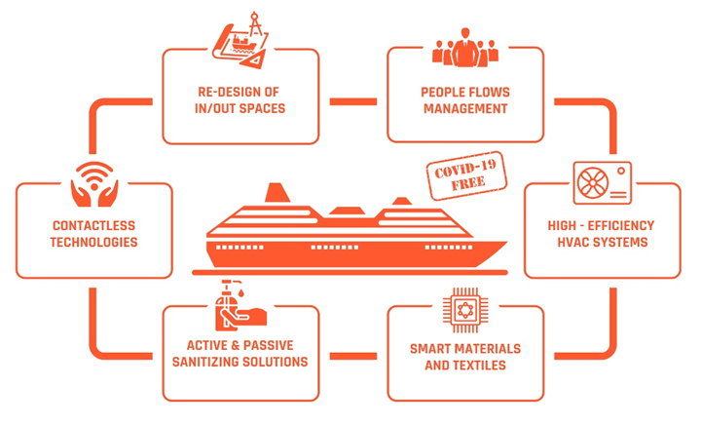
The assistance plan also involved the supply of devices that could facilitate connection with family members and the desire to translate communications into the various languages ​​corresponding to the 57 nationalities present on board allowed the transmission of information in a transparent and unequivocal manner [5]. The continuous updates on the evolution of the situation by the captain made it possible to preserve that share of existential reassurance, essential in a state of emergency.
Figure 4. Design guidelines diagram applicable Cruise Ships in the post Covid-19 era. Diagram by Angela Denise Peri. Published courtesy of the author.

The holistic approach analysis of the operations that took place showed how COVID-19 widespread on board suddenly became part of an already complex structured network of operations that synoptically take place daily on a cruise ship. The absence of a modus operandi to follow due to the lack of protocols capable of providing univocal directives on the management of epidemiological situations on board has certainly provided food for thought addressed to every field of the international scientific community. The numerous publications indexed at this regard highlights how the case study of the Diamond Princess has constituted de facto epidemiological laboratory [12], which provided a wide amount of data useful for understanding what are the main vectors of virus propagation [13]. In the following sections, an overview of their most significant features are presented, together with an indication about how much each one of them affected [14] the situation which developed on board.

An overview about SARS-CoV-2 propagation modes
Transmission of SARS-CoV-2 can occur through direct, indirect, or close contact with infected people, through saliva and respiratory secretions, which are expelled when a person coughs, sneezes, talks or sings. These last are called droplets if their diametre is greater than 5-10 μm and referred to as droplet nuclei or aerosols if they are smaller than 5μm [15].
Airborne transmission can occur when a person is in close contact (within 1.5 metres) with an infected person. Indirect contact transmission involving contact of a susceptible host with a contaminated object or surface (fomite transmission) may also be possible [16].

Potential role of HVAC system against COVID-19 airborne transmission
Infectious diseases widespread through airborne transmission are often associated with building ventilation and its corresponding airflow pattern. Rather, it should be stressed how a good HVAC system is important to keep a proper degree of thermal comfort and indoor air quality; moreover, a correct design, maintenance and operation of the system allows decreasing the risk of transmission of infectious diseases through the dilution of the concentration of potential contaminated aerosols [17].
On the Diamond Princess, random distribution of cases of infection on all of the ship’s decks and the lack of any spatial clusters of close contact infection (within cabins) suggests there was no cross-room transmission between passengers who were in different cabins during the isolation. This might be partially explained by the fact that no recirculation was allowed during the passenger confinement period. The observed higher rates of infections prior to the quarantine implies that most transmission occurred during leisure and social activities [18].
With careful consideration for these aspects, cruise lines companies are focusing on HVAC as a line of defense against COVID-19, using the system to circulate more fresh air inside, to filter air more effectively and for the application of such technologies as in-duct UV-C lights and bipolar ionization to fight and eradicate viruses [19]. However, there are many sides to the equation. Pumping in more fresh air would result in higher air conditioning costs, for instance, as more air needs to be cooled/heated more often [20]. A further design parametre to be controlled is the speed of the air moving through the system [21]; it cannot move too fast in order to trap and kill viruses [22]. ASHRAE’s COVID-19 guidance suggests using MERV 13 (at the time of the Diamond Princess outbreak MERV 5 filters were installed), especially in medical facilities and isolations areas, or higher rated filters based on their ability capture virus-sized particles (<1 µm) through a dense weft of tiny fibers. Higher efficiency filters may not be a viable option for some HVAC systems as they may hamper the fresh air exchange and cause greater resistance to air flow than allowable by design specifications [23]. Furthermore, for actual common HVAC systems, recirculation cannot be avoided because the system wouldn’t be no longer able to ensure the efficient cooling or heating of the rooms, while they are designed for recirculation of 40–60% from total airflow [24]. However, if the heat exchanger has enough spare power to ensure the cooling/heating of the room with fresh air only, the energy consumption will increase significantly [25].
Finally, there should be the possibility of isolating those sectors of the HVAC acting on some areas dedicated to the management of emergency situations, thus preventing possible virus outbreaks without affecting too much the normal operating conditions of the overall HVAC system; it can be applied both with new projects and with existing units In particular, the vessel should be split into more gastight zones, which can be quite easily executed by existing fire vertical zones [22]. These subdivision shall provide the proximity of the Medical Centre to the percentage of cabin required for isolation, which is equal to 5% of the number of passengers and 5% of crew members; if disembarkation is possible, it can be reduced to 1% [26]. Intake and exhaust air management for each gastight area should be designed so that air recirculation between different HVAC systems is not possible and relative openings should also be located far from the other vessel hazardous areas. A further implementation is to provide in-duct UVGI lamps [27] or by designing upper air zones devices inside cabuns with high ceiling elevation; both for existing and new projects, UV disinfection zone has to be kept above the minimum elevation from the floor of around 2.13 m.

How the application of Smart materials and Contactless technologies can enhance safety on board

Smart materials
The SARS-CoV-2 virus is highly stable, viable, and potentially infectious. Respiratory secretions or droplets expelled by infected individuals can reach surfaces and objects, often referred to as fomites or passive carriers [28] [29]. Several studies highlighted the virus capability to survive better at low temperatures and extreme relative humidity. Because the biological function of viruses strongly depends on their integrity, the use of physical treatments (such as UV irradiation, heating, and desiccation) and chemical sanitization (strong acids, alkalis, oxidants, alcohols, and surfactants) would disrupt virus survival on the surface by compromising its structure [30]. It should be marked how certain disinfectants can also trigger asthma and can be linked to other chronic respiratory conditions. The above mentioned procedures require intensive labour and material use; they are diﬃcult to be applied for all exposed areas, and need periodical operation. Therefore, the possible development of antimicrobial surfaces and coverings for objects that are frequently used by the public can be a practical route to avoid the release of polluting substances into air and water, harmful to the environment and the personnel in charge of the sanitation procedures [31].
Before understanding how to convey scientific research and, consequently, future design choices, it is necessary to make a preliminary comment related to the pathogen ability to resist on different kind of surfaces, especially on non-porous ones. In the initial stages of the study aimed at finding traces of the virus in recovery units, only the genetic heritage of the virus linked to environmental contamination was sought and not the presence of intact viral particles, the only ones capable of infecting when they came into contact with the human organism. Laboratory experiments have sought the permanence of the pathogen on different types of materials, including copper, cardboard, stainless steel and plastic. An ambient temperature (21-23 °C) and a relative humidity level of 40% were considered as reference environmental parameters, values that are easily comparable to those present in a domestic space. The lasting capacity of the viral load of the virus over time was also tested [32]. From the results it emerged that the most inhospitable materials were copper and cardboard, with a halving of the infectious capacity respectively of less than 2 hours in the first case and within 5 hours in the second one. A complete suppression of viral load was observed after 4 hours for copper and 24 hours for cardboard, respectively.
As for stainless steel, the infectious charge was halved after about 6 hours, compared to 7 hours for plastic. If we make a comparison with the first two materials, the time period required to zero infectivity was much longer: at least 48 hours for steel and 72 for plastic [33].
Hence the need, starting from the behavior of parent materials, to adopt such solutions that could combine specific performance characteristics. Among the many products present on the market and currently being developed, the presence of smart materials comes out. They are capable of reacting to an external stimulus (which can be acoustic, electrical, magnetic, luminous, mechanical, thermal) by modifying their structural, morphological, chromatic or thermal properties. These dynamics allow, in a direct way, to significantly increase the performance of the objects for which they are used. [34]
Among them, especially in kitchen and maintenance areas, the presence of self-healing materials can be advised [35]. They are polymers, metals, ceramics and their composites that have the intrinsic ability to repair damage due to normal usage. It ensure a significant bacterial reduction activity and is highly hygienic. This makes it extremely easy to clean and suitable for contact with foods.
It is worth mentioning ceramics coated with polymer composites containing nanoparticles such as silver, gold, copper, zinc oxide and titanium dioxide, which allows the degradation of pollutants including V.O.C. (Volatile Organic Compound), formaldehyde and other toxic organic compounds, through a process called photocatalytic oxidation (which can also be used for active air purification systems). It is obtained through devices capable of generating the same natural reaction process between the solar radiation (through special UV-C lamps at specific frequencies) and some elements (generally noble metals) such as titanium dioxide (TiO2). It retraces a chemical reaction in nature that mimics the chlorophyll photosynthesis of trees in absorbing and transforming pollutants into harmless elements [36].
Among the so-called smart textiles [37], there are fabrics developed with an extrusion of graphene applied during the yarn production phase. The conductive and antiviral properties of the nanomaterial allow the textile to kill the virus deposited on it and guarantees protection, greatly mitigating the possibility of transmission without losing their thermal and antiviral properties over time. This would allow for effective use in the manufacture of medical devices such as masks, hospital gowns and bed sheets.
It is evident how the choice of surface will require special attention, as these will be exposed more frequently to cleaning agents. Antibacterial materials [38] are already widely used on board, but will become even more prevalent as cruise companies will tend to further reach a higher degree of safety. Changes to cabin routines could also include antimicrobial carpets, touch-free tools and toilets with glass dividers instead of curtains.

Contactless technologies
As far as the application of contactless technologies is concerned, it is possible to include all those devices capable of increasing the operational efficiency on board, such as electronic bracelets and applications which can be easily accessible on smartphones. These solution allow to effectively manage the embarkation and disembarkation procedures through the use of biometric check-in systems [39], which enable to identify passengers at the moment they arrive at the port, thereby avoiding congestion and bottleneckings. They help staggering the entrances and to minimize the cumulative contact time between hosts and staff. The use of virtual queuing apps will allow to check how many people are able to go to a certain area at any given time, which would make certain there is no crowding at a lunch buffet, in the fitness center or at the pool. It will be also possible to order the meal, to be delivered out of restoration areas.
Booking activity to organized events allows to predict in advance the correct venue and the number of expected guests. Telemedicine techniques are exploited in order to reduce contact and potential contagion between people.
Upon arrival in the cabin, the opening of the doors is contactless, as well as the control of the temperature and lighting levels and the payment method. It is also important for cruise ship companies to constantly monitor the flow of passengers to refine the offer, compatibly with the needs of the customer [40] [41]. Furthermore, it is possible to keep track of the guests activities in order to trace movements and, in case of overt and presumed infectivity, proceed with the interpolation of the contacts that the person has had on board before ascertaining the positivity to the virus.

Conclusion
The Diamond Princess case study constituted a confined control volume that allowed the entire scientific community to acquire an important set of data and information about the virus and its propagation modes. From the storytelling of Captain Gennaro Arma it suddenly emerged the set of multiple challenges raised by an unknow virus widespread, which overwhelmed the complex daily routine activities. It is important to remember how similar episodes, in their drama, have significantly boosted the formulation of guidelines which succeeded in managing emergency situations of pandemic nature in an increasing efficient way, both at sea and on the mainland.

References
- WHO [Internet]. Pneumonia of unknown cause – China; 2020 Jan 5 [cited 2021 Apr 16]. Available from: https://www.who.int/emergencies/disease-outbreak-news/item/2020-DON229
- WHO [Internet]. WHO Statement regarding cluster of pneumonia cases in Wuhan, China; 2021 Jan 9 [cited 2022 Apr 22]. Available from: https://www.who.int/china/news/detail/09-01-2020-who-statement-regarding-cluster-of-pneumonia-cases-in-wuhan-china
- Doi S, Yajima D, Tsuru S. Cruise ship put under 2-week quarantine as 10 cases confirmed. The Asahi Shimbun Asia & Japan Watch; 2020 Feb 5 [cited 2021 Apr 16]. Available from: http://www.asahi.com/ajw/articles/13102622
- Arma G. La lezione più importante. Quello che il mare mi ha insegnato. Milano: Mondadori; 2020. 180 p.
- Jimi H, Hashimoto G. Challenges of COVID-19 outbreak on the cruise ship Diamond Princess docked at Yokohama, Japan: a real-world story. Glob Health Med. 2020 Apr 30;2(2):63-65. doi: 10.35772/ghm.2020.01038. PMID: 33330779; PMCID: PMC7731266.
- Nakazawa E, Ino H, Akabayashi A. Chronology of COVID-19 Cases on the Diamond Princess Cruise Ship and Ethical Considerations: A Report From Japan. Disaster Med Public Health Prep. 2020 Aug;14(4):506-513. doi: 10.1017/dmp.2020.50. Epub 2020 Mar 24. PMID: 32207674; PMCID: PMC7156812.
- Yamahata Y, Shibata A. Preparation for Quarantine on the Cruise Ship Diamond Princess in Japan due to COVID-19. JMIR Public Health Surveill. 2020 May 11;6(2):e18821. doi: 10.2196/18821. PMID: 32365046; PMCID: PMC7216790.
- Kakimoto K, Kamiya H, Yamagishi T, Matsui T, Suzuki M, Wakita T. Initial Investigation of Transmission of COVID-19 Among Crew Members During Quarantine of a Cruise Ship - Yokohama, Japan, February 2020. MMWR Morb Mortal Wkly Rep. 2020 Mar 20;69(11):312-313. doi: 10.15585/mmwr.mm6911e2. Erratum in: MMWR Morb Mortal Wkly Rep. 2020 Apr 03;69(13):389. PMID: 32191689; PMCID: PMC7739985.
- Mizumoto K, Chowell G. Transmission potential of the novel coronavirus (COVID-19) onboard the diamond Princess Cruises Ship, 2020. Infect Dis Model. 2020 Feb 29;5:264-270. doi: 10.1016/j.idm.2020.02.003. PMID: 32190785; PMCID: PMC7068636.
- Baraniuk C. What the Diamond Princess taught the world about covid-19. BMJ. 2020 Apr 27;369:m1632. doi: 10.1136/bmj.m1632. PMID: 32341001.
- Princess[Internet]. Diamond Princess Deck Plans.; 2022 [cited 2022 Apr 22]. Available from: https://www.princess.com/deckPlans.do?shipCode=DI
- Dahl E. Coronavirus (Covid-19) outbreak on the cruise ship Diamond Princess. Int Marit Health. 2020;71(1):5-8. doi: 10.5603/MH.2020.0003. PMID: 32212140.
- Zhou L, Ayeh SK, Chidambaram V, Karakousis PC. Modes of transmission of SARS-CoV-2 and evidence for preventive behavioral interventions. BMC Infect Dis. 2021 May 28;21(1):496. doi: 10.1186/s12879-021-06222-4. PMID: 34049515; PMCID: PMC8160404.
- Kurabuchi T, Yanagi U, Ogata M, Otsuka M, Kagi N, Yamamoto Y, Hayashi M, Tanabe S. Operation of air-conditioning and sanitary equipment for SARS-Cov-2 infectious disease control. Japan Architectural Review. 2021 Jul 2:10.1002/2475-8876.12238. doi: 10.1002/2475-8876.12238. PMCID: PMC8420534.
- WHO [Internet]. Coronavirus disease (COVID-19): How is it transmitted?; 2021 Dec 23 [cited 2022 Apr 22]. Available from: https://www.who.int/news-room/questions-and-answers/item/coronavirus-disease-covid-19-how-is-it-transmitted
- Marquès M, Domingo JL. Contamination of inert surfaces by SARS-CoV-2: Persistence, stability and infectivity. A review. Environ Res. 2021 Feb;193:110559. doi: 10.1016/j.envres.2020.110559. Epub 2020 Dec 1. PMID: 33275925; PMCID: PMC7706414.
- Elsaid AM, Ahmed MS. Indoor Air Quality Strategies for Air-Conditioning and Ventilation Systems with the Spread of the Global Coronavirus (COVID-19) Epidemic: Improvements and Recommendations. Environ Res. 2021 Aug;199:111314. doi: 10.1016/j.envres.2021.111314. Epub 2021 May 25. PMID: 34048748; PMCID: PMC8146370.
- Xu P, Jia W, Qian H, Xiao S, Miao T, Yen HL, Tan H, Kang M, Cowling BJ, Li Y. Lack of cross-transmission of SARS-CoV-2 between passenger's cabins on the Diamond Princess cruise ship. Build Environ. 2021 Jul;198:107839. doi: 10.1016/j.buildenv.2021.107839. Epub 2021 Apr 15. PMID: 33875902; PMCID: PMC8046742.
- Elsaid AM, Mohamed HA, Abdelaziz GB, Ahmed MS. A critical review of heating, ventilation, and air conditioning (HVAC) systems within the context of a global SARS-CoV-2 epidemic. Process Saf Environ Prot. 2021 Nov;155:230-261. doi: 10.1016/j.psep.2021.09.021. Epub 2021 Sep 20. PMID: 34566275; PMCID: PMC8450051.
- Zheng W, Hu J, Wang Z, Li J, Fu Z, Li H, Jurasz J, Chou SK, Yan J. COVID-19 Impact on Operation and Energy Consumption of Heating, Ventilation and Air-Conditioning (HVAC) Systems. Advances in Applied Energy. 2021 Aug 25;3:100040. doi: 10.1016/j.adapen.2021.100040. Epub 2021 May 31. PMCID: PMC8166037.
- Ogawa M. Contamination control in HVAC systems for aseptic processing area. Part I: Case study of the airflow velocity in a unidirectional airflow workstation with computational fluid dynamics. PDA J Pharm Sci Technol. 2000 Jan-Feb;54(1):27-31. PMID: 10778305.
- Mihai V, Rusu L. An Overview of the Ship Ventilation Systems and Measures to Avoid the Spread of Diseases. Inventions. 2021, 6, 55. https://doi.org/10.3390/inventions6030055.
- Christopherson DA, Yao WC, Lu M, Vijayakumar R, Sedaghat AR. High-Efficiency Particulate Air Filters in the Era of COVID-19: Function and Efficacy. Otolaryngol Head Neck Surg. 2020 Dec;163(6):1153-1155. doi: 10.1177/0194599820941838. Epub 2020 Jul 14. PMID: 32662746.
- Mousavi ES, Kananizadeh N, Martinello RA, Sherman JD. COVID-19 Outbreak and Hospital Air Quality: A Systematic Review of Evidence on Air Filtration and Recirculation. Environ Sci Technol. 2021 Apr 6;55(7):4134-4147. doi: 10.1021/acs.est.0c03247. Epub 2020 Sep 11. PMID: 32845618; PMCID: PMC7489049.
- Risbeck MJ, Bazant MZ, Jiang Z, Lee YM, Drees KH, Douglas JD. Modeling and multiobjective optimization of indoor airborne disease transmission risk and associated energy consumption for building HVAC systems. Energy Build. 2021 Dec 15;253:111497. doi: 10.1016/j.enbuild.2021.111497. Epub 2021 Sep 23. PMID: 34580563; PMCID: PMC8457902.
- EU HEALTHY GATEWAYS. Guidelines for cruise ship operations in response to the COVID-19 pandemic. 2022 Apr 4. 62 p.
- de Souza SO, Cardoso AA Jr, Sarmento ASC, d'Errico F. Effectiveness of a UVC air disinfection system for the HVAC of an ICU. Eur Phys J Plus. 2022;137(1):37. doi: 10.1140/epjp/s13360-021-02240-y. Epub 2021 Dec 18. PMID: 34956809; PMCID: PMC8683362.
- Tharayil A, Rajakumari R, Mozetic M, Primc G, Thomas S. Contact transmission of SARS-CoV-2 on fomite surfaces: surface survival and risk reduction. Interface Focus. 2021 Dec 10;12(1):20210042. doi: 10.1098/rsfs.2021.0042. PMID: 34956610; PMCID: PMC8662391.
- Katona P, Kullar R, Zhang K. Bringing Transmission of SARS-CoV-2 to the Surface: Is there a Role for Fomites? Clin Infect Dis. 2022 Feb 26:ciac157. doi: 10.1093/cid/ciac157. Epub ahead of print. PMID: 35218181; PMCID: PMC8903442.
- Ding S, Wang J, Dong S, Ashour A, Liu Y, Qiu L, Han B Ou J. Developing Multifunctional/Smart Civil Engineering Materials to Fight Viruses. ACS Sustainable Chemistry & Engineering 2022 10 (2), 678-690. doi: 10.1021/acssuschemeng.1c07642.
- Rosa V, Ho D, Sabino-Silva R, Siqueira WL, Silikas N. Fighting viruses with materials science: Prospects for antivirus surfaces, drug delivery systems and artificial intelligence. Dent Mater. 2021 Mar;37(3):496-507. doi: 10.1016/j.dental.2020.12.004. Epub 2021 Jan 10. PMID: 33441249; PMCID: PMC7834288.
- Shamim JA, Hsu WL, Daiguji H. Review of component designs for post-COVID-19 HVAC systems: possibilities and challenges. Heliyon. 2022 Feb 22;8(3):e09001. doi: 10.1016/j.heliyon.2022.e09001. PMID: 35224237; PMCID: PMC8863315.
- Kurabuchi T, Yanagi U, Ogata M, Otsuka M, Kagi N, Yamamoto Y, Hayashi M, Tanabe S. Operation of air-conditioning and sanitary equipment for SARS-Cov-2 infectious disease control. Japan Architectural Review. 2021 Jul 2:10.1002/2475-8876.12238. doi: 10.1002/2475-8876.12238. PMCID: PMC8420534.
- Bengisu M, Ferrara M. Materials that Move: Smart Materials, Intelligent Design. Berlin: Springer; 2018. 243 p.
- Hager MD, Greil P, Leyens C, van der Zwaag S, Schubert US. Self-healing materials. Advanced Materials. 2010; 22:5424-5430.
- Shakeri A, Yip D, Badv M, Imani SM, Sanjari M, Didar TF. Self-Cleaning Ceramic Tiles Produced via Stable Coating of TiO₂ Nanoparticles. Materials (Basel). 2018 Jun 13;11(6):1003. doi: 10.3390/ma11061003. PMID: 29899252; PMCID: PMC6025286.
- Weise BA, Wirth KG, Völkel L, Morgenstern M, Seide G. Pilot-scale fabrication and analysis of graphene-nanocomposite fibers. Carbon. 2019;144(351-361). Doi: 10.1016/j.carbon.2018.12.042.
- Chatterjee S, Murallidharan JS, Agrawal A, Bhardwaj R. Designing antiviral surfaces to suppress the spread of COVID-19. Phys Fluids (1994). 2021 May;33(5):052101. doi: 10.1063/5.0049404. Epub 2021 May 4. PMID: 34040336; PMCID: PMC8142823.
- Zulfiqar M, Syed F, Khan MJ, Khurshid K. Deep Face Recognition for Biometric Authentication. 2019 International Conference on Electrical, Communication, and Computer Engineering (ICECCE). pp. 1-6. doi: 10.1109/ICECCE47252.2019.8940725.
- Goo J, Huang CD, Yoo CW, Koo C. Smart Tourism Technologies' Ambidexterity: Balancing Tourist's Worries and Novelty Seeking for Travel Satisfaction. Inf Syst Front. 2022 Jan 27:1-20. doi: 10.1007/s10796-021-10233-6. Epub ahead of print. PMID: 35103046; PMCID: PMC8791698.
- Ometov A, Shubina V, Klus L, Skibińska J, Saafi S, Pascacio P, Flueratoru L, Quezada Gaibor D, Chukhno N, Chukhno O, Ali A, Channa A, Svertoka E, Bin Qaim W, Casanova-Marqués R, Holcer S, Torres-Sospedra J, Casteleyn S, Ruggeri G, Araniti G, Burget R, Hosek J, Lohan ES. A Survey on Wearable Technology: History, State-of-the-Art and Current Challenges. 2021. doi.org/10.1016/j.comnet.2021.108074.

