How COVID-19 has been affecting the overall cruise ship design paradigm
Massimo MUSIO-SALEª , Angela Denise PERI^{b} and Valerio RUGGIERO^{c}
ª Architect, Full Professor. Department of Architecture and
Design (DAD), University of Genoa
^{b} Naval Architect, PhD Student. Department of Architecture and Design (DAD), University of Genoa
^{c}Naval Architect, Professor and Researcher. University of Messina
Abstract. The actual, global pandemic situation has dramatically involved every aspect of our lives. This also greatly affected the cruise ship industry. At first, cruise companies tried to face the problem by adapting existing ships at the situation, with no time to rethink completely their project. The opinion of scientists, architects and field experts highlighted the need to devise a new way to design cruise ships, considering passenger management, marketing and medical aspects. Particular attention must be paid to public areas, where individuals would be most vulnerable to airborne transmission. The sanitizing operations have now to follow even stricter operational protocols than in the past. A constant update monitoring of the passenger flows through the so-called smart technologies would allow, when dealing with a suspected case, to trace a timeline of its activities on board and, therefore, to avoid the rise of an outbreak. An implementation of the overall efficiency of vertical connections (which helps the management of potentially contaminated waste) and on-board medical spaces such as the hospital and the pharmacy shall be advised. From an anthropological point of view, it is essential to consider in more depth issues such as social distancing and the possibility of permanently decreasing the number of passengers, in favour of safety and on-board liveability. In the post COVID-19 era, the cruise ship can become a “health bubble”, a microcosm where people can enjoy an even more rewarding and safe experience.
Keywords. Cruise Ship Design, COVID-19, HVAC, air filtering systems, UVGI

Introduction (Musio-Sale M)
To the present day, the COVID-19 pandemic situation globally has resulted in 505.817.953 confirmed cases and 6.213.876 cumulative deaths (17:43 CEST on April 22, 2022) [1]. Thousands of scientific publications have followed one another in all disciplinary fields, where researchers and experts in various macro-sectors including medicine, physics, mathematics, economics, sociology, engineering and design have come together in understanding the complex dynamics of birth, spread and possible control of the virus.
Through a seacentric approach we will highlight in particular how design and the relational dynamics that characterize this research field can become an element of support and interaction with civil architecture.
The cruise ship Splendid stationed for several months in the Port of Genoa, starting from mid-March 2020, and guaranteed almost 200 people a post-hospitalization period or the possibility of carrying out the entire quarantine period in complete isolation. It was an admirable example of conversion in a relatively short time and provided important design ideas, to be applied also to other units intended for passenger transport [2].
The first recorded outbreak of Covid-19 outside of China occurred right on board a cruise ship. A situation which was faced without the support of emergency protocols that contemplated a modus operandi to follow [3].
It should be stressed that the studies carried out and still being implemented are not only referable to the actual pandemic situation, but the design guidelines being defined should be seen as a global implementation of safety standards for people in closed environments.

Pandemic design measures to avoid contagion risks on cruise ships (Ruggiero V)
The cruise ship is capable of carrying thousands of people, including passengers and crew members; for this reason it is often defined as a "floating city", characterized by a set of entertainment venues such as restaurants, theaters, cinemas, ballrooms and wellness areas, designed to give guests moments of leisure and escape from everyday life. The presence of large, open and closed spaces reproduces, in terms of dimensions and functions, those of public and private civil architecture. In both dimensions, however, the occurrence of possible super-spreading events is a phenomenon that should not be overlooked [4].
Figure 1. Diamond Princess cruise ship. Creative Commons License.

The whole scientific community underlined the importance to adopt measures in order to prevent a rapid growth of the infections as quickly as possible. Surely these recommendations had a relative impact on the design of existing and new passenger ships units. Basically, these measures can be summarized in:

- preventive hygiene measures and adoption of personal protective equipment;
- passenger flow management, based on the study of proper guests distribution within common spaces, in order either to limit or to prevent the spread of contagion; it can be implemented throughout the use of contactless technologies (i.e. smartphone dedicated software provided by companies, such es electronic bracelets and devices for people monitoring);
- isolation of positive cases, in order to avoid infections spread.

Furthermore, these three indications have been applied in the case of “Diamond Princess”, but clashing with the absence of original predisposition of the unit such as, for instance, the limited sectioning capacity of the Heating, Ventilation and Air Conditioning (HVAC) system and the lack of adequate spaces to be used for the hospitality of those infected or suspected passengers, certainly facilitated the spreading of the infection [5].

Internal layout solutions to manage infected cases (Musio Sale M, Ruggiero V)
In naval architecture there is always a mutual exchange between the need to satisfy the requirements listed above and the preservation of the functional needs of the entire project. That is, internal and external spaces have to perform a matching between the relative location of watertight bulkheads with the design of large spaces such as restaurants, theaters, cinemas, dance floors, wellness zones) together with the arrangement of the main plants like air conditioning, water and lighting systems.
Main Vertical Zones are those sections of a vessel into which the hull, superstructure, and deckhouse are divided, in order to control boundaries imposed by structural fire protection requirements. They are performed by adopting transverse subdivisions in order to prevent a fire or fumes propagating longitudinally along the ship. These separations do not have the required sanitary characteristics, but from the point of view of feasibility, they already provide structural and plant engineering sections for suspended ceilings and ventilation ducts. Therefore, it would still be a great advantage in exploiting such partition to circumscribe a possible outbreak phenomenon.
These considerations are useful for understanding actual design guidelines orientation, both in the case of new designs as well as the refitting of existing ships, towards interventions that preserve the integrity of the layout and functions of a cruise ship. This should be performed by the identification of isolation areas [6] constituted by a prescribed number of cabins, properly connected with the medical center through a minimization of their relative distance.
Based on this layout distribution principle, there have been some attempts to address areas of normal use to the management of positive cases [7]. This doesn't mean the creation of real hospital zones, but areas that can be quickly transformed into a "Quarantine Zone".
Two possible layouts are presented in this work, which differ according to the type of spatial distribution that has been hypothesized. The first was the subject of extensive studies in 2020 by the same authors, as a prompt response to the occurrence of the first episodes of COVID-19 outbreaks on board. The second, currently adopted by several cruise companies, sees a longitudinal arrangement of the cabins.

Vertical isolation zone arrangement (Musio Sale M, Ruggiero V)

The first case study (Figure 2) under consideration is a large cruise ship currently in service, which offers hospitality for about 5000 people including on-board staff (1500) and passengers (3500), hosted on about 17 decks. The main crew bridge, which is located at Deck 0, represents the nerve center of the ship. All technical connections and crew routes go through this level. Here the on-board medical center is also located. Currently this area is capable of hosting about ten patients and gravitating between two and three medical officers and three to six nurses (Figure 3). Normally this capacity is adequate to cope with ordinary healthcare, but completely inadequate compared to a viral emergency such as that of COVID-19.
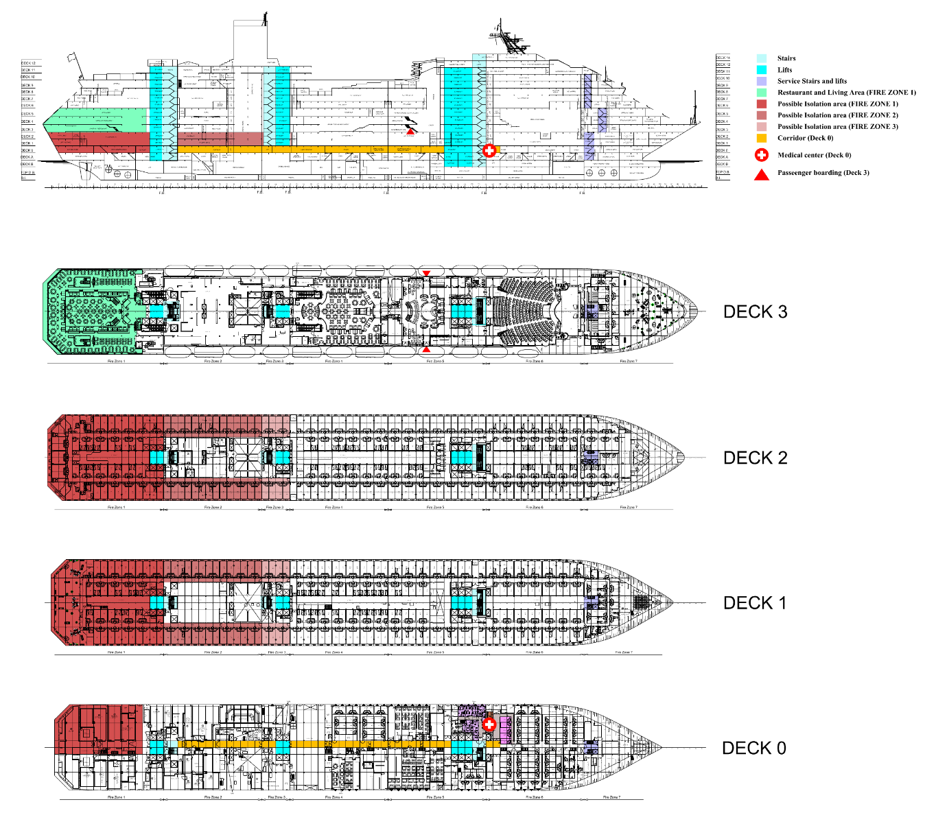
Figure 2. Case study deck plans and possible vertical isolation arrangement.
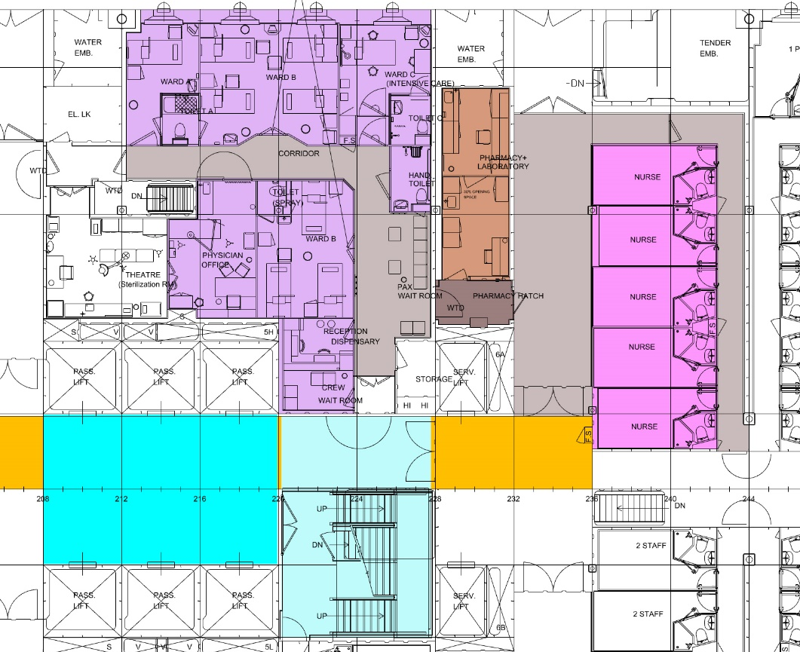
Figure 3. A focus on the case study medical center (Deck 0).
The possibility of implementing of the hospital area on board has proved to be an invasive solution as it requires important changes in terms of spatial and functional distribution. To keep the ship's body as functional as possible to carry out the cruise activities, it is necessary to think of flexible solutions that can be quickly implemented in case of emergency without upsetting the main board structure.
Internal distribution of actual cruise ships can dedicate the stern area to provide accommodation and public spaces sufficient to isolate 10% of the people on board resulting contaminated, making the remaining 90 % be safeguarded from infection.
It would be a matter of working (illustrated in Figure 1) on the lodgings on the levels corresponding to the fire-zones 1, 2 and 3 of Bridges 1 and 2 obtaining about 150 beds. Extending the hospitality to fire-zone 4 would bring the capacity to 250 patients. The stern restaurant on both levels can be dedicated to them, having to consider that this venues can become respectively a canteen and a living room in case of emergency.
Regarding the compartmentalization of the new ships (or for radical refitting of the existing ones) it is advisable to maintain the location of the Medical Centre at Bridge 0, but it will be appropriate to include an intensive care unit, imagining the arrangement in proximity of fire zones 1, 2 and 3, moving it aft from the current location, which instead is part of the fire zone 5 [8].

Vertical isolation zone arrangement according to actual confinement prescriptions (Peri AD)
Similar design considerations has actually led to a longitudinal type distribution approach, addressing a proper number of cabins on a single side of a deck (included by one or more fire zones) to the management of both infected and suspected cases (red and orange zones), as well as for the treatment of other common illnesses (i.e. Norovirus, influenza, yellow zone).

Figure 4 . A schematic view of the actual, longitudinal isolation zones arrangement

The second case study is capable of carrying around 3600 passengers and 1340 crew members. The highlighted areas are able to host about 50 people, that is, around 1% of the total number of people on board, considering the ship at 100% of its capacity. In case of an extended cluster of infected people, the deck is able to increase the hospitality up to 5%.
These configuration is in compliance with the rules contained in section 4.10 of Guidelines for cruise ship operations in response to the COVID-19 pandemic (Version 4, April 2022). In particular , they suggest ad adequate number of single cabin occupancy for confirmed COVID-19 cases able to guarantee isolation to 5% of the passengers and 5% of the crew members. If disembarkation is possible, the above percentage can be reduced to 1%. Moreover, they have to employ a negative-pressure airflow system to keep particulates from escaping in the air when the doors to those rooms are opened.
Additionally, the following design conditions have to be observed:
- Proximity to the medical facility and gangways for ease of patient transport;
- Dead-end corridors or low-traffic areas to minimize potential exposures;
- Spacing between other occupied cabins to reduce transmission risk;
- Absence of interconnecting doors to reduce accidental exposures;
- Presence of natural light (window or balcony) and cabin complementary amenities.

For what HVAC system is concerned, medical facilities, as well as the designated isolation spaces, should have separate air handling units. The return air from these zones should either be HEPA filtered or exhausted to the outside.
Furthermore, the minimum required air changes per hour (whose threshold values are going to be presented) for each space on the ship should be respected, and whenever possible, further increased in order to reduce the risk of transmission. Exhaust fans of bathrooms should be functional and operate continuously. If technically possible, the use of air recirculation should be avoided as much as possible by closing the recirculation dampers all the AHUs. In case it is not possible to completely stop it, the ship should explore improving air filtration of the return air as much as possible such as using ePM1 80%, HEPA filters and/or Ultraviolet Germicidal Irradiation (UVGI). It is not recommended to change heating, cooling and humidification set points of the HVAC system. [6]
The following sections will constitute a synoptical analysis of the above cited air circulation enhancements, which come after an extensive scoping review activity. This conceptual effort is aimed not only to fulfil COVID-19 management protocols but have to be considered as an attempt to increase the overall comfort and safety levels to be be assured on board.

Measures for preventing and limiting transmission of COVID-19 through HVAC System (Peri AD)

Main HVAC design parametres for cruise ships (Peri AD)
Diamond Princess cruise ship, where the first pandemic episode occurred, was built in 2004 by Mitsubishi Industries. A centralized full-air conditioning system with variable air volume is articulated in 88 spatial zones, each of them served by a dedicated air handling unit (AHU). An autonomous exhaust-air system has been installed in all of the bathrooms. The additional air supply to each cabin escapes to the corridor where the ceiling return is located. Under normal operating conditions, the guest room compartments of the Diamond Princess have a circulating air-conditioning system with 30% outside air, values which is increased to 50% for public areas and 100% for galley, clinics, mess rooms and laundry, where recirculation is not allowed [9] [10].
HVAC systems for accommodation are calculated and designed according to ISO standard 7547. The reference values to be considered for the summer condition are +35 ◦C and 70% RH for outdoor air and +27 ◦C and 50% RH for indoor air; as regards the winter season, the external and internal air temperatures are indicated, set respectively at -20 ◦C and +22 ◦C (there are no indications about relative humidity values in this season condition) [11].
International Convention for the Safety of Life at Sea also prescribes a minimum number of 10 changes per hour, which should be increased to 20 during loading and unloading operations, and a minimum ventilation rate of 8 L/s per person, that is 28.8 m3/h; this intrinsically satisfies the condition of an indoor CO₂ concentration below the threshold of 1000 ppm.
Typically, the cooling/heating capacity of the air conditioning system is mainly determined by the quantity of fresh air that should be cooled or heated and humidified or dehumidified. Using of 100 % outdoor air and high-efﬁciency filtering solutions can lead to signiﬁcant increases of the overall energy consumption [12].

HVAC System role concerning potential airborne transmission (Peri AD)
A surface swab taken from a corridor ceiling return vent on board the Diamond Princess tested positive for SARS-CoV-2 RNA, which suggests that the airborne transmission of the virus may not necessarily occur in the presence of infection sources and susceptible individuals [13].
Federation of European Heating Ventilation and Air Conditioning Associations (REHVA) and the European Centre for Disease Prevention and Control recommends to maximize fresh air income in order to lower the concentration of any viral particles present in indoor air. However, some degree of recirculation in HVAC systems is necessary to maintain both humidity and temperature while limiting energy costs [14].
Several studies have been conducted on the role that the HVAC system may have played in facilitating the spread of the virus [15] [16] [17]. It has followed that no cross-room transmission between passengers who were in different cabins occurred during the isolation period. The random distribution of cases of infection on all of the ship’s decks and the lack of any spatial clusters of close contact (within cabins) infections suggests that no particular AHU cabin zones had more cases than others. This might be partially explained by the fact that no recirculation was allowed during the quarantine period, which started on February 5. In particular, circulation fan was stopped, fire and smoke prevention dampers were closed, as well as louvers in the doors between the living room and the corridors [10].
The observed higher rates of infections prior to the quarantine implies that most transmission took place during leisure and social activities. Restaurants, gyms and cafes were found to be the highest risk venues for COVID-19 spread. The possibility of SARS-CoV-2 cross-infection in public areas in this superspreading events suggests the importance of controlling occupancy or improving ventilation in crowded spaces [18]. The infectious virus contained in the return air may spread from one room to another, but its concentrations can be maintained at a sufficiently low level if proper ventilation and air filters are installed. Therefore, the risk of spreading infection between rooms through an air-conditioning system is considered to be significantly low in a normal air-conditioned space.

Potential surveillance techniques for the control of SARS-CoV-2 airborne virus spread (Peri AD)
Indoor CO₂ levels may be used as an indicator of ventilation as part of a professional assessment and are typically evaluated based on time-averaged readings. High indoor CO₂ levels can potentially identify spaces with poor ventilation rates (be aware that CO₂ is not an explicit indicator of COVID-19 transmission risk). [19]
Recently, a study carried out on student dormitories describes the development and application of methodologies for the identification of SARS-CoV-2 virus in HVAC air samples. This activity can be an important surveillance technique for the control of viral spread in large buildings, especially congregant living settings [20].

Air purification and filtering systems (Peri AD)

Air filters
The effectiveness of a filter is rated by the Minimum Efficiency Reporting Value (MERV, ranging from 1 to 16), based on the fraction of particles removed from air passing through it under standard conditions [21]. ASHRAE’s COVID-19 guidance suggests using MERV 13 (at the time of the Diamond Princess outbreak MERV 5 filters were installed) or higher rated filters based on their ability to hamper virus-sized particles flow (<1 µm), especially in medical facilities and those area dedicated to the management of infected persons [22]. They may not be a viable option for some HVAC systems as they may obstruct the fresh air exchange and cause greater resistance to air flow than allowable by design specifications. The pressure drop of actual, commercial HEPA filters is about 150–300 Pa when the filters are clean. According to the manufacturer’s recommendation, the final pressure drop should be kept as low as possible to avoid high energy consumption and in line with available standard fans operational capacity [23].
Their installation on both the supply and the recirculation ducts could increase the protection since there are two filtration stages. If the air recirculation is contaminated, viruses are trapped on the main recirculation line; therefore, the fresh air will be mixed with almost clean air. Finally, the presence of a HEPA filter installed on the supply main distribution duct will clean the viruses or bacteria that escaped from the first stage of filtration or if outside fresh air is contaminated. This increase of the total pressure drop due to the second filter should be considered. In addition, if the recirculation line is provided with a HEPA filter, the pressure inside the rooms will increase with the backpressure of that filter. It is therefore mandatory to provide recirculation (exhaust) fan so that the pressure inside the room is kept in accordance with the requirements.
Regarding the pressure inside the accommodation area, it is necessary that the system is designed/balanced to keep the same pressure in all rooms, corridors, and common spaces so that natural circulation between different rooms/corridors is reduced to a minimum. The solution indicated above can be simplified by cancelling the HEPA filter installed on the recirculation line, but in this case, the contaminated air is mixed with the fresh air and introduced into the AHU unit. The filtration occurs on the main supply ventilation duct only. Another solution, the most advisable, is to keep the recirculation HEPA filter and to cancel that present on main air supply. In this case, the contaminated air is not mixed with fresh air and does not enter the AHU unit anymore, but the recirculation (exhaust) fan is mandatory. It should also be mentioned that the recirculation filter is 40–60% smaller than the main supply filter because the recirculation airflow is in general 40–60% lower than the supply airflow. In general, they cannot be cleaned and should be changed after one month up to one year. In any case, the filter should be checked and cleaned/changed every time it becomes clogged; therefore, it is recommended to be provided with pressure drop measuring devices [24].
Moreover, the combination [25] of air ﬁlters together with a UVGI system may help to prevent the spread of COVID-19 in indoor environments, avoiding problem related to air pressure drops. The following section will introduce this kind of sanitation mode, exploring the main operational features and application methodologies.

UVGI (Ultraviolet Germicidal Irradiation) System (Peri AD)
UVGI system is an effective virus inactivation method that uses short-wave ultraviolet energy to disinfect viral, bacterial, and fungal organisms [26]; recently, the possibility of employing UVGI to inactivate the SARS-CoV-2 virus has also been investigated [27].
Ultraviolet is that part of electromagnetic radiation bounded by the lower wavelength extreme of the visible spectrum and the upper end of the X-ray radiation band. The spectral range of ultraviolet radiation is, by definition, between 100 and 400 nm. The portion of the spectrum (the “germicidal” region) that is important for disinfection is the range that is absorbed by the DNA chain of dangerous microorganism (RNA in the case of viruses). It causes an alteration of their genetic composition and consequently inactivation and replication inhibition [28].
UV spectrum is subdivided into three main bands: UV-A (315-400 nm), which is not capable to inactivate the viruses, UV-B (280-315 nm), which can be effective for disinfection, but penetrates the skin more deeply; therefore, in the case of accidental exposure, it is more dangerous. UV-C (200-280 nm) is the most effective. Its peak wavelength (260–265 nm) coincides with the peak UV absorption of DNA [29] [30] [31].
The effectiveness of UV disinfection is proportional to the dose of exposure to UV rays (J /m²), which is the product of the irradiation rate (W / m²) and time (s).
UV-C in an HVAC system can be used by irradiating the upper room air or by investing the air as it passes through the ducts. In the latter case exposure to UV rays is reduced to a few or fractions of seconds, proportionally to the air speed. ASHRAE suggests, to avoid increasing costs and system power, to set the exposure time to UV rays to be at least 0.25 seconds.
It is therefore necessary that the irradiance rate is adequate to perform the function, assisted by a choice of highly reflective materials (such as aluminum for example) that allow to maximize the reflection of energy in the affected area. The position of the lamps must be properly defined in order to maximize their operational efficiency. The most suitable place, thanks to a low air speed, is the air handling unit, taking into account future periodic inspection, maintenance and replacement interventions. Installing a high in-duct UV-C lamp within the return air duct of the HVAC should be more appropriate for the rapid inactivation of highly infectious viruses [32]. A further implementation is to provide upper-air UV-C devices inside the rooms in spaces with high ceiling elevation; it's worth pointing out that, for safety reasons [33], UV disinfection zone has to be kept above the minimum safe distance from the floor of around 2.13 m (7 feet) [34].

Conclusion
What the authors have proposed demonstrates the actual possibility of modifying the design of passenger ships without radical interventions and, at the same time, significantly raising the level of health safety in the event of contagious diseases. The implementation of the entire design paradigm comes from the know-how gained on the field over the last two years. The design and use of spaces have been synoptically involved, as well as the study of sectorial HVAC system, equipped with effective air filtering and purification solutions. Research activity of the authors is following a diachronic approach which tends towards solutions which can, in present and future perspective, lead to a significant increase in safety and comfort standards on board that are expected to be implemented, regardless of the development of the state of emergency.

References
- WHO [Internet]. WHO Coronavirus (COVID-19) Dashboard; 2022 Apr 22 [cited 2022 Apr 23]. Available from: https://covid19.who.int/
- RINA [Internet]. Conversione della M/n Splendid in una "nave ospedale"; 2022 Mar [cited 2022 Apr 21]. Available from: https://www.rina.org/it/media/CaseStudies/nave-ospedale-coronavirus
- Arma G, Bertirotti A, Musio-Sale M, Peri AD, Zignego MI. Learning from Emergency. The inside story of the Diamond Princess cruise ship. MUGAZINE [Internet]. 2021;3:12-20. Available from: https://gup.unige.it/node/261
- Goyal A, Reeves DB, Schiffer JT. Multi-scale modelling reveals that early super-spreader events are a likely contributor to novel variant predominance. J R Soc Interface. 2022 Apr;19(189):20210811. doi: 10.1098/rsif.2021.0811. Epub 2022 Apr 6. PMID: 35382576; PMCID: PMC8984334.
- Braidotti L, Bertagna S, Dodero M, Piu M, Marinò A, Bucci V. Identification of measures to contain the outbreaks on passenger ships using pedestrian simulations. Procedia Comput Sci. 2022;200:1565-1574. doi: 10.1016/j.procs.2022.01.357. Epub 2022 Mar 8. PMID: 35284027; PMCID: PMC8902520.
- EU HEALTHY GATEWAYS. Guidelines for cruise ship operations in response to the COVID-19 pandemic. 2022 Apr 4. 62 p.
- Guagliardo SAJ, Prasad PV, Rodriguez A, Fukunaga R, Novak RT, Ahart L, Reynolds J, Griffin I, Wiegand R, Quilter LAS, Morrison S, Jenkins K, Wall HK, Treffiletti A, White SB, Regan J, Tardivel K, Freeland A, Brown C, Wolford H, Johansson MA, Cetron MS, Slayton RB, Friedman CR. Cruise Ship Travel in the Era of Coronavirus Disease 2019 (COVID-19): A Summary of Outbreaks and a Model of Public Health Interventions. Clin Infect Dis. 2022 Feb 11;74(3):490-497. doi: 10.1093/cid/ciab433. PMID: 33978720; PMCID: PMC8244552.
- Musio-Sale M, Ruggiero V. How Covid-19 Will Affect the Cruise Ship Projects. In: HIPER '20 - 12th Symposium on Performance Marine Vehicles; 2020 Oct 12-14; Cortona, Italy. Hamburg: Technische Universität Hamburg; 2020. p. 74-84.
- Kosako M, Shiiyama K. Introduction of air-conditioning system design for a large cruise ship: Princess Cruises Mitsubishi Grand Series implementation example. J Jpn Soc Nav Ocean Eng. 2008;17:24-26. https://doi.org/10.14856/kanrin.17.0_24.
- Xu P, Jia W, Qian H, Xiao S, Miao T, Yen HL, Tan H, Kang M, Cowling BJ, Li Y. Lack of cross-transmission of SARS-CoV-2 between passenger's cabins on the Diamond Princess cruise ship. Build Environ. 2021 Jul;198:107839. doi: 10.1016/j.buildenv.2021.107839. Epub 2021 Apr 15. PMID: 33875902; PMCID: PMC8046742.
- ISO 7547:2004, Ships and Marine Technology – Air-Conditioning and Ventilation of Accommodation Spaces – Design Conditions and Basis of Calculations, ISO Standard. 2022.
- Zheng W, Hu J, Wang Z, Li J, Fu Z, Li H, Jurasz J, Chou SK, Yan J. COVID-19 Impact on Operation and Energy Consumption of Heating, Ventilation and Air-Conditioning (HVAC) Systems. Advances in Applied Energy. 2021 Aug 25;3:100040. doi: 10.1016/j.adapen.2021.100040. Epub 2021 May 31. PMCID: PMC8166037.
- Yamagishi T, Ohnishi M, Matsunaga N, Kakimoto K, Kamiya H, Okamoto K, Suzuki M, Gu Y, Sakaguchi M, Tajima T, Takaya S, Ohmagari N, Takeda M, Matsuyama S, Shirato K, Nao N, Hasegawa H, Kageyama T, Takayama I, Saito S, Wada K, Fujita R, Saito H, Okinaka K, Griffith M, Parry AE, Barnetson B, Leonard J, Wakita T. Environmental Sampling for Severe Acute Respiratory Syndrome Coronavirus 2 During a COVID-19 Outbreak on the Diamond Princess Cruise Ship. J Infect Dis. 2020 Sep 1;222(7):1098-1102. doi: 10.1093/infdis/jiaa437. Erratum in: J Infect Dis. 2021 Feb 13;223(3):540. PMID: 32691828; PMCID: PMC7454703.
- Kurabuchi T, Yanagi U, Ogata M, Otsuka M, Kagi N, Yamamoto Y, Hayashi M, Tanabe S. Operation of air-conditioning and sanitary equipment for SARS-Cov-2 infectious disease control. Japan Architectural Review. 2021 Jul 2:10.1002/2475-8876.12238. doi: 10.1002/2475-8876.12238. PMCID: PMC8420534.
- Elsaid AM, Mohamed HA, Abdelaziz GB, Ahmed MS. A critical review of heating, ventilation, and air conditioning (HVAC) systems within the context of a global SARS-CoV-2 epidemic. Process Saf Environ Prot. 2021 Nov;155:230-261. doi: 10.1016/j.psep.2021.09.021. Epub 2021 Sep 20. PMID: 34566275; PMCID: PMC8450051.
- Guo M, Xu P, Xiao T, He R, Dai M, Miller SL. Review and comparison of HVAC operation guidelines in different countries during the COVID-19 pandemic. Build Environ. 2021 Jan;187:107368. doi: 10.1016/j.buildenv.2020.107368. Epub 2020 Oct 11. PMID: 33071439; PMCID: PMC7548082.
- Canadian Agency for Drugs and Technologies in Health (CADTH). COVID-19 CADTH health technology review: heating, ventilation, and air conditioning systems in public spaces [Internet]. Ottawa, ON: Canadian Agency for Drugs and Technologies in Health; 2020 [cited 2021 Jan 27]. Available from: https://covid.cadth.ca/infection-control/heating-ventilation-and-air-conditioning-systems-in-public- spaces/
- Majra D, Benson J, Pitts J, Stebbing J. SARS-CoV-2 (COVID-19) superspreader events. J Infect. 2021 Jan;82(1):36-40. doi: 10.1016/j.jinf.2020.11.021. Epub 2020 Nov 25. PMID: 33245943; PMCID: PMC7685932.
- Di Gilio A, Palmisani J, Pulimeno M, Cerino F, Cacace M, Miani A, de Gennaro G. CO2 concentration monitoring inside educational buildings as a strategic tool to reduce the risk of Sars-CoV-2 airborne transmission. Environ Res. 2021 Nov;202:111560. doi: 10.1016/j.envres.2021.111560. Epub 2021 Jul 3. PMID: 34224708; PMCID: PMC8253691.
- Sousan S, Fan M, Outlaw K, Williams S, Roper RL. SARS-CoV-2 Detection in air samples from inside heating, ventilation, and air conditioning (HVAC) systems- COVID surveillance in student dorms. Am J Infect Control. 2022 Mar;50(3):330-335. doi: 10.1016/j.ajic.2021.10.009. Epub 2021 Oct 22. PMID: 34688726; PMCID: PMC8530765.
- Christopherson DA, Yao WC, Lu M, Vijayakumar R, Sedaghat AR. High-Efficiency Particulate Air Filters in the Era of COVID-19: Function and Efficacy. Otolaryngol Head Neck Surg. 2020 Dec;163(6):1153-1155. doi: 10.1177/0194599820941838. Epub 2020 Jul 14. PMID: 32662746.
- Stephens B, Siegel JA. Ultrafine particle removal by residential heating, ventilating, and air-conditioning filters. Indoor Air. 2013 Dec;23(6):488-97. doi: 10.1111/ina.12045. Epub 2013 May 13. PMID: 23590456.
- Xu B, Yu X, Wu Y, Lin Z. Experimental investigation of air pressure affecting filtration performance of fibrous filter sheet. Environ Technol. 2017 Mar;38(5):558-565. doi: 10.1080/09593330.2016.1202328. Epub 2016 Jul 1. PMID: 27351253.
- Mihai V, Rusu L. An Overview of the Ship Ventilation Systems and Measures to Avoid the Spread of Diseases. Inventions. 2021, 6, 55. https://doi.org/10.3390/inventions6030055.
- Medical Advisory Secretariat. Air cleaning technologies: an evidence-based analysis. Ont Health Technol Assess Ser. 2005;5(17):1-52. Epub 2005 Nov 1. PMID: 23074468; PMCID: PMC3382390.
- Türsen Ü, Türsen B, Lotti T. Ultraviolet and COVID-19 pandemic. J Cosmet Dermatol. 2020 Sep;19(9):2162-2164. doi: 10.1111/jocd.13559. Epub 2020 Jul 8. PMID: 32573919; PMCID: PMC7361848.
- Biasin M, Bianco A, Pareschi G, Cavalleri A, Cavatorta C, Fenizia C, Galli P, Lessio L, Lualdi M, Tombetti E, Ambrosi A, Redaelli EMA, Saulle I, Trabattoni D, Zanutta A, Clerici M. UV-C irradiation is highly effective in inactivating SARS-CoV-2 replication. Sci Rep. 2021 Mar 18;11(1):6260. doi: 10.1038/s41598-021-85425-w. PMID: 33737536; PMCID: PMC7973506.
- Sabino CP, Ball AR, Baptista MS, Dai T, Hamblin MR, Ribeiro MS, Santos AL, Sellera FP, Tegos GP, Wainwright M. Light-based technologies for management of COVID-19 pandemic crisis. J Photochem Photobiol B. 2020 Nov;212:111999. doi: 10.1016/j.jphotobiol.2020.111999. Epub 2020 Aug 19. PMID: 32855026; PMCID: PMC7435279.
- Gidari A, Sabbatini S, Bastianelli S, Pierucci S, Busti C, Bartolini D, Stabile AM, Monari C, Galli F, Rende M, Cruciani G, Francisci D. SARS-CoV-2 Survival on Surfaces and the Effect of UV-C Light. Viruses. 2021 Mar 5;13(3):408. doi: 10.3390/v13030408. PMID: 33807521; PMCID: PMC7998261.
- Criscuolo E, Diotti RA, Ferrarese R, Alippi C, Viscardi G, Signorelli C, Mancini N, Clementi M, Clementi N. Fast inactivation of SARS-CoV-2 by UV-C and ozone exposure on different materials. Emerg Microbes Infect. 2021 Dec;10(1):206-210. doi: 10.1080/22221751.2021.1872354. PMID: 33399524; PMCID: PMC7872580.ù
- Biasin M, Bianco A, Pareschi G, Cavalleri A, Cavatorta C, Fenizia C, Galli P, Lessio L, Lualdi M, Tombetti E, Ambrosi A, Redaelli EMA, Saulle I, Trabattoni D, Zanutta A, Clerici M. UV-C irradiation is highly effective in inactivating SARS-CoV-2 replication. Sci Rep. 2021 Mar 18;11(1):6260. doi: 10.1038/s41598-021-85425-w. PMID: 33737536; PMCID: PMC7973506.
- Luo H, Zhong L. Ultraviolet germicidal irradiation (UVGI) for in-duct airborne bioaerosol disinfection: Review and analysis of design factors. Build Environ. 2021 Jun 15;197:107852. doi: 10.1016/j.buildenv.2021.107852. Epub 2021 Apr 6. PMID: 33846664; PMCID: PMC8021448.
- Lyons AB, Narla S, Torres AE, Parks-Miller A, Kohli I, Ozog DM, Lim HW, Hamzavi IH. Skin and eye protection against ultraviolet C from ultraviolet germicidal irradiation devices during the COVID-19 pandemic. Int J Dermatol. 2021 Apr;60(4):391-393. doi: 10.1111/ijd.15255. Epub 2020 Dec 1. PMID: 33259055; PMCID: PMC7753667.
- Shamim JA, Hsu WL, Daiguji H. Review of component designs for post-COVID-19 HVAC systems: possibilities and challenges. Heliyon. 2022 Feb 22;8(3):e09001. doi: 10.1016/j.heliyon.2022.e09001. PMID: 35224237; PMCID: PMC8863315.

