Definition and development of “modularity and operational flexibility” with pros and cons of the concepts in the Italian Navy PPA experience.

Cdr. Antonio PETRUCCI

General Navy Staff - Ship Design Office; Rome, Piazzale della Marina 4, Italy

**Abstract.** The Mission Package philosophy is tied to NATO concepts, indeed, the standardization of interface and procedures are essential for potential interoperability between Navies. Furthermore, the standardization and modularity offer opportunities of cooperation between Nations. All NATO Navies are therefore facing the challenge of meeting current and future operational requirements while reducing procurement and life cycle cost of naval platform. To this regard, the Italian Navy has adopted, over the last years, new design concepts in order to maximize operational flexibility for future needs by an extensive use of modularity features on its platforms. The PPA experience combined with the mission package concept gives to the platform two levels of flexibility: in the short term, for the accomplishment of specific missions, known as Mission Modularity and the medium/long run to maintain “updated” the ship Mission capability. This paper aims at underlining the Italian innovative approach used to develop the concepts of modularity and operational flexibility in the PPA experience emphasizing strengths and opportunities, as well as weaknesses and threats. While the PROs of modular equipment are more self-evident, there are also critical aspects to be considered. In fact, taking modularity to extreme might cause a too high reduction of platform performances in terms of: loss of accommodation space for the crew, in some cases loss of ship overall endurance, decrease of maximum speed and increase vibration and noise. Hence, only through an in-depth study on whole-warship design impact of Mission Bays and standardized modular areas, we would be able to underline the pros and cons of these concepts in the Italian Navy PPA experience.

**Keywords.** Italian Navy,Marina Militare Italiana,Mission Modularity, Mission Bays, standardization, operational flexibility, PPA (Pattugliatore Polivalente di Altura), Multirole Patrol Vessel

# Introduction

Over the past years, the concept of modularity and operational flexibility in reference to warships has been studied to allow nations to equip themselves with ships that can be easily reconfigured according to the mission to be fulfilled, overcoming the concept of single mission ships.

Indeed, the maritime Mission Modularity (MM), expressed by the NATO nations, represent the mean to reconfigure the capabilities of a warship through the use of standardized modules (such as containers, skids or other arrangements). MM allows to the Navy to configure a vessel properly on the assigned mission in a short period of time but also to share these capabilities across navies engaged in the same mission in a NATO context [1]. Actually, the standardization of interfaces and procedures is essential for potential interoperability between Navies and to reduce costs for the satisfaction of future requirements.

For this reason, most of the major Navies started to design new naval platforms able to express MM capacity by the presence of one (or more) “mission areas or compartments”: spaces able to stow mission modules, vehicles (such as RHIB, UAV, USV, ROV etc.) and equipped with cargo/boat handling systems other than boat Launch and Recovery System (LARS) [2]. In addition, the design of modular areas or compartments shall be ducted focusing not only on the actual operational requirements but also on keeping flexibility.

However, dealing with the concept of modularity is not at all simple, because it is necessary to integrate the various mission requirements with those intrinsic to the ship without then having to realize that some of the equipment must always be considered on board, but through a careful study of the operational scenarios and of the missions to fulfill.

For this reason, the Mission Package (MP) philosophy used in recent Italian Navy programs, tied also to NATO concepts, was developed with a standing working group with both Governmental and Industry representatives [3].

# Italian Navy PPA (Pattugliatore Polivalente d’Altura) experience.

The PPA experience has led to the development of versatile platform that respond to different operational needs of the Italian Navy. The key concepts used during the procurement phase were: Growth Potential with the definition of platform requirements capable of supporting weight increase and higher performances on auxiliary facilities throughout the ship’s life cycle (30 years) in relation to possible future operational scenarios and Fitted For defining already in the design phase of spaces and predispositions (on multiple levels of readiness) to accommodate new pay-loads or reshape the existing.

Indeed, this key concepts were combined with the MP concept gives to the PPA platform (image in Figure 1) two levels of flexibility: in the short term, for the accomplishment of specific missions with MM and in medium/long term to maintain updated the ship mission capability.

Therefore, Ships will be delivered with the same platform but with three different combat system configurations:

* Light: with limited warfare capabilities, but with a high versatility granted by its “fitted for” configuration, which allows an improvement of operational capabilities through the installation of systems and equipment according to the specific mission to be carried out;
* Light plus: similar to “light” but with Anti-Air Warfare (AAW) and enhanced Anti-Surface Warfare (ASuW) capabilities;
* Full: able to carry out tasks in all warfare areas such as AAW, ASuW and Anti-Submarine Warfare (ASW).

To limit to the most apparent features, in the light configuration the complete set of gunnery is set to operations; in the light plus layout, the SAAM-ESD (Surface Anti-Air Missile – Extended Self Defence) system is added; in the full configuration, the ASW systems are installed.

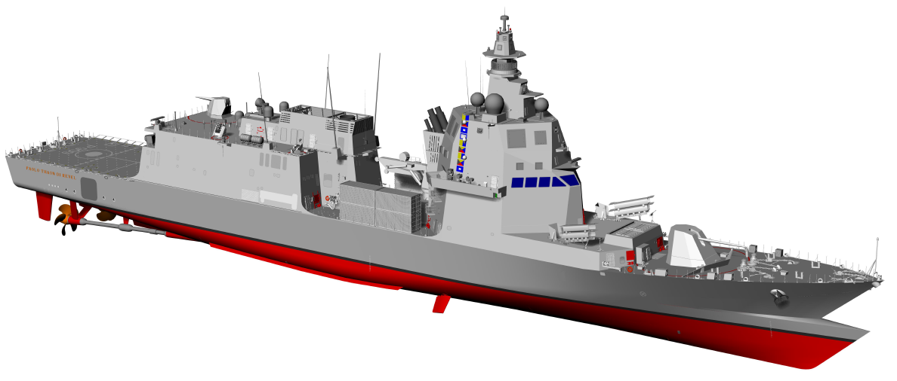

**Figure 1.** Image of PPA.

Therefore, operational capabilities upgrading is facilitated by the Fitted For design, indeed during the ship-life, selected upgrades of the Fitted For systems will keep the ships up to the evolving scenario.

Furthermore, Ships have been conceived since the beginning of the design phase with enhanced “dual use” features, fit for traditional military tasks and able to intervene also during peace time, supporting humanitarian and disaster relief assistance operations.

Certainly, the modularity is one of the main distinctive characteristics of the PPA program; there are two independent Mission Bays, external one in the ship central zone and internal one under the flight deck.

## Central Mission Bay

In the central mission bay amidships (images in Figure 2), on both sides of the area, the solution identified is to adopt 2 20’ ISO BOX skid-mounted double arms cranes for boats, normally installed onboard and designed to be removed and unloaded by central main cargo crane (with capability of 20 tons at 14 meters) up to the mission configuration request (e.g. in case of disaster relief operation it could be more important to load and transport the highest number of containers than boats LARS, in fact up to 10 20’ ISO containers or other combinations with 10’ and 20’ ISO containers can be transported). The systems are designed based on the possibility to move, for interoperability needs, boats already in use by Italian Navy up to a maximum size of 11,0 meters in length or more. The most important features of such item is its deployability, hence the capability to be removed, restoring the flush deck for other cargo purpose. Tanks to the standard interface, it will be possible to host and operate also future systems not yet developed, such as LARS for unmanned vehicles.

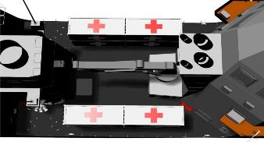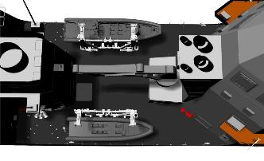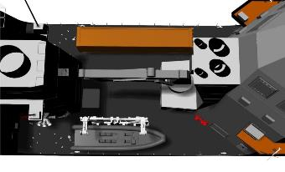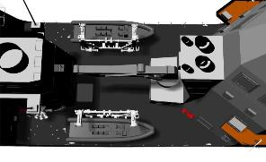

**Figure 2.** Central mission bay with different mission modules.

By the end, to host living or operative modules, the central modular area is fitted with hot and cold fresh water connections, gray and black water connections, phone and data link connections, low pressure air connection and electric system connection.

## Aft Mission Bay

The aft mission bay (images in Figure 3) has been thoroughly designed in order to be able to host several different mission configurations and all these different assets are configured for plug and play, with all the needed connections already available. The space can also be adapted for SAR operation and in the future as a hangar for unmanned and remotely operated vehicles.

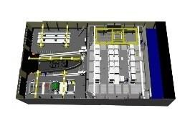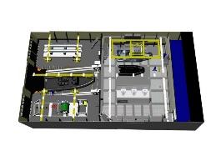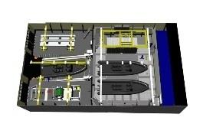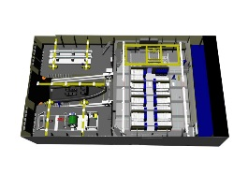

**Figure 3.** Aft mission bay with different mission modules.

The aft mission bay design was probably one of the most challenging aspect in the PPA project mainly because of the great number of operational requirements and physical constraints.

The area is composed of two contiguous separated compartments, positioned below the flight deck, adjoined through a large sliding watertight door.

Both the compartments, which are vertically extended for two decks below the flight deck, have been designed with supporting structures properly sized to avoid pillars. In this way it is possible to move any object around without facing any obstacle.

The forward compartment (also called ZMPP 1) have, on each side, a large watertight door, while there is a large hatch on the top trought flight deck, sized to load and unload up to 5 20’ ISO containers by harbor cranes.

The compartment is equipped with an overhead handling system for containers and RHIBs designed mainly to: move up to 20’ ISO containers transversally, transfer a container up to 20’ ISO to the aft modular compartment and vice versa, move RHIBs transversally and transfer a RHIB to the aft modular compartment and vice versa.

The forward compartment of the aft mission bay is fitted for hosting living, operational data center and medical module therefore the interfaces to main onboard circuits are achieved (hot and cold fresh water, gray and black water, electric system connection, data, low pressure air, air ducts, phone and data link connections) other than a fire protection by water mist full flooding application. The ISO containers will be fixed to the deck mainly through standard connections (twist lock).

The aft compartment (also called ZMPP 2) is fitted for hosting a LARS useful for PPA organic RHIBs. To achieve maximum operational flexibility across the two compartment there is a complex handling system capable of moving alternatively either 20’ ISO containers or RHIBs or cargo across the sliding watertight door. In the aft compartment there is also a Transversal Handling System (THS) that sweeping the compartment side to side for various purposes.

Another feature integrated in the aft compartment is the possibility to install, temporarily onto the stern ramp, a steel platform. This gives the possibility to restore a flush horizontal deck in the central area in ZMPP 2, useful to launch and recovery trought the Astern Door open, Italian Navy owned assets, deployable throughout containerized solution.

# Modularity and operational flexibility

The general trend among navies, for the best cost-effective solution, appears to be applying typical containers standardization technology to the military systems required for several mission profiles. Hence, in the PPA experience the concept of modular weapons was faced by three different ship configurations with the possibility of bringing them to their maximum configuration or during the ship-life selected upgrades of the fitted for systems will keep the ships up to the evolving scenario.

The need to maximize the versatility of operational use of military ships has addressed design choices towards the use of MPs, so the Mission Bays will be mainly used to achieve various capability for different missions such as:

* Humanitarian Assistance and Disaster Relief: with the use of medical module and/or power distribution module, water module, food module, water storage and other modules for support (image in Figure 4);
* Anti-pollution (Oil Spill): with the use of modules with floating containment barrier, oil skimmer, boats and other modules for support (image in Figure 5);
* Command and Control: Accommodation module for transporting personnel and modules with Staff Rooms (image in Figure 6);
* Supply Ship: with workshop module, food modules, water module and modules for the support of another ship (image in Figure 7);
* Search and Rescue (SAR): with the use of a combination of different modules and boats (image in Figure 8);
* Special Forces Operations: Accommodation module for transporting personnel, special operations boats and technical modules to support Special Forces’ operations.

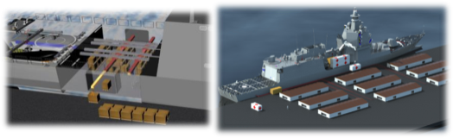

**Figure 4.** Humanitarian Assistance and Disaster Relief.

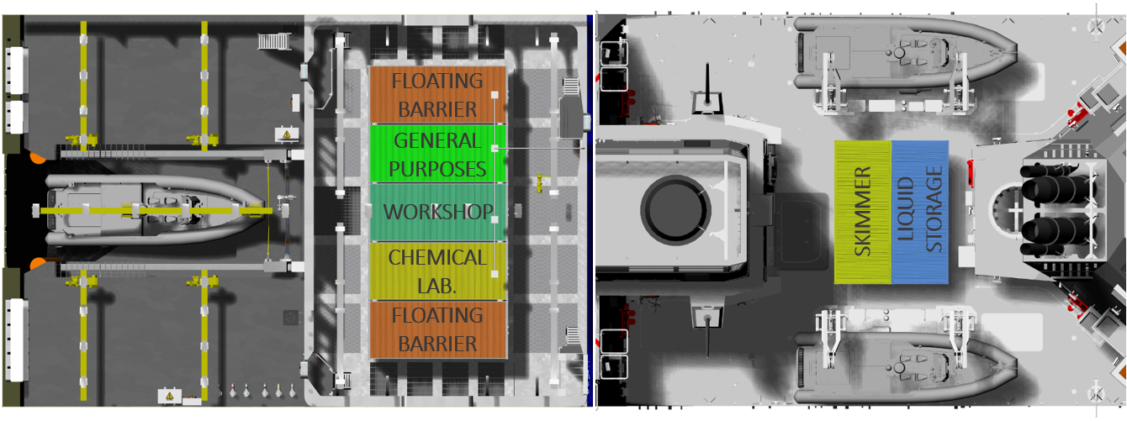

**Figure 5.** Anti-pollution (Oil Spill).

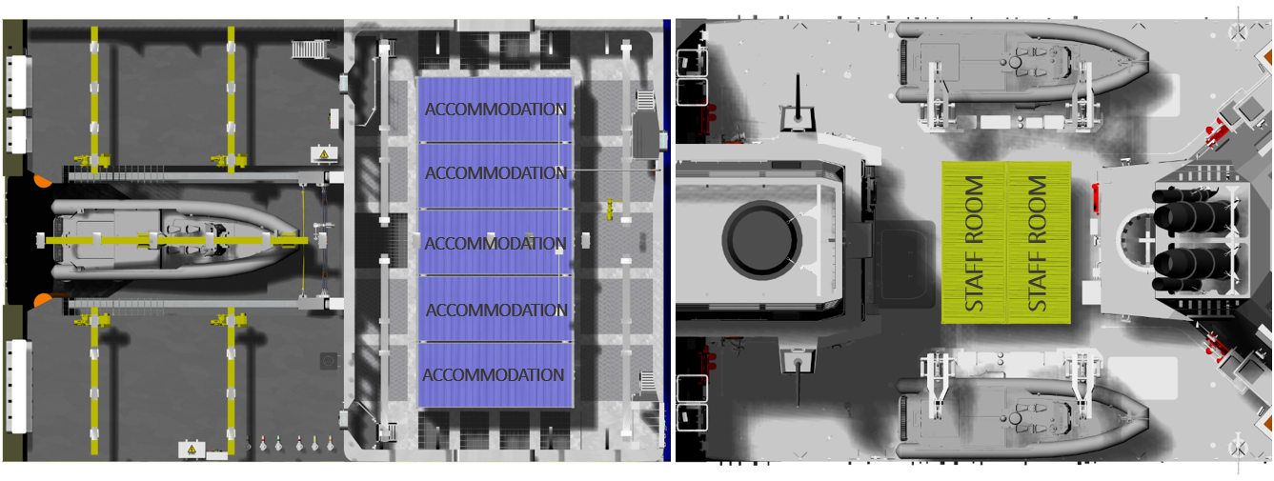

**Figure 6.** Command and Control.

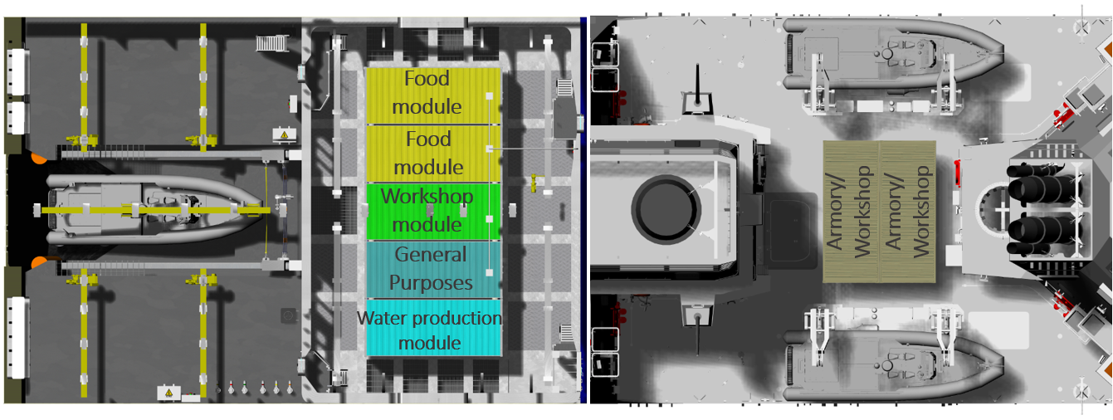

**Figure 7.** Supply Ship.

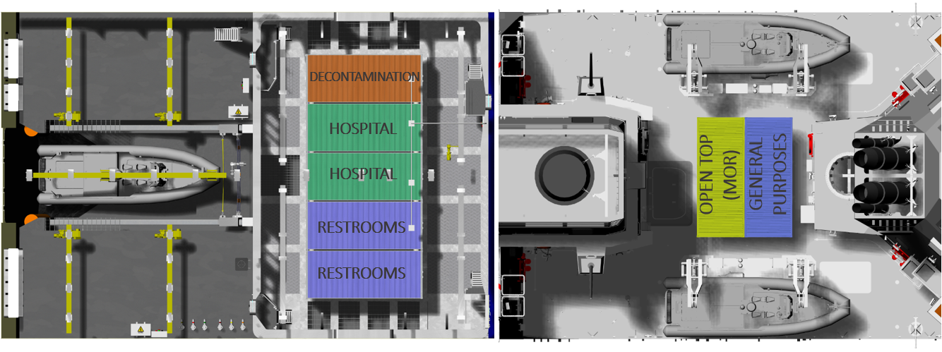

**Figure 8.** Search and Rescue (SAR).

Though, the concept of modularity embeds strengths and opportunities, as well as, weaknesses and threats. While the PROs of modular equipment are more self evident, there are also critical aspects, CONs, to be considered which will be analyzed below [4].

## Advantages

The advantages on the concept of modularity have already been highlighted in some points of the previous paragraphs, in fact the modularity allows to quickly reconfigure the ship according to the mission without having to carry out very invasive interventions, guaranteeing operational flexibility [5].

This reconfiguration of the PPA, carried out using ISO containers, allows savings in terms of time, costs and confeer a longer operational life to the ship.

So, the greatest strengths are represented by:

* Increased adaptability: medical module, power distribution module, disaster relief modules, anti-pollution modules are capabilities that can be use for a short duration mission but can be delivered over different PPA version or different platforms.
* Potential for rapid re-role: the ship can be quickly reconfigured in the home bases through the use of containers that can also be quickly deployed in the operational area using common means of transport.
* New technologies insertion: modularity allows to update the capabilities available based on new technologies regardless of the platforms on which they are installed (longer operational life of the ship).

The greatest opportunities are represented by:

* Decreased maintenance burden: The modules can be stored in the naval base where they can be managend, maintained and updated without burdening on the operations and the crew of the ship.
* Reduced equipment holding: the total amount of equipments and systems contained in the modules is reduced compared to a permanent installation on each ship with a reduction of costs and maintenance.
* International cooperation: modularity allows to share this capabilities across navies engaged in the same mission in a NATO context.

The advantages have been analyzed so far, now the major disadvantages will be analyzed.

## Disadvantages

In the PPA experience some disadvantages also emerged in relation to the modularity, in fact taking modularity to extreme level might cause a too high reduction of platform performances in terms of loss of space for crew accommodation, in some cases loss of ship overall endurance (this is the case when too much volume is taken away against fuel tanks size), decrease of maximum speed and machinery spaces, with the aim of extremely enlarging the modular areas volume.

In effect, the greatest weaknesses are represented by:

* Design constraints on ship size and cost: there were more initial design constraints in terms of cost and size due to standard solutions. Space designated for Mission Bays cannot be easily used for other Ship functions. These modular zones for PPA had to be considered like impenetrable areas. The inclusion of constraints in the PPA Project led to huge impact in the basic design principles, in terms of loss of space for crew accommodation, driving choices regarding watertight subdivision, overall performance, ship’s systems, hull definition and life cycle cost.
* Trade-offs among operational capabilities: the trade-off among the operational capabilities was necessary to have a right balanced platform in order to support the large missions spectrum. It is also necessary to develop the mission modules quickly so as not to take too long from the delivery of the ships.
* Increased Displacement: especially for the aft mission bay, hull definition must respect rigid drivers like no pillars under the flight deck, large openings, watertight bulkhead penetration for ship’s systems, height of the decks for overhead handling system with a general strengthening of the structures, but also to the central Mission Bay amidship with the strengthening of the weather deck. The consequence was the increasing of the propulsion plant power, decrease of maximum speed, etc.
* Weight balance: Mission Bays integration has also an impact on the distribution of masses that has to be considered particularly from an hydrostatic point of view. In fact, most of the weights are to be computed on the extreme aft (critical for floatability) and above the weather deck (critical for stability).
* Reconfiguration time: It is necessary to take into consideration the time necessary for the reconfiguration of the ship between one mission and the next, including the travel time to arrive in the naval base or wherever the modules are located.
* Storage infrastructure: in order to maintenance and preserve modules for all them is necessary to create a new infrastructure and an organization within the naval bases which in any case require acquisition and management costs including personnel training.

The greatest threats are represented by:

* loss of platform flexibility: it is necessary to study well all the missions spectrum to develop modularity to avoid the risk that a capacity is left on board permanently or the same modules are always used on board. In these cases the modularity loses its flexibility in the short term with the risk of becoming only a means to facilitate the modernization of the ship in the future.
* Increased ship size: with the creation of adequate Mission Bays to allow spaces around modules to perform maintenance and connections, it was necessary to increase the size of the ship with the consequent problems of increased propulsion plant power, generation power, auxiliary systems, cost, noise radiated into the water and vibrations compared to a traditional ship.
* Human factors: when team specialists board the ship to support the modular capabilities there is some integration problem with the crew of the ship. They also have integration problem with the ship routine and with the emergency situation onboard. In addition, the Navy needs to use all the personnel available on board for various services, excluding the possibility of having part of the personnel assigned only to the modules.

All these aspects can cause a general loss of Whole Warship flexibility.

# Conclusion

In this paper, the modularity and operational flexibility in the Italian Navy PPA experience were presented, highlighting the capabilities that can be expressed through the Mission Bays in the short term and the Growth Potential and Fit For in the medium/long term to maintain updated the ship mission capability. In particular, a series of missions were presented that can be carried out by reconfiguring the Mission Bays with the specific modules designed to be operated by each ship.

Subsequently, pros and cons were analyzed highlighting what are the strengths and opportunities, in fact, modularity allows to quickly reconfigure the ship according to the mission without having to carry out very invasive interventions and guaranteeing operational flexibility. But also highlighting the weaknesses and threats that can cause a general loss of Whole Warship flexibility.

Therefore, a future platform only after careful balanced study will have to be conceived and designed as flexible, indeed, it is possible to state that Mission Modularity is important not only because it provides opportunities to the Navy to configure a vessel properly on the assigned mission in a short period of time and maximize operational flexibility for future needs but also to share these capabilities within the Navy across their platforms and within the international community across navies with mission modules in a NATO context.

References

1. NATO STANDARD – ANEP 91 – Standard Interfaces for Mission Modules – Edition A Version 1.
2. Grimaldi A., Designing of a Modular Mission Bay for a Multirole Patrol Vessel, 18th International Conference on Ships and Shipping Research NAV 2015, 24-26 June, Lecco, Italy.
3. Greco F., Serpagli S., Definition and Development of the Modularity Features for the Italian Navy Multirole Patrol Vessel Mission Bays, 19th International Conference on Ships and Maritime Research NAV 2018, 20-22 June, Trieste, Italy.
4. David Manley FRINA, RCNC, UK Ministry of Defence, The NATO drive to mission modularity, Warship 2018 Procurement of Future Surface Vessel 11-12 September 2018, London, UK.
5. R.A. Logtmeijer, J.D. Caron, A.M. Rudius, S.R. Otten, D. Manley, M.S. Clarke, NATO Mission Modularity Cost-Benefit Analysis, 15th International Naval Engineering Conference & Exhibition, INEC 2020, IMarEST.
6. Doerry, N., H., Institutionalizing Modular Adaptable Ship Technologies, 2012, Journal of Ship Production and Design, Vol 30, Issue 3.
7. John F. Schank, Scott Savitz, Ken Munson, Brian Perkinson, Designing Adaptable Ships – Modularity and Flexibility in Future Ship Designs, 2016 Rand Corporation.
8. OCCAR, PPA Contract No.PPA.14. PROD.001 For the Design, Development, Production, and In-Service Support of 6+1 Multipurpose Patrol Ship (PPA) for the Italian Republic (and Amendment No.5).