Optimal conceptual design using NSGA-II algorithm for Galápagos interisland service small craft including flaps
José R. MARÍN-LÓPEZ^{a,}, Janeth L. MELÉNDEZª, Rubén J. PAREDESª and
Esteban L. CASTRO-FELICIANO ^{b}
ª ESPOL Polytechnic University, Guayaquil, Ecuador
^{b} Crown Hydrodynamics LLC, San Juan, Puerto Rico, USA
Abstract. In early 2020, sea trials carried out in some interisland high-speed boats in Galápagos confirmed the need to improve the comfort of the passengers during those trips. Results from those tests showed very high levels of vertical acceleration which, according to ISO 2631 standard, provoke high negative effects on the passengers, as was directly observed. This project aims to design at conceptual level a fiberglass reinforced plastic high-speed boat including flaps, with minimum vertical acceleration while also considering the boat resistance. The design variables considered were length, beam, longitudinal position of the center of gravity, hull deadrise angle, flap deflection angle and its chord. In addition, the constraints considered were dynamic trim angle for porpoising, length-beam ratio, metacentric height, freeboard, and required area for passengers. A multi-objective optimization method available in pymoo, an open-source Python-based framework, was employed along with an open-source planing craft hydrodynamic evaluation framework, OpenPlaning The resistance was evaluated with a combination of semiempirical formulations with a prismatic hull assumption that included the effect of waves, whisker spray and flaps; while the vertical acceleration was estimated with formulations from lab tests based on significant wave height. To estimate the Pareto front, the NSGA-II (Non-Dominated Sorting Genetic Algorithm) optimization algorithm is chosen considering the complex relations and number of design variables. First, the benefits of including flaps to reduce the boat planing angle, and as result a reduction in the motion acceleration were confirmed. Also, results show that sea performance of the boat is highly affected by CG position, deadrise angle and angle of flap. The combination of these parameters that helps to reduce the acceleration objective function are identified. Finally, the estimated Pareto front identifies a set of solutions, which shows that the acceleration could be reduced by up to 45% and the resistance to advance of the boat by 7% with the increase of some design variables.
Keywords. high-speed craft, flaps, optimization, Pareto front, acceleration

Introduction
In 2019, before the Coronavirus world pandemic, around 271K tourists visited the Archipelago of Galápagos, according to a report from the Ministry of Environment and Water of the Republic of Ecuador, [1]. This group of islands has been declared one of the most beautiful tourist destinations in the world, and to move between islands, because of cost, the use of small craft is the usual way of travel. According to Ecuadorian naval authorities, 142 trips are completed daily using 71 planing boats.
Some private companies provide interisland transportation in Galápagos, employing boats built with fiberglass reinforced plastic, FRP, with around 12 meter in length, 3 meter in beam and 1.5 meter in depth. Their capacity is around 28 passengers and navigate with velocities of 28 knots, usually with 3 gasoline outboard engines totaling about 950 hp. Principal routes, as may be seen in Figure 1, are between Santa Cruz-Isabela islands, and, between Santa Cruz-San Cristóbal islands. For both routes distances are about 80 kilometers, and trips take about 2 hours, partially navigating in open water.
According to reports from the Oceanographic Institute of the Ecuadorian Navy, the highest sea state in Galapagos islands is 4, during the month of July. These sea conditions, together with high velocities of interisland boats and long journeys cause sickness on passengers as was recently reported by Mendoza et al [2,3]. They observed several passengers with symptoms of sea sickness and even some of them vomited after arriving to Isabela departing from Santa Cruz. And because of this negative effect, it is necessary to look for options to improve this transportation service to the visitors of this wonderful place.

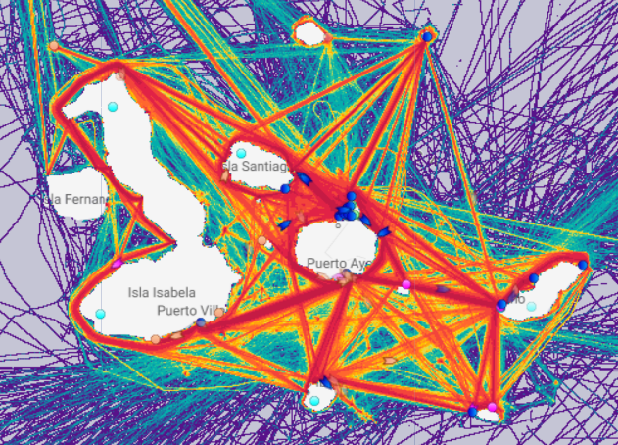
Figure 1. Main routes of interisland tourist trips between Galápagos islands.

In a previous work, Marin-Lopez et al [4] applied an optimization process based on feasible directions approach [5] to calculate main characteristics of these small craft for interisland service. A weighted combination of planing drag force considering air, whisper spray and increment due to waves; and vertical acceleration of the centroid of the vessel, CG, was considered as objective function. For both functions of this multi-objective optimization semiempirical formulations were employed. Results showed an increment in length, a larger deadrise angle and a forward movement of the CG would improve the vessel’s performance in 1.0-meter waves. It was also recognized the limitations of the optimization algorithm, which needed several combinations of the design variables initial values to check the optimization procedure convergency. Authors recommended to consider flaps to further reduce the trim angle and to improve the hydrodynamics efficiency of the hull.
Several projects have been developed to perform optimization of small high-speed craft. For example, Sakaki et al [6] employed a genetic algorithm to minimize resistance of a planing boat including trim tabs and interceptors. They considered the influence of deadrise angle, velocity and LCG position, and reduced total resistance and trim angle. Also, Mohamad et al [7] applied Non-dominated Sorting Genetic Algorithm, NSGA-II, to minimize resistance while stability and seakeeping criteria serve as constraints of a coastal surveillance craft. They also applied two other evolutionary algorithms, IDEA and EASDS, which were found to consistently perform better than NSGA in providing the resistance-optimized design for all sea-states by using the marginally infeasible solutions during the search. To consider the influence of uncertainty in design variables and parameters in the design of a planing craft, Knight [8] employed particle swarm optimization. They minimized drag and vertical acceleration at the center of gravity. Castro-Feliciano [9] optimized a planing craft geometry along with its active control system parameters. His case-study considered variations of vessel’s beam, LCG, deadrise angle and pitch velocity gain for linear-quadratic regulator estimation; results show potential to reduce calm-water and seaway drag and to improve seakeeping.
In this project it is desired to produce an optimal design of an interisland small craft considering a multi-objective function which combines resistance in waves and vertical acceleration of CG. For the resistance, the classical Savitsky formulation is applied, [10], considering the influence of flaps and with increments due to navigation in waves [11] and whisper spray, [12]. The vertical acceleration of CG of the boat is related to the motion sickness index, MSI, in the ISO 2631 standard [13], and it is used here to judge the improvement in dynamic response in waves. For the vertical acceleration formulations from Savitsky [11], based on Fridsma experiments [14] are applied. For the optimization it is applied the NSGA-II algorithm to find simultaneously a family of possible solutions, avoiding the need of multiple initial trials for the design variables.

Implementation of the optimization procedure
In this work the Non-dominated Sorting Genetic Algorithm (NSGA-II) is applied for the conceptual design of a planing boat including the effect of flaps as a multi-objective optimization. This algorithm was proposed by Deb [15] introducing the concept of dominated and non-dominated solutions.
The procedure is implemented in the script “FlapOptResisandSeakeep.py” in Python language. It is linked to the open source packages “OpenPlaning” developed by Castro-Feliciano [16] which implements Savitsky´s method, and to “Pymoo” by Blank and Deb [17] which solves for multiple objective optimization problems using the NSGA-II algorithm.

Objective function, design variables and constraints
For the objective functions, resistance, f₁(x), and vertical acceleration of CG, f₂(x), are normalized using $f_{1o}$ and $f_{2o}$ as reference values. The reference values $f_{1o}$ and $f_{2o}$ are estimated considering the main characteristics of boat A as seen on Table 3, which is currently operating in Galapagos. The resulting objective function is:
$Minimize \left(\frac{f_{1}(x)}{f_{1o}}; \frac{f_{2}(x)}{f_{2o}}\right)$ (1)
Resistance is calculated with semi-empirical formulation developed by Savitsky [10], which considers frictional, pressure and flap components. Increment in resistance due to navigation in waves is applied with formulations from [11], and the contribution of whisper spray is considered with results from [18], eqn. (2):
$f_{1}\left(x\right)=R_{fric}+ R_{air}+R_{press}+R_{flaps}+R_{waves}+R_{wspray}$ (2)
To estimate the vertical acceleration of the boat, Savitsky´s formulation [19] is applied. It includes geometric variables of the planning hull, design velocity of 28 knots, trim angle, and significant wave height of 1 m for Sea State 3. Trim angle results from the calculation of boat resistance with the equilibrium of forces and moments.
The following parameters are taken as design variables: length overall, beam, longitudinal position of CG measured from transom, deadrise angle, and flap deflection angle and its chord. In Table 1 ranges for each design variable are presented.
Table 1. Design variables and ranges of variation
Variable | Range | Units
Length overall | 9.5 < LOA < 16.0 | meters
Hull beam | 3.0 < B < 5.0 | meters
LCG/LOA  Deadrise angle | 0.3 < LCG < 0.5  10 < β < 30 | %LOA  degrees
Flap deflection angle | 0 < δ <15 | degrees
Flap chord | 0.15 < L_{F} < 0.211 | meters

For the constraints, aspects like geometry of the hull, static stability, possibility of porpoising considering Savitsky formulation [10] and minimum area for passengers are considered. For the freeboard and required area for passengers, values from actual boats operating in that service are considered; for the maximum value of KG, KG_{DynMom}, to be stabilizing for dynamic transverse reference [20] is employed. All constraints are implemented as inequalities, see Table 2.

Table 2. Constraints and limit values
Parameter | Range | Units
Possibility of porpoising | 2 < τ < τ_{Porpoising} | degrees
Keel wetted length | L_{k}<0.9*L_{OA} | m
Ratio L/B | 3.0 < L/B < 5.0 | -
Vertical position of CG | 0.4 < KG < KG_{DynMom} | m
Freeboard | Fb > 0.68 | m
Area for passengers | A_{P} > 21.11 | m²

Parametric relations to define the hull
To complete the conceptual design based on the design variables, the following relations were developed using data from actual boats built with fiberglass reinforced plastic including wooden cores currently operating in Galapagos [21].

From the hull beam B, the depth D is estimated as: $D={(B}/{2.25}), [m]$. Weights of the hull and superstructure are estimated: $W_{hull}=\left(53.15 LOA*D*B\right) 9.8, [N]$, $W_{sup}=\left(5.55*LOA*B\right)9.8, [N]$, with B and D in meters. Weights of passengers, consumables and engines are taken as fixed values totaling $45630, [N]$.

Total Weight: $W_{total}$ = $(W_{hull}$ + $W_{sup}$ + $W_{pass+comsu}), [N]$, then volume is
$Vol={(W_{total}}/{ \left(9.8*1025\right) ), [m^{3}]}$, and taking a mean value of 0.43 for block coefficient, from actual boats in operation:

Draft: $T= Vol/\left(L_{wl} B C_{b}\right), \left[m\right]$, and static freeboard may be calculated.

Once the beam of the hull, $B$, and the deadrise angle β have been set up in the optimization scheme, the beam at chine, $B_{c}$, is estimated following the geometry of the hull section. For this calculation, the angle of the side of the hull with the vertical has been taken as 20º, following boats currently in operation, see Fig. 2.
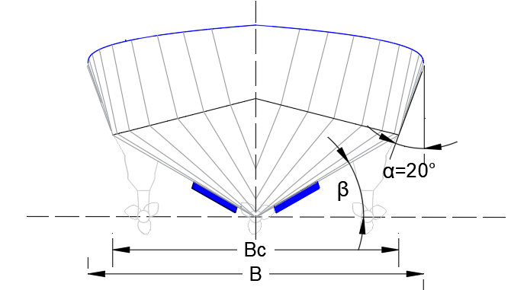
Figure 2. Geometric relations of the midship section.

Algorithm implementation
In Fig. 3 a flow chart of the Python script implementation of the process is presented [22]. On the left side of the chart, appears the link with the open-source algorithm for optimization.

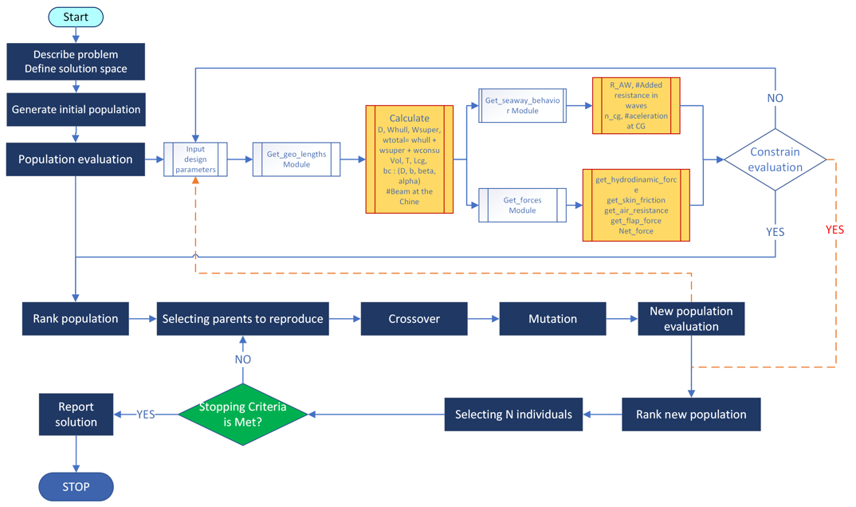
Figure 3. Flow chart for the implementation of the optimization process.

Results
In a multi-objective optimization algorithm, it does not exist a single solution satisfying all requirements of the objective functions. Instead, a set of optimum prospects for the objective functions define a Pareto front, formed by a set of solutions that cannot improve an objective without worsening at least one of the others. In this work the optimal Pareto front for resistance and vertical acceleration of the CG is estimated.

The design process in this work stops, using a tolerance value of 0.0025, after 105 generations, with a total of 19900 evaluations of the objective functions and a computational time of 323 seconds. At the beginning of the process, the total resistance, $f_{1o}$ and vertical acceleration, $f_{2o}$, are estimated as 17952 N and 1.14g respectively. Figure 4 shows the effect of sigma, the ratio of the flap span to the beam at chine, on the Pareto front. The drag and impact acceleration reductions w.r.t. no flap case are significant.
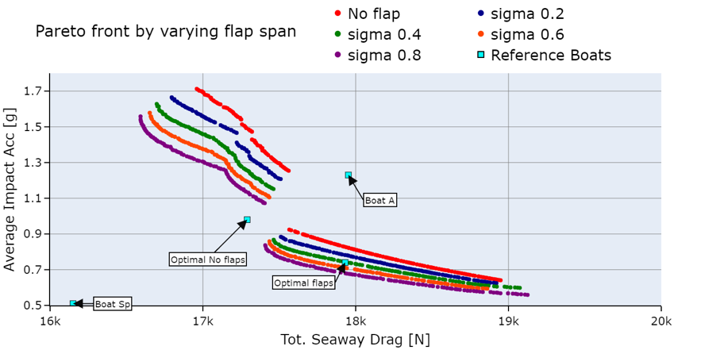
Figure 4. Pareto front for the conceptual design of Galápagos interisland planning boat as a function of the flap span ratio.

The estimated Pareto front for drag and vertical acceleration of CG is presented in Fig. 5, which presents discontinuities for no flaps case on the left-hand side. On the right-hand side, the sigma ratio of 0.40 was selected considering the space required for the outboard engines. Comparing the latter with the reference values from boat A, the optimization procedure can get maximum reductions of 7% for drag and 45% for the CG vertical acceleration.
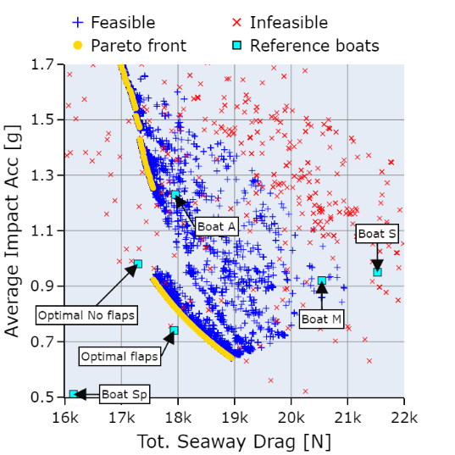 | 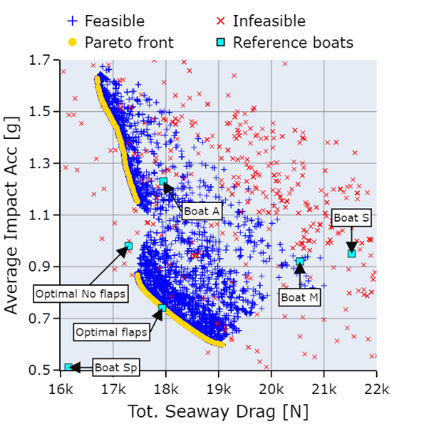
Figure 5. Pareto front for the conceptual design of Galápagos interisland planning boat. Left: No flaps are included. Right: case with flap span ratio: 0.40.
On the left side of Fig. 6, Pareto fronts for the design variables are presented using color scales to show stronger influence. Longitudinal center of gravity, LCG, and deadrise angle, β, show strong influence on motion acceleration. In the case of deadrise angle, values of 10º and 30º are main attractors for optimal solutions, combined with a value of LCG of about 40%L; these results agree with general recommendations in [23].
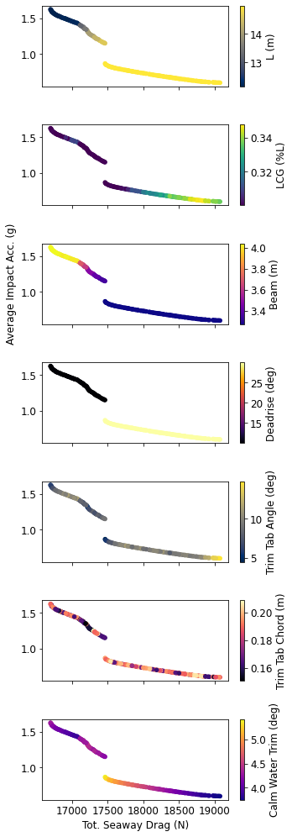 |  | 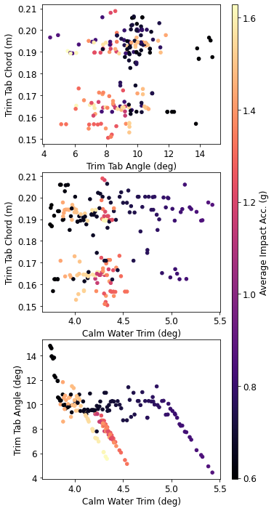
 |  | 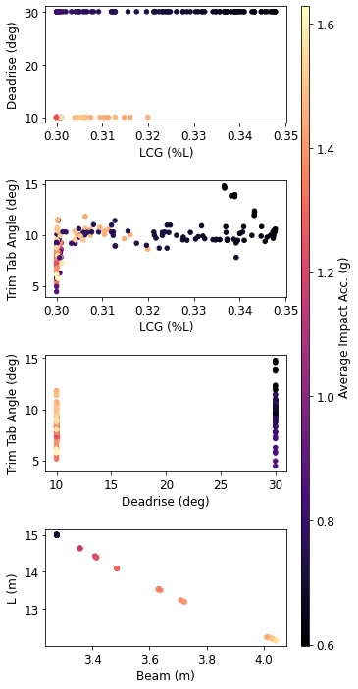
Figure 6. Pareto front for the conceptual design of Galápagos interisland planning boat, flap span ratio: 0.40, and optimal design variables.
In the work developed by Marin-Lopez et al [4], a standard optimization was employed for an interisland small craft conceptual design for 24 passengers. Those results are compared in Table 3 with those from a planning boat operating in Galápagos and a vessel similar to boat A, obtained from the Pareto in this project, which includes flaps on the transom.

Table 3. Comparison of optimal boat characteristics with those described in [3,4] considering LWL = 0.95LOA
Parameter | Boat A, ref [4] | Boat S, ref [3] | Boat M, ref [3] | Boat Sp, ref [3] | Optimal no flaps, ref. [4] | Optimal w flaps
LWL, m | 11.01 | 12.27 | 12.75 | 11.88 | 13.66 | 14.25
BxD, m | 3.45x1.51 | 4x1.6 | 4x1 | 2.61x1.65 | 3.44x1.55 | 3.27x1.53
LCG, m | 4.80 | 5.78 | 5.82 | 5.56 | 5.58 | 4.72
Disp., tons | 8.26 | 18.07 | 8.79 | 5.92 | 8.52 | 9.61
β, [º] | 14 | 8 | 14 | 25 | 22 | 30
Flap chord, m | - | - | - | - | - | 0.19
Flap angle, [º] | - | - | - | - | - | 9.6
Total drag, N | 17952 | 21526 | 20543 | 16150 | 17290 | 17931
rms a_{CG}, g | 1.14 | 0.95 | 0.92 | 0.51 | 0.98 | 0.74

Conclusions and recommendations
Results show that in this optimization procedure, LCG, deadrise angle and flap deflection angle have strong influence on the vertical acceleration of the boat CG, and as consequence on the negative effects on passengers. This influence is more pronounced when those variables are about δ∼10º, β∼30 º and LCG∼35%L. A combination of design parameters from the Pareto front can reduce the acceleration by up to 45% with respect to the reference boat A operating in a Sea State 3 at Galapagos archipelago.

References
[1] Dirección del Parque Nacional Galápagos. Informe anual de visitantes a las áreas protegidas de Galápagos del año 2019 [Internet]. Galapagos, Ecuador; 2019. Available from: https://galapagos.gob.ec/estadistica-de-visitantes/.
[2] Mendoza, Jorge I.; Vásquez EK. Pruebas de Mar de Lanchas Interislas de Galápagos. Guayaquil, Ecuador; 2020.
[3] Villamarin, Edgar;Mendoza, Jorge; Paredes R. Sea trials aboard an inter-island passenger vessel operating in Galapagos: Part I. Guayaquil, Ecuador; 2021.
[4] Marín López JR, Villamarín EG, Mendoza JI, et al. Conceptual design recommendations to improve seakeeping of small high-speed craft providing interisland transportation in Galápagos. SNAME Int Conf Fast Sea Transp [Internet]. Providence, Rhode Island, USA: SNAME; 2021. p. 10. Available from: https://onepetro.org/snamefast/proceedings/FAST21/2-FAST21/D021S003R004/470681.
[5] Vanderplaats GN. Multidiscipline Design Optimization. 1st ed. Colorado Springs, CO: Vanderplaats Research & Development, Inc.; 2007.
[6] Sakaki A, Ghassemi H, Keyvani S. Evaluation of the Hydrodynamic Performance of Planing Boat with Trim Tab and Interceptor and Its Optimization Using Genetic Algorithm. J Mar Sci Appl [Internet]. 2019;18:131–141. Available from: http://link.springer.com/10.1007/s11804-018-0040-6.
[7] Mohamad Ayob AF, Ray T, Smith WF. Hydrodynamic design optimization of a hard chine planing craft for coastal surveillance. Int Marit Conf 2010, Pacific 2010. Sidney, Australia: Engineers Australia; 2010. p. 73–82.
[8] Knight JT, Zahradka FT, Singer DJ, et al. Multiobjective Particle Swarm Optimization of a Planing Craft with Uncertainty. J Sh Prod Des [Internet]. 2014;30:194–200. Available from: https://onepetro.org/JSPD/article/30/04/194/173549/Multiobjective-Particle-Swarm-Optimization-of-a.
[9] Castro-Feliciano EL. Co-design of planing craft and active control systems. The University of Michigan; 2016.
[10] Savitsky D. Hydrodynamic Design of Planing Hulls. Mar Technol SNAME News [Internet]. 1964;1:71–95. Available from: https://onepetro.org/MTSN/article/1/04/71/172383/Hydrodynamic-Design-of-Planing-Hulls.
[11] Savitsky D, Brown PW. Procedures for Hydrodynamic evaluation of planing hulls in Smooth and Rough Water. Mar Technol. 1976;13:381–400.
[12] Perez R, Alonso V. The ultimate approach for General Arrangement definition. SNAME Marit Conv 2014, SMC 2014. 2014;1–6.
[13] ISO. Mechanical Vibration and Shock - Evaluation of Human Exposure to Whole Body Vibration - ISO 2631-1. Geneva, Switzerland; 2021.
[14] Fridsma G. A Systematic Study of the Rough-water Performance of Planing Boats (Irregular waves - Part 2). Hoboken, NJ; 1971.
[15] Deb, K.; Pratap, A.; Agarwal, S.; Meyarivan T. A Fast and Elitist Multiobjective Genetic Algorithm: NSGA-II. Trans Evol Comput. 2002;6.
[16] Castro-Feliciano EL. OpenPlaning: Open-source Framework for the Hydrodynamic Design of Planing Hulls. Int Conf Fast Sea Transp. Providence, RI: The Society of Naval Architects and Marine Engineers; 2021.
[17] Blank, J.; Deb K. Multi-objective optimization in Python. IEEE Access. 2020;
[18] Savitsky D, DeLorme MF, Datla R. Inclusion of whisker spray drag in performance prediction method for high-speed planing hulls. Mar Technol SNAME News. 2007;44:35–56.
[19] Savitsky, Daniel; Koelbel JG. Seakeeping of hard chine hulls. 1993.
[20] Lewandowski EM. The Dynamics of Marine Craft. WSPC; 2004.
[21] Rodas H. Listado de la flota de naves autorizadas para transporte maritimo de pasaje entre puertos poblados de la provincia de Galapagos. Guayaquil; 2017.
[22] Meléndez JL. Conceptual Design of planing boats with flaps for Galápagos interisland service using the NSGA-II algorithm. ESPOL Polytechnic University; 2021.
[23] Savitsky D. Chapter IV: Planing Craft. Nav Eng J [Internet]. 1985;97:113–141. Available from: https://onlinelibrary.wiley.com/doi/10.1111/j.1559-3584.1985.tb03397.x.

Corresponding Author: Jose Rolando Marin-Lopez, Escuela Superior Politécnica del Litoral, ESPOL, ESPOL Polytechnic University, Campus Gustavo Galindo Km. 30.5 Vía Perimetral, Guayaquil 09-01-5863, Ecuador; E-mail: jrmarin@espol.edu.ec.

