Visual languages effectiveness ​​in the context of communications for safety and on-board orientation.
Maria Linda FALCIDIENO ^{a,} Maria Elisabetta RUGGIERO ª Ruggero TORTI ª Nicoletta SORRENTINO ª
ª Department of Architecture and Design, University of Genoa, Italy
Abstract. The dimensions and level of complexity of contemporary passenger ships are evolving in an ever increasing and fast way. The logistics and possibilities to orient oneself independently must therefore deal with increasingly complex issues to be managed especially in terms of communication. If on one hand it is necessary to provide all the information regarding the safeguards and the useful practices in case of emergency, on the other hand a communication system must be structured to guarantee not only a development of life on board as smooth as possible, but also a positive perception of the level of assistance. Today Visual languages ​​and new technologies can, through their integration, offer new possibilities for optimizing these design themes. The here presented work reports the research developed by the authors starting from considerations of the state of the art to arrive at hypothetical methodological formulas and experimental applications to be implemented. The first phase of the study focused on a series of logistic and sociological research (also through an interview campaign) in order to identify the criticalities and potentialities of the communication currently active systems. The second phase defined a study methodology through which to identify areas of action and respective languages ​​to be adopted. Finally, the possibilities of integration among new technologies for the development of 'on demand' visual languages ​​were evaluated in order to fill and systematize a plurality of needs in a transversal manner.
Keywords. Wayfinding, visual communication, AR, passenger vessel

State of the art: new concepts and new needs
In recent decades the concept of passenger transport has been increasingly oriented towards an offer of articulated and differentiated services; with specific reference to ferries we can see how these are not proposed as simple means of transport, but as opportunities to live the experience of a real cruise.
In particular this phenomenon can be seen starting from passenger ships of modest sizes on which navigation can last a few hours, but even more evidently on naval vehicles where passengers are expected to stay overnight.
In the 60’s in Italy the first ferries Ro-Pax (ferries where you can independently embark your car and take it with you to the destination were born, Fig.1.
This introduces an important step in the way of conceiving the journey by sea, that is, an experience in which a certain autonomy of the passengers with respect to the ship itself begins to become evident, but not only: at the same time the boarding becomes something more articulated than the mere crossing of a gangway.
Here it begins to emerge how the continuous evolution of the need for degrees of autonomy and the equally continuous evolution of the services offered can introduce dysfunctions in the passenger’s capacity of logistical and functional orientations.
In terms of the analysis of visual languages on board, we are therefore witnessing a continuous stratification of solicitations addressed from time to time to the will / need to capture attention or more simply to provide information, many of which are even mandatory.
Each specific need corresponds to a specific ‘language’ and, among these, some would even need a code to be deciphered not being intuitive at all.
The formal language, therefore, introduced by decorative apparatus and compositional solutions intersects with an already complex and articulated signage.
What is the outcome? During the cooperation with Grandi Navi Veloci it was possible to verify, thanks to meetings and inspections, a certain criticality on the theme of orientation, especially in some specific phases or in some contexts.
These considerations were further validated by the results of survey campaigns carried out by the research group, as better specified below.
From this analysis derives a schematization of the operating areas in order to be able to identify case studies on which to develop the application part of the research.
We can consider two macro scenarios: an ordinary one, that is, when the navigation and passenger movements do not present any degree of criticality, the other instead when, either for the external conditions or for the need to carry out more complex operations, conditions of disturbance of the ordinary state can be determined.
Among these, in turn, we can make two further distinctions: the former where the severity of the agents who intervene are so serious that they must refer to prescriptions and above all to indications provided for by law (such as the case of fire on board or abandonment of ship).
The latter, on the other hand, in which the severity is less serious, but it is still necessary to intervene to facilitate the condition and orientation of the passengers (see as case studies the procedures for embarking and disembarking, the need to reduce access to certain areas due to weather conditions, the need to introduce an aid even to reach the cabins due to the complex articulation of the ship) Fig.2.
The latter are the areas where the research proposed here is developing and is implementing experiments in which integrated visual languages can contribute to the improvement of orientation on board.

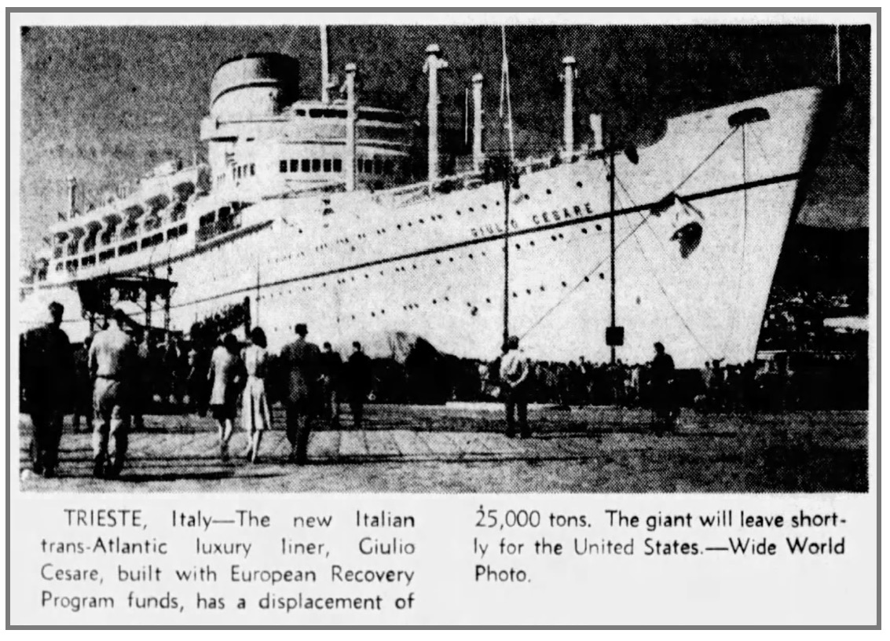
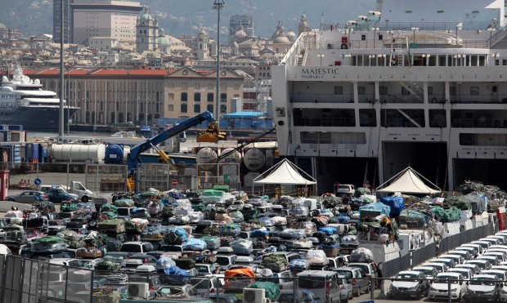
Figure 1. Old fashion vs contemporary embarkation and disembarkation.

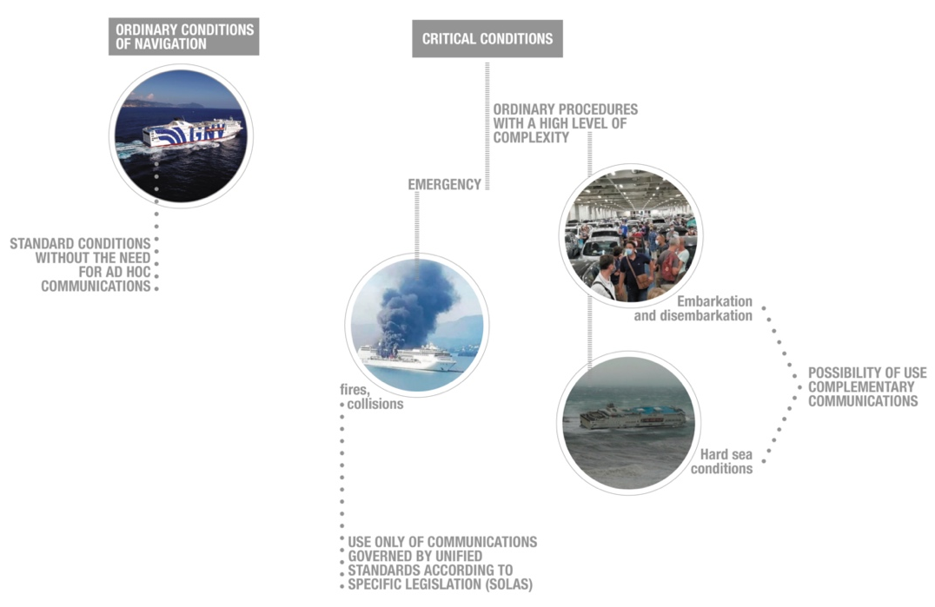
Figure 2. Reference Conditions Scheme.

Orientation and perception: survey results
If it is true that wayfinding behavior is a complex issue where many factors are at play, not least people’s “ability to perceive, select and understand information when faced with dense and stimulus rich environments” [1], it is also true that a poorly organized signage system can affect the navigation even in people more able to orient themselves.
According to Paul Symonds [2], the attention and care that cruise companies nowadays invest in the implementation of systems for wayfinding are making this a sort of non-problem. Moreover, he strengthens this concept by bringing his own experience, having been on five cruises himself without facing any difficulties, but it can be argued that this was due to his being a scholar expert in the field of wayfinding.
Indeed, the results of a survey conducted by the research team last year, and briefly commented on below, suggest outcomes different from Symonds’ experience and assertions.
First, some considerations about the survey method used: the questionnaire was designed and implemented online, using the Microsoft® Forms application and consisted of 21 multiple choice questions, with the opportunity of additional free space for any optional personal considerations.
The target of the interviewees was composed of people who had gone in the past on a cruise or had at least a transfer by sea of 12 hours or more.
The aim was to gather the direct experiences of users to identify strengths or weaknesses of the communication and information methodologies currently in use, thus directing a subsequent stage of research.
The questionnaire was administered through social networks, especially in some thematic conversation groups on Facebook, aiming to intercept a wide range of users. This delivery method had the advantage of being the fastest in reaching people interested in compiling, thanks to the chance of sharing the link also on other digital platforms.
In about one month since the posting, the survey collected 70 answers. In this respect, it is important to note that the process is comparable to a web survey, and it was affected by similar factors, including a response rate lower than expected [3].
At first sight, the resulting answers seem to partly disregard and disprove the premises of the research, pointing out a situation where there are not so many critical issues as seen in the literature.
Due to space constraints, it is not possible to present here the full, detailed review of the results; however, as anticipated above, it can be said that it has been highlighted a general and not full degree of satisfaction particularly with the issues investigated in the first section (Your experience onboard - Orient yourself, move, find information), with a high percentage of "Moderately" among the most common answers to almost all the questions.
Surprisingly the analysis of disaggregated responses shows a prevalence of this type of response in relatively young subjects, and/or with more travel experiences behind, maybe due to having been on several different ships, and therefore having experienced a wider range of occurrences, Fig.3.

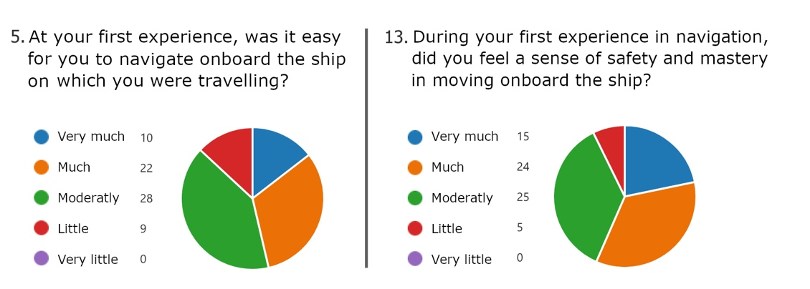
Figure 3. Part of survey about navigation experience.

Perception and communication: the role of visual language
From the observations made so far, it is evident that a clear, recognizable and unambiguous form of communication can also play on board, as is the case in general.
What we want to emphasize here are the different types of visual languages that can be used in big passengers ships as in ferries and that perhaps are not yet sufficiently chosen with awareness of the potential and limits underlying each.
In this sense, it is necessary to proceed with an initial general differentiation, which sees on the one hand structured communications with direct messages – visual and textual –and, on the other, structured communications with indirect messages – always visual and textual –.
In the first approximation, it is possible to define the type of messages conveyed with a direct language (we could also define it as "immediate"), such as those that address, without further information, the purpose of the communication itself: for example, the promotion of a product, shown directly, without leaving room for implied suggestions and references.
It is evident that this is the simplest level, certainly effective and unique, even if difficult to distinguish and memorable, in the during the noise of images that daily bombard the observer.
On the contrary, the type of messages conveyed with an indirect (or "mediated") language is based on the unsaid, on the implicit, on the metaphor – or, more generally, on the rhetorical figures – so as to always suggest interpretations and meanings; in this case it is a much more complex level of communication design, sometimes even too much and with the risk of being certainly distinguishable and memorable, but not always univocal and therefore fully effective, Fig.4.
Among the described languages, so opposite to one another, there is of course an infinite series of intermediate levels and contaminations, which here cannot be exhaustively treated [4] [5], but which are nevertheless intuitive; what is instead more the result of field experiments, as seen, is the awareness that a cruise ship or a ferry contains a complex and complete microcosm, full of the need to communicate information that is also extremely diversified in purpose, urgency and deadline.
These considerations lead to be able to affirm that in the context object of the research it is not so much the originality that must be sought (therefore the memorability and the distinction among similar visual apparatuses), but the recognizability of the levels and categories of information, to eliminate any misunderstandings or, worse, incorrect understandings. In this sense, the introduction of visual storytelling is being tested, i.e. the adoption of narratives recognizable by graphic treatment, transmitting information as if they were parts of a story; with this methodology, ultimately, the diversification of communications by purpose, urgency, deadline, with a decidedly high achievement of effectiveness, would become clearly visible and immediately perceptible.

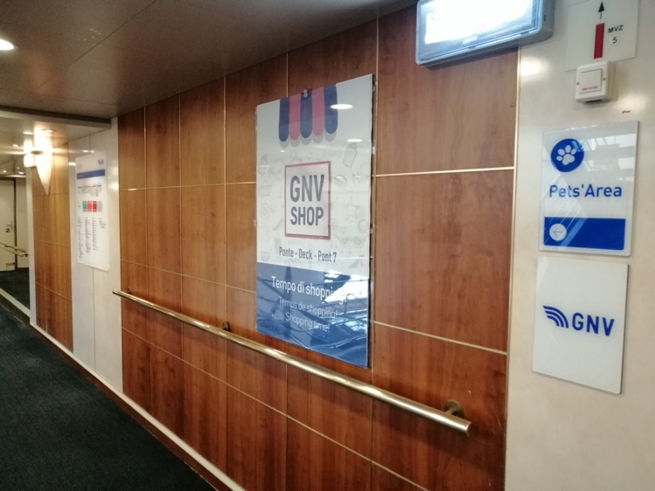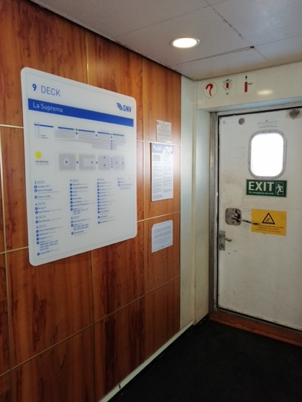
Figure 4. Communications referring to the restaurant service and technical communication referring to safety standards.

New technologies: versatility and speedness
Precisely with regard to the effectiveness of communication on board passenger ships, that is not mandatory and bound by general rules, it is also necessary to refer to the important theme of new technologies, which seem to be able to give some solutions to the most recurring problems, including the replacement of the touch screen – so far seen as the innovative and decisive element – following the acquisitions of the awareness of the risks in case of protection from infections.
ICT are, at present, widespread and customary practice; also in this case, it is necessary to think about what the best applications can be, referring to the specific purposes of passenger ships: augmented reality, virtual reality, apps are undoubtedly effective tools that can be used by even very wide targets; however, the research should be aimed at languages even more accessible to users with little or no computerization. Many of the passengers, in fact, belong to medium-high age groups or they are nuclei also composed of children and very young people and, therefore, if the visual language is immediate and without any interpretative filter (not even the written or spoken language!) the goal is certainly achieved in an almost total way; in short, experimentation is about visual storytelling. As an example, it is possible to refer to the case studies deepened by the research related to augmented reality projections [6] which are visible even in daylight conditions and without the aid of viewers or devices and that can "tell" what must be done or where it is necessary to go at certain times of navigation. These are indications of routes and destination, or even warnings about changes adopted in the event of critical issues that do not encroach on the emergency, but that nevertheless become necessary. Among these as an example the embarkation and disembarkation can be considered, with the consequent indications of where to go to reach the cabins on the saloons or even restaurants and bars – at the entrance – and the cars – outgoing –, or even at the temporary closure of an exit door on the outside, for rough sea with the consequent risk of falling due to slippery floor, and so on, Fig.5. This sophisticated system, integrated between hardware and software, moreover, has the effectiveness of being modified as needed, without any problems and costs, since it depends only on the modification of the file to be projected and has the flexibility to be used both on vertical and horizontal surfaces. Let's imagine the best yield and effectiveness of a signage system projected in emergency events, such as the one introduced by the COVID regulations, which involves a considerable intervention on the structures – albeit removable, always with a further economically costly intervention –, realized through the projection: in the face of an initial economic commitment, certainly not trivial, there will then always be the opportunity to convey any information, with the only change of files. [7]

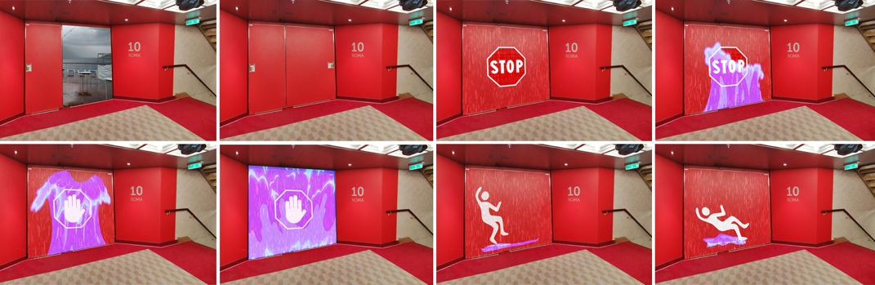
Figure 5. Case study of communication in case of interdiction to outdoor areas.

Conclusions
At the end of these notes, it is clear that we must conclude with the observation that, if on the one hand the communication on board cruise ships follows the same rules as general communication, on the other hand it is detached from it by the peculiarity of having to disseminate, within a concluded space, a set of extremely diversified information, all made even more delicate by being the ship a very large place, articulated and complex, at the same time open and closed.
Therefore, alongside the now "traditional" ICT, the possibilities of using the mechanisms of projection of visible structured light for the "intelligent" scanning of the environment combined with projected augmented reality were evaluated, and the development of visual languages that give targeted answers to specific questions asked by the individual users of the ship. The integration of new technologies with artificial intelligence, then, allows to formulate on-demand communications that can reach users as completely as possible and through the tools that are most suited to them, be they computers, tablets, mobile phones [8].
Truly a new frontier to be conquered for information on board at the same time transversal and targeted.

Maria Linda Falcidieno, Department of Architecture and Design, University of Genoa, Stradone Sant’Agostino 37, 16123 Genova, Italia; E-mail: marialinda.falcidieno@unige.it
Endnotes See Convention Department of Architecture and Design (Unige) and Grandi Navi Veloci (2022) on the theme: visual languages and customer caring on board passenger ships. Scientific managers M.L. Falcidieno and M.E. Ruggiero.
This part of the research is supported by Ateno 2020 Research Funds of the University of Genoa as part of the study: "naval charts and new models of orientation: evolutions of visual communication" conducted by M.E. Ruggiero and N. Sorrentino. References - Passini R. Wayfinding design: logic, application, and some thoughts on universality. Design Studies. 1996; 17(3): 321. - Symonds P. Cruise Ship navigation wayfinding. Boats, signs, ports, safety, and security. c2021. Available from: https://www.travelwayfinding.com/cruise-ship-navigation/. - Fan W, Yan Z. Factors affecting response rates of the web survey: A systematic review. Computers in human behavior. 2010; 26(2): 132-9. - Falcidieno ML. Parola, disegno, segno. Firenze: Alinea; 2006. 336 p. - Falcidieno ML. Comunicazione, rappresentazione. Firenze: Alinea; 2009. 180 p. - Factura B, La Perche L, Reyneri P, Bret J, Karsch K. Lightform: Procedural Effects for Projected. c2018. Availablefrom:https://www.semanticscholar.org/paper/Lightform%3A-procedural-effects-for-projected-AR-Factura-LaPerche/1cf31abbbb5635305aae4bdae09da46744013dc2. - Falcidieno ML, Ruggiero ME, Torti R. Visual Languages: On–Board Communication as a Perception of Customercaring. In: Giordano A, Russo M, Spallone R, editors. Representation Challenges. Augmented Reality and Artificial Intelligence in Cultural Heritage and Innovative Design Domains. Milano: Franco Angeli; 2021. p. 397-1. - Torti R. Nuovi orizzonti: l’esempio della comunicazione a bordo delle navi da crociera. GUD. 2021; 4: p. 74-9.

