Experiments for the definition of communication models: the visual identity of a navigation companies in relation to on-board services.
Maria Linda FALCIDIENO ^{a,} Maria Elisabetta RUGGIERO ª Massimo MALAGUGINI ª Ruggero TORTI ª Nicoletta SORRENTINO ^{b}
ª Department of Architecture and Design, University of Genoa, Italy
^{b} Department of Economics, University of Genoa, Italy
Abstract. The The advent of the pandemic in the last two years has called into question the communication apparatus referred to the identities of the shipping companies: not only this must respond to the needs of marketing and identification of those who are to be considered real brands, but even today it must respond to the need for 'reassurance' regarding a new aspect, perhaps less considered before, namely that of 'health and hygiene' safety. Forms of innovation introduced in recent years, such as those entrusted to touch screens, have proved difficult to pursue and therefore printed communications ad personam, app and social media, are perhaps more effective, highlighting a progression of targets that are gradually younger. Many media have been involved in this process and consequently the adopted languages ​​ have changed according to different needs.
The research work here presented intends to illustrate a study-methodology starting from the assumptions of visual and linguistic analysis of the state of the art in order to arrive at defining reflections and proposals. The experimentation was also conducted with the involvement of didactic experiences (seminars and applications) from which it was possible to deduce some useful reflections for further ideas, such as the perception of certain problems, the need to resort to integrated communication systems and finally the possibility development of specific applications. In this context, it is worth noting the role that social media play today in the dissemination of visual communications which, as a whole, amplify the perception of a brand's identity and allow for in-depth information on issues, subject to sudden changes, just like the one mentioned as a premise.
Keywords. Visual communication, brand identity, cruiseships, passenger vessel

State of the art: cruise market, routes, services and identity (MER)
The success and expansion of the offer of medium and long range passenger transport services, in recent years, has made even more evident the need to approach the issue of communication related to this sector. It is no longer only the need/willingness to choose a specific route but also factors such as the offered services can condition the choice of one shipping company over another; or even one means of transport compared to another.
The origin of the importance of visual communication in this area coincide with the birth of liner ships, such as the refined collaboration between Italia Navigazioni and famous designers such as Vittorio Accornero [1], who produced in the 30s real integrated projects filled with the definition of the identity of the shipping company. Today, the growth of the type of media to rely on makes this area even more complex and articulated, where competition and marketing define important choices. An example of this evolution are the liveries of ships completely borrowed with the graphic language of cartoons and fantastic superhero films [2]. The study carried out, aimed precisely at defining areas of development of visual communication in this sector, has shown that we can, and must, intervene in a multiplicity of directions, and that this process can have a critical element precisely in the possibility of maintaining an identity continuity compatible with the different communication needs. The greatest difficulty encountered, in fact, is concentrated in the difficulty given by being able to establish an evident visual coherence among communications aimed at marketing actions and what will, instead, be the language on board to approach different types of situations and needs.

Figure 1. Communication of navigation companies in comparison: brand identity and different communication concepts.

The visual communication of a company like Virgin, for example, will have completely different tones and languages from the fleet of Saga Ships, aimed at passengers of the so-called silver age, Figure 1. The question is: can these differences be maintained, then, even in the chosen languages present on board? Or again: communication campaigns, for example, referring to the covid risk how have conditioned the perception of how a company faced the emergency? Hence the reflections that follow and some of the examples developed during the laboratory experiments.

Communication and perception of danger (MM)
The information apparatus present within a cruise structure is developed on different levels that must be able to combine regulatory requirements with identifying images of the structure itself. On the one hand there is the need to inform passengers about the behaviors to be kept on board (a place not commonly usual for most of them) and on the other hand we want to propose an identity image of the company itself and the offered services. In both cases, great attention is paid to the indications relating to orientation (directional signs) which, in such a large space and often repetitive in visual references (seriality of corridors, cabins and decks), is of primary importance.
These are two particularly different levels of information: the first - which concerns communications that we could define as 'service' - aims to clearly communicate what must be done in particular circumstances (even if circumstances are difficult to verify); the second intends to guide the user within the spaces of the ship, suggesting the activities (generally of a playful type) that he can carry out during his stay on board. The latter also includes all 'institutional' communications, such as those that contribute to transmitting the image and identity of the company itself, as well as communication relating to the activities and the different spaces where they take place. In both cases, the clarity and effectiveness of communication is of fundamental importance, which must always reach a particularly large and diversified target, composed of people from different countries (and therefore who speak different languages and can have uses and habits that are not at all assimilable), who belong to every age group (from children to the elderly), or to different societies and cultures. This is not just a problem of idiom, but a real question of language. In particular, it is necessary to communicate with the use of languages that are universal, or in any case easily decoded regardless of the used language or the used images and symbols. In addition to this, it must be considered that the user, that is, the passenger, is most likely not aware of many of the terms that concern the world of boating and navigation. In such a complex context where different communication systems must coexist and integrate and be able to guide the passenger in the use of the spaces, instruct him on the behaviors to be kept and push him to use the services offered, also participating in recreational activities, the need to inform him about the most recent provisions imposed by the pandemic emergency has been added in the last two years.
The result of this further need has been seen in every type of environment (from public spaces, to hospital environments, to means of transport in general, up to every type of activity that has to do with the public) through a sudden and uncontrolled mixture of information signs. The obligation to wear a mask, the maintenance of 'social distancing', the suggestion to disinfect your hands assiduously and many other similar indications, required the implementation of existing signage with an additional communication system linked to the Covid emergency [3].
This new need, sometimes, has also imposed a distortion of the use of the environments themselves, going to clash with the indications already present. This situation was even more evident in the cruise and naval field, where there was already a complex communication system – sometimes not even organized with clarity and uniformity – which should have simultaneously informed, instructed and publicized. In some cases there has been a certain coincidence between the regulations imposed by the pandemic emergency and the more usual hygienic-sanitary rules that it has always been suggested to keep on board. Despite this, however, the extremely 'punctual' prescriptions dictated by precise legislative systems have imposed an inevitable adaptation of the communication system linked to the pandemic emergency in compliance with even more rigid parameters.
The result of this 'stratification' of information (born at different times, with different objectives and, above all, conceived by different figures) has generated on the ships – but also in most of the places frequented by the public – a real 'bombardment' of information often disconnected from each other, sometimes contradictory and, in any case, inevitably uneven. This entails, on the one hand, the loss of identity of the communication system (and consequently of the image of the shipping company) and, on the other, the potential ineffectiveness of the communication itself. It may be useful to consider this particular historical moment, in which a fundamental importance to security communications is being recognized, as a moment of transition necessary to systematize such different and constantly evolving communication needs.
The next step should, however, be the development of a unitary communication system that can respond both to the needs related to the image of the shipping company, as well as to the needs imposed by the regulations, experimenting with a coherent and univocal language that leaves no space for erroneous and contradictory interpretations or that visually damages the spaces and environments of the ship, Figure 2.

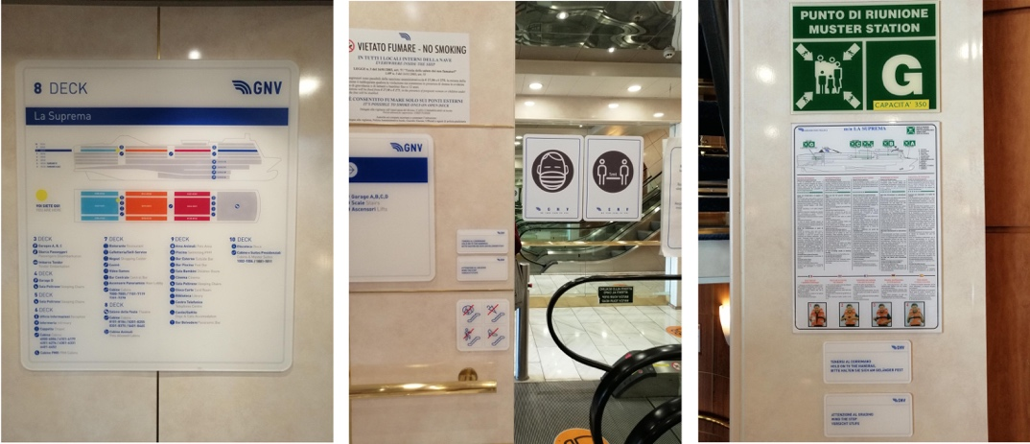
Figure 2. Images of different types of communication on board.

Definition of brand identity objectives (MLF)
The observations made, especially with regard to the communication of the danger, make it clear how essential it is to be able to make users understand the messages conveyed on board complex structures, such as large cruise ships, real "urban" areas, by number of presences, mixture of activities (management, control – including hygienic-sanitary –, commercial, leisure, etc.), articulation of spaces (residential, celebratory, infrastructural, technical, etc.) and permeability between the inside and the outside.
Particular situation, therefore, in which each of the specificities listed requires ad hoc communications, with the consequent inevitable confusion and abundance of messages. Of course, the information is also partly conveyed verbally [4], but mostly it is visual messages, in perfect coherence and harmony with the awareness that the image remains the most powerful, immediate and potentially universal medium, a real language that, if correctly structured, does not require translations and has the speed that only understanding through the gaze can give. And this is precisely what it is about, that is, to deepen the methodology that allows to distinguish information and instinctively classify it according to the level of urgency of the information, even in the plethora of visual suggestions that characterize a passenger ship, exactly as they characterize cities; different purposes, different information to be systematized immediately, even before making a critical reasoning. On reflection, however, it is a matter of working on the brand, or on the elements that characterize the identity of a promoter of messages, since it is precisely from the brand that the foundations for the recognizability of the belonging of the message itself are drawn: the visual communications that as a whole.
How to decline these principles in the case of the information to be transmitted on board? The proposed methodology makes use of the replacement of the term "brand" with the term "sub-brand": it means that, given the definition of the Company's brand (the main brand, starting from the definition of the brand, connotative, visual, verbal or mixed sign), we will work to decline the different types of information. Of course, some constant and recognizable elements will be maintained, but for example it will be possible to work on colors, geometries, the use of particular visuals that become protagonists. And this flexibility will have to be combined with the multiplicity of media intended to host communications; always visual languages, of course, since in communication even the text has its own very strong image value, but each declined according to the characteristics of the specific medium. The foundation is that communication is the visual translation of textual information, always univocal in interpretation; to do this, it is necessary to verify punctually that the sign has a precise correspondence with the concept that you want to transmit ... exercise not always practiced, which can lead to misunderstandings and misunderstandings such as to frustrate the work done, even if graphically correct and appealing.

Didactic experiments: method and outcome (RT)
The exercises carried out with the students really wanted to verify the correspondence between the content and its graphic formulation, as well as verify which tools had been chosen by them as preferable, compared to the initial question. Interesting and varied answers; all have grasped the importance of the recognition of the GNV brand, but at the same time have taken the opportunity to decline the information with specific languages depending on the host support, from paper-typographic works, to online ones, up to apps and qr-codes. Also interesting was the articulation of the information, which dealt with topics that were also very distant from each other, but always examples of the proposed working method, which was precisely that of the declination of the brand into sub-brand, which they addressed with a single topic, proposed however as a possible case study, applicable to the other areas eventually identified. Naturally, the works started from the added value that GNV wanted to indicate with an agreement that tends to expand the range of possible graphic-visual solutions to guarantee even more the care and well-being of the cruiser on board: an in-depth and conscious reading of the state of affairs and the usual visual designs was the foundation from which to start and from which we then proceeded with the creation of concepts aimed at themes Details. And this added value has meant that the topics covered were often linked to contemporary issues recognized and also present in the 2030 Agenda: the well-being of the sea and the logical decrease in the use of plastics, green choices and compatible with respect for the food choices of individuals, the guarantee of commitment to a development increasingly in line with what has been said in terms of safeguarding the planet. Even in the works that dealt essentially with communications of life on board, however, there was a sensitivity to the care of the most "fragile": children and accompanying animals were the subject of attention and dedicated graphic languages, which immediately made the underlying information stand out visually, Figure 3.
A further useful information derived from the proposed concepts was that of the instinctive ease to use different forms of communication, contaminating them and making them intrinsically connected: traditional typographic works always contain the QR-code that projects in the deepening of the online expression, considerable space has been dedicated to the traditional site, which however is responsive and can be consulted from any device, as well as apps. Finally, social networks are chosen for their intrinsic value as a multiplier of messages, as well as for their function as a "container" of ideas, images, thoughts, memories to share and comment. From this experience it will be possible to draw lymph for field experiments, which will conclude the research.

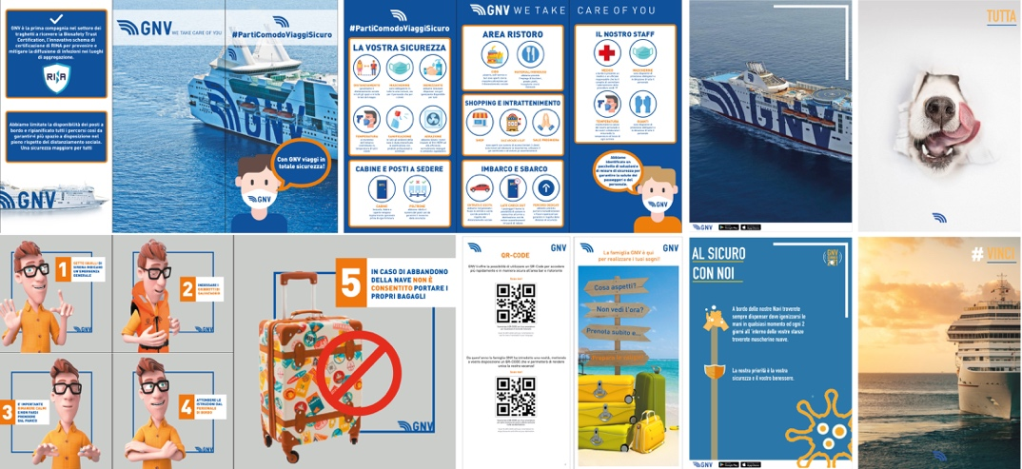
Figure 3. Some examples of communicative models developed by the students of the Laboratory of Graphics, Degree Course in Product and Nautical Design.

New applications and inclusive logic (NS)
In the contemporary context, the spread of social networks has been a strong element of innovation in the communication of content related to their activities by companies, with a view to increasing proximity and contact with the customer. The possibility of disseminating visual content that refers to and recalls each other from one channel to another (for example, from the Facebook profile to the Instagram profile and vice versa, and at the same time closely connected to the website) strengthens and amplifies the perception among users of the identity and reliability of the brand, where communications are managed in synergy in terms of content and consistently from the point of view of visual identity. In this way, thanks to a social communication based on transparency and trust, a direct and equal relationship can be established between the company and the user, such as to attract the latter in the creation of a relationship. [5]
In this sense, the use of social networks has been the privileged channel for shipping companies in the cruise sector to maintain not only their visibility, but the relationship with their customers during the recent health emergency, especially in the first phase initially characterized by the total lockdown and suspension of travel. From the monitoring and comparison of the Instagram profiles of different companies in that period, both Italian and international, however, significant differences in the approach to communication emerged. If, in fact, Royal Caribbean has limited promotional posts almost to the suspension after the WHO declaration of the beginning of the pandemic, entrusting the platform with dry and simple communications, companies such as Costa and MSC have focused more on content related to the enthusiasm of the trip and its lack on the one hand, on the experiences usually offered on board on the other, in both cases with invitations to their followers to stay in safe situations. An undoubtedly particular case was that of the Italian company GNV-Grandi Navi Veloci: operating in the field of scheduled connections, which physiologically suffer a drop in the number of passengers in the winter months and due to the general closure had been zeroed, Figure 4.
Remaining active in freight transport, in the initial period of the pandemic it intensified the activity on its profile, enhancing in the posts the logistical support to the work of the categories that even in emergency could not stop, the organization of extraordinary crossings to facilitate the return of compatriots stuck abroad and, last but not least, the contribution to the National Health System in the management of patients affected by the COvid-19 virus with the preparation of one of the ferries of its fleet converted into a hospital ship [6].

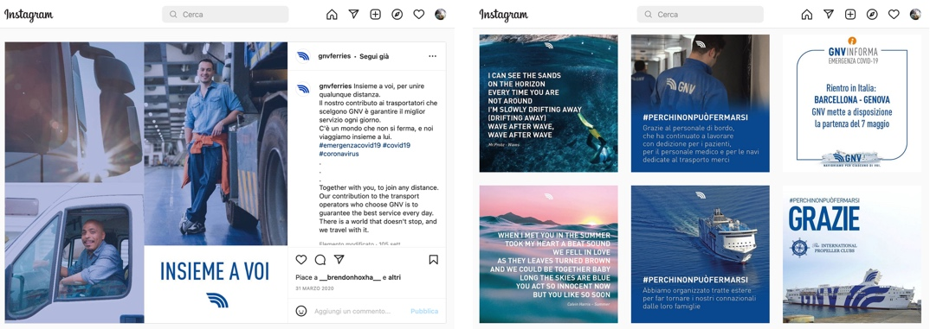
Figure 4. Comparison between the posts of March and May 2020 from the GNV Instagram page: the contents are presented in a manner consistent with the coordinated image of the company

Conclusions (MLF)
From all the considerations carried out, it is clear that communication on board passenger ships should not and is no longer understood today as a mere vehicle of "service communications", but as a continuous and discreet presence of the Shipping Company, which is a guest and as such takes care, cares and takes care of its guests, from every point of view: from embarkation, navigation and disembarkation; from attention to food, to leisure, to cultural activities and knowledge of the places; from spaces dedicated to children, to those intended for pets, always communicating safety and attention to health and hygiene. The media are all those of everyday life, which still presuppose a computer literacy; however, next to these there is the need for paper or projection, to be sure to reach each individual user. The way to achieve the goal is undoubtedly to propose new definitions of communication models, based on the visual identity of the Company, but declined in a flexible way in its constant components, so as to be able to characterize the different information relevant to the different on-board services; in this way, the user will be able to distinguish visually and immediately the nature of the information and will be able to more quickly acquire those that are necessary for him at a given time.

Maria Linda Falcidieno, Department of Architecture and Design, University of Genoa, Stradone Sant’Agostino 37, 16123 Genova, Italia; E-mail: marialinda.falcidieno@unige.it
Endnotes See Convention Department of Architecture and Design (Unige) and Grandi Navi Veloci (2022) on the theme: visual languages and customer caring on board passenger ships. Scientific managers M.L. Falcidieno and M.E. Ruggiero.
This part of the research is supported by Ateneo 2020 Research Funds of the University of Genoa as part of the study: "Experience design" conducted by R.Torti.
This part of the research is supported by Ateneo 2020 Research Funds of the University of Genoa as part of the study: "naval charts and new models of orientation: evolutions of visual communication" conducted by M.E. Ruggiero and N. Sorrentino. References - Ruggiero ME. Graphics history. Notes for a critycal and methodological approach. Genova: Genova University Press; 2020. p. 239. - Ruggiero ME. The colour in ships: communication and identity. The colour culture and science journal. 2018 Sept; p. 7-15. - Braidotti L, Bertagna S, Dodero M, Piu M, Marinò A, Bucci V. Identification of measures to contain the outbreaks on passenger ships using pedestrian simulations. Proceeding of the 3rd International conference on industry 4.0 and Smart manufacturing; 2021 Nov 17-19; Hagenberg: Procedia Computer Science 200. Elsevier BV; c2022. p.1565-4. - Falcidieno ML. Comunicazione, rappresentazione. Firenze: Alinea; 2009. 180 p. - Locatelli E. Analizzare la comunicazione nei social network tra ricerca accademica e amministrativa. Riflessioni sull’etica della ricerca. Comunicazioni Sociali. 2013; 3: p. 359-4. - Ruggiero V, Musio Sale M. How Covid will affect the Cruise Ship projects. In: Bertram W, editor. Proceeding of the Hiper’20 12th Symposium on High performance Marine Vehicles; 2020 Oct 12-14;. Hamburg: Technische Universität Hamburg, c2020. p. 74-4.

