Intact stability assessment of RO-RO pax vessel in the framework of Second Generation Intact Stability criteria with a specific focus on the operational profile
Nicola PETACCO^{a,}, Valerio RUGGIERO ^{b} and Paola GUALENI ª
ª University of Genoa, Italy
^{b} University of Messina, Italy
Abstract. One year later the finalization of Second Generation Intact Stability criteria (SGISc), there is still the need to validate the robustness and consistency of these criteria as indicated by IMO. Not compliance with a stability criterion cannot be always fixed acting only on the vessel design; also operative considerations are needed in order to reduce the risk level during the navigation. After an introduction to SGISc and rule framework for passenger ships, an application will be carried out. A Ro-Ro pax ferry has been selected as subject of this investigation. Vulnerability levels (i.e. Level 1 and Level 2) are applied in order to assess the compliance of a modern representative Ro-Ro ferry. Moreover, a study about how the environmental conditions may affect the results is undertaken considering different scenario, such as the geographical area or the maximum encountered wave height.
Keywords. Stability in waves, Design for safety, Operational Measures, Ro-Ro ferry.

Introduction
In the general context of the worldwide merchant fleet, passenger ships represent nearly the 6.5 % [1] and they are among the most demanding ship typologies also because of the safety rules that need to be complied with during both the design phase and the operational life.
Within this category ro-ro passenger ships play an important role and guarantee the safe and efficient transportation of people and vehicles where peninsular and archipelagos territories are significantly inhabited.
For this ship typology a great attention is paid to the stability issue, both in the intact and damaged conditions [2] also in relation to the actual operational profile in terms of specified environmental conditions the ship is supposed to face during the scheduled sail routing, as it will be better detailed in the following.
The concept to assess ship behaviour in waves is also at the base of the recent IMO Second Generation Intact Stability Criteria where a strong link between the design phase and the ship operational life can be recognized as well.
In order to better frame the safety of roro passenger ships in terms of stability in waves, in the following an application case will be developed for a Ro-Ro ferry representative of the Mediterranean fleet

Rule Context

The Regulatory Framework of SGISc
During the 8th meeting of the IMO sub-committee on Ship Design and Construction (SDC) the final draft of the Explanatory notes to the interim guidelines on the Second Generation Intact Stability criteria (SGISc) has been approved [3]. The final version is going to be approved by the Maritime Safety Committee (MSC) during the subsequent meeting in 2022 by means of a MSC Circular. This event represents the conclusion of their long period of development begun nearly 20 years ago. In the MSC.1/Circular 1627 [4] the official text of the SGISc can be found. Currently, their application will not be mandatory by the International Maritime Organization (IMO) strongly endorse it in order to gather feedbacks and experience for further improvements. The SGISc represent an important step toward the probabilistic and performance-based approach in the ship safety field. These criteria tackle the ship stability performance considering the dynamical effects due to wind and waves. Therefore, a wide knowledge is required to assess the physical phenomena, comprising seakeeping and maneuvering features. The SGISc address five stability failures modes: parametric rolling, pure loss of stability excessive acceleration, dead ship condition and surf-riding/broaching-to.
Each stability failures modes is evaluated according to the multi-layered approach where each level has an increased accuracy and complexity (Figure 1). The vulnerability levels represent the most simple and basic tool to evaluate the vulnerabilities of a ship; in addition a third level named design stability assessment (DSA) requires a more sophisticated numerical tool able to process a time-domain dynamic model having at least 4 degrees of freedom. In literature, applications and detailed description of the multilayered approach as well as the vulnerability levels [5, 6, 7] and DSA [8, 9, 10] can be easily found.
The ship operational aspects have been taken into account in the definition of SGISc. This represent another innovation compared to the first-generation criteria, i.e., the Intact Stability code (IS code) [11]. The new criteria introduce the so-called Operational Measures (OM), made up of Operational Limitation (OL) and Operational Guidance (OG). This has been necessary because it was recognized that to ensure safer ship performance it is necessary take into account also operational aspect [12, 13]. The operational measure can be considered as a complementary tool to fully ally address the safety performance of a vessel. It is worth to highlight that it cannot be considered sufficiently safe a loading condition requiring an intensive application of OMs.
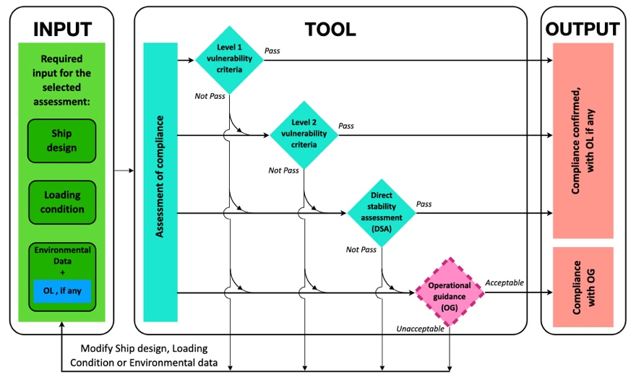
Figure 1. Graphical representation of the Multi-Layered approach.

Operational Limitations
The OL can be described as restrictions to the navigation in terms of geographical area or allowed sea state. In fact, OL are subdivided in two different categories:
- OL related to geographical area or routes and season;
- OL related to maximum significant wave height.
The first restriction identifies a specific operational profile limited in terms of geographical area or route and seasons which is deemed safe. Outside this boundary the vessel safety cannot be ensured. The second restriction set an upper limit to the sea state in which the vessel may sail in terms of significant wave height.
An unrestricted assessment considers the wave scatter diagram of the North Atlantic Ocean. Thanks to the modularity of the SGISc structure, the limitations above can be evaluated by a modification of the wave scatter diagram, which becomes a limited wave scatter diagram. Many applications and studies on the OL can be found in literature [14, 15].
As a consequence of their structure, OL can be considered as an external tool acting on the environmental input data of the SGISc analysis. OL do not depend on the ship geometrical characteristics or the considered loading condition.

Operational Guidance
OG are the second category of operational measures. OG directly tackle the operative ship profile and they provide a set of information to the master about a safe handling of the vessel in the most likely environmental conditions. Their scope is to reduce the probability that a failure occurs by operative action such as reduction of speed or changing in the wave encounter heading for certain sea states. The OG have to consider all most probable situations (i.e., the combination of ship speed, heading, wave period and significant height) that might be encountered in the vessel voyages. Therefore, the guidance is effective if detailed weather forecasts are available to the master.
OG can be deemed as an independent tool able to point out which situations should be avoided to ensure a sufficient safety level in terms of stability in a seaway condition. Three typologies of guidance have been defined:
- Probabilistic operational guidance;
- Deterministic operational guidance;
- Simplified operational guidance.
The first two typologies rely on the same numerical prediction tool used in the DSA and their approaches differ in terms of the post-processing methodology. The simplified typology relies on the similar methodology adopted in the vulnerability levels, nevertheless minor adjustments are required to take into account the ship speed and heading. The SGISc allow the designer to develop a methodology to carry out simplified OG different from the suggested one. It is important that a superior level of safety compared to design assessments (i.e., vulnerability levels and DSA) must be ensured. An in-depth description on OG can be found in [14].

Regulatory Context for Passenger Ships
Ro-Ro passenger ferries represent an important vessel typology in the Italian maritime fleet. Therefore, Italian institution put a great effort to ensure the highest level of safety for passenger and goods carried on board. This can be granted by the ratification of international rules issued by IMO and other international institution, but also the development of more stringent national rules aimed to reach the highest safety standard. In light of this, a review of the current international directives and national rules for passenger ship has been carried out. With the aim to assess a representative application case, the definition of the environmental condition and related limitation in the rule text have been considered.
Figure 2. Identified Italian sea areas in relation to the significant wave height [16].

Outcomes point out that existing national rules identify the expected significant wave height along the Italian sea coast [16]. In Figure 2, the map of the identified wave heights is reported. Considering the European legislation, the Directive 2010/36 [17, 18] defines four different classes for passenger ships on the basis of the operational profile. Each class identifies the sea areas where the vessel is engaged in considering the distance from the coastline and the probability to exceed a certain wave height threshold. In Table 1, the classes defined by the Directive have been summarized and the maximum expected wave height are reported.
Table 1. Main dimension of the considered Ro-Ro ferry.
Classes | Distance from a place of refuge | Distance from the coastline | Expected maximum significant wave height
Class D | ≤ 6 nm | ≤ 3 nm | 1.5 m
Class C | ≤ 15 nm | ≤ 5 nm | 2.5 m
Class B | ≤ 20 nm | - | unrestricted
Class A | unrestricted domestic voyage* |  | unrestricted
* voyage from a port to the same or another port within the same Member State

Application Case
In this analysis, a Ro-Ro ferry representative of the Mediterranean fleet has been considered. The main data and loading condition information are reported in Table 2.
Table 2. Main dimension of the considered Ro-Ro ferry.
Main Data
Length between perpendiculars | L_{PP} | 73.60 | m
Breadth moulded | B | 15.00 | m
Draft | d | 3.43 | m
Displacement | ∆ | 2 258 | t
Service speed | V_{S} | 18.0 | kt
Block coefficient | C_{B} | 0.592 | -
Amidship coefficient | C_{m} | 0.956 | -

In this paper, the vulnerability levels for each stability failures have been applied, except for surf-riding failure mode. As further important data for the assessment of dead ship condition, the lateral exposed area for the design loading condition and the coordinate of its center are required. For the application of the excessive acceleration failure mode, the highest point where passenger or crew may be present (Point A) and the bridge location (Point B) have been considered. These data can be found in Table 3.
Table 3. Additional information for the SGISc application.
Additional Data
Lateral exposed area | A_{LE} | 914.6 | m²
Vertical position of the center of A_{LE} | Z_{LE} | 9.56 | m
Coordinate of the highest point
Longitudinal position | X_{A} | 18.29 | m
Vertical position | Z_{A} | 15.88 | m
Coordinate of the bridge
Longitudinal position | X_{B} | 63.68 | m
Vertical position | Z_{B} | 15.05 | m

In light of the results and the specific operational profile of the considered unit, it has been decided to continue the analysis with the application of the OL. Both the typologies of limitations have been considered. Firstly, taking into account the possible routes of the analysed Ro-Ro ferry, it has been deemed interesting to limit the sailing area from the North Atlantic Ocean to the Central Mediterranean Sea. The second typology of OL, instead, has been defined comparing the national and European directive rules, as reported in 2.2. In particular, two significant wave heights have been selected as limiting wave height: H_{S} = 2.50 m and H_{S} = 1.50 m.

Results
In this section the results have been presented in terms of limiting KG curves as a function of the draft. Results for parametric roll, pure loss of stability and dead ship condition are represented by a maximum KG curve; the curves are selected as the highest of the respective vulnerability levels. The final maximum KG curves is selected as the envelope among the limiting curves of each stability failures. On the contrary, the excessive acceleration failure mode is represented by minimum KG curve, selected as the lowest between the vulnerability levels. The grey shaded area represents the safe area where a loading condition (i.e., combination of draft and VCG) is deemed safe according to SGISc.
In Figure 3, the limiting curves for the unrestricted navigation are shown. It points out that the resulting minimum and maximum limiting curves crosses each other; this affects the size of the safe zone (grey area) which is limited to a narrow area. However, the design loading condition is still considered safe by SGISc vulnerability levels.
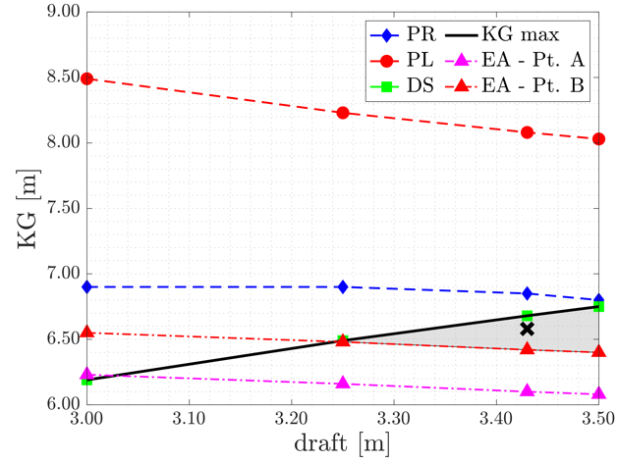
Figure 3. Limiting KG curves for the unrestricted navigation.

In Figure 4, maximum KG limiting curves obtained by the application of OLs, are compared to the unrestricted limiting curves (i.e., obtained considering the North Atlantic Ocean). Each maximum KG curves takes into account the more stringent values considering the parametric roll, pure loss of stability and dead ship condition failure modes.
In Figure 5 the comparison among minimum KG curves is shown. Curves have been obtained considering the excessive acceleration failure mode applied to Point B representing the bridge location.
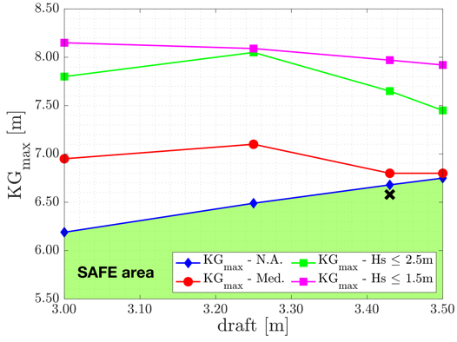  Figure 4. Comparison among unrestricted navigation and OLs in terms of maximum KG curves. | 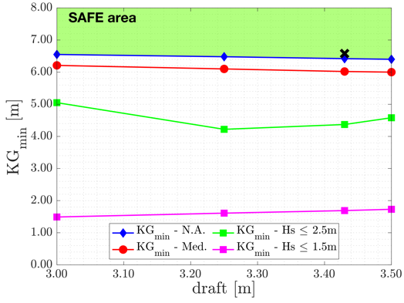  Figure 5. Comparison among unrestricted navigation and OLs in terms of minimum KG curves.

Conclusions
At the beginning of this work a brief overview on the regulatory context for the safety of passenger ships with a focus on the operational profile has been done. Subsequently, an application of the SGISc to a Ro-Ro passenger ferry representative of the Mediterranean fleet has been carried out. Furthermore, OLs in term of both geographical area and maximum wave height have been considered for the Mediterranean Sea.
Outcomes show that the vessel is deemed not vulnerable for the unrestricted navigation, even if limitations of the design domain exist. It is worth mentioning that the lower boundary of the safe zone (i.e., the minimum KG curve evaluated with the excessive acceleration criteria) is not related to the highest point on board, as suggested by the rule.
As expected, the comparison of OLs limiting curves show that considering a navigation limited to the Mediterranean Sea the design domain increases. In particular, it seems that the largest improvement to the safe area occurs when the navigation is limited in relation to the maximum wave height defined for the domestic voyages, i.e., H_{S} = 2.50 m and H_{S} = 1.50 m.
As a final comment, this work points out that the selected Ro-Ro passenger ferry complies with the international safety rule framework considering the stability aspect. Beside, it appears that considering domestic voyages may ensure a larger reserve of safety in relation to the stability aspects.

References
- Equasis. The 2020 World Merchant Fleet Statistics from Equasis Electronic Quality Shipping Information Sytems. 2021
- Ruggiero V. 2004-2014 Ten Years of Changing in the Project of Passenger Ferries on Italian Lakes Due to the 2006/87/CE and Consequent Rules. In NAV2015 : Proceedings of 18th Conference on Ships and Shipping Research 2015 Jun; 1080-1089.Lecco, Italy.
- IMO. SDC 8/WP.4 - Development of Explanatory Notes to the Interim Guidelines on Second Generation Intact Stability Criteria. International Maritime Organization. 2022 Jan; London, UK.
- IMO. MSC.1/Circular 1627 - Interim Guidelines on the Second Generation Intact Stability Criteria. International Maritime Organization. 2020 Jan; London, UK.
- US Coast Guard. Continued development of Second Generation Intact Stability criteria. 2019; Carderock Naval Architecture Division, USA.
- Petacco N, Vernengo G, Villa D, Gualeni P. Influence of Systematic Hull Shape Variations on Ship Stability Performances in Waves. Journal of Ship Research 2021; 65(3):243-256.
- Szodza S, Krata P. Towards Evaluation of the Second Generation Intact Stability Criteria - Examination of a Fishing Vessel Vulnerability to Surf-Riding, Based on Historical Capsizing. Ocean Engineering 2022 Mar; 248.
- Gualeni P, Paolobello D, Petacco N, Lena C. Seakeeping Time Domain Simulations for Surf-Riding/Broaching: Investigations Toward a Direct Stability Assessment. Journal of Marine Science and Technology 2020 Dec; 25(4):1120-1128.
- Shigunov V, Themelis N, Spyrou K. Critical Wave Groups Versus Direct Monte-Carlo Simulations for Typical Stability Failure Modes of a Container Ship. Contemporary Idea on Ship Stability, Springer, Cham, CH2019; 407-412.
- Yang SH. Study on the Parametric Rolling of Medium-Sized Containership Based on Nonlinear Time Domain Analysis. Proceeding of the ASME 2020 39th International conference on Offshore Mechanics and Arctic Engineering. 2020; 6b.
- IMO. MSC.Resolution 267(85) - Adoption of the International Code on Intact Stability. 2008; London, UK.
- Rudaković S, Bačkalov I. Operational Limitations of a River-Sea Container Vessel in the Framework of Second Generation Intact Stability Criteria. Ocean Engineering 2019; 183:409-418.
- Liwång H. Exposure, Vulnerability and Recoverability in Relation to a Ship's Intact Stability. Ocean Engineering 2019; 187
- Petacco N, Gualeni P. IMO Second Generation Intact Stability Criteria: General Overview and Focus on Operational Measures. Journal of Marine Science and Engineering 2020; 8:494
- Rinauro B, Begovič E, Gatin I, Jasak H. Surf-riding Operational Measures for Fast Semidisplacement Naval Hull Form. InHSMV 2020: Proceedings of the 12th Symposium on High Speed Marine Vehicles 2020 Nov 3; 5:219. IOS Press.
- Italian Coast Guard. D.750/2005 - Individuazione dei tratti di mare in cui le navi Ro-Ro da passeggeri effettuano servizi di linea e corrispondenti valori d'altezza significativa d'onda. Ministry of Infrastructures and Transport 2005; Rome, Italy.
- EU Commision. 2009/45/EC - Directive on safety rules and standards for passenger ships. Official Journal of the European Union, 2009 Jun.
- EU Commision. 2010/36/EU - Directive on safety rules and standards for passenger ships - Update. Official Journal of the European Union, 2010 Jun.

Corresponding Author: Department of Electric, Electronic and Telecommunication Engineering and Naval Architecture (DITEN), Via Montallegro 1, 16145 Genova, Italy; E-mail: nicola.petacco@unige.it .

