A combined CFD-FEM approach to evaluate acoustic performances of an integrated scrubber-silencer for marine applications
Giada KYAW OO D’AMORE ^{a,}, Francesco MAURO ^{b}, Mitja MORGUT ª, Giovanni ROGNONI ª and Marco BIOT ª
ª Department of Engineering and Architecture, University of Trieste, Via Alfonso Valerio 7/4, 34127 Trieste, Italy
^{b} Maritime Safety Research Centre, Department of Naval Architecture, Ocean and Marine Engineering, University of Strathclyde, Glasgow, G4OLZ, Scotland, UK

Abstract. In recent years, green shipping becomes one of the fundamental challenges for the marine industry: the limits imposed on ship emissions by IMO (International Maritime Organization) are increasingly stringent, especially in terms of SOx (sulfur oxides). The installation on board of scrubbers has proved to be a helpful solution to SOx abetment, in particular for the ships already in navigation: it allows to respect the limits imposed by the IMO even with the use of HFOs (Heavy Fuel Oils), so without the need to carry out a complete refitting of the propulsion system. However, such systems, usually installed in the funnels, have large dimensions. The integration between components is the best method to optimize the spaces, facilitating the installation of the scrubbers on board. The present work investigates a combined CFD-FEM (Computational Fluid Dynamics-Finite Element Method) methodology to evaluate the acoustic performances of a model-scale scrubber. Some papers in the literature consider the acoustic properties of SCRs (Selective Catalytic Reduction systems) for marine applications, while a thorough study on scrubbers' performances is missing. Independent CFD or FEM calculations may evaluate the acoustic properties of the scrubber. However, the combined methodology reduces the computational burden by about 90% compared to the CFD modelling. Moreover, it gives the advantage of considering the influence of flow on acoustic properties, which is impossible for a fully FEM approach
Keywords. Transmission Loss, CFD, FEM, Scrubber, Silencer

Introduction
Maritime transport accounts for approximately 10-15% of global Sulphur (SOx) and Nitrogen (NOx) oxides emissions and accounts for about 80-85% of world trade by volume [1]. The latter led to an increasing concern about the global impact of maritime emissions, and, consistently, IMO (International Maritime Organization) has restricted the limits imposed by MARPOL (Marine Pollution) 73/78 Annex VI Regulation [2] on the ships’ emissions and specifically those of SOx and NOx.
Installing scrubber systems onboard could represent a reliable technical solution to satisfy the limits imposed on the NOx and SOx emissions. However, such solutions are hardly applicable because of space limitations, especially for existing ships [3]. Indeed, the de-pollution devices are usually installed in the funnel and have a large size, so integrating such systems with other components of the exhaust line like silencer becomes mandatory to save space [1].
In addition to chemical emissions, control and minimization of onboard noise are remarkable, particularly in the case of cruising ships [4]. Therefore, in this work, an integrated scrubber-silencer is studied.
It has already been demonstrated in a previous work [5] how it is possible to use a FEM model to optimize the scrubber acoustic performances. However, considering the importance of the flows inside the scrubbers, it is fundamental to assess the influence of such flows on acoustic performances.
The available literature does not address the acoustic characteristics of pollution control devices such as scrubbers, except for one notable example on an SCR converter [1]. On the contrary, acoustic performances of mufflers have been addressed to some extent [6,7], using both the FEM [8–10] and CFD [11–14] approaches; the first one considers the geometry as an influencing parameter, while the second one takes into account also the influence of the flow inside the silencer. However, the CFD approach requires a high computational cost. Here, the authors propose a combined FEM and CFD analysis to evaluate the acoustic performances of a scrubber/silencer considering both the geometry and the flow while maintaining a low computational cost. In literature, just a few works use the combined approach between FEM and CFD [15,16], but they do not consider the viscous dissipation in the acoustic simulations. Moreover, they modelled the real geometry of the holes in both FEM and CFD simulations, while in the present work, the holes of the perforated elements are modelled using a transfer admittance leading to a lower meshing and computational cost.
In this study, the sound Transmission Loss (TL) is chosen as the reference acoustic parameter as it is a property of the muffler only and can be easily calculated with numerical models [7].

Material and methods
Here two geometries have been analyzed: a straight-tube perforated muffler and a model-scale scrubber (Figure 1).
The straight-tube perforated muffler geometry has been taken from the literature [13] and is used to evaluate CFD model results accuracy. The perforated pipe has holes featuring a diameter of 6 mm with a porosity of 9% and a thickness of 2 mm.
The model-scale scrubber has been tested experimentally and the measured TL is used to evaluate the accuracy of the FEM model. The perforated plates are 1 mm thick, with holes featuring a diameter of 6 mm, and the spacing of the holes is 9 mm.
Finally, the combined approach is used to evaluate the acoustic performances, considering the presence of the flow, of both the analyzed geometries.
The hardware employed for the computations has the following characteristics: one physical processor Intel(R) Core(TM) i7-8565U CPU @ 1.80 GHz 1.99 GHz with four cores and 8 logical processors, an installed RAM (Random Access Memory) of 16.0 GHz and a GPU (Graphics Processing Unit) NVIDIA GeForce MX250 with 2.0 GB of dedicated memory.
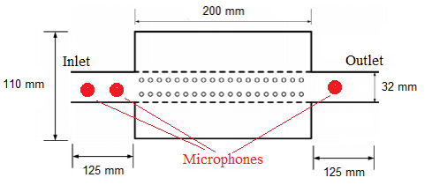
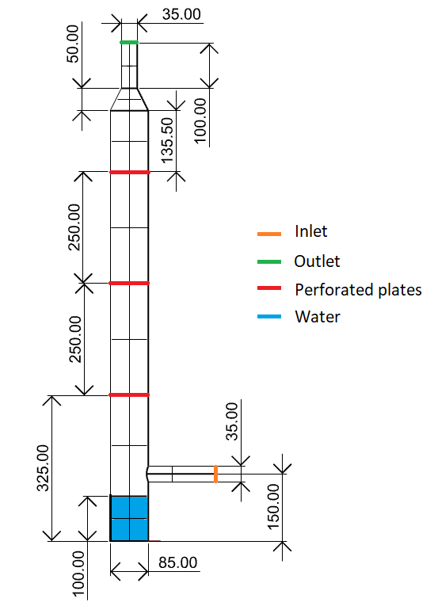
(a)
(b)

Figure 1. (a) Straight-tube perforated muffler geometry; (b) model-scale scrubber geometry.

Experimental set-up
The TL measurement of the model-scale scrubber was performed using an impedance tube featuring a diameter of 45 mm. The two-load technique [7] was adopted, and the two loads were reproduced using a closed and an open termination (Figure 2).
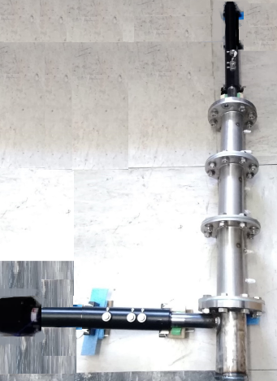
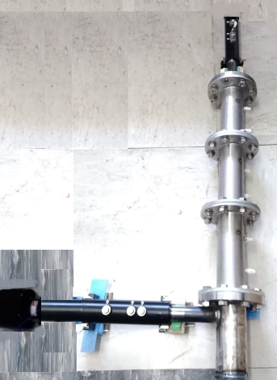
(a)
(b)

Figure 2. TL measurement set-up with (a) open end and (b) closed end.

The speaker emits a sine sweep with the following parameters: duration 10 s, frequencies range 50–5000 Hz, and variable amplitude between 0.05 V and 0.40 V.
The signals were acquired by two PCB Piezotronics 378C10 microphones connected to a data acquisition device NI USB 4431, National Instruments, Austin, TX, USA. The acquired traces were elaborated in order to obtain the TL values using the Main_TL software developed by Materiacustica s.r.l.
The distance between microphones 1–2 and 3–4 is equal to 30 mm, which is in accordance with the standard ISO 10534-2 [17]. The analysis was performed in the frequency range 10-2300 Hz in order to ensure a plane wave propagation [17].
The air conditions during the experimental measurements are reported in Table 1.
Table 1. Average air characteristics during experiments.
c (m/s) | ρ (kg/m³) | μ (Pa/s)
340 | 1.225 | 1.78 × 10⁻⁵

CFD model
The software STAR-CCM+ was used to perform the CFD simulations. RANS (Reynolds Averaged Navier Stokes) model was used to solve the Navier-Stokes equations, setting the k-ε turbulence model and considering for the working medium air as compressible ideal gas with physical properties dependent on the temperature [18]. The segregated approach was used, adopting the SIMPLE (Semi Implicit Method for Pressure Linked Equation) and the PISO (Pressure Implicit with Splitting of Operations) algorithms for respectively the steady and the unsteady-state simulations. The time step used for unsteady simulations was 5 · 10⁻⁶ s. The prism layer settings were chosen in order to have a Wall y⁺ ≤ 1, while the mesh base size and refinement area were generated according to previous studies available in the literature [13].
The boundary conditions were set as follow: mass-flow inlet (41 kg/m², equivalent to a velocity of 0.1 Ma), pressure outlet (101325 Pa) with a Non-Reflection Boundary Condition (NRBC), no slip condition at walls and temperatures at 288 K.
For the TL calculation, three microphones have to be set in the model (Figure 1) and positioned in accordance with ISO standards [17] The registered signals are then elaborated using a decomposition technique [7]. For this porpoise, after a steady simulation, two subsequent unsteady simulations are needed, one with the simple mass-flow inlet and another with a half sine wave impulse superimposed to the constant mass flow [13]. Residuals in the order of 10⁻⁵ were chosen as convergence criterion.

FEM model
The numerical simulations were performed using the software Actran VI, implementing a Direct Frequency Response analysis. The geometry was discretized with a tetrahedral mesh with 10 linear elements per wavelength (base size 10 mm) [19].
At the inlet, the duct modes [5] were used to model the incident wave, imposing a plane wave propagation in a frequency range 0–2300 Hz. In order to avoid reflection, free mode propagation was set in the direction opposite to the excitation.
At the outlet, the anechoic condition was modelled using the duct modes and by setting free mode propagation.
Environmental conditions and fluid characteristics reproduce the values measured during the experimental tests (Table 1). Moreover, the scrubber was modelled with and without the presence of the water at the bottom (Figure 1).
Perforated elements were modelled inside the software environment considering their viscous dissipation: the transfer admittance is set and calculated using the Maa theory [20].

The combined CFD-FEM approach
In the combined approach the pressure and velocity fields are calculated with CFD simulations and their average values are imported in the FEM solver to estimate the TL. The calculated fields are transferred from the CFD mesh to the FEM one through mesh mapping.
For the combined approach, the CFD model does not require the same complexity and detail level of a full CFD computation, neglecting the impulse excitation, the NRBC and the control points.
The pressure and velocity fields for the straight-tube perforated muffler were calculated with both steady and unsteady-state simulations and the respectively obtained TLs are compared.
The combined approach is then used to estimate the influence of both the flow velocity and temperature on the TL of the model-scale scrubber: the velocity was varied between 0.1 and 0.2 Ma, while the temperature between 300 and 473 K.

Results and discussion
In the following sections, the FEM and CFD models are firstly compared with the available experimental and literature data, respectively. Then, the results obtained with the combined approach are analyzed.

Comparison between experimental and numerical results
The FEM model has been assessed using the experimental measurements performed on the model-scale scrubber, not considering the flow. As it was not possible to experimentally insert the flow into the model-scrubber, to evaluate the goodness of the CFD model, literature experimental and numerical data have been used.

FEM model: comparison between experimental and numerical TL
A perusal of Figure 3 shows a good fit between the FEM-simulated and experimental TL curves in the frequency range up to 1500 Hz. The observed discrepancies between TL minima and amplitudes are less than 3%, and 5 dB, respectively. At higher frequencies, the discrepancy between the TL amplitudes becomes higher. This inaccuracy is caused by a non-plane wave propagation of the sound at higher frequencies in the model-scale scrubber due to a change of the wave propagation direction caused by the angle between the inlet pipe and scrubber body [21]. However, the FEM model shows appreciable accuracy [22] in the frequency range 20–1000 Hz, where human hearing is the most sensitive [23].
Then, the influence on the TL of the presence of water in the model-scale scrubber bottom (depicted in Figure 1) has been considered: the TL peak around 500 Hz is completely dumped, while the TL above 920 Hz is increased (Figure 3). This effect should be kept present when interactions with exciting frequencies are considered.
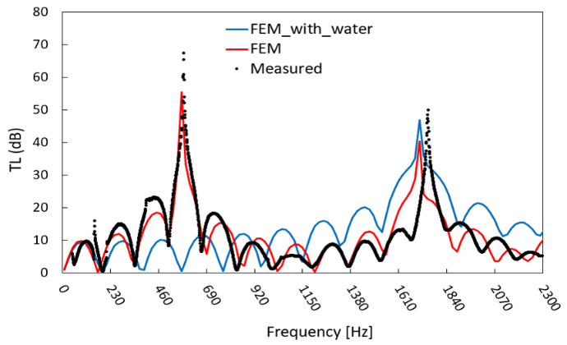
Figure 3. Comparison of model-scale scrubber TL: experimental vs numerical.

CFD model: comparison between experimental and numerical TL
In Figure 4 the TL of the straight-tube perforated muffler calculated with CFD approach is reported and compared with both experimental data and CFD-modeled TL reported in literature [13]. It is possible to notice a good fitting between the curves up to 2450 Hz, at higher frequencies the numerical curves show a gap with the experimental data up to 10 dB. However, the numerical results can be considered reliable in the frequency range where human hearing is most sensitive [23].

Application of combined CFD-FEM approach
The combined approach is used on both the analyzed geometries in order to evaluate the influence of the flow field. The calculation CPU times are then compared for all the tested cases.

Straight-tube perforated muffler
The TL of the straight-tube perforated muffler has been calculated also with the combined approach. In Figure 4 it can be observed that this approach provides a TL fitting well with experimental measurements also at higher frequencies. Considering the TL calculated with FEM it is possible to highlight the influence of the flow that lead to a damping of the sharp peak around 3000 Hz (Figure 4). Moreover, as the TL curves obtained with both the flow fields extracted from the steady and the unsteady-state CFD simulation are coincident. Therefore, it can be said that the unsteady simulations are not strictly necessary, as the combined approach just a faster and easier to implement steady CFD simulation to calculate the flow field.
In Table 2 the CPU (Central Processor Unit) time of the combined approach is compared to the times required for the two unsteady simulations of the CFD approach: the proposed methodology takes 1% of the time needed for the CFD approach.
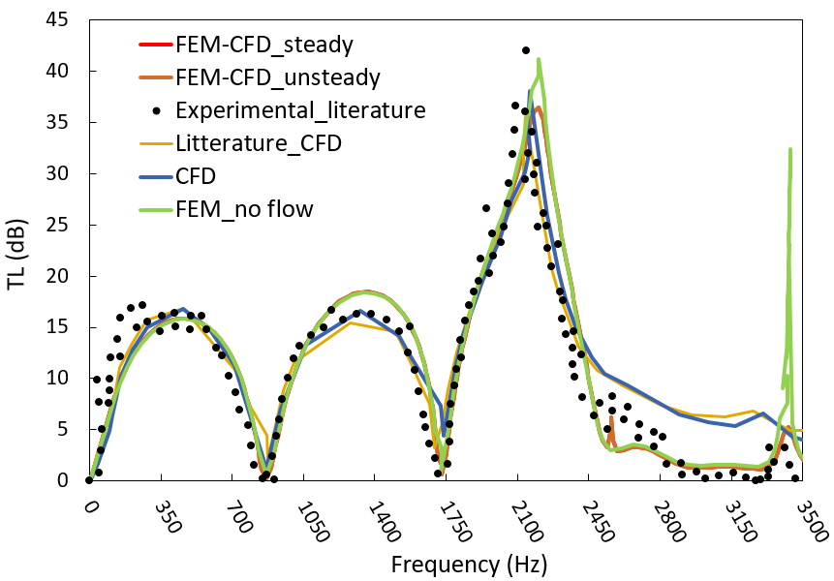
Figure 4. Comparison of straight-tube perforate muffler TL: literature experimental/numerical vs numerical.
Table 2. CPU time comparison.
 | CFD-FEM approach | CFD unsteady | CFD impulse
CPU Time [s] | 25 × 10⁴ | 15 × 10⁶ | 15 × 10⁶

Model-scale scrubber
In Figure 5 the TL of the model-scale scrubber calculated with the combined approach for different flow conditions is reported. For this geometry, the influence of the considered flows acts at higher frequencies: it tends to eliminate the sharp peak of the TL and to shift the curves towards lower frequencies.
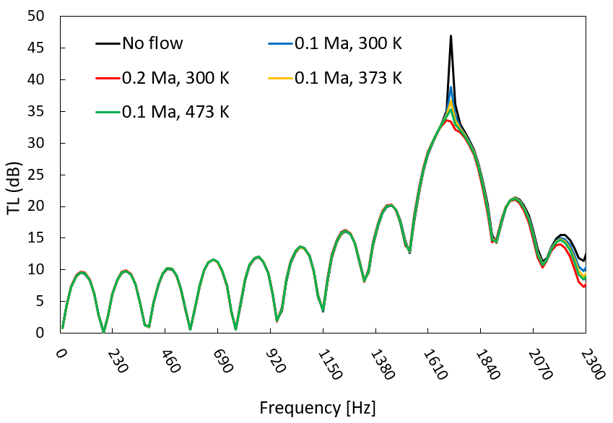
Figure 5. Comparison of model-scale scrubber TL with different flow.

Conclusion
In this paper a combined CFD-FEM approach is proposed to evaluate the TL considering the flow influence. The methodology is assessed using experimental measurements and can be summarized in the following steps: steady-state CFD simulation to calculate flow field, mesh mapping to transfer the pressure/velocity field on the acoustic FEM mesh, TL calculation with FEM. This approach allows saving computational time, as it requires about 1% of the CPU time needed for a fully CFD approach, while considering the flow influence. Moreover, unlike the combined approaches proposed in literature, in this work the viscous dissipation is considered and the holes of the perforated elements are modelled in the acoustic FEM analysis setting a transfer admittance instead of modelling the real geometry of the perforations, leading to an easier and faster meshing.

References
[1] Y. Chen, L. Lv, Design and evaluation of an Integrated SCR and exhaust Muffler from marine diesels, J Mar Sci Technol. 20 (2015) 505–519. https://doi.org/10.1007/s00773-014-0302-1.
[2] IMO, Revised MARPOL Annex VI, 2008.
[3] I. Boscarato, Integration of catalytic technology into marine engine pollution abatement system, PhD., University of Trieste, 2011.
[4] IMO, CODE ON NOISE LEVELS ON BOARD SHIPS-RESOLUTION MSC.337(91), 2012.
[5] G. Kyaw Oo D’Amore, M. Biot, F. Mauro, J. Kašpar, Green Shipping—Multifunctional Marine Scrubbers for Emission Control: Silencing Effect, Applied Sciences. 11 (2021). https://doi.org/10.3390/app11199079.
[6] Beranek L.L. and Ver I.L., Noise and Vibration Control Engineering, (1992).
[7] Z. Tao, A.F. Seybert, A Review of Current Techniques for Measuring Muffler Transmission Loss, in: 2003: pp. 2003-01–1653. https://doi.org/10.4271/2003-01-1653.
[8] S. Bilawchuk, K.R. Fyfe, Comparison and implementation of the various numerical methods used for calculating transmission loss in silencer systems, Applied Acoustics. 64 (2003) 903–916. https://doi.org/10.1016/S0003-682X(03)00046-X.
[9] S. Jeon, D. Kim, C. Hong, W. Jeong, Acoustic performance of industrial mufflers with CAE modeling and simulation, International Journal of Naval Architecture and Ocean Engineering. 6 (2014) 935–946. https://doi.org/10.2478/IJNAOE-2013-0223.
[10] J. Fu, M. Xu, W. Zheng, Z. Zhang, Y. He, Effects of structural parameters on transmission loss of diesel engine muffler and analysis of prominent structural parameters, Applied Acoustics. 173 (2021) 107686. https://doi.org/10.1016/j.apacoust.2020.107686.
[11] M. Swamy, R. Kulkarni, R. Dharmadhikari, S. Rajput, Estimation of Pressure Drop across Exhaust System by CFD Simulation, 07 (2020) 7.
[12] L. Liu, X. Zheng, Z. Hao, Y. Qiu, A time-domain simulation method to predict insertion loss of a dissipative muffler with exhaust flow, Physics of Fluids. 33 (2021) 067114. https://doi.org/10.1063/5.0056316.
[13] D.D. Zhu, Z.L. Ji, Transmission loss prediction of reactive silencers using 3-D time-domain CFD approach and plane wave decomposition technique, Applied Acoustics. 112 (2016) 25–31. https://doi.org/10.1016/j.apacoust.2016.05.004.
[14] G. Kyaw Oo D’Amore, F. Mauro, Numerical study on modelling perforated elements using porous baffle interface and porous region, JEDT. (2021). https://doi.org/10.1108/JEDT-07-2021-0356.
[15] W. Fan, L.-X. Guo, An Investigation of Acoustic Attenuation Performance of Silencers with Mean Flow Based on Three-Dimensional Numerical Simulation, Shock and Vibration. 2016 (2016) 1–12. https://doi.org/10.1155/2016/6797593.
[16] B. Gardner, A. Mejdi, C. Musser, S. Chaigne, T. De Campos Macarios, Coupled CFD and Vibro-Acoustic Modeling of Complex-Shaped Mufflers Accounting for Non-Uniform Mean Flow Effects, in: 2015: pp. 2015-01–2313. https://doi.org/10.4271/2015-01-2313.
[17] ISO 10534-2, Acoustics-Determination of sound absorption coefficient and impedance tubes-Part 2: Transfer-function method, 1998.
[18] https://www.engineeringtoolbox.com/dry-air-properties-d_973.html, (2021).
[19] S. Marburg, B. Nolte, eds., Computational acoustics of noise propagation in fluids: finite and boundary element methods, Springer, Berlin, 2008.
[20] D.-Y. Maa, Potential of micro perforated panel absorber, J. Acoust. Soc. Am. 104 (5), (1998)
[21] Y. Yang, H. Jia, W. Lu, Z. Sun, J. Yang, Impedance-matching acoustic bend composed of perforated plates and side pipes, Journal of Applied Physics. 122 (2017) 054502. https://doi.org/10.1063/1.4996848.
[22] C. Pestelli, Wartsila Italia S.p.A., Personal communication., (2021).
[23] J.R. Dubno, M.A. Eckert, F.-S. Lee, L.J. Matthews, R.A. Schmiedt, Classifying Human Audiometric Phenotypes of Age-Related Hearing Loss from Animal Models, JARO. 14 (2013) 687–701. https://doi.org/10.1007/s10162-013-0396-x.

Corresponding Author, Giada Kyaw Oo D’Amore, Department of Engineering and Architecture, University of Trieste, Via Alfonso Valerio 7/4, 34127 Trieste, Italy, giada.kyawood’amore@phd.units.it

