A digital twin approach to the diagnostic analysis of a marine diesel engine
Marco ALTOSOLE^{a,}, Flavio BALSAMOª, Maria ACANFORAª, Luigia MOCERINOª, Ugo CAMPORA^{b}, Francesco PERRA^{c}
ª Dept. of Industrial Engineering, University of Naples “Federico II”, Italy
^{b} Dept. of Mechanical, Energy, Management, Transport Engineering (DIME), University of Genoa, Polytechnic School, Italy
^{c}Cetena S.p.A, Genova, Italy
Abstract. Marine diesel engines are systems integrated into a complex ship’s propulsion plant and comprehensive diagnostic analysis of possible degradations and failures is very challenging. Nowadays, current software and hardware allow exploring innovative ways, although each methodology cannot be considered apart from an adequate onboard monitoring system. In this work, the effects of several typical degradations of a ship’s engine, affecting some parameters that can be monitored on board, have been supposed and analyzed in order to their detection at an early stage by processing some parameters that can be monitored on board. The main aim is to provide a tool able to trace the engine performance decay. The procedure is based on the simulation of the engine model performed with input data measured on board and on a comparison of the outcomes with the real data. The case study is a 12.000 kW (750 rpm) 4-stroke marine diesel engine, simulated in a Matlab/Simulink environment and validated through the manufacturer’s datasheet. At this stage of the research, to make up for the lack of experimental data recorded onboard, a more detailed engine simulator is used to generate onboard data, with some alterations of the operating conditions as, intercooler efficiency and loss of pressure, turbocharger fouling, and many others. The numerical diagnostic tool acts on the minimization of the mean square errors (optimization problem) between the measured and the numerically simulated engine variables (such as pressures, temperatures, etc…) by properly varying the model parameters. The state of the engine is evaluated by analyzing the offset between the parameters of the degraded model and those obtained through the identification procedure for the degraded case.
Keywords. Digital twin, diesel engine, simulation, diagnostic, degradation

Introduction
A regular and proper preventive maintenance program for ship diesel engines plays a fundamental role in guaranteeing ship operability and safety and in ensuring propulsion and electric power generation [1][2][3][4]. Among the different preventive maintenance methods, Predictive Maintenance (PDM) is the most recent and promising technique to reduce the risk that a system failure occurs before a maintenance intervention; really, it is an extension of Condition-Based Maintenance (CBM), where the traditional methodologies based on sensors data gathering are improved by means of computer modelling and artificial intelligence [2]. The CBM is based on the assumption that generally, a component failure happens after a preliminary phase of incipient degradation during which one or more operating parameters start to deviate slightly from the expected values [4]. The duration of this phase ranges from months to a few minutes. In the case of complex systems, a prompt identification of such deviations requires measurements that are often impossible or at least very expensive. This is the case of internal combustion engines, in which complex mechanical and mainly thermodynamical phenomena that cannot be easily monitored occur [5]-[10]. To overcome these difficulties the digital twin approach is thought as a useful and promising technique to get an estimate of the engine working parameters, including those generally not accessible during normal running [11][12][13]. A computer model simulation of the engine is performed and the outcomes are continuously compared with the corresponding direct measurements so that any abnormal working condition can be detected at an early stage. The core problem of this approach is to build a reliable engine digital model and the development of an effective identification procedure.
The aim of this work is to develop a tool capable of identifying, by analysing a limited set of data monitored on board, the origin and cause of a possible malfunction that cannot be easily inferred from the measurements. A parameter estimation technique was applied on a numerical model of the diesel engine, in order to determine a set of engine model parameters that are compatible with experimental data recorded from the real engine; in the event that the measured data are related to an altered situation, the numerical analysis results should show the most probable source of the anomaly.
During the preliminary stage, the full-scale setup and testing of the procedure is unpractical for evident reasons, therefore the experimental data in normal and degraded operating modes are generated by an accurate and detailed computer model of the real engine, validated on the operating data available from the manufacturer.

Engine model
The diesel engine model is developed in SIMULINK® (MATLAB® Toolbox) language, and is organized in a modular form., consisting of the following sub-modules (Figure 1): cylinders, intercooler & air manifold, exhaust duct, turbocharger compressor and turbine, turbocharger shaft dynamics, friction mean effective pressure (f.m.e.p), torque and brake specific fuel consumption (BSFC) calculation modules. Each block consists of a set of algebraic and differential equations describing the subsystem behavior. A filling and emptying approach is applied to each engine simulator block. The in-cylinder phenomena calculation is based on a fully thermodynamic actual cycle. A real gas model is used for the fluid properties calculation; specific internal energy and enthalpy are assumed to be functions of both fluid composition and temperature.
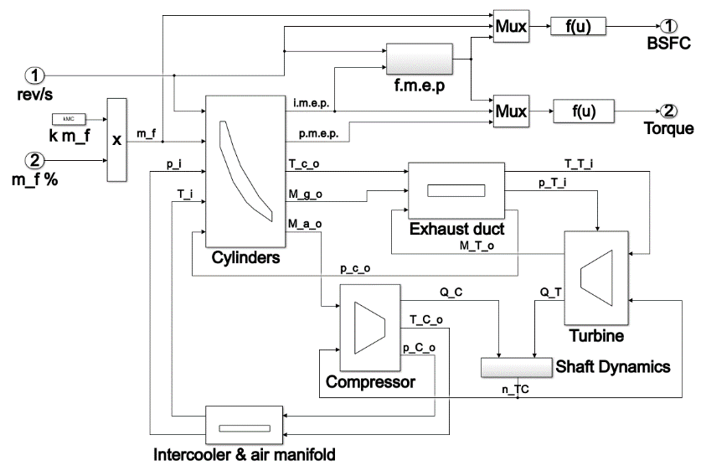
Figure 1. Overall of the engine model
In Figure 1: rev/s is the engine rotational speed; m_f is fuel mass flow; k m_f the cylinder fuel mass at Maximum Continuous Rating (MCR) engine working condition; p_i and T_i are the cylinders inlet pressure and temperature, M_g/a_o are the cylinders outlet gas or air mass flow; T_c_o the cylinders outlet temperature; i.m.e.p. the indicated mean effective pressure; p.m.e.p. the pumping mean effective pressure; p_C_o and T_C_o are the compressor outlet pressure and temperature respectively; p_T_i and T_T_i are the turbine inlet pressure and temperature respectively; Q_T and Q_C are the turbine and compressor torque respectively; n_TC the turbocharger shaft speed; p_c_o the cylinders outlet pressure; M_T_o the turbine outlet mass flow.
The input variables to the engine simulator are the engine speed and the fuel mass flow rate, as a percentage of the MCR one (rev/s and m_f % respectively in Figure 1), Fluid mass and energy stored in each engine component volume are calculated through the continuity and the energy dynamic equations (eq. 1 and eq. 2) [14]:
(1)
(2)
where: ρ is the gas density; U the gas specific internal energy; V the volume; M_{i} and M_{o} the mass flow rate at the inlet and outlet section; H_{i} and H_{o} the fluid specific enthalpy at the inlet and outlet section; M_{f} and H_{f} the fuel mass flow rate and fuel lower heating value respectively; Φ the heat flow and P the mechanical power [14]. The turbocharger shaft dynamics equation is (eq. 3):
(3)
where ω is the angular velocity; J is the total moment of inertia; Q’_{T} and Q’_{C} are the turbine and compressor torque respectively. A single zone actual cycle approach is used to assess the in-cylinders phenomena. The in-cylinder calculations use the crank angle (ϑ) as an independent variable and start when the inlet valve is open and ends at the gas exhaust phase end. The flow through the inlet and exhaust valves is determined according to [14]. At each calculation step dϑ, the heat released in the combustion process (dQ_{f}) is determined by (eq. 4):
(4)
where H_{f} is the fuel lower heating value and dm_{b} is the fuel mass burned. The latter is obtained multiplying the total fuel mass injected per cycle for the fuel mass burned in each calculation step dϑ, this last is determined by the Wiebe equation, according to [14]. In each calculation step dϑ, the work done onto the piston (dW) is calculated by multiplying the in-cylinder pressure during the cycle step dϑ computation and the cylinder volume change (dV). The cylinder pressure p_{cy} is found through the ideal gas equation once the fluid temperature from the energy equation (eq. 2) is known. The brake mean effective pressure (b.m.e.p) is determined by subtracting friction mean effective pressure to the sum of gross indicated mean effective pressure (i.m.e.p.) and pumping mean effective pressure (p.m.e.p.). To the exhaust gas manifold (Exhaust duct block in Figure 1) calculation, the dynamic continuity equation and the energy equation (eq. 1 and 2) are used. The exhaust manifold outlet temperature (T_T-i in Figure 1) is calculated considering the blow-down effect through the exhaust valve as reported in [15]. The turbocharger compressor and turbine are modelled as reported in [15]. Compressor behavior is simulated by two numerical 2D tables extrapolated from the manufacturer’s datasheet. From the compressor pressure ratio and efficiency, it is possible to assess the outlet air pressure and adsorbed torque. The turbine simulation approach is very similar to the compressor one, since the turbine gas flow rate and efficiency are estimated by a steady-state map depending on the pressure expansion ratio and the kinematic ratio u_{t}/c_{o}, where u_{t} is the turbine rotor tip speed and c_{o} is the isentropic expansion velocity. The Shaft Dynamics block of Figure 1 has in input the TC turbine and compressor torque (Q_T and Q_C respectively). The engine governor senses the engine speed and controls the fuel flow with the aim of maintaining the required speed; based on this logic, the governor has in input the actual and the requested engine speed and the output is the fuel mass flow percentage (m_f % in Figure 1) injected in the cylinders [15].
The engine model is applied to the MAN 12V32/44CR four-stroke marine diesel engine, characterized by a MCR power of 12 MW at 750 rpm. In Table 1 are reported: the engine performance at 750 rpm in terms of power, consumption, charge air and exhaust flow rate, and temperature after compressor and turbine, for different engine loads, from the engine project guide [16].
Table 1. Engine performance at constant (750 rpm) speed.
Engine load | Power | Specific fuel consumption | Charge air pressure | Temperature after compressor | Airflow rate | Exhaust flow rate | Temperature after turbine
[-] | [kW] | [g/kWh] | [bar] | [K] | [kg/s] | [kg/s] | [K]
1 | 12000 | 175,5 | 5,2 | 520,15 | 21,67 | 22,3 | 592,15
0,85 | 10200 | 174 | 4,44 | 488,15 | 18,47 | 19,55 | 587,15
0,75 | 9000 | 178 | 4,57 | 486,15 | 18,15 | 18,63 | 588,15
0,65 | 7800 | 179 | - | - | - | - | -
0,5 | 6000 | 182 | 2,96 | 431,15 | 13,3 | 13,63 | 596,15
0,25 | 3000 | 194 | - | - | - | - | -

Calibration and validation
The comparison in terms of engine power and specific fuel consumption, between calculated and reference data, was carried out for all different engine working conditions (engine load equal 100%, 85%, 75%, 65%, 50%, and 25% of MCR) at constant speed (750 rpm) and at variable rpm (see Figure 2 and Figure 3 respectively). Results shows the good simulator accuracy: the errors are less than 0.5% in the MCR engine load conditions, and less than 1% in the other examined engine working conditions.

Figure 2. Engine performance and simulation results at constant speed.

Figure 3. Engine performance and simulation results at variable speed.
According to Table 2, the specific fuel consumption errors between calculated and reference data are lower than ±1%.
Table 2. Errors obtained for specific fuel consumption.
Engine load | 1 | 0,85 | 0,75 | 0,65 | 0,5 | 0,25
Specific fuel consumption (constant speed)  Error (%) | 0,4% | 0,4% | -0,6% | -0,1% | -0,5% | 0,4%
Specific fuel consumption (variable speed)  Error (%) | 0,4% | 0,7% | -0,6% | - | -0,4% | -0,2%
From the data in Table 1 it was possible to validate the model also on other engine parameters, for different engine loads at a constant speed. Figure 4 reports the percentage errors between simulation and reference data (reported in Table 1), an average error value below 6% is obtained (average errors respectively of 4.1% for the charge air pressure, 5.6% for the temperature after compressor, 2.8% for the airflow rate, and 4.1% for the temperature after turbine.

Figure 4. Constant speed engine model validations.

Failures and malfunctions
The possible degradations, based on the type of engine to be analyzed, are reported in Table 3 and grouped for intercooler, compressor, shaft turbocharger, turbine and cylinder [17]. In this stage of the research, ten gains (one for each degradation) have been added within the model; this gain can alter the performance of a particular block. Each of these degradations has been assumed to have its own decay range, however, never higher than 20% of the nominal performance [17].
Table 3. Degradation types.
Simulation block | Degradation | Range of degradation
Intercooler | Intercooler fouling | [0-10%]
Intercooler | Efficiency reduction | [0-20%]
Compressor | Dirty air filter | [0-10%]
Compressor | Efficiency reduction | [0-10%]
Compressor | Mass flow reduction | [0-10%]
Shaft TG | Bearing deterioration | [0-5%]
Turbine | Efficiency reduction | [0-10%]
Turbine | Erosion or fouling of the blades | [± 5%]
Cylinder | Fuel flow reduction | [0-10%]
Cylinder | Alteration of injection angle | [± 5^{O}]
The 28 parameters monitored during the degraded simulations are reported in Table 4 while an example of the output results is reported in Figure 5. In detail, Figure 5 shows the influence of the air filter degradation (5% and 10%) on the 28 parameters considered in the simulation analysis.
Table 4. Monitored parameters.
ID | Intercooler (I)  and Compressor (C) | ID | Turbine (T)  and exhaust duct (D) | ID | Cylinder
1 | Outlet temperature (I) | 11 | Turbine efficiency (T) | 19 | p.m.i
2 | Compressor efficiency (I) | 12 | Turbine Mass flow (T) | 20 | Outlet temperature
3 | Compressor torque (I) | 13 | Exhaust flow (T) | 21 | Outlet pressure
4 | Outlet pressure (C) | 14 | Epsilon (T) | 22 | Exhaust mass flow
5 | Outlet temperature (C) | 15 | Turbine torque (T) | 23 | Air mass flow
6 | Mass flow (C) | 16 | Outlet pressure (T) | 24 | air/fuel ratio
7 | rpm (C) | 17 | Outlet temperature (T) | 25 | p.m.e
8 | beta (C) | 18 | rpm (T) | 26 | Power
 |  | 9 | Outlet pressure (D) | 27 | Consumption
 |  | 10 | Outlet temperature (D) | 28 | Engine torque

Figure 5. Loss of air filter efficiency.
After having carried out all the single simulations with degradation, the obtained results were used to develop a methodology for identifying the failures and/or degradations. The tool used for the analysis is the Parameter Estimation Matlab toolbox. Parameter estimation is the process of computing the parameter values of a model from measured data. The toolbox solves the problem of optimization of the error between the measured variable and the simulated variable by finding the solution of the optimal combination of the degradation coefficients. The basic assumptions are based on the minimization of the mean square error by nonlinear algorithm [18]. The application of the parameter estimation allows identifying the component degradation that causes a given realization of the monitored variables. In the optimization procedure, the parameters suitably vary until their value produce numerical outcomes matching with those of the degraded simulation (that, in this study, replaces the measured data on board). Figure 6A, for example, shows the results obtained for simulations with a pressure loss at the intercooler equal to 10%. It is possible observing how the most sensitive parameter is the one related to the pressure loss of the intercooler. Indeed, after ten iterations, this parameter settles on a value equal to 0.9 corresponding to a 10% degradation of its performance, whereas all the other coefficients, provide a value 1 (i.e. unchanged behavior that means the absence of degradation). Finally, the parameter estimation was also carried out for a scenario involving two simultaneous degradations. In this example, a pressure loss for the intercooler (-5% due to fouling of the air filter) and a problem on the turbine blades (-10% due to fouling of the turbine blades) has been set (see Figure 6B). Also in this case, it is possible noticing that the corresponding parameters modify to 0.95 and 0.9 while all the others remain unchanged.
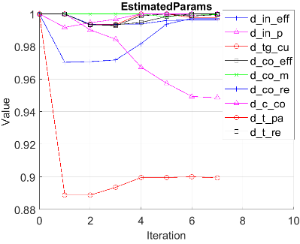
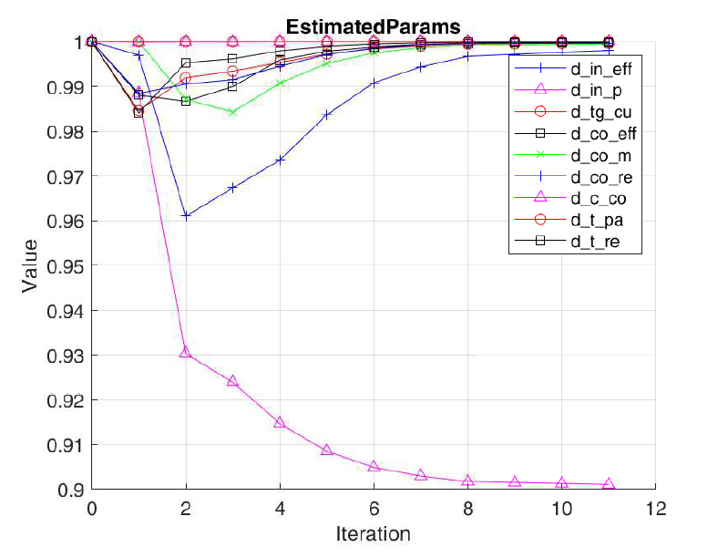
B
A
Figure 6. Parameter estimation results for one (A) and two (B) degradation.

Future work and conclusions
The paper describes the development of a digital twin model, integrated with a diagnostic numerical tool for the identification of possible degradations and failures of a marine diesel engine. The whole procedure is developed in Matlab/Simulink environment and it is able to consider ten types of degradations/malfunctions of the examined engine. The diagnostic tool, based on a parameter estimation approach, can identify the engine malfunctions by comparing simulation and field data. Unfortunately, experimental values in degraded conditions are not yet available at this stage of the research, therefore, in the present application, they are estimated through the same simulation model. The numerical procedure has been successfully tested in the identification of two simultaneous degradations (about the air filter and intercooler of the engine). However, the positive results can probably also be attributed to using the same Matlab simulation model to represent both measured and simulated data. From this point of view, the diagnostic tool should be validated by using the field data derived from a different simulation model of the engine (at least until real experimental data are available). To this end, a further engine model will be developed in another software language (e.g. commercial software dedicated to engine performance simulation) to represent the experimental data that in the real world should be collected onboard [19]. This further study should strengthen the proposed parameter estimation methodology for identifying degradation.

References
- Cicek, K., & Celik, M. (2013). Application of failure modes and effects analysis to main engine crankcase explosion failure on-board ship. Safety science, 51(1), 6-10.
- Mishra, C. S., Ali, F., Adam, S., Tesfariam, A., Yemane, A., Amanuel, H., ... & Alem, Y. (2017). Study of the Causes of Engine Failure in Ship and Maintenance Required to Prevent Engine Failure. International Journal of Contemporary Research and Review, 8(7), 20218-20241.
- Danny, F., & Shariman, M. (2013). Failure Mode and Effect Analysis of Diesel Engine for Ship Navigation System Improvement.
- Mossey, B. Regular maintenance of marine diesel engines key to more uptime and lower life-cycle costs. Detroit: MTU Detroit Diesel. nd.
- Altosole, M., Balsamo, F., Campora, U., & Mocerino, L. (2021) Marine dual-fuel engines power smart management by hybrid turbocharging systems. Journal of Marine Science and Engineering, 9(6), 663.
- Altosole, M., Benvenuto, G., Figari, M. (2005). Performance prediction of a planing craft by dynamic numerical simulation. Proceedings of the 7th Symposium on High-Speed Marine Vehicles, 2005 Conference, HSMV 2005, 105-111.
- Altosole, M., Boote, D., Brizzolara, S., & Viviani, M. (2013). Integration of numerical modeling and simulation techniques for the analysis of towing operations of cargo ships. International Review of Mechanical Engineering, 7(7), 1236-1245.
- Ircani, A., Martelli, M., Viviani, M., (...), Podenzana-Bonvino, C., & Grassi, D. (2016). A simulation approach for planing boats propulsion and manoeuvrability. International Journal of Small Craft Technology, 158, B-27-B-42.
- Altosole, M., Campora, U., Mocerino, L., & Zaccone, R. (2022) An innovative variable layout steam plant for waste heat recovery from marine dual-fuel engines. Ships and Offshore Structures, in press
- Ahmad, R., & Kamaruddin, S. (2012). An overview of time-based and condition-based maintenance in industrial application. Computers & industrial engineering, 63(1), 135-149.
- Acanfora, M., Altosole, M., Balsamo, F., Micoli, L., & Campora, U. (2021). Simulation Modeling of a Ship Propulsion System in Waves for Control Purposes. Journal of Marine Science and Engineering, 10(1), 36.
- Song, X., Cai, H., Jiang, T., Schlegel, S., & Westermann, D. (2021, October). Parameter Tuning for dynamic Digital Twin of Generation Unit in Power Grid. In 2021 IEEE PES Innovative Smart Grid Technologies Europe (ISGT Europe) (pp. 01-06). IEEE.
- Fonseca, Í. A., Gaspar, H. M., de Mello, P. C., & Sasaki, H. A. U. (2022). A Standards-Based Digital Twin of an Experiment with a Scale Model Ship. Computer-Aided Design, 103191.
- Altosole, M., Campora, U., Figari, M., Laviola, M., & Martelli, M. (2019). A diesel engine modelling approach for ship propulsion real-time simulators. Journal of Marine Science and Engineering, 7(5), 138
- Benvenuto, G., Campora, U., Carrera, G., & Casoli, P. (1998). A two-zone diesel engine model for the simulation of marine propulsion plant transients. Proceedings of the MARIND, 98.
- https://www.man-es.com/docs/default-source/marine
- Rubio, J. A. P., Vera-García, F., Grau, J. H., Cámara, J. M., & Hernandez, D. A. (2018). Marine diesel engine failure simulator based on thermodynamic model. Applied Thermal Engineering, 144, 982-995.
- Rouquette, S., Guo, J., & Le Masson, P. (2007). Estimation of the parameters of a Gaussian heat source by the Levenberg–Marquardt method: Application to the electron beam welding. International Journal of Thermal Sciences, 46(2), 128-138.
- Mocerino, L., Soares, C. G., Rizzuto, E., Balsamo, F., & Quaranta, F. (2021). Validation of an Emission Model for a Marine Diesel Engine with Data from Sea Operations. Journal of Marine Science and Application, 20(3), 534-545.

Corresponding Author, Marco Altosole, Dept. of Industrial Engineering, University of Naples “Federico II”, Italy E-mail: marco.altosole@unina.it

