Fully-Recyclable Epoxy Fibres Reinforced Composites (FRCs) for Maritime Field: chemical recycling and re-use routes
Saitta LORENA^{a,}, Pergolizzi EUGENIO ª, Tosto CLAUDIO ª, Sergi CLAUDIA ^{b} and Cicala GIANLUCA ^{a,c}
ª Department of Civil Engineering and Architecture, University of Catania, Viale Andrea Doria 6, 95125 Catania, Italy
^{b} Department of Chemical Engineering Materials Environment, University of Rome “La Sapienza”, Piazzale Aldo Moro 5, 00185 Roma, Italy
^{c} INSTM-UDR CT, Viale A. Doria 6, 95125, Catania, Italy

Abstract. The maritime transport is guilty for about 2.5% of global greenhouse gases emission, since 940 million tonnes of CO₂ are emitted around every year. Moreover, even though now the 96% of ships can be recycled, current recycling practices cause negative environmental impacts. Indeed, researches carried out on ‘ships graveyard’ showed a concentration of petroleum hydrocarbons 16,793% higher than at the control. Epoxy Fibres Reinforced Composites (FRCs) are sustainable candidates in this field. In fact, having the FRCs structures a light weight, fuel-efficient ships can be built. The global epoxy composites market size was valued at USD 25.32 billion in 2019 and is expected to expand at a compound annual growth rate (CAGR) of 6.2% from 2020 to 2027. In this sense, in the next few years, the market is expected to rapidly replace conventional materials with epoxy composites in several fields, including the marine one. However, concerns about their non-recyclability are rising more and more. In this study, by following a twofold “design for recycling” and “design from recycling” approach the chemical recycling process for thermoset polymer composites developed by Connora Technologies (California, USA) was considered as solution to overcome this issue. Moreover, the adoption of natural fibres, i.e. flax, and bio-based epoxy resin was used as environmentally-friendly solution to even avoid the use of petroleum based raw materials. To follow the first approach, i.e. “design for recycling”, Flax FRCs with bio-epoxy matrices were first produced via hand lay-up with vacuum bagging. Next, they were chemically treated to obtain a recycled thermoplastic (rTP). Then moving on the “design from recycling” approach, a reuse strategy was developed by exploiting the Electrospinning technique and producing electrospun fibers suitable for the interlaminar toughening of composite laminates.
Keywords. Chemical recycling, bio-based epoxy resin, natural fibres, fully-recyclable composite, electrospinning, circular economy.

Introduction
Epoxy resins are the most commercialized classes of thermosets due to their excellent thermal and anticorrosion properties, effortless processability and wide range of applications. This class of material is mainly used in combination with reinforcement materials to fabricate structural composites which are able to address toughness and high strength requirements. The global market regarding the latter class of materials has been valued at USD 25.32 billion in 2019 and is expected to expand at a compound annual growth rate (CAGR) of 6.2% from 2020 to 2027 [1]. However, a huge concern about their non-recyclability is growing, since they represent a waste at the end of their life. In fact, being epoxy resin a permanent cross-linked polymer, it cannot be fused, solubilized or re-processed. Thus, once the end-of-life has been reached, the two major options for their disposal are: (1) landfills or (2) incineration. However, environmentally legislation is becoming more and more restrictive, because the environmental impact caused from the disposition of this class of materials in landfills is pushing towards the search for more eco-friendly disposal solutions [2].
Focusing on maritime field, the 96% of the ship can be recycled. However, current recycling practice can have negative social and environmental impacts because, even in this case, the use of thermosets for the matrices limit the options to landfill or incineration mostly. The International Marine Organization (IMO) first raised concerns about this issue in 1190s [3]. Some researchers have been carried out in ‘graveyard’ for ships that have reached the final stage of their life cycle. Here the concentrations of petroleum hydrocarbons were 16,793% higher than at the control. Moreover, the ship recycling industry generates a large amount of heavy metals. Thus, due to the high level of metal content in the seawater, the number of pathogenic bacteria (i.e. E.Coli and E. Feacalis) sharply increased. Conversely, metals are of particular concern due to their toxicity to marine biota [3]. The maritime transport is responsible for about 2.5% of global greenhouse gases emission, since 940 million tonnes of CO₂ are emitted around every year [4]. To address the negative impacts of ship recycling properly, hazards must be considered during the design process. Hence, the key of the ‘design for recycling’ concept is to identify the recycling challenges during the design step [3]. Fibres Reinforced Composites (FRCs) made of thermoset polymeric matrices are sustainable candidates in this field. Indeed, due to FRCs light weight structures, ships which are fuel efficient, may be built. Moreover, several recycling technologies have been developed for thermoset composite [3]. Eventually, adoption of natural fibres (NF), i.e. flax or basalt, is also an environmentally-friendly solution to avoid the use of petroleum based raw materials.
In this context, this experimental work firstly aimed at the production of eco-friendly composite materials, using bio-based and fully recyclable epoxy resin matrix with the use of natural fibers as reinforcement, i.e. flax fibers. In particular, wanting to exploit chemical recycling as an alternative for the disposal of composite materials at the end of their life, the epoxy resin-hardener Recyclamines® was used. The latter have been developed by Connora Technologies and allows to recycle thermosets by obtaining thermoplastics as recycled products. Its key factor for recyclability is the presence of acid-cleavable groups within the chemical structure.
Secondly, in the perspective of the circular economy, a re-use strategy for the recycled thermoplastic, obtained from the chosen chemical recycling process, was identified. In particular, by exploiting the electrospinning technique, mats based on electrospun nanofibers were produced and properly characterized.

Materials and Method

Materials
The Polar Bear bio – based epoxy system, containing a biocontent > 19% and the recyclable hardener RecyclamineTM R*101 ware purchased from the company R*CONCEPT (Barcelona, Spain). The key factor for the recyclability of the amine is based on the presence of acid – cleavable groups within their chemical structure, with the purpose to obtain recyclable thermosets which can be converted into applicable thermoplastic. Both the Polar Bear resin and the curing agent are liquid at 25°C.
The natural fibres used to manufacture the green composite was the Biotex Flax woven fabrics having a weave style 2x2 twill with 450 gsm (grams per square meter) areal weight purchased by Composite Evolution (UK).

Composite manufacturing
The fully recyclable green composite panel has been manufactured using the vacuum assisted hand lay-up method. The contents of epoxy resin and flax fibers were equal to 60 wt% and 40 wt%, respectively.
In particular, four plies of woven flax were cut by using a square template having an area of (15×15) cm². Next, each ply was stacked on top of each other and the epoxy resin was added and uniformly spread, by using the hand lay-up method, on each added ply of fabric. As soon as the hand lay-up manufacturing step was completed, the panel was closed within the vacuum bag and put under vacuum conditions for 24 hours to achieve a double purpose: a complete infusion of the resin within the plies and the release of the trapped air between the fiber plies. Once the curing process was completed, the vacuum bag was destroyed to get out the final panel manufacture. The whole described manufacturing process is shown in Figure 1. The epoxy resin matrix was cured at 25°C for 24 hours and then, it was post – cured at 100°C for 3 hours. The epoxy resin part A (Polar Bear) and the amine were mixed by using a mixing ratio equal to 100:22.
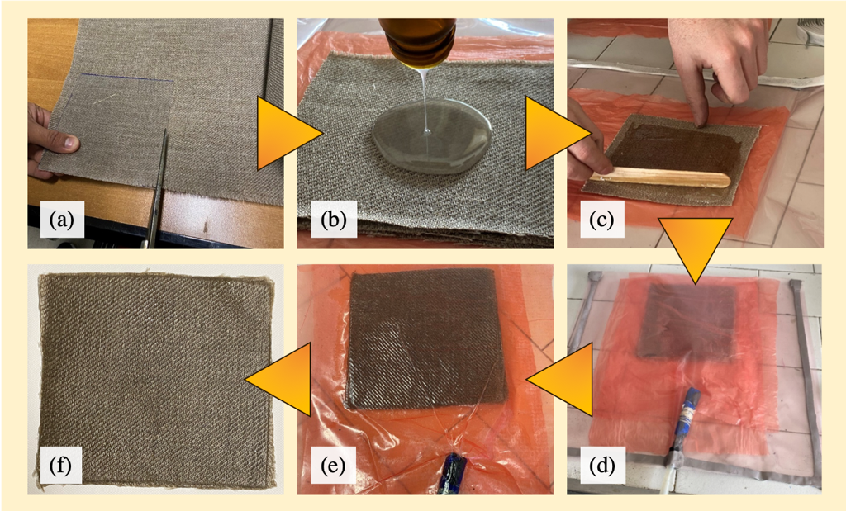
Figure 1. Green fully recyclable composite manufacturing procedure: (a) plies cutting; (b) plies stacking and epoxy resin adding; (c) epoxy resin hand lay-up; (d) vacuum bag preparation; (e) curing under vacuum conditions; (f) cured epoxy flax fibers composite.

Chemical recycling
Once the composite panel was cut in small pieces, 10g of specimens were solubilized in 300 ml of acetic acid solution (75%vol acetic acid and 25%vol distilled water) at 80°C for 90 minutes. As soon as the dissolution of the epoxy matrix was completed, the released short flax fibers were filtered from the acetic acid solution and recovered. While, the liquid solution was neutralized with a sodium hydroxide solution (40g of NaOH in 250ml of distilled water) until a solid whitish precipitate appeared: the recycled thermoplastic. The latter was filtered and then washed in distilled water. In the end, the epoxy recycled thermoplastic polymer was dried for 24 hours and pulverized using mortar and pestle. The entire recycling procedure is outlined in Figure 2.

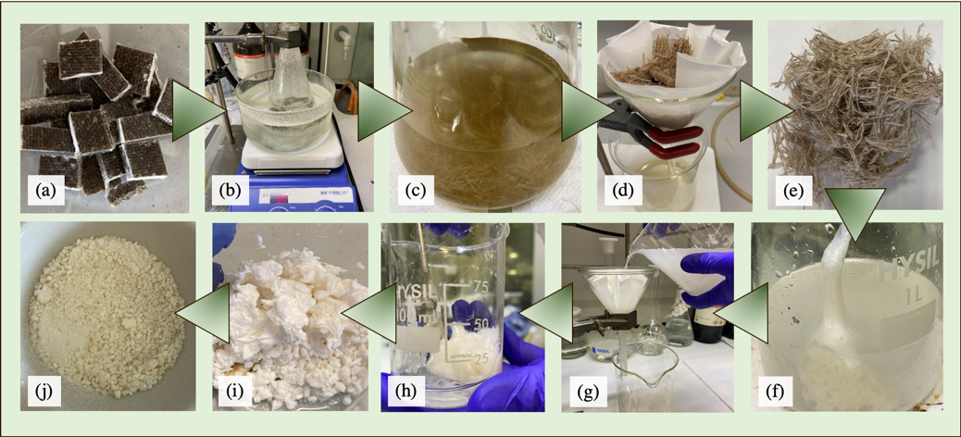
Figure 2. Chemical recycling procedure of the flax fibers composite: (a) cut composite specimens; (b) composite dissolution within acetic acid solution; (c) epoxy matrix dissolved and free flax fibers; (d) flax fibers filtration; (e) dried recycled flax fibers; (f) neutralization process and recycled thermoplastic precipitation; (g) recycled thermoplastic filtration; (h) recycled thermoplastic washing; (i) recycled thermoplastic recovered; (j) dried and pulverized recycled thermoplastic.

Recycled Thermoplastic re-use: electrospun fibres
As a reuse strategy, to follow a typical circular economy approach, the recycled thermoplastic was used to produce electrospun veils which, in turn, may be used for the interlaminar toughening of composite laminates. About that, 5g of recycled thermoplastic powder were solubilized in a solvent mixture of N,N-dimethylformamide (6ml) and Toluene (5ml) at 40°C and under stirring conditions. Once the polymer was totally solubilized, it was electrospun by using an IME Technologies Electrospinning machine. This setup apparatus consists of a syringe filled with the polymer solution, a high voltage source (3-3kV) and ground collector. In addition, a metering syringe pump is used to control the flow rate of the polymer solution. The electrospun veil was produced by using the following conditions: d.d.p. of 18kV; a gap between the spinneret and the collector equal to 15cm and a polymer solution flow of 35μl/min.

Differential Scanning Calorimetry (DSC) analysis
The calorimetric measurements were carried out using a Shimadzu DSC-60 (Shimadzu, Kyoto, Japan). DSC analyses were run on the recycled thermoplastic obtained from the chemical recycling process (solid state). The sample, having a size of 6mg, was placed into a 40-μL sealed aluminium crucibles and next it was heated from room temperature (25°C) up to 300°C at a rate of 20°C/min in air. Two different scans were run.

Scanning Electron Microscopy analysis
To analyse the morphology of the electrospun veils, a scanning electron microscopy SEM EVO 15 (Zeiss, Cambridge, UK) was used. To gather high-quality information, the sample was positioned on a sample stub and gold sputtered by using a sputter coater machine. The SEM analysis has been carried out at different magnifications ranging from 5000x to 20000x. The electron source used was a LaB6 emitter (Lanthanum Exaboride).

Results and Discussion
Recovered flax fibers (2.0g) and recycled thermoplastic polymer (2.85g) obtained from the chemical recycling process are shown in Figure 3. A recycling process yield equal to 100% was obtained for the flax fibers’ recovery, while it was of 95% for the thermoplastic polymer. The recycled thermoplastic obtained from the chemical recycling process was characterized by DSC analysis. The first scan was necessary for the release of impurities (residues of solvents and water) from the recycled thermoplastic, according with the irregularity of the curve. While, the results obtained from the second scan showed a glass transition temperature (Tg) equal to 63.9°C. The latter was lower than the starting fully cured epoxy network (Tg = 96.2°C). So, this thermal parameter has undergone a decrease of about the 51%. Comparable results were obtained from polymers derived from the recycle of bio-based epoxy resin cured with cleavable amine [6].

The result of the electrospinning process is shown in Figure 4. No difficulties were faced during the electrospinning process. The morphological analysis confirmed the suitability of the recycled thermoplastic for the electrospinning technique. Nano scale electrospun fibers, ranging between about 220 nm up to 410nm were obtained. Nevertheless, the process parameters must be optimized to reduce the presence of beads. The optimization process should mainly involve two operating parameters: the applied voltage, which should be increased, and the solution feeding rate that should be decreased, to solve the beads formation issue. In fact, it was found that the latter is a phenomenon due to electrospun jet’s axisymmetric instabilities, and it was proved that both applied voltage and solution feeding rate are key parameters for the development of different fiber morphologies, thus for the beads formation reduction [7].
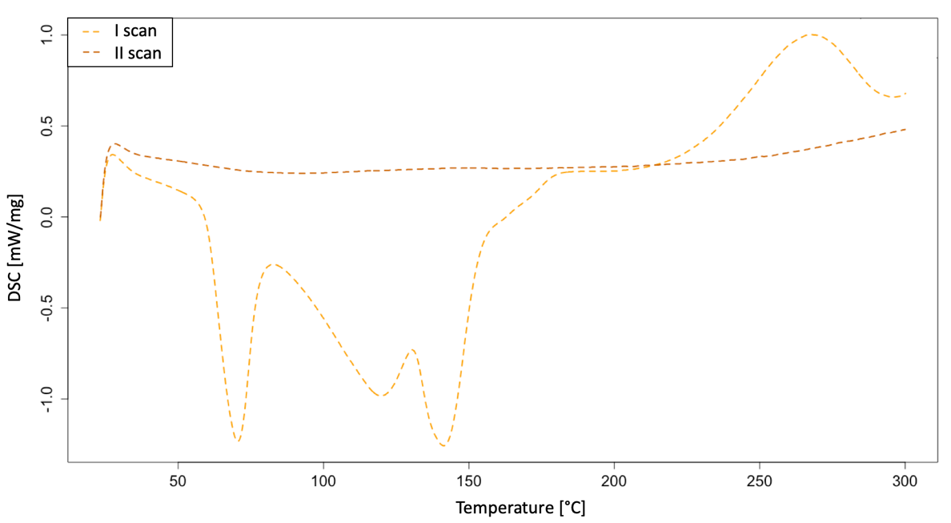
Figure 3. DSC analysis (I scan and II scan) result obtained for the recycled thermoplastic produced.
Figure 4. SEM analysis results obtained for the electrospun fibers produced starting from recycled thermoplastic (magnification equal to x9000).

Conclusion
Since the current recycling practice in the maritime field result to have negative social and environmental impacts, the use of recycling alternatives for composite materials which address to hazards reduction is needed. The chemical recycling process used in this experimental work represents an environmentally-friendly alternative for the end-of-life thermoset FRCs treatment. Environmental advantages, mainly due to material recovery, have been proved by previous LCA study [5]. Finally, this study opens up further possibilities to reuse the recycled polymer for the electrospinning technique. In turn, produced electrospun thermoplastic fibers may be used for the interlaminar toughening of composite laminates, since both Mode I and Mode II crack propagation results improved [8,9], delamination resistance increased and fatigue life enhanced [10].

References
A. E. Krauklis, C. W. Karl, A. I. Gagani, and J. K. Jørgensen. Composite material recycling technology - state-of-the-art and sustainable development for the 2020s. J. Compos. Sci. 2021; 5(1).
G. Oliveux, L. O. Dandy, and G. A. Leeke. Current status of recycling of fibre reinforced polymers: Review of technologies, reuse and resulting properties. Prog. Mater. Sci. 2015; 72:61-99.
Science for Environment Policy. Ship recycling: reducing human and environmental impacts. Issue produced for the European Commission DG Environment by the Science Communication Unit, UWE, Bristol. 2016: Thematic Issue 55.
[4] https://ec.europa.eu/clima/policies/transport/shipping_en
G. Cicala, et al. Hybrid composites manufactured by resin infusion with a fully recyclable bioepoxy resin. Composites Part B: Engineering. 2018; 132:69-76.
G. Cicala, E. Pergolizzi, F. Piscopo, D. Carbone, G. Recca. Hybrid composites manufactured by resin infusion with a fully recyclable bioepoxy resin. Compos. Part B Eng. 2018; 132:69-76.
W. Zuo et al. Experimental study on relationship between jet instability and formation of beaded fibers during electrospinning. Wiley InterScience. 2005.
L. Daelemans et al. Nanofibre bridging as a toughening mechanism in carbon/epoxy composite laminates interleaved with electrospun polyamide nanofibrous veils. Elsevier 2015:244-256.
G.W. Beckermann et al. Mode I and Mode II interlaminar fracture toughness of composite laminates interleaved with electrospun nanofibre veils. Elsevier. 2015:11-21.
- G. Cicala, et al. Influence of Soluble Electrospun Co-Polyethersulfone on Veils on Dynamic Mechanical and Morphological Properties of Epoxy Composites: Effect of Polymer Molar Mass. Advances in Polymer Technology. 2018; 37(3):798-809.

Corresponding Author, Lorena Saitta, Department of Civil Engineering and Architecture, University of Catania, Viale Andrea Doria 6, 91125 Catania, Italy; E-mail: lorena.saitta@phd.unict.it.

