Surfing green, saving money

ELISABETTA PIANA

General Manager Karberg & Hennemann srl

**Abstract.** The paper addresses the importance of fuel/lube oil treatment in marine applications. Oil filtration allows the fluid to maintain its characteristics for longer; this increases its duration and therefore reduces the need for supply. Old oil has to be disposed and every liter produces 2.6 kg of CO2 during the disposal process. Moreover, clean oil increases reliability of machinery, saving plant stops an unplanned expensive maintenance. Oil can be maintained but as contaminants accelerate oil degradation, it is very important to keep it clean and dry. A cased study is reported to better understand what this means.

**Keywords.** Oil filters, CO2 emission, energy savings

# 1. Introduction

Every time we talk about reducing emissions, we think of expensive investments. Instead, you can protect the environment with an advantage also for your wallet! How? Making resources last longer! How? Maintaining them! Have you ever thought of filtering the oil (be it synthetic or mineral) on board, regardless of its function (fuel or lubricant)? If you do, the fluid will last longer with the following benefits:

* Reduction of supplies: oil lasts longer, you have to buy less
* Reduction of CO2 emissions by reducing waste oil to be disposed of (1 liter of waste oil produces 2.6 kg of CO2)
* CO2 reduction due to the reduction of transport for the supply of new fluid
* CO2 reduction due to the reduction of transport for components that fail due to the wear of consumable components of generators, motors, winches, etc.
* Lower consumption for energy needs (today if you do something, you do it using centrifuges that have a high consumption for heat production)
* Fewer failures and consequent repairs and replacement of components.
* Carbon dioxide (known by the chemical formula CO2) is a colorless gas present in the atmosphere that is inert and odorless.

CO2 is involved in the life processes of animals and plants, respiration and combustion. Since it is a greenhouse gas moreover, its main function is to retain global warming, in a natural phenomenon of thermoregulation. This process allows ideal thermal conditions to favor the birth of life on the planet and its maintenance.

An uncontrolled increase in carbon dioxide, however, risks overheating the planet causing enormous environmental damage. Among the many negative effects are the melting of glaciers and the rise in sea level, with an increase in periods of drought alternating with devastating floods.

The excessive use of fossil fuels as sources of non-renewable energy, together with the alteration of the territory and the progressive overbuilding of the environment, creates, therefore, a serious imbalance in the earth's natural cycle.

In addition to being involved in the natural biogeochemical cycle, in fact, CO2 is produced by man with the combustion of organic compounds such as oil, coal and natural gas.

In 2020, the concentration of CO2 in the atmosphere exceeded the level of 400 ppm (parts per million) with a growth rate of about 2.5 ppm per year. The carbon dioxide thresholds of the pre-industrial period amounted to about 280 ppm [1].

Reducing oil consumption, making it last longer, helps to reduce emissions since 1 liter of used oil produces 2.6 KG of CO2 [2]. Otherwise, waste oil from ships could be recycled to obtain new oil, as proposed in [3] and [4].

# 2. Oil filtration: why?

The technical literature states that 70-80% of all failures and breakdowns are attributable to an inadequate filtration system [5].

## 2.1 Solid Contamination

The effects that solid contamination has on the system can be catastrophic if they cause in a short time the breakage or in any case the unavailability of a component (e.g. a pump), temporary if they involve the temporary loss of operating characteristics (e.g. obstructions of a pilot valve) and progressive, resulting from a relatively slow and hidden process, without a particular external visibility, which lead to a degradation of the performance. Particle contaminants that affect hydraulic systems have dimensions between a few micron and a few hundred micron.

As an indication, the resolving power of the human eye is about 40 μm, while the average diameter of human hair is 70 μm. Over 90% of the particles present in hydraulic systems are between 5 and 15 μm in size.



**Figure1.** Size comparison

In general, 100 liters of hydraulic fluid of a circuit contain from 1 to 5 billion particles larger than 1 μm.

## 2.1.1 External Contamination

## Contaminants existing in the surrounding environment that enter the hydraulic system passing through the worn seals of the lids, cylinder stems and filling and topping up nozzles are called sources of external contamination.

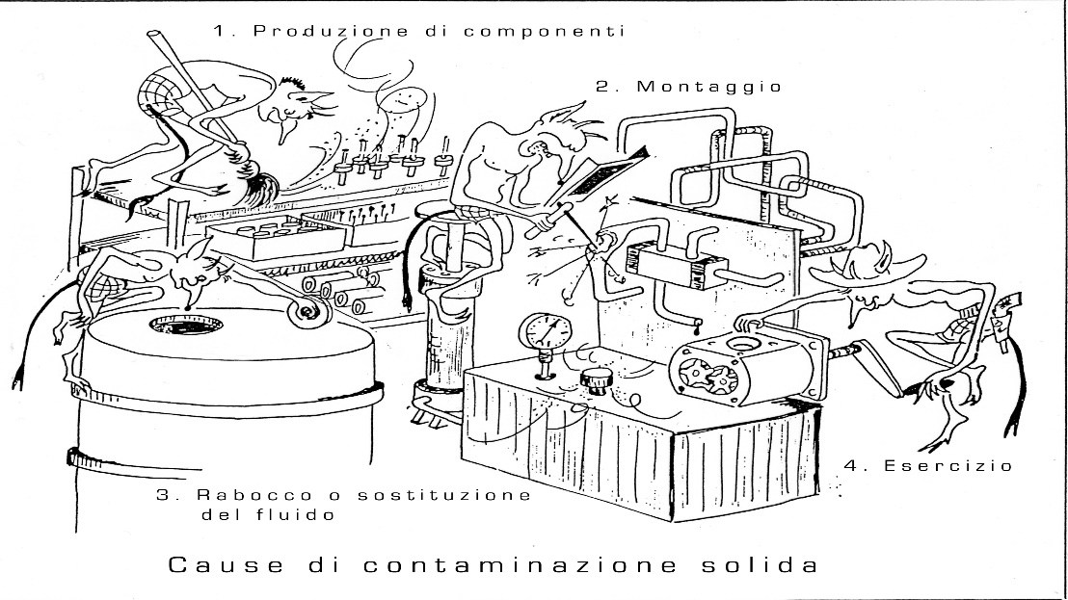

**Figure2.** Source of contaminant

## 2.1.2 Internal contamination

The contamination generated within the system by the components with elements in relative motion, accelerated by any solid contaminants or by water already present in the system, is one of the most important causes of malfunction or breakage of a hydraulic system.

The following causes of internal contamination may be identified.

## 2.1.2.1 Abrasion

Abrasion develops because of medium-sized particles that enter the meatus that is created between the surfaces in relative motion: they adhere to one surface and act on the other like a cutting tool, engraving the material.

The particles that cause the most serious damage are those solid and having dimensions equal to or slightly greater than those of the meatus, while those that are generated by abrasion are hardened by an overheating process (quenching); if they are not removed by adequate filtration they remain in circulation and in turn cause abrasion and other detachment of particles with an increasing effect over time.

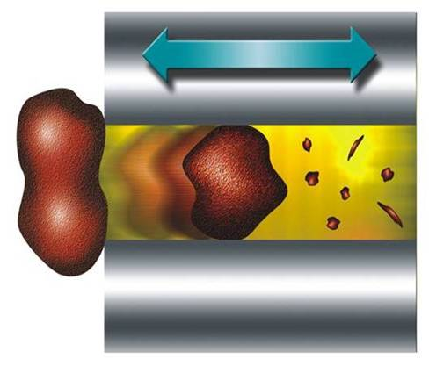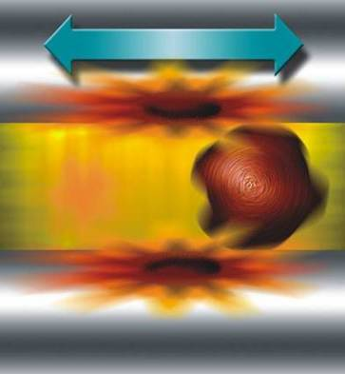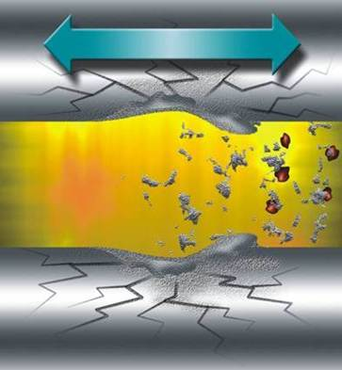

**Figure 3.** Abrasion

## 2.1.2.2 Erosion

Erosion is due to the impact of even very small but very fast particles on the surface of a component.

The transformation of kinetic energy into heat causes very strong localized overheating, micro fusion and detachment of small particles. This type of wear is typical of components with very high fluid speeds, such as for example in control valves. The large number of particles that detach can give rise to a rounding of the adjustment edges of the components with consequent loss of functional characteristics. The formation of large quantities of small particles is then a cause of acceleration of the aging process of lubricating fluids, as the small numerous particles capture large quantities of oxygen molecules which oxidize to the additives of the oils.

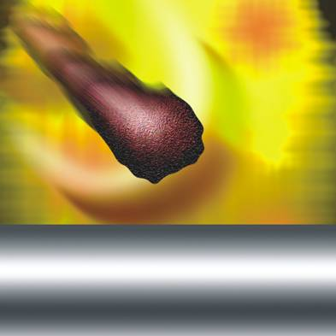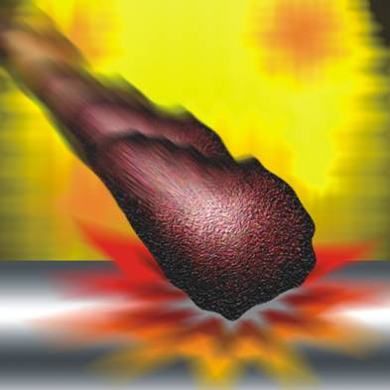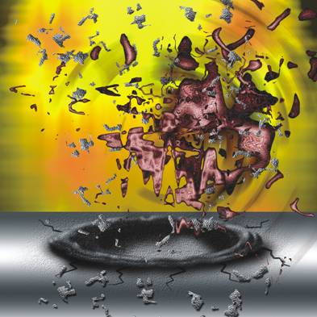

**Figure 4.** Erosion

## 2.1.2.3 Fatigue

The bearing surfaces are particularly subject to fatigue phenomena, due to the repeated stresses due to the particles trapped between the moving surfaces.

The surfaces initially become rough, subsequently micro-cracks appear which increase in size, often causing detachment of material and formation of craters.



**Figure 5**. Fatigue

## 2.1.2.4 Cavitation

An insufficient size of the suction pipes of the pumps or the entry of air, due to an imperfect seal of the pipes, or fittings generate cavitation phenomena that cause implosions on the smooth surfaces of the more sensitive internal organs of the hydraulic components. The resulting effect is a pitting that pits the surfaces and releases large quantities of contaminant into the circuit, in some cases it can even lead to sudden seizures.

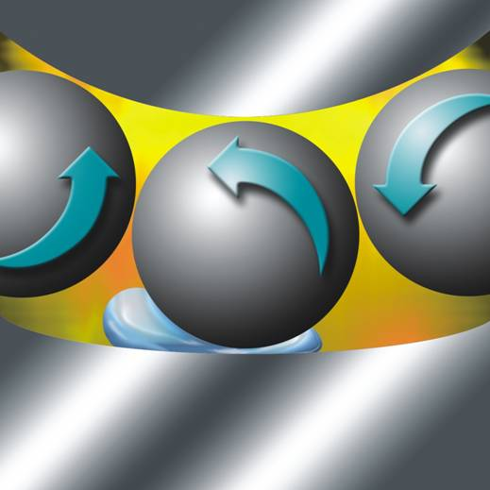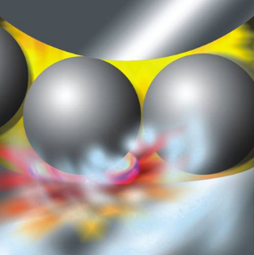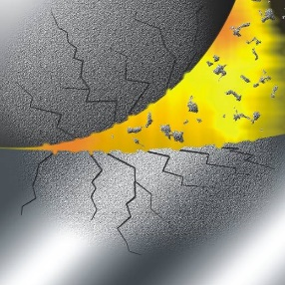

**Figure 6.** Cavitation

## 2.1.2.5 Adhesion

Excessive loads, low speeds and / or reduced viscosity of the fluid can reduce the lubricant film, thus allowing direct contact between metal surfaces. Surface asperities tend to weld together (cold welding); the relative movement of the surfaces then causes the subsequent breaking of this bond with the consequent generation of heat and detachment of solid particles.

## 2.1.2.6 Corrosion

Corrosion is generally due to the presence of water and chemical agents that cause rust or damage to metal surfaces or gaskets.



**Figure 7**. Life extension [6].

## 2.2 Water

The water in the hydraulic fluid can be present in free or dissolved form, i.e. mixed at a molecular level and therefore not too dangerous.

The boundary between free or dissolved water is set by the saturation point which varies from fluid to fluid and increases with temperature. Once the saturation limit has been reached, the fluid can no longer hold or dissolve an additional amount of water and releases it. Normally, one notices the presence of free water because it determines a milky appearance of the hydraulic fluid.

The damage caused by the presence of water is manifold, the anti-wear additives precipitate forming acid substances, and thus it is possible to reach a total breakage of the lubricating film.

Biodegradable fluids consist largely of natural esters (e.g. rapeseed oil) or synthetic esters that are poorly compatible with water. The formation of the ester takes place in a process in which special acids react with alcohol with the elimination of water. This process is reversible: that is, the introduction of water can transform itself back into alcohol or acids. In this case, of course, the hydraulic fluid will lose its characteristics and the resulting acids represent a danger for the components of the machines.

In systems that work with mineral oils, the ingress of water can lead to significant malfunctions in a short time due to corrosion of the metal parts, swelling or destruction of the gasket materials and accelerated aging of the oil.

If we are in the presence of high temperatures, the contact between water and metals of different nature creates a galvanic couple with consequent corrosion of the surfaces which thus take on a typical pitted appearance.

**Figure 8**. Life extension moisture [6].

## Soft Contaminant - Varnish

Sludge, also known as a soft contaminant, are lacquers that are formed due to the degradation of the oil. The precursors of varnish are the so-called soft contaminants, created by the aging processes of the oil. The speed of the flow or flow. The undissolved reaction produces form agglomerates that cause varnish deposits, sludge in the system, especially in hot and cold spots in areas subject to stress and in narrow passages such as, for example, radiator valves, tank walls, bearings.

Due to the temperature dependence, in lubrication systems with start-stop operation, i.e. in the presence of temperatures <40 ° C for many hours if not days, there is a precipitation of the dissolved compounds and consequently of the most intense deposits. Varnish is the name used for accumulations similar to wax or paint that form a fixed, adhesive layer on the surfaces of metals, adhering to the particles causing a polishing effect, intensifying the wear process. To avoid varnish formation, dissolved and undissolved contamination must be removed. Soft contaminations, in loose form, usually at oil temperatures above 40 ° C, cannot be removed with traditional mechanical and electrostatic filters. Consequences are shortened component life, increased wear and maintenance cost.

Varnish cause The so-called Monday crisis, alias failure in the start-up phase.

# 3. Case Study

Let us now proceed to see the practical effects of oil filtration through a test we made on two ships: CMS "Hong Kong Express” and CMS "Hamburg Express" 13.177 TEU. Both ships are equipped with a MAN 11K8ME MK 7.1 (throttled to 45.100 kW @ 84rpm since 2017) slower-running 2 stroke diesel engine with 8.000 running hours (Rh) per year. Lube oil is different but similar for the two ships: “Hong Kong Express” uses Mobilgard 300 11,9 cst @ 100°C, while “Hamburg Express” uses LukOil Navigo 6 SO 11,5 cst@100°C. The tank volume is the same for both applications: 70 m3 (i.e. 1.2 l/kW).

The test lasted 45 weeks, equivalent to 5244 Rh (running hours) during the test (24556 to 29800 hours).

The engines were equipped with two conventional systems (centrifuge) for each engine.

A CJC 3x427 /108 filtration system was installed for fine filtration and dehumidification (24h/7days per week /365 days per year).

Conventional systems during the test have been disabled.

The characteristics of the installed system are the following:

* pump flow rate: 3000 l / h;
* filter material: 100% cellulose;
* filtration degree: 3 micron absolute, 1 micron nominal;
* 72 kg solid contaminant accumulation capacity;
* system equipped with oil condition monitoring.

The implementation of a CJC Oil condition monitoring system on the “Hong Kong Express” enables precise real-time oil condition values ​​to be transmitted to the ship's bridge. The sensor package detects differential pressure, temperature, relative humidity (Rh%) and wear particles.

Anomalous events and harmful influences can be recognized at an early stage, so that it is possible to take countermeasures in good time in a cost-effective and unpredictable manner.

The weekly oil samples were analyzed in two laboratories (Filtrex, Alcontrol/Synlab). The condition of the oil was rated as "normal" throughout the test period:

* particle and water content minimized;
* stable viscosity;
* stable Base Number (TBN);
* No influence on the content of additives.

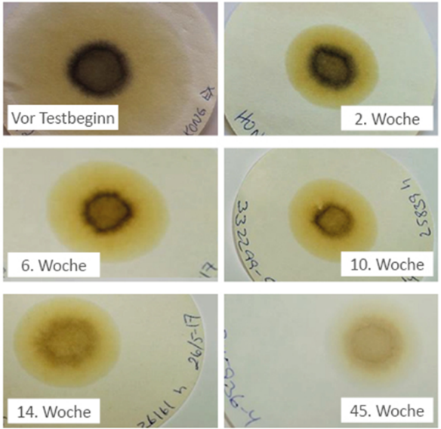

**Figure 9**. Dab test

The patch test (see Fig.9) shows that the lubricating oil was still heavily contaminated with dust, metal abrasion and other particles >1 micron before and at the beginning of the test period. In addition, the oil showed the first signs of aging (brownish coloration) and a higher water content (jagged edge zones). Thermal stress on so-called hot spots (e.g. bearings) and particles from component wear (copper, iron, aluminum) accelerate the breakdown of the base oil and the breakdown of additives and thus oil aging processes. There was no contamination of the circulating lubricating oil with fuel.

Due to the efficient oil care with CJC, not only particles and free water, but also water dissolved in the oil as well as aging products and possibly acidic components are continuously and permanently removed - the oil purity and the dispersing ability have clearly improved during the test phase.

## 3.1 Results - savings in CO2 emissions as well as operating and energy costs

By means of filtration is possible save:

* Oil: about **98% lower lubricating oil losses** in relation to the lubricating oil treatment. On the contrary, centrifuge, together with the contaminant, also removes a lot of fluid = 9846 l/year.
* Energy: **97% lower energy requirement** in relation to lubricating oil processing = **332.725 kWh/year.** When using the systems for conventional lubricating oil processing, the steam required for the preheating (heating capacity 9 kW) of the lubricating oil from 36°C to 92°C must be generated by means of the boiler during the lay times in the port. With CJC oil care systems, there is no need for fuel in the boilers in the port to burn, as no pre-heating of the lubricating oil is required – therefore, there are significant savings in fuel consumption and fewer emissions in the port.
* **CO2** **96% lower emissions** in relation to the lubricating oil treatment = **154 ton/year**. The extreme discrepancy between the two systems in terms of energy requirements and lubricating oil losses enables Hapag Lloyd to significantly improve the CO2 emissions of CMS "Hong Kong express" and CMS "Hamburg Express" when using the CJC oil maintenance system. When burning 1 liter of fuel or thermally disposing of 1 liter of old oil sludge, around 2.6 CO2 are produced [7].

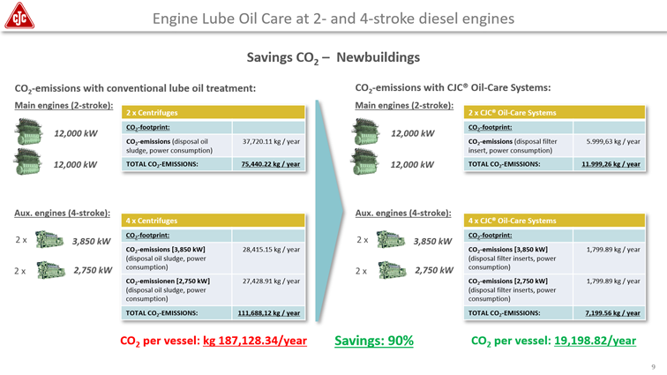**Figure 10**. CO2 saving

# 4. Conclusion

We care say “oil is for the machine as blood is for our heart”. A cholesterol-free blood prolongs your life as a clean oil prolongs the life of the engine. That reduces also oil consumption with high economic and environmental benefits. In particular, the oil filtration technology presented in this paper allows a CO2 emission reduction greater than 90% in comparison with conventional lube oil treatment. Last but not least, also the engine will be more reliable and last longer (at least 1.3 times according to Noria study [6]).

**References**

1. <https://www.tuttointornoanoi.it/emissioni-co2>
2. [https://www.spritmonitor.de/de/berechnung_co2_ausstoss.html](https://eur04.safelinks.protection.outlook.com/?url=https%3A%2F%2Fwww.spritmonitor.de%2Fde%2Fberechnung_co2_ausstoss.html&data=05%7C01%7Cep%40cjc.it%7C25f3e880282c4d51bbec08da38ade0d9%7Cbf44656b6bc74f2ab19ec6d658d31f1f%7C0%7C0%7C637884616689518900%7CUnknown%7CTWFpbGZsb3d8eyJWIjoiMC4wLjAwMDAiLCJQIjoiV2luMzIiLCJBTiI6Ik1haWwiLCJXVCI6Mn0%3D%7C3000%7C%7C%7C&sdata=5MBxq3WO5d8JvXd4vgFHNnVgrU4HRuDWBXNNRc%2BHoEw%3D&reserved=0)
3. Vigna V, Altosole M, Figari M, Ferrari A. A ship energy efficiency analysis by considering trim influence and waste recycling. In: Georgiev P, Guedes Soares C, editors. Proceedings of the 18th International Congress of the International Maritime Association of the Mediterranean, IMAM 2019; 2019 September 9-11; Varna, BU. Boca Raton CRC Press; 2020. p. 316-21.
4. Mazzoccoli M, Altosole M, Vigna V, Bosio B, Arato E. Marine Pollution Mitigation by Waste Oils Recycling Onboard Ships: Technical Feasibility and Need for New Policy and Regulations. Frontiers in Marine Science 2020, 7, 566363.
5. [CORSO DI OLEODINAMICA (cefran.altervista.org)](http://cefran.altervista.org/formazione/Archivio/OLEODINAMICA_INDUSTRIALE.pdf).
6. Noria Corporation INC.
7. [www.cjc.de](http://www.cjc.de) /www.cjc.dk.