**Technical feasibility study of an ammonia-fuelled mega-yacht powered by PEM fuel cells**

Russo Roberta a,[1], Acanfora Maria, Coppola Tommaso, Micoli Luca.

a Industrial Engineering Department, University of Naples

**Abstract.** The maritime sector forecasts that ammonia will play a pivotal role in decarbonizing ships since it does not emit carbon dioxide (CO2). Nevertheless, burning ammonia in ICE produces nitrogen oxides (NO2 and N2O), which are GHG more dangerous than CO2. The use of Proton Exchange Membrane Fuel Cell (PEM) systems instead of ICE avoids the emissions of harmful compounds. In this study, a PEM system is considered for the electric power generation onboard a 63 m length mega-yacht, replacing a traditional MGO gen-set. The pure hydrogen required for fuelling the PEM is produced through an ammonia decomposition reactor and a purification system, to be installed onboard as well. It results that an ammonia processing system for generating hydrogen requires additional power, in this case study is in the range of 360-475 kWe, and it is heavier and bulkier than the gen-set. Despite these cons, its installation onboard seems to be feasible and it does not involve significant modifications to the original configuration of the mega-yacht. The ammonia-fuelled mega-yacht reduces the original duration of navigation from 11 to about 5 days, nevertheless, this value appears still adequate considering the innovative solution at zero-emission proposed.

**Keywords.** Zero-emission ship; Fuel Cell application; Ammonia; Mega-yacht.

# Introduction

In the last decades, the International Maritime Organization (IMO) has targeted greenhouse gas (GHGs) emissions on ships by introducing several regulations aiming at a severe reduction of the carbon footprint (1,2). To reach this goal, some climate-friendly alternative fuels and technologies are being considered (3,4). Among this ammonia has been attracting a wide interest as fuel (5,6). For example, according to a DNV’s report (2019), ammonia could make up 25% of the maritime fuel mix by 2050, with nearly all newly built ships running on ammonia from 2044 onward (7). Ammonia (NH3) has the energy potential as an alternative marine fuel having a heating value of 18.6 MJ/kg, additionally, it's widespread and abundant. It is a colourless gas under ambient conditions (the boiling point is 240 K), while at pressures above 8.6 MPa at 293 K is liquid with a density of 0.61 t/m3(8).

The most relevant advantage of using ammonia in the marine sectors is that it does not release CO2 and other harmful compounds, such as Sulphur oxides (SOx) and particulate matter (PM), allowing it to comply with stringent environmental regulations (8). It is forecast that NH3 will play a pivotal role; however, its applications are still in early stages, since today there are not any vessels ready to use it. Indeed, some technical hurdles and safety issues must still be overcome in designing ammonia ships, for instance, related to toxicity, corrosiveness and NOx emissions burning in ICEs (8).

An option to prevent air pollution with ammonia is to use the fuel cell (FC) technology instead of ICEs. An FC is an electrochemical device that converts the chemical energy of a fuel directly into electrical energy with an efficiency higher than those of ICEs. Since no combustion process occurs in an FC, the release of harmful gases or particles into the air is avoided. In the case of FC, ammonia can be fed directly or used as hydrogen (N2) carrier. In the latter case, ammonia is dissociated easily into nitrogen (N2) and H2 through an endothermic reaction, then the H2 is concentrated before feeding a PEM (Proton Exchange Membrane) FC. The PEM is the most commercialized FC type, and it has already been applied on several ships (9).

The present work aims to study the technical feasibility of using ammonia as a hydrogen carrier for PEM onboard a passenger ship to reach the zero-emission condition both in port and in navigation. For this investigation, a 64 m length mega-yacht has been selected as a case study. The outcomes of this study could be considered for applications on other passenger vessels.

# Methodology

The PEM operates in the range of 70-80 °C requiring pure hydrogen as fuel. For a preliminary design and investigation, the product FCgen®-HPS provided by Ballard (Canada) has been assumed as a reference, that provides 140 kW power with an electrical efficiency of 55%; other main characteristics are reported in Table 1.

**Table 1.** Main specifics of PEM power system

|  |  |  |
| --- | --- | --- |
| **Specific** | **Unit** | **Value** |
| Operating Temperature | K | 353-363 |
| Rated Power | kW | Up to 140 |
| Rated Voltage | V | 202 |
| Rated Current | A | 645 |
| Efficiency | % | 55 |
| Weight | kg | 55 |
| Volume | m3 | 0.052 |
| Fuel Standard (H2) |  | ISO 14687-2 |
| Oxidant |  | Air up to 0.25 MPa |

The required H2 flow rate (m) is calculated according to the following equation (1), if the electrical efficiency (η) is constant:

$m=\frac{P}{η LHV }$ $m=\frac{P}{η LHV }$ (1)

Where P is the power generated and LHV is the lower heating value of H2 (120 MJ/kg). A basic PEM working scheme and main electrodes’ reactions are shown in Figure 1.

*~~*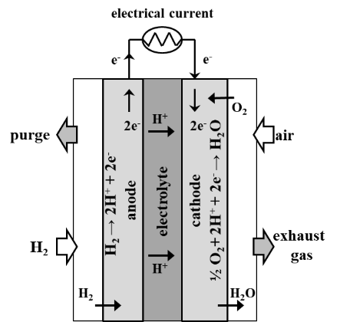

**Figure 1**. Image of the PEM system (FCgen®-HPS) by Ballard and basic principle of the working scheme.

Pure H2 is supposed to be produced by an ammonia decomposition reactor and a purification system, named Ammonia Processing System (APS). Within the reactor, ammonia can be dissociated into H2 and N2 via the endothermic reaction (2):

$2{NH}_{3} → N_{2} +3H_{2}$ ΔH = 46.22 kJ/mol (2)

This reaction requires both a catalyst and a heat source, which is produced electrically onboard. Then, a PSA (Pressure Swing Adsorption) system is used for the purification of H2. In this study, we referred to the specifics and performance of the APS supplied by SinceGas company (China), that can process an NH3 flow rate up to 250 Nm3/h and produces about 15 kg/h of pure H2. The main specifics are reported in Table 2.

**Table 2.** Main specifics of 250 Nm3/h gas generator system

|  |  |  |  |  |  |  |
| --- | --- | --- | --- | --- | --- | --- |
|  | **Length** | **Width** | **Height** | **Volume** | **Weight** | **Efficiency** |
| **[m]** | **[m]** | **[m]** | **[m3]** | **[t]** | **[%]** |
| Reactor | 2.3 | 2.6 | 3.0 | 17.9 | 3.5 | 98 |
| PSA | 5.0 | 1.6 | 3.6 | 28.8 | 10 | 90 |

The APS requires about 150 kW of electric power from the main switchboard, consequently, the electrical balance has been adjusted accordingly. The overall efficiency is evaluated from the inlet and outlet molar flows (88%), it considers the 98% efficiency of the decomposition reactor and the 90% of the PSA system. A scheme of the overall ammonia power production system is shown in Figure 2.

**Figure 2.** Scheme of the ammonia processing and power production systems.

# Case study

The target ship is a mega-yacht with an overall length (Lo) of about 64 m, which has an Atlantic autonomy of 4000 nm at 14 kn and reaches a maximum speed of 18 kn. The main shipowner’s requests are reported in Table 3.

**Table 3.** General specifications of the mega-yacht case study

|  |  |
| --- | --- |
| Main dimension, LoxBxD [m] | 64.4 x 11.3 x 6.2 |
| Displacement [t] | 921 |
| Maximum draught [m] | 3.6 |
| Decks [num] | 4 |
| Passengers [num] | 12 |
| Crew members [num] | 10 |
| Cruise speed [kn] | 14 |
| Maximum speed [kn] | 18 |
| Autonomy [day] | 14 |

The ship's structure is laid out over four decks named as reported in Figure 3.

The engine room is placed between the basic line (BL) and the Main deck, while the fuel is stored between the 50th frame and 73rd frame (collision bulkhead). The ship is powered by two main diesel engines (Rolls Royce, 4 strokes MTU 12V 4000 M33F) that allow a maximum power of 3021 kW to reach 18 kn speed, including sea and engine margin. Two shaft generators (Siemens, type C SISHIP EcoProp) are provided to supply additional power to the propeller when the main engines are underperforming. Both the “Power Take In” (PTI) and the “Power Take Off” (PTO) modes are planned. For the non-propulsion power demand, a diesel genset (Rolls Royce, 4 strokes MTU 12V M41A) is installed providing 575 kW.

Main loads are reported in Table 4 regarding the navigation and port profiles. It has been supposed that there is no evident seasonal variation of the loads (i.e. between Summer and Winter), instead, the loads vary in a range obtained from a predicted daily fluctuation, and the highest power request is about 300 kW. In Table 4, propulsion’s load (358-398 kW) refers to a speed of 8 kn in navigation.

**Table 4.** Electrical loads demand (kW) during navigation and port condition

|  |  |  |  |  |  |  |  |  |
| --- | --- | --- | --- | --- | --- | --- | --- | --- |
| **Condition** | **Propulsion**  **@ 8kn** | **Deck** | **Air**  **conditioning** | **Kitchen** | **Rooms** | **Lightning** | **Maximum**  **Hotel**  **Loads** | **Total Power** |
| Navigation | 358-398 | 36-60 | 60-100 | 42-70 | 15-50 | 21-70 | 300 | 606-693 |
| Port | 0 | 15 | 60-100 | 42-70 | 15-40 | 21-70 | 280 | 180-280 |

The electrical distribution of the ship is based on an Integrated Power System (IPS) configuration [57]. The genset supplies the primary switchboard, which controls the distribution to the electrical motors and the secondary energy networks (hotel loads). For the verification of the stability of the ship, the volumes and weights of consumables have been evaluated, assuming a specific consumption of the MGO of 197 g/kWh and a density of 830 kg/m3. The volume of fuel has been increased by 10% accordingly to the SOLAS regulation. Modification of initial spaces and weights on board must verify the stability of the ships. The lightship displacement, the centre of gravity and the freeboard have been recalculated after the introduction of the ammonia power plan and storage tanks onboard the mega-yacht to verify the flotation and trim (10).



**Figure 3.** The layout of the mega-yacht: A: Sun deck (12.9 m above BL); B: Upper deck (9.2 m above BL); C: Main deck (6.2 m above BL); D: Lower deck (3.3 m above BL).

# Results

The ammonia power generating plant has been located on the inner bottom between 30th and 48th frames; from the available volume onboard, has been assessed that four APSs can be installed with an overall volume and weight of 187 m3 and 54 t respectively. In the case of the zero-emission condition, the power supply is completely on the PEM system, consequently, the electrical balance was modified including the APSs electrical demand, as reported in Table 5.

**Table 5.** Electrical balance (kW) in zero-emission condition

|  |  |  |  |  |
| --- | --- | --- | --- | --- |
| **Condition** | **Propulsion** | **Ammonia Processor** | **Hotel Loads** | **PEM Power** |
| Navigation | 202 | 600 | 300 | 1102 |
| Port | 0 | 480 | 280 | 760 |

The APS can produce a maximum H2 flow rate of 60.1 kg/h corresponding to a maximum supplied power of 1102 kW and requiring 600 kW of electric power from the grid; therefore, the net electric power available from the PEM is about 502 kW. Considering that the hotel loads need up to 300 kW, it results that the power left for propulsion is about 202 kW, instead of the 398 kW initially required. The maximum speed that can be reached is about 3 kn, enough to allow green entry and exit from ports. In port, the maximum hotel loads power is 280 kW, which implies that the PEM must produce 760 kW including 480 kW required by the APS.

The APS has been arranged in two symmetrical main groups (2 reactors + 2 PSA), allowing an 85 cm wide corridor for the passage of the crew. The enclosed space for APS is classified as Hazardous Area Zone 1 and complied with the actual rules and guidelines of the IGF code; therefore, the space is enclosed by A60 protections and two airlocks. According to the electrical balance and the available H2 from the APS, 8 x 140 kW PEM modules are required, which occupy a total volume of 0.42 m3 and are 440 kg heavy. PEMs must be placed in a dedicated room: these are symmetrical with respect to the diametrical plane and located between the 25th and 27th frames, as shown in Figure 4. The FC space is also classified as a Hazardous Area Zone 1: A60 protection and forced ventilation are mandatory. The FC and APS spaces must be considered as a “Category A Machinery Space” and classified under SOLAS (Chapter II-2) for fire protection purposes, the fire suppression system must be suited to the specific fuel and FC technology proposed.



**Figure 4.** PEM and ammonia processing systems arrangement SG e GB.

Nine tanks of liquid ammonia can be installed onboard between the 50th frame and the collision bulkhead. Since ammonia is a low-flammability fuel, the IGF Code and RINa suggest the installation of A60 bulkheads and airlocks for storage space, that is supposed to be enclosed by gas-tight bulkheads; additionally, ammonia must be contained in type C double-walled tanks. It is expected that three tanks are 8.5 m in length and weigh 1.5 t, with a volume of 6 m3 each; six tanks have a volume of 5 m3 and a weight of 1.2 t each, with a length of 6.8 m. These have an external diameter of 980 mm and an internal diameter of 950 mm. The overall tanks’ weight is 11.7 t and the amount of ammonia stored is 48 m3 accordingly.

Four operating conditions are proposed: Booster Mode (BM), Full Electric Mode (EM), Cruise Mode (CM) and Port/Anchor Mode (PM). The operating schemes of such power solutions are presented in Figure 5. In the BM mode the mega yacht requires the highest power generation to cruise at the maximum speed: the main diesel engines, the shaft generator (PTI mode), the genset and the FCs work jointly. When main diesel engines and genset are shut off, the EM mode is configured: the FC system guarantees the onboard loads and, thanks to the shaft generator, it provides the propulsion as well. This configuration ensures GHG and noise emissions control and allows the "Power Take Home". In the CM mode, propulsion is provided by the main diesel engines while hotel loads are handled by the FC system. This mode provides redundancy thanks to the PTO of the shaft generator. PM mode assures "zero emissions" condition: the overall load is powered by the FC system.

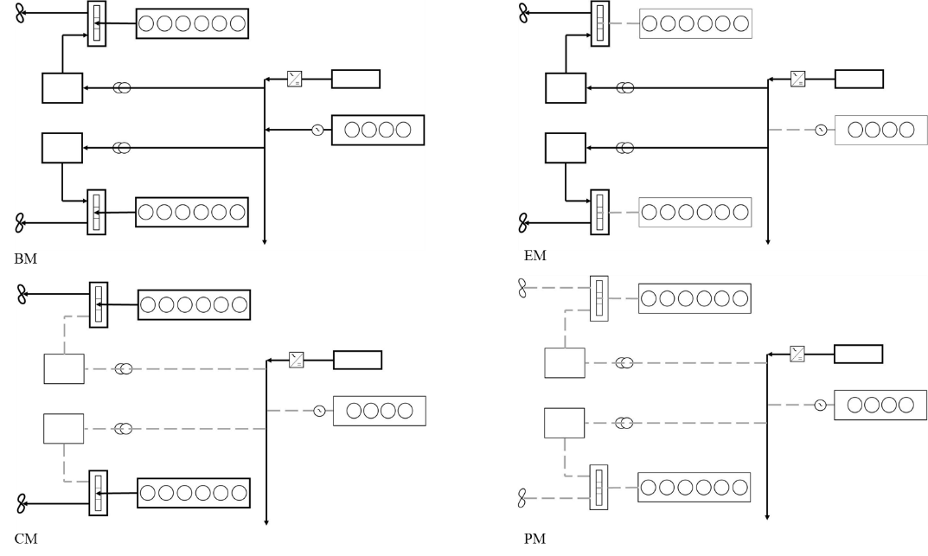

**Figure 5.** Operating condition schemes: Booster Mode (BM), Full Electric Mode (EM), Cruise Mode (CM) and Port/Anchor Mode (PM).

The amount of ammonia stored (48 m3) and the FC power plant installed onboard is not enough to guarantee the expected Atlantic autonomy, the maximum autonomy in hybrid configuration is evaluated for the different operating modes. In the case of CM, where the propulsion is on Diesel engines and PEM powers the other loads (658.4 kW), the autonomy is about 6 days. Within the EM the autonomy decreases to 4 days since the PEM supplies 1102 kW, of which only 202 kW are available for propulsion (at 3 kn). On the other hand, if it is assumed to reduce the hotel loads to increase the propulsion power up to 398 kW (8 kn), the autonomy is 3 days. Table 6 summarizes the autonomies for different operating modes in zero-emission and hybrid modes.

**Table 6.** PEM system autonomy for different operating modes in zero-emission and hybrid modes

|  |  |  |  |  |
| --- | --- | --- | --- | --- |
| **Operation** | **Electrical Power**  **[kW]** | **Propulsion Power**  **[kW]** | **Speed**  **[kn]** | **Autonomy**  **[days]** |
| Hotel loads | 658 | 2800 (on ICE) | 0-18 | 6 |
| Hotel loads + propulsion | 900 | 398 | 8 | 3 |
| Hotel loads + propulsion (250 nm) | 900 | 202 | 3 | 4 |



**Figure 6.** Vertical view of the mega-yacht showing the position of the centre of gravity (G: previous position, G’: new position).

Consumables to be stored are evaluated according to the CM condition with 6 days of autonomy. The new lightship displaced has been calculated: it resulted that Δ’ and DW’ are 912 and 151 t respectively. Before the refitting, the centre of gravity (G) had the following coordinates: LCG = 27.85 m, VCG = 2.93 m. The new centre of gravity (G’) resulted shifted to the bow of about 2.33 m and to the top of about 0.17 m (G’: LCG = 30.18 m, VCG = 3.10 m), as shown in Figure 6. The new location of G’ does not significantly affect the flotation, trim and stability of the ship.

# Conclusions

This work investigated the technical feasibility of an ammonia-fuelled mega-yacht aiming at the zero-emission condition. This goal was pursued by using ammonia as a hydrogen carrier for the PEM technology. Pure H2 production from NH3 needs a bulky and heavy fuel processing system which had to overcome some constrictions for the installation onboard. Despite this, it did not involve any significant modifications to the original configuration of the mega-yacht. The amount of ammonia to be stored onboard (48 m3) affects considerably the autonomy of the ship which varies from 3 to 6 days depending on the operating modes. Allocating more spaces onboard to the NH3 storage tanks can increase the autonomy, but it requires fundamental modification of the original arrangement of the ship. Nevertheless, such a solution allows navigation in ECA areas or stays in ports with stringent environmental regulations. It should be underlined that the use of green NH3 is encouraged to reduce remarkably the carbon footprint.

# Reference

[1] Mocerino L, Quaranta F, Rizzuto E. Climate changes and maritime transportation: A state of the art. Technology and Science for the Ships of the Future - Proceedings of NAV 2018: 19th International Conference on Ship and Maritime Research. 2018 Jan 1;1005–13.

[2] Cutting GHG emissions from shipping - 10 years of mandatory rules [Internet]. [cited 2022 Feb 1]. Available from: https://www.imo.org/en/MediaCentre/PressBriefings/pages/DecadeOfGHGAction.aspx

[3] Micoli L, Coppola T, Turco M. A Case Study of a Solid Oxide Fuel Cell Plant on Board a Cruise Ship. Journal of Marine Science and Application. 2021 Sep 1;20(3):524–33.

[4] Anders J. Comparison of Alternative Marine Fuels SEA\LNG Ltd. 2019 [cited 2022 Feb 1]; Available from: www.dnvgl.com

[5] Hansson J, Fridell E, Brynolf S. On the potential of ammonia as fuel for shipping: a synthesis of knowledge. 2020;

[6] What does an ammonia-ready vessel look like? [Internet]. [cited 2022 Feb 1]. Available from: https://www.wartsila.com/media/news/01-12-2020-what-does-an-ammonia-ready-vessel-look-like--2825961

[7] Ammonia as a marine fuel DNV [Internet]. [cited 2022 Feb 1]. Available from: https://www.dnv.com/Publications/ammonia-as-a-marine-fuel-191385

[8] MacFarlane DR, Cherepanov P v., Choi J, Suryanto BHR, Hodgetts RY, Bakker JM, et al. A Roadmap to the Ammonia Economy. Joule. 2020 Jun 17;4(6):1186–205.

[9] Afif A, Radenahmad N, Cheok Q, Shams S, Kim JH, Azad AK. Ammonia-fed fuel cells: a comprehensive review. Renewable and Sustainable Energy Reviews. 2016 Jul 1;60:822–35.

[10] Lewis E v. Principles of Naval Architecture Second Revision Volume III Motions in Waves and Controllability. Principles of Naval Architecutre. 1989.

1. roberta.russo5@unina.it