Proposal of a coastal ferry using last hybrid technology for green transportation in touristic areas.

Matteo ZANGRANDIa, Valerio RUGGIERO b AND Gian Piero REPETTIa

a VULKAN Italia

b Università degli Studi di Messina

**Abstract.** The coastal passenger transport in touristic areas like Costa Smeralda (Sardinia), Cinque terre (Liguria), Costiera Amalfitana (Campania), Venetian Lagoon (Veneto) and others, is constantly growing. At the same time, the sensitivity of authorities to the issue of environmental impact in those areas is leading the transportation companies to investigate technical solutions that can guarantee high volumes of passenger being as much as possible eco-friendly.

Hybrid or full electric passenger vessels are becoming more and more popular, starting from this assumption the authors examined the possibility to combine state of art technologies, with an innovative approach to match the propulsion system with hull resistance data, in order to propose a passenger ferry capable to operate in protected areas with an extremely low impact on the environment and taking advantage also from a basic energy distribution ashore. The usage of new generation batteries, with the highest safety standards, will be also investigated.

The paper starts from the determination of the operative profile for the ferry, evaluating the best solution in terms of efficiency and power management, considering the resistance data of various hulls, focusing on a traditional displacement hull, and then developing a study of the propulsion system through the usage of last generation generators with variable speed and batteries different from traditional Li-Fe-PO4, in order to achieve a high efficiency level.

**Keywords.** Hybrid Propulsion, Salt Batteries, Hybrid Ferry

# Introduction

Diesel fueled short-haul ferries deplete fossil fuel resources, emit greenhouse gases, are noisy, produce an unpleasant odor, and use inefficient internal combustion engines. Further, internal combustion engine operation adds to passenger discomfort through increased vibration levels [1]. Among the various possible alternatives to this configuration, the International Maritime Organization (IMO) identified the hybrid electric vessel concept [2]. A hybrid architecture, compared to a fully electric one, guarantee the same performance of the current diesel configurations, achieving a higher efficiency level and allows for electric running near terminals and residential or protected areas, reducing noise and pollution issues [3] [4].

One key point in the development of a today’s hybrid ferry is a future-oriented view, designing the system to be able to be refitted in the near future, substituting the diesel engine with a low or zero-emission energy source.

The other main topics are the energy storage system integration and the power management system design.

The trend toward integration of batteries into ferries has gained increased attention in recent years [5]. For this reason, a transition from AC to DC ship power systems are more and more under evaluation. Is recognized that a DC power system eases integration difficulties, through obviating the phase imbalance, synchronization, inrush current and power factor correction issues associated with AC power systems [6].

Moreover, the authors investigated possible alternatives to the more consolidated lithium-based chemistries for the battery systems. Due to the high cost of raw materials and the environmental impact of lithium-based chemistries[7], the authors identified in SMC (Sodium-Nickel-Chloride) chemistry a good alternative.

# The platform

The ship considered for this paper has a typical inland or coastal hull. In Table 1 are reported the main characteristics.

1. Ship characteristics

|  |  |
| --- | --- |
| **Data** | **Value** |
| Length overall | 33,95m |
| Beam | 7,20 m |
| Depth | 3,40 m |
| Design draft | 1,80 m |
| Design displacement | 205 t |

In Figure 1 is reported the general layout of the ship including the propulsion system.

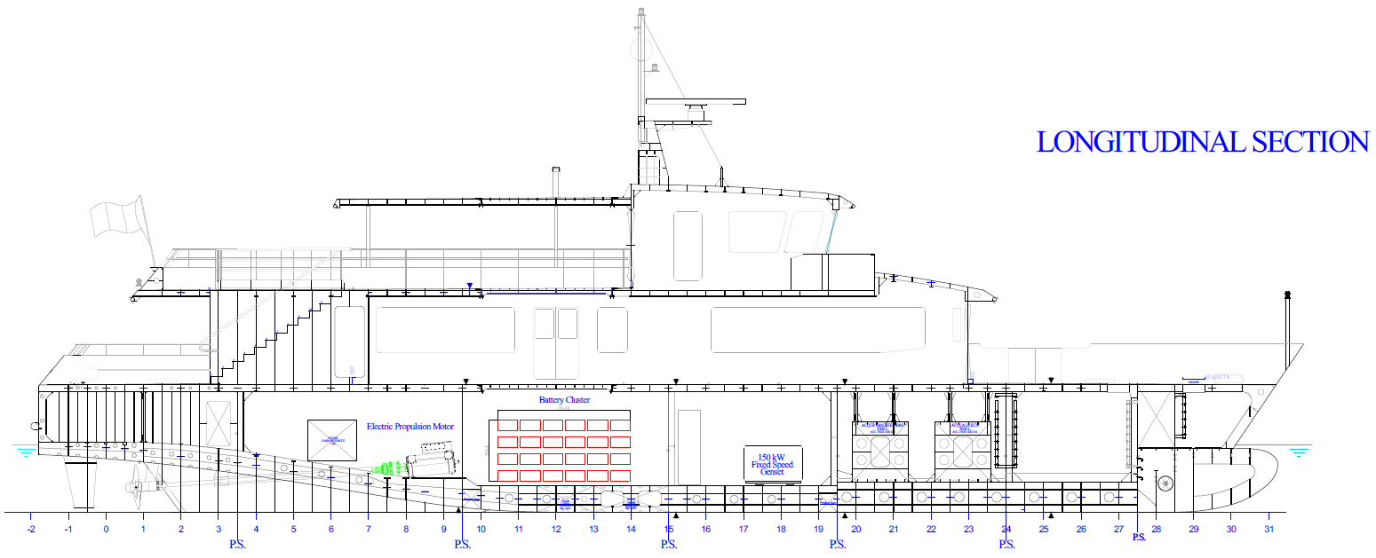

1. Longitudinal section

# Operational profile analysis

## Area of Operation

The considered Area of Operation is located in the Ligurian area of Cinque Terre. The ferry will touch 7 harbors with an average stopover of 5 minutes (Figure 2).

1. Operative route.

The cruise will touch 7 ports in a round trip:

* La Spezia (Departure and arrival)
* Portovenere
* Riomaggiore
* Manarola
* Vernazza
* Monterosso
* Levanto

## Operational profile

The cruise speed evaluated for the ferry is 10 knots, while the maneuvering speed is 4 knots.

The target of the system is to guarantee a zero-emission navigation during the port maneuvering and stops and a maximum comfort and low emission navigation during the transfer time. In Table 2 are reported the considered operational speeds for the different operational modes.

1. Operational speeds

|  |  |
| --- | --- |
| **Cruise Speed [knt]** | **Maneuvering Speed [knt]** |
| 10 | 4 |
|  |  |

The power request during cruise and maneuvering has been evaluated on the basis of tank tests of similar hulls. The results have led to consider a cruise propulsive power of 250 kW and a maneuvering propulsive power of 60 kW. The hotel load has been calculated assuming the average load of a 30m passenger ferry equipped with air conditioning and is equal to 50 kW.

Once the power request has been identified it was possible to define the energy consumption during the assumed round trip La Spezia – Levanto – La Spezia. Figure 3 and Figure 4 show the different power demands during the assumed cruising day.



1. Power demand La Spezia - Levanto



1. Power demand Levanto – La Spezia

# System Architecture

## General Layout

The most efficient architecture evaluated for the specific ferry is a diesel electric, or serial hybrid, configuration, where the diesel generator is used solely as a range extender, with a reduced power compared to the load.

As already demonstrated, the optimal solution for the electrical distribution is through a DC bus bar [8]. In the specific case a 750 VDC grid has been chosen. Directly to the main grid will be linked 4 battery clusters, the Fixed Speed Genset and the two propulsion motors (Figure 5).

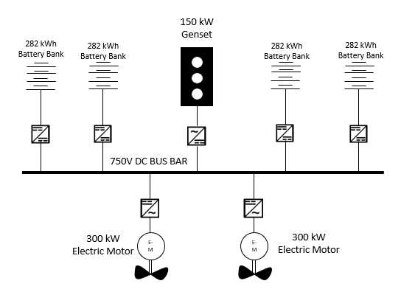

1. Propulsion System Architecture

## Drive Train Layout

In order to achieve the maximum efficiency and to minimize the mechanical losses the shaft line will be composed by a straight shaft in which the Electric Motor is a high torque synchronous permanent magnet machine, directly coupled on the propeller shaft without gearbox. The coupling device will be a VULKAN Propflex TB, which have the property to significantly cut the torsional vibrations and to act as a thrust bearing.

The characteristics of the selected E-Motor are reported in Table 3.

1. Electric motor characteristics 1.

|  |  |  |
| --- | --- | --- |
| **Data** | **Value** | **Unit** |
| Nominal Power | 300 @ 600 | kW @ rpm |
| Nominal torque | 4.78 | kNm |
| Weight | 1100 | Kg |
| Efficiency | 95,8 | % |

## Battery pack

The battery pack is composed by 4 different clusters, each one with a nominal capacity of 282 kWh and connected to the DC-link via a DC/DC converter. The total capacity of the battery is 1128 kWh (100% DoD). The battery pack is subdivided into two racks placed in the battery room from frame 10 to frame 15. Each rack is composed by two clusters and 24 modules (12 modules per cluster). The selected module is based on a SMC (Sodium-Metal-Chloride) chemistry with the following characteristics (Table 4):

1. SMC battery module characteristics

|  |  |  |
| --- | --- | --- |
| **Data** | **Value** | **Unit** |
| Nominal Capacity | 23.5 | kWh |
| Minimum Voltage | 426 | Vdc |
| Maximum Voltage | 696 | Vdc |
| Weight | 208 | kg |

The total weight of the battery pack is approx. 11 tons, including the supporting structures.

## Diesel generator and future implementations

Reducing the Diesel Generator to a mere range extender has two main advantages:

* The ship can always count on a robust and redundant power source that can be always activated in case of emergency.
* The ship is future ready. When the infrastructure will enable an easier usage of alternative fuels, for example hydrogen or ammonia, it will be much easier to substitute a small genset with an alternative power source like a fuel cell. Thanks to the system architecture, at least at an electrical integration point of view, the substitution of the diesel with a different electrical source would be almost plug and play.

To reduce since the beginning the emissions a dual fuel or a methanol genset can be evaluated. By the time this paper was written no methanol genset was available with the size needed for this project.

# Analysis of the battery choice

## Car-carrier “Felicity Ace” accident analysis

The case of the car-carrier “Felicity Ace” is a good example on how dangerous the transport of Lithium-Ion batteries can be.

On February 16th, 2022, vehicle carrier “Felicity Ace” was sailing off the Azores when a fire broke out. The ship was carrying an unspecified number of electric vehicles, despite the causes of the fire are not yet known, is sure that the presence on-board of a large number of Li-ion batteries has complicated the firefighting effort. The usage of water to extinguish a Li-ion battery fire is still under investigation [9][10][11][12], and a final set of rules is not yet released for these vessels, moreover the fumes from a burning battery are toxic and potentially explosive[13]. The battery packs kept the fire alive, and as result the ship sank on March 1st. All 22 crew members were safely evacuated from the ship and taken ashore.

## Alternative Solution for propulsion batteries – SMC batteries

Despite the accidents that may occur due to the presence on board of Lithium-Ion batteries (LIBs), this technology is still the most suitable for the majority of marine applications. Thanks to the automotive sector during the last 10 years, LIBs (in their various chemistries: LFP, NMC, LTO, etc.) has greatly improved their technological readiness, both on a performance and on a safety point of view. On the other hand, different solutions and different chemistries are already available on the market. In this paper the authors have investigated the possible application of Sodium-Nickel-Chloride (SMC) batteries. The basic reactants of this chemistry are Sodium Chloride (NaCl) and metal powders mainly composed by nickel. In the charged state these reactants are converted to sodium and metal chlorides:

$2NaCl+Ni↔NiCl2+2Na$ (1)

The electrolyte is solid state β” alumina, which provides fast transport of sodium ions and ensures the galvanic isolation between anode and cathode. The operating temperature of the cell is around 265°C, but the module is thermal isolated from the environment, thus the surface temperature of the enclosure is just a few degrees above the environment. The advantages of this kind of battery can be seen from several perspectives:

* Ecological aspects: the batteries are made with non-toxic material, with a low-impact life cycle and are 100% recyclable
* Safety aspects: the SMC batteries are intrinsically safe and several certifications for marine applications has been already released. It is proved that they do not suffer thermal run-away problems and in case of external fire they do not contribute to the fire spreading. Moreover, in case of mechanical damage of the module no toxic, explosive or flammable gases are emitted.
* Strategical aspects: given the uncertainties of lithium and other metals supply chain that during the last years are affecting the world, the opportunity to rely on a technology based on common, easy to find raw materials is a not negligible advantage.
* Operative aspects: When at ambient temperature the reactants stay in solid state. In this mode the battery is completely inert. This means that when the battery is cool does not need any monitoring and does not suffer any aging. This feature can be particularly interesting for a seasonal vessel, cause during the non-working months the ship can be stored, and the batteries are preserved from usury.

On the other hand, several disadvantages affect the SMC technology which make it not suitable for any kind of applications:

* Power density: the maximum continuous discharge for a SMC module is around 0.5C, this mean that it would be impossible to apply this technology where is demanded a small battery pack for high load peaks.
* Energy density: the energy density of the SMC batteries is comparable to the LFP chemistries (around 110/120 Wh/kg for the complete module) but lower if compared to NMC (180 Wh/kg for the complete module)
* Operative aspects: the high operating temperatures involve long warm-up time and high self-discharge rates; cause part of the internal energy is needed to keep the temperature while the battery is not charging/discharging

# Performance analysis

## Daily trip with the hybrid system

Given all the assumptions above mentioned, during the evaluated daily trip a total energy of 1225 kWh is consumed. The optimal operative profile evaluated will imply the usage of the genset at its optimal working point only during the cruise speed transfer, while it will be switched off during the harbor approach achieving a zero-emission navigation. With this usage the genset will contribute all day long with an energy production of 470 kWh. The rest of the energy, equal to 755 kWh, is supplied by the batteries. With this usage the batteries are discharged approx. with a 67% DoD (Depth of Discharge), which is optimal to ensure a long lifespan to the cells. At the end of the working day the ship will come back to the home port (La Spezia) and will be plugged to the shore connection for the night charge. A small shore charger with a power of 75 Kw, comparable to a common automotive charger, will be enough to recharge during the night stop the complete battery pack. In Figure 6 is reported the simulation for the battery daily energy consumption, assuming the first departure from La Spezia at 8.30 AM. During the berth night stop, a 10 kW power consumption has been evaluated, in order to keep active the onboard essential systems and to maintain the salt batteries working temperature.

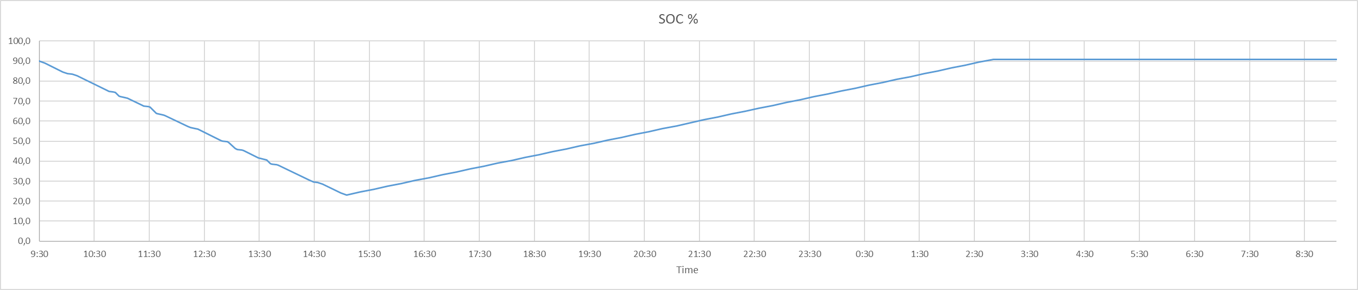

1. Battery energy evolution during day cruise and night recharge

# Conclusions

The paper examined a feasibility study for a serial hybrid coastal passenger ferry, with innovative solutions. The philosophy applied to the project was to realize a future oriented vessel, not completely eliminating its dependency on ICE, but greatly reducing the contribute of the diesel engine in the load sharing of the on-board power sources. This approach enables a future easier adoption of alternative and zero emission power sources, while guaranteeing the operative performances requested for the evaluated cruise. The serial hybrid system, based on DC distribution, with a small genset in range extender configuration will significantly decrease the total emissions from the vessel for two main reasons: the first is because considering the total amount of energy consumed during a working day, only the 38% is supplied by the diesel, and secondly, because with the evaluated operative profile the diesel engine will work constantly at its optimal point. A possible alternative for the battery system has been evaluated too. The usage of Salt Battery follows the general approach to the project, aiming at decreasing as much as possible the environmental impact of the vessel, not only during its operative life, but also from a construction and final recycling point of view. Those batteries are inherently safe, they don’t suffer any thermal run-away problem and don’t contribute to flame spreading in case of external fire event. Moreover, they are based on poor raw material with a supply chain easier to control compared to the lithium one and with a lower environmental impact. Lastly, Salt Batteries are 100% recyclable.

References

1. K. Fagerholt, et al., "Maritime routing and speed optimization with emission control areas," Transportation Research Part C: Emerging Technologies, 2015.
2. E. K. Dedes, D. A. Hudson, and S. R. Turnock, "Assessing the potential of hybrid energy technology to reduce exhaust emissions from global shipping," Energy Policy 2012.
3. J. Kumar, L. Kumpulainen, and K. Kauhaniemi, "Technical design aspects of harbour area grid for shore to ship power: State of the art and future solutions," International Journal of Electrical Power & Energy Systems, 2019.
4. V. Bucci, A. Marinò, D. Bosich, G. Sulligoi, "Inland waterway gas-fuelled vessels: An innovative proposal of a hybrid ship for the European network", Electrical Systems for Aircraft, Railway and Ship Propulsion, ESARS, 2015-May, art. no. 7101474, DOI: 10.1109/ESARS.2015.7101474, 2015.
5. G. A. Livanos, G. Theotokatos, and D.-N. Pagonis, "Techno-economic investigation of alternative propulsion plants for Ferries and RoRo ships," Energy Conversion and Management, 2014.
6. K. Kim, et al., "DC-grid system for ships: a study of benefits and technical considerations," Journal of International Maritime Safety, Environmental Affairs, and Shipping, 2018.
7. J. F. Peters, et al., “The environmental impact of Li-Ion batteries and the role of key parameters – A review”, Renewable and Sustainable Energy Reviews, 2016.
8. S. Castellan, et al., "A review of power electronics equipment for all-electric ship MVDC power systems," International Journal of Electrical Power & Energy Systems, 2018.
9. V. Ruggiero, “New approach to the fire risk and firefighting in small ships, as consequences of latest developments in Industry 4.0 for the use of hybrid propulsion.” ISM 2020 – International Conference on Industry 4.0 and smart manufacturing, Linz (Austria), 2020.
10. V. Ruggiero, “The future developments of Hybrid and electrical propulsion for small vessel, according to new possibilities offered by Industry 4.0” ISM 2021 - – International Conference on Industry 4.0 and smart manufacturing, Linz (Austria), 2021.
11. P. Russo, et al., “Effective Fire Extinguishing Systems for Lithium-ion Battery”, CHEMICAL ENGINEERINGTRANSACTIONS, VOL. 67; ISSN 2283-9216, 2018.
12. P.T. Long, A.M. Misera, “Sprinkle protection guidance for Lithium based Energy Storage system”, NFPA Report, Fire Protection Research Foundation, 2019.
13. C. Yuqing, et al., “A review of lithium-ion battery safety concerns: The issues, strategies, and testing standards”, Journal of Energy Chemistry, 2021.