Life Cycle Assessment in the naval sector: between certification and new materials
Barbara Busettoª, Alessandro Bordignon^{b,1}, Anna Bortoluzzi^{b}, Stefano Milanesi^{c}, Andrea Paduano^{d}, Andrea Mio^{e}
ª MICAD
^{b} Mapping LCA
^{c} NavalDesign & Consulting
^{d} Northern light
^{e} Department of Engineering and Architecture, University of Trieste, Italy
Abstract. . In recent years, the maritime sector has become increasingly interested in environmental sustainability issues, leading to the development of innovative technologies and materials. Seldom these solutions were analyzed with a life cycle approach and, when this has been done, the studies have been carried out without a reproducible methodology. The lack of a standardized methodology based on Life Cycle Assessment prevents a fair comparison between studies carried out on different vessels or technological solutions. As a result, determining whether the new solution or the new material employed is more sustainable than the prior one is difficult. The aim of the project was to develop a Product Category Rules (PCR), i.e. the standard that defines the rules for the publication of environmental labels based on Life Cycle Assessment (LCA) studies, based on ISO 14044 and ISO 14025, that could be used on a wide variety of vessel categories. This work presents the approach adopted for the development of the PCR, in order to produce comparable outcomes among different investigations. This article also includes an LCA analysis of a boat that represents one of the standard’s fields of application’s extremes, in order to confirm and verify our approach’s applicability. Indeed, we conducted a through investigation of a racing sailing boat built in composite material, whose components are all made by recyclable and recycled materials, i.e., a thermoplastic matrix filled with linen natural fibers.
Keywords. Life Cycle Assessment, Environmental Product Declaration, Product Category Rules, Naval, Ship

Introduction
Life Cycle Assessment (LCA) is a tool to assess the environmental impacts of a product or service throughout its life cycle, i.e. from the collection and processing of raw materials to the end of the product's life, including the production and use phases. LCA in environmental impact measurement techniques is characterized by two main features, the first being that the results are referred to a functional unit and the second being the analysis of a product system outlined through the definition of system boundaries.
The LCA methodology is widely used in different industrial fields, as a tool to measure the environmental impacts of processes and products. However, since LCA in the marine is not well-established yet, there are few literature examples of such applications. Mio et al. [1] applied multiscale modelling to obtain Life Cycle Inventory (LCI) data for materials suitable for marine applications, Favi et al.[2] gained inventory
information for ship analysis at the design stage using shipyard’s documents, Cucinotta
_______________________
Corresponding Author: Alessandro Bordignon, MappingLCA, alessandro.bordignon@quotasette.it
et al. [3] analyzed the production process of yachts using LCA methodologies, Jeong et al. [4] developed a framework for LCA, assessing two case studies for validation, Pommier et al. [5] examined LCA of yachts made by different materials, Rahman et al. [6] assessed the end-of-life of ships in Bangladesh and Ling-Chin et al. [7] applied LCA methodology to marine propulsion systems.
Given the growing public interest in the issue of environmental sustainability, it is increasingly important to regulate the communication of environmental claims by private companies. Indeed, an increasingly amount of products are placed on the market with a label declaring their environmental performance.
Type III environmental labels based on LCA studies are known as Environmental Product Declarations (EPDs) and are increasingly used as a marketing tool and required in public tenders. EPDs are mostly used as a marketing tool towards consumers and/or other companies with the aim of conveying environmental performance by defining a product's environmental footprint through a series of environmental parameters. This information, however must be verified by a third party to ensure compliance with ISO 14025. The main objective of these environmental labels, as stated in the ISO 14025 standard, is to compare the environmental footprints of different products belonging to the same product category. This aspect therefore requires the introduction of harmonized rules for a specific product sector, enabling the comparison between LCA studies, and reducing systematic errors due to methodological choices and arbitrary assumptions.
Life cycle analysis is based on the ISO 14040 and ISO 14044 standards, whose purpose is defining the general methodology for carrying out LCA studies. Product Category Rules (PCR) published within a program operator, provides the instructions for the conduction of LCA for a specific product category defined in the scope of the PCR.
This paper reports the reasons behind the assumption and criteria used by the PCR being developed for the nautical industry, applying them to an extreme case within the scope of the PCR, i.e., the life cycle of an optimist, a small sailing boat 2.3 m long, globally used to teach children the fundamentals of sailing. In particular, the optimist under investigation differs from others on the market by the innovative materials employed for the construction of the hull, with the aim of improving the recyclability of the boat at its end of life phase.

PCR for marine sector: methodological assumptions and criteria
This section deals with the definition of the criteria employed during the development of the PCR for the naval sector. Each subsection presents a specific aspect analyzed during the decisional process.

Scope of PCR
PCRs are standards developed for a specific product family identified by UN-CPC codes. The main focus was harmonizing the marine sector developing a standard that encompasses the widest possible spectrum of vessel types, including commercial, leisure and scientific research purposes. Vessels are all characterized by two main functions, the former being to float and the latter being to move across the water surface. Moreover, as vessels share a common manufacturing process, this approach allows the same rules to be applied to different vessel types, thus enabling to compare their environmental impacts.
Broadening the scope of PCR including commercial vessels generates an issue related to the occurrence of an additional function besides floating and moving across water surface, e.g., fish processing and preservation equipment may be installed on board of a fishing vessel, adding the additional function of processing and storing fish.
Therefore, for this type of vessels it is essential to specialize the approach. A dedicated decision criteria has been included for this purpose, defined as "80/20 rule", which is related to the portion of the onboard installed power dedicated to auxiliary system. For instance, if a vessel allocates more than 20% of the power installed on board for auxiliary systems, defined as those systems which are not necessary for floating and moving on the water, it is mandatory to use a different functional unit than other vessels. This functional unit needs to take into account this additional function, to which energy consumption and other flows relevant to environmental impact are directly related.

Functional unit
In LCA studies the functional unit represents the product reference to be used for the final outcomes normalization. The functional unit defined in the naval sector PCR is one ton of vessel, in the light craft condition, for one year of use. From the study published by Favi et al. [2], it appears that the largest contribution to the environmental impacts of a vessel comes from the use phase, i.e. the use of engines and/or generators used for propulsion and power generation on board.
Therefore, with the aim of promoting harmonization, several operating profiles are provided in the PCR to model an average use according to vessel type.

System boundary
The vessel’s life cycle has been split in life cycle modules which cover all life cycle phases separately:
- Upstream processes: Extraction, processing and transport of the materials used for the vessel and components construction.
- Core process: Vessel manufacturing and component installation up to the test phase before delivery to the customer.
- Downstream processes: this phase has been split in:
  - Use phase: Transport to the customer or dealer, use and maintenance.
  - End of Life Which comprehends transport to the disposal site and disposal processes.

Case study: PCR application and optimist LCA
A case study has been investigated in order to validate the criteria adopted during the PCR development. The EcoOptimist chosen as a case study is a small sailing boat built with innovative materials such as a thermoplastic resin, based on PMMA based polymer and natural fibres. The peculiar chemical and physical properties of this polymer could allow for recycling process for the composite parts of the hull at the end of the boat's life; this is why in this study the hull has been considered recyclables. Further studies are needed to confirm this approach. The LCA model of the boat was developed using the software Simapro and Ecoinvent database v3.7 as a source of secondary data.

LCA model
The main goal of this LCA study is to validate the criteria adopted in the PCR development, le latter one is to evaluate the contribution of the use of the innovative materials employed on the environmental impacts of the boat. The following section describes the procedure followed during the development of the LCA study.

Functional unit
In the LCA model of the EcoOptimist the functional unit used was defined as one tonne of boat for one year of use. The total weight of the boat, is 53.61 kg thus 18.65 boats should be considered for the reference flow, as shown in Eq. (1)
$$\frac{1000 [kg]}{53.61 [kg]}=18.65$$ | (1)
The year of use has been modelled using the operational profile Warm season integral sailing which comprehends sailing for 260 hours per year. In the use phase, routine maintenance activities such as minor repairs and spare parts for sails and other equipment has been considered.

System boundaries
A cradle to grave approach was used in the study: meaning that, all life cycle phases were analysed, from the extraction and processing of raw materials until the disposal of the vessel and its components. In the PCR, each phase of the vessel’s life cycle (Upstream, Core process, Use phase and End of Life) was divided into modules. Given the type of boat under assessment, not all modules can be applied, these considerations are presented in Figure 1.
In the Upstream processes different materials and components production used for the optimist manufacturing has been considered, like: the production of the PMMA based resin, the polyester based gelcoat, the harvesting and elaboration of flax fibres and the PVC foam used as core material in the hull lamination; together with the production of various components like masts, appendages and the sail (A1). Also the moulds production has been considered (A2) and the transport from components, materials and mould production site to the yard (A3).
In the Core processes the hull infusion process has been considered (B1) together with the assembly of the three parts in which the hull is subdivided and the components installation (B2).
In the Use phase only the ordinary maintenance activity has been considered because sailing has no environmental impacts. To model the ordinary maintenance the reference service life of the boat has been set to 20 years with 3 maintenance cycles which considers small repairs on the hull and production of spare parts components (C3).
In the End of life phase different processes has been considered for different materials used on board (D3). The hull, made out of the PMMA based resin, natural fibres and PVC foam has been considered recyclable, also the mast, made out of aluminium, and other plastics based components have been considered recyclable. Other non-recyclable components like appendages, made out of epoxy resin and fibreglass, the sail and the blocks made out of different materials that can’t be separated have been considered as landfilled.
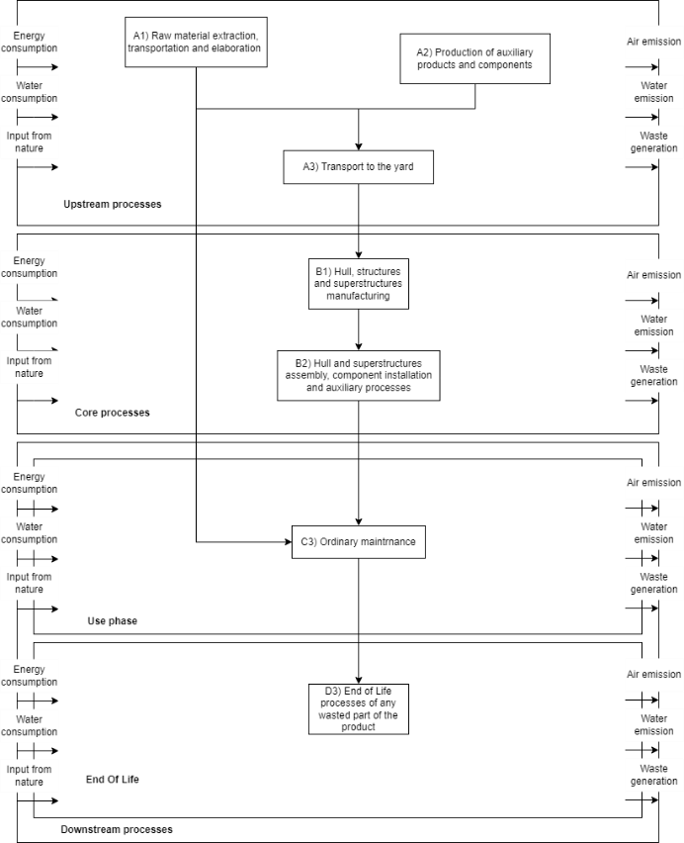
In the PCR, for the Upstream phase, a mass cut-off criteria has been defined, thus the including inventory data shall together give rise to, at least, 99% of the total inflows in mass. In this LCA study only the wax used for demoulding and the fixing plate used for the equipment fastening on the hull haven’t been considered in the inventory data.
Figure 1 System boundary

Life Cycle Impact Assessment methodology
For the assessment of environmental impacts, the most established method adopted for the publication of environmental labels, i.e., the EPD 2018 method, which includes the following impact categories:
Table 1 LCIA methodology – EPD 2018
Impact category | Reference unit | Reference
Global Warming potential (GWP) | kg CO2 eq. | IPCC report
Acidification potential (AP) | mol H+ eq. | Hauschild and Wenzel
Eutrophication potential (EP) | kg P eq. | Seppälä et al, Posch et al.
Photochemical ozone creation potential (POCP) | kg NMVOC eq | Van Zelm et al.
Ozone depletion potential (ODP) | 1 kg CFC 11 | Guinée et al.
Abiotic depletion potential (ADP) for fossil resources | MJ | Guinée et al.
Abiotic depletion potential (ADP) for minerals and metals (non-fossil resources) | kg Sb eq. | Guinée et al.
Water deprivation potential (WDP) | m3 | Boulay et al (2017)

Environmental impact assessment
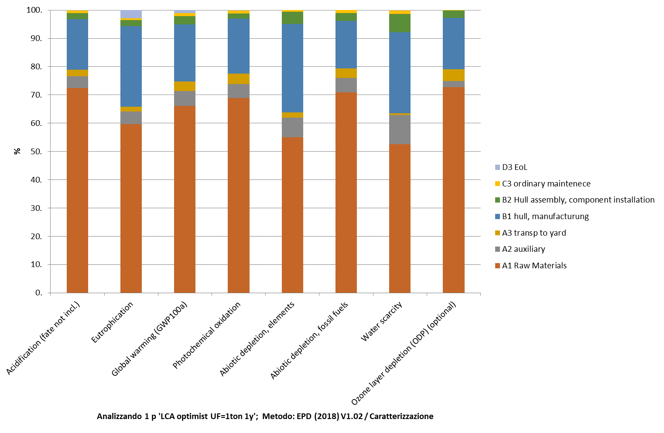
The main goal of this LCA study was to validate the criteria and assumption developed for the PCR this is why two different impact analysis has been carried out: the first one allows to evaluate the effect of the subdivision of the vessel life cycle into different modules while the second analysis that will be shown is the contribution analysis of different materials on the boat environmental impacts. Figure 2 shows the results of the first analysis that is environmental impacts of the boat normalized to the functional unit: along with the contribution from each life cycle stage:
Figure 2 Environmental impact assessment for life cycle modules
The PCR has been developed for both vessels EPD publishing and for the development of Complementary Product Category Rules (C-PCR) for components used in the marine industry, for this latter purpose a subdivision of products category groups has been developed in order to applicate different system boundaries, cut-off rules and data quality requirements based on the function the components have on-board. Table 2 shows the main products groups with a brief description and examples of how components considered in this study have been sorted into these groups.
Table 2 Product groups subdivision
Main product groups |  | Description | Example
Hull and structures | HS | Main external surfaces such as hull, decks with necessaries structures. | Hull, appendages, masts.
Machinery & Propulsion | MP | All elements needed to move the boat and to produce energy on board. | Sail, paddle.
Systems | SY | Systems not linked to the navigation function. | N/A
Naval systems | NS | System essential for navigation and for vessel safety. | N/A
Electrical System & Electronics | ES | Electrical systems not linked to the navigation function. | N/A
Naval electrical system & electronics | NE | Electrical system essential for navigation and for vessel safety. | N/A
Panels and coatings | PC | Internal surfaces coatings. | N/A
Fittings | FI | Group of components needed to improve liveability of the vessel. | N/A
Deck machinery and equipment | DE | Groups of components installed on external areas needed for navigation and safety of the boat. | Blocks, ropes, buoyancy bags, mast collar, hand bailer.
Paintings | PA | Surfaces treatment. | Gelcoat .
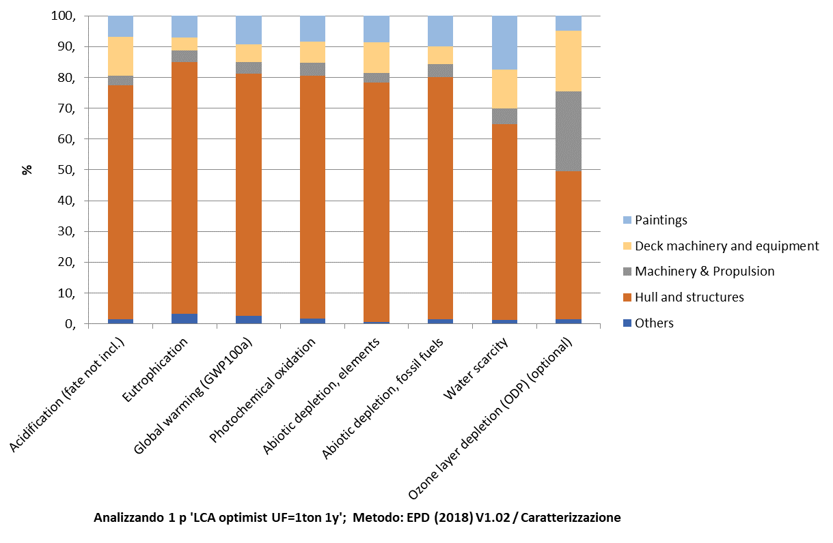
This subdivision allows also to assess the different contribution of the product groups to the environmental impacts of the boat. Figure 3 shows the impacts generated by each product group:
Figure 3 Environmental impact assessment for product groups

Conclusion
This study presents an important synergy between LCA modelling and the development of technical rules for the marine industry, namely a PCR. In a complex field such as vessel manufacturing, the PCR has indeed the role of solving, with the agreement of the interested parties, the main technical issues that the practitioner faces in LCA modelling. The possible applications of LCA in the shipbuilding sector are of great interest and range from eco-design of materials to engineering solutions related to hull and propulsion. This is a broad panorama of potential that the expert would not be able to address in life cycle modelling if not supported by industry regulations that provide guidance and act as guidelines. This study allows to validate most of the criteria and assumption applied in the PCR development such as the division into life cycle modules and the cut-off rules on the upstream phase for data collection. However, the study also revealed one of the critical points of the PCR, namely the choice of one ton of vessel in the functional unit; for small boats more than one boat has to be considered in the environmental statement per functional unit. From the Impacts results figures it can be seen that the greatest contribution to environmental impacts comes from the production and processing of the raw materials needed to build the boat, and mostly due to the resins production. While from figure 3 it can be seen that most of the impacts are related to the hull production, due to the predominance of the hull materials in comparison with the other components. A comparative Life Cycle Assessment between the Eco-optimist analysed in this study and Optimist build with traditional materials as fiberglass and polyester resin could give a more detailed view on the effects on environmental impacts of the use of recyclable PMMA based resin and natural fibres. This study also shows that, in addition to the indications provided by the comparison with similar vessels, it will be very productive in the future to direct energies towards LCAs that highlight the use of other materials for the construction of the hull, such as innovative materials with high recyclability. LCA analyses of different engineering solutions for the vessel manufacturing for possible recovery and reuse may also be of interest.

References
[1] Mio A, Bertagna S, Cozzarini L, Laurini E, Bucci V, Marinò A, et al. Multiscale modelling techniques in life cycle assessment: Application to nanostructured polymer systems in the maritime industry. Sustain Mater Technol 2021;29:e00327. https://doi.org/10.1016/J.SUSMAT.2021.E00327.
[2] Favi C, Campi F, Germani M, Manieri S. Using design information to create a data framework and tool for life cycle analysis of complex maritime vessels. J Clean Prod 2018;192:887–905. https://doi.org/10.1016/j.jclepro.2018.04.263.
[3] Cucinotta F, Guglielmino E, Sfravara F. Life cycle assessment in yacht industry: A case study of comparison between hand lay-up and vacuum infusion. J Clean Prod 2017;142:3822–33. https://doi.org/10.1016/j.jclepro.2016.10.080.
[4] Jeong B, Wang H, Oguz E, Zhou P. An effective framework for life cycle and cost assessment for marine vessels aiming to select optimal propulsion systems. J Clean Prod 2018;187:111–30. https://doi.org/10.1016/j.jclepro.2018.03.184.
[5] Pommier R, Grimaud G, Prinçaud M, Perry N, Sonnemann G. Comparative environmental life cycle assessment of materials in wooden boat ecodesign. Int J Life Cycle Assess 2016;21:265–75. https://doi.org/10.1007/s11367-015-1009-1.
[6] Rahman SMM, Handler RM, Mayer AL. Life cycle assessment of steel in the ship recycling industry in Bangladesh. J Clean Prod 2016;135:963–71. https://doi.org/10.1016/j.jclepro.2016.07.014.
[7] Ling-Chin J, Roskilly AP. A comparative life cycle assessment of marine power systems. Energy Convers Manag 2016;127:477–93. https://doi.org/10.1016/j.enconman.2016.09.012.

