Strategies for ship Decarbonisation: Technical Measure for reducing Energy Efficiency Existing Ship Index
Valentina BORTUZZOª, Massimo DE DOMENICO^{b} Vittorio BUCCI ^{a,}
ª Department of Engineering and Architecture, University of Trieste, Italy
^{b} Fratelli D’Amico Armatori, Italy
Abstract. Emerging energy efficiency regulations and ongoing industrial studies are boosting the reduction of ship pollutant emissions. Researches are progressively stimulating innovation in energy efficiency management allowing the adoption of new technologies by shipowners. In order to find new strategies to reach Greenhouse Gas (GHG) goals, the IMO imposed new technical requirements to reduce carbon intensity by means the Energy Efficiency Existing Ship (EEXI) Index. This new technical measure is compulsory for existing ships. These indexes estimate grams of CO₂ per transport work (g of CO₂ per tonne-mile). For each vessel in operation an Attained EEXI must be calculated and benchmarked for compliance with a Required EEXI. The parameters that have the greatest impact on the determination of the Attained EEXI values will be assessed and compared the Required EEXI. Therefore, case by case, different technical solutions able to reduce the EEXI Exceedance percentage (i.e., the difference between the Attained EEXI and the Required EEXI) are tailored for each vessel with reference to the operating profile/scenario. Furthermore, in this paper a case study referred to a merchant fleet engaged in global operations is presented.
Keywords. Keyword, keyword

Introduction
The global maritime shipping industry is committed to a complete and immediately decarbonisation of international shipping and transport [1].
The new measures imposed by the MARPOL Convention, Chapter 4, Annex VI, entitled "Energy Efficiency Regulation for Ships" for operational reduction measures and new ships consists of two main measures [2]:
- Energy Efficiency Design Index (EEDI), which requires new ships to meet mandatory minimum energy performance levels;
- Ship Energy Efficiency Plan (SEEMP), which establishes a mechanism for shipowners to improve the energy efficiency of existing vessels using operational measures such as trim, meteorological routes, draught optimisation, speed optimisation, etc.
IMO’s main objective is to reduce greenhouse gas emissions from international maritime transport and eliminate them as soon as possible in this century [3]. Preliminary studies have shown in the past the dependence of EEDI on the quantity of fuel burned and have made it possible to identify correlations between the latter and the quantity of air pollutant emitted [4]. During the 76th edition of the IMO’s Marine Environment Protection Committee (MEPC 76) technical and operational measures have been adopted in order to reduce the intensity of carbon emissions from international maritime transport from 2023 [5]. Such measures include the introduction of the Energy Efficiency Existing Ship Index (EEXI), which will measure CO₂ emissions per transport work (grams of CO₂ per ton-mile).
The EEXI will be verified at the first annual, interim or renewal survey of the International Air Pollution Prevention (IAPP) certificate or at the first survey of the International Energy Efficiency Certificate (IEEC), whichever is the first, from the date of entry into force [6].
The EEXI calculation will be applied to the following existing ships [7]: (i) bulk carriers; (ii) combination carriers; (iii) container ships; (iv) cruise passenger ships having non-conventional propulsion; (v) gas carriers, (vi) general cargo ships; (vii) refrigerated cargo carriers; (viii) LNG carriers; (ix) ro-ro cargo ships; (x) ro-ro cargo ships (vehicle carriers); (xi) ro-ro passenger ships; and (xii) tankers of 400 GT and above engaged in international voyages.
The aim of improved energy efficiency for reduced air emissions can notably be achieved through actions in two main directions that involve the vessel design within Multi-Attribute Decision-Making tools [8, 9, 10] and the vessel operation level [11, 12, 13]. New strategies and technologies aiming at reducing ships' fuel consumption are currently a priority for the industry, which shall search both to introduce innovative solutions and to innovate technologies currently employed. These pathways have notable implications on policies for energy use and sustainable economic development [14]. In this context, research and evolution aimed at ensuring transport decarbonisation is also analysing and comparing governmental, economic and academic perspectives and their potential alignment [15].

Methodology

EEXI Calculation
For the above-mentioned types of vessels, the Attained EEXI shall be calculated and compared to the Required EEXI (Figure 1), in order to verify the following relationship [16]:
$$\text{Attained EEXI ≤ Required EEXI}$$ | (1)
The Required EEXI is calculated as:
$$\text{Required EEXI} \text{= (1-Y/100)EEDI Reference line value}$$ | (2)
Where:
- EEDI Reference line value = ab^{-c} (see Table 1 for the values of a, b, and c);
- Y represents the reduction factor and is specific for each ship type as shown in Table 2.
The Attained EEXI is fully calculated through an equation provided in [17], but it can be simplified as follows [18]:
$$\text{Attained EEXI = }\frac{\text{(Power ∙} \text{SFC ∙} {\text{C}}_{\text{f}}\text{)}}{\text{Cargo Capacity} \text{∙} V_{ref}}\text{ \sim }\frac{ {V_{ref}}^{\text{3}}\text{ ∙ SFC ∙ }{\text{C}}_{\text{f}}}{\text{Cargo Capacity} \text{∙} V_{ref}}$$ | (3)
In which:
- Power represents the installed power of the vessel in kW;
- SFC represents the Certified Specific Fuel Consumption in g/kWh;
- C_{f} represents the non-dimensional conversion factor between fuel consumption and CO₂ emission;
- Cargo Capacity represents the DWT of the vessel;
- V_{ref} represents the vessel reference speed in nautical miles per hour.
In case of non-compliance, which occurs when the Attained EEXI is higher than the Required EEXI, modifications to the investigated ships must be carried out in order to pursue the following achievements as shown in Table 3:
- the numerator of the Attained EEXI formula shall decrease.
Actions may be taken on:
- P_{ME} that represents the main engine power in kW;
- P_{AE} that represents auxiliary engines power in kW;
- P_{eff} that represents the output of innovative mechanical energy efficient technology for propulsion at 75% main engine power in kW.
- the denominator of the Attained EEXI formula shall increase.
Actions may be taken on Cargo Capacity and V_{ref}.

In case of non-compliance, calculating the EEXI Exceedance in percentage through the following equation could be useful to quantify the surplus entity:
$$\text{ EEXI} \text{Exceedance [\%] = }\frac{\text{Attained EEXI ∙100}}{\text{Required EEXI}}\text{-100}$$ | (4)
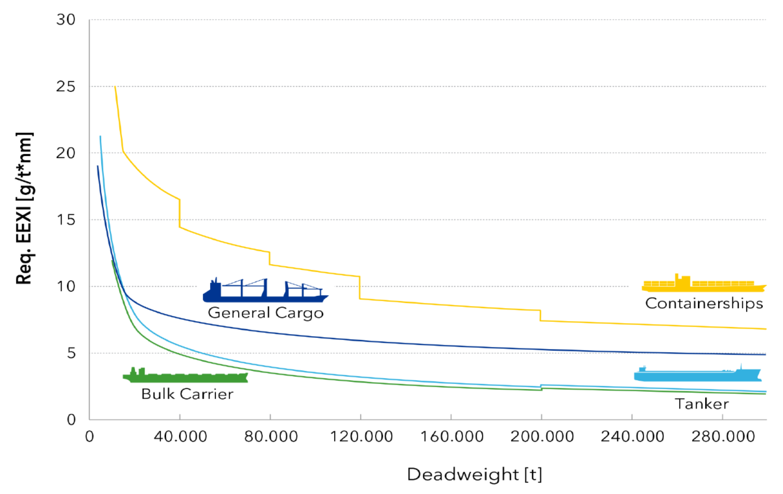
Figure 1. Required EEXI for several types of ships [19].

Table 1. Parameters a – b – c for the calculation of the EEDI Reference value depending on ship type [17].
Ship type | a | b | c
Bulk carrier | 961.79 | DWT of the ship where  DWT ≤ 279,000;  279,000  where DWT > 297,000 | 0.477
Gas carrier | 1120 | DWT of the ship | 0.456
Tanker | 1218.80 | DWT of the ship | 0.488
General cargo ship | 107.48 | DWT of the ship | 0.216
Refrigerated cargo carrier | 227.01 | DWT of the ship | 0.244
Combination carrier | 1219.00 | DWT of the ship | 0.488
Ro-ro cargo ship  (vehicle carrier) | $$\text{780.36∙}{\text{(DWT/GT)}}^{\text{0.7}}$$  where DWT/GT < 0.3;  14812.63  where DWT/GT ≥ 0.3 | DWT of the ship | 0.471
Ro-ro cargo ship | 1686.17 | DWT of the ship where  DWT ≤ 17000;  17000  where DWT > 17000 | 0.498
Ro-ro passenger ship | 902.59 | DWT of the ship where  DWT ≤ 10000;  10000  where DWT > 10000 | 0.381
LNG carrier | 2253.7 | DWT of the ship | 0.474
Cruise passenger ship having non-conventional propulsion | 170.84 | GT of the ship | 0.214
Ro-ro cargo ship | 1686.17 | DWT of the ship where  DWT ≤ 17000;  17000  where DWT > 17000 | 0.498
Table 1. Y is the reduction factor, ship-type specific and depending on ship size [17].
Ship type | Size | Reduction factor  (Y) | Equivalent to Required EEDI  Phase
Bulk carrier | DWT ≥ 200,000 | 15 | 1 +
 | 20,000 ≤ DWT < 200,000 | 20 | 2
 | 10,000 ≤ DWT < 20,000 | 0-20 | 2
Gas carrier | DWT ≥ 15,000 | 30 | 3
 | 10,000 ≤ DWT < 15,000 | 20 | 2
 | 2,000 ≤ DWT < 10,000 | 0-20 | 2
Tanker | DWT ≥ 200,000 | 15 | 1 +
 | 20,000 ≤ DWT < 200,000 | 20 | 2
 | 4,000 ≤ DWT < 20,000 | 0-20 | 2
Container ship | DWT ≥ 200,000 | 50 | 3
 | 120,000 ≤ DWT < 200,000 | 45 | 3
 | 80,000 ≤ DWT < 120,000 | 35 | 2++
 | 40,000 ≤ DWT < 80,000 | 30 | 2+
 | 15,000 ≤ DWT < 40,000 | 20 | 2
 | 10,000 ≤ DWT < 15,000 | 0-20 | 2
General cargo ship | DWT ≥ 15,000 | 30 | 3
 | 3,000 ≤ DWT < 15,000 | 0-30 | 3
Refrigerated cargo carrier | DWT ≥ 5,000 | 15 | 2
 | 3,000 ≤ DWT < 5,000 | 0-15 | 2
Combination carrier | DWT ≥ 20,000 | 20 | 2
 | 4,000 ≤ DWT < 20,000 | 0-20 | 2
Ro-ro cargo ship (vehicle carrier) | DWT ≥ 10,000 | 15 | 2
Ro-ro cargo ship | DWT ≥ 2,000 | 5 | 1
 | 1,000 ≤ DWT < 2,000 | 0-5 | 1
Ro-ro passenger ship | DWT ≥ 1,000 | 5 | 1
 | 250 ≤ DWT < 1,000 | 0-5 | 1
LNG carrier | DWT ≥ 10,000 | 30 | 3
Cruise passenger ship  having non-conventional propulsion | GT ≥ 85,000 | 30 | 3
 | 25,000 ≤ GT < 85,000 | 0-30 | 3
Table 2. Actions to meet the Required EEXI and their impact [18], [20-24].
ACTIONS TO MEET THE REQUIRED EEXI AND THEIR IMPACT
HIGH  (EEXI Exceedance % > 15%) | MODERATE  (EEXI Exceedance % = 5-15%) | LOW  (EEXI Exceedance % < 5%)
Engine Power Limitation  (EPL) | Fuel change  (e.g., LNG retrofit or biodiesel) | Energy Recovery  (e.g., Shaft Generator, WHR)
Shaft Power Limitation (ShaPoLi) | Hydrodynamic Solutions  (e.g., high efficiency propellers, propeller boss cap fins, Mewis duct, low friction paints, air lubrication) | DWT increase
Vessel Speed reduction |  | Fuel Efficiency Devices  (e.g., fuel additives)
 |  | Fuel Efficiency Monitoring (digital solution)

Action with High Impact: Engine Power Limitation (EPL)
The Engine Power Limitation (EPL) is one possible solution to fulfil the IMO requirements regarding the EEXI. The engine's Maximum Continuous Rating (MCR) is limited by changing a set of governor's fuel index limiter [19].

EPL can be realised in two different ways [25]:
- EPL-Power (Figure 2a) - Limits by estimation of the power control. It requires an advanced control system – it consists of a remote-control system that can limit the main motor load control and an EPL Monitoring Unit (EMU);
- EPL-FI (Figure 2b) - Limits by Fuel index equivalent to power. It is a method for limiting the fuel index with a mechanical stopper and is widely adopted in mechanical engines. Limitation of the engine power by physical limitation of the fuel index is by removable mechanical stop. The power limitation can be released by removing the mechanical cap, which will then reveal the original stop corresponding to 100% of the engine power. The mechanical stopper is locked with a unique metal seal. IMO and serial number control of the mechanical stopper is required to prevent unauthorized modifications [26].

Case study
The above-mentioned methodology has been applied to a fleet of tanker vessels whose main data and the associated EEXI calculations are shown in Table 4.
The authors considered the following aspects to develop a rank of the analysed ships in order to identify the best solution to apply:
- for the considered ship type (i.e., tanker vessels), the deviation between the Attained and Required EEXI value is significant;
- the technological solutions addressed in the previous paragraph have been analysed. Considering that the MCR in all the cases will have to be reduced approximately from 23% to 30% (Figure 3a), the solution proposed must have a high impact in order to reduce Attained EEXI;
- additional characteristics such as the age of each ship shall be considered and, taking into account that all ships have only maximum 5 years of expected life, a solution that does not involve a large investment should be adopted.
Based on the previous considerations, all the ships of the case-study fleet could be subject to an intervention of EPL. Indeed, this is the most economical solution able to satisfy the EEXI achievement in the immediate future, it is relatively easy to implement and more cost-effective than the measures for EEXI improvement by energy-saving modification. As only power limitation is involved, there is no change in the performance of the main engine that would be able to operate as before under the load limit. When necessary, temporary cancellation is permitted for emergencies and engine maintenance.
When applying the EPL solution, it is fundamental to consider that the input power value of the main engine in the EEXI formula decreases, but at the same time the speed of the reference vessel decreases too and the specific fuel oil consumption increases. To fix such consequence, retrofit measures able to improve hydrodynamic performances could be taken into account. However, these retrofit measures should be ideally undertaken only in combination with engine measures aimed at both ensuring a suitable light running margin after conversion and still enabling the ship to operate the engine at the minimum of the SFOC (Specific Fuel Oil Consumption) curve (Figure 3b). Typically, larger improvements in the EEXI can be expected when the retrofitting of energy efficiency technologies is performed in combination with a derating of the main engine.
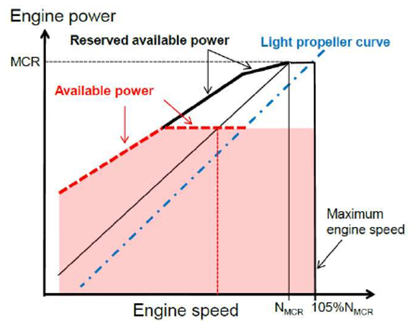 | 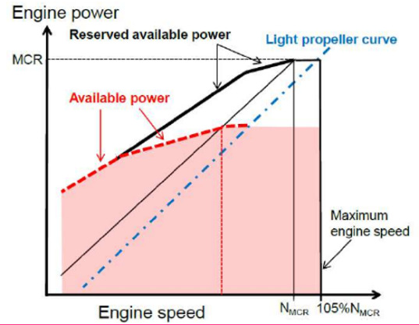
Figure 1a. EPL - Power | Figure 2b. EPL – Fuel Index
Figure 3a. Load Diagram | Figure 3b. Comparison of SFOC curve at before/after EPL
Table 3. Calculation of EEXI Exceedance % of the case-study fleet.
SHIP NAME | SHIP TYPE | AGE OF SHIP | DWT | ME MCR | Attained EEXI | Required EEXI | EEXI Exceedance | ME MCR Red.
[-] | [-] | [-] | [t] | [kW] | [-] | [-] | [%] | [%]
SHIP 1 | Tanker | 13 | 163.591 | 19.500 | 3,495 | 2,829 | 23,6 | 29,6
SHIP 2 | Tanker | 11 | 159.489 | 19.450 | 3,492 | 2,828 | 23,5 | 29,5
SHIP 3 | Tanker | 11 | 156.577 | 19.300 | 3,493 | 2,828 | 23,5 | 29,5
SHIP 4 | Tanker | 13 | 112.121 | 14.300 | 3,965 | 3,375 | 17,5 | 23,6
SHIP 5 | Tanker | 14 | 109.143 | 14.150 | 3,966 | 3,375 | 17,5 | 23,6

Conclusions
To comply with the forthcoming IMO’s EEXI requirements, fleet owners and manager must deal with a thorough assessment of their vessels, focusing on the following details:
- identification of the potential technology solutions to adopt and their impact level (high, moderate, or low) according to value of the EEXI Exceedance %;
- comparison of the different solutions in terms of EEXI improvements and future investments, with specific attention to both the operative and expected life of vessels belonging to the analysed fleet and the most interesting alternatives to achieve its development.
Among all the possible solutions, the EPL represents the most chosen one to improve the value of the Attained EEXI; as a result, in the present paper the authors have applied such methodology to the selected case-study. Thus, the fleet taken in consideration will be able to respect the IMO requirements, whose target is decarbonisation, obtaining an Attained EEXI that comply with the new regulation.
The technical measure considered in the case study, like the other measures mentioned in this article, can only partially help to reach decarbonisation. Indeed, in order to reach the target of decarbonisation, the transition to new types of fuels in combination with technical and operational efficiency measures must be implemented. Such a change requires a vast scale-up and the application of carbon-neutral or zero-carbon fuels and technologies. However, these represent the necessary solutions to allow the shipping industry to achieve IMO’s ambition of full decarbonisation.

References
- Müller-Casseres E, Edelenbosch O, Szklo A, Schaeffer R, van Vuuren D. Global futures of trade impacting the challenge to decarbonize the international shipping sector. Energy. 2021;237:121547.
- International Maritime Organization. Resolution MEPC.203(62), MARPOL ANNEX VI, 2011 July.
- Johnson D, Heltzel R, Nix A, Clark N, Darzi M. Greenhouse gas emissions and fuel efficiency of in-use high horsepower diesel, dual fuel, and natural gas engines for unconventional well development. Applied Energy. 2017;206:739-750.
- Figari M, D'Amico M, Gaggero P. Evaluation of ship efficiency indexes. Paper presented at the Sustainable Maritime Transportation and Exploitation of Sea Resources - Proceedings of the 14th International Congress of the International Maritime Association of the Mediterranean. IMAM. 2011. p. 621-627.
- International Maritime Organization. 2021 Guidance on Treatment of Innovative Energy Efficiency Technologies for Calculation and Verification of the Attained EEDI and EEXI. 2021 Dec.
- ECSA. FuelEU Maritime – Avoiding Unintended Consequences. Efficacy and implications of potential measures, including new EU fuel standards, to help decarbonise international shipping. 2021 May.
- RINA. Main Decision of MEPC 76. 2021 June.
- Degan G, Braidotti L, Marinò A, Bucci V. LCTC Ships Concept Design in the North Europe- Mediterranean Transport Scenario Focusing on Intact Stability Issues. Journal of Marine Science and Engineering. 2021;9(3):278.
- Mauro F, Braidotti L, Trincas G. Determination of an Optimal Fleet for a CNG Transportation Scenario in the Mediterranean Sea. Brodogradnja. 2019;70(3):1-23.
- Mauro F, Braidotti L, Trincas G. A Model for Intact and Damage Stability Evaluation of CNG Ships during the Concept Design Stage. Journal of Marine Science and Engineering. 2019;7(12):450.
- Dodero M, Bertagna S, Marino’ A, Bucci V. Performance In-Live of Marine Engines: A Tool for Its Evaluation. Applied Sciences. 2020;10(16):5707.
- Altosole M, Campora U, Figari M, Laviola M, Martelli M. A Diesel Engine Modelling Approach for Ship Propulsion Real-Time Simulators. Journal of Marine Science and Engineering. 2019;7(5):138.
- Trincas G, Braidotti L, De Francesco L. Risk-Based System to Control Safety Level of Flooded Passenger Ships. Brodogradnja. 2017;68(1):31-60.
- Romano A, Yang Z. Decarbonisation of shipping: A state of the art survey for 2000–2020. Ocean &amp; Coastal Management. 2021;214:105936.
- Zhang R, Fu Y. Technological progress effects on energy efficiency from the perspective of technological innovation and technology introduction: An empirical study of Guangdong, China. Energy Reports. 2022;8:425-437.
- International Maritime Organization. 2021 Guidelines on the Method of Calculation of the Attained Energy Efficiency Existing Ship Index (EEXI). 2021 June.
- RINA. RINA Interim Recommendations for the Evaluation Of Energy Efficiency Existing Ship Index (EEXI). 2021.
- RINA. The pathway to decarbonisation. 2021 April.
- DNV GL Maritime Advisory. Energy Efficiency Existing Ship Index (EEXI). 2021.
- Nepomuceno de Oliveira M, Szklo A, Castelo Branco D. Implementation of Maritime Transport Mitigation Measures according to their marginal abatement costs and their mitigation potentials. Energy Policy. 2022;160:112699.
- ABS. Sustainability Trends – Tankers. 2021.
- DNV GL – Maritime. Decarbonization Services From DNV GL - How to best improve GHG performance for your vessels. 2021.
- DNV. The Carbon Intensity Indicator –What Have We Learnt So Far. 2021 Dec.
- The Lloyd’s Register Maritime Decarbonisation Hub. First movers in shipping's decarbonisation - A framework for getting started.
- Mitsui E&S Machinery Co. EEXI improvement methods (EPL). 2021
- MAN. EEXI Solutions webinar. 2021, 25th Oct.

Vittorio Bucci, University of Trieste; e-mail: vbucci@units.it

