Italian Navy Green Fleet - Energy Saving Measures: a Solution to Increase Overall Efficiency of a Military Ship of “Bergamini” FREMM Class
Lt. CDR. Antonio BIGNONE, Lt. Gianluca BENETELLO
General Navy Staff - Capabilities Development Dept - Propulsion System Office
Rome, Piazzale della Marina 4, Italy
Abstract. The Italian Navy has always had, among its missions, the safeguard of the marine environment, and is strongly oriented to give its contribution to the targets fixed form the European Parliament with the European Green Deal. In 2012, the Italian Navy launched the Green Fleet initiative, with the aim of reducing greenhouse gas emissions and improving national energy security. To achieve these goals, the Italian Navy follows three main strategies:
- adoption of a renewable synthetic fuel;
- development and use of innovative eco-design technologies, which allow the reduction of the environmental impact of ships (LED lighting, SCR, foul release coatings);
- adoption of energy saving operating procedures (electric propulsion, energy dashboard).
The paper presents a case study focused on increasing the overall efficiency of a ship by recycling the thermal energy normally released to the environment by diesel engines. In fact, the overall efficiency of a diesel engine is about 40%, which means that 40% of the energy coming from the fuel is normally converted into usable power and the remainder is waste, which is delivered as heat to the environment. The case study identifies an effective solution to use a significant portion of that energy, while reducing the ship's energy consumption, thereby increasing overall efficiency and reducing fuel consumption and greenhouse gas emissions during operations. At the same time, the identified technical solution makes possible to reduce electrical load peaks, making the electrical load diagram more homogeneous, with the further result of optimizing the working conditions of the diesel engines.
Keywords. Green Fleet, Energy-saving devices, efficiency, thermal energy, diesel engine, fuel consumption, heat exchanger.

Introduction and examination of the operational requirement
The energy consumption by on board services is a fundamental aspect of the design of the ship. A fuel consumption reduction means an increased operative range, a reduction in operating costs and also in polluting emissions, an aspect which is also relevant in the current context which places considerable attention on environmental issues.
In the paper, using an overall approach, the problem of energy efficiency has been faced identifying the greatest energy losses and verifying their availability to power other services.
The analysis of energy losses starts from the combustion inside diesel engines: we know that a fast diesel engine efficiency is approximately 38%, therefore less than half of the available chemical energy is transformed into useful work, while most of it is dissipated through the exhaust gases and through refrigeration.
This paper takes FREMM class ships as a practical application example. In particular, the study aims to identify a technical solution with two objectives: to allow for a more homogeneous on board electrical load absorption diagram and, at the same time, in the context of the environmental impact and the reduction of emissions, to make the unit more efficient, from an energy point of view, as a whole.
Currently, aboard FREMM ships, an electric 120 kW heater (approximately 100 liters of storage volume) is used to heat water for crew use. The circuit has a constant water flow rate of 2 m³/h. The actual request for hot water, however, is variable and therefore the unused part enters the circuit upstream of the electric heater again. This means that the resistor, controlled by a thermostat, continuously switches ON and OFF, creating considerable fluctuations in the electrical load. In figure 1, you can see the behavior just described: the red line indicates when the resistor is powered; the blue line indicates the whole on-board electrical load.

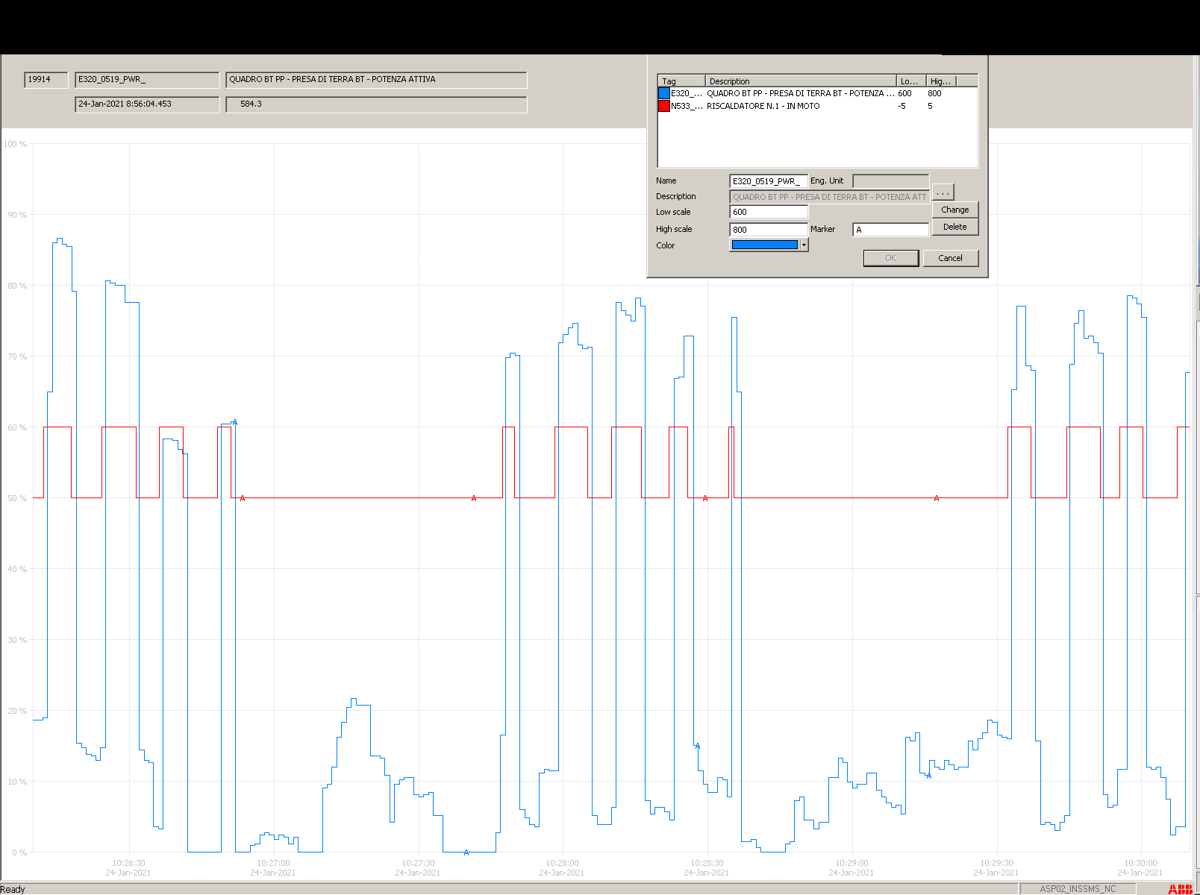
600 kW
800 kW
Figure 1: in blue, active electrical load on board expressed in kW.
In red, start and stop electrical heater

FREMM ships are equipped with 4 Diesel-Generators (DG) of 2100 kW each. In accordance with the Unit’s operating situation, the generation system can be powered by a variable number of generators, from 1 to 4 in parallel, to optimize the performance of the generators. During 1 DG – operations, with a low electrical load (about 700 kW), the continuous switching ON-OFF of the electric heater, results in a consistent electric (and mechanical) load variation on the DG (about 17%). This condition represents a big issue for diesel engines.
The possible solution examined in this paper is to recover the thermal energy dissipated for the cooling of diesel engines to heat the water for crew use on board. In this way, a double benefit would be obtained:
- the energy savings that should have powered the electric heater;
- the more stable operation of on-board diesel generators as they are subjected to a more constant load.

Calculation of thermal power dissipated by the diesel engine

Engine thermal balance
We analyze the amount of heat introduced with the fuel to produce work on the crankshaft. The transmission of thermal energy of the fuel to the engine occurs through the walls of the combustion chamber, the exhaust gas manifold and the turbocharging turbine by forced convection of the combustion gases, in particular of the tri-atomic gases CO₂ and H₂O, conduction and irradiation.
The heat that must be subtracted varies with operating conditions of the engine and generally increases in according to the number of revolutions and the power load. Furthermore, the heat to be subtracted is inversely proportional to the energy density of the engine, the ratio between the power supplied and the engine mass. The general equation of the heat balance can be written as follows:
$$W_{f}=W_{u}+W_{g}+W_{i}+W_{sw} \left[kW\right]$$
where:
$W_{f}=$amount of heat introduced into the engine through the fuel
$W_{u}=$thermal equivalent of the work useful to the crankshaft
$W_{g}=$amount of heat lost with the exhaust gases
$W_{i}=$amount of heat lost by radiation
$W_{sw}=$amount of heat transferred to the sea water cooling system, that can be scomposed in $W_{sw}=W_{w}+W_{comb air}$, (respectivally, for refrigerating technical fresh water and combustion air)
The total amount of heat introduced with the fuel can be obtained through the known relationship:
$$W_{f}=H_{i}∙Q_{f} \left[kW\right]$$
where:
$H_{i}\left[\frac{kJ}{kg}\right]=$lower calorific value of the fuel
$Q_{f}\left[\frac{kg}{s}\right]=$fuel consumption
It has been calculated that the heat balance of the diesel engine in the stationary condition of maximum load (2100 kWe) is the following:

W_{u} | W_{g} | W_{w} | W_{comb air} | W_{i}
38% | 30% | 15% | 15% | 2%
2190 kW | 1730 kW | 870 kW | 870 kW | 115 kW
Table 1. thermal balance at the maximum load.

Dissipated heat power calculation
The inlet and outlet temperature of the heat exchangers are identified, under different load conditions, by the sensors present on the seawater refrigeration circuit of the diesel generator.
The measured temperature data and the relative dissipated thermal power are shown in the following table, calculated according to the formula:
$$W_{sw}=ρ_{sw}∙Q_{sw}∙c_{p_{sw}}∙ {ΔT}_{sw} \left[kW\right]$$
where:
$ρ_{sw}\left[\frac{kg}{m^{3}}\right]=$ sea water density
$Q_{sw}\left[\frac{m^{3}}{s}\right]=$ volumetric flow rate
$c_{p_{sw}}\left[\frac{kJ}{kg∙K}\right]=$ sea water specific heat
${ΔT}_{sw}\left[K\right]=$ temperature difference between the inlet temperature and outlet temperature of the exchanger $(T_{{sw}_{out}}-T_{{sw}_{in}})$

Electric load | $$T_{{sw}_{in}}$$ | Sea water flow rate | Heat exchanger | $$T_{{sw}_{out}}$$ | Heat power dissipated
[kWe] | [°C] | [m³/h] | - | [°C] | [kW]
1400 | 26.7 | 36 | SW / COMB_AIR | 33.3 | 283
 |  | 40 | SW / CAB_AIR | 28.1 | 42
 |  | 18 | SW /ALT_AIR | 29.8 | 92
 |  | 32 | SW /W | 42.8 | 480
1000 | 13.8 | 36 | SW / COMB_AIR | 18.2 | 189
 |  | 40 | SW / CAB_AIR | 15 | 36
 |  | 18 | SW /ALT_AIR | 17 | 95
 |  | 32 | SW /W | 27.5 | 408
700 | 16.9 | 36 | SW / COMB_AIR | 19.3 | 103
 |  | 40 | SW / CAB_AIR | 17.7 | 23
 |  | 18 | SW /ALT_AIR | 18.8 | 56
 |  | 32 | SW /W | 29.3 | 369
Table 2. Heat power dissipated.

Choice of exchanger
As table 2 shows, the heat exchangers: sea water / cabinet air (SW / CAB_AIR) and sea water / alternator (SW /ALT_AIR), dissipate a relatively low thermal power. We therefore proceeded to analyze the remaining exchangers: the sea water / combustion air (SW / COMB_AIR also cold intercooler) and the sea water / engine water (SW /W) exchangers.
It has been verified, in figure 2, that at low loads the thermal power dissipated by the intercooler is very modest compared with the dissipated portion of the SW /W exchanger. Furthermore, it has been seen that as the electrical load required by the alternator increases, the thermal power dissipated in this heat exchanger remains almost constant, instead of the intercooler which grows exponentially its heat portion with the load.
Figure 2: in blue the variation of the thermal power dissipated, as the load varies, by the SW /W exchanger. The intercooler behaviour is in orange.
From the results obtained, it was estimated that the amount of dissipated heat most suitable for our purpose is that coming from the engine water.

Circuit design, evaluations and heat exchanger project

Functional circuit diagram
The figure below shows the existing hot water circuit in black and the additional part of the circuit deriving from this study in red. In this case, it has been created a new section of piping that connects the diesel and the storage boiler to the hot water circuit. The new circuit has been inserted downstream of the electric heaters, whose role it would functionally take.
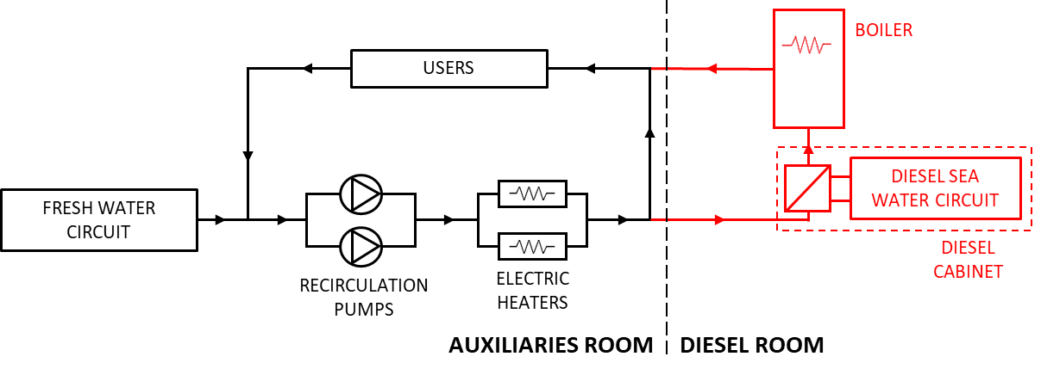
Figure 3: in black the existing hot water circuit,
in red the additional part of the circuit deriving from this study.

Calculation of the output hot water temperature leaving the diesel exchanger and boiler sizing
With the intention of eliminate any proliferation of Legionella bacteria, it is necessary to reach temperatures above 50°C. In order to be able to reach this temperature in all sections of the piping of the circuit, it was planned to set the value of 70°C as the minimum temperature at the outlet of the exchanger. Therefore, it is possible to calculate the water outlet temperature from the exchanger using the following formula:
$${T_{hw}}_{o}={T_{hw}}_{i}+ \frac{W_{sw}}{ρ_{hw}∙Q_{hw}∙c_{p_{hw}}}$$
It has been verified that the technical solution proposed by this study is sufficient to heat the water to exceed the required temperature of 70°C, also with inlet fresh water temperature very low (4°C) as it is possible in the coldest seas.

Boiler volume calculation
Since it has been evaluated to implement this system only on the bow diesel generators, we have also foreseen the case in which the eventual setup of the on-board generation system does not include any running bow generator (electrical load on the stern diesel-alternators or on axis generators). To solve this problem, it was decided to install an accumulator equipped with electric resistances downstream of the heat exchanger on the engine that can heat the water when the engine is running. The result has been that an accumulator of 500 liters should guarantee a shutdown of the electrical resistance, at the maximum hot water flow rate, of about 90 seconds.
This boiler must be equipped with a resistance, to be used, as stated, when the heating system through the forward diesel generator circuit is not available. To raise the temperature of the maximum water flow rate by a ΔT equal to 60°C (i.e. from 15°C to 75°C) a power equal to:
$$W_{w}=ρ_{w}∙Q_{w}∙c_{p_{w}}∙ {ΔT}_{w}=139.5 kW$$
Since the objective of this study is to "soften" the electrical power absorption diagram as much as possible, it can therefore be assumed to install a total resistance of 150 kW divided into 3 independent resistors, controlled by relative dedicated sequential thermostats, which in addition to this would ensure an excellent level of redundancy.

Heat exchanger design
This study identified as a technical solution the implementation, inside diesel generator water cooling circuit, of a second heat exchanger completely similar to the first one in order to limit design costs and to optimize spare parts stocks. The only difference between the two exchangers is the coolant which removes the heat from the engine water: in the existing one, it is sea water, in the implemented one , it is the fresh water of the on-board “hot water circuit”. In the engine water cooling circuit, therefore, from a functional point of view, the two exchangers will be positioned in series. In order to privilege the heat exchange with fresh water, this will be the first exchanger that the hot motor water will encounter at the banks outlet.
As in the existing heat exchanger, the additional one will also have engine water access regulated by a group of thermostatic valves. In this way, in the condition of an unloaded engine with low temperatures, the thermostatic valves of the fresh water exchanger will be closed and the engine water will bypass both exchangers being pushed by the pumps directly into the engine. When the temperature rises, the thermostatic valves of the fresh water exchanger will open, allowing the engine water to cool. At this point, after the first refrigeration, the sensitive bulbs of the sea water thermostatic valves will also be hit by the flow of engine water, but until the temperature increases further they will remain closed. Just in case of particularly high engine temperatures the thermostatic seawater valves will open and engine water will also pass through this exchanger.

Results and Discussions
The result obtained can be evaluated in economic terms considering that the ship's activity can be quantified in about 4˙000 engine hours per year. Considering that on average the currently installed electric heaters have a cumulative operation of a quarter of the total service time, as can be seen in figure 1, it is easy to calculate the fuel oil saved in a year:
$$120 kW∙4000 h∙1/4∙210 g/{kWh}=25.2∙{10}^{6} g=25.2 t$$
which, considering the cost of NATO F-76 fuel oil of around 1˙030 € per ton (March 2022), it is estimated that this system would allow annual savings of about 26˙000 €. In terms of emissions, instead, considering an average emission of CO₂ of 3.174 g/kg of fuel oil burnt, the result obtained from this technical solution can be quantified in approximately 80 tons of CO₂ emitted less than the solution currently in use in a year. The second great advantage obtained from this system is the harmonization of the electrical load on board. Infact, this aspect translates into a much gentler use of diesel generators, so in a lower engine wear and frequency of breakdowns. Therefore it means a lower cost in terms of spare parts and manpower time, as well as not indifferent operational advantage of greater reliability and global availability of electrical generation equipment.

Conclusions
This document presents the results of the analysis, calculation and design of a simple and economical technical solution that expresses an important concept of efficiency performance increasing on the FREMM class Units. The results show how the adoption of an heat exchanger using the thermal energy of the engine otherwise dissipated to heat the water for crew use allows an effective energy saving, an increase in overall ship efficiency and a significant decrease of polluting emissions.

Reference
[1] Isotta Fraschini Motori, istruzioni per l’uso e la manutenzione del motore serie VL1716C2ME8FREMM.

Lt. Gianluca Benetello, Italian General Navy Staff – Capabilities Development Dept – Propulsion System Office; Rome, Piazzale della Marina 4, Italy, gianluca.benetello@marina.difesa.it.

