Systems Engineering and Ship Design: a synergy for getting the right design and the design right
Mattia BOTTERO^{a,} and Paola GUALENI ª
ª DITEN – University of Genoa (Italy)

Abstract. What makes a successful ship design? The most brilliant solution cannot be called a success if it is something that nobody desires. Nonetheless, if a solution can in principle fulfill customer’s needs but it is not appropriately executed, it is a failure as well. Therefore, for a successful solution, both elements are crucial: getting the right design and getting the design right. Respectively they answer the question “ what is the right thing to build and why?” and “how do we build it?”. The traditional design method, represented by the “design spiral”, is a solution-oriented approach that works well when requirements have already been defined. It surely provides a feasible ship possibly fulfilling the customer’s requirements, but it is not ascertained a priori that it is the best one from all points of view. The exploration of the problem domain, necessary to select the more appropriate design, can be achieved with a problem-oriented approach such as Systems Engineering (SE) methodology. SE aims is to identify the best possible solution that satisfies customer needs in the most efficient and effective way. In this paper, a new approach that merges the traditional ship design procedure with the Systems Engineering (SE) processes will be discussed, with a special focus on the conceptual integration between the SE V-model and the design spiral. In this perspective, it will be necessary to discuss the definitions of Measures of Performance (MOPs) and Measures of Effectiveness (MOEs). MOEs are related to the achievement of the mission in the intended operational environment, while MOPs characterize the physical attributes of system/ subsystems. The aim is to open a discussion within the naval architects community to define an innovative methodology that will support the decisional process in finding the best possible solution, in the specific domain of naval ships.
Keywords. Design methodology; Warships; Systems Engineering; V-model; Design spiral.

Introduction
European shipyards are specialized in designing and producing complex ships which usually are capital intensive and technologically innovative, such as naval ships. The complexity of this kind of vessel, the increasingly high-performance requirements, and the evolution of international rules toward a goal-based approach demand a change in the design methodology.
The traditional ship design is performed heuristically following the well-known ship design spiral model by Evans [1] with a linear iterative process where the level of knowledge about details increases at each design spiral. The definition of requirements in the early design stages is often executed using the ‘experts’ perspective and rule of thumb, constraining the design by previously known and workable technical solutions. Moreover, the time-consuming efforts for the several iterations necessary to achieve the final result usually favor the adoption of a past and already consolidated reference model, limiting the project merely to a tuning and customization process that can certainly meet the operational requirements, but which is not necessarily the best possible solution.
Systems Engineering (SE) applies the systems approach to observe large and complex systems design exploration, development, and problem-solving through systematic and systematic processes. The systems approach models the product as systems, sub-systems, and components in hierarchical form through the functional decomposition and re-composition processes. It concentrates all its efforts on defining “what” the solution should be (in terms of functions), before thinking about “how” to physically realize it.
Possible ways to integrate the SE methodology with traditional ship design have been already explored by some leading figures in this field. Andrews [2] analyzes how Systems Engineering can be applied in the early stages of naval ship design using requirements elucidation to reduce the complexity of the ship and understand “what” is really needed for a specific naval vessel. SE notions are used to state that the concept phase (for complex vessels) is unlike the rest of ship design, having the primary purpose to explore the problem domain and understanding what is needed to be designed [3]. SE metrics, such as Measures of Performance (MOPs) and Measures of Effectiveness (MOEs), are frequently used also by Brown [4] to explore the design space and identify the ship functions necessary to satisfy mission requirements. The KPIs model is then used to allow the selection of the more appropriate solution both from an economical and effective perspective. A total-ship system design approach for naval ship concept design, making use of SE systemic and systematic methodology is proposed in [5].
The next chapters will deepen where the design spiral and SE processes take place in the design process of naval ships and how they can communicate with each other.

Design spiral: getting the design right
Getting the design in the right way is about synthesizing the customer needs into a final technical solution making use of an appropriate and orthodoxy methodology. Traditionally, the ship design synthesis is performed using the design spiral. The spiral is a sequential, point-based design approach, focused on designing towards a refined result, iteratively. Many literature sources refer to Evans [1] being the first to present the process of ship design in a spiral in 1959. This kind of approach is very effective in conveying both the interactive and iterative nature of the whole ship design.
During the years, many researchers tried to improve the design spiral. In 1998 Watson [6] defined two different spirals distinguishing between merchant and naval ships, shown in Figure 1. As it can be seen, the differences are more concerned with using a different nomenclature specific to each field than with identifying different processes. He puts in evidence how operational requirements, which are obviously not the same for merchant and naval vessels, are the input for the iterative process, affecting all the next design steps. However, the operational requirements are taken as fixed inputs within every cycle of the spiral.

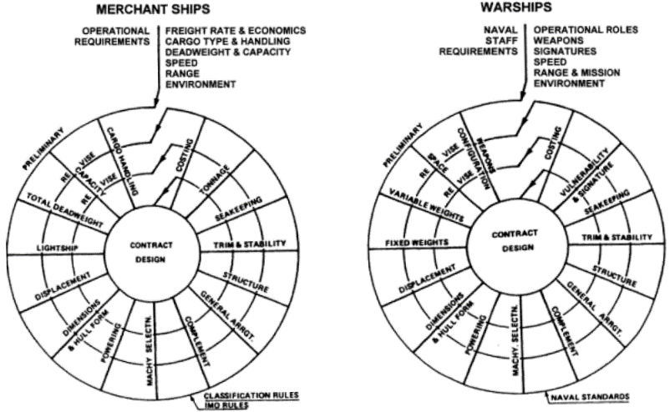
Figure 1. Design spirals for merchant ships and warships by Watson [6].

The most recent representation of the design spiral has been proposed by Papanikolaou in 2014 [7] and it is shown in Figure 2. He reminds that ship design can be divided into four main phases:

- Concept design
- Preliminary design
- Contract design
- Detailed design

The proposed model looks like a stretched spiral, trying to involve in the process the definition of the ship's requirements and functions.

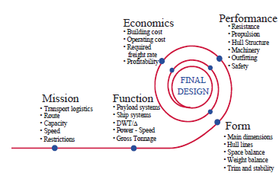
Figure 2. Design spirals according to Papanikolaou [7].

Other spiral models can be found in literature, such as the ones proposed by Rawson and Tupper [8] and Birmingham [9], but there is clearly a lack of a commonly endorsed and quantitative method to address the assessment of the solution effectiveness.
The design spiral is surely a powerful tool to get “the design right”, resulting in a feasible and reliable ship that fulfills the requirements as initially identified. The spiral process in fact addresses mainly the engineering of the vessel, once the main requirements and functions have been made.
The necessity of an evolution and empowerment in the traditional ship design approach is stated by several international leading figures in the field of warships design, such as Andrews (University College of London) [10] and Brown (Virginia Polytechnic Institute and State University) [11]. A possible way to make the ship design approach evolving is to focus, from the very beginning, on the naval ship's functions rather than on the several singular components the ship is made of.
This will be possible with a system thinking approach enabling the designers to focus on identifying “what” is needed to satisfy the customer's needs before thinking about “how” technically reaches them, with the final purpose to “get the right design”.

Systems Engineering: getting the right design
The idea of the ship as a complex system is today worldwide recognized by many leading figures in the ship design sector [10] and in this perspective, it is stated that ship design is a “wicked problem”. A wicked problem means that the problem is not understood until after the formulation of a solution.
The idea that there is not an absolute “right design” or even “optimum design” for ships is also stated by Rawson and Tupper [8], which describe how it is only possible to use available optimization methods to reach a balanced solution, depending on the designer scope.
The wicked nature of the ship design and the lack of a method in the design spiral process to assess the solution effectiveness loudly demand for a quantitative methodology to assist the designers and the customers in the decisional process, which is the foundation to “get the right design”.

The Systems Engineering approach is commonly recognized as a powerful guide to rationally and successfully develop complex systems. Its aim is to identify the best possible solution that satisfies customer needs in the most efficient and effective way, both from a technical and economical point of view; i.e.: Systems Engineering is about “getting the right design”. The International Council on Systems Engineering defines Systems Engineering as follows:

“An interdisciplinary approach and means to enable the realization of successful systems. It focuses on defining customer needs and required functionality early in the development cycle, documenting requirements, then proceeding with design synthesis and system validation while considering the complete problem” [12].

The SE method, codified by the INCOSE, is a systemic and systematic methodology where the system of interest (SOI) is considered as an integrated set of elements, subsystems, or assemblies that accomplish a defined objective. It can capture and manage the dynamic interactions between all subsystems and their impact on stakeholders' perspectives and on the operational environment in which the final product will work.
Such a description of a complex system can surely capture the nature of a physically large and technologically advanced system, such as a naval ship, where the platform and the payload (e.g. combat systems) interact with each other towards multiple common objectives.

As a point of strength, able to empower the design spiral, SE is a life cycle approach: it needs to determine every step of the system’s life following the design, from the cuddle to the grave. In such a way, it is possible to observe and understand the system behavior and possibly improve future designs. The life cycle model is one of the key concepts of SE and it generally consists of a series of stages regulated by a set of management decisions that confirm that the system is established enough to leave one stage and enter another one. These models are useful in defining the start, stop and process activities appropriate to each life cycle stage, which are the following:

- Requirements definition stage
- Concept stage
- Development stage
- Production stage
- Utilization stage
- Support stage
- Retirement stage

The sequential method called the “V-model” is emerging as the standard way to represent SE. The model is shown in Figure 3.

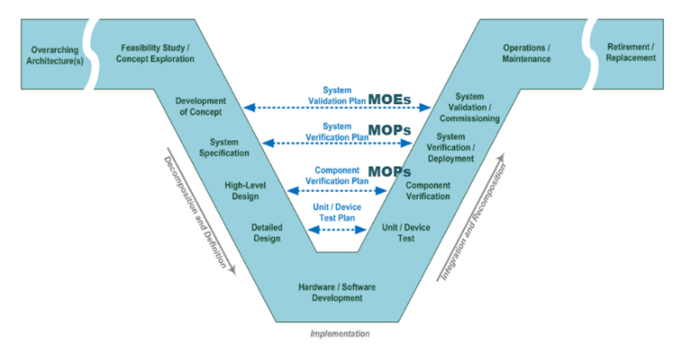
Figure 3. Systems Engineering V-model [13]

In the model, it is evident how the SE approach defines project requirements and specifications before technology choices are made and the system is implemented. The “V” well represents how SE is the fusion between two different approaches: the top-down and the bottom-up processes. On the left side of the “V” (Decomposition and Definition), the system definition progresses from a general stakeholder's view of the system to a detailed design. The system is decomposed into subsystems and the subsystems are in turn decomposed into components through many layers of further decomposition. The top-down process guarantees that technical choices have a link with initial requirements but it does not assure the physical feasibility of the whole system. This is guaranteed by the bottom-up process on the right side of the “V” (Integration and Recomposition). In Figure 3, wings have been added to the “V” to show how the SE method follows the system throughout its life and not only during the design and production phases.
The connections between the left and the right side are the conceptual core of the V-model and they well reflect one of the SE main principles: start with your eye on the finish line. It is not possible to create successful systems if it is not clear from the beginning what we need and foreseen as the final product. In this perspective, the Verification and Validation processes are crucial to assess that we are designing the right product in the right way. These processes can be described as follows [14]:

Verification Process: it takes place in the lower part of the V-model. Its purpose is to check that the subsystems and the system have been “built in the right way” from a technical point of view, providing objective evidence that a system fulfills its specified requirements.

Validation process: in the upper part of the V-model, the Validation process ensures that “the right product is built” by providing objective evidence that the whole system when in use fulfills stakeholders' requirements achieving its intended use in its intended operational environment.

From the very beginning of the project, it is necessary to well define Key Performance Indicators (KPIs) to better instruct Verification and Validation processes and establish a dialogue with the stakeholders. Appropriate metrics help project managers make better decisions throughout the life cycle to increase the probability of delivering a technical solution that meets both the specified requirements and the mission needs. Measures used for the Validation process are called Measures of Effectiveness (MOEs), while measures used for the Verification process are called Measures of Performance (MOPs) and they are defined as follows [14]:

Measures of Effectiveness (MOEs): the “operational” measures of success that are closely related to the achievement of the mission or operational objective being evaluated in the intended operational environment under a specified set of conditions; i.e., how well the solution achieves the intended purpose.

Measures of Performance (MOPs): the measures that characterize physical or functional attributes relating to the system operation, measured or estimated under specified testing and/or operational environment conditions. MOPs are used to assess whether the system meets design or performance requirements that are necessary to satisfy the Measures of Effectiveness (MOEs).

The next chapter will explore how the design spiral and the SE approach could be merged to provide the basis of an innovative design methodology.

Design spiral and Systems Engineering: a winning synergy
The previous chapters presented two different design approaches: the design spiral, which has been described as a powerful tool to get “the design right”, and the Systems Engineering method, which turned out as the key to get “the right design”. It seems clear how the key to a successful design is not to choose between one of these two approaches but to merge them to provide the basis of an innovative design methodology.
As described above, one of the main differences between DS and SE is that the spiral concentrate all efforts on synthesizing a solution starting from a predetermined set of design input. On the other side, SE is a life-cycle approach that constantly follows the design even from the very beginning, concentrating all its effort on the exploration of the problem domain for the definition of requirements that could be used to define design input.

In Figure 3 a merge of the two approaches is proposed, based on the KPIs described above. At the bottom of the figure, in a horizontal representation, the left part of the V-model is recalled while at the top the right part is represented. The middle of the figure shows how the SE process starts much before the first loop of the design spiral, including the definition of the requirements in its processes.

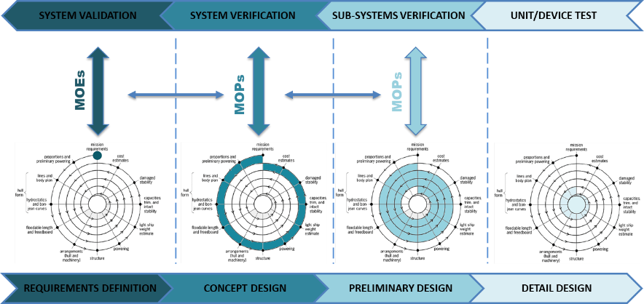

Figure 4. Design spiral and Systems Engineering integration

As the project progresses towards an increasingly detailed design (thanks to further design spirals i.e. from preliminary design to detail design), more information becomes available and new KPIs are generated. These will better instruct the Verification and Validation processes on the right side of the V-model (the upper part of the figure). Furthermore, KPIs can be also used to instruct the decision gates, evaluating the effectiveness at the end of each design stage to understand if the project can go on or if it needs relevant modifications. Thus, it enables the use of the SE processes to evaluate the solution's effectiveness at each step of the project during the evolution of the spiral.
MOPs are used to check the technical performances and to identify and correct possible anomalies, then MOEs can provide a quantitative estimation of the effectiveness of the ship in its intended operational environment. In such a way, the designer and the customer can have an objective vision of the solution, which can assure they are projecting the right ship in the right way. This kind of approach can also support the decisional process in the design early stages, helping to analyze which requirements have a major impact on the operational life of the ship. Thus, requirements will not be any longer only an input, but they will be finally an integral part of the design process.

Conclusions
“Getting the right design” and “design in the right way” are the key to the success of every project. The traditional ship design spiral and the Systems Engineering method, as described above, are two powerful tools to achieve this objective. The ship design phases involving the two approaches have been identified to set the basis for a mixed methodology, which can exploit the strengths of both of them.
The knot that can keep them together is represented by the KPIs defined in the SE processes, which will allow the final assessment of the solution. Thus, it will be necessary to identify and analyze them in the ship parameters domain in order to develop a hierarchical model and formulations to quantitatively compute them.
In such a way, it will be possible to define a new systemic and systematic methodology able to overcome the limits of the traditional projecting. This will allow having quantitative and objective proof that the final naval ship not only can satisfy the customer needs but is the best possible solution for all the involved stakeholders.
Further development of this research activity will be to identify the KPIs (MOE, MOP,…) for the different ship capabilities with the aim to create a framework useful to link possible naval tasks to the technical specifications of the ship; and by the end of the design, the same framework can enable the objective process to give evidence that the ship as designed and built is able to fulfill the MoD needs.

References
- Evans, J.H. (1959). Basic Design Concepts. Naval Engineers Journal, 71 (4), pp. 671-678.
- Andrews D. J. (2011). Marine Requirements Elucidation and the Nature of Preliminary Ship Design. Transactions of the Royal Institution of Naval Architects Part A: International Journal of Maritime Engineering , 153 (A1) pp. 23-39.
- Andrews D. J. (2018). The Sophistication of Early Stage Design for Complex Vessels. International Journal of Maritime Engineering.
- Brown A. J. (2013). Application of Operational Effectiveness Models in Naval Ship concept exploration and design. Ciencia Y tecnología De Buques, 7(13), 9-21.
- Brown A. J., Salcedo J. (2003). Multiple-Objective Optimization in Naval Ship Design. Naval Engineers Journal 115(4).
- Watson, D.G.M. (1998). Practical Ship Design. United Kingdom, Kidlington (Oxford): Elseviers Science Ltd.
- Papanikolaou, A. (2014). Ship Design; Methodologies of Preliminary Design. The Netherlands, Dordrecht: Springer Science and BusinessMedia.
- Rawson K. J., Tupper E. C. (2001). Basic Ship Theory (Fifth Edition). Oxford. Butterworth-Heinemann.
- Sen P, Birmingham R (eds) (1997) Proceedings of the 6th International Marine Design Conference IMDC 1997, University of Newcastle UK.
- Andrews D. J. (1998). A comprehensive methodology for the design of ships (and other complex systems). Proceedings of the Royal Society A, London, 454187–211.
- Brown A. J. (1998). Reengineering the Naval Ship Concept Design Process. From Research to Reality in Ship Systems Engineering Symposium, ASNE.
- INCOSE (2015) “Systems Engineering Handbook – a guide for System lifecycle processes and activities.”, published by John Wiley & Sons.
- TIRONE L. , GUALENI P., SCOGNAMIGLIO M. G., BONOFIGLIO P. (2021) “A Capability Based Approach for Warship Design.”, The 16th International Conference on Systems (ICONS), Porto, Portugal.
- INCOSE (2005) “Technical Measurement - a Collaborative Project of PSM, INCOSE, and Industry.”, published by INCOSE.

Corresponding Author; E-mail: mattia.bottero@edu.unige.it

