Innovative solutions for the integration of medical facilities on *dual-use* naval ships

Nicola NORCIAa,[1], Serena BERTAGNA b, Luca BRAIDOTTI b, Vittorio BUCCI b, Alberto MARINO’ b

a Italian Navy, Italy

b Department of Engineering and Architecture, University of Trieste, Italy

**Abstract.** According to the historical and social context and the evolution of technologies, medical care onboard ships has been a requirement of variable priority throughout the ship design. Strangely, this statement is much more evident in the field of naval ships, where there is a greater probability of injured or sick personnel when operating in warfare scenarios or humanitarian operations. NATO provides simple prescriptive recommendations, which indicate the health care and assistance facilities that naval units must offer. The classification describes the operational capabilities of the ship’s health facility using the word "*Role*", depending on the response in terms of available treatments. The level is assigned with progressively increasing capabilities from *Role 1* up to *Role 4*, which requires a complete operational response. On naval ships, the need to integrate many requirements minimises the design margins regarding the use of onboard volumes.

In spite of the particular mission profile of naval units, the medical treatment capability is often underestimated. Indeed, it is necessary to reserve an appropriate part of the overall space onboard to rationally allocate adequate medical facilities. In this paper, the integration of innovative medical facilities with *Role 2 Enhanced* capability within the general arrangements of an LPD ship is presented. Furthermore, the 90 m2-wide hospital enables the dual-use of the military ship more effectively. Specifically, the accommodations onboard are convertible to beds for patients, whilst complying with all safety and survivability criteria.

**Keywords.** Dual-use, medical facilities, evacuation analysis, general arrangements.

# Introduction

Natural disasters, large scale accidents and acts of terrorism have, over the past several years, demonstrated the importance of further development of the civil-military medical interface in order to strengthen both crisis management and the ability to work effectively with other actors, as well as to develop and implement specific contributions to an international comprehensive approach.

The necessary and constant modernisation process concerning Navy operational instruments sees the flexibility of the assets increasingly emphasized and, consequently, also the ability to perform tasks that are not purely military: this is the so-called "Dual-use", i.e., the possibility to use the same vehicles for either civil or military purposes.

Dual-usability has recently become a prominent feature within ship design, with a significant increase in applications. However, if it is true that the dual-use of military means is increasingly topical, it must be said that this innate characteristic is not born today, but has its roots in the history of the Armed Forces. Indeed, they have always shown to be a flexible organization in terms of means and capabilities, able to complete the required tasks even when these were outside their specific roles [1].

It is undeniable that, nowadays, dual-usability is an essential capacity for the modern needs of the country and requires crew specific skills but also constructive criteria and technological characteristics that cannot be improvised. These must be planned and implemented to put the safety and well-being of the civilian population as a central priority of both the Navy and the other Armed Forces, along with the ordinary and extraordinary measures aimed at ensuring the protection of the activities related to social life. Hence, a dual-use Navy will be increasingly requested [2].

As a result, introducing novelties within the design of dual-use naval vessels is fundamental. Specifically, the possibility of supporting hospital capacity in the fight against natural disasters represents a key requirement to fulfil future tasks [3,5]. Indeed, the necessity to develop new operational needs onboard is a consolidated reality: designers must deal with the integration of advanced hospital facilities and the definition of modular hospitals that can be displaced by the ship, through containerised modules with triage, therapy and sub-intensive capabilities [6].

In such a context, in this paper the authors focus on a ship able to serve as both a crucial component for the Italian Health System during natural disasters and a powerful tool within the National Diplomatic Arsenal to assist international partners [7]. The designed ship will be able to fulfil both military and civil requirements. The availability of a significant and deployable medical asset onboard will guarantee the National Health Service to have a transportable, versatile and modern hospital capable of operating along the countless coastlines of the world. Herein, a new rational ship design approach is presented able to define general arrangements of a dual-use naval vessel, with particular attention to the layout of medical facilities and their integration with other ship spaces. The work is based on the use of the 3D parametric software PARAMARINE® since early-stage design phases; the exploitation of such software allowed authors to obtain a high number of outcomes, with major savings in terms of time and a bigger number of possible solutions [8]. In addition, the innovative utilization of dedicated flex spaces is proposed and a new ventilation system to prevent Chemical, Biological [9,10], Radiological, Nuclear, and Explosive (CBRNE) contamination is studied. [11]

# Methodology

## Digitalised and integrated design process

Historically, compartment design and definition of the ship’s general arrangement have been achieved by 2D drafting tools combined, but not integrated or poorly integrated, with other calculation and analysis tools [12]. The recent evolution of the 3D CAD tools has led to a new approach for compartment design, based on the generation of an early 3D model of the ship, including ship compartments [23].

One of the main objectives of this article was the creation of a 3D parametric model, which is a model that allows a wide range of potential solutions to be investigated, identifying which best suits the requirements. In these situations, the majority of ship design tools do not provide the best solution, focusing on a small number of outcomes only. Parametric design, instead, can model topology as well as geometry offering advantages often not exploited. PARAMARINE® is an integrated ship design environment that allows the parametric connection of all aspects of both the product model and analysis together. Design configuration is managed to ensure that relationships within the model are topologically correct and kept up to date. [13,14]. The focus was placed above all on the arrangement of the rooms dedicated to the hospital area and on the dual-use purpose of the ship, in order to create a useful tool for exploring different design possibilities in the early stages and obtaining useful information in a short time. The final model, elaborated with the integrated design software PARAMARINE®, gave an excellent estimate of the characteristics of the new unit.

One of the best advantages offered by PARAMARINE® Software is the smart combination of both 2D and 3D approaches, which are thoroughly explained in [15] and summarised as follows. Within the 2D or traditional approach, designers work with standard drafting tools on a set of views of the ship, typically an elevation view and several deck plants views, to draw the ship’s general arrangement. Libraries of 2D views or symbols of equipment and accommodation items are also used. Some advantages of the 2D are the possibility of starting from scratch, or with very little information available, and the ease of small modifications, directly made on a drawing. Another advantage is that 2D software is widely used by all designers. The primary drawbacks refer to the lack of capability that is offered by legacy 2D systems associated with the compartments and general arrangement, and the lack of possibility to reuse or integrate the information with other calculation and analysis tools. The possibility of introducing errors and inconsistencies is another important drawback. On the other hand, within the 3D approach, compartments are generated as solids, based on or referred to the main surfaces of the ship (hulls, decks and bulkheads). The objective is to define not only the geometry of the spaces but a complete product model including the ship’s general arrangement and a hierarchical tree structure of ship compartments with associated attributes. 3D layout techniques are used in combination with libraries of predefined models of equipment and accommodation items, to complete the ship’s general arrangement. The main advantage is that the designers can build an accurate and practical 3D product model of the ship’s general arrangement from the very beginning, including attributes associated with compartments. The main drawback with 3D modelling is that this arrangement is more time-consuming in the initial stages, when it is necessary to perform several modifications in the layout of compartments or when designers face a lack of 3D information for new equipment and accommodation items.

Commonly, the design of the ship’s spaces is undertaken in two parts: allocation and arrangement, described in [16] as follows. The allocation phase objective is to assign each space required in the ship to a region of the ship (Zone-deck) with consideration of its overall and relative space location preferences and to provide efficient space utilization of the Zone-decks. The available space should be fully utilized, but not overcommitted: in such cases, under-utilization is better than over-utilization. To allow space for unassigned functions such as lockers, minor passages, air shafts, etc., only a significant assigned area percentage (circa 95%) of the available Zone-deck area would be the ultimate goal. As regards arrangement, it handles one Zone-deck at a time defining its assigned spaces in agreement with the overall structural requirements of the ship. The arrangement is carried out through two iterative steps: topology and geometry. Topology gives the relative fore and aft position of each space, then in the second step, they are expanded to size and shape filling the available area of the Zone-deck. A series of calculations are made to determine the most efficient bulkhead locations that maximise useable area whilst simultaneously complying with damage stability requirements.

## Rule framework

Due to the unique environmental factors that involve moving platforms, long supply lines, and limited evacuation possibilities, medical support to maritime operations is organised differently from land-based ones. Specifically, the North Atlantic Treaty Organization (NATO) subdivides its medical care levels into Roles and such division, presented below, will be adopted in this paper [17].

*Role 1* is the nationally mandated minimum medical requirements for that platform to provide primary care, triage, first aid, pre-hospital emergency care and evacuation.

*Role 2* includes the capabilities of Role 1 plus access to specialist doctor-led resuscitation and damage control surgery within clinical timelines. It includes one surgical team and one operating table, basic laboratory and imaging capability, limited intensive care and a small holding capacity. The basic laboratory capability should be able to provide simple blood measures. Basic imaging should include x-ray and ultrasound capabilities. It should be possible to provide a dedicated medical ward with specialist nursing care and the provision of intensive care if required. In addition, the *Role 2 enhanced* provides elements of greater consistency.

*Role 3* includes the capabilities of Role 2 plus access to specialist surgery within clinical timelines. This level represents a task force capability and, thus, not necessarily in one hull.

*Role 4* offers the full range of resolutive treatments that cannot be administered in the theatre or that require a long time to be sustained in the theatre. Role-4 structures normally provide resolutive interventions of specialist surgery, reconstructive surgery and rehabilitation. Specialist surgery is usually performed in national hospitals, military or civilian of the National Health Service.

Herein, the attention is focused on the NATO Role 2 Enhanced, whose medical asset includes the capabilities of ensuring measures that exceed the access to specialist surgery within clinical timelines. A Role-2-Enhanced ship is mission-tailored but typically is equipped with up to four operating theatres for surgical teams, at least eight intensive care beds, a diagnostic capability (including CT scanner), an oxygen production capacity, a dedicated MEDical EVACuation (MEDEVAC) capability, and a larger capacity for patients. For the specifically designed ship, medical support capability shall be able to treat patients for 7-10 days or until evacuation to a shore-based facility can be achieved. With regards to primary clinical healthcare evaluation, the ship should have an advanced laboratory able to support microbiology and equipped with a robust transfusion service. With regards to secondary healthcare and hospitalisation, at least two operating theatres and treatment and ventilation to a certain number of post-surgery patients for 7-10 days should be available. These medical treatment facilities should be able to provide definitive surgery, including specialist surgical interventions as necessary, within the timeframe of 7-10 days. It shall also provide non-surgical specialist care.

# Case study

The primary aim of this paper is to define the characteristics of a dual-use naval vessel. The goal of this design is to elaborate a ship concept able to accomplish mission requirements prescribed by the Navy, and, at the same time, to provide the following capabilities:

* Immediate and mobile medical services to deployed military both ashore and afloat;
* Mobile medical services for humanitarian aid and disaster relief in emergency situations;
* Maximize patient flow.

The 3D model of the dual-use naval vessel generated with the software PARAMARINE is shown in Figure 1, while Table 1 reports its main characteristics.

**Figure 1**: Dual-use naval ship concept.

**Table 1.** Dual-use naval vessel main characteristics.

|  |  |
| --- | --- |
| **Displacement** | 10500 tons |
| **LOA** | 141.6 m |
| **LBP** | 136.6 m |
| **Beam** | 23.0 m |
| **Draft** | 5.6 m |
| **Depth** | 18.0 m |
| **Accommodations** | 400 for crew + 200 for civil passengers or military transported |

## Medical facilities arrangement

The inboard profile (Figure 2) illustrates the location of the main compartments within the ship. As medical facilities represent the principal design priority, the first step during design consisted of their classification in the following two categories:

* Facilities organic to the ship;
* Facilities to be outfitted before mission departure, if requested.

For both categories, medical facilities are centralised on the second deck in the hull stern. Since optimizing patient flow through the hospital was the primary focus during design, by this arrangement patients can be transported more efficiently from all three entryways. These flows can be modelled in subsequent design spaces especially to check their suitability in reducing the risk of outbreaks [22]. A large reconfigurable medical space provides the proper volume to house additional facilities when requested.

The stern second deck was chosen for principal and critical medical care facilities. From this location, the path length for patient transportation to the Hangar Deck (Well Deck) and to the Flight Deck entry is limited, being two decks up and one deck down, respectively. The elevator allows better patient transport between the hospital level and both Well and Flight Decks and ensures increased efficiency. Centralising medical facilities and clustering medical stuff such as ward beds, labs, and sterile receiving areas were essential. On the second deck, also radiology equipment, labs, operating rooms and intensive care units are kept in close proximity in a linear flow.

Decontamination facilities are located at each point of vessel entryway. As seen on both the Main and the Hangar Decks, there are multiple decontamination stations located by both Well and Flight Deck entries, strictly dedicated to patients. These are used to prevent any type of Chemical, Biological, Radiological, Nuclear, and Explosive (CBRNE) contamination inside the vessel.

Figure 3 shows the details of the medical facilities arrangement for the designed dual-use naval vessel.

|  |  |  |  |  |  |  |  |
| --- | --- | --- | --- | --- | --- | --- | --- |
|  | Medical spaces |  | War rooms |  | Dual-use spaces |  | Fuel & Ballast |
|  | Patient transport |  | Machinery |  | Crew spaces |  |  |

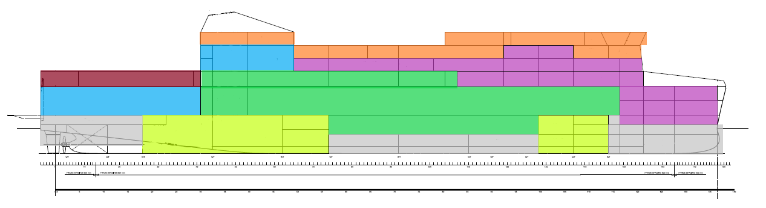

**Figure 2.** Inboard profile.

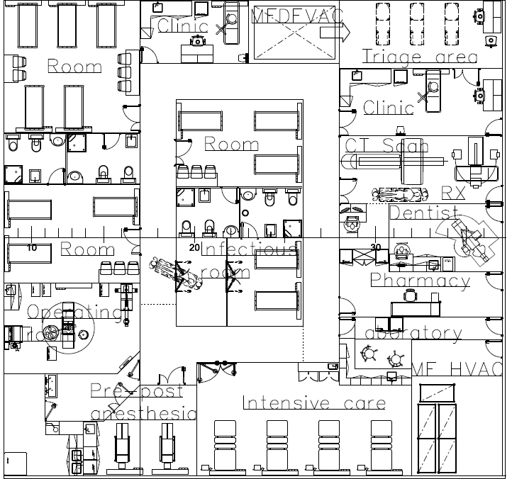

**Figure 3.** Medical facilities.

## Flex space

The flex space is a large reconfigurable medical space in the hangar designed applying modular design paradigms [18,21], which may be outfitted dockside before each mission to meet certain specific needs by being equipped with numerous services that include the supply of oxygen and water, HVAC (heating, ventilation, and air conditioning), and electrical systems. For example, the flex space could be outfitted as a primary communication centre to facilitate exchanges between foreign governments, NGOs, and other entities involved in a disaster relief mission. Otherwise, in case of a combat care mission, the flex space could be outfitted for overflow berthing, operating rooms, or immediate care wards. Figures 4 and 5 illustrate the flexibility of the space for the two above-mentioned mission types.

Two separate examples of flex spaces can be found onboard the presented dual-use naval vessel. Their reconfiguration would be carried out by exploiting temporary walls, which allows the spaces to be rearranged also in transit or during the mission. The primary flex space is located on the Hangar deck, directly under the medical care space for critical care. Given its extension equal to 1400 m2, such space could be converted into a range of several medical facilities for specific missions. The secondary flex space is located on the second deck and its area is approximately equal to 1000 m2. It could be converted into berthing spaces for survivors of disasters.

## Ventilation system

The dual-use naval vessel design includes a pressurized ventilation system to ensure protection against CBRN contamination. This system works by filtering all the intake air and applying positive air pressure to the ship internal spaces to prevent contaminated air particles from entering safe areas (e.g., accommodation, surgical, work, etc.). Different levels of protection are required based on the category of the space to protect: the ship is then subdivided into a multi-layered citadel. The rooms requiring the highest tier of protection include medical facilities that demand a particularly clean environment like operating theatres, particularly important labs and intensive care units. The second tier includes less critical medical facilities like wards and general ship spaces such as berthing, messing, and stores. Finally, a third-tier includes machinery spaces. Decontamination stations and airlocks will be placed between any two different citadel tiers. Furthermore, the dual-use naval vessel will be divided into several independent HVAC zones, each equipped with its independent air intake filter. Thus, if the quality of the air in one zone is compromised, this will not affect the other zones and a good degree of ship redundancy will be ensured.

## Patient transfer

Helicopter capabilities are absolutely essential for this type of vessel as they provide the vital possibility to reach patients in areas otherwise inaccessible by sea. Additionally, certain helicopters have the capability of transporting items such as ISO containers. Helicopters also provide a large range inshore and can serve as a secondary transport system to amphibious vehicles. The large Flight Deck area allows for simultaneous landing and take-off of two medium-size helicopters. Furthermore, the large Hangar allows them to be securely stored when not in use. Although it is possible to have a V-22 Osprey helicopter present on the ship, it is more feasible to choose the EH-101 model. This helicopter has a large payload capacity, which allows it to airlift medical care baggage, as well as to provide large patient capacity.

The dual-use naval vessel is also equipped with a Well Deck and so it will be possible to transport patients between the ship and the shore by amphibious vessels. Patients can directly access the ship at the waterline level by means of special vehicles for amphibious support such as LC-23 units. These provide a sufficiently large patient transfer capability with quick transfer times for loading and unloading of passengers combined with good seakeeping capabilities in rough weather conditions.

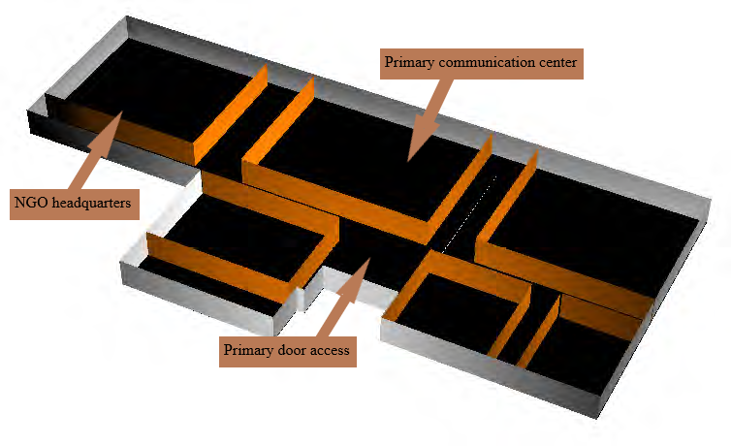

**Figure 4.** Hangar flex space equipped for humanitarian aids/disaster relief missions.

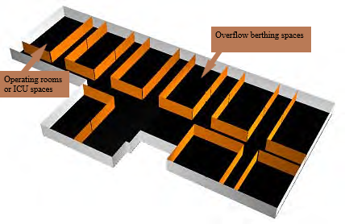

**Figure 5.** Hangar flex space equipped for combat care missions.

# Conclusions

The need to replace existing and aged ships is a rising concern for global Navies. As previous shipsreach the end of their service life, the fleet will need to replace them with modern, more efficient and affordable dual-use ships that will be able to efficiently satisfy the required missions. In addition, Navies need for modular medical facilities and amphibious support to enable increased ship-to-shore patient transfer and to improve medical capabilities.

Indeed, all the operative hospital ships are close to decommissioning. The construction of a new and innovative naval unit able to combine both dual-usability and hospital purposes would give extraordinary international value to the Italian Navy.

This article started from these assumptions to study the possibility of integrating advanced medical facilities onboard a dual-use naval vessel. Several aspects aimed at facilitating medical care and operations were taken into account.

The outfitting of the dual-use naval ship offers great flexibility as regards the utilisation of available spaces, which can be tailored to different missions such as humanitarian assistance, disaster relief, and combat care missions. By incorporating medical ISO container systems and large flex spaces, the design can provide modular medical facilities in response to a variety of missions. Additionally, the general arrangements are organized to ensure a consistent patient flow and the optimization of space location. Furthermore, the ship was equipped with both a Well and a Flight Deck, able to provide efficient solutions for patient transportation by sea and air.

As regards operativity management, the Italian Navy would be responsible for providing the support necessary to operate the ship and guarantee its maintenance, while the medical capabilities would be sourced and selected from medical structures external to military forces. Such cooperation would perfectly represent the virtuous synergy between the Italian Armed Forces and external civil organizations.

Finally, further studies regarding the possibility of implementing design alternatives able to combine both *green* technological aspectsand efficiency will be carried out, in order to highlight the most promising opportunities to attain ecological improvements. As an example, the exploitation of fuel cell technology and accumulation systems onboard the presented dual-use naval vessel would help the reduction of fuel consumption. At the same time, it would ensure the reduction of noise and vibration and allow to sustain all the operational systems essential to the ship’s mission and requirements.

References

1. Ray S, Naidu C. Navy Hospital Ships in History. Journal of Medical Society. 2017.
2. Norcia N. LPD di nuova generazione per la Marina Militare Italiana. University of Trieste. 2021.
3. Sechriest F, Wing V, Walker J, Aubuchon M, Lhowe D. Healthcare delivery aboard US Navy hospital ships following earthquake disasters: Implications for future disaster relief. American Journal of Disaster Medicine. December 2012.
4. Carey N, Grefer J, Trost R, Levy R. Future Deployable Medical Capabilities and Platforms for Navy Medicine. 2002.
5. Riley T, Bergan T, Uniskiewicz R, Kroot L. Shipboard medicine.
6. Tomer B. LPD 17 Hospital Variant Rough Order of Magnitude Study. 1997.
7. Baker M, Baker J, Burkle F. The Hospital Ship as a Strategic Asset in 21st Century Foreign Policy and Global Health Crises. Military medicine. 2022.
8. Bertagna S, La Monaca U, Marinò A, Bucci V. Integrated ship design: an innovative methodological approach enabled by new generation computer tools. International Journal on Interactive Design and Manufacturing. 2019.
9. Bertagna S, Dodero M, Bortuzzo V, Marinò A, Bucci V. An innovative approach for the biological risk management onboard ships during COVID-19 crisis. Marine Transport Research. 2021.
10. Ruggiero V, Guglielmino E, Cucinotta F. An interactive approach for the design of an Italian fast medical support ship as consequence of world emergency due to Sars2-Covid19. International Journal on Interactive Design and Manufacturing. 2022.
11. Sidell F, Takafuju E, Franz D. Textbook of Military Medicine Part I: Medical Aspects of Chemical and Biological Warfare. Borden Institute, Walter Reed Army Medical Center; Washington, DC. 1997.
12. Carlson C, Fireman H. General arrangement design computer system and methodology. Naval Engineers Journal. 1987.
13. Bole M, Forrest C. Early stage integrated parametric ship design. ICCAS. 2005.
14. Munoz JA, Forrest C. Advantages of software integration from initial design through to production design. ICCAS. 2002.
15. Perez R, Alonso V. The ultimate approach for General Arrangement Definition. Ship Production Symposium. Houston. 2014.
16. Nick E, Parsons MG, Nehrling B. Fuzzy optimal allocation of spaces to zone-decks in general arrangements.
17. NATO AJMedP-6 “*Allied joint civil-military interface doctrine*”, Edition A, Version 2. September 2021.
18. Drewry JT, Jons OP. Modularity: Maximizing the Return on the Navy’s Investment. Naval Engineers Journal. 1975; 87(2):198-214.
19. Doerry NH. “Institutionalizing Modular Adaptable Ship Technologies”. Journal of Ship Production and Design. 2014; vol. 30(3), pp. 1–18.
20. Braidotti L, Bertagna S, Marinò A, Bosich D, Bucci V, Sulligoi G. “An Application of Modular Design in the Refitting of a Hybrid-electric Propelled Training Ship”. Proceedings of the 2020 AEIT International Annual Conference – AEIT. Catania (Italy). 2020.
21. Braidotti L, Bertagna S, Prudente M, Marinò A, Bucci V. The role of virtual prototyping in the early-stage design of a research vessel for the Mediterranean Sea. Proceedings of the 6th International Conference on Maritime Technology and Engineering (MARTECH). Lisbon, Portugal. 2022. (in press)
22. Braidotti L, Bertagna S, Dodero M, Marinò A, Bucci V. Identification of measures to contain the outbreaks on passenger ships using pedestrian simulations. Procedia Computer Science. 2022; Vol. 200, pp. 1565-1574.
23. Andrews D. A Creative Approach to Ship Architecture. RINA International Journal of Maritime Engineering. 2003.

1. Vittorio Bucci, University of Trieste; e-mail: vbucci@units.it