The evolution of large pleasure vessel towards a green future
Gianmarco VERGASSOLA^{a,}, Dario BOOTEª and Federico TOCCHI^{b}
ª DITEN, University of Genova
^{b} SanLorenzo SpA
Abstract. The future of transportation means is quickly moving towards green solutions in order to reduce the emission of COx and SOx firstly and, secondly, to progressively abandon the fossil fuels. In this perspective, alternative propulsion such as fully electric engine, biofuels, hydrogen, LNG are now largely used in the automotive field and for mass transportation means. The naval field is now moving on the same trend by using hybrid and fully electric engine especially for pleasure vessels, where the relatively small engine power allows the installation of battery stacks onboard without adding unreasonable weight for only few navigation miles. In this paper, the transformation of a traditional pleasure vessel towards a new hybrid version is proposed; after a more comprehensive view of the modifications that are necessary to install hybrid engine and battery onboard, highlighting all the critical aspects of these new design, a FE numerical analysis of the basement of electric variable speed generators is presented..
Keywords. Superyacht design, Yacht structure, Green propulsion for vessel, Finite Element Analysis

Introduction
Engineering and stylistic innovations are among the key success factors for the Sanlorenzo Group, one of the most important Italian yacht and superyacht shipyard.
Investments in R&D endeavors enable innovation to be increasingly geared towards the study of sustainable ways of making products and using them. The overarching objective of such a focus is to identify all the new directions that can be relied upon in order to maintain Sanlorenzo’s success, in terms of market share and shipowner loyalty and corporate visibility and reputation.
Precisely for this reason, in 2015, Sanlorenzo was recognized as the first shipyard in the world to use an early-generation hybrid system for planning yachts over 30 meters (SL106 Hybrid). Two years later, the Company followed up with a second application of the parallel hybrid model on a more compact vessel, in both cases operating through two MTU engines, two variable speed generators and a lithium battery system.
In September 2021, Sanlorenzo finalized an exclusive partnership with Siemens Energy, through which they will jointly develop innovative solutions to reduce the environmental impact of yachts. Specifically, the partnership is focusing on the following areas:
- Development for next generation diesel-electric propulsion systems for yachts over 50 meters and for next-generation hybrid systems for yachts under 50 meters, made compatible with limited space on board and aimed at reducing greenhouse gas emissions and fuel consumption.
- Development of solutions for the integration of methanol fuel cell technology for yachts between 24 and 80 meters in size to generate electricity on board when engines and generators are turned off, significantly extending the time spent at anchor and maneuvering without emissions.
Such a collaboration scheme will enable Sanlorenzo to develop – by 2024 – the first superyacht with diesel-electric propulsion and the first vessel with on board hotellerie powered by fuel cell.
Obviously, the introduction of this type of hybrid propulsion system has meant a careful redesign of various structural, plant engineering and styling aspects. In particular, Sanlorenzo has been very careful to preserve one of the most valuable advantages of electric propulsion: reduced noise.
For this reason, well in advance of production, Sanlorenzo launched an extensive research program with DITEN (UNIGE) to design the frames of the variable speed generators, also considering installation methods that would optimize accomodation space on board.

Alternative propulsions system in the yachting industry

Different type of hybrid propulsion system on board
It is worth clarifying the types of hybrid propulsion that can be found on board a yacht, their characteristics and how Sanlorenzo uses one or the other depending on the size of yacht:
- HYBRID PROPULSION SYSTEM (identified as parallel hybrid) for yachts under 50 meters: A system where the main propulsion relies on traditional Diesel engines, and electric motors operate on demand along with the main engine when low power/ low speed is needed. The hybrid system is installed on GRP vessel metalic ones up to 50 meters and allows the owner to sail in standard diesel mode without any problem to reach maximum speed and ensure the yacht's usual autonomy. Only when required (e.g., in the ever-increasing numbers of MPAs - maritime protected areas), thanks to the Lithium-Ion batteries, the boat can sail at speeds of up to 8-10 knots with the diesel engines completely switched off and zero emissions, or it can stay without gensets running for more than 8 hours. When sailing in diesel mode, the electric motors can be used as energy generators to manage the onboard consumption and/or to recharge the batteries.
- DIESEL-ELECTRIC PROPULSION SYSTEM (identified serial hybrid) for yachts over 50 meters: A system where the motion to the propeller is always given by an electric motor fed by variable speed generators, by Lithium-ion batteries or by a combination of the two. The diesel/electric system onboard the Sanlorenzo Superyachts consists of four or more generators (called VSG) according to the size of the yacht and the required performances, without the traditional power generators. These generators take much less space compared to the “classic” engines and can considerably reduce the volume usually dedicated to the engine room, to the benefit of the onboard leisure areas. Since the propeller rotation is managed by the electric motors positioned closed to the propellers, there is no need of any mechanical transmission connection. The electric system is therefore more silent, efficient, and lasting than a traditional one, and more flexible to install, giving maximum freedom in the interior lay-out possibilities.

Benefit and challenges
Both systems provide various advantages to the shipowner:
- Reduction of emissions (NOx, CO2, and hydrocarbons) from main engines and generators in the most common condition of usage and when emissions are more noticeable (when the yacht is near the cost).
- Possibility to reach and stay within MPAs (Maritime Protected Areas) not accessible with combustion engines switched on.
- Very fast charging of lithium batteries in navigation (not possible via standard generators).
- Improved silence and comfort in maneuvering and low speed navigation.
- Greater safety at sea thanks to multiple power generation systems (electric motor, generator, and lithium-ion batteries).
- Lower number of running hours for main engines and generators with consequent extended service life (it’s possible to navigate with just one main engine running and gensets switched-off).
- System already aligned with principles under study from European Commission – ‘Sustainable and Smart Mobility Strategy 2025-2030’.

Structural design of foundations for Variable Speed Generators

Definition of the study case
In order to verify which would be the best foundation designs for serial hybrid propulsion, a 50 m Explorer type superyacht has been assumed as a studycase.
The vessel was originally designed for classical 4-stroke quick diesel engine and it has been subsequently redesigned for possible hybrid propulsion. In particular, the hybrid propulsion will be guarantee in this case by 4 Variable Speed Generators (VSG) that have to be installed in bunk condition.
For the scope of this research, the engine room only has been redesigned both in terms of hull shape and structural layout; in particular, for what the structural layout is concerned, the keelsons has been dimensioned with the same web height in order to sustain directly the first row of VSG in case of single suspension solution and to easily weld the foundation structure. In Fig. 1 the layout of the engine room is reported. In the middle it is possible to see the engine control room.

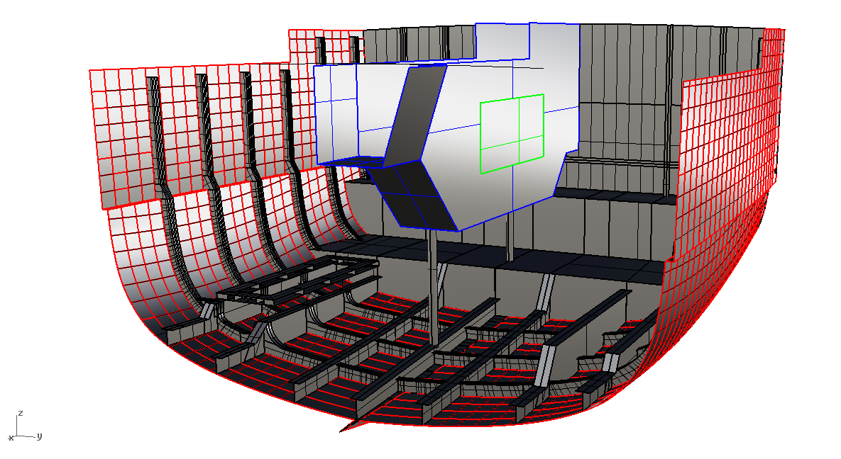
Figure 1. Engine room geometrical model
As a result of a first attempt calculation, however, it was noted that the internal keelson was excessively high and without adequate strengthening, causing excessive propagation of vibrations, also partly due to the stabilization of the web itself. The layout was therefore modified, creating two identical keelsons with a reduced height on which a foundation base was added.
The scantling VSG foundation castle has been carried out by considering a load amplification factor of 2.5, because considering only the static weight of the VSG block would result in an under-dimensioned structure

Creation of the Finite Element model
A FE model of the engine room has been created in MSC Patran and Nastran starting from the geometrical model aforementioned and it has been reported in Fig. 2. In yellow it is possible to see the foundation castle.
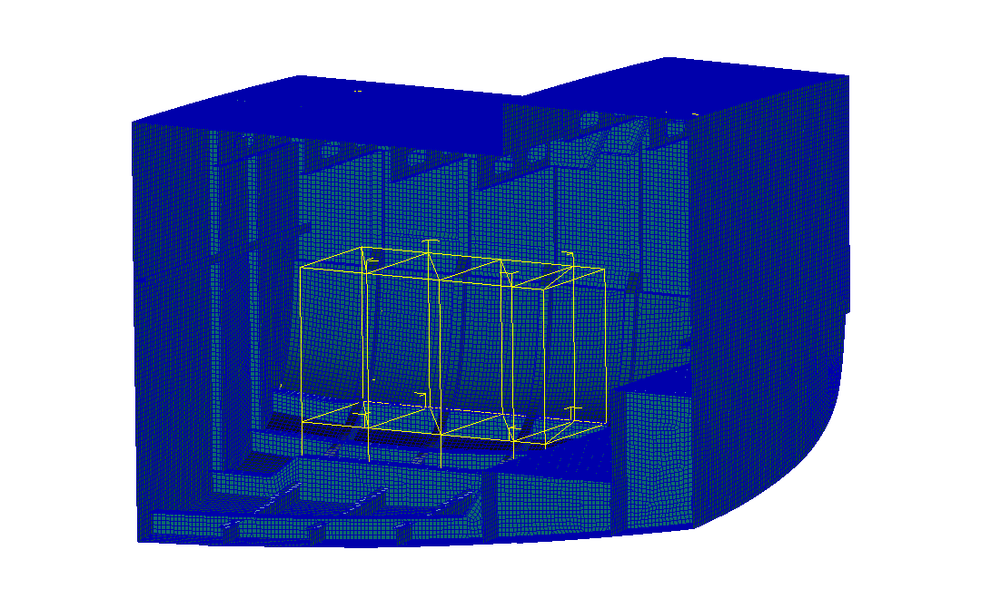
Figure 2. Engine room numerical model
As from previous research by authors themselves[1]–[6], in order to perform frequency response numerical analyses, the mesh was made using linear 4-node SHELL elements for the plates and reinforced elements while linear 2-node BEAM elements were used for the secondary stiffeners, for the foundation castle and for the pillars. The steel structure has been realized in Fe430 for the hull and AlMg5083 H321 aluminum light alloy for the deck, considering E=207 GPa and ν=0.33 for the steel and E=70 GPa and ν =0.3 for the aluminum light alloy.
The vibration dampers were modeled as spring-damper elements[7]. The rigidity of the dampers has been considered equal to
• K=1500 N/mm between the VSG and the foundation castle
• K=3045 N/mm between the castle and the yacht structures.
In order to simulate the structural damping, that is crucial for this type of numerical analyses[8]–[12], it has been considered a global structural damping of 0.01 for the yacht structures and 0.1 for the dampers.
The loading condition has been given by the VSG manufacturer as a velocity spectrum that has been equally applied to all the engine mountings; as a first approximations, the four CSG has been considered in phase.
The model was constrained with symmetry condition in correspondence with the symmetry plane while the nodes of the perimeter of each bulkhead were blocked in order to simulate the continuation of the ship beam without excessively stiffening the model.
Since it is only a benchmarking model, the added mass has not been considered.[13]

Different seating layout
In order to benchmark different type of foundation castle, 4 different models (Fig. 3) has been considered:
- Model 1: castle on double suspension connected to the bottom and to the side
- Model 2: castle on double suspension connected only to the bottom
- Model 3: double suspension castle connected to the bottom, side and deck
- Model 4: castle welded to the bottom.

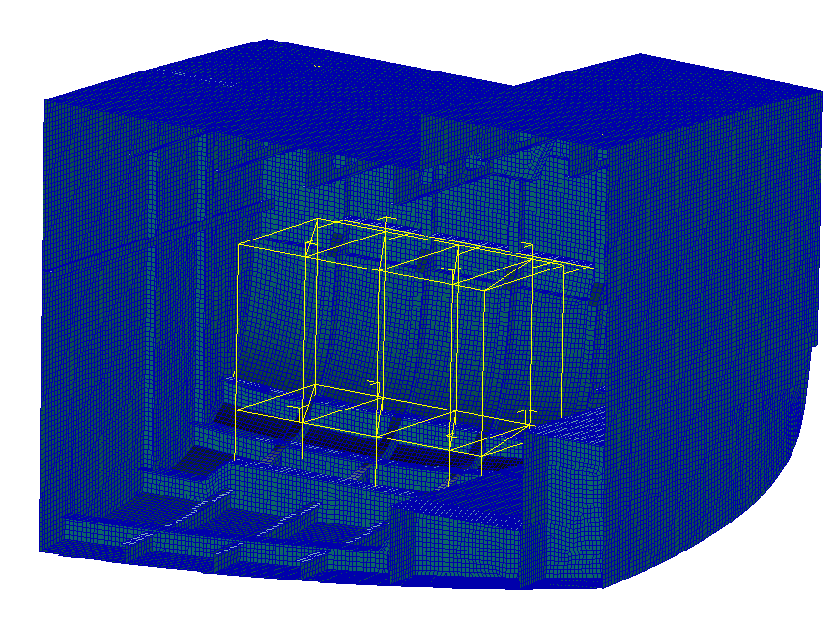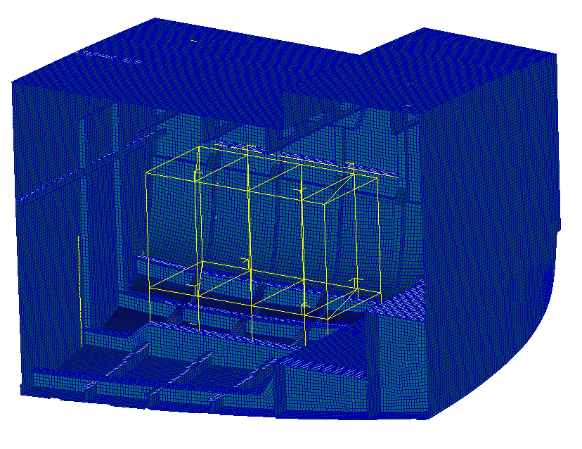
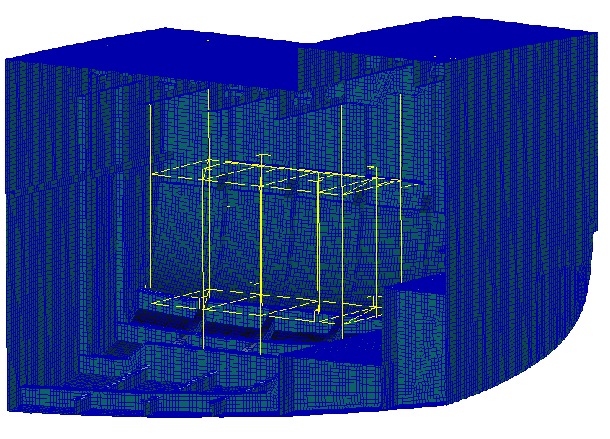
Figure 3. Different foundation castle solutions: top left Model 1, top right Model 2, bottom left model 3 and bottom right Model 4.

Two different point has been considered as significant: the first one in correspondence of the inner keelson, in order to verify the amount of vibration transmitted through the bigger longitudinal beam and one in correspondence of the main deck, on order to assess the comfort situation on that deck.

Discussion on Finite Element Analysis results

Vibration propagation on the keelson
In Fig. 4, the vertical velocity spectrum on the main keelson has been reported.
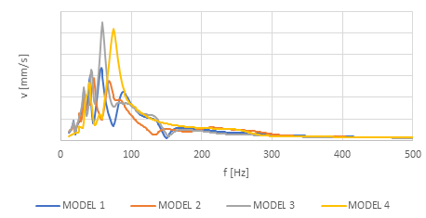
10 mm/s
Figure 4. Vertical velocity spectra on the main keelson
As can be seen, Model 1 has a significantly lower vibration spectrum than the others, especially in the resonant condition. It can therefore be deduced that connecting the castle only to the bottom or also to the bridge is harmful and that the connection on the side (Model 1) is enough to significantly reduce the vibration transmitted to the structure, since this connection is able to attenuate the transverse vibrations of the castle.

Vibration propagation on the maindeck
In Fig. 5, the vertical velocity spectrum on the main keelson has been reported.
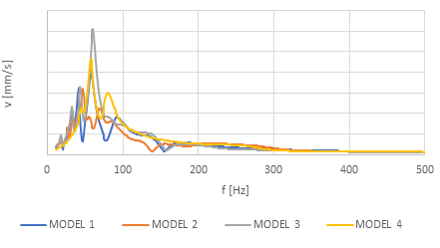
10 mm/s
Figure 5. Vertical velocity spectra on the main deck
As can be seen, Model 1 and 2 have a significantly lower vibration spectrum than the others; in addition, Model 1 shifts the resonance condition to lower frequencies than in the other cases, staving off the critical vibration frequency of a classical motoryachts. It can therefore be deduced that a further connection is harmful to the propagation of vibrations on the bottom.
It can also be noted that the double suspension model also connected to the deck is the most ineffective case, since it would cause the entire structure of the yacht to vibrate vertically, which would find different ways to propagate vibrations (pillars, bulkheads, etc.), that requires more sophisticated countermeasures.[14]

Conclusions
As a result of the study of the best layout for the foundation castles of variable speed generators for hybrid diesel electric propulsion, the following critical issues were noted:
- The results are strongly influenced by the structure of the yacht and therefore the results obtained must be considered as benchmarks among the various solutions, without considering mere quantitative values;
- The static scantling of the castle is not sufficient, even considering a factor of dynamic amplification of the weight of the machinery since it would tend to under-size the castle itself which would propagate excessive vibrations in the rest of the hull;
- The realization of the inner keelson must not have an excessive core height, since it could go into instability, causing also in this case an uncontrollable propagation of vibrations;
- The generator castle can be made with simple beam elements in FEM software, since there is no interest in the vibration of the castle itself, but rather in the propagation towards the hull and deck;
- To obtain a low propagation of vertical vibrations (ie the most important component for comfort on board) towards the deck, or where there are livable spaces, the double suspension solution is undoubtedly the best (in particular if combined with the connection towards the side) and connecting the castle to the side and / or the bridge increases the propagation of vibrations towards the keel;
The research is currently undergoing by considering different operational conditions (e.g. only some VSG working and/or VSG working not in phase)

References
[1] M. Biot, D. Boote, E. Brocco, P. N. M. Vassallo, L. Moro, and T. Pais, “Validation of a design method for the simulation of the mechanical mobility of marine diesel engine seatings,” Transport Means - Proceedings of the International Conference, vol. 2014-January, pp. 376–379, 2014.
[2] M. Biot, D. Boote, E. Brocco, L. Moro, T. Pais, and S. D. Piane, “Numerical and experimental analysis of the dynamic behavior of main engine foundations,” Proceedings of the International Offshore and Polar Engineering Conference, vol. 2015-January, pp. 1176–1181, 2015.
[3] G. Vergassola and D. Boote, “Numerical and experimental comparison of the dynamic behaviour of superyacht structure,” Ships and Offshore Structures, vol. 14, no. sup1, pp. 1–8, Oct. 2019, doi: 10.1080/17445302.2018.1546451.
[4] G. Vergassola, T. Pais, and D. Boote, “Numerical tools and experimental procedures for the prediction of noise propagation on board superyachts,” Transactions of the Royal Institution of Naval Architects Part B: International Journal of Small Craft Technology, 2018, doi: 10.3940/rina.ijsct.2018.b1.207.
[5] G. Vergassola, T. Pais, and D. Boote, “Low - Frequency analysis of super yacht free vibrations,” Ocean Engineering, vol. 176, no. December 2018, pp. 199–210, 2019, doi: 10.1016/j.oceaneng.2019.02.037.
[6] T. Pais, D. Boote, G. Vergassola, and M. di Iorio, “Engine foundation re-design due to modification of the shaft line arrangements,” Transactions of the Royal Institution of Naval Architects Part B: International Journal of Small Craft Technology, vol. 160, no. B1, pp. 17–30, 2018, doi: 10.3940/rina.2018.ijsct.b1.208.
[7] T. Pais, D. Boote, and G. Vergassola, “Vibration analysis for the comfort assessment of a superyacht under hydrodynamic loads due to mechanical propulsion,” Ocean Engineering, vol. 155, no. February, pp. 310–323, May 2018, doi: 10.1016/j.oceaneng.2018.02.058.
[8] G. Vergassola, D. Boote, and A. Tonelli, “On the damping loss factor of viscoelastic materials for naval applications,” Ships and Offshore Structures, pp. 1–10, 2018, doi: 10.1080/17445302.2018.1425338.
[9] V. v. Krylov, “Acoustic black holes and their applications for vibration damping and sound absorption,” Proceedings of International Conference on Noise and Vibration Engineering (Isma2012) / International Conference on Uncertainty in Structural Dynamics (Usd2012), 2012.
[10] H. Koruk and K. Sanliturk, “On measuring dynamic properties of damping materials using Oberst beam method,” in Proceedings of the ASME 2010 10th Biennial Conference on Engineering Systems Design and Analysis ESDA2010, 2010, pp. 1–8.
[11] P. Silvestri, T. Pais, F. Gaggero, and M. Bassetti, “Dynamic Characterization of Steel Decks with Damping Material by Impact Test,” International Journal of Structural Stability and Dynamics, vol. 21, no. 7, Jul. 2021, doi: 10.1142/S0219455421500966.
[12] M. Carfagni, E. Lenzi, and M. Pierini, “The loss factor as a measure of mechanical damping,” 1998. doi: 10.1038/gim.2017.114.
[13] T. Pais, “Analytical and numerical computation of added mass in vibration analysis for a superyacht,” Ships and Offshore Structures, vol. 13, no. 4, pp. 443–450, 2017, doi: 10.1080/17445302.2017.1416899.
[14] T. Pais and D. Boote, “Developments of Tuned Mass Damper for yacht structures,” Ocean Engineering, 2017, doi: 10.1016/j.oceaneng.2017.06.046.

Gianmarco Vergassola, Electrical, Electronics and Telecommunication Engineering and Naval Architecture Department (DITEN), University of Genova, Vi Montallegro 1, 16135, Genova, Italy, E-mail: gianmarco.vergassola@edu.unige.it

