A multipurpose simulation framework for ship design and operational assessment
Authors:
LUCA ISGRO’ª, LUCA FENGONE^{b}, DAVIDE TOZZI^{c}
ª Simulation Solutions Area Manager
^{b} Head of Production of Simulation Solution
^{c} Research & Development – Simulation Solutions

Abstract. One definition of simulation is: an approximate imitation of the operation of a process or a system.
It is very easy for us to understand the concept of simulation and in fact Simulation, Virtual Reality and Mixed Reality often become the most effective and immediate ways to understand our reality.
There are many kinds of simulation but in CETENA, when we talk about simulation solutions, we refer to maritime real-time simulation that can be used in different applications and fields.

Keywords. simulation, virtual reality, testbed, design assessment, digital twin.

Introduction
Simulation is a natural process of the brain; in fact, we continuously create simulations in our mind using the imagination to understand and predict actions, events and their relationships, including long and short term repercussions. The brain itself is a predictive machine that makes choices based on experience and simulation of future events.
The brain is able to evaluate both a simple event and complex artistic or sporting performance because it is simply designed around this requirement by nature and optimized over the centuries for this purpose.
Despite this innate instinct, human beings need material support that allows them to focus and optimize this ability to increase the chances of success.
Today, immersive virtual reality is the best tool to visualize digital scenarios for training but, in the coming years, virtual reality will be increasingly supported by mixed reality to reach a new kind of training in scenarios in which the union of real and virtual worlds produces environments and visualizations where physical and synthetic digital entities coexist and interact in real time.
Mixed reality does not take place exclusively in the physical or virtual world but is a hybrid of augmented reality and virtual reality. The first one takes place in the physical world, with information or objects added virtually as an overlay; the second one immerses you in a completely virtual world abstracted from the real physical world.

Simulation aplications
There are many types of simulation and, in the real-time simulation, Cetena identifies four main applications:
1 - Training systems for maritime and naval applications
2 – Test bed which means using the simulation systems to test, verify and validate equipment, entities and procedures
3 – Manoeuvrer simulator for port assessment
4 – Marketing and promotion where the simulation systems become the effective and natural way to engage the stakeholders
Simulation systems have many advantages because they allow to rationalize investments and to increase the safety and efficiency of any process that involves human beings: from simple checklist-based procedure to complex team operations, from driving vehicles in all weather conditions to their tactical use.
For instance, in the context of naval manoeuvring simulations, there can be very dangerous, sometimes prohibitive, environmental conditions when operating in the open sea or even inside ports. The use of simulators allows to face the stormy sea, make a mooring with 50 knots of wind or navigate accurately with currents that change suddenly, without any type of risk for men and vehicles, also involving multiple assets.
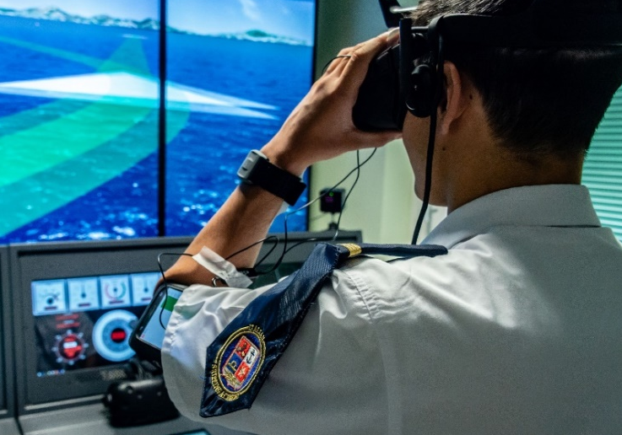
Figure 1 – Man-in-the-loop in a MANTA simulator

Simulators require dedicated infrastructures ranging from simple desktop solutions to complex systems distributed in different industrial buildings. The cost of these infrastructures is absorbed in a short time because the cost of simulation is infinitely lower than the real equivalent.
With a simulator it is possible to perform joint missions in very complex scenarios and to do any kind of exercise to cooperate, compete or fight with other entities involved in the same scenarios.
There is a lot of talk nowadays about the digital twin in which the real time simulation is an area where this technology is widely used. It is possible to use simulators to verify the functional relationship between different types of existing assets, as well as the relationship between their digital twins, because the test-bed simulator allows to verify and validate devices, entities and procedures in realistic contexts.
For example, it is possible to perform preliminary tests of a new type of radar, reducing the number of real sea trials and the related costs or to test procedures and systems for the defence of a specific port area both against an asymmetric threat and against a symmetrical threat with real personnel for both attack and defence teams.
Figure 2 – A MANTA based simulator
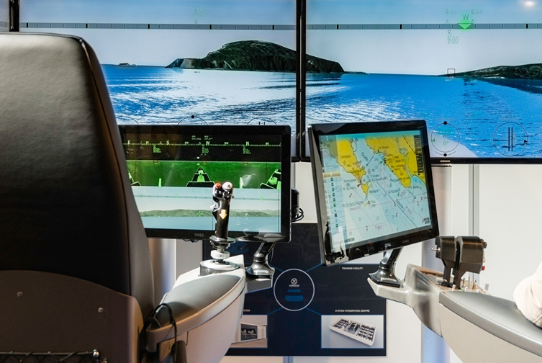

Thanks to immersive virtual reality, simulation also allows to support anthropocentric and post-anthropocentric (ecospheric) design through interactive ergonomic assessment between the end user and the world in which he interacts with other artifacts.

MANTA framework
To meet the needs of the simulation world community, CETENA has developed MANTA (Multiplayer Advanced Network Training Architecture). MANTA is a suite of software and hardware products used to realize different simulation systems.

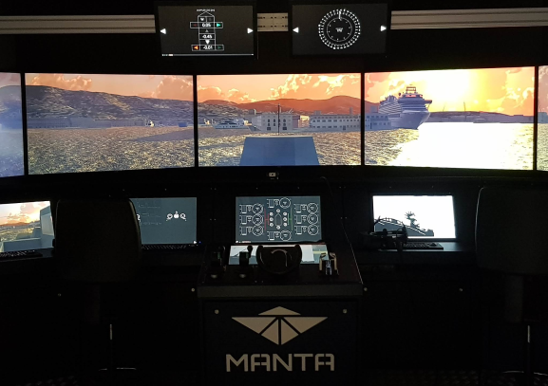
Figure 3 – A MANTA based simulator

Manta is developed according to the latest generation standards: it is designed to be modular, reconfigurable, expandable and interoperable.
It has an open architecture that allows the connection with other simulation systems in compliance with all distributed simulation standards such as DIS or HLA.
It is also ready to be connected to real equipment, using industrial standard connection systems like CAN BUS or specific protocols such as NMEA, Asterix and so on.
MANTA is based on the most advanced commercial hardware and software and it is continuously updated with physics algorithms, computer graphical and virtual environments. Moreover, CETENA performs the sea trials of all ships built by Fincantieri; more than 4000 ships were tested over the years and all the data collected during the sea trials supply the MANTA mathematical model which is, in this way, continuously updated and validated.
Through MANTA it is possible to simulate any kind of entities like ships, fast boat, helicopter, underwater vehicles and any kind of equipment like Conning, Radar, Electronic Chart, Communication etc., used in maritime domain.
MANTA allows to build many different solutions, from desktop to full mission simulator that can work individually or connected in a multiplayer and multi-role simulation.
- The desktop solution is mainly used for individual use or to simulate specific consoles or equipment.
- Full Motion solution uses the 6DOF motion platforms to recreate the same movement of the simulated entity.
- Full Bridge solutions are used to simulate all activities of a command bridge ship.
- Full Mission solutions integrate the simulators of all main naval ship roles: Navigation, Propulsion and Combat systems.

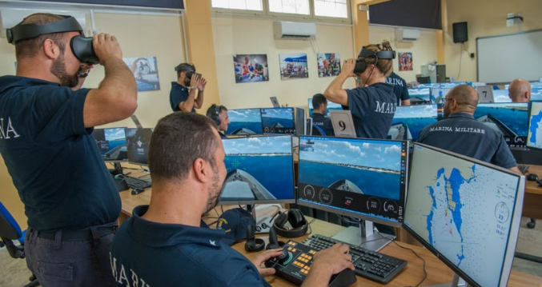
Figure 4 – MANTA multi-desktop solution
CETENA supports the Italian Navy in crew training through different types of simulation systems such as the classroom for individual navigation training and the full mission simulator which integrates the bridge simulator with the simulator of machinery control room and the combat system simulator.

MANTA dynamics core
MANTA framework is composed by a heterogeneous set of software modules depending on the purpose of the final product to realize. One of the most significant parts that is usually included in every simulation solution consists in the dynamics calculation of the boat to be simulated. In the simulation field, ships types can be divided in two main categories: displacement and planning ships. In terms of mathematical representation of the ship’s behaviour, these two categories are difficult to be described by the same model. Effects acting on displacement ships are typically different from those to be considered for planning ships. For these reasons CETENA developed two different mathematical models that can work together as the core of the whole simulation framework.

SAND core – Displacement ships
CETENA’s dynamics core for displacement ship is called SAND. SAND is part of MANTA framework and the mathematical model included in SAND is based on a Maneuverability and Seakeeping model integration, that allows to calculate the six degrees of freedom (Surge, Sway, Heave, Roll, Pitch, Yaw). SAND has been validated during the years either from the use and sensitiveness of the Port pilots who used it during the port assessment activities and, moreover, from the huge real data coming from the experiment activities CETENA performs onboard ships.

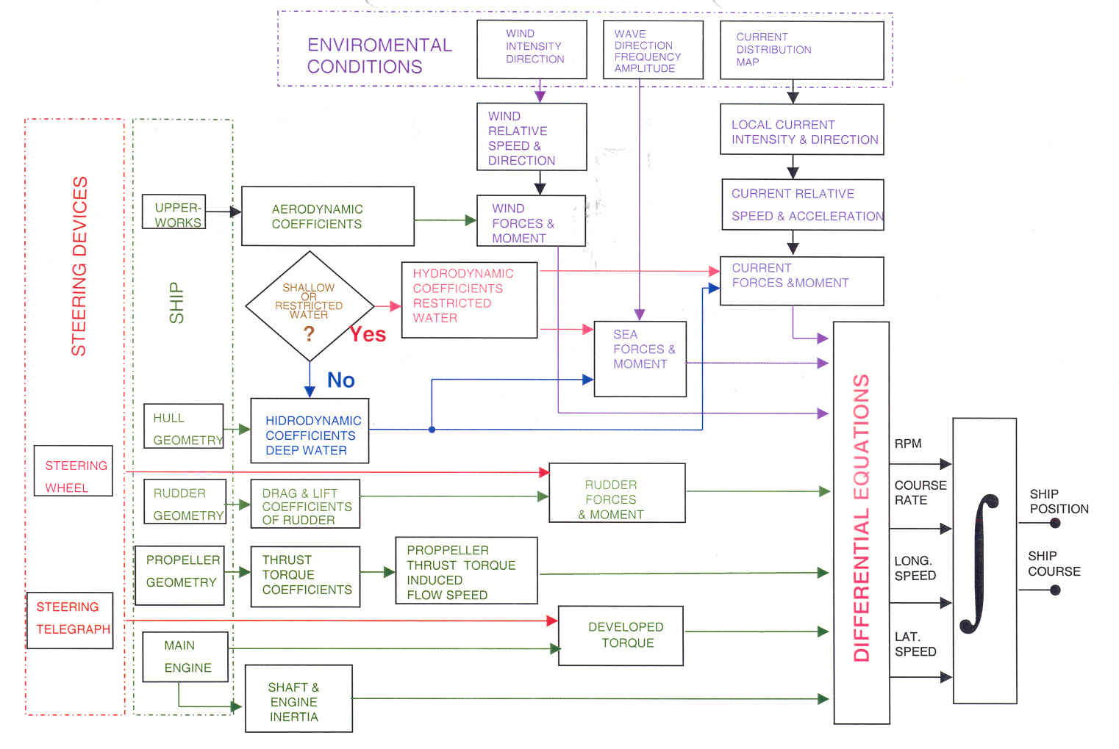
Figure 5 – SAND mathematical core
The simulation model is designed to be “open” and configurable for all type of displacement ship (cruise, bulk carrier, petrol, LNG, container ship) and for all environmental scenarios (map, sea state, wind, sea current, time of day).
Different type of vessels can be easily configured using a wide range of characteristics such as:
- hull data
- engine type (diesel, diesel-electrical, turbine, or every combination of them)
- propulsion (azimuth, fixed/controllable pitch propeller, POD, water-jet)
- thruster
- rudder (simple type, compound butt, under hung deep horn, shallow horn, spade)

The physical model is completely modular allowing the implementation of add-ons to take into accounts new or more detailed environmental and interaction effects.
The user can choose the environmental condition through a set of sea state, wind intensity and sea current and the software compute the interactive ship behavior for very accurate and realistic vessel simulation taking into account several aspects like:
- shallow water effects
- navigation in narrow channel
- collisions
- anchors and chains

PhyMan core – Planing ships
The dynamics core for planning ships is called PhyMan.
PhyMan is another module belonging to the MANTA framework and it is based on the latest physics engine technologies in order to guarantee fast responses in calculation of fast boats’ motions. The PhyMan core is able to calculate the behaviour and the consequence of the interactions among objects being part of the simulation scenario, such as the collision forces.
PhyMan core allows to develop high performances dynamics simulators for this kind of ships, where the interaction between the ship’s hull and the sea surface needs very fast responses. In fact, for planning ships, despite of larger ones, the motions are strictly connected with the instant shape of the waves.
The ship’s size and dimensions can be easily changed by the user together with all the configuration inputs useful to set up the ship’s motion model.
The 3D model of the ship is divided in multiple sections in order to represent the hull shape to allow the calculation of the forces applied to the hull itself during the interaction with the waves shape.
In the following figure a representation of the hull section is shown.

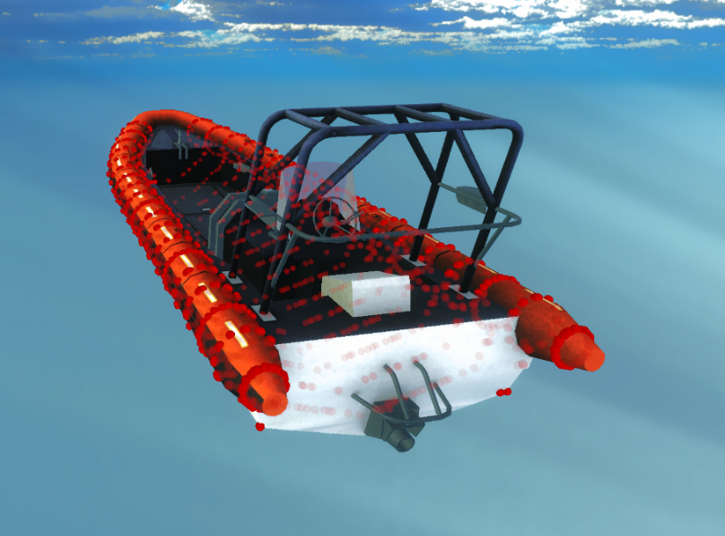
Figure 6 – Planing ship’s sections definition

At each simulation time step, the mathematical model finds the intersection between the ship’s hull and the sea waves, in order to calculate the hydrodynamics forces to be applied to the ship.
The resulting force due to the engine that has to be applied to the RHIB in order to behave in the proper way, is placed in the real propeller location of the ship, and varies at each step of the simulation session in order to give the proper thrust to the ship itself.

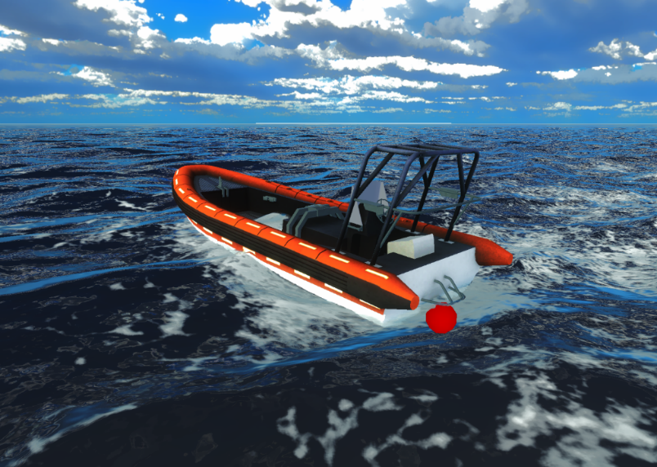
Figure 7 – Planning ship in the virtual reality environment

Applications – Testbed for operational assessment
A simulation system developed with the aim to assess the feasibility of a small craft approaching manoeuvre to a mother ship through an interactive time domain virtual reality-based simulator is described in this section.
The focus of this simulation scenario was to simulate the behaviour of the RHIB while it is moving on the sea towards the aft entrance of the mother ship (a frigate).
The developed system was based on the following assumptions:
- The manoeuvre to be assessed is the approach of a small craft to the stern entrance of a mother ship (a general frigate)
- The architecture is based on real time and time domain simulators of surface vessel
- The mother ship simulator can be either simulated by the CETENA real time simulator, or it can be replaced with a set of precalculated motion based since its behaviour is not influenced by any input from the operator. The mother ship trajectory is straight forward at a constant speed
- The small craft simulator can work in two different modes:
o Autonomous: the small craft is piloted by an autopilot modules without the human presence
o Manual: the small craft is piloted by a human operator through inputs commands on engine and rudders
- The manoeuvre to be assessed starts at a predefined relative position from the mother ship and it ends as soon as the small craft is in the proximity of the stern entrance of the mother ship
- The assessment of the manoeuvre is based on a set of values that should give an estimation of the safety and feasibility of the manoeuvre itself.

The working principle is shown in figure below.

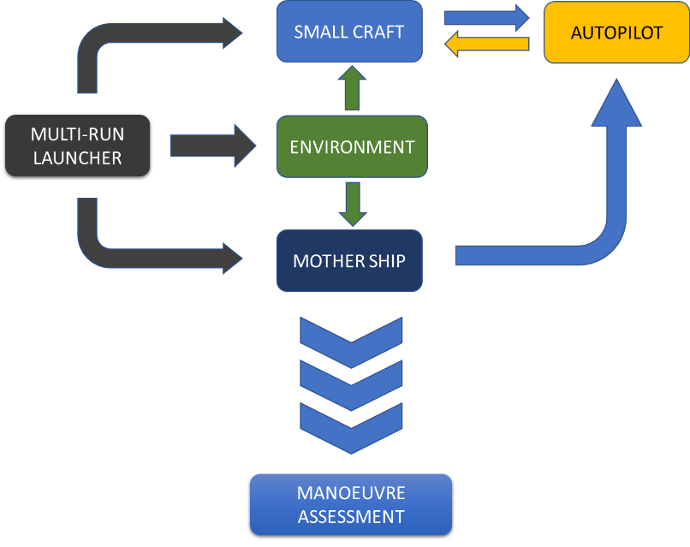
Figure 8 – MANTA based process for operational assessment

Such a simulation system can be used both in stand-alone and in multi-run modes. When the need is to test the manoeuvre directly by the user, the stand-alone version is useful because it puts the user in front of a scenario that will replicate the real one. When the scope is to support the design phase by assessing the operation feasibility a multi-run approach instead, it can represent a high value solution.

This is a significant application of the CETENA’s simulation framework used as a testbed for the verification and validation of a naval operation that can be adopted as a multiple use tool for:
- The support of early stage and advanced design phases,
- The verification of operational limits in rough environmental conditions
- The training of pilots for the execution of the operation

Applications – Port assessment
CETENA has been using the simulation systems for port assessment for more than 20 years.
Port assessment is an analysis performed with simulators to verify the compatibility between the ship and the port or a specific quay.
Each evaluation can be carried out not only between existing real assets but also between assets at preliminary design stage, without cutting a single centimetre of metal sheet or lay a gram of concrete before having the certainty of the final result thanks to operators' validation.
In CETENA, a specific team carries out port assessment analyses for many different clients such as Port Authorities and shipowners, involving all port actors such as pilots, coast guard, tugboat companies, moorers etc.

Future developments
One of the new applications of real-time simulation systems is the digital twin. It is a concept linked to the digitalization of the industry according to the most recent paradigms where simulation is used to observe the behaviour of a digital twin of a given technology and its impact on real scenarios where ship crew operates in conditions that are as close as possible to reality.
Today we are also working on new methods and applications that allow us to involve the end user more and more effectively thanks to the use of AR (Augmented Reality) and MR (Mixed Reality); in the near future, new technologies will bring us closer and closer to what our mind instinctively does, to simulate what will happen.

